Assessment 2
Individual Report (Practical SQL Coding)

DATA4200 Data Acquisition and Management

T2 2025

Facilitator: Dr Carlos Tapia

Isadora Faria
Student ID: 1857869

Table of contents

- Introduction

- SQL Findings

- Business Insights and Visualizations

- Conclusion

- Reference list

- Introduction

This report examines consumer loan data from the US bank that provides personal loans across the country. Due to a limited analytical process, the bank faces risk of customer defaults and inconsistent loan approvals. To address this challenge, the objective of this report is to obtain clear information and generate insights on customer demand, borrowing behaviour and credit risk. The insights aim to support decision makers and bank managers in making more reliable loan decisions, identifying potential risks and minimising financial losses.

The data is analysed using SQL queries, which enables summarising and extracting loan information to answer business questions. Combined with that, Power BI was used to develop visualisation, it highlights patterns important for the outcomes such as delinquency trends, interest rate, loan terms and loan status. Using these methods, raw data is transformed into business intelligence to improve US bank’s credit approval and optimising risk management.

- SQL findings

  - Section 1

The column “recoveries” was added for measuring the amounts collected after defaults, allowing the bank to evaluate the success of its collection efforts. As a result, managers can assess portfolio performance and make better decisions.


Figure 1: SQL query to add new column

The next query was used to check all records to confirm that all variables relevant for the analysis are accessible and properly formatted. Following by “LIMIT 10” which allows quick inspection of data without overloading the system used.

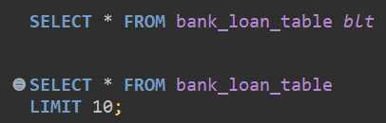
Figure 2: SQL query to add select column and limit 10

  - Section 2 – part 1

The results show that in 2015 home improvement was the most common purpose with a total of 289 customers. This indicates that customers were more interested in financing property improvements rather than car or medical expenses. By recognising this demand pattern, the bank can prioritise the key demand and guide marketing strategies or resource allocation aligned with customer needs.

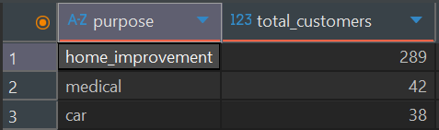
Figure 3: Results from SQL query related to loan purpose

  - Section 2 – part 2

With this analysis we can assume that most customers preferred a 36-month loan over 60-month loan, in 2014 and 2015, indicating preference for faster repayment. Understanding this trend helps the bank to manage its balance between profitability and risk. For example, a 36-month loan of $10,000 may generate less total interest than a 60-month loan but returns the capital sooner and reduces the risk to default. In contrast, longer loans bring higher revenue but increase credit exposure. With that information, managers can promote short-term products to have stability while monitoring long-term loans to protect earnings.

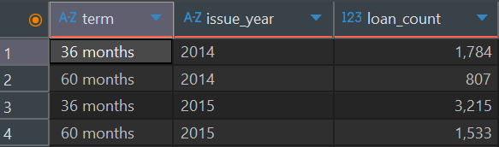
Figure 4: Results from SQL query related to loan terms

  - Section 2 – part 3

This analysis provides an overview of the bank’s credit pricing in 2015. It shows that the bank had a wide range of interest rates that varies from 5.31% for low risk to 28.49% for high-risk customers, the average is 12.51%. There is a mix of customer profiles, in which safer customers are offered better credit and riskier customers have higher rates to compensate for the chance of default

Figure 5: Results from SQL query related to max, min and average of interest rate

  - Section 2 – part 4

This is an analysis of loan distribution by state, loan volumes grew from 2013 t0 2014, an increase of nearly 69%. The largest volumes were in California, New York and Texas and the lowest were in Vermont, Wyoming and South Dakota. For managers this indicates better opportunities in high-demand states.

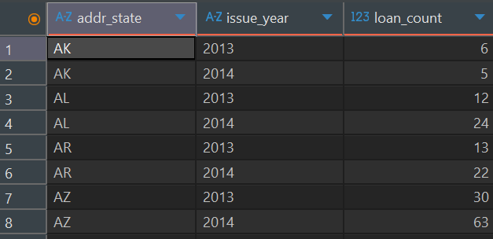
Figure 6: Results from SQL query showing top 8 states

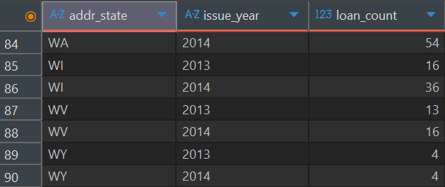
Figure 7: Results from SQL query showing bottom 7 states

The tables below represent a few sample loans from each region, some states have higher loan amounts and prefer long-term loans, while others prefer short-term loans with lower amounts. It provides valuable insights to understand preferences across the country, helping with targeted regional approaches.

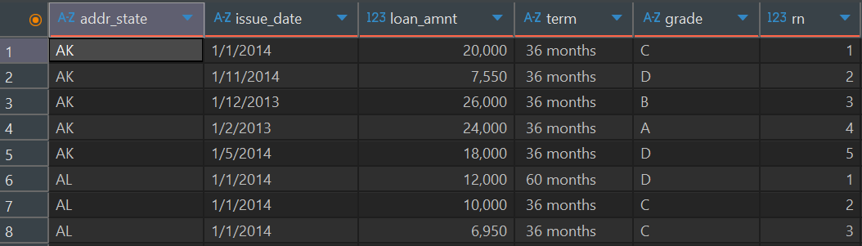
Figure 8: Results from SQL query that displays top first 5 rows of data

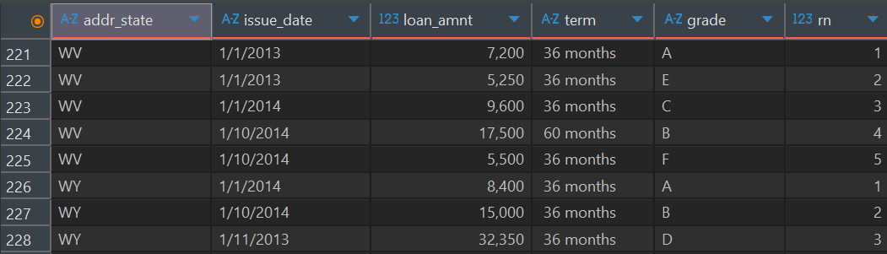
Figure 9: Results from SQL query that displays bottom first 5 rows of data

  - Section 2 – part 5

These findings suggest that most loans are concentrated in grades B and C, the bank is lending more to moderate-risk customers, it generates returns but could generate risk ff default rise in these categories. This emphasises the role of continuous monitoring to maintain good lending practices.

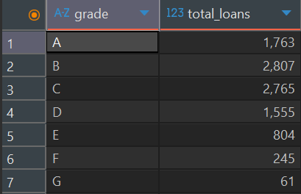
Figure 10: Results from SQL query related to grades

The sub-grade distribution shows that the concentration of lending is in B3-C3, as mentioned before this reinforces the need to monitor delinquency trends, as these segments have a big impact on the bank’s overall lending results.

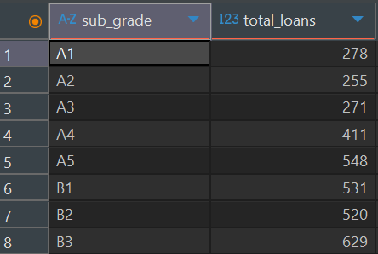
Figure 11: Results from SQL query related to top sub-grades

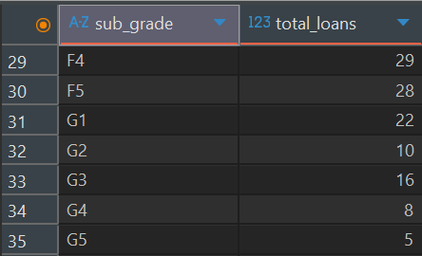
Figure 12: Results from SQL query related to bottom sub-grades

  - Section 2 – part 6

This is an overview of the health of loan portfolio. Most of loans were “current”, it reflects borrowers are paying on time. “Fully paid” category coming in 2nd is excellent, it shows loans that were successfully completed. “Charged off”, “Late” and “In grace period” represents risk exposure. For the bank, monitoring repayment behaviour allow early warning signals of risk, helping managers to make better decisions in credit policies reducing future defaults.

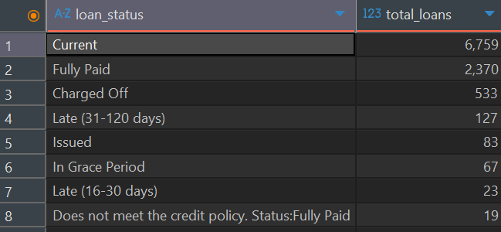
Figure 13: Results from SQL query related to status

This breakdown highlights non-performing loans, with 533 charged off representing credit losses, while the other statuses are warnings of future defaults. For the bank, these insights reinforce the need to refine credit policies.

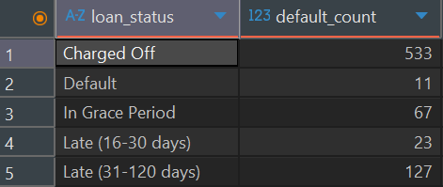
Figure 14: Results from SQL query related to status

- Business insights and visualizations

  - Temporal trends in loan purpose

The visualization of loan purpose over time shows a solid growth in overall lending activities between 2011 and 2015, with loan amounts increasing sharply from 2013 onward. It highlights that the most common and consistent purposes were credit card and debt consolidation loans, reflecting a increasing of customers demand, while smaller categories such as home improvement and small business remained present but minor. This pattern is positive in terms of client base but since its activity is concentrated in just a few loan purposes, it becomes important to track these segments closely once any small decline in these categories could affect stability of portfolio.
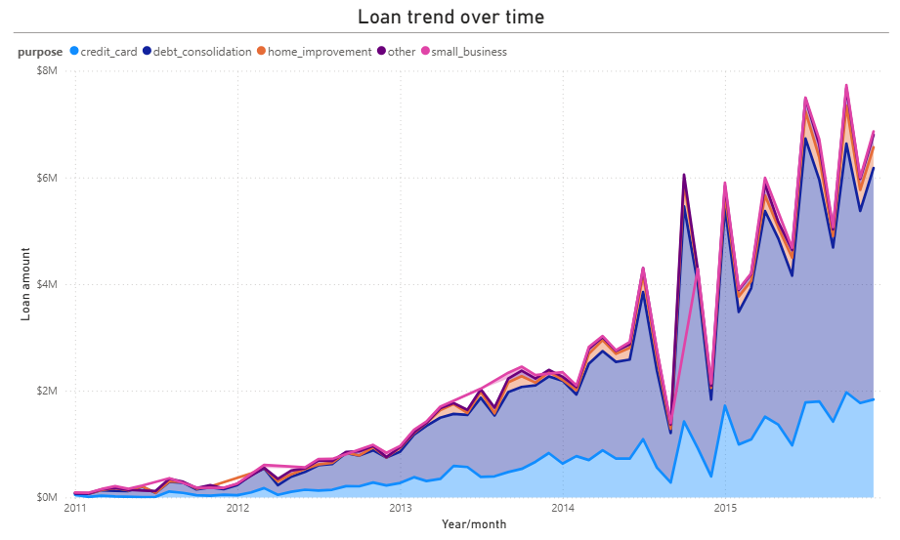
Graph 1: Loan trend over time

Credit uptake grew across all loan purposes in October 2014 and October 2015, suggesting a seasonal borrowing peak in the U.S, as holidays and year-end spendings approach. With this observation, the bank can anticipate seasonal peaks, mitigate risk plans, adjust operational capacity and develop lending strategies that enhance portfolio diversification and customer retention.

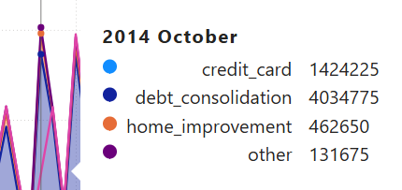
Figure 15: Extract from October 2014

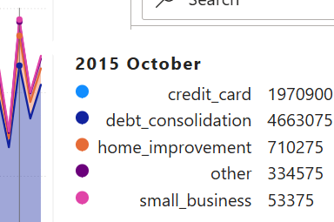
Figure 16: Extract from October 2015

3.2 Geographic Analysis: Healthy vs Risky Loans

The present graphic shows that California, New Yok and Texas are the states with largest lending activity. The statuses were grouped into 3 main categories for better visualization. California alone reached almost $20M in healthy loans and more than $1.5M in defaults, making it the most profitable but riskiest state. Most loans remained healthy, which means strong revenue generation but concentrating loans in just a few states raises default risk.

In summary, the strategy that can be used is diversifying geographically and demographically. By expanding into smaller markets and targeting new demographic segments the bank can spread risk and capture new opportunities.

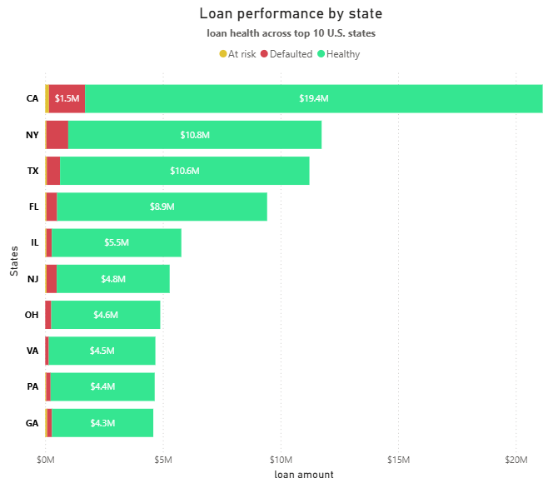
Graph 2: Loan performance by state

  - Risk–Return Trade-Off by Grade

The chart illustrates a clear risk-return trade-off. Lower grades such as A, B and C have smaller average loan amounts and lower interest rates, indicating safer lending but limited income potential. By comparison, higher grades E, F and G present higher interest rates and larger available loan amounts but have greater risk to default. Managing exposure across grade analysis allows the bank to achieve sustainable profitability while controlling risks.

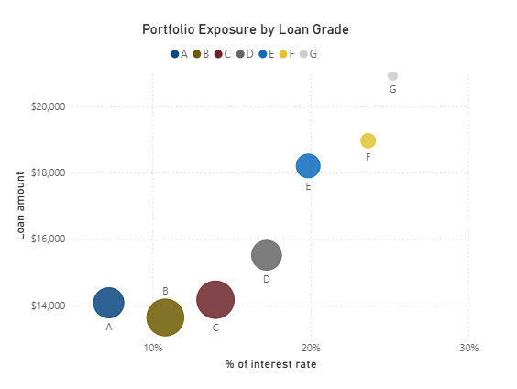
Graph 3: risk-return trade-off by loan grade

- Conclusion

In conclusion, the combined SQL analysis and visualizations offer a precise understanding of loan performance, emphasizing the opportunities for expansions and risk considerations. The SQL queries were useful to identify patterns of loan, customer activity and default outcomes, bringing insights and forming the foundation for the visual analysis. The findings point a strong growth, but a concentration of loan purposes in some specific regions, purposes and grades that can lead to high exposure to default. Balancing profitability and risk signals are important for managing portfolio and generate better returns.

From a strategic perspective, the bank should aim to tighten credit policies but also anticipate seasonal borrowing peaks to adjust their operational capacity. Diversification should be pursued across regions by expanding into different states and reaching new segments while loan purposes and grades represent strategic opportunities to achieve a more balanced lending profile. Such actions would enable the institution to increase revenues without compromising its financial stability.

- Reference list

Seasonal Lending Trends in the United States 2017, BorrowSphere, viewed 4 September 2025, <https://borrowsphere.com/en/guide/seasonal-rental-opportunities>.

Log in to the site | MyKBS 2025, Kbs.edu.au, viewed 4 September 2025, <https://elearning.kbs.edu.au/pluginfile.php/2792629/mod_resource/content/12/DATA4200_Workshop_06_T1_2024.pdf>.

Wise Explainer 2024, U.S. Bank Personal Loans Honest Review - Watch Before Using, YouTube, viewed 4 September 2025, <https://www.youtube.com/watch?v=ZWqejLoUuWk>.

