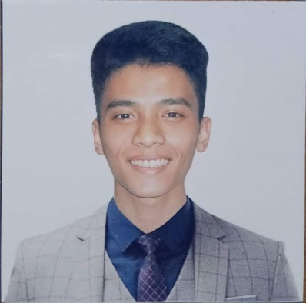

EUGENE DAVID V. TOLEDO

# Phase 3 Package 2 Block 29 Lot 26 Bagong Silang, Caloocan City

# 09854850130

**eugenedavidtoledo9817@gmail.com**

# OBJECTIVES

# Seeking an entry-level position in a computer-related field where I can leverage my strong problem-solving skills, attention to detail, and passion for technology to contribute to the company's success. I am a motivated and fast learner, willing to take on new challenges and collaborate with a team to achieve organizational goals.

# EDUCATIONAL ATTAINMENT

|  |  |  |
| --- | --- | --- |
| Tertiary: | St.Clare College of Caloocan |  |
|  | Bachelor of Science in Computer Science | 2019-2023 |
| High School: | Bagong Silang High School | 2010-2014 |
| Elementary: | Silanganan Elementary School | 2004-2010 |

# COMPUTER SKILLS

HTML   
CSS  
JAVASCRIPT  
C LANGUAGE  
PHP  
C#  
MS SQL  
MICROSOFT EXCEL, WORD, ACCESS, POWERPOINTS

# EXPERIENCES

# Big Media PH Digital Corporation (INTERN)

# 2/F Lipam's Building 48 President's Avenue BF Homes, Graphic Artist

# Paraaque City, Metro Manila, Philippines 1700

**JCBA SOLUTIONS AND CONSULTANCY INC. (****INTERN)**

21 South Esteban St. Brgy. Dalandanan, Valenzuela City **FullStack Web Developer**

# CERTIFICATES

SAP B1 Technical / SDK Training at JCBA Solutions and Consultancy, Inc.

Web Development Training (Javascript, PHP) at JCBA Solutions and Consultancy, Inc

Free Coding Bootcamp: Basic Web Development Workshop

# PROJECTS

Simple Automated Teller Machine System (C#.NET / Microsoft Access)  
E-Voting System For Private Organization (C#.NET / MS SQL Server)  
Student Registration System (VB.NET / Microsoft Access)

# PERSONAL BACKGROUND

Nickname: Uge Age: 24

Birthday: September 17, 1998 Birth Place: Caloocan

Civil Status: Single Religion: Roman Catholic

# CHARACTER REFERENCES

|  |  |  |
| --- | --- | --- |
| Enrico Columna  *I.T Supervisor/Center for Online Education*  Era Nikka Garcia  *Front-end developer* | St.Clare College of Caloocan  Freelance | 09500631694  09567942927 |
| Joshua Arman Galvez  *Senior Web Programmer* | JCBA Solutions and Consultancy, Inc | 09638445580 |

*I hereby certify that the above information is true and correct to the best of my knowledge and belief.*

# EUGENE DAVID V. TOLEDO

Applicant