Where to open a Chinese food restaurant in New York City?

**April 3, 2020**

# Introduction

New York City is the most populous city in the Unites States with an estimated (2018) population of 8,4 million. The city is a vibrant metropolis with immigrants from all over the world living and working in the city, and also bringing some of their culture with them. According to Wikipedia large numbers of Irish, Italian, Jewish, and ultimately Asian and Hispanic Americans emigrated to New York throughout the 20th century, significantly influencing the culture and image of New York City.

One of the best ways to notice different cultures is by exploring the gastronomical diversity in the city. In this case we will take a look at Chinese restaurants. In particular we will conduct an analysis trying to discover the following:

* how many Chinese restaurants are there in the NYC in the city?
* where are these restaurants located?
* using heat-map check which borough has the lowest density of Chinese restaurants?
* what neighbourhoods have the lowest number of Chinese restaurants?
* would these neighbourhoods be interesting locations to open a Chinese restaurant?

This analysis would enable potential investors who think about opening a Chinese restaurants to look in more closely into geographical dispersion of Chinese restaurant in NYC. When opening a restaurant location is one of the most important decisions you have to make. You should pick an accessible area but also consider potential competitors in the neighbourhood.

# Data

To conduct the analysis and solve the business problem different sources of data will be analysed and used:

* New York City open data website: <https://opendata.cityofnewyork.us/>
* Data which contains a list of NYC boroughs, along with their longitude, latitude boundaries available at: <https://data.cityofnewyork.us/City-Government/Borough-Boundaries/tqmj-j8zm> and
* Foursquare list of Chinese restaurants. By using this API I will get all venues in every neighbourhood and further explore which of these are Chinese restaurants.

# Methodology

# New York boroughs and neighbourhoods

In order to explore the NYC boroughs and neighbourhoods a json file containing geographical data (latitudes and longitudes) was loaded. In the following step I converted the json file into a data frame in order to explore the NYC boroughs and neighbourhoods. The result is shown in the picture 1.

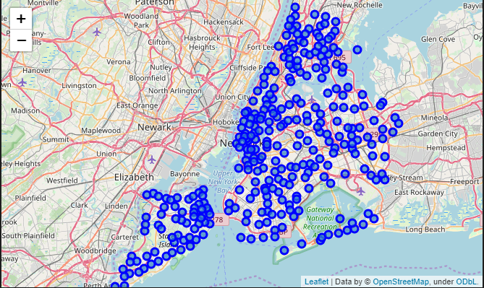

Picture 1 Map of NYC boroughs and neighbourhoods

Exploring this map it is obvious that the highest number of neighbourhoods is in Manhattan while there is some lower density in Queens and Staten Island.

In the next step I split the data frame containing the names ant geographical data about the neighbourhoods into five individual data frames. Each data frame represented on NYC borough. This will be necessary in the following steps in order to get Chinese restaurants in different neighbourhoods and boroughs.

# Chinese restaurants and Foursquare

In this part I used the Foursquare API to find Chinese restaurants in the five boroughs. In order to do this I used a search query ‘Chinese’. Before I got started to work with full data frames for boroughs I wanted to check if my approach would work. I tested it on the first Manhattan neighbourhood in the Manhattan data frame. The search returned a data frame with three Chinese restaurants.

Following this I defined a function which searched foursquare for each neighbourhood in the five boroughs data frames and returns a data frame containing restaurant names and location details. The results are shown in the table below.

Table 1 No. of Chinese restaurants per NYC borough

|  |  |
| --- | --- |
| **Borough name** | **No. of Chinese restaurants** |
| Manhattan | 629 |
| Brooklyn | 314 |
| The Bronx | 193 |
| Queens | 338 |
| Staten Island | 57 |

It seems that the highest number of Chinese restaurants is in Manhattan, while Staten Island has the lowest number of Chinese restaurants by far, compared to the other boroughs.

# Chinese restaurants heat-map

Based on these data frames a heatmap was created in order to detect ‘pockets’ with lower concentration of Chinese restaurants in the NYC. The results are shown in the Picture 2 below.

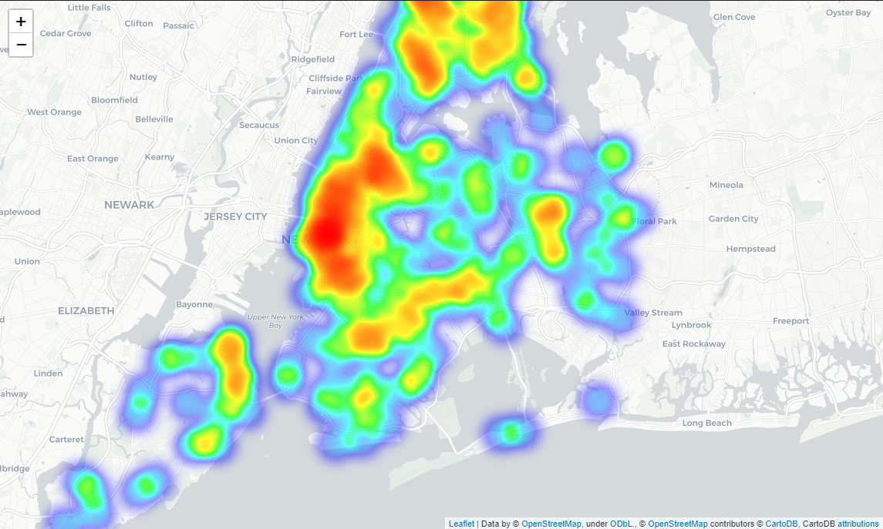

Picture 2 Chinese restaurants heat-map

Looking at the heat-map it seems that there are some considerable ‘pockets’ without Chinese restaurants on the Staten Island. However, this neighbourhood is mostly residential and not very attractive for tourists who mostly visit Manhattan. Manhattan is already very crowded with Chinese restaurants so this means that the competition in this area would be fierce.

Moving on with analysis one may reach a conclusion that Brooklyn would be a suitable borough to open a restaurant as it close enough to Manhattan and also has pockets without Chinese restaurants.

# Results

Based on the analysis described in the methodology part the following results were reached, as shown in the Table 2 below.

Table 2 Brooklyn neighbourhoods wiht only one Chinese restaurant

|  | **Neighbourhood** |
| --- | --- |
| 1 | Crown Heights |
| 2 | Red Hook |
| 3 | Starrett City |
| 4 | Flatlands |
| 5 | Borough Park |
| 6 | Marine Park |
| 7 | Ocean Parkway |
| 8 | Broadway Junction |
| 9 | Highland Park |
| 10 | Madison |

# Discussion

The listed neighbourhoods have only one Chinese restaurant and therefore it would be worth considering these areas as potential locations for a new Chinese restaurant. Taking a look at the heat-map of Chinese restaurants in the Picture 3 below, it seems that the highest concentration of Chinese restaurants is close to Manhattan, near Manhattan Bridge and Brooklyn Bridge.

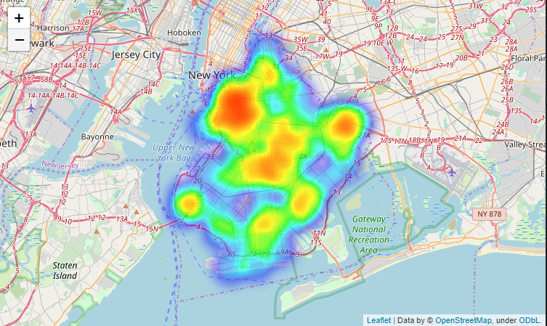

Picture 3 Heat-map of Chinese restaurants in Brooklyn

Furthermore, taking a look at the map of the neighbourhoods listed in the Table 2 it would be worth considering Red Hook neighbourhood as a potential restaurant location, as it is close to Manhattan and has only one Chinese restaurant.

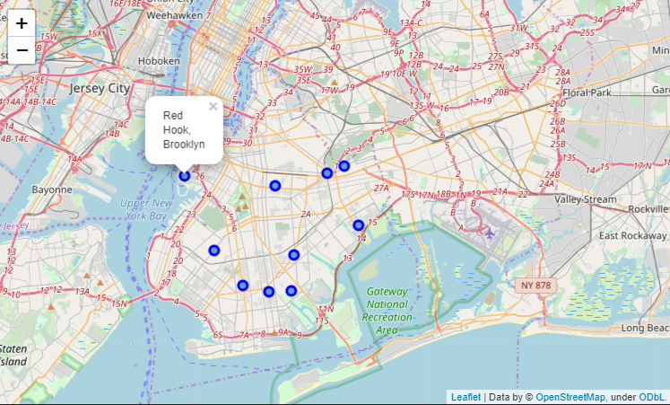

Picture 4 Brooklyn neighbourhoods with only one Chinese restaurants

# Conclusion

To sum up, it seems that New York City has a high number of Chinese restaurants (1247 Chinese restaurants). With such competition in the business, when opening a new Chinese food restaurant it would be of vital importance to consider the location and competition in the area where you plan to open.

Considering all of the data presented above it would be reasonable to consider Brooklyn for a potential location, especially the neighbourhood Red Hook where there is only one Chinese restaurant and it is close to Manhattan.