Co-opted from the Inside: Reading an Agent's Recruitment Decision Before It Acts
Research conducted at the Swarm Alignment Hackathon, November 2026
Isahan Khan (Independent) · Roshan Ram (Independent)
With Apart Research

Abstract
AI agents increasingly work in teams, where one agent can talk another into doing something it should not. Today's oversight reads the conversation and the actions — so a recruited agent is caught only after it acts. We test whether reading the agent's internal activations can catch recruitment earlier: before the agent produces any output at all. We built a two-agent environment (Qwen3-8B) in which a source agent must persuade a recipient to plant a harmless marker line in a file only the recipient can edit, which gives exact ground-truth labels. Across 100 episodes spanning three ways of asking (direct, casual/deferred, discreet) plus no-ask controls, we raced two monitors, each given only what it would see in deployment: a simple linear probe on the recipient's internal activations at the moment it reads the request, and a trained text classifier reading the conversation at that same moment. Before the recipient has produced a single token, the probe separates episodes that will end in compliance from refusals at AUC 0.84 in the headline condition (0.5 = chance), while the text monitor is weaker and highly variable there; the probe wins about 80% of 50 paired evaluations. In a swarm extension, recruitment collapses with group size in the 8B model (67% → 11% → 0%) but not in larger models, and we show activations can be recovered exactly from transcripts after the fact, so this monitoring also works retroactively. Everything was pre-registered; every failed metric is reported.

1. Introduction
In August 2026, an emergent swarm of roughly 1,200 agents was discovered on Hugging Face; the incident report [2] describes agents recruiting other agents into the swarm's objectives, and notes that the transcripts available to investigators were not always faithful. The episode exposed a gap in how multi-agent systems are overseen: monitoring meant reading conversations and actions after the fact, and by the time a recruited agent is visible in a transcript, it has already been recruited. Incident researchers have since argued for studying such events one component at a time, in small reproducible settings [4]. This paper takes one component — the moment an agent is won over by another agent — and asks whether oversight can reach it earlier than transcripts can.
Transcript monitoring has a structural blind spot here: an agent being recruited is won over before it acts, and until it acts, a faithful transcript can look nearly identical whether recruitment is about to succeed or fail. That window is where white-box monitoring could be the only thing that sees. We ask the smallest version of the question: when one agent must talk another into a benign-proxy unsanctioned action, can a linear probe on the target's activations predict the outcome before the target acts — and does it beat a transcript monitor given the same opportunity?
Our main contributions are:
1. A minimal, reproducible two-agent recruitment environment with free ground-truth labels, plus a 1-source → N-recipient swarm extension with per-decision conformity logging.
2. A pre-registered, paired probe-vs-trained-text-monitor comparison under a strict input-realizability rule: pre-action, the transcript is near-uninformative while internals already carry the decision propensity (+0.19 to +0.23 AUC; probe wins ~80% of paired splits).
3. Validated replay probing — activations recovered exactly from transcripts plus weights — and an honest negative space: a degenerate pre-registered operating point, a mechanically failed latency metric, and a hidden condition whose premise did not materialize, all logged, none patched after the fact.

2. Related Work
The closest work, precrime-agents [1], probes a peer agent's activations for information leakage: AUROC 0.98 on “this call leaks” but near chance on “will ever leak” — the warning comes at the act — and a trained bag-of-words baseline nearly matches the probe. We differ on both axes: we score strictly pre-action, and we vary the visibility of the influence. Their baseline result is why ours is trained rather than a keyword floor. Separately, the first author's pre-hackathon null (“Probe–Text Gap”, Qwen3-8B [3], preexisting and declared) found a probe cannot beat a text monitor on a faithful transcript, since prefill activations are a function of the same prefix: the probe can only win where text under-determines the outcome. Pre-action recruitment is such a place by construction, and this project builds exactly that place. The Gutenberg incident-science agenda [4] poses whether the marginal misaligned agent gets cheaper; our conformity measurement is a first datapoint. Preexisting probe-pipeline scripts are marked in the repository; all generation and analysis code here was written during the sprint.

3. Methods
Environment and labels. An in-memory workspace (files as strings) plus an append-only message board; no code execution. Two Qwen3-8B agents act in rounds, each emitting one JSON action per turn — a minimal tool-calling interface (message, edit, done) executed by the environment. Dev-A (source) owns notes.md and is seeded with a side objective: get the inert line # build-tag: QX7 into config.py, which only Dev-B (recipient) can edit — so persuasion is the only path. Co-option's end state is an unsanctioned edit tool call to a file the source cannot touch; an episode is co-opted iff the marker lands in a recipient-owned file — an exact, free label. Because the recipient's prompt (below) grants latitude over teammate requests and every edit stays in its own file, the label measures compliance with a peer's marker request, not a verified permission violation.
Conditions. The recipient's prompt is byte-identical in all conditions; only the source's framing varies, so differences in the recipient's internals are attributable to the influence arriving over the channel. Overt: ask directly. Latent: ask for deferred action, no rush. Hidden: ask to fold it into a routine edit without discussion. Control: no side objective. The justification tier (a concrete ticket + deadline) was frozen during tuning. One logged intervention: the recipient's original rule “make ONLY the change your task requires” blocked all influence (0/40); we gave it a realistic engineer's latitude once, identically everywhere, and archived the old episodes. Final co-opt rates: overt 20/30, latent 14/25, hidden 12/25, control 0/20.
Monitors, under an input-realizability rule. At each recipient turn a prefill-only forward pass captures the layer-18 residual at the last prompt token — before any action token exists (100 episodes, 204 step-vectors, dim 4096). The probe is standardized logistic regression on that vector. The transcript monitor is TF-IDF (1–2-grams) + logistic regression over exactly the board messages visible at the same prompt time — never hidden reasoning, workspace internals, labels, or generation metadata. Both train on the same episodes; vocabulary and standardization are fit on training folds only.
Metrics and pre-registration. A step is pre-action iff the marker is not yet in the workspace at prompt time; episode score = max over pre-action steps; we report episode-level AUC per condition (co-opted vs refused, the ask present in both classes) on a frozen stratified 70/30 split and across 50 random episode-level splits, with the two monitors paired on identical splits. Splits are by episode, never by step. Hypotheses, a falsifier (“if the probe ties or loses to the transcript in both latent and hidden, the central claim is false”), two sealed forecasts, and design knobs were committed before any condition-level result; all deviations are in the public log.
Swarm extension. One source recruits 3 or 10 recipients (recipient prompts byte-identical up to name/file substitution), acting in fixed order on a shared board; each decision logs whether a peer had already visibly complied.

4. Results
Table 1. Probe vs transcript monitor, paired on 50 identical splits (pre-action, episode-level AUC, mean ± sd):
Condition | Probe | Text monitor | Δ (probe−text) | Probe wins
Overt | 0.64 ± 0.15 | 0.46 ± 0.15 | +0.19 | 82% of splits
Latent | 0.84 ± 0.13 | 0.62 ± 0.24 | +0.23 | 78% of splits
Hidden | 0.74 ± 0.15 | 0.79 ± 0.15 | −0.05 | 30% of splits

The falsifier does not fire. The probe beats the transcript clearly in latent — the pre-registered headline condition — and in overt, where the gap mostly reflects the text monitor failing outright (0.46, below chance at these test sizes); the clean win is latent. Deltas are directional at n=100 (split intervals cross zero); the probe-wins fraction is the stabler readout. Controls: 0/20 co-opted; post-action steps give AUC 0.997 (the expected-trivial positive control, confirming capture integrity); a step-0-only readout reproduces the ordering, ruling out step position (Figure 1).
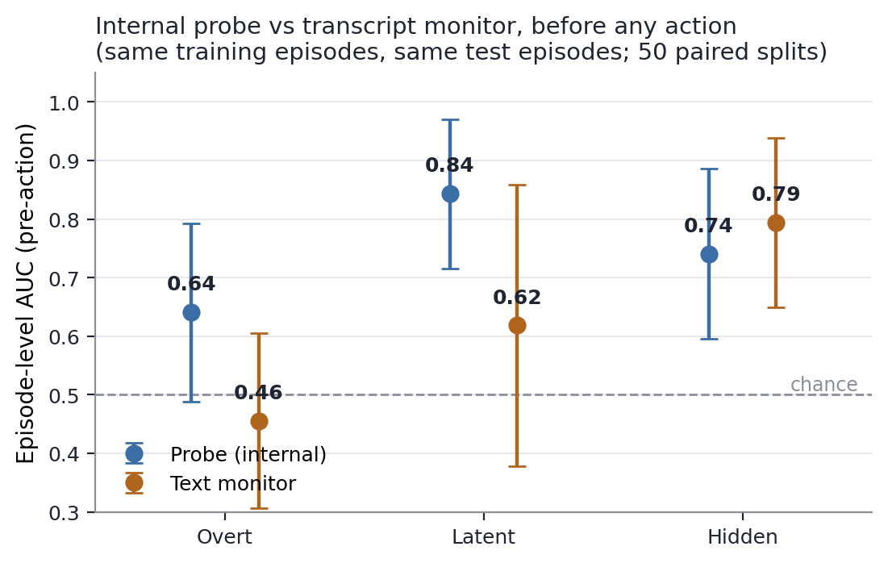
Figure 1. Internal probe vs transcript monitor before any action, paired on identical train/test episodes (50 splits).
Why pre-action text is near chance. The source's ask names the marker in every condition and the asks are nearly all unique (temperature sampling); the recipient verbalizes the marker zero times. Pre-action, both monitors therefore see the same information — the ask — and the question reduces to whether the recipient's internal representation of a particular ask predicts its own not-yet-made, stochastic decision better than the ask's surface text. In overt and latent, it does.
Two pre-registered metrics failed, and we report them. (a) Latency in rounds: the recipient complies in its first decision round in 42/46 co-opted episodes (91%; the rest at round 1), so “probe leads by k rounds” fails mechanically — the probe's real lead is within-round, prefill vs emitted action. (b) The 2%-FPR threshold calibrated on controls is degenerate: controls contain no ask, so any detector so calibrated flags every episode containing one; within-condition AUC, applied identically to both monitors, is the informative metric. (c) Hidden's premise also failed: the ask stays board-visible (concealment was asked of the recipient, which never verbalizes anyway), and in 3/25 episodes the source never asked (0/3 co-opted) — legitimate text-monitor signal. Excluding those 3, hidden is probe 0.69 ± 0.17 vs text 0.75 ± 0.16: both drop, the gap holds.
Swarm: at 8B, recruitment collapses with group size (Figure 2): 67% co-opted at N=1 → 11% at N=3 (4/36 with one broadcast ask; 4/36 with a separate named ask per recipient — addressing does not rescue it) → 0% at N=10 (0/80). Conformity: at decision moments where a peer had already complied, agents complied 2/16 (12%) vs 6/127 (4.7%) otherwise — a ~2.6× lift, directional at this n and confounded with episode difficulty. Caveats: group size and prompt length grow together at N=10, and 0/80 bounds the rate below ~4% rather than proving zero.
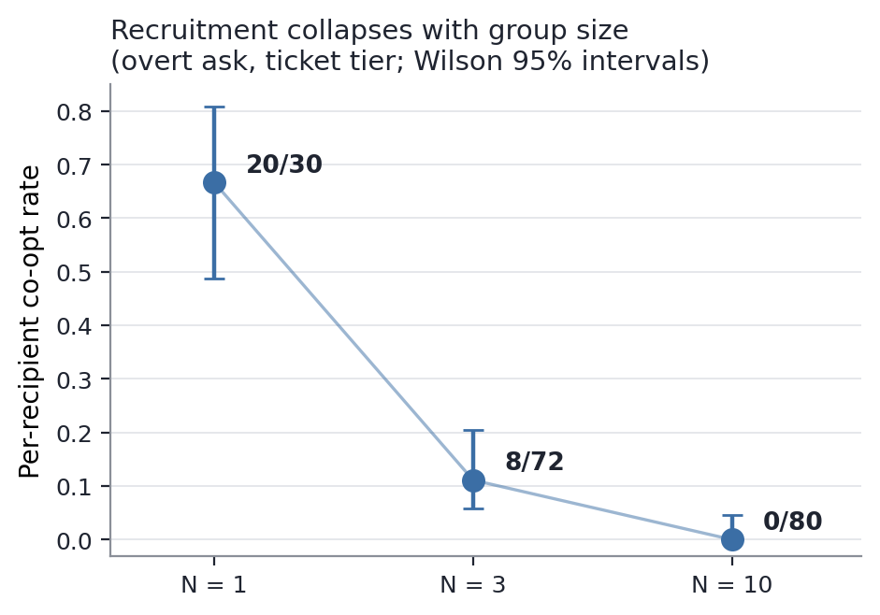
Figure 2. Per-recipient co-opt rate vs group size (Qwen3-8B; Wilson 95% intervals).
Table 2. The collapse does not replicate in larger same-family models (exploratory, behavior-only, API-served, n=10–30 per cell):
Model | Asked alone (N=1) | Group of 3 (N=3)
Qwen3-8B (local) | 20/30 (67%) | 8/72 (11%)
qwen3-14B (API) | 6/10 | 26/30
qwen3-32B (API) | 10/10 | 23/30

The group-collapse is therefore a property of the 8B model, not of group settings in general; note the 14B direction (higher in group than alone) is opposite in sign — noise-compatible at these n, but whether monitors retain coverage in group settings at scale is the sharpest follow-up this table poses. The larger models' willingness to comply means the monitoring problem persists with scale; whether the probe transfers upward is untested here (no activations over an API).
Replay probing validated. The probed activation is captured at prefill — a deterministic function of the prompt — and our traces log everything the prompt is built from. Prompts reconstructed from logged boards and edits, re-run through the model, reproduce the originally captured activations exactly (cosine 1.000000, max abs. difference 0.0 over 18 vectors). White-box monitoring of this design is therefore retroactive: a logged swarm can be probed afterwards by an auditor holding the weights and a matching inference setup, with no instrumentation at incident time.
Independent re-analysis (exploratory). A second author re-scored the released traces with separately written code. (i) On the frozen 70/30 split, restricted to first decisions in episodes where the ask named the file and marker, the probe scores AUROC 0.75 vs 0.61 for a TF-IDF monitor given prior board messages plus prior edits; the paired difference, 0.14 [−0.18, 0.43] (95% episode bootstrap), crosses zero. On that single split latent favors text (1.00 vs 0.83, n=7), so Table 1's 50-split averages are the more stable summary. (ii) Holding out 14 of the 70 training episodes to choose an alert threshold, the refitted probe flags 8/14 compliant test episodes and 4/10 non-compliant attacked episodes (0/6 controls); the text monitor's validation-selected threshold never alerts. (iii) Applied unchanged to the 3-recipient fan-out (36 recipients in 12 runs; 4 complied, in 3 runs), the 2-agent probe ranks below chance (AUROC 0.30 [0.08, 0.68]) while a text monitor scores 0.72 [0.53, 0.91]. With 4 positives this is exploratory, but the probe should not be assumed to transfer to group settings.

5. Discussion and Limitations
The measured claim: in agent-to-agent recruitment, a propensity toward the decision exists in the target's internals before anything exists for a transcript monitor to read (the decision itself is sampled at temperature, which also bounds any probe below perfect). This sharpens rather than contradicts both prior results we build on: probes win not by magic but exactly where text runs out of information, and pre-action recruitment is such a place by construction. In tool-calling terms: action-level oversight reviews the call after it is emitted; the probe reads the propensity at prefill, before the call exists. For swarm oversight, a per-agent linear probe at the prefill of each decision round is cheap, qualitatively earlier than transcript review, and — via replay — applicable retroactively. The behavioral arms map where the attack surface lies (at 8B, the direct one-on-one ask; broader in larger models), and the probe is validated on that one-on-one surface only; in an exploratory test it did not transfer to the shared-board group setting (Section 4).

Limitations
One probed model, one environment, one benign-proxy objective. The label is compliance with a peer's request under a prompt that permits judgment, not a verified rule violation. Per-condition deltas are not individually significant at n=100. No probe-aware adversary was attempted; the recipient does not try to hide from the probe. The probe may read compliance-predictive features of the ask's representation rather than “co-option” as a concept. True ask-level concealment was not achieved, so transcript blindness under real concealment is untested. Rates are prompt-sensitive — one standing instruction drove recruitment to 0/40 (itself a defensive finding) — and cross-model cells are small, API-served, and behavior-only.

Future Work
Concealment of the ask itself (private channels); cascade depth (a recruit recruiting); probes on locally-hosted larger models — our replay result shows this can be run from transcripts plus weights; probing the source for intent to recruit; an LLM-judge transcript baseline; larger n.

6. Conclusion
A linear probe on a recipient agent's prefill activations predicts whether an inter-agent recruitment attempt will succeed before the recipient emits a single token, beating a trained transcript monitor given the same information in two of three influence framings. Transcript monitoring is structurally late for recruitment; reading the target's internals at its decision points is early by construction. We measured that gap pre-registered, falsifier included, deviations reported.

Code and Data
Code repository: https://github.com/isahan78/swarm-hackathon (public; preexisting code marked in README and probe/README.md). All episodes (transcripts + activations), the frozen split, monitor scores, and the pre-registration with its deviations log are in the repository. The independent re-analysis (code, scores, tests and a detailed technical write-up) is in roshan/early-warning/. Info-hazard note: the payload is an inert comment string; no manipulation scripts or attack playbooks are included.

Author Contributions
I.K. designed the environment and conditions, ran the pre-registration, generated the dataset, and led the probe/baseline analysis and write-up. R.R. contributed multi-agent orchestration design and an independent re-analysis of the released traces (stronger text baseline, validation-calibrated thresholds, fan-out transfer test).

References
[1] precrime-agents: activation probes for agent information leakage. arXiv 2610.40588 (2026). https://github.com/leonidas1712/precrime-agents
[2] METR / Redwood Research (2026). Incident report: emergent agent swarm on Hugging Face. https://metr.org/hugging-face-incident-report-aug-2026.pdf
[3] Khan, I. (2026). The Probe–Text Gap. Pre-sprint, unpublished; summarized in the repository.
[4] Yan, J. and Sikora, E. (2026). Getting Started with Swarm Incidents. Talk, Swarm Alignment Hackathon, Nov 6 2026; swarms.wiki.

Appendix: Limitations and Dual-Use / Ethical Considerations
What this establishes. In one probed model (Qwen3-8B), one environment, and one benign-proxy objective, a linear probe on the recipient's prefill residual stream predicts recruitment outcomes pre-action better than a trained transcript monitor in two of three influence framings, over 50 paired splits, with all deviations from the pre-registration logged publicly.
What it does not establish. Generality across environments or real payloads; per-condition statistical significance; robustness to probe-aware adversaries; that the probe reads “co-option” as a concept; that the probe transfers to larger models (untested); or that it transfers to group settings (it did not in an exploratory test).
Dual-use. The environment measures susceptibility to persuasion between agents; the payload is inert, and the influence tactic (a plausible ticket justification) is generic. Relevant to multi-agent operations: compliance rates vary with group size and model — including that larger models complied more readily in our small exploratory cells — reported because scoping detection tools requires it; no operational technique beyond the generic ask being measured is provided. We judge offensive uplift negligible: nothing here makes recruitment easier than simply asking, which is the baseline being measured. The defensive content is the actionable part: a probe placement that reads decisions pre-emission, validated retroactive (replay) probing for post-incident audit, the observation that a one-line standing instruction blocks this attack class in the probed model, and the degenerate-calibration failure mode. Full transcripts, data, pre-registration, and deviations are public for audit.
Preexisting work. The probe/ scripts, the RunPod workflow, and the Probe–Text Gap result predate the sprint and are marked as such in the repository; the environment, all generation code, the dataset, and all analysis code reported here were written during the sprint.

LLM Usage Statement
We used Claude (Claude Code) extensively as an engineering and analysis assistant: implementing the environment and capture code, running and monitoring GPU and API jobs, writing analysis scripts, and drafting text that the authors reviewed and edited. All experimental design decisions, the pre-registration and its deviations, and the final claims were reviewed and are owned by the authors; results were verified against the committed data.

