EDGE AI:   
Cloud, AI, Data Business Plan

Created by

Isa Hunter, COO/CTO

### Contents

Introduction 3

Executive Summary 5

Business Description 6

Market Opportunity 8

Product and Services Offerings 20

Marketing & Sales Strategy 23

Operations 30

Financial Projections 32

Management Team 38

Appendices 40



## Introduction

Writing a business plan for your new Cloud business, your parent company spinoff, your newly-merged organization or your new business practice can be a daunting task. We hope this business plan template will guide you through this process, and will help you to effectively crystalize and articulate your vision so that you can share it with others.



### Statement of Confidentiality & Non-Disclosure

This document contains proprietary and confidential information. All data submitted to [INSERT RECEIVING PARTY] is provided in reliance upon its consent not to use or disclose any information contained herein except in the context of its business dealings with EDGE AI INC. The recipient of this document agrees to inform its present and future employees and partners who view or have access to the document's content of its confidential nature.

The recipient agrees to instruct all employees that they must not disclose any information concerning this document to others except to the extent that such matters are generally known to, and are available for use by, the public. The recipient also agrees not to duplicate or distribute or permit others to duplicate or distribute any material contained herein without EDGE AI INC's express written consent.

EDGE AI INC retains all title, ownership and intellectual property rights to the material and trademarks contained herein, including all supporting documentation, files, marketing material, and multimedia.

BY ACCEPTANCE OF THIS DOCUMENT, THE RECIPIENT AGREES TO BE BOUND BY THE AFOREMENTIONED STATEMENTS.

### Executive Summary

EDGE AI INC. is a pioneering enterprise in the realm of artificial intelligence, dedicated to integrating AI solutions into everyday business operations to drive innovation and efficiency. Our existence is anchored in the belief that AI is not just a technological advancement but a transformative force that can redefine industries. Our core values revolve around innovation, integrity, and inclusivity, with a purpose to democratize AI technology, making it accessible and beneficial for all sectors. As a new division, we leverage the expertise of a seasoned management team with a track record of success in technology startups, AI development, and business strategy.

Our offerings encompass a suite of AI-driven products and services tailored to the needs of modern businesses. These include state-of-the-art business applications, cloud infrastructure, data platforms, and custom development, all infused with the power of artificial intelligence. We also provide comprehensive professional and managed services to ensure seamless integration and operation of our solutions. Our products are designed to address the pressing challenges of data analysis, automation, and predictive modeling, thereby enhancing decision-making and operational efficiency for our clients.

The market for AI solutions is vast and rapidly expanding, with EDGE AI INC. positioned at the forefront of this growth. We target a diverse range of industries, including healthcare, finance, retail, and manufacturing, where the demand for intelligent automation and data insights is surging. The global AI market is projected to reach billions of dollars in the coming years, with an impressive annual growth rate, signaling a robust and lucrative opportunity. Our go-to-market strategy is multifaceted, encompassing direct sales, online platforms, and a network of resellers and distribution channels to maximize reach and impact.

EDGE AI INC. stands at the forefront of the artificial intelligence revolution, offering cutting-edge solutions that redefine the competitive landscape of AI technology. Our competitive advantage lies in our proprietary algorithms and first-to-market software, which not only streamline deployment but also ensure ease of integration with existing systems, providing unparalleled value to our clients. We have identified a critical gap in the market for intelligent automation, and EDGE AI INC. is uniquely positioned to address this need with our innovative products that deliver tangible efficiency gains.

Our revenue model is based on a SaaS subscription service that offers continuous updates and support, ensuring our solutions evolve alongside our clients' needs. We are vigilant in monitoring market pricing to remain competitive while also mitigating risks through rigorous product testing and a seasoned management team adept at navigating the fast-paced tech landscape.

Financially, EDGE AI INC. is seeking an investment to accelerate growth and solidify our market position. We project robust sales and a clear path to profitability within the next fiscal year, driven by our strategic market approach and the increasing demand for AI-driven solutions. To date, significant investments have been made into product development and market research, laying a solid foundation for future success and ensuring a strong return for our investors and stakeholders. EDGE AI INC. is not just a company; it's a visionary enterprise ready to lead the AI charge and deliver on the promise of tomorrow's technology, today

### Business Description

EDGE AI INC (EDGE AI or Company), established in May 2024 and headquartered in Casper, Wyoming, is a pioneering corporation in the field of artificial intelligence. As a legally incorporated entity, we have swiftly grown to a team of dedicated professionals, focusing on innovative AI solutions. Our product suite includes cutting-edge AI software and cloud services, designed to empower businesses with smart technology. With a vision to lead the AI revolution, our goals are set on expanding our reach and enhancing our offerings within the next five years. Our strategic partnership with Microsoft AI Cloud Partner Network, participation in the ISV Success and Black Partner Growth Initiative, and our role as an Indirect Reseller of Azure Cloud Services through Insight, a Channel Partner, underscore our commitment to excellence and growth.

We recognize a significant opportunity in addressing the lack of efficient, scalable AI solutions in the market. EDGE AI is positioned to meet this demand, providing high-value services that organizations are eager to invest in for their strategic development. Our revenue model is based on a subscription service, offering scalable solutions at competitive market prices. We are aware of the risks associated with product development and market competition, and we plan to mitigate these through continuous innovation, rigorous market analysis, and agile management practices.

Financially, EDGE AI is seeking initial capital to accelerate our market entry and product development. We project robust sales and profit margins that will not only sustain our business model but also provide attractive returns for our investors. Profitability is forecasted within the first three years of operation, thanks to our strategic partnerships and market positioning. To date, significant investment has been made into the company, focusing on research and development, ensuring that EDGE AI INC remains at the forefront of AI technology. Our financial strategy is designed to support our ambitious goals and ensure long-term success and stability.

Specifically, EDGE AI aims to:

* generate 20 new subscription license users by May 2025
* develop new monthly recurring optimization services, resulting in net new service revenues
* achieve $10 million in annualized revenues by 2026

#### **EDGE AI - Global Enterprise Cloud Management Software: Cloud Lens Studio**

Cloud Lens Studio (CLS) represents a significant advancement in the field of cloud management software, offering a comprehensive suite of tools for enterprise cloud environments. As a SaaS subscription-based web application, CLS provides a unified interface, often referred to as a Single Pane of Glass, which streamlines the user experience and enhances productivity. The use of the MXGraph JavaScript Library in its design allows for a highly interactive and customizable GUI/GUX, catering to the diverse needs of users. 

The integration of Generative AI within CLS is a testament to the innovative approach to infrastructure management. By leveraging the Azure SDK for JavaScript and the Azure Resource Manager REST API, CLS can automate a wide range of tasks, including deployment, configuration, and management. This automation extends to monitoring, governance, security, and cost-optimization, ensuring that enterprises can manage their cloud resources efficiently and effectively.

The ability to generate Infrastructure as Code (IaC) is a key feature of CLS, enabling users to define and provision their infrastructure through code, which can be versioned and reused, leading to more consistent and reliable environments. This approach aligns with the industry's best practices and supports the DevOps philosophy of continuous integration and delivery.

CLS's use of Generative AI also means that it can learn from patterns and usage to suggest optimizations and improvements, further enhancing the management capabilities of the software. This self-improving system can lead to significant cost savings and performance enhancements over time. 

In the rapidly evolving landscape of cloud computing, tools like CLS are invaluable for enterprises looking to maintain a competitive edge. The ability to manage complex cloud environments with ease, automate routine tasks, and optimize resources dynamically is crucial for businesses operating at scale.

As the demand for edge computing and AI integration continues to grow, solutions like CLS will become increasingly important. They not only provide the necessary tools to manage infrastructure but also offer the insights and automation required to adapt to changing business needs swiftly.

Cloud Lens Studio is a powerful ally for any enterprise seeking to harness the full potential of cloud computing. Its robust design, combined with cutting-edge AI capabilities, positions it as a leader in cloud management solutions, ready to meet the challenges of today's dynamic and demanding digital landscape.

#### Core Values

EDGE AI, as part of the Microsoft AI Cloud Partner ecosystem, emphasizes core values that align with transformative technology and partnership growth. These values are derived from the principles outlined in the Microsoft AI Cloud Partner - AI and Data Playbook and reflect a commitment to innovation, security, and collaboration. The core values include:

* **Innovation**: Encouraging continuous technological advancement and creative solutions.
* **Expertise**: Building deep technical knowledge and capabilities in AI and data science.
* **Security**: Prioritizing the protection of data and AI systems against evolving threats.
* **Collaboration**: Fostering strong partnerships and co-development opportunities.
* **Growth**: Driving business expansion and market competitiveness through AI adoption.
* **Customer Focus**: Aligning AI solutions with customer needs and industry demands.
* **Ethics**: Upholding ethical standards and responsible AI practices.
* **Accessibility**: Ensuring AI technologies are inclusive and accessible to all.
* **Agility**: Responding swiftly to market changes and customer feedback.
* **Sustainability**: Promoting environmentally sustainable AI practices and solutions.

These values guide partners in creating AI services and edge devices that not only transform businesses but also contribute positively to society and the global economy. For a comprehensive understanding and application of these values, partners are encouraged to refer to the Microsoft AI Cloud Partner Program Playbook and the AI Transformation Partner Playbook, which provide detailed guidance on building successful AI-based practices.



### Cloud Opportunity

EDGE AI INC operates within the rapidly evolving edge AI market, which is structured around key components such as hardware, software, edge cloud infrastructure, and services. The industry is experiencing significant growth, with the global edge AI market size valued at USD 14,787.5 million in 2022 and projected to expand at a CAGR of 21.0% from 2023 to 2030. This growth is driven by the increasing use of edge AI applications across various sectors, including healthcare, automotive, and manufacturing, to name a few.

#### **Industry Analysis**

The industry is highly sensitive to technological advancements and economic cycles, with profitability hinging on the ability to innovate and scale solutions effectively. Seasonality has a lesser impact on this sector compared to consumer-driven markets. Key drivers include advancements in IoT, 5G technology, and the need for low-latency processing and real-time decision-making capabilities.

#### **Industry Trends**

Current trends affecting the edge AI industry include the integration of AI with IoT devices for smarter solutions, the surge in demand for privacy and data security, and the shift towards decentralized processing to address latency issues. The ongoing deployment of 5G networks is also a significant trend, enhancing edge AI capabilities by providing high-speed, low-latency communication essential for real-time analytics and decision-making.

#### **Market Analysis**

Economic factors such as investment in technology infrastructure and political factors like government regulations on data privacy significantly impact the industry. Social and cultural shifts towards remote work and telemedicine, demographic changes like urbanization, and environmental concerns are also influencing market dynamics.

EDGE AI INC's specific market is characterized by its focus on providing edge AI solutions that prioritize real-time data processing, privacy, and security. Important developments within this niche include the creation of more efficient and compact hardware, software that can process complex AI algorithms locally, and services that support the deployment and maintenance of edge AI systems. 

#### **Competitive Analysis**

In terms of competition, EDGE AI INC faces challenges from well-established companies with robust cloud solutions, significant capital, and market share. The competitive landscape is marked by a mix of startups and large corporations, with competition intensity varying based on innovation, market penetration, and technological capabilities. Strategic partnerships, mergers, and acquisitions are common, reflecting a trend towards consolidation in the industry.

To effectively compete, EDGE AI INC must leverage its marketing strategy, product superiority, company reputation, capital resources, expertise, and industry relationships. A competitive analysis table would compare EDGE AI INC with its top competitors, focusing on these aspects and evaluating market share, capital investment, cloud solutions, and overall market presence to identify areas of strength and opportunities for growth.

### SaaS Opportunity

|  |  |
| --- | --- |
| 19.7% | Global SaaS marketplace  Comppound Average Growth Rate |

The evolution of SaaS has been driven by changes in buyer demand and expectations, combined with advancements in Cloud technology.

|  |  |
| --- | --- |
| $1,298.92 | Forecasted size of Global SaaS  marketplace by 2030 |

The benefits of SaaS to EDGE AI will be lower development and support costs, streamlined sales cycles, unified deployment environments, and new, data-driven insights into customer behavior.

The SaaS (Software as a Service) model is revolutionizing the way Independent Software Vendors (ISVs) operate, offering a plethora of opportunities for growth and innovation. With the global SaaS market projected to reach USD 1,298.92 billion by 2030, growing at a CAGR of 19.7%, ISVs are poised to tap into a lucrative and expanding market. The transition to SaaS enables ISVs to deliver applications via the cloud, freeing them from the constraints of on-premises legacy systems and allowing for scalability and rapid innovation. This shift not only supports existing customers but also attracts new ones, broadening market reach and enhancing competitiveness.

The benefits of adopting a SaaS model are multifaceted. It allows for agility in operations, fostering an environment where innovation can thrive. ISVs can benefit from a subscription-based pricing model, which provides a more predictable revenue stream compared to traditional software sales. Moreover, the cloud-based nature of SaaS applications offers the advantage of centralized security management, real-time updates, and improved application performance monitoring.

For ISVs, the move to SaaS is not just about technology transformation; it's a strategic business decision that requires careful planning and execution. Developing a clear vision and strategy for SaaS is crucial, as it ensures that all business and technical challenges are considered and addressed. It's essential for ISVs to validate their assumptions with data to avoid starting with a skewed vision and to ensure that their goals are achievable.

The SaaS model presents a high-value opportunity for ISVs to fundamentally transform their business, deliver greater value to customers, and streamline internal operations. By embracing SaaS, ISVs can increase their market presence, adopt agile processes, and drive growth at scale. As the market continues to evolve, ISVs that successfully navigate the SaaS transformation journey will likely emerge as leaders in the new era of software delivery

### Key Benefits of the SaaS Model

The SaaS subscription model offers a multitude of advantages for Independent Software Vendors (ISVs), fundamentally transforming their business operations and market approach. One of the primary benefits is the ability to tap into new market segments and geographies, thanks to the broad reach of cloud-delivered applications. This model also allows for the generation of predictable, recurring revenues, which is crucial for financial stability and forecasting. Moreover, the agility afforded by SaaS enables ISVs to innovate rapidly, deploying new features and updates efficiently to meet the evolving needs of their customers.

Operational efficiency is another significant benefit, as SaaS allows for real-time, automatic updates and centralized security management, reducing the complexity and cost of infrastructure maintenance. The shift to SaaS also aligns with the growing market demand for software solutions that offer flexibility, ease of use, and lower total ownership costs. Financially, the transition to a SaaS model can lead to an increase in the proportion of recurring revenue, enhancing the predictability and reliability of financial performance.

Furthermore, SaaS pricing models offer the flexibility to align more closely with customer usage and business needs, potentially driving increased revenue for ISVs. The collection and analysis of product usage data through the SaaS model enable ISVs to gain detailed insights into customer behavior and preferences, which can drive focused product development and rapid improvement of offerings. This data-driven approach can significantly speed up the development process, making it more responsive to market demands.

In summary, the SaaS subscription model for ISVs is not just a trend but a strategic move that can lead to sustainable growth, enhanced customer value, and a competitive edge in the rapidly evolving software industry. By embracing SaaS, ISVs position themselves at the forefront of innovation, leveraging the power of the cloud to deliver superior software solutions and services.

Unlock new customer segments



* + Lower customer adoption costs
  + Lower operating costs
  + Reduce technical requirements
  + Lower cost to serve

75%

installation time reduction

30%

savings on system costs

|  |  |  |
| --- | --- | --- |
| Reduce complexity and lower customer TCO | Integrate new cloud services | Leverage aggregated data |
| * Reduce upfront infrastructure costs * Eliminate ongoing customer   support costs | * Deliver fuller features and capabilities * Improve capabilities without   diverting dev resources | * Derive new customer insights from usage data * Develop and optimize at   scale |

50%

integrated cloud-based services into product

10%

improvement to algorithms

Source: Keystone, The Shift to SaaS: A High-Value Opportunity for ISVs, June 1, 2017

### Global Enterprise Cloud Management Software Market

The Global Enterprise Cloud Management Software (GECMS) Market is experiencing a significant growth trajectory. As of 2021, the market was valued at USD 11.34 billion and is projected to expand to USD 85.02 billion by 2029, with a Compound Annual Growth Rate (CAGR) of 28.6%. This surge is attributed to the increasing demand for cloud automation, performance management, workload scheduling, and configuration management. Key market players like VMware, Inc., Microsoft Corporation, and IBM Corporation are pivotal in providing these services, which are essential for organizations to manage and monitor cloud operations effectively. The COVID-19 pandemic has further accelerated this growth, as businesses sought cloud-based solutions to maintain continuity in the face of unprecedented challenges. The market's expansion is also fueled by strategic collaborations and investments, such as the agreement between Splunk, Inc. and Google Cloud in May 2020, which aimed to unlock valuable insights from data and enable real-time visibility across enterprises. With North America holding a dominant market share, the enterprise cloud management software market is set to create significant opportunities for market players globally.

### Industry Analysis

EDGE AI’s target vertical industry is the freight transportation industry. This industry is forecasted to grow by over 74% between 2014 and 2022 in the United States9. The trucking industry – especially in North America – will be transformed with the entrance of newer and cheaper technology solutions. These solutions will drive efficiencies while increasing safety and accountability throughout supply chains. Massive change will occur in the freight transportation industry, and concurrently in the freight software industry, as companies adopt mobile, Cloud applications.

The trucking and freight transportation industry is extremely large. Approximately 70% of all freight in North America is moved by truck. It is estimated that US freight tonnage will increase by 28.6% by 2026. This will result in a commensurate increase in revenues of 74.5%10.

###### The Transportation Management Software (TMS) Market

The TMS market is large and diverse. The North American TMS market leads the world due to advancements in transportation, technical, and financial network infrastructure. This infrastructure was built over the past century, connecting over 350 million people geographically, via the Internet and throughout numerous financial networks. The estimated value of this market is $9.2 billion.11 The global TMS market is expected to grow from $9.22 billion to $19.0 billion by the end of 2020, at a compound annual growth rate (CAGR) of 15.6%.12

TMS growth highly correlates with the continued and anticipated growth of freight volumes and revenues around the world. With an increasingly interconnected world, the industry will benefit from the efforts of optimized supply chains – driving out inefficiencies and creating additional wealth for its participants.

9 Ibid.

10 Ibid.

11 Transparency Market Research, [http://www.transparencymarketresearch.com/pressrelease/transportatio](http://www.transparencymarketresearch.com/pressrelease/transportation-management-systems-market.htm) [n-management-systems-market.htm](http://www.transparencymarketresearch.com/pressrelease/transportation-management-systems-market.htm)

**Primary Vertical Segment**

##### Freight Transportation Market Size & Business Pain

According to the American Trucking Association (ATA), revenues were over $726 billion in 2015, with the industry responsible for transporting 81.5% of the freight in the United States. There are approximately 1.2 million freight transportation companies in the US. 97% operate fewer than 20 trucks, and 90% operate fewer than 6 trucks.

There are over 700,000 freight transportation companies with more than 1 truck, and some 4 million trucks moving freight across North America alone.

The ATA predicts that freight tonnage will increase by 35% between 2016 and 2027, with tonnage moved by trucks forecasted to grow by 27%.

It is estimated that at any given time, approximately 17- 20% of trucks are running empty across North America. They’re either waiting to be loaded, travelling empty trying to find another load, or backhaul trucking. In the same way that passenger airlines gain profitability with full planes or train operators increase their yield through better operating ratios, a trucking company that keeps its rolling stock in motion at full or near-to-full capacity maximizes its profitability. Big gains can be made in small increments with a tightly run operation.

While there is some concern due to recent changes in the political landscape in the United States and in other countries around the world, it is important to understand that organic economic expansion is to be expected, this fueled by population growth.

In the US alone, it is forecasted that freight volume will increase by 40% over the next 30 years, driven by a projected population increase of 70 million people (Beyond Traffic 2045 report, recently released by the US Secretary of Transportation).13

###### Secondary Vertical Segment

12 Ibid.

13

[https://www.transportation.gov/sites/dot.gov/files/docs/B](https://www.transportation.gov/sites/dot.gov/files/docs/BeyondTraffic_tagged_508_final.pdf) [eyondTraffic_tagged_508_final.pdf](https://www.transportation.gov/sites/dot.gov/files/docs/BeyondTraffic_tagged_508_final.pdf)

##### Third Party Logistics (3PL) & Brokerages

EDGE AI’s second primary market consists of over 16,000 freight brokerages. Predominantly located in the US, this group helps shippers optimize their supply chains through the brokering of shipments amongst competing trucking

suppliers. The trucking industry was deregulated in the 1980s during the Reagan administration. This served as a springboard for the freight brokerage industry, with the emergence of third-party logistics (3PL) companies offering unique services to shippers across the continental US and beyond.

**Freight Companies – North America**

|  |  |  |  |  |  |  |
| --- | --- | --- | --- | --- | --- | --- |
|  | Businesses  US CA | | Revenue USD Billion US CA | | Annual Growth 11-16  US CA | |
| Freight Forwarding Brokerages & Agencies* | 40,427 | 3,434 | 123 | 6 | 5.3% | 1.9% |
| Local Freight Trucking | 209,636 | 24,850 | 41 | 9 | 1.6% | 0.7% |
| Long-Distance Freight Trucking | 362,726 | 22,111 | 185 | 20 | 2.4% | 0.2% |
| Local Specialized Freight Trucking | 56,595 | 10,019 | 42 | 8 | 3.7% | -0.9% |
| Tank & Refrigeration Trucking | 16,633 | 7,591 | 37 | 11 | 4.1% | 0.0% |
| Long-Distance Refrigerated Trucking | 1,788 | - | 6 | - | 3.3% | - |
| Total Number of Businesses | **755,810** | | | | | |



### Industry Trends

**There are many industry trends that are aligning to provide EDGE AI with several opportunities.**

**The ‘Uber-ization’ of the Trucking and Freight**

**Transportation Industries**

A confluence of factors – mobile technologies, online applications, the ‘Internet of Things’ (IoT) – are expected to transform the freight industry. These factors will allow small to medium-sized freight businesses to compete more effectively with the large, integrated freight carriers through the application of new, more nimble technologies. These flexible, less expensive technologies will allow niche players like EDGE AI to participate in a very large and growing marketplace, one that’s forecasted to grow by 74% over the next 8 years.

There are significant opportunities for TMS providers such as EDGE AI to capture and serve this profitable, large market and growing marketplace. They’ll sell and distribute newer, more mobile, and more affordable technologies to companies that previously found the costs untenable. New TMS systems that are more open and connected into other data sets – Financial, GPS, Regulatory, and Fuel Management – will give companies richer, more detailed insight into their operations. TMS helps companies refine their offerings while optimizing their business.

TMS enables small-to-medium players in the freight industry to find, protect, and own profitable niches in the marketplace. Over the longer term, it will allow them to grow their businesses and build momentum. They’ll challenge the hegemony of some of the largest freight companies in North America, who are either unwilling or unable to quickly adopt these new technologies.

###### Customers – Changing Demographics

The ‘New Kids on the Engine Block’



A significant transformation is occurring, a younger generation – one much more comfortable with the Internet and smart phones – is inheriting or taking over operations of established firms. Many trucking and freight operations today materialize via pen and paper, and through the power of a handshake.

This younger buyer is much more attuned to the possibilities of technology and understands that, in addition to helping streamline the business, it can also provide significant competitive advantage in a highly commoditized market. A substantial portion of the industry – some with 75 trucks or more – still operates on either a paper-based system, or more commonly, a combination of paper and Excel spreadsheets. As this younger demographic takes over from their parents, they will demand more user-friendly, easier-to-use technologies that are accessible online and on their mobile devices.

###### Regulatory & Compliance Issues

The regulatory environment plays a significant role in the industry. In the United States, the Federal Motor Carrier Safety Administration (FMCSA) implements and enforces policies developed by the Federal Department of Transportation (DOT), within the legislative framework provided by Congress.

Companies strive to minimize the costs of complying with industry regulations. To this end, they need automation solutions that track information in a centralized database – a transportation management software system – that is accessible and that can provide analytics and reporting.



###### Hours of Service (HOS) – Electronic Logging Device – Mandate

The Hours of Service mandate came into effect in December 2017. It required trucking companies to have an electronic logging device in every truck by that time. TMS systems need to be integrated with these electronic logging devices to comply with such Department of Transportation rules.

###### US Federal Department of Transportation (DOT) Audits

Trucking companies are at risk of temporary or permanent suspension if they do not comply with federal regulations associated with their equipment, driver certifications and driving behavior. These audits can be time consuming for many companies. One of the biggest challenges for smaller trucking companies is having the time and the ability to assemble all the information of DOT audits, not to mention the fear of suspension. TMS systems help companies save time in assembling the data, and can minimize the risk of non-compliance.

###### Food Safety Modernization Act (FSMA) – Federal Drug Administration

Under the auspices of the FDA, the FSMA was enacted in 2011. It regulates the transportation of human and animal food. Its goal is to protect foods from contamination while travelling from ‘farm to table’. Refrigerated trucks play a key role in this supply chain – yet only the biggest trucking companies are able to provide detailed data on tracking of the temperature and location of each truck.

New technologies are emerging in the marketplace, which TMS systems will tap into. These present opportunities for smaller niche players to offer services traditionally provided by the bigger players. These new entities will capture pieces of the market by specializing either in a particular commodity/product, in a geographic region, or in customer/shipper type.

###### Driver Shortages – Advent of Self-Driving Trucks

The average long-haul truck driver has a physically demanding job, has to travel great distances away from home and family, and has to deal with his/her personal safety both on and off the road. Men comprise 97% of the industry, and the average truck driver is 57 years of age.

With the aging demographic and lack of qualified, professional truck drivers, the industry foresees the advent of driverless trucks. While this technology is still in the distant future, it does speak to the ever-increasing automation in the industry and new opportunities for EDGE AI.

Newer trucks are also increasingly embedded with GPS and ELD systems; hence, the ‘Smart Truck’ is becoming a reality and EDGE AI will pursue developing or licensing new offerings to take advantage of this trend.

###### Optimization of Supply Chains and Operations –

**Big Data, Business Intelligence (BI)**

With so many moving parts in a freight transportation company and so many dynamics to monitor, increasing returns to scale will accrue only for players who generate unique insight into their operations and their markets. In other words, those who ‘know more’ and ‘know it more quickly’ will be the winners. For logistics and brokerage providers, it’s essential to make prudent business decisions about their product/services offerings, the customers they serve, and the markets in which they operate.

Trucking companies can optimize their operations through analyses of their customers, their freight, their lanes, their equipment, their drivers, etc. Companies will seek more detailed and nuanced information about their businesses, striving to unlock value that may have been trapped in their operations. EDGE AI is therefore also investing development resources into business intelligence and data analytics solutions and services.

###### Industry Consolidation

With an increasing regulatory environment, growing customer demand, management of fuel, labor and insurance costs, as well as greater consolidation in the trucking industry, some players simply won’t be able to compete. The freight transportation industry is evolving quickly. TMS providers will need to build platforms that provide quicker ‘just in time’ features and services that will respond to the changing market conditions and needs of their customers.





### Market Analysis

###### New ‘App’ Entrants

A number of emerging smaller players are building ‘great apps’, and are attempting to become the next ‘Uber’ for the trucking industry. However, they’re finding that the complexity of supporting diverse customers, understanding the unique business processes and running a successful software business presents many challenges.

It’s evident that while these companies have developed some promising applications, they have not yet incorporated the unique business insight required. Also, these companies haven’t surrounded their online software with the necessary operational infrastructure.

###### Client Server Systems in Decline

Many of the large, existing TMS installations will gradually decline over the next few years. Meanwhile, those who support these installations will retire or potentially go out

of business if they do not keep up the customers desire to move to the cloud and purchase software as a service.

While the Tier 0 and Tier 1 trucking and logistics companies may continue to invest in fully customized, on- premise solutions, the mid-market will continue to rapidly move to the Cloud over the next 12 to 24 months.

###### ‘Software-as-a-Service’ Emerging

The year 2016 was the turning point when many computer applications were delivered via a ‘Software-as-a-Service’ (SaaS) business model. The trend towards SaaS is expected to continue unabated. While the general trend in all software markets is the movement from client server to hosted online (Cloud) applications, the TMS industry has been slow to adopt this new technology in the past. Early adopters are now beginning to actively move to Cloud- based Software-as-a-Service solutions, which will help them minimize their initial capital investment, gain agility, scale and secure a competitive advantage.

### Competitive Analysis

There is currently no dominant player in the industry. The market is fragmented and served by several players.

There are three types of competitors in the market:

1. Large Multi-Faceted TMS Providers

There are large, multi-faceted, heavily-integrated TMS systems that run a 250+ truck operation, offering all of the components necessary for performance, compliance, and business intelligence. These are predominantly client server-based systems that have been customized for individual companies. They follow a traditional on- premise licensing model, with an initial investment of hundreds of thousands, and often millions of dollars for licensing and initial implementation. Beyond that, there are ongoing software maintenance programs. Examples of companies serving this market are McLeod and TMW.

1. Mid-Market TMS Providers

There are many vendors in the mid-market. Some are pure play software companies, while others offer a ‘resource portal’ for smaller players. For example, TruckStop.com’s software system ITS Dispatch integrates with its Loadboard, and is offered along with other services and products.

Most mid-market, competitive, TMS system vendors offer a medium level of capability with client server-based software systems. Companies included in this segment are Degama, PCS, Prophesy, Axon, Aljex, and TransPlus

Software. Many of these established players are now dealing with increasingly demanding customers who want more advanced technologies – especially EDI integrations. They are struggling to move their solutions to the Cloud, and transform their business models and processes. Many of their applications are built on older, less flexible software platforms, and are based on an economic model tied closely to maintenance revenue.

1. New Entrants – Born in the Cloud

There are many new entrants to the marketplace – some

with grandiose visions of becoming the next ‘Uber’, or

‘Truber’, for the freight industry. They have employed new development technologies, creating the types of applications the industry will need in the future. A number of these are small startups with limited industry knowledge, capital or business experience, and no previously installed customer base.

One entrant that has stronger technology and looks to be a solid entrant to the market is Ascend Software. This company offers an easy-to-use solution for those introducing technology in their businesses for the first time. They are backed by a venture capital company.

Ascend offers financial as well as factoring services to small trucking companies.

EDGE AI’s competitive advantage is a large installed customer base, strong industry domain expertise, and a deep, fully vertical suite of solutions that can be deployed in 30 days. EDGE AI’s functionality, extent of features, and price point are unbeatable in the industry.



### Competitive Differentiation

Relative to these competitors, EDGE AI has the following competitive differentiation:

* Market Presence: In an industry where, new entrants come and go with relative frequency, few players manage to achieve the longevity required to build true market awareness. With over 17 years of business experience (through its parent), EDGE AI has such a market presence. In the highly competitive IT industry, this market presence translates directly into an ability to source new prospects more easily and cost effectively than its competitors. EDGE AI is also better able to compete on a non-price basis, resulting in higher margins.
* Industry Expertise: A key factor in meeting customer expectations is the ability to provide industry-specific solutions,

either ‘out-of-the-box’, or by way of customization. EDGE AI has both the depth and breadth of domain expertise to successfully provide these solutions to the transportation industry.

* Ability to Scale: The EDGE AI team has many years of cumulative technology industry expertise, in addition to high-

volume sales process expertise. Unlike its competitors, the EDGE AI team knows how to package, simplify, and apply a volume selling process and strategy to the new Cloud business model. The team can quickly scale sales and marketing and shorten the sales cycle. Most other competitors are much slower to transform their current sales and marketing processes from a traditional, on-premise and perpetual license model and are weak at acquiring new cloud customers.

|  |
| --- |
| Directions: Product and Services Offerings |
| This section is an overview summary of your product and/or services offerings. You should describe the benefits secured by your target customer, and unique features or proprietary aspects of the offering (do not list every product or service offering, nor detailed features – those belong in the appendices.)  Describe:   * The value and benefits of all of your products/services in order of highest to lowest sales, or highest to lowest importance of product line; include any proprietary knowledge, IP or skills. * Your pricing strategy, costs, and profit margin for each product/services line. * The stage of growth your product/services are in (introductory, growing, mature); the stage of product/services development (existing, beta). * The unique, value-added characteristics of your offering, and how these create a competitive advantage. * How your services offering is provided – direct, through partners or contractors – and how service quality and levels are measured and maintained. * Your plans for future or next generation products – what and when. * Customer quotes. * Your product and services strategy in terms of the future offering roadmap, and the big picture context of what the offering will become.   See sample copy below & delete this table when template is complete. |

### Product and Services Offerings

###### EDGE AI Transportation Software Solutions and Services

EDGE AI’s software helps companies centralize all the data associated with running a trucking and/or freight brokerage company. Its suite of software applications and services serves as the hub of a freight business, linking the data from Operations and Administration departments, while connecting to complementary technologies.

Transportation companies must continually track data and information on all of the essential elements of the delivery: truck, trailer, driver, freight, condition of the freight, pick-up and drop-off locations, taxes, insurance, invoices, and remittances. This effort can be complex, and at times, overwhelming for these companies, especially smaller ones. EDGE AI offers these companies a fully integrated suite of solutions that address a broad set of needs.

###### The EDGE AI Software Brand

EDGE AI’s product brand “*North Star Guidance”* speaks to the small-to-medium players who cannot afford custom solutions and big capital investments in IT or servers, and who have a small or non-existent IT department. It helps those companies daunted by regulatory requirements and increasingly complex demands of shippers and customers expecting ‘just-in-time’ information on their freight. It allows small-to-medium transportation companies to compete with national and international competitors with greater capital, resources and distribution.

EDGE AI also offers Office 365 to facilitate office productivity, collaboration and mobility, thereby allowing small trucking firms to modernize their workplace.

*North Start Guidance* is designed to extend the best-of- breed Microsoft Dynamics 365 Business Central product.

EDGE AI is currently developing an IoT solution to facilitate truck and delivery monitoring, as well as a field service module to optimize routing and scheduling. Also, in development are several other Azure-based solutions to streamline and extend the core functionality of EDGE AI’s current solution in order to meet the unique needs of the

trucking and brokerage industries. EDGE AI is also actively working on a new driver safety monitoring solution.

###### Product Innovation Direction

In addition to providing its core solutions, EDGE AI will integrate with other applications on a continuous basis to build out the EDGE AI Application Eco-system. EDGE AI will place itself at the intersection of complementary Cloud technologies – by coordinating with GPS and ELD providers and others to meet the industry’s current and future needs. Connecting to or re-selling pre-built other Microsoft-based ISV solutions will also allow EDGE AI to offer a high-value, end-to-end, comprehensive industry solution to its target customers faster than competitors can. EDGE AI will also provide new offerings based on Power BI and Microsoft Azure services.

###### Services

EDGE AI supports its customers through several mechanisms – weekly live online training webinars, a Customer Success (support) group, training videos, and self-help documentation, and will continue to build out its service offering with the aim of providing customers with more automated, self-serve options and value add service offerings. EDGE AI also offers implementation services through local implementation partners in key geographic regions, and the Company plans to begin expanding globally outside the US market within the next 2 years.

In 2019, EDGE AI will develop and launch an Enterprise-level solution set leveraging the Microsoft Dynamics 365 finance and operations solution. EDGE AI will also offer a set of fixed price, packaged deployment services.

###### Development Strategy

The EDGE AI development strategy focuses on lean and agile processes, using a minimum viable product strategy to take new solutions and functionality to market with minimal investment and risk.

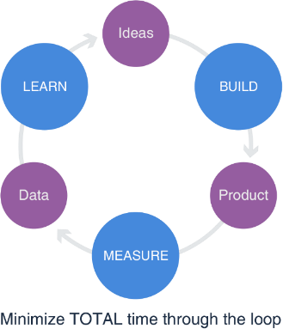Continuous development cycle:

1. New idea
2. Build
3. Measure results
4. Gain new ideas

In terms of planning:

1. Determine what we need to learn
2. Determine what metrics are required to test assumptions
3. Determine which product to build as an experiment to get metrics

The development goal with all new product and service offerings is to travel through the Build-Measure-Learn loop as quickly as possible to prove out our assumptions, and quickly identify market opportunities and new minimal viable solution offerings. We will question all assumptions in the strategy, and then design experiments that will generate data either supporting or disproving these assumptions. Experiments can involve new features, marketing A/B testing, customer interviews, etc. We then decide whether we progress with the strategy or pivot. Pivots can be big (new product, new market), medium (same product, different market), or small (feature X vs feature Y).

The vision for EDGE AI’s application suite is to put the company at the intersection of key technologies and datasets that offer small-to-medium sized trucking companies and freight brokerages the ability to compete with larger, multi-faceted competitors. The EDGE AI product pathway outlines the key integrations and functionality to be added to the application on a quarterly basis. EDGE AI will leverage existing ISV solutions where possible, and build the rest. This includes applications to address the following areas:

* Portals – customer, carrier, driver
* Compliance and safety
* GPS and Hours of Service – ELD
* ACE/ACI – automated border clearance
* Electronic Data Interchange - EDI
* Refrigeration trucks – temperature tracking and monitoring
* HR administration
* Business intelligence - BI
* CRM – enhancements and integration
* Data transfer and migration utilities
* Artificial intelligence - AI
* Internet of things - IOT
* Data Analytics

*“We were able to adapt the EDGE AI platform with ease and the learning curve was short. The system has a lot of functionality and the support we receive is excellent! We have been able to quickly scale our operations. We increased our fleet by 100% without needing to increase our head office staff count. I would definitely recommend*

*EDGE AI!”*

Alan S., VP, Pacific Trucking

*“EDGE AI has truly given our organization the capabilities and confidence to compete against multi-billion-dollar corporations and win. Thanks for doing such a great job with your team and your solution.”*

Patrick C., President, Big Solutions Freight

Services

|  |
| --- |
| Directions: Marketing & Sales Strategy |
| This section details how you will present and communicate your offering to a pre-determined market segment in a compelling and differentiated way in order to capture attention.  You will need to:   * Articulate your marketing goals. * Fully describe the market segment(s) targeted and their unmet needs. * Identify how you will position your offering to prospective users in relation to the competition. * Show how you’ll position your offering to induce channel partners to sell your solution (if applicable). * Offer a SWOT analysis of the strengths and weaknesses of your company as well as its external opportunities and threats. * Outline your pricing and provide supporting information as to why it will be effective with your target customers; explain the pricing structure - tiers and bundles. * Describe your go to market approach – sales team, online, OEM, use of VARs or distributors, referral or affiliate programs, 3rd party consultants, system integrators, online Marketplaces (AppSource, Azure) and more. * Explain how you will introduce and promote your offering to the marketplace, and what marketing mediums, tools and activities you will use.   See sample copy below & delete this table when template is complete. |



### Marketing Strategy & Sales

###### Target Market

EDGE AI currently serves trucking companies with 10-80 trucks, and freight brokerages with 10+ agents.

Additionally, EDGE AI uniquely serves those companies trying to run both at the same time – a trucking company with a brokerage division, or a brokerage business with some trucking assets.

EDGE AI is looking to aggressively expand its target market parameters to include mid-market customers. With a more robust and expanded solution offering which will offer integrations to other technologies in addition to increase capabilities, EDGE AI will increase its attractiveness and value proposition to larger customers. As the breadth and depth of the core solution increase, so too will the volume and size of its customer engagements and associated project and support services.

###### Positioning

EDGE AI is positioned at the tipping point where individual entrepreneurs or single proprietorships are ready to take the leap into expanding their business. This could be a small business of 3-5 trucks with visions of growing to 50 and beyond. On the other hand, it could be a forward- thinking broker teaming up with another broker with hopes of taking a company with two or three agents up to

15 or 20. EDGE AI offers a sophisticated software solution that allows small to mid-size companies to reach critical mass, and then scale beyond. This segment of the market is very attractive to EDGE AI, and adding new users in a SaaS model will happen at an accelerated rate due to the rapid growth and expansion of this market.

This dynamic will create divergence in the TMS software mid-market; EDGE AI will leverage its head start in the Cloud while competitors cling to their existing models, drop out, or start the long journey by themselves.

###### Sales Strategy

EDGE AI sells its solutions directly to end user customers, as well as through strategic partners.

EDGE AI employs four marketing and sales professionals. The marketing team qualifies leads and responds immediately to incoming prospective customers. Hot, qualified leads are then passed on to the sales team, who pursue these leads. Unqualified leads are placed into a three-month digital marketing nurture program (those prospects early in the decision-making cycle who are not yet ready to buy).

EDGE AI is employing an aggressive migration strategy to move its current installed base of on-premise customers to the new Cloud platform and offerings.

One of EDGE AI’s goals is to reduce the average sales cycle from the current 6 – 9 months down to 30 – 90 days. The SaaS model leads to accelerated sales by making it easier for customers to find and access EDGE AI’s trials, and explore the potential value of the product offering. Cloud marketplaces like Microsoft AppSource provide EDGE AI with a straightforward platform to showcase its software, eliminating the need for complex software demos and environments.

###### Pricing

The company’s new cloud business application is packaged and offered on-demand, on a monthly subscription basis. There are three tiered offers: Core, Pro, and Enterprise – priced at $79, $139 or $219 per user, per month, respectively. These tiers offer a successive level of capability and integration options, designed to match the

way a freight business typically grows and evolves. In addition, each tier bundles various levels of support.

Competitors charge significantly more per month for the use of their software. They also require customers to pay high daily rates for customization, integration and configuration services to achieve the functionality EDGE AI offers out-of-the-box.

Customers can secure more favorable pricing through longer contract commitments and increasing volumes (# of users).

At EDGE AI, deployment and customer support services are offered in a fixed packaged price model.

|  |  |  |
| --- | --- | --- |
|  | Best Value |  |
| North Star Guidance  Core | North Star Guidance  Pro | North Star Guidance  Enterprise |
| $79/mo | $139/mo | $219/mo |
|  |  |  |

###### Free Trial

Like many SaaS companies, EDGE AI offers customers a Free Trial of the software for 15 days via the Microsoft AppSource marketplace. Customers can determine for themselves the value the application can bring to their businesses. Customers can continue with the service at the end of the trial by licensing the solution. For more complex customers, EDGE AI’s sales team conducts guided, customized trials.

EDGE AI also offers a library of 1-5-minute self-running demos of core functionality, based on buyer persona, so prospective customers have control over their own buying journey.

###### Sales and Marketing Goal

EDGE AI’s goal is to generate 1,000 new subscription license users by December 2019. EDGE AI allocates 10% of its overall gross annual revenues to marketing, including salaries.

Over the past year, EDGE AI invested in creating and launching its new brand and website, and re-positioned its solutions as modern Cloud-based solutions. The positioning of the ‘***North Star Guidance’*** brand speaks to the needs and desires of small to medium-sized businesses.

###### Marketing Strategy

**Inbound**

Content thought leadership

EDGE AI’s marketing strategy and investment in marketing and sales assets are

**Marketing**

intended to educate buyers on why they need to invest in technology as a means to gain a competitive advantage. Marketing is inbound rather than outbound focused. Content will speak to the needs and business pains of the trucking and brokerage industries more than product features and functionality.

The company has three marketing team members focused on product

**Approach**

2 way communication Search engine optimization Advocacy program Educational assets

marketing, content creation, increasing company awareness, generating leads and positioning the company’s solutions in the market. EDGE AI is leveraging its industry domain expertise and showcasing its thought leadership in the industry and utilizing both traditional marketing and a full digital strategy.

EDGE AI’s marketing campaigns and activities are not only aimed at acquiring NEW customers, but also on upselling, cross- selling and ensuring high annual renewal rates. EDGE AI knows that decreasing customer acquisition costs will be essential to a successful SaaS business model and low churn rates will be key to high long-term revenue growth. EDGE AI is also investing in and building out a ‘customer advocacy’ program, which is aimed at nurturing existing customers, securing referrals and ensuring high renewal rates.

The Internet has transformed buyer behavior. It has tipped the power and control in the buying process from the salesperson to the prospect. Research indicates buyers want to remain anonymous and do not make themselves known until they are more than halfway through the buying journey. They are self-educating on the Internet, reading blogs and reviews, downloading software, and only providing their email or phone number when they are ready to buy. EDGE AI is therefore rapidly changing its sales and marketing content and strategy to better align with the needs of this new Cloud buyer.

EDGE AI is actively digitizing the sales cycle by providing self-running demos, free trials, packaged pricing on the website, educational videos on YouTube, and blogs that cover industry trends and developments.

EDGE AI will align all marketing campaigns and content with the buying journey and invest in the following key activities:

* On-page search engine optimization (keyword research, keyword placement, title tags, meta descriptions, content layout, etc.)
* Off-page search engine marketing (article writing, link building, press releases, etc.)
* Social media content, advertising
* Proprietary content creation (eBooks, guides, white papers, case studies, landing pages, new products, blogging)
* Multi-media content creation (webinars, videos, infographics, slide shares)
* Nurture marketing (email campaigns to nurture leads)
* Marketing automation and data analytics

Buying Journey Marketing Asset Map

Explore

Evaluate

Purchase & Expand

Renew & Advocacy

Social media Public relations Referrals

Email marketing Educational content Speaking events

Sales presentations ROI tools

Case studies Offers & incentives Account management

Email campaigns Telemarketing Events (online and in person)

Videos

Product trials &

demos

SEO & content Social media Blogs

White papers Social selling Educational videos ebooks

Online assessments

###### Persona Based Marketing

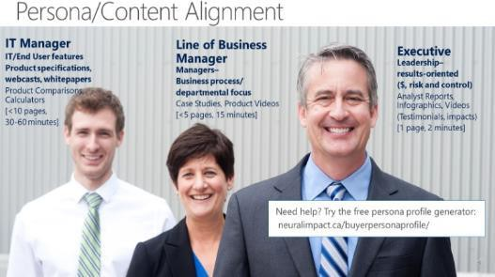EDGE AI has extensive domain expertise and knows the trucking and brokerage industry buyers’ needs intimately. Therefore, it can design marketing assets and landing pages that speak to the specific needs of three key buyer profiles or ‘personas’. The WHY persona is the business owner who is motivated to increase margins, grow revenue, and decrease risk and costs. The HOW persona is a mid-level manager responsible for the day-to-day operations of the trucking business. This persona is concerned about safety, scheduling, following process and protocols, on-time deliveries, customer service levels, and efficiencies. Finally, the third persona, the WHAT persona, is the person in the organization who is

responsible for the technology buying decision. He/she is concerned about the platform, cost, what the product can and

can’t do, security, and more.

###### Simplicity as a Core Differentiator

By offering SaaS solutions, EDGE AI sets up customers much more rapidly, and can do so with limited infrastructure and customization. Some Cloud software vendors have reported an up to a 75% reduction in installation time. EDGE AI is re- aligning its deployment process to guarantee customers they can be up and running in 30 days. The software industry has traditionally made it complicated for customers to buy from them, and time and materials proposals have lengthened this buying process. Trucking and brokerage industry business owners are NOT technologically savvy. They have a pre-conceived belief that technology is expensive, complicated, and difficult to get up and running. They fear that an investment in a new core business system will be complicated, expensive and will require valuable resources. Unlike any competitor in the industry, EDGE AI plans to de-mystify and simplify the buying process, thereby reducing customers’ perceived risks and fears. This will function to shorten the sales cycle and lower customer acquisitions costs.



**EDGE AI SWOT**

**EDGE AI has several key strengths, weaknesses to address, opportunities to capitalize upon and threats to mitigate.**

|  |  |
| --- | --- |
| **STRENGTHS** | **WEAKNESSES** |
| * True Cloud-based application – hosted SaaS * Engaging brand – ‘North Star Guidance’ – aligned to broadest segment of the market * Existing customer base of 1200+ * Product breadth – combined trucking and freight   brokerage application, ‘all-in-one’ solution   * Digital marketing capabilities * Optimized vertical industry solution * Low cost of support leveraging digital ‘Customer Support’ infrastructure – live webinars, videos, self- help documents Extensive integration that expands product reach and partnerships * Strong company culture – tight team – supportive commitment of staff – ‘noble mission’ * Domain expertise - years of industry insight in both brokerage and trucking industries | * Capital * Technical resources – need more * Limited sales resources * Older billing processes * Lease ends in 2018 – potential move * Low brand recognition * Limited to North American market |
| **OPPORTUNITIES** | **THREATS** |
| * Mid-market competitors are behind – just beginning to move to the Cloud * Competition has much greater legacy infrastructure or is immature in terms of a SaaS business model * Changing buyer demographic more tech savvy * Industry trend towards automating manual processes   – shared data   * Surrounding technologies are all moving to SaaS –   GPS, ELD, ACE/ACI, BI, CRM   * New regulatory requirements – border clearances, safety, hours of service – helping drive the need for new TMS features | * High labor costs * Shortage of technical talent * Regulations, political unpredictability in US * New competitive entrants * Fewer barriers to entry * Commoditization of ERP, CRM and other business applications, forcing rapid innovation * Increasing security risks |

**New Product and Services Strategy**

As discussed in the product strategy section of this business plan, EDGE AI will continue to invest in developing and offering add-on functionality and apps, as well as building out a full enterprise suite of Cloud offerings and Azure-based intelligent Cloud services. These will address specific business pains and issues affecting the trucking and brokerage industries – especially for Enterprise customers.

Over the course of the next year, EDGE AI will also develop a series of recurring monthly optimization service offerings tied to automating business workflows and processes. For example, EDGE AI will provide enhanced insight and reporting using Power BI, integrate with Office 365 and more.

EDGE AI has also identified recurring services possibilities that leverage the Microsoft Azure suite of products and services, which can offer added value to customers. For example, customers will be able to subscribe to a daily highway driving conditions and weather forecast service and AI-based route scheduling and optimization service.

###### Go to Market Channel

EDGE AI sells directly to its North American market through its own website, as well as through an internal sales force that will be equally split between SMB and Enterprise tiers.

The EDGE AI compensation plan is based on a combination of base salary and commission (with different percentages tied to recurring revenue targets) that is commensurate with industry standards.

To further pursue the opportunity outlined in this plan, EDGE AI will recruit two new sales personnel, as outlined in the Financials section (see dispersion of funds). These new sales professionals will focus on streamlining the SMB segment sales process. The existing sales force will be redirected to the new Enterprise tier segment, and will focus on securing large deals as well as associated implementation project services.

Further, a customer success team will be formed to focus on upselling and cross-selling solutions to the company’s installed customer base. This customer success team will also be responsible for ensuring customer success, high renewal rates, identifying new sales opportunities as well as identifying future innovative subscription services offerings.

###### Promotional Strategy & Monthly Campaigns

In addition to the strategies already identified, EDGE AI will employ a systematic nurture campaign process targeted at prospective, current, and former customers. The goal will be to deliver relevant, timely educational, and engaging communications that will trigger customers to do one of the following:

* Sign up for a trial
* Convert from a trial to a sale
* Convert from a lower tier to a higher tier
* Add users
* Become re-engaged after having churned
* Purchase additional value-add subscription services
* Provide ROI-based testimonials and case studies

|  |
| --- |
| Directions: Operations |
| In this section, you will outline the processes used to produce and deliver your offering to the marketplace. You should include information related to location, systems, development, production, logistics, etc. Be sure to carefully link the design of your operations to the goals of the business and marketing plan.  Specifically, you should do the following:   * Describe the scope of your operations, and include details of what you do in-house and what is outsourced. * Explain what specific systems you need to deliver your product/services – billing systems, deployment services, client management, web or online systems, and more. * Describe your hiring plan and review employment contracts for key employees such as designers, marketing experts, consultants and the like. * Indicate what your facility or office needs are. * Think of the operating plan as an outline of the [capital](https://www.thebalancesmb.com/capital-investment-2948114) and expense requirements your business will need to operate from day to day.   See sample copy below & delete this table when template is complete. |

### Operations

###### Strategy

The thrust of EDGE AI’s operations plan will involve positioning the company to accelerate its growth, effectively expanding into new markets, and scaling the organization.

The operational success of the business depends on four core processes that will be continuously refined:

* Product and service quality, repeatability - application usability and customer satisfaction – user retention
* Continuously innovating and expanding product capabilities – product development path
* Offering value-add and optimization services – hiring key resources with domain expertise
* Driving customer acquisition and retention – modernizing and improving internal sales and marketing processes
* Growing recurring services revenue – shifting to a packaged, fixed price, recurring billing process

### Operational Plan 2019

EDGE AI will invest in the training of resources. In addition, it must streamline and adapt many of its existing implementation and support processes to be fully Cloud-relevant.

The following plan shows which strategic actions will be initiated and when. Each is designed to contribute to the 4 core operations processes listed above:

|  |  |
| --- | --- |
| Q1 | Offer the First of Three New Services Offerings  EDGE AI will launch three new services offerings in 2019, one per quarter. These will be designed to drive recurring revenue and increase customer return on investment. |
| Increase Sales Resources  EDGE AI will hire two additional salespeople to drive sales in the two target verticals: trucking and brokerage firms. One will be hired in the first quarter and the other in the second. |
| Increase Cloud Competencies  EDGE AI currently employs ten young, smart developers. They are led by two long-term technical leaders. EDGE AI will hire three additional resources to complement the core development team and investigate outsourcing key development projects to a Microsoft ISV development center. EDGE AI will invest in Cloud readiness training and skills development for this team. |
| Q2 | Accelerate the Sales Process with New Sales Enablement Assets  EDGE AI will run monthly marketing campaign programs targeted at key industry segments tied directly to its product pathway. Integrated campaigns will be launched to maximize conversion.  EDGE AI will also hire one additional marketing resource to develop customer success stories, and build a series of sales enablement and educational assets including videos, demos and blogs.  EDGE AI will incorporate video into all aspects of its operation to simplify and improve its support, marketing and customer communications. Investments will be made towards a more integrated marketing automation and reporting process, which will dynamically update marketing and sales results.  EDGE AI will enhance its brand and extend its reach by building out its YouTube channel called Fleet Flix. Through this channel, EDGE AI will promote its products and services and offer support and training to its customers.  EDGE AI also plans to launch a transportation-focused monthly podcast on Spotify and iTunes to educate the industry on key trends and changes, and to position the company as a thought leader. |
| Accelerate Speed of Deployment  EDGE AI will accelerate deployment time through the following initiatives:   * Staff training on the latest Microsoft Cloud technologies * A revamping of traditional implementation processes to be more streamlined * Investing in tools to speed up integration, migration, data cleansing and more * Moving to a support video and AI model for customer service and support * Training the support and professional team to more effectively cross-sell and upsell additional offerings * Deploying continuous innovation * Offering fixed price implementation services packages * Leveraging ISV solutions when possible |
| Q3 | Secure the Base - Customer Migration Program  EDGE AI will continue to transition the rest of its existing on-premise customers to the Cloud offering. The transition will occur over a two-year period, starting in the 3rd quarter. |

|  |  |
| --- | --- |
|  | The goal is to retain as many customers as possible, and to ensure a smooth transition to EDGE AI’s new online  applications and recurring license and service model.  EDGE AI will offer a tiered discount or incentive program, depending on when customers want to move. The earlier customers move, the greater the incentive. The later they wait to convert, the lower the savings since more value has been built into the application in the intervening period.  EDGE AI aims to communicate to customers a fixed date after which point in time it will no longer provide updates and new releases to the current on-premise product.  EDGE AI will also provide three fixed time and price migration packages for its customers so as to reduce resistance and perceived risks. |
| Q4 | Launch New Enterprise Solution  EDGE AI’s online application is currently offered only in Core and Pro Tiers. By the end of the year, EDGE AI will launch its Enterprise Tier, which will add the following services to the core application:   * Customer portal * Link to FMCSA site (carrier certifications and monitoring) * GPS integration   EDGE AI has a significant number of customer opportunities (120+) in the pipeline waiting for a true online TMS that is integrated with key technologies.  Build a Customer Success Team  One new professional services team member will be hired to sell new services to the current installed base of customers and to further penetrate the user base. This customer success manager will identify new optimization services the company can sell, and will focus on building customer retention and advocacy.  A customer loyalty program will be launched, which incentivizes new Cloud customers to participate in referrals, case studies and PR opportunities.  This customer success manager will also be tasked with ensuring that customers have a measurable, high rate of return on their investment, and that each new customer is referenceable, with quantifiable data for case studies and marketing assets. |

|  |
| --- |
| Directions: Financial Projections |
| In this section, you will show how the key components of the plan lead to the projected financial results. You need to consider who your financial audience is – lending institution, investor, internal management committee – as this will dictate your focus. A lending institution will focus on the borrowing and debt servicing capacity of your business; investors will evaluate the projected rate of return on funds; and an internal management committee will compare your anticipated rate of return, benchmarked to competing projects seeking funding. You will need to include a strong, well-constructed set of projected financial statements for at least the next three years.  This section should outline the following:   * The capital investment required and how you intend to allocate these funds. * An operating forecast providing an estimate of the sales and expenses your business will incur for the next three years (include assumptions and sources in an appendix). * The break-even point in dollars and units for your business (the point at which your business expenses match your sales or services volume). * A complete set of financial spreadsheets for a three-year period: cash flow, income statement, balance sheet (in appendices). * Identification and mitigation of risk factors.   See sample copy below & delete this table when template is complete. |

### Financial Projections

###### Investments and Dispersion of Funds

The Company seeks $1,250,000 in debt financing, which will bear interest of 15% per annum and provide for a bonus payment of 10% on payout, which is expected within three years. The funds will be used to expand and scale sales and marketing efforts, as well as to develop new Cloud-based solutions for the transportation and brokerage industries.

These funds will be invested in the following key areas of the business:



Capital Investment

Operatio

ns 5%

Marketin

Develop ment & Delivery 36%

g 37%

Sales 22%

Marketing Sales

Development & Delivery Operations

Specifically, the proceeds of funds will be applied to the following initiatives:

1. Build and Solidify Development Team & Build Enterprise Solution - $375,000

Add 3 full-time technical resources to the team and complete 20+ product integrations – GPS, ELD, EDI, CRM, and BI – to attract larger customers.

This activity will enhance the functionality and power of the EDGE AI platform, increasing the value proposition of EDGE AI’s Enterprise solution. It will attract new customers from competitors who desire to move to a Cloud-centric platform.

1. Build Out Modern Marketing Content and Execute Customer Acquisition Campaigns - $75,000

Develop and implement a comprehensive, digital marketing motion to automate lead generation and ongoing customer communications. This is designed to either convert, sell additional products and services, or increase usage by jumping a tier. This includes new video and other educational marketing content.

1. Marketing Programs – Establish Dominance in Mid-Market - $350,000

With a growing and capable platform, combined with a Marketing Campaign Engine, EDGE AI will drive towards market dominance in the mid-market. EDGE AI will also drive systematic and consistent lead flow to its business through a combination of digital marketing initiatives.

This budget will run at $30,000 per month, of which 80 to 85% will be directed to modern digital marketing activity. This will allow EDGE AI to assert dominance over several other mid-market TMS systems, who still predominantly rely on referrals, traditional long sales cycle solution selling and expensive event-based marketing approaches.

* + Online search optimization initiatives will include Capterra, Google, and Bing
  + Social media – LinkedIn, iTunes, YouTube
  + Public relations – production of a book leveraging existing blog content and ongoing thought leadership to raise the profile of the company

1. Industry specific tradeshow participation, conferences,

speaking engagements – Great American Truck Show (GATS), Truckworld Hire Two Additional Sales Personnel – Acquisition of Customers – Generate More Sales – $150,000

Hire two junior inside salespeople to migrate and qualify new leads. This group will chase trials and leads that aren’t assigned to the Enterprise sales group.

Currently, two full-time salespeople are responsible for both renewals and acquiring new customers. With the launch of the Enterprise solution, we expect larger, more multi-user deals to occur. The two existing, experienced salespeople will continue to work on converting key target opportunities.

1. Hire Customer Success Manager – $90,000

An individual with strong process and domain expertise will be hired from within the industry to drive high customer lifetime value and renewal rates.

1. Build Out ‘Fleet Flix’ YouTube Channel – $35,000

EDGE AI will work with internal and external industry experts to build a series of industry specific educational videos and content which will increase online engagement, bias prospects toward EDGE AI and assist in converting more web visitors to prospects. And

1. Move to New Facility – $35,000

It is anticipated that EDGE AI will need help in finding, designing, and setting up a new location, which is required to facilitate the anticipated growth over the next 5 years. A tentative date is set for June 2019.

1. Licensing of internal new software systems -

$30,000

This involves investments into streamlining the internal billing system, marketing automation, trial tracking software, video hosting and reporting system and deployment acceleration tools.

1. Partner Development Initiatives – $40,000

Building out the product platform and creating a reseller and referral network for the application will require some in-person meetings and travel. Some expenses for tradeshows and for peer-to-peer discussions with executives will also be required. These will involve trips to attend tradeshows, meetings with companies (pre- arranged), and attendance at Microsoft Inspire and other industry events.

1. Build Platform and Mechanisms to Facilitate Migration from Competitive On-Premise Applications – $40,000

EDGE AI will continue to build and refine mechanisms to help migrate data from competitor platforms. This will entail investment in some intermediary technology that facilitates this transfer, and/or the engagement of a third- party service provider.

1. Cloud Training – $30,000

EDGE AI will invest in training team members on Cloud business processes and new technology.

### Summary Financial Projections

The financial plan outlines the projected 2018 sales of

$3,367,870, equating to a gross profit margin (GPM) of nearly 60%, a SaaS GPM of 73%, and net margins of approximately 40% before tax. EDGE AI expects to steadily grow across all of these measures over the next three years, and easily meet its debt servicing load and discharge date. Other expenses are budgeted as a percentage of revenues and are in line with industry ratios. The important results of the financial plan are summarized in the following table, and a full set of pro-forma financials can be found in the Appendices section.

|  |  |  |  |  |
| --- | --- | --- | --- | --- |
|  | 2017 (Actual) | 2018 | 2019 | 2020 |
| Revenue ($) | 2,754,887 | 3,367,870 | 8,414,740 | 10,009,593 |
| Operating Profit ($) | 1,270,003 | 1,606,099 | 5,915,562 | 7,407,099 |
| Total GPM | 46.1% | 58.3% | 70.3% | 74% |
| SaaS GPM | 55.9% | 73% | 83.8% | 86.1% |



### Risk Factors

The Company operates globally in a dynamic and rapidly changing environment that involves numerous risks and uncertainties. The following section lists some, but not all, of these key risks and uncertainties, which may have a material adverse effect on the business, financial position, results of operations or cash flows.

M&A Risk: If the company chooses to pursue an M&A growth strategy, it will need to merge and integrate disparate systems, facilities, business cultures, financial systems and reporting cycles in order to reap the benefits of the target acquisition or merger. This activity will also potentially require an unexpected amount of extra funding, or may result in disruption to the core business due to management diverting attention elsewhere. There is also a risk of inheriting unexpected contingencies or liabilities. *(Insert your strategy to overcome this risk here.)*

Long expensive development cycles: Because the Company’s solutions are complex and require extensive product testing, development cycles can take months. Although the Company is working towards moving to a continuous, rapid and lean development cycle, it may not have the resources available, in the short term, to complete the development of new, enhanced or modified Cloud solutions in timely fashion, or may incur significant, unexpected costs before I is able to attain revenue from these new solutions, putting us in a difficult cash flow position. *(Insert your strategy to overcome this risk here.)*

Lack of capital and insufficient resources: The Company may not have enough funds, or the technical resources or capabilities required to build competitive Cloud solutions in order to stay ahead of competitors. *(Insert your strategy to overcome this risk here.)*

Market failure: The Company may invest substantial resources into the development of new Cloud solutions but not achieve the desired and expected levels of market success and revenue.

Fixed project price exposure: The business often involves long-term, large complex projects. As the Company begins to offer fixed price packaged service offerings, there will likely be an increase in profit margin risk due to the increase in uncertainty in the early stages of this transition regarding clients’ environments and capabilities, and our projects may unexpectedly change in scope or duration, leading to increased costs and write offs.

Variable sales cycle: The sales cycle is variable and can take many months. It depends upon many factors outside of our control, and requires us to commit significant time and resources prior to generating any associated revenues. Some deals end in a no decision to purchase.

Although the Company is investing in shortening this sales cycle and lowering costs related to customer acquisitions, the typical sales cycle for our solutions requires a pre- purchase evaluation by several internal decision makers at different levels within the organization. A comprehensive RFP or evaluation process will frequently also include outside competitors. Our sales cycle for new customers is typically 6-9 months, but can extend longer. The Company spend substantial time, effort and money in our sales efforts without any assurance that such investment will result in a contract with accompanying revenue.

High cost of technical resources: Investment in highly- skilled research and development as well as customer support team members is critical to the Company’s success. The Company’s ability to develop and enhance solutions, and to continue to provide value add services and excellent support is highly dependent on the quality of the people hires. Keeping solutions ahead of the competition requires that the company hire’s skilled and competent technology professionals. Skilled technology professionals are in high demand and in short supply. If the company is unable to hire or retain qualified technical personnel to develop, implement and improve the Company’s solutions, the Company may be unable to meet the demands and requirements of current and future customers. The cost of salaries and benefits are rising and competition for talented technical people is increasing, resulting in an escalation in resource costs, which may ultimately affect profitability if not accompanied by the expected increase in revenue. One strategy to mitigate this rising cost of talent is to contract qualified technical resources abroad in the Ukraine, India

and elsewhere. This, however, introduces additional new risks related to time zones, cultural differences, language, accountability, and more.

Failure to manage rapid growth: Not being able to keep up with organic growth could negatively impact the business. Demand could exceed the Company’s ability to deliver in accordance with high standards of product and service quality due to a lack of operational, financial or key human resources. To manage the Company’s anticipated future growth effectively, EDGE AI will continue to invest in improving and streamlining the Company’s information technology infrastructure, financial and accounting systems and controls, as well as sales and marketing systems; the Company will also need to effectively manage expanded operations and employees in geographically distributed locations. Additionally, the Company must invest effort into continuously attracting and hiring new qualified personnel in areas of sales, marketing, professional services, and software engineering, in addition to retaining those employed today. Onboarding can often take up to 6 months. Failure to manage rapid growth effectively could have a material adverse effect on business results. Expanding the business too quickly could also lead to increased financial risks if the expected accompanying revenue does not follow at the same pace. *(Insert your strategy to overcome this risk here.)*

Customer Retention: Because the long-term financial returns for a Cloud business hinge heavily on customers renewing their subscriptions and purchasing additional licenses, any material customer ‘churn’ could negatively impact overall financial results. To mitigate this risk, the Company plans to bolster customer service and nurture marketing capabilities as well as hiring a customer success manager with the capital raised.

Dependence on too few customers: Currently, the Company has a dependency on too few large customers from whom it generates a significant amount of our revenue. 80% of revenue comes from 20% of customers. The Company will need to expand the installed customer base to mitigate this risk.

Revenue dependence on existing installed base: The Company is currently too heavily dependent on repeat product and service revenues from its existing base of customers. The Company will need to continue to invest in new customer acquisition to mitigate this risk.

Liability claims: The Company may inadvertently be liable to clients for damages caused by a violation of intellectual property rights, the disclosure of confidential information including personally identifiable information, system failures, errors or unsatisfactory performance of services. The Company has secured D&O insurance as well as other key insurance policies, but these may not be enough to cover all potential damages. The Company is also at risk of unauthorized parties, employees or subcontractors potentially attempting to misappropriate certain intellectual property rights that are proprietary to our clients, or otherwise breach clients’ confidences without the Company’s knowledge. A failure in a client’s system or any breach of security could result in a claim for substantial damages, regardless of the Company’s degree of responsibility for such failure. The Company has invested in advanced detection, prevention and proactive systems to minimize these risks. Errors performed by employees in the due course of their work for a client could also result in a client terminating relationship or worse, seeking damages from the Company. The software industry is also characterized by the existence of many patents and frequent claims and related litigation regarding patents and other intellectual property rights, which pose a risk to the company.

Compliance with GDPR and others: Personal privacy laws have become a significant issue in the United States. and in many other countries. The protection of customer data is essential for the Company’s survival. However, with the increase in privacy law requirements around the world, staying compliant is becoming increasingly complicated and expensive. The Company will do its best to invest in measures that ensure it stays compliant with new requirements and avoid penalties. Many steps have been taken to protect clients and their data, to protect against data breaches, and to be more stringent about how the Company obtains the clients and prospect consent.

Consolidation in the industry: M&A activity in the technology industry is accelerating. Large companies are acquiring smaller ones, and many are joining forces via merger. One of the threats to the organization is that there are much larger competitors with more resources and capital entering the Company’s vertical market.

However, this also creates an opportunity to be acquired by a larger competitor at a later point in time, potentially providing the Company’s shareholders and investors with a liquidity event or a high return on their investment.

Shrinking target customer base: There is significant consolidation in the trucking and brokerage industries, reducing the number of potential customers that can be targeted and thus intensifying competition for those fewer customers. This will also put pressure on EDGE AI to launch a new larger, more robust enterprise solution in the next 12 months.

Customer Acquisition Costs: As detailed earlier, acquiring customers for Cloud solutions requires a significant investment in sales and marketing capacity. Should these investments not generate the volume of customer additions anticipated, customer acquisition costs will be higher than expected relative to the revenue generated, resulting in a greater than anticipated cash flow deficit. To mitigate this risk, the Company has allocated the capital to reflect what is required to withstand such an event.

Adverse Economic Conditions: Although demand for Cloud solutions is currently strong and growing, adverse global economic conditions and political volatility in the US and elsewhere could negatively affect this demand, resulting in financial projections not being met. There is also the distinct possibility the Company will face price pressure from competitors seeking to establish themselves in our target markets. Competitors could buy market share at predatory prices, lower than can be sustained over the long term. To mitigate this risk, the Company will engage in swift execution of this business plan once the needed funds have been raised.

Service Disruptions: Cloud solutions must be available 24/7/365, and any service disruptions could negatively impact the business. In addition, the Company relies upon 3rd party suppliers such as Microsoft to provide customers with continuous access to their applications and IT infrastructure. Catastrophes can be caused by various events, including amongst others hurricanes, tsunamis, floods, windstorms, earthquakes, tornados, explosions, severe weather conditions, as well as fires. Moreover, acts of terrorism or war could cause disruptions in the

|  |
| --- |
| Directions: Management Team |
| In this section, you will need to describe the strength of your management team, with an honest account of your accomplishments and capabilities, while mitigating any obvious shortcomings and weaknesses. You need to identify what makes your team the right one to deliver on this plan. To that end, you should provide the following:   * A summary of résumés of key senior management and owners, as well as a list of professional advisors, strategic alliances, board members and directors. You should also include a summary of gaps in your team and a plan for filling these gaps.   See sample copy below & delete this table when template is complete. |

Company’s or its customers’ businesses. The risks associated with such disasters and catastrophes are inherently unpredictable, and it is difficult to predict the timing of such events or estimate the amount of loss they will generate. To mitigate this risk, the Company has chosen to partner with Microsoft for its reliability, security, uptime and global reach.

International operations: As the Company expands its business to new global markets, additional risks may affect the business:

* increased tax complexity
* requirements to comply with foreign laws and legal standards
* import and export license requirements, tariffs, taxes and other trade barriers
* increased costs of accounting and additional reporting requirements
* increased threats to intellectual property
* political, social and economic instability abroad, terrorist attacks and security concerns
* currency volatility
* higher transaction costs
* increased management, travel, infrastructure and legal compliance costs
* credit risk, longer payment cycles, difficulties in enforcing contracts and collecting accounts receivables
* the need to localize products and licensing programs
* uncertainty regarding foreign regulatory requirements

As EDGE AI continues to expand the business globally, the Company’s success will depend, in large part, on the Company’s ability to anticipate and effectively manage all these and other additional risks.

### Management Team

###### Ed Hartford – President & CEO

Ed formed the Company in 2000 and has driven the rapid transformation of the organization to a Cloud business model over the past 2 years. Prior to his current role, Ed worked with Transport Vision Worldwide to enhance the marketing and sales efforts of its distribution channel across the globe. He later consolidated and ran the North American operations of ABC Logistics IT, the then largest transportation scheduling software company in the US. Under Ed’s leadership, the product line was expanded through acquisitions to grow to over $55 million annually.

###### Mark Hanson – Chief Revenue Officer

Mark joined the Company in April of 2008. Prior to joining the Company, he was President and owner of Technomic Inc., selling distribution and logistics solutions to the largest shipping companies around the world. From 1997 to 2008, Mark was Senior Vice President for Cystidia Inc., headquartered in Chicago. Mark started his career selling ERP solutions with Xerox Computer Services in 1985. Over the last 30 years, he has held multiple senior executive positions.

###### Mary Pelton – Chief Marketing Officer

Mary joined the Company in 2005 and has been instrumental in achieving the growth EDGE AI has experienced over the last 2 years. With over 20 years of experience in senior marketing roles (including that of Vice President of a national credit card issuer), Mary has crafted and implemented numerous marketing, sales, customer loyalty, and product strategies. Mary had direct functional responsibility for business units ranging from insurance, travel fulfillment, and loyalty programs to outside sales channels.

###### Justin Harrison – Vice President of Delivery and Customer Success

Justin heads up the Company’s delivery team, and was previously directly responsible for a team of 25 consultants and 5 help desk personnel at Johnsons Distribution Inc. Under Justin’s leadership, EDGE AI has achieved a consistently high ‘on-time, on-budget’ project delivery track record, and customer satisfaction ratings in excess of 90%. Justin came to the Company in 2009. Prior

to that, he led technology delivery teams at several regional software IT services providers across the US mid- west.

Peter Smith - Chief Technical and Product Development Officer

Peter serves as Chief Technology Officer for EDGE AI. He is an award-winning, 30-year technology veteran with expertise in virtualization, Cloud security and telecommunications. Peter designs the EDGE AI roadmap, leads the company’s project teams and works closely with customers and partners. He was named one of Chicago’s top 40 under 40 and selected as the region’s Top IT Innovator by the Chicago Business Journal. Earlier in his career, Peter served as Vice President of Speed Tech and XBT Communications. There, he was responsible for driving the company’s most advanced and innovative offerings, and for developing strategies to bridge the gap between traditional telecommunications and next generation products. Known for his ability to address prospects’ needs in a language they can understand, Peter was instrumental in bringing dynamic security- and productivity-enhancing solutions to the marketplace.

Peter is involved with various regional business and industry groups, serving as board member for the Chicago CIO Institute and Silicon Valley Cloud Conference. He is also a frequent contributor to business and technology publications, and is often sought out to speak at industry events.

###### Jackie Harris – Chief Financial Officer

Jackie joined the Company in April 2012. Jackie’s career encompasses 5 years of ERP consulting experience and 25 years of accounting & financial management. She worked at PricewaterhouseCoopers and US Container Corporation. Jackie earned her MBA at Boston University and her BBA at the University of Illinois.

See the Appendix section for a detailed profile of EDGE AI’s advisors and board members.

|  |
| --- |
| Directions: Appendices |
| Include any supporting documentation as appendices. This could include but is not limited to:   * Product roadmaps, pertinent product and services literature * Market research data, surveys and studies * Financial documents – pro-forma income statements, cash flows, balance sheets, and past audited financials * Detailed competitor analysis * Support for assumptions (average deal size, customer adds, etc.), trends, comparisons * Board and advisor bios   Add all of your relevant appendices and delete this table when template is complete. |



### Appendices - Samples

#### Assumptions Documentation

As EDGE AI executes its SaaS strategy and introduces its Enterprise Tier solution and recurring optimization services, it anticipates the deal structure outlined below. EDGE AI anticipates securing a minimum of 30 new deals annually with a churn rate of 8%.

|  |  |  |
| --- | --- | --- |
| **Deal Structure** | | |
| Average Deal Size | 50 | users |
| Upfront Project Services Fees | $25,000 | per customer |
| Ongoing Project Services Fees | $2,500 | per customer per year |
| Azure Consumption | $2,500 | per customer per year |
| Own IP License Fee | $75 | per user per month |
| Managed Services Fees | $55 | per user per month |

|  |  |
| --- | --- |
| **Margin Structure** | |
| Azure Margin & Incentives | 20% |
| Office 365 Margin & Incentives | 20% |
| Gross Margin (Project Services) | 35% |
| Gross Margin (Managed Services) | 45% |
| Anticipated IP Gross Margin | 65% |

Please see the following financial modelling tools to help you with your financial planning: [https://assetsprod.microsoft.com/](https://assetsprod.microsoft.com/%20financial-models.zip) [financial-models.zip](https://assetsprod.microsoft.com/%20financial-models.zip) (if you have trouble accessing these spreadsheets, let us know and we will provide them.)



### Financial Models

See the financial modelling worksheets available to partners located at: [https://assetsprod.microsoft.com/financial-](https://assetsprod.microsoft.com/financial-models.zip) [models.zip](https://assetsprod.microsoft.com/financial-models.zip)

#### CSP Financial Model

Determine which Cloud Solution Provider model makes the most sense for your business:

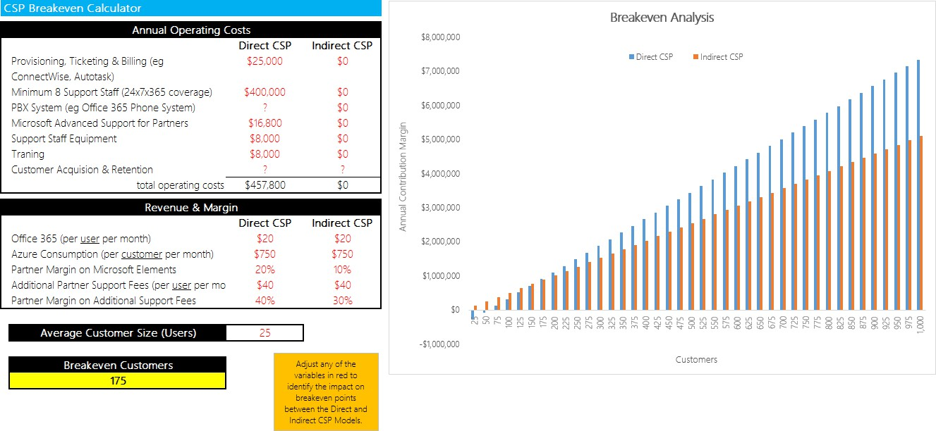

#### Solution Play Model

Define your solution play elements, revenue profile, customer adds, and resource requirements to fully understand your financial opportunities and cash flow projections:

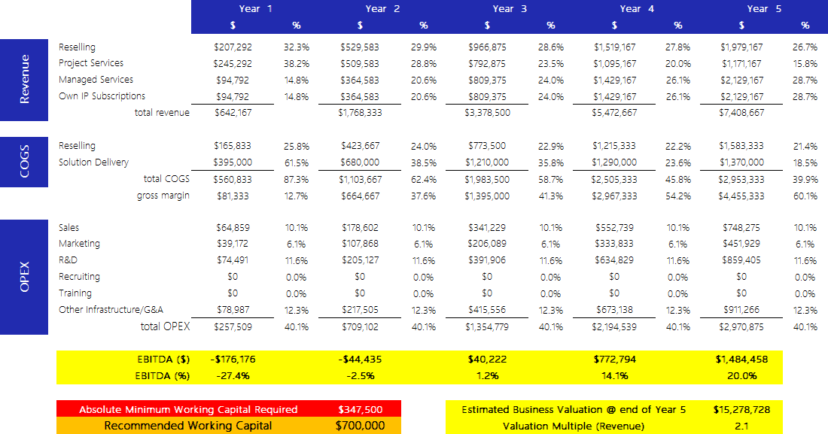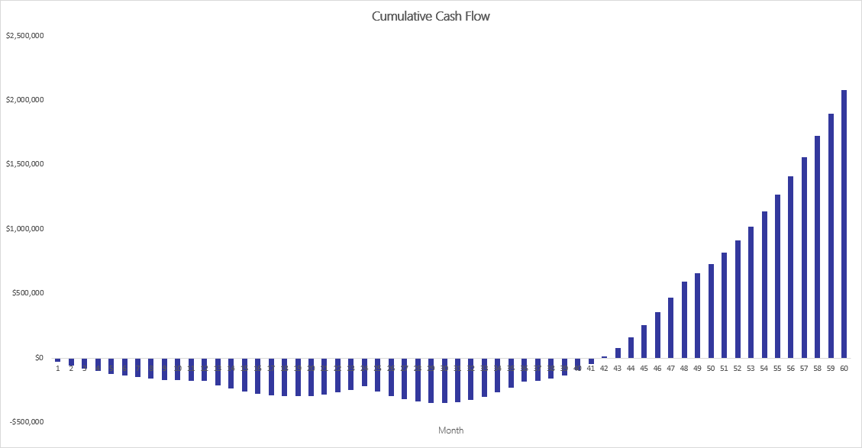

#### P&L Impact Model

Understand how to generate profit by increasing revenue and reducing costs:

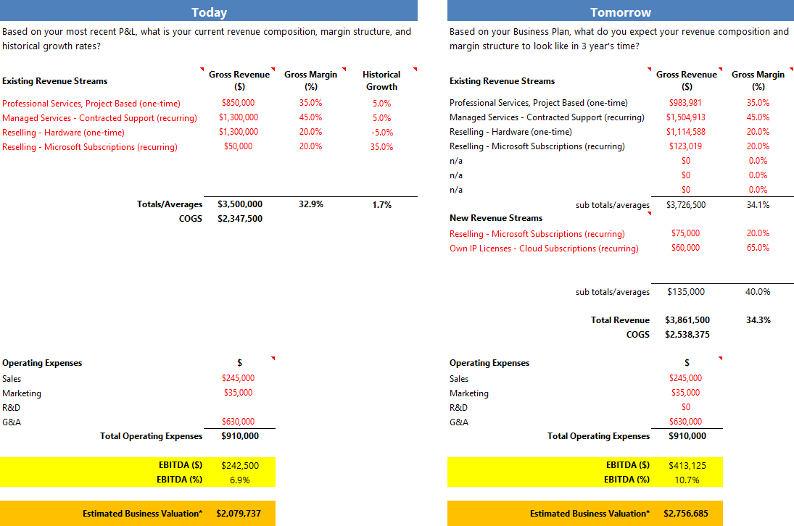

#### Customer Lifetime Value Model

Define a focus, create your solution, and build your marketing plan to determine the customer lifetime value of your customer:

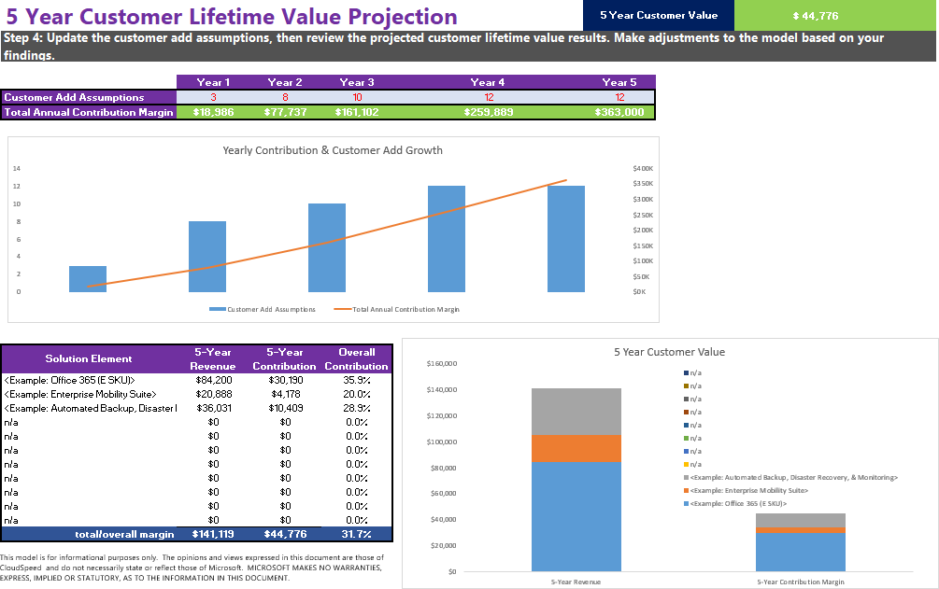

### Anticipated Valuation Impact

EDGE AI intends to pursue an aggressive Cloud strategy because the rise in Cloud computing has caused a dramatic shift in how companies in the IT industry are valued and how customers want to buy. Since Cloud solutions involve the purchase of ongoing subscriptions rather than upfront investments in hardware, software, and configuration services, valuation metrics tend to be driven by recurring revenue levels, and the margins resulting from those revenue streams. One-time project services revenues or one-time software revenues are less highly valued. In today’s market, IDC sees the following valuation differentials for privately held IT services providers.

|  |  |  |
| --- | --- | --- |
| Potential Valuation | Traditional Revenue Business | Recurring Revenue (Cloud) Business |
| Revenue Multiple | 0.2-1.5x | 2-6x |
| EBITDA Multiple | 2-2.5x | 5-14x |

Based on these metrics and the adoption of this business plan, the estimated valuation of EDGE AI at the end of 4 years would be in the $15 to $20 million range.

See the set of detailed financial modelling sheets located on Partner Network at [https://assetsprod.microsoft.com/financial-](https://assetsprod.microsoft.com/financial-models.zip) [models.zip,](https://assetsprod.microsoft.com/financial-models.zip) and run your own financial modelling scenarios, forecasts, cash flow impacts, and more.

### Advisor and Board Members Bios

Insert here.