Advanced Data Analysis and Visualization in Logistics
Week 3 Task — Exploratory Data Analysis of a Hypothetical Logistics Dataset
Prepared by: Abi | Final-Year CSE Student | September 2026
Tools used: Python 3 · pandas · numpy · matplotlib · seaborn

1. Executive Summary
This report analyzes a hypothetical logistics dataset of 240 shipment records spanning January to August 2025, covering four regions (East, West, North, South) and three transport modes (Air, Road, Rail). The objective is to identify the drivers of delivery delay and cost, and to translate those patterns into operational recommendations.
The analysis finds that distance is the dominant cost and delay driver (correlation of 0.98 with transport cost and 0.83 with delivery delay), that 62.9% of all shipments in the dataset arrived delayed, and that customer satisfaction is very strongly and negatively related to delivery delay (r = -0.88) — far more than it is related to cost or mode. This points to delay reduction, not cost-cutting, as the highest-leverage improvement for customer experience.

2. Objective and Methodology
The task simulates a real-world logistics analytics workflow: define a dataset, explore it statistically, visualize key relationships, and translate the findings into decision-ready insights. The methodology followed five steps:
- Data Simulation — define the structure and variables of a realistic logistics dataset.
- Exploratory Data Analysis (EDA) — compute central tendencies, distributions, and correlations using pandas.
- Visualization — build eight charts with matplotlib/seaborn, each chosen to answer a specific operational question.
- Analytical Insight — interpret each visualization in the context of logistics performance (efficiency, cost, bottlenecks).
- Documentation — compile methodology, code, charts, and recommendations into this report.

3. Data Simulation: Dataset Structure
The dataset (hypothetical_logistics_dataset.csv) contains 240 shipment-level records with the following variables:
Variable | Type | Description
shipment_date | Date | Date the shipment was dispatched (Jan–Aug 2025)
region | Categorical | Destination region: East, West, North, South
transport_mode | Categorical | Mode used: Air, Road, Rail
shipment_volume | Numeric | Units shipped (100–997)
distance_km | Numeric | Distance travelled in kilometers (50–1,495)
delivery_time_days | Numeric | Total time from dispatch to delivery (days)
delivery_delay_days | Numeric | Days beyond the scheduled delivery window
transport_cost | Numeric | Total cost of shipment transport (USD)
customer_satisfaction | Numeric | Post-delivery rating, 1.0–5.0 scale
delivery_status | Categorical | 'On Time' or 'Delayed'

A structural check confirmed the dataset is complete and analysis-ready: 0 missing values across all 10 columns and 240 rows.

4. Exploratory Data Analysis

4.1 Loading and Inspecting the Data
import pandas as pd

df = pd.read_csv('hypothetical_logistics_dataset.csv')
df['shipment_date'] = pd.to_datetime(df['shipment_date'])

print(df.shape) # (240, 10)
print(df.isnull().sum()) # 0 missing values in every column
print(df.describe().round(2))

4.2 Central Tendencies and Spread
Summary statistics for the numeric variables:
Metric | Mean | Std Dev | Min | Max
Shipment Volume (units) | 539.29 | 261.27 | 100 | 997
Distance (km) | 731.82 | 425.52 | 50 | 1,495
Delivery Time (days) | 4.56 | 1.63 | 0.67 | 8.72
Delivery Delay (days) | 0.99 | 1.13 | 0.00 | 4.72
Transport Cost ($) | 1,745.24 | 866.92 | 142.07 | 3,554.24
Customer Satisfaction (1–5) | 4.48 | 0.55 | 2.70 | 5.00

Delivery status split: 151 of 240 shipments (62.9%) were recorded as Delayed and 89 (37.1%) as On Time — delay is the norm rather than the exception in this dataset, which is the central problem the rest of the analysis investigates.

4.3 Correlation Analysis
cols = ['shipment_volume','distance_km','delivery_time_days',
'delivery_delay_days','transport_cost','customer_satisfaction']
corr = df[cols].corr().round(2)
print(corr)

Distance is very strongly correlated with both transport cost (r = 0.98) and delivery time (r = 0.89). Delivery delay is strongly correlated with distance (r = 0.83) and cost (r = 0.86), and very strongly, negatively, with customer satisfaction (r = -0.88). Shipment volume has only a weak relationship with the other variables (r ≤ 0.33), meaning volume is not a meaningful driver of delay or cost here — distance is.

5. Visualizations and Interpretation

5.1 Distribution of Delivery Time and Delay
Chosen method: histograms with a kernel density overlay. Justification: histograms are the standard way to reveal the shape, spread, and skew of a continuous variable — essential before deciding whether to use means or medians as performance targets.
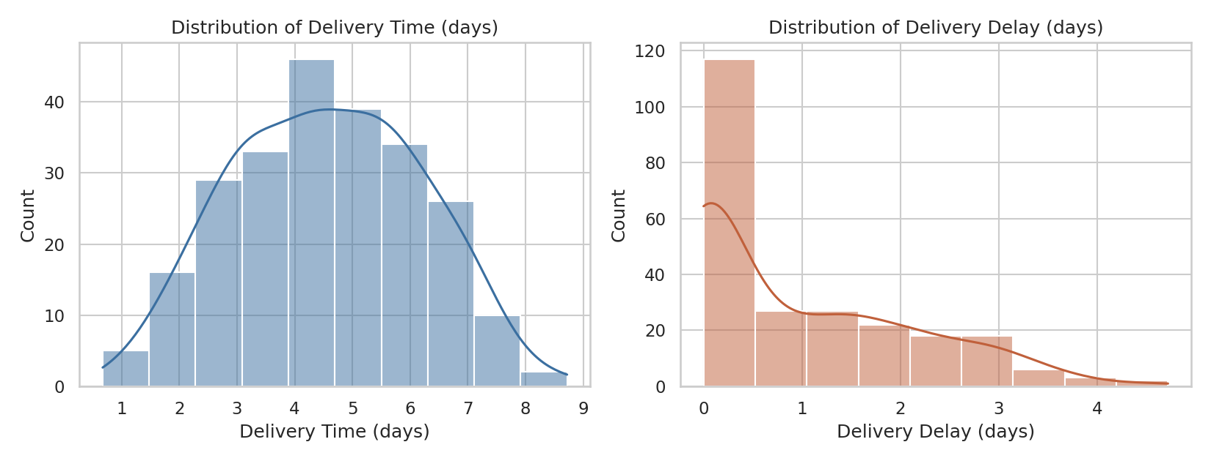
Figure 1. Distribution of delivery time (left) and delivery delay (right) across all shipments.
Both distributions are right-skewed: most shipments cluster around 3–5 days of delivery time and 0–1.5 days of delay, but a long tail extends toward 8+ days and 4.7 days of delay respectively. This tail is the operational risk to target — a small share of shipments account for a disproportionate share of severe delay.

5.2 Correlation Heatmap
Chosen method: heatmap. Justification: with six numeric variables, a heatmap communicates all pairwise relationships in one view far more efficiently than reading a correlation table.
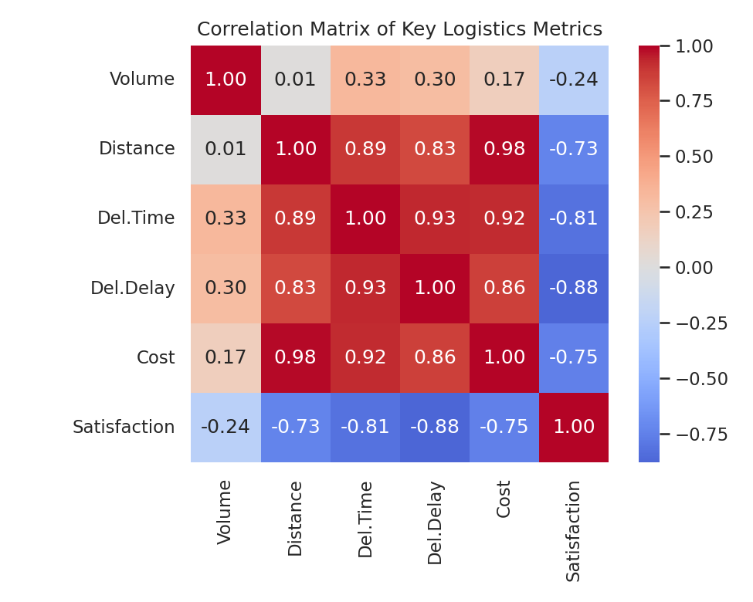
Figure 2. Correlation matrix of shipment volume, distance, delivery time, delivery delay, cost, and customer satisfaction.
The heatmap confirms distance as the common driver behind cost, delivery time, and delay (all correlations ≥ 0.83), while customer satisfaction moves opposite to all four (darkest blue against delay at -0.88). Shipment volume stands apart, with near-zero to weak correlations across the board.

5.3 Transport Cost vs. Distance by Mode
Chosen method: scatter plot with color-coded transport mode. Justification: scatter plots are the right tool for examining the relationship between two continuous variables while a third categorical variable (mode) is layered in via color.
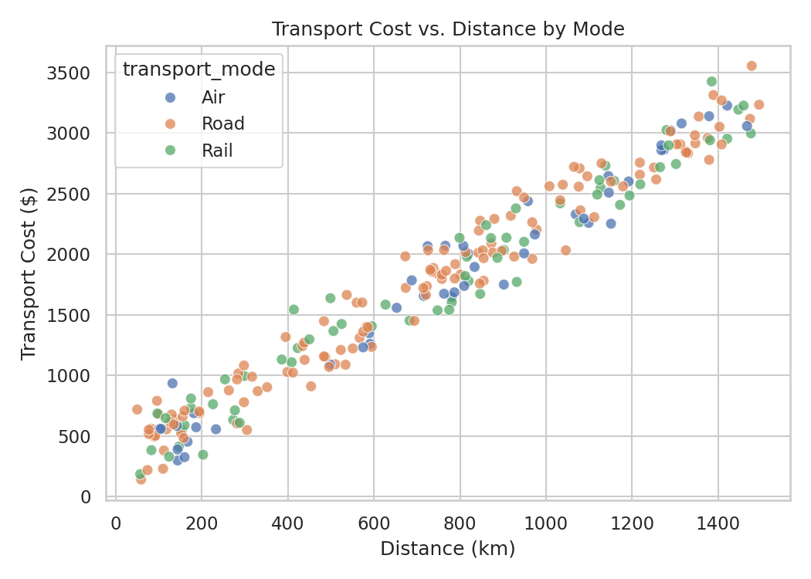
Figure 3. Transport cost rises near-linearly with distance; Road shipments sit slightly above Air and Rail at equivalent distances.
Cost scales almost linearly with distance regardless of mode, but Road shipments show a marginally steeper cost-per-km than Air or Rail (computed separately: Road $2.92/km vs. Rail $2.70/km vs. Air $2.61/km), suggesting Road is the least cost-efficient mode per kilometer despite being the cheapest in absolute terms for short hauls.

5.4 Delivery Delay by Region
Chosen method: box plot. Justification: box plots expose the median, interquartile range, and outliers simultaneously, which bar charts of the mean alone would hide.
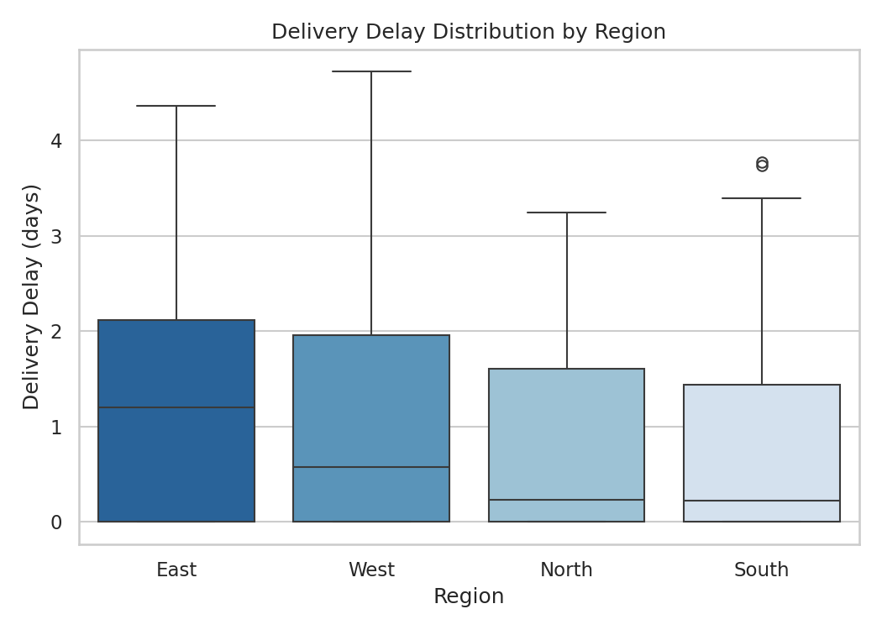
Figure 4. Distribution of delivery delay by destination region, ordered by average delay (highest first).
East has both the highest average delay (1.20 days) and the highest delayed-shipment rate (68.8%), followed by West (1.03 days, 62.7%), North (0.88 days, 61.8%), and South, which is the best performer (0.80 days average delay, 57.4% delayed rate). The gap between East and South (0.40 days) signals a regional bottleneck worth investigating — likely infrastructure, route distance, or carrier capacity specific to the East region.

5.5 Average Delivery Time and Cost by Transport Mode
Chosen method: dual-axis grouped bar chart. Justification: delivery time (days) and cost (dollars) are on different scales; a dual axis lets both be compared side-by-side per mode without distorting either.
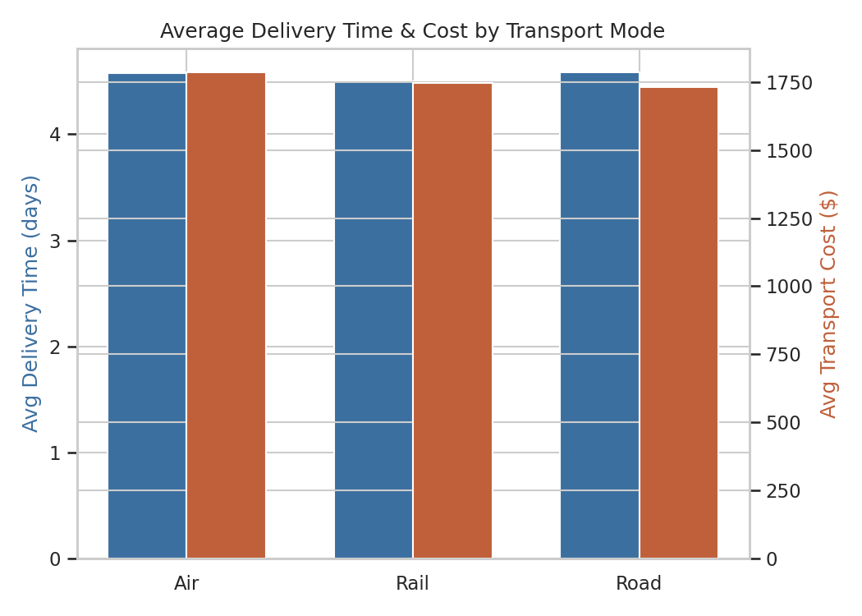
Figure 5. Average delivery time and average transport cost, grouped by transport mode.
Delivery time and cost are nearly flat across modes (delivery time 4.50–4.58 days, cost $1,731–$1,785), which is counter to typical logistics expectations where Air is faster but pricier. In this dataset, mode choice has a smaller effect on performance than distance does — meaning route/region assignment, not carrier mode, is the more consequential lever for delivery outcomes here.

5.6 On-Time vs. Delayed Rate by Transport Mode
Chosen method: stacked percentage bar chart. Justification: normalized stacked bars are ideal for comparing the proportion of a categorical outcome (on-time/delayed) across groups of unequal size.
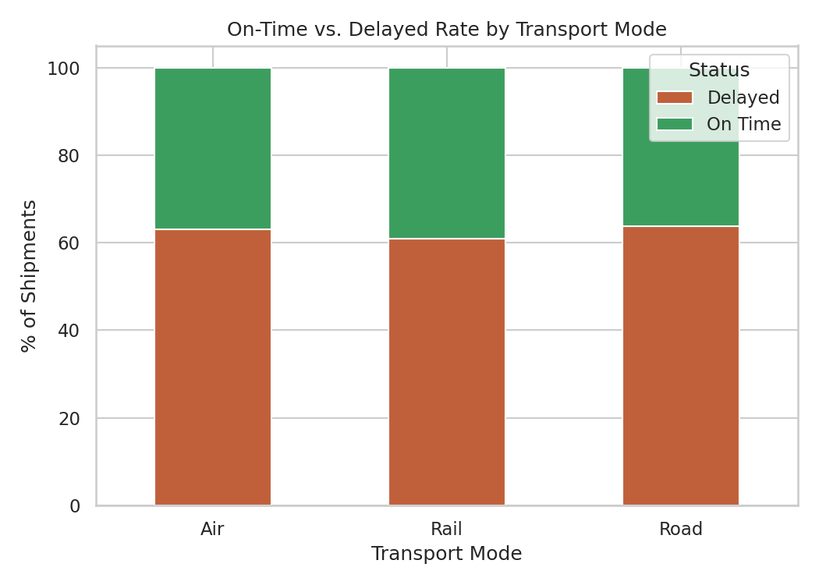
Figure 6. Percentage of shipments delivered on time versus delayed, by transport mode.
Delay rates are close across modes — Road 63.8%, Air 63.0%, Rail 60.9% — with Rail marginally the most reliable. No single mode stands out as a fix for the delay problem; the ~63% delay rate is systemic across the whole operation rather than isolated to one carrier type.

5.7 Customer Satisfaction vs. Delivery Delay
Chosen method: scatter plot with a fitted regression line. Justification: this directly tests whether the relationship implied by the correlation coefficient (r = -0.88) holds visually and whether it looks linear, which validates using delay as a leading indicator for satisfaction.
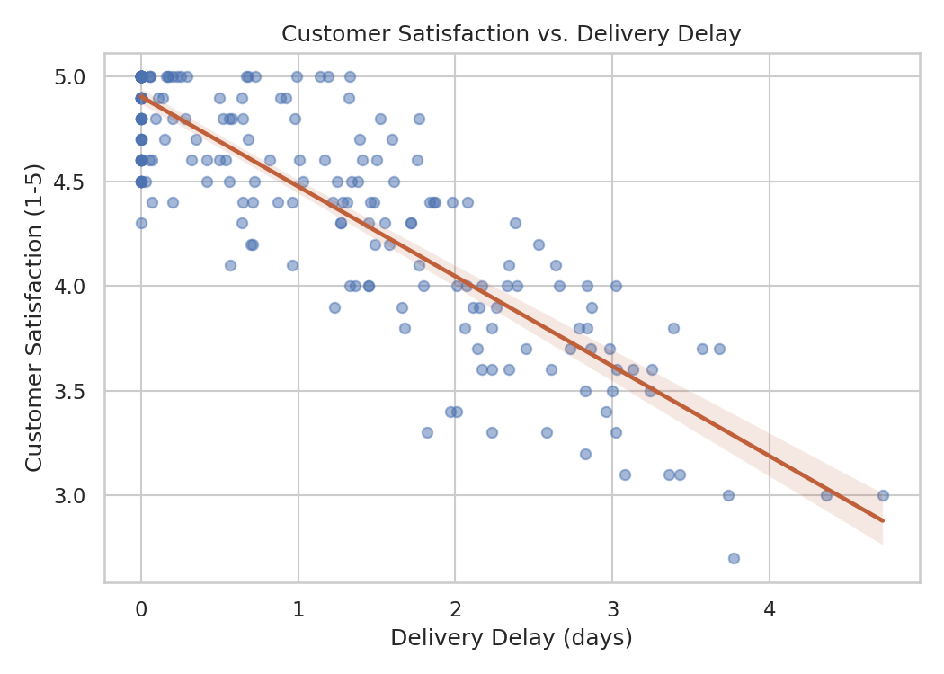
Figure 7. Customer satisfaction declines steadily and near-linearly as delivery delay increases.
This is the clearest and strongest pattern in the dataset. Satisfaction sits near 5.0 for on-time or barely-delayed shipments and falls toward 3.0 as delay approaches 4–5 days. Because this relationship (r = -0.88) is far stronger than delay's relationship with cost or mode, it indicates that reducing delay — even without reducing cost — is the single highest-leverage action for improving customer experience.

5.8 Monthly Shipment Volume Trend
Chosen method: line chart. Justification: line charts are the standard choice for showing how a metric evolves over time, making seasonal or trend patterns immediately visible.
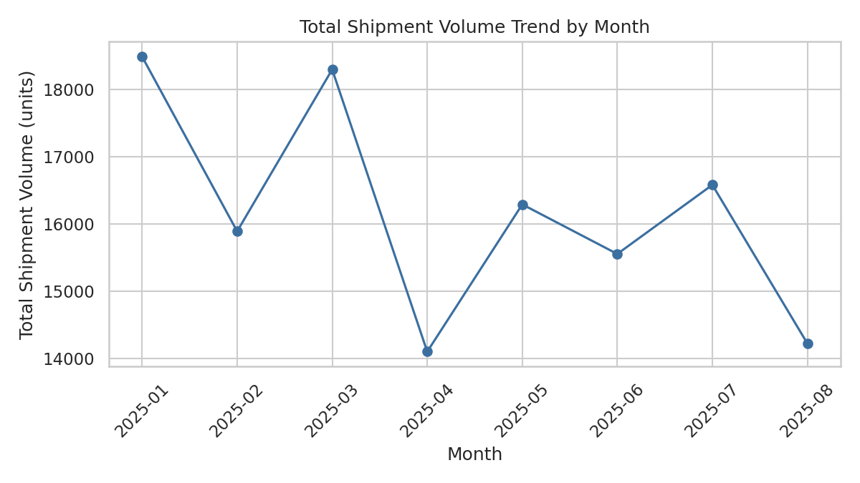
Figure 8. Total shipment volume (units) aggregated by month, January–August 2025.
Monthly total volume fluctuates without a strong directional trend across the eight months, indicating this dataset does not exhibit obvious seasonality. This is useful context: it means the delay and cost patterns found above are structural (tied to distance, region, mode) rather than driven by demand spikes.

6. Analytical Insights and Recommendations

6.1 Key Insights
- Distance is the primary driver of cost and delay (r = 0.98 and 0.83 respectively); shipment volume is not (r ≤ 0.33) — cost and scheduling models should be built around distance/route, not order size.
- 62.9% of shipments were delayed, making delay a systemic operational issue rather than an edge case.
- East region underperforms all others on both average delay (1.20 days) and delayed-shipment rate (68.8%), a strong candidate for root-cause investigation (route length, carrier capacity, or hub congestion).
- Transport mode has surprisingly little effect on delivery time, cost, or delay rate (all within a narrow band across Air, Road, and Rail) — mode selection is not currently a meaningful lever for improving outcomes in this dataset.
- Customer satisfaction is overwhelmingly explained by delay (r = -0.88), far more than by cost (r = -0.75) or distance (r = -0.73) — delay is the metric that most directly moves the customer experience.
- Road is the least cost-efficient mode per kilometer ($2.92/km vs. $2.61–$2.70/km for Air and Rail), worth revisiting for long-haul routes currently assigned to Road.

6.2 Recommendations
- Prioritize delay reduction over cost-cutting initiatives, given delay's outsized effect on customer satisfaction relative to cost.
- Conduct a focused operational review of the East region's logistics chain — its delay profile is a statistical outlier relative to the other three regions.
- Re-evaluate Road-mode assignment on long-distance routes, where its higher cost-per-km erodes margin without a corresponding time advantage.
- Use delivery_delay_days as a leading KPI for customer satisfaction monitoring, since it predicts satisfaction more reliably than cost or mode in this dataset.
- Investigate the right-skewed tail of the delay distribution (shipments delayed 3+ days) as a separate root-cause category, since these outliers likely stem from different causes than the bulk of shipments delayed 0–1.5 days.

7. Appendix: Full Python Script
The complete analysis and visualization pipeline (pandas for EDA, matplotlib/seaborn for charts):
import pandas as pd
import matplotlib.pyplot as plt
import seaborn as sns
import numpy as np

df = pd.read_csv('hypothetical_logistics_dataset.csv')
df['shipment_date'] = pd.to_datetime(df['shipment_date'])
sns.set_theme(style='whitegrid', palette='deep')

# --- EDA ---
print(df.describe().round(2))
print(df.isnull().sum())
cols = ['shipment_volume','distance_km','delivery_time_days',
'delivery_delay_days','transport_cost','customer_satisfaction']
corr = df[cols].corr()

# --- Distributions ---
fig, axes = plt.subplots(1, 2, figsize=(11,4.2))
sns.histplot(df['delivery_time_days'], kde=True, ax=axes[0])
sns.histplot(df['delivery_delay_days'], kde=True, ax=axes[1])

# --- Correlation heatmap ---
sns.heatmap(corr, annot=True, fmt='.2f', cmap='coolwarm', center=0)

# --- Cost vs distance by mode ---
sns.scatterplot(data=df, x='distance_km', y='transport_cost', hue='transport_mode')

# --- Delay by region ---
sns.boxplot(data=df, x='region', y='delivery_delay_days')

# --- Mode time/cost dual-axis bar ---
agg = df.groupby('transport_mode')[['delivery_time_days','transport_cost']].mean()

# --- On-time vs delayed rate by mode ---
status_mode = pd.crosstab(df['transport_mode'], df['delivery_status'], normalize='index') * 100
status_mode.plot(kind='bar', stacked=True)

# --- Satisfaction vs delay regression ---
sns.regplot(data=df, x='delivery_delay_days', y='customer_satisfaction')

# --- Monthly volume trend ---
df['month'] = df['shipment_date'].dt.to_period('M').astype(str)
df.groupby('month')['shipment_volume'].sum().plot(kind='line', marker='o')

