**Exercise 1: Parameterized Tests Scenario**

You want to test a method that checks if a number is even. Instead of writing multiple test cases, you will use parameterized tests to run the same test with different inputs.

Steps: 1. Create a new Java class `EvenChecker` with a method `isEven(int number)`.

2. Write a parameterized test class `EvenCheckerTest` that tests the `isEven` method with different inputs.

3. Use JUnit's `@ParameterizedTest` and `@ValueSource` annotations.

**EvenChecker.java**

package com.example.junitdemo;

public class EvenChecker {

public boolean isEven(int number) {

return number % 2 == 0;

}

}

**EvenCheckerTest.java**

package com.example.junitdemo;

import org.junit.jupiter.params.ParameterizedTest;

import org.junit.jupiter.params.provider.ValueSource;

import static org.junit.jupiter.api.Assertions.*;

public class EvenCheckerTest {

EvenChecker checker = new EvenChecker();

@ParameterizedTest

@ValueSource(ints = {2, 4, 6, 8, 10})

void testIsEvenTrue(int number) {

assertTrue(checker.isEven(number));

}

@ParameterizedTest

@ValueSource(ints = {1, 3, 5, 7, 9})

void testIsEvenFalse(int number) {

assertFalse(checker.isEven(number));

}

}

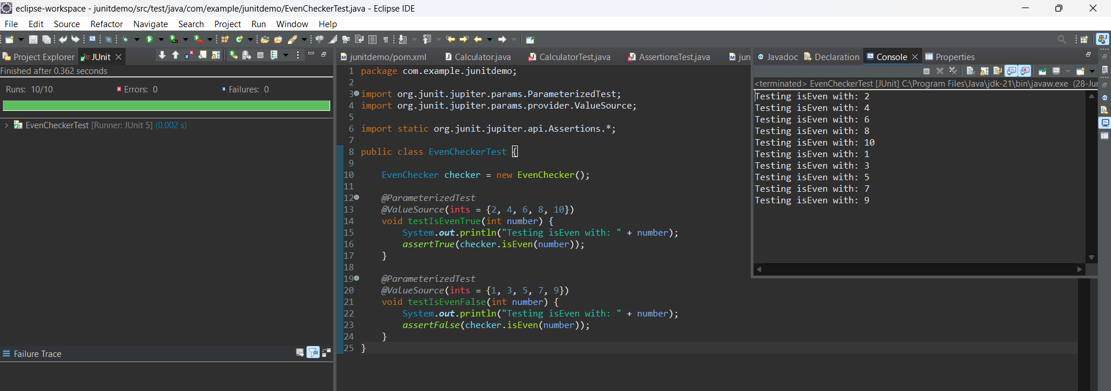

**Exercise 2: Test Suites and Categories Scenario**

You want to group related tests into a test suite and categorize them.

Steps: 1. Create a new test suite class `AllTests`.

2. Add multiple test classes to the suite.

3. Use JUnit's `@Suite` and `@SelectClasses` annotations.

**AllTests.java**

package com.example.junitdemo;

import org.junit.platform.suite.api.SelectClasses;

import org.junit.platform.suite.api.Suite;

@Suite

@SelectClasses({

EvenCheckerTest.class,

CalculatorTest.class

})

public class AllTests {

}

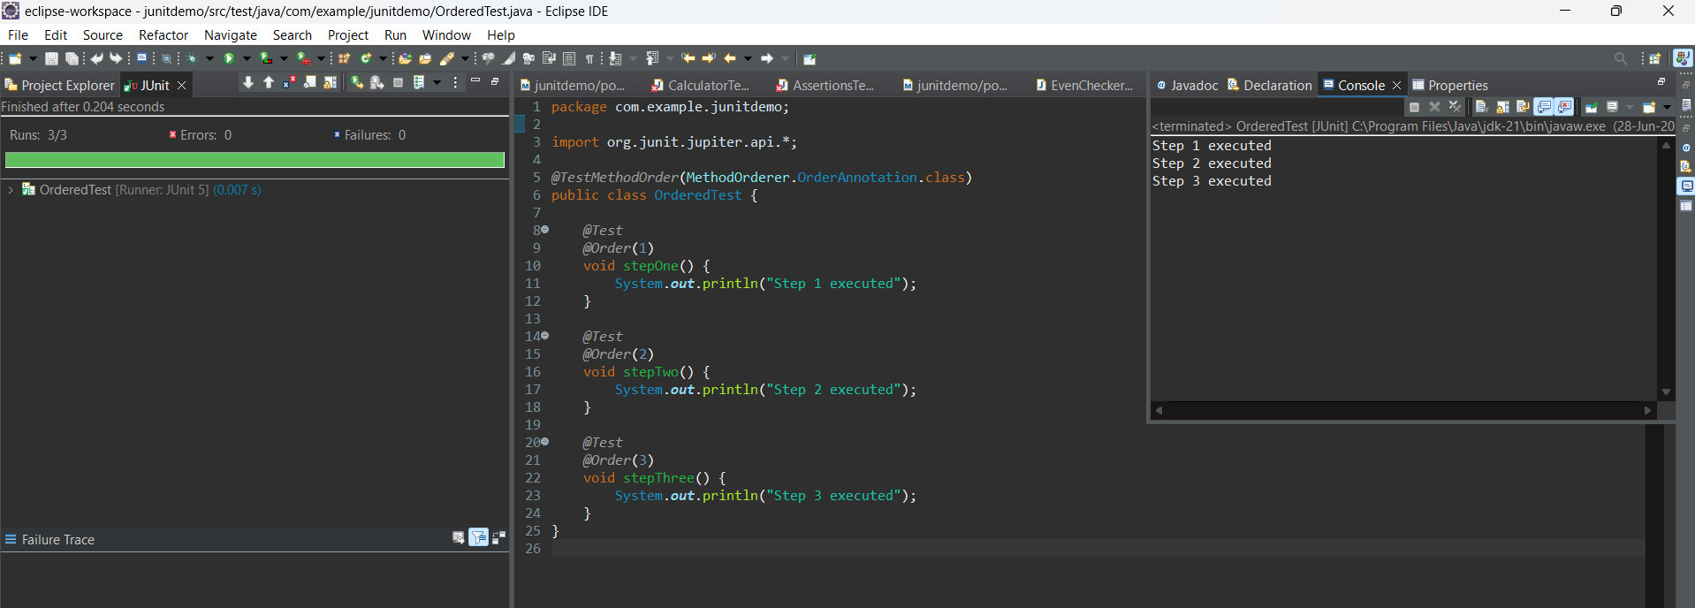

**Exercise 3: Test Execution Order Scenario**

You want to control the order in which tests are executed.

Steps: 1. Create a test class `OrderedTests`.

2. Use JUnit's `@TestMethodOrder` and `@Order` annotations.

**OrderedTests.java**

package com.example.junitdemo;

import org.junit.jupiter.api.*;

@TestMethodOrder(MethodOrderer.OrderAnnotation.class)

public class OrderedTests {

@Test

@Order(1)

void testA() {

System.out.println("Running test A");

}

@Test

@Order(3)

void testC() {

System.out.println("Running test C");

}

@Test

@Order(2)

void testB() {

System.out.println("Running test B");

}

}

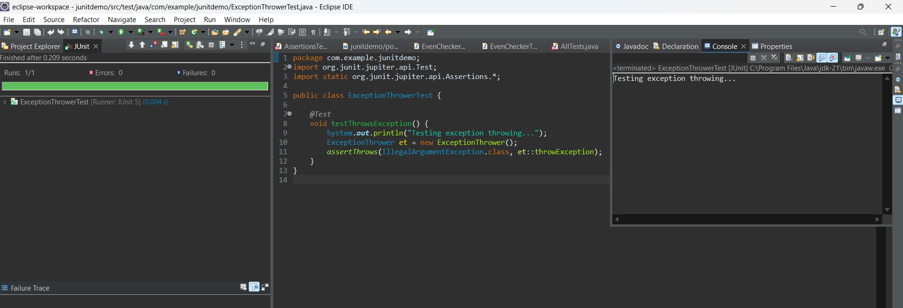

**Exercise 4: Exception Testing Scenario**

You want to test that a method throws the expected exception.

Steps: 1. Create a class `ExceptionThrower` with a method `throwException`.

2. Write a test class `ExceptionThrowerTest` that tests the method for the expected exception.

**ExceptionThrower.java**

package com.example.junitdemo;

public class ExceptionThrower {

public void throwException() {

throw new IllegalArgumentException("Invalid argument");

}

}

**ExceptionThrowerTest.java**

package com.example.junitdemo;

import org.junit.jupiter.api.Test;

import static org.junit.jupiter.api.Assertions.*;

public class ExceptionThrowerTest {

@Test

void testThrowException() {

ExceptionThrower et = new ExceptionThrower();

assertThrows(IllegalArgumentException.class, et::throwException);

}

}

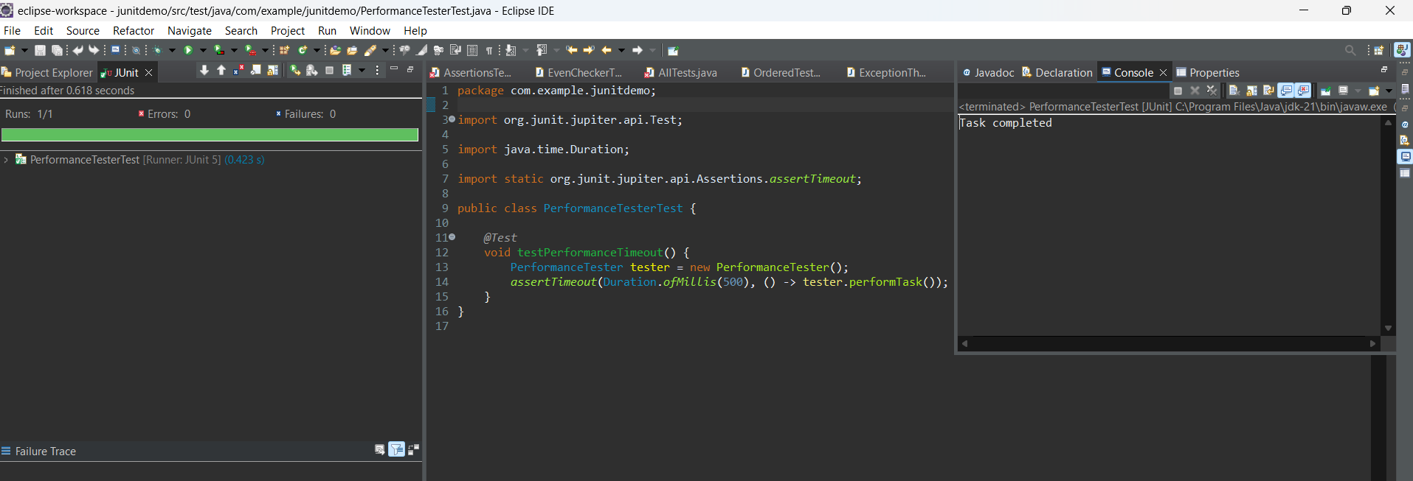

**Exercise 5: Timeout and Performance Testing Scenario**

You want to ensure that a method completes within a specified time limit.

Steps: 1. Create a class `PerformanceTester` with a method `performTask`.

2. Write a test class `PerformanceTesterTest` that tests the method for timeout.

**PerformanceTester.java**

package com.example.junitdemo;

public class PerformanceTester {

public void performTask() throws InterruptedException {

Thread.sleep(400); // Simulate a task

}

}

**PerformanceTesterTest.java**

package com.example.junitdemo;

import org.junit.jupiter.api.Test;

import static org.junit.jupiter.api.Assertions.assertTimeout;

import java.time.Duration;

public class PerformanceTesterTest {

@Test

void testPerformTaskWithinTime() {

PerformanceTester pt = new PerformanceTester();

assertTimeout(Duration.ofMillis(500), () -> pt.performTask());

}

}

