**Exercise 1:**

Setting Up JUnit Scenario: You need to set up JUnit in your Java project to start writing unit tests. Steps: 1. Create a new Java project in your IDE (e.g., IntelliJ IDEA, Eclipse).

2. Add JUnit dependency to your project

. If you are using Maven, add the following to your pom.xml:

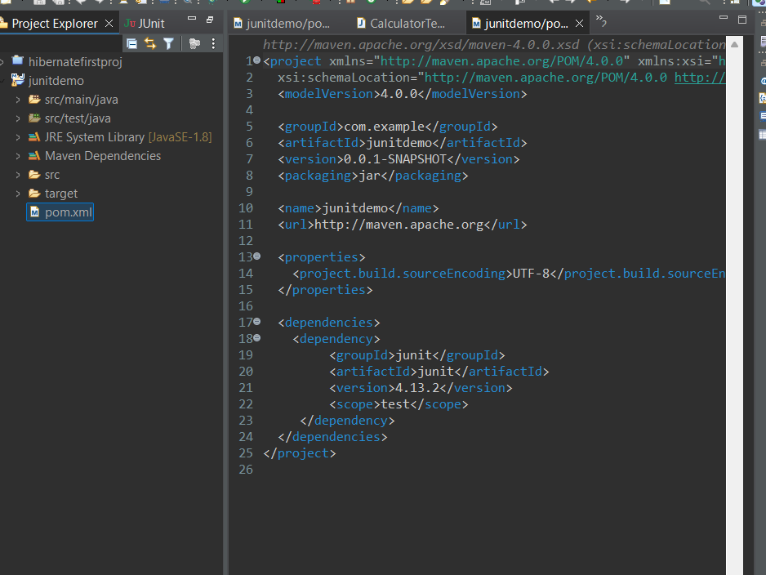

3. Create a new test class in your project.

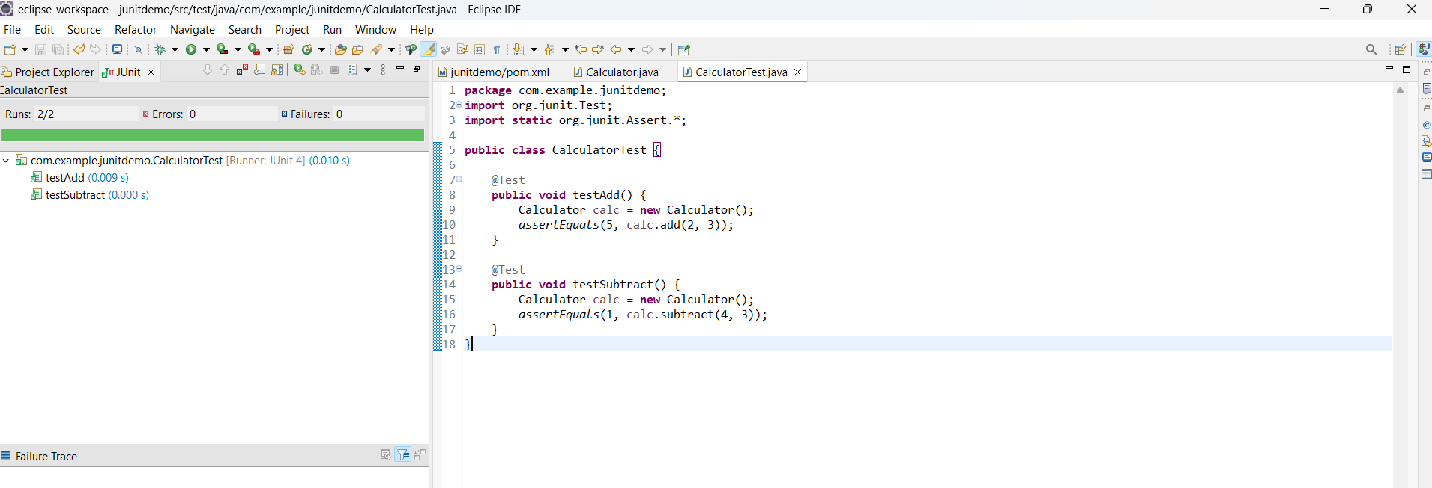

**Exercise 2:**

Writing Basic JUnit Tests Scenario: You need to write basic JUnit tests for a simple Java class. Steps: 1. Create a new Java class with some methods to test. 2. Write JUnit tests for these methods.



**Exercise 3:**

Assertions in JUnit Scenario: You need to use different assertions in JUnit to validate your

test results.

Steps: 1. Write tests using various JUnit assertions.

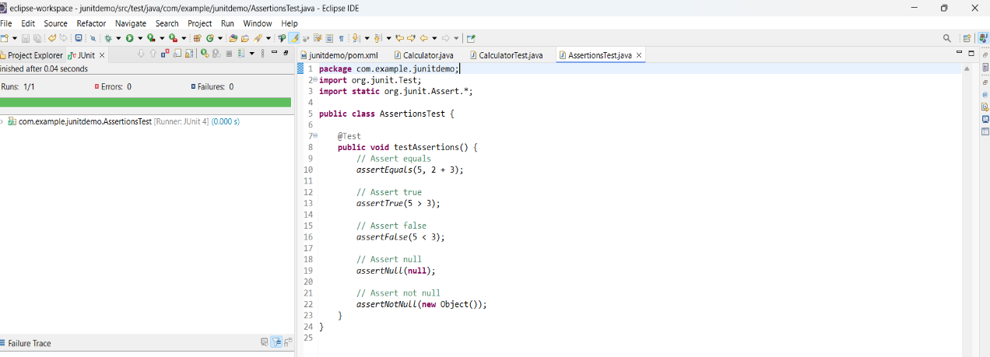

**Exercise 4:**

Arrange-Act-Assert (AAA) Pattern, Test Fixtures, Setup and Teardown Methods in JUnit Scenario: You need to organize your tests using the Arrange-Act-Assert (AAA) pattern and use setup and teardown methods.

Steps: 1. Write tests using the AAA pattern.

2. Use @Before and @After annotations for setup and teardown methods.

