**Logging using SLF4J**

**Exercise 1: Logging Error Messages and Warning Levels Task**

Write a Java application that demonstrates logging error messages and warning levels using SLF4J. Step-by-Step Solution:

Add SLF4J and Logback dependencies to your `pom.xml` file:

Create a Java class that uses SLF4J for logging:

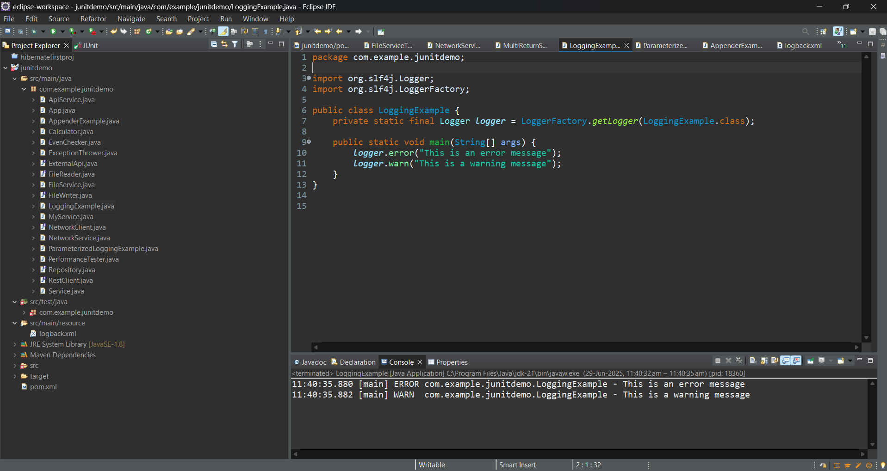

**Exercise 2: Parameterized Logging Task**

Write a Java application that demonstrates parameterized logging using SLF4J.

Step-by-Step Solution:

Add SLF4J and Logback dependencies to your `pom.xml` file

Create a Java class that uses SLF4J for parameterized logging:

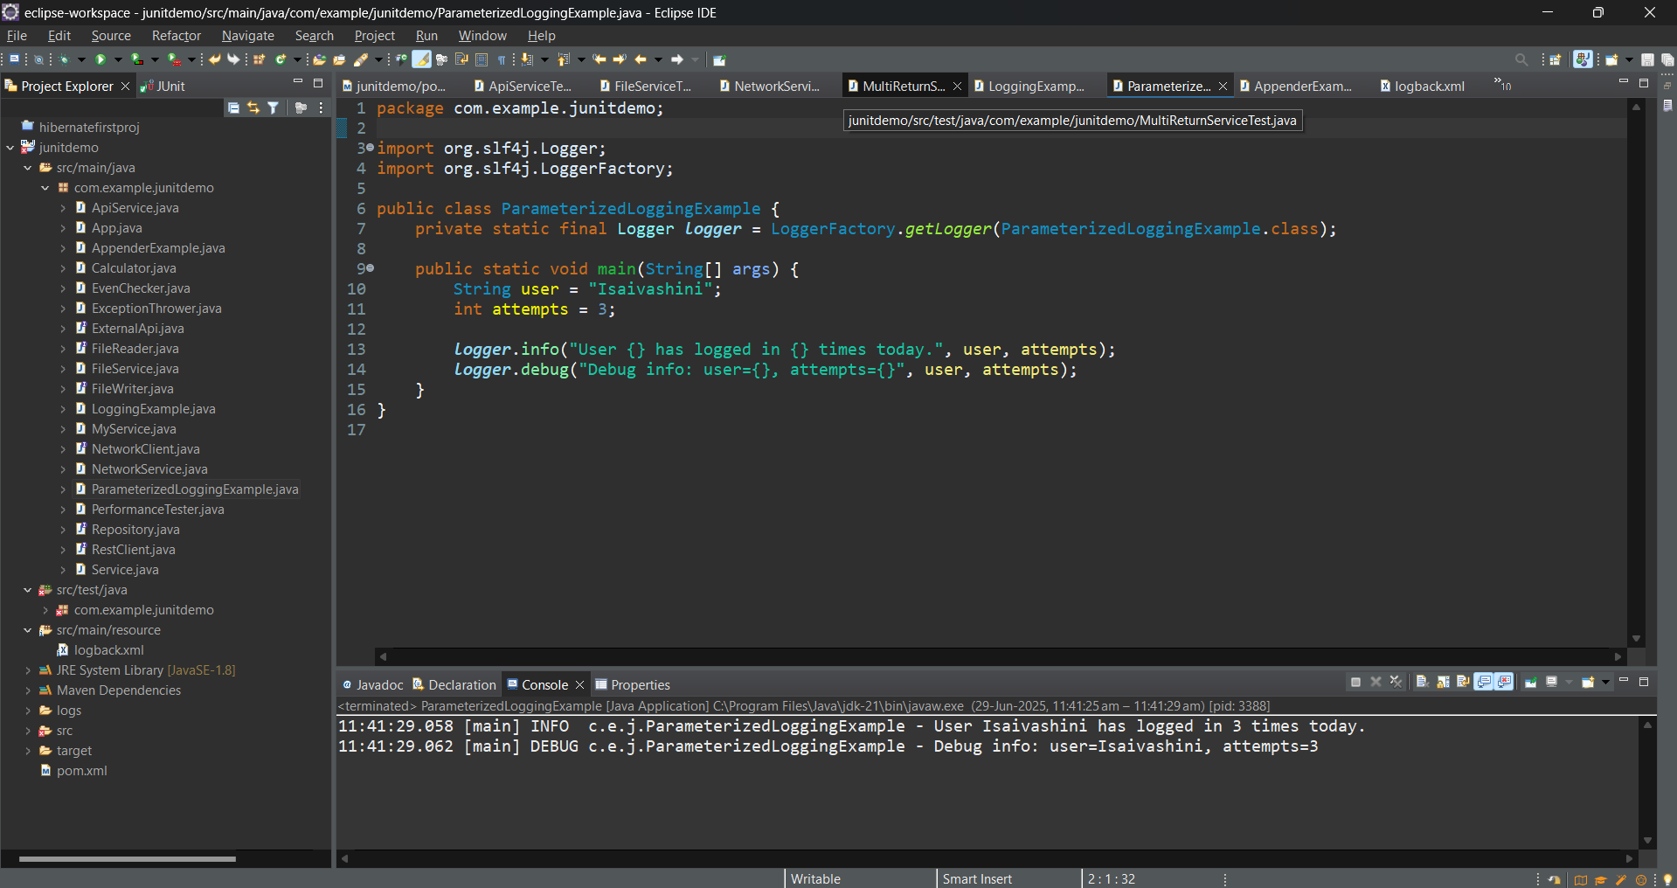

**Exercise 3: Using Different Appenders Task**

Write a Java application that demonstrates using different appenders with SLF4J.

Step-by-Step Solution:

1. Add SLF4J and Logback dependencies to your `pom.xml` file.

2. Create a `logback.xml` configuration file to define different appenders: %

3. Create a Java class that uses SLF4J for logging: Write code for this.

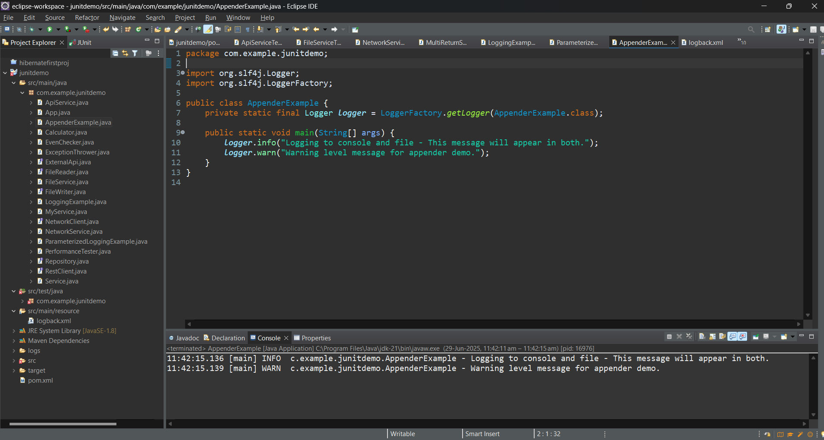

**LOGBACK.XML**

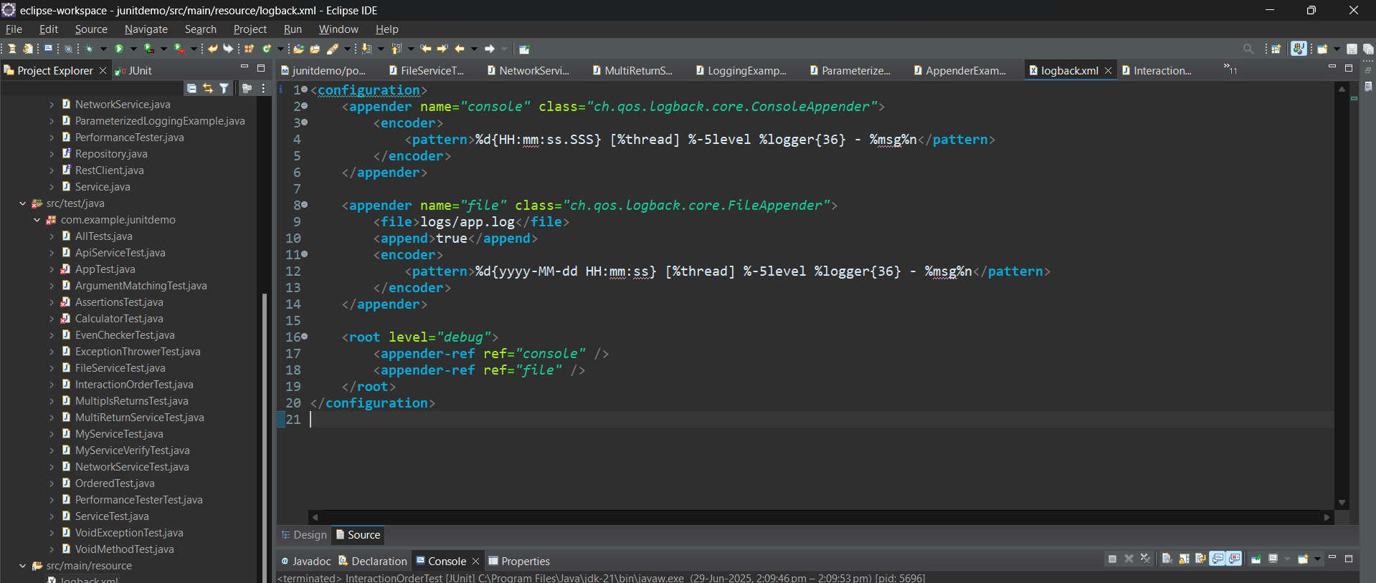

**POM.XML**

<project xmlns="http://maven.apache.org/POM/4.0.0"

xmlns:xsi="http://www.w3.org/2001/XMLSchema-instance"

xsi:schemaLocation="http://maven.apache.org/POM/4.0.0

http://maven.apache.org/xsd/maven-4.0.0.xsd">

<modelVersion>4.0.0</modelVersion>

<groupId>com.example</groupId>

<artifactId>junitdemo</artifactId>

<version>0.0.1-SNAPSHOT</version>

<packaging>jar</packaging>

<name>junitdemo</name>

<properties>

<project.build.sourceEncoding>UTF-8</project.build.sourceEncoding>

<maven.compiler.source>1.8</maven.compiler.source>

<maven.compiler.target>1.8</maven.compiler.target>

</properties>

<dependencies>

<!-- JUnit 5 Core -->

<dependency>

<groupId>org.junit.jupiter</groupId>

<artifactId>junit-jupiter</artifactId>

<version>5.9.3</version>

<scope>test</scope>

</dependency>

<!-- JUnit 5 Suite API -->

<dependency>

<groupId>org.junit.platform</groupId>

<artifactId>junit-platform-suite</artifactId>

<version>1.9.3</version>

<scope>test</scope>

</dependency>

<!-- Mockito -->

<dependency>

<groupId>org.mockito</groupId>

<artifactId>mockito-core</artifactId>

<version>5.11.0</version>

<scope>test</scope>

</dependency>

<!-- SLF4J API -->

<dependency>

<groupId>org.slf4j</groupId>

<artifactId>slf4j-api</artifactId>

<version>1.7.30</version>

</dependency>

<!-- Logback Implementation -->

<dependency>

<groupId>ch.qos.logback</groupId>

<artifactId>logback-classic</artifactId>

<version>1.2.3</version>

</dependency>

</dependencies>

<build>

<plugins>

<!-- JUnit 5 runner -->

<plugin>

<groupId>org.apache.maven.plugins</groupId>

<artifactId>maven-surefire-plugin</artifactId>

<version>3.0.0-M7</version>

</plugin>

</plugins>

</build>

</project>