**Mockito Hands-On Exercises**

**Exercise 1: Mocking and Stubbing Scenario**

You need to test a service that depends on an external API. Use Mockito to mock the external API and stub its methods.

Steps: 1. Create a mock object for the external API.

2. Stub the methods to return predefined values.

3. Write a test case that uses the mock object.

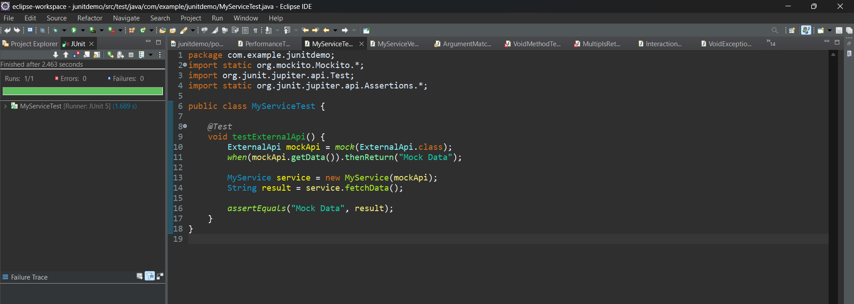

**Exercise 2: Verifying Interactions Scenario**

You need to ensure that a method is called with specific arguments.

Steps: 1. Create a mock object.

2. Call the method with specific arguments.

3. Verify the interaction.

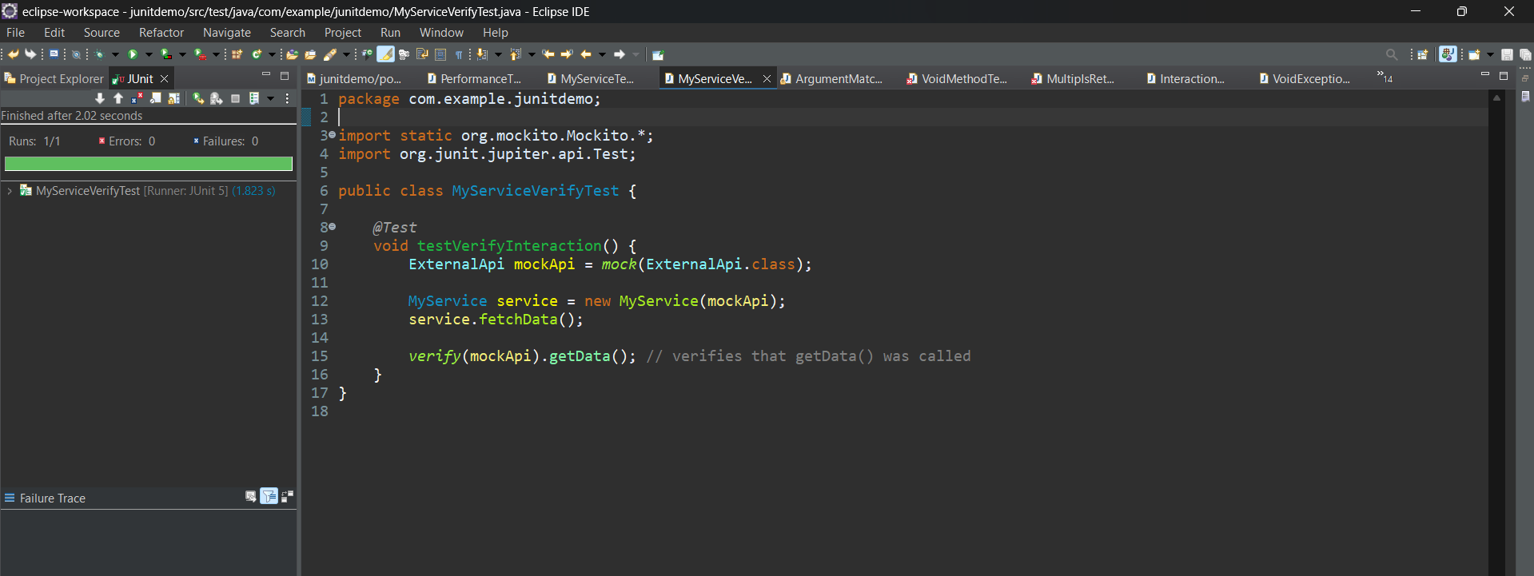

**Exercise 3: Argument Matching Scenario**

You need to verify that a method is called with specific arguments.

Steps: 1. Create a mock object.

2. Call the method with specific arguments.

3. Use argument matchers to verify the interaction.

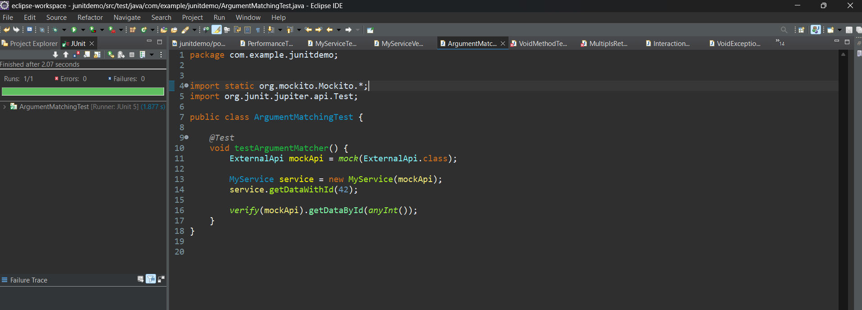

**Exercise 4: Handling Void Methods Scenario:**

You need to test a void method that performs some action.

Steps: 1. Create a mock object.

2. Stub the void method.

3. Verify the interaction.

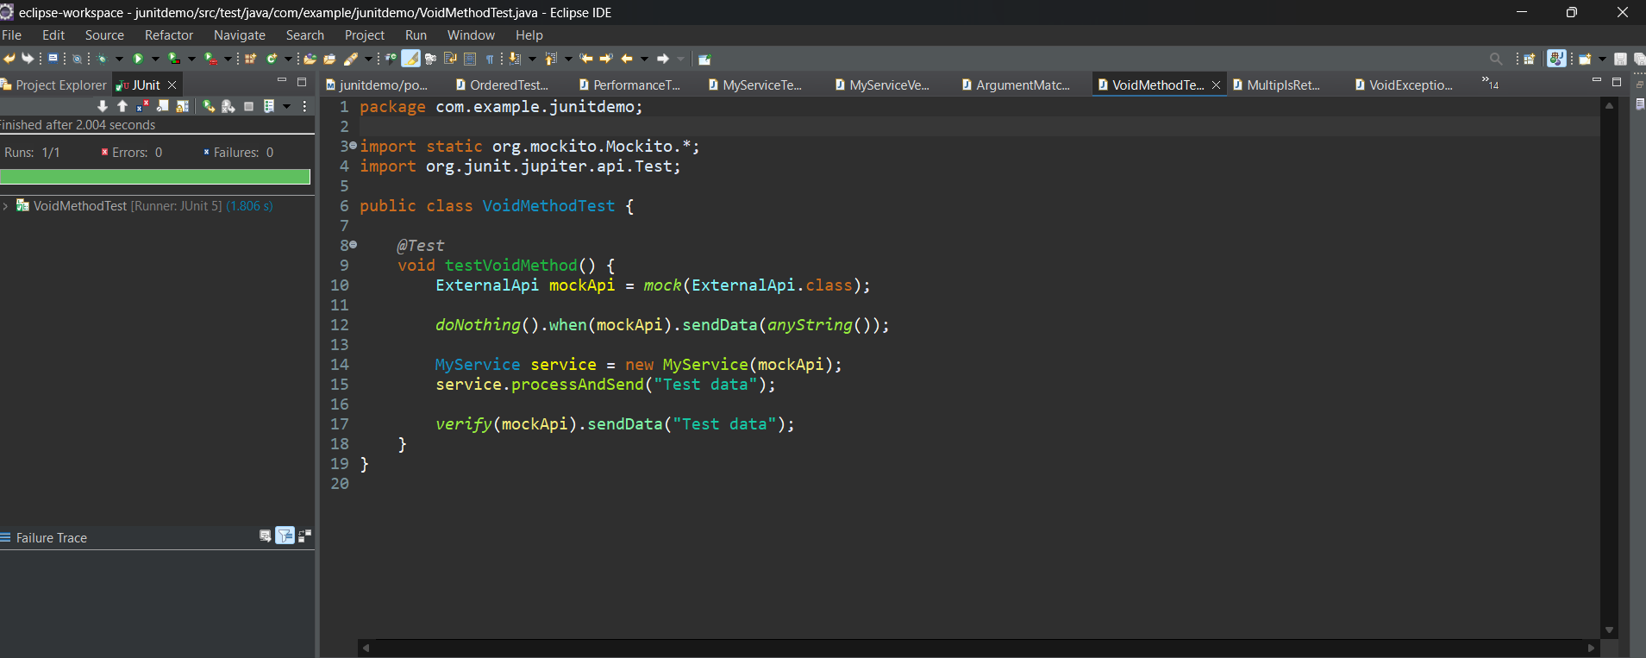

**Exercise 5: Mocking and Stubbing with Multiple Returns Scenario:**

You need to test a service that depends on an external API with multiple return values.

Steps: 1. Create a mock object for the external API.

2. Stub the methods to return different values on consecutive calls.

3. Write a test case that uses the mock object.

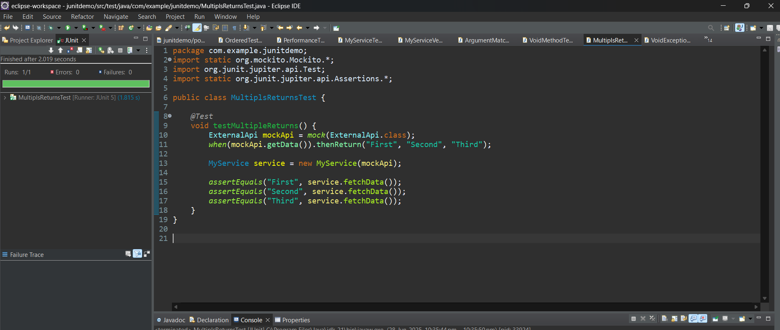

**Exercise 6: Verifying Interaction Order Scenario:**

You need to ensure that methods are called in a specific order.

Steps: 1. Create a mock object.

2. Call the methods in a specific order.

3. Verify the interaction order.

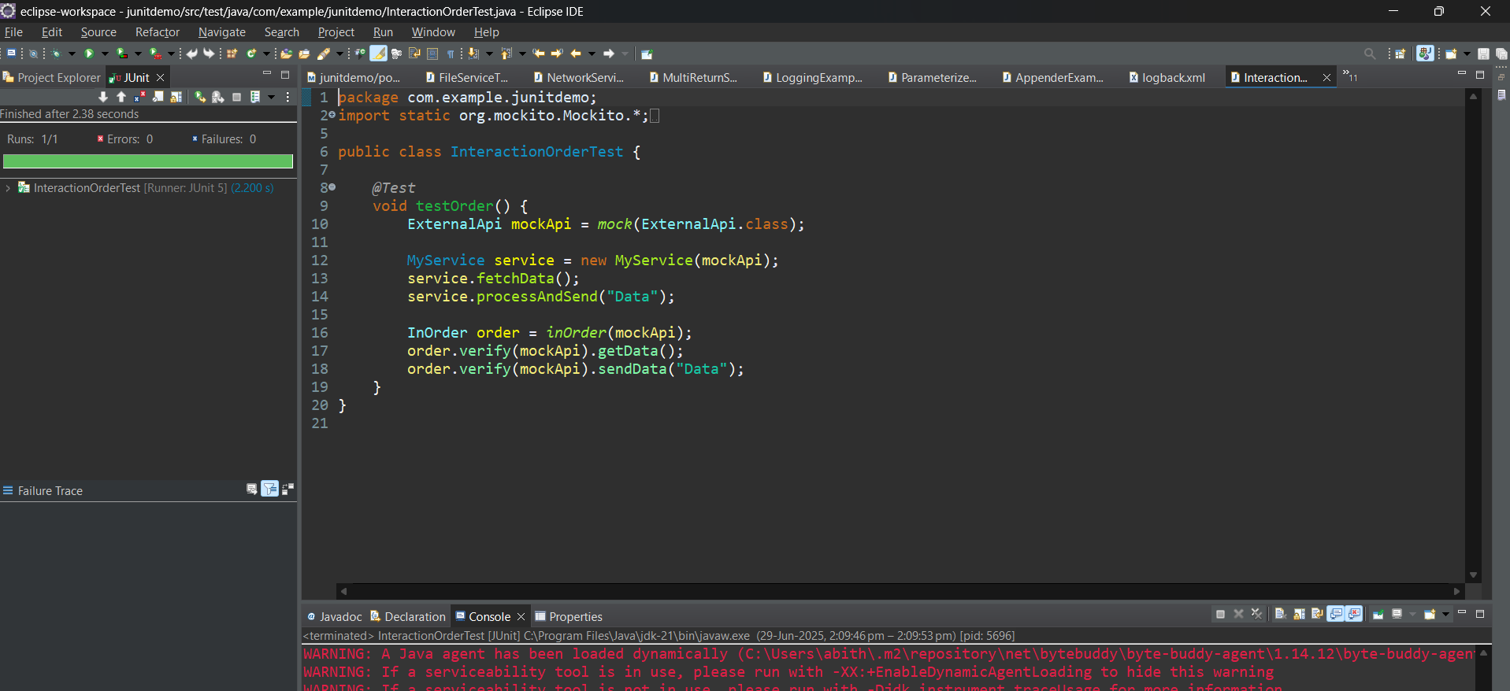

**Exercise 7: Handling Void Methods with Exceptions Scenario:**

You need to test a void method that throws an exception.

Steps: 1. Create a mock object.

2. Stub the void method to throw an exception.

3. Verify the interaction.

