**WEEK 6 REACT**

**EX-1**

**App.js**

import React from 'react';

import './App.css';

import Home from './Components/Home';

import About from './Components/About';

import Contact from './Components/Contact';

function App() {

return (

<h1>Welcome to the first React Session </h1>

);

}

export default App;

**OUTPUT:**

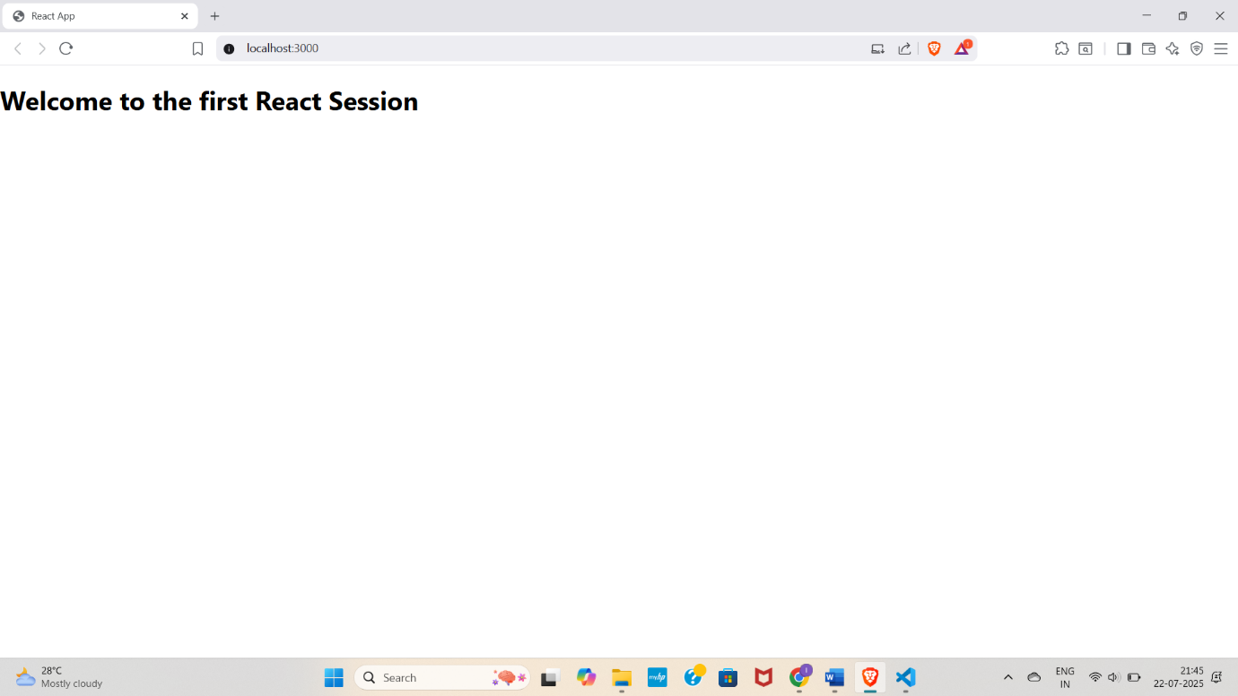

**Ex:2 STUDENTAPP**

**Home.js**

import React, { Component } from 'react';

class Home extends Component {

render() {

return (

<div>

<h2>Welcome to the Home page of Student Management Portal</h2>

</div>

);

}

}

export default Home;

**About.js**

import React, { Component } from 'react';

class About extends Component {

render() {

return (

<div>

<h2>Welcome to the About page of the Student Management Portal</h2>

</div>

);

}

}

export default About;

**Contact.js**

import React, { Component } from 'react';

class Contact extends Component {

render() {

return (

<div>

<h2>Welcome to the Contact page of the Student Management Portal</h2>

</div>

);

}

}

export default Contact;

**App.js**

import React from 'react';

import './App.css';

import Home from './Components/Home';

import About from './Components/About';

import Contact from './Components/Contact';

function App() {

return (

<div className="App">

<Home />

<About />

<Contact />

</div>

);

}

export default App;

**OUTPUT**

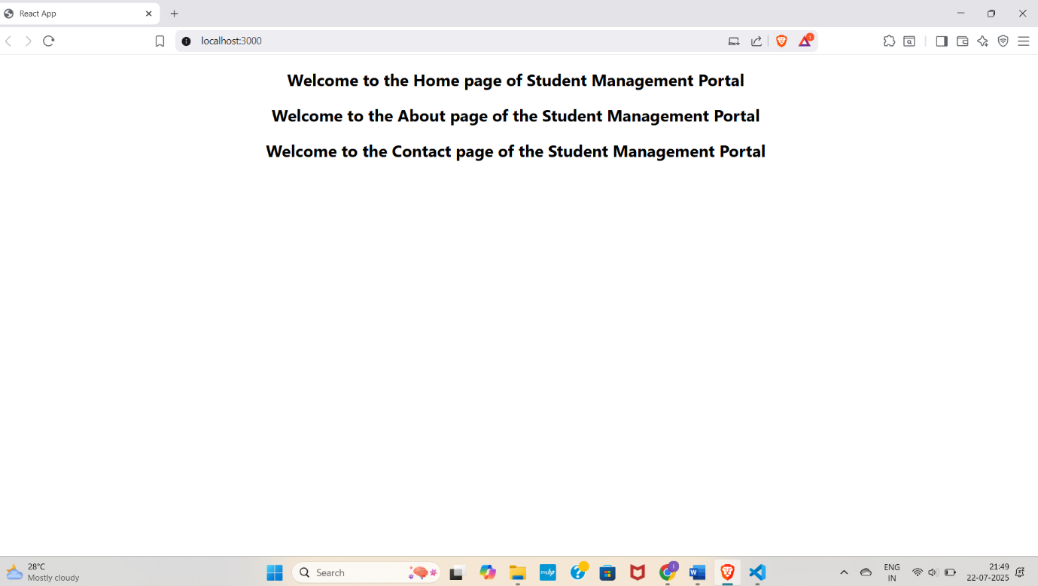

**EX 3 SCORECALCULATORAPP**

**CalculateScore.js**

import React from 'react';

function CalculateScore(props) {

const { name, school, total, goal } = props;

const average = (total / goal).toFixed(2);

return (

<div className="score-card">

<h2>Student Score Calculator</h2>

<p><strong>Name:</strong> {name}</p>

<p><strong>School:</strong> {school}</p>

<p><strong>Total Marks:</strong> {total}</p>

<p><strong>Goal:</strong> {goal}</p>

<p className="highlight">Average Score: {average}</p>

</div>

);

}

export default CalculateScore;

**App.js**

import React from 'react';

import './App.css';

import CalculateScore from './Components/CalculateScore';

function App() {

return (

<div className="App">

<CalculateScore

name="John Doe"

school="Green Valley High"

total={450}

goal={5}

/>

</div>

);

}

export default App;

**OUTPUT**

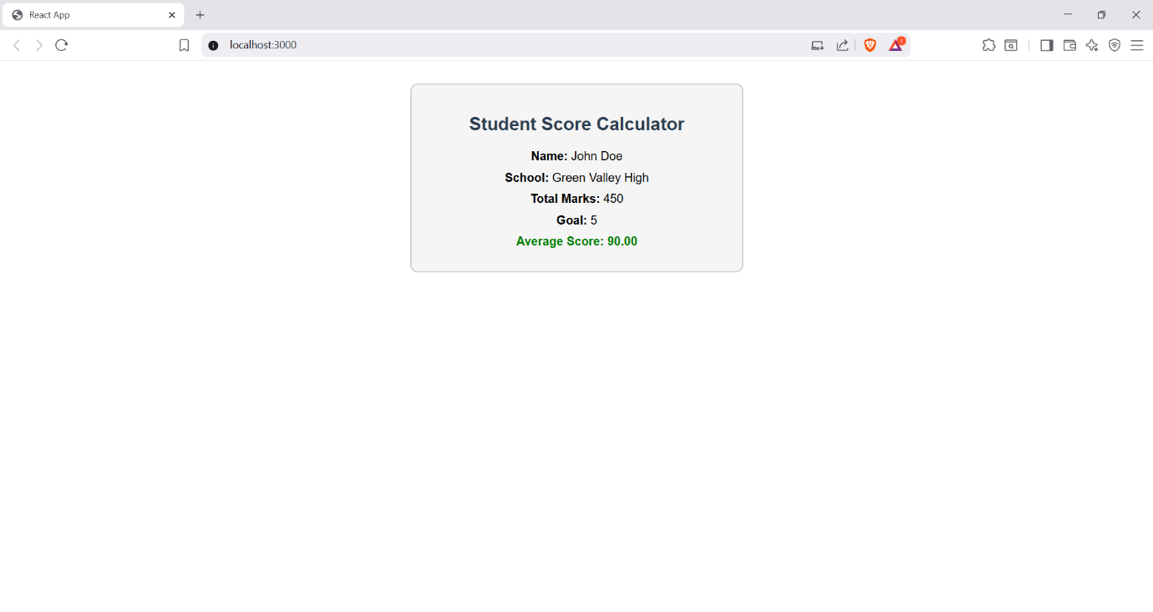

**EX 4 BLOGGAPP**

**Post.js**

import React from 'react';

class Post extends React.Component {

render() {

return (

<div className="post">

<h3>{this.props.title}</h3>

<p>{this.props.body}</p>

</div>

);

}

}

export default Post;

**Posts.js**

import React from 'react';

import Post from './Post';

class Posts extends React.Component {

constructor(props) {

super(props);

this.state = {

posts: [],

hasError: false,

};

}

loadPosts = () => {

fetch('https://jsonplaceholder.typicode.com/posts')

.then((response) => response.json())

.then((data) => this.setState({ posts: data }))

.catch((error) => {

console.error('Error fetching posts:', error);

this.setState({ hasError: true });

});

};

componentDidMount() {

this.loadPosts();

}

componentDidCatch(error, info) {

alert('Something went wrong!');

console.error("Caught by componentDidCatch:", error, info);

}

render() {

if (this.state.hasError) {

return <h2>Unable to load posts.</h2>;

}

return (

<div>

<h2>Posts</h2>

{this.state.posts.slice(0, 10).map((post) => (

<Post key={post.id} title={post.title} body={post.body} />

))}

</div>

);

}

}

export default Posts;

**App.js**

import React from 'react';

import './App.css';

import Posts from './Posts';

function App() {

return (

<div className="App">

<header className="App-header">

<h1>Blog App</h1>

<Posts />

</header>

</div>

);

}

export default App;

**OUTPUT**

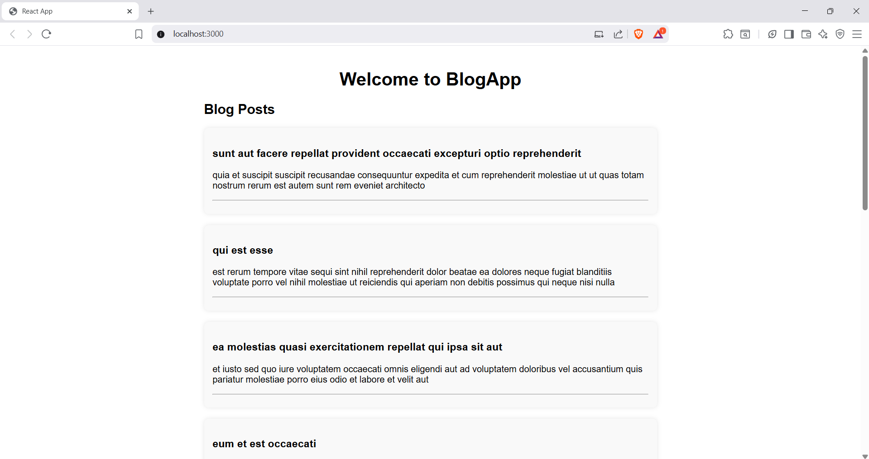

**EX 5 COHORTDETAILS**

**CohortDetails.js**

import React from "react";

import styles from "./CohortDetails.module.css";

function CohortDetails(props) {

const { cohort } = props;

const statusStyle = {

color: cohort.status.toLowerCase() === "ongoing" ? "green" : "blue"

};

return (

<div className={styles.box}>

<h3 style={statusStyle}>{cohort.name}</h3>

<dl>

<dt>Trainer</dt>

<dd>{cohort.trainer}</dd>

<dt>Status</dt>

<dd>{cohort.status}</dd>

<dt>Participants</dt>

<dd>{cohort.participants}</dd>

</dl>

</div>

);

}

export default CohortDetails;

**App.js**

import React from "react";

import CohortDetails from "./CohortDetails";

function App() {

const cohorts = [

{

name: "React Bootcamp",

trainer: "Ravi",

status: "ongoing",

participants: 25

},

{

name: "Node.js Deep Dive",

trainer: "Anita",

status: "completed",

participants: 30

}

];

return (

<div>

<h1>Cohort Dashboard</h1>

{cohorts.map((cohort, index) => (

<CohortDetails key={index} cohort={cohort} />

))}

</div>

);

}

export default App;

**CohortDetails.module.css**

.box {

width: 300px;

display: inline-block;

margin: 10px;

padding: 10px 20px;

border: 1px solid black;

border-radius: 10px;

}

dt {

font-weight: 500;

}

**OUTPUT**

