Isai Mercado Oliveros
April 1, 2016
Clustering Lab

Report your exact results on sponge data set with k=4 clusters. For k-means use the first 4 elements of the data set as initial centroids.
Cluster 1 | Cluster 2 | Cluster 3 | Cluster 4
point 0  point 13  point 14  point 16  point 20  point 22  point 25  point 26  point 27  point 29  point 30  point 31  point 39  point 40  point 41  point 46  point 48  point 49  point 53  point 60  point 61  point 63  point 64  point 70  point 72  point 73  point 74  point 75 | point 1  point 7  point 8  point 9  point 10  point 11  point 12  point 33  point 34  point 35  point 37  point 38  point 42  point 43  point 44  point 45  point 50  point 51  point 52  point 54  point 55  point 56  point 57  point 58  point 59  point 62  point 65  point 66  point 67  point 68  point 69 | point 2  point 3  point 4  point 5 | point 6  point 15  point 17  point 18  point 19  point 21  point 23  point 24  point 28  point 32  point 36  point 47  point 71

Run your Clustering Algorithm on Iris data with no target column. Run it for k = 2-7. State whether you normalize or not (your choice). Graph the total SSE for each k and discuss your results
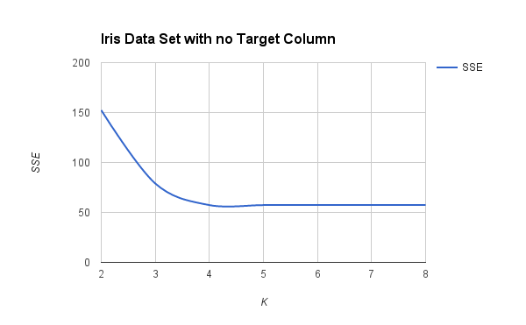

K | SSE
2 | 152.3687
3 | 78.9450
4 | 57.3454
5 | 57.3550
6 | 57.4732
7 | 57.4732
8 | 57.4732

I did not normalize my data. From this graph I can see that as K increases, the SSE value levels out. I think this happens because even if K is increasing, the number of clusters found by K Means stops at certain point, and some clusters end up being empty, so the SSE value is calculated from non empty clusters whose quantity, as mentioned before, gets stabilized at certain K.
Now do it again where you include the output class as one of the input features and discuss your results and any differences.
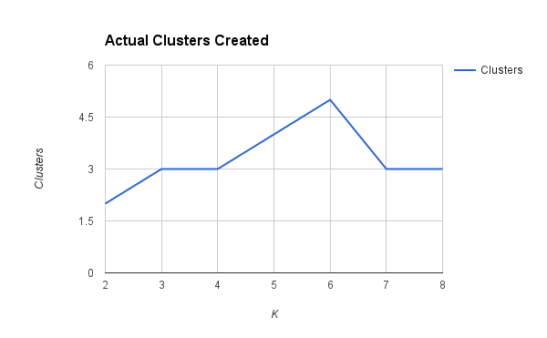
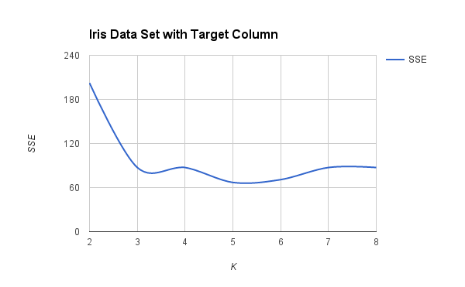
K | SSE
2 | 202.368
3 | 87.3296
4 | 87.3296
5 | 66.9785
6 | 70.7993
7 | 87.3296
8 | 87.3296

Now that the output class is included, it is easier for KMeans to find the actual 3 clusters. An interesting fact that I observed while increasing K is that even though K got larger and larger sometimes KMeans only found 3 clusters and the rest of the clusters where empty. So in this experiment, the SSE leveled out at 3 clusters.

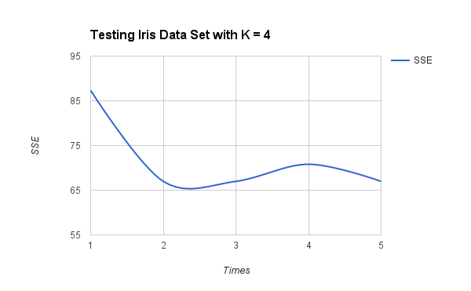
Run k-means 5 times with k=4, each time with different initial random centroids and discuss any variations in the results.

Times | SSE | Clusters
1 | 87.3296 | 3
2 | 66.9785 | 4
3 | 66.9785 | 4
4 | 70.7993 | 4
5 | 66.9785 | 4

As observed before, the SSE leveled out between 3 and 4 clusters. Sometimes, it returned 3 clusters because the Iris data set has 3 real clusters, but at the same time, since KMeans was given 4 as the K, it was trying to force points to cluster into 4 clusters

Run your variation abalone data set. Treat“rings”as a continuous variable. Why would I suggest that? Run it for k = 2-7. Graph your results without normalization.
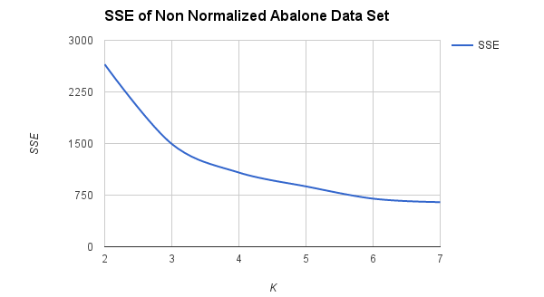
K | SSE
2 | 2650.3459
3 | 1493.5063
4 | 1077.8740
5 | 876.8568
6 | 698.7114
7 | 647.920

It is better to use rings as a continuous value because since it represents years, it is better to calculate their distance by euclidean distance rather than 0 or 1. In addition from this graph, I can see that without normalization, the increment in K makes the SSE go down. I think that this happens because more clusters cause the inner cluster-points distance to decrease, so the overall SSE is smaller.
Run it again with normalization.
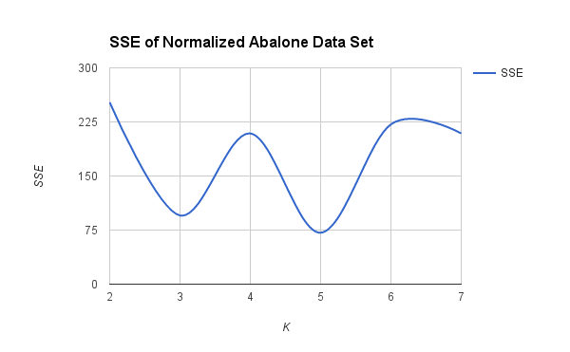

K | SSE
2 | 252.118
3 | 95.2109
4 | 208.9906
5 | 71.3128
6 | 221.6001
7 | 208.9906

This graph is completely different from the graph without normalization. I think that SSE is more stable with normalization since all dimensions pull with equal magnitudes. Thus, the SSE is more perceptible to changes in distances. In this case, I think that the data has 5 clusters since K = 5 has the smallest SSE which means that the clusters are more compact.

For your normalized abalone experiments, calculate and graph a performance metric for the clusterings for k = 2-7. Use the Silhouette. Discuss how effective the metric you used might be in these cases for selecting which number of clusters is best.
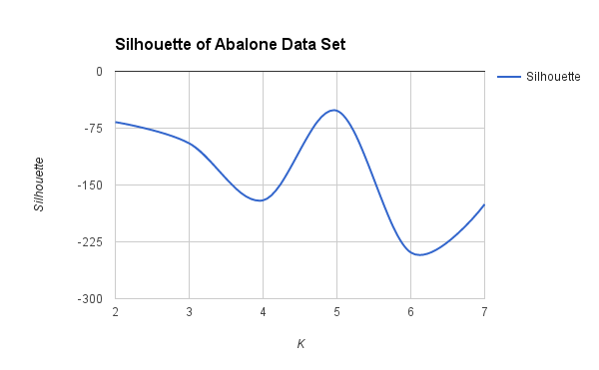
K | SSE | Silhouette
2 | 282.0261 | -67.0026
3 | 221.6001 | -94.9887
4 | 240.6865 | -170.2089
5 | 71.3094 | -52.0247
6 | 58.6403 | -239.0877
7 | 49.6857 | -175.4321

The results of the silhouette function make me think that the abalone data set must have 5 clusters because K = 5 has the greatest silhouette of all Ks. This means that the overall cluster-inner-distance is smaller than the overall cluster-outer-distance which means that points are better pertaining to their current cluster rather than a neighboring cluster. Therefore, K = 5 has better quality clusters which makes me think that the abalone data set might have 5 groupings.

Do an experiment of your own regarding clustering.
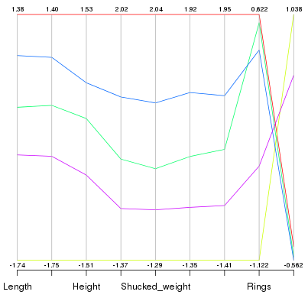
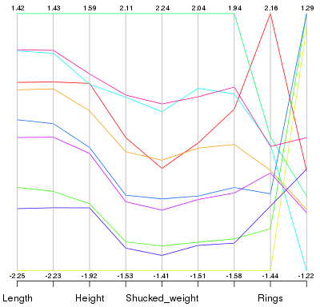
For my experiment I wanted to visualize the means in order to see if having 5 clusters for the abalone data set made sense. I used R to make two parallel coodinate plots for kmeans with K = 5, and K = 10. My goal was to see if 10 means would kind of cluster into 5 means... And it looks like the 10 clusters could actually be merged into 5 clusters. Thus, my hypothesis of the abalone data set having 5 clusters could be correct.

