***Torres, Isaiah C***

***BSTM 191***

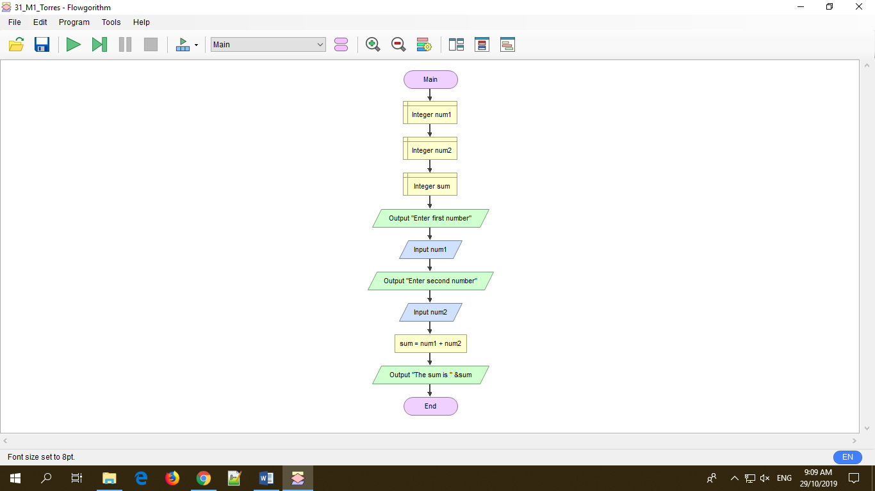

The flowgarithm flowchart above shows the program that adds two numbers. First, it is required to declare all integers that will be used in the program. As seen in the image, the first three yellow boxes declares integers named as num1, num2 and sum respectively. Num1 is for the first number, num 2 for the second number and sum for the sum of the two numbers. Second is the output box which will initiate to ask the user to enter the first number. Third will be the input box which will be able for the user to enter his/her preferred first number. Fourth is the same with the first output box however it will initiate to ask the second preferred number of the user. Fifth will be the same with the first input box as well but this time, the user will be entering his/her preferred second number. After that num1 and num2 is already filled by the user, it is time to put all inputs into process. The sixth process will be the process box which contains the formula in adding that entered numbers. Sum = num1+num. Lastly, to show the answer, I used output box stating that “The sum is”, followed by “&sum” to show the processed final answer.

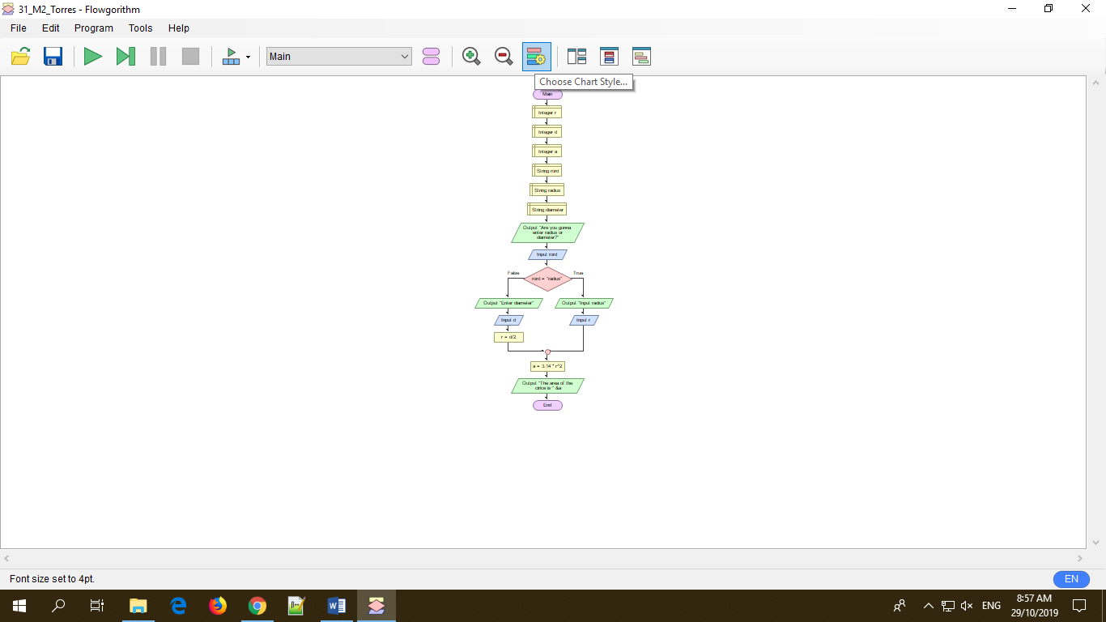

The image above shows the flowgarithm chart in getting the area of a circle which is needed to determine if the user will input the diameter or the radius. First, I declared all variables that will be used in the whole duration of the program such as the values as integers and a string for determining whether the user will input radius or diameter. If the user input radius, a decision symbol will be utilized and will proceed to the step of the formula in getting the area of a circle. However, if the user input diameter, before proceeding to the formula of the area of a circle, the input value will be divided in to two first. In that way, program made was able to determine the whether the user made use of diameter or radius and was able to find out the area of a circle.