🧠 A+ Core 1 (220-1201) — Motherboard Study Sheets

STUDY SHEET 1: POWER (Most common failure point)
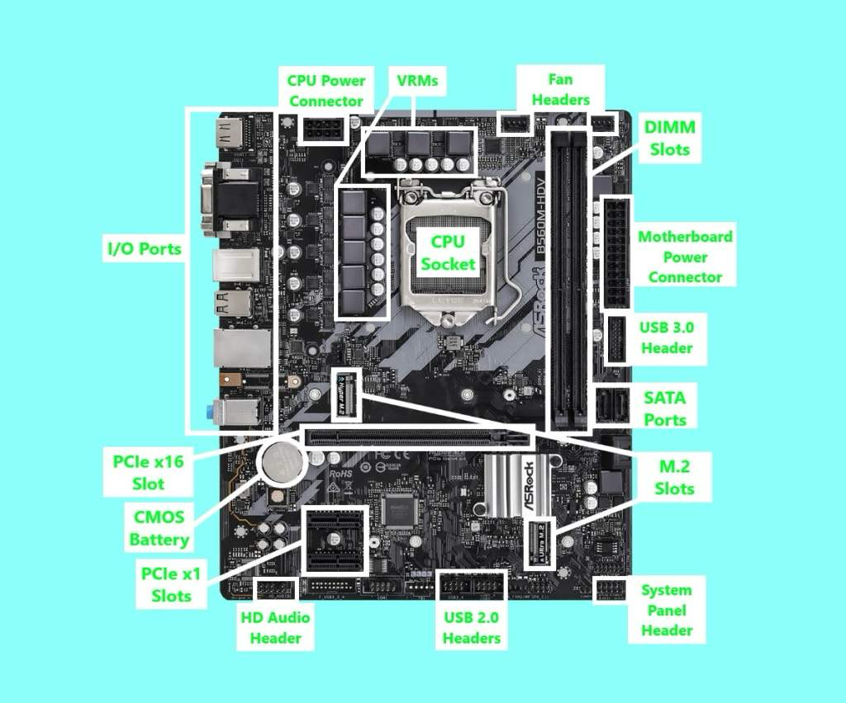

1. ATX 24-pin (Main Power)

What it is:
Primary power to the motherboard (chipset, slots, ports).

A+ tricks:
- System appears dead → 24-pin not fully seated (they click hard).
- Board powers LEDs but won’t boot → CPU power missing (next item).

2. EPS 8-pin CPU Power (4+4)

What it is:
Dedicated 12V power to CPU + VRMs.

A+ traps:
- Confusing EPS 8-pin with PCIe 8-pin GPU (keying differs).
- Plugging only the 24-pin → fans spin, no POST.
- High-end boards may have 8+4 or 8+8 — exam may ask when extra power is needed (overclocking / high-TDP CPUs).

STUDY SHEET 2: CPU + COOLING

3. CPU Socket

What it is:
Physical + electrical interface for the processor.

A+ traps:
- Bent pins (LGA) vs bent CPU pins (PGA).
- CPU installed correctly but unsupported BIOS version → no boot.
- Mismatched socket (AM4 ≠ AM5 ≠ LGA1700).

4. CPU_FAN Header vs SYS_FAN

What it is:
Dedicated fan header the BIOS monitors.

A+ traps (VERY common):
- Cooler plugged into SYS_FAN → “CPU Fan Error” at boot.
- AIO pump should go to AIO_PUMP or CPU_OPT, not SYS_FAN.
- Fan spins but BIOS halts boot → wrong header.

STUDY SHEET 3: MEMORY (They love this)

5. RAM / DIMM Slots

What it is:
Temporary, volatile memory.

A+ traps:
- Wrong slot population → single-channel instead of dual-channel.
- Mixed speeds/voltages → instability.
- “No POST” fixed by reseating RAM (click on both ends).
- ECC vs non-ECC confusion (consumer boards usually non-ECC).

Exam wording to watch for:

“System boots with one stick but not two”
→ Wrong slots or mismatched DIMMs.

STUDY SHEET 4: EXPANSION

6. PCIe Slots (Physical vs Electrical)

What it is:
Expansion interface for GPUs, NICs, RAID cards, etc.

A+ traps:
- x16 physical slot wired as x4 electrical.
- GPU must go in top PCIe x16 slot (CPU lanes).
- Card fits physically but runs slower → lane limitation.

7. Legacy Slots (AGP / PCI)

What it is:
Older expansion standards.

A+ traps:
- AGP ≠ PCIe (they will try to trick you).
- AGP was graphics only.
- PCI is shared bandwidth; PCIe is point-to-point.

STUDY SHEET 5: STORAGE (Guaranteed exam content)

8. SATA Ports

What it is:
Connects HDDs and SATA SSDs.

A+ traps:
- SATA port disabled when M.2 is populated.
- Wrong SATA mode (IDE / AHCI / RAID) after CMOS reset.
- Data vs power cable confusion (SATA power comes from PSU).

9. M.2 (NVMe vs SATA)

What it is:
Direct-mount storage interface.

A+ traps (high yield):
- NVMe ≠ SATA M.2 (same slot, different protocol).
- Installing NVMe disables SATA ports.
- Wrong keying: M-key vs B-key.

STUDY SHEET 6: CHIPSET & ARCHITECTURE

10. Northbridge / Southbridge (Legacy)

What it is:
- Northbridge: CPU ↔ RAM ↔ graphics
- Southbridge: I/O (USB, SATA, audio)

A+ traps:
- Modern boards don’t use these terms → replaced by PCH.
- Exam may show an old board and expect recognition.

11. PCH (Modern Boards)

What it is:
Single chip handling all non-CPU I/O.

A+ traps:
- CPU lanes vs chipset lanes distinction.
- Too many devices → bandwidth contention.

STUDY SHEET 7: HEADERS (PBQ FAVORITES)

12. Front-Panel Header (Power/Reset/LEDs)

What it is:
Case buttons and LEDs.

A+ traps:
- System “won’t power on” → power switch on wrong pins.
- LEDs not lighting → polarity reversed (only LEDs care).

13. USB Headers (Internal)

What it is:
- USB 2.0: 9-pin
- USB 3.x: 19/20-pin
- USB-C front panel: Type-E

A+ traps:
- Case has USB-C but board doesn’t.
- Plugging USB 3 cable into USB 2 header (won’t fit).
- Bent pins on USB 3 header.

14. Audio Header (HD_AUDIO)

What it is:
Front panel headphone/mic.

A+ traps:
- AC’97 vs HD_AUDIO mismatch.
- Front audio dead → header unplugged or wrong standard.

STUDY SHEET 8: FIRMWARE & TROUBLESHOOTING

15. BIOS vs UEFI

What it is:
Firmware interface.

A+ traps:
- Legacy vs UEFI boot mode mismatch.
- Secure Boot blocking OS install.
- BIOS update required for new CPU.

16. CMOS Battery & Clear CMOS

What it is:
Maintains firmware settings and clock.

A+ traps:
- Wrong system time → dead battery.
- Clearing CMOS resets SATA mode → OS won’t boot.
- Clearing CMOS fixes POST issues after bad overclock.

STUDY SHEET 9: PHYSICAL INSTALLATION (PBQ HEAVY)

17. Standoffs

What it is:
Prevent shorts between board and case.

A+ traps:
- Extra standoff → board short → no power.
- Missing standoff → board flexing/cracking.

18. I/O Shield

What it is:
Grounding + port alignment.

A+ traps:
- Metal tabs inside USB/Ethernet ports.
- Ports blocked or misaligned.

FINAL EXAM STRATEGY (IMPORTANT)

When you see a motherboard question, ask yourself in this order:
- Is this power, signal, or firmware?
- Which exact connector/header is involved?
- Is this a recognition question or a scenario fix?
- What is the most common failure humans make here?
