Isaiah Hernandez

Aguirre

CS 2302

9/13/18

Lab 1: A

In this lab we are presented with the problem of determining whether a picture is of a dog or a cat. Then after we determine what it is we must separate them into list, so that you will have a list of dog photos and a list of cat photos. Lastly we had to do all this while using recursion.

I first attempted to solve it by sending each picture through the method that determines if the photo is of a dog or a cat. Then put the file in the corresponding list. Which would then lead me to call the method again with the next file. The main problem I had was I am not really familiar with python or how to traverse/manipulate directories. In order to complete this I had to do a lot of research just to see what I was able to do with directories, and how to be able to do it.

After completing my research I found that the best way to traverse through the files and directories recursively was to use a “for loop” when looking at each file. Then traverse through the directories recursively. When I first started this lab I tried to use methods in the OS library, but like Professor Aguirre said in class it would defeat the purpose of the lab.

Below is a sample of when I ran my code. I ran it several other times moving some things around, and it all ended up the same as the one below.

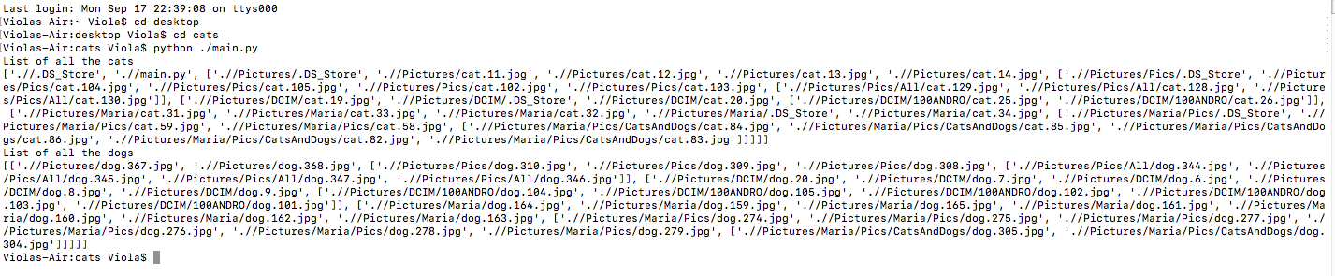

The main thing I learned from this lab was how to manipulate directories. Since I did not really know how they worked before completing this lab. For example I did not know the best way traverse through them was with a “for loop”. I thought that if I had used one I would not be doing the lab right. Overall this lab just helped me become that much more confidant using python.

“I certify that this project is entirely my own work. I wrote, debugged, and tested the code being presented, performed the experiments, and wrote the report. I also certify that I did not share my code or report or provided inappropriate assistance to any student in the class.” –Isaiah Hernandez