Isaiah Hernandez

Aguirre

CS 2302

10/23/18

Lab 2:

In this lab we were presented with the problem of sorting a given file of passwords, and printing the 20 most used passwords. We had to do this using merge sort, bubble sort, and a dictionary. Lastly we had to use a linked list as a data structure.

When I first started working on this lab I tried to read the file and then just put it in the linked list right away, but it would go into the linked list. What I ended up doing was putting each word into an array list. Then from there I put it into a linked list. To do this I had a check method to check if the word was already in the linked list, and if it was I would just increase the counter. Otherwise I would and the word to the linked list.

Then main problem that I had with the lab was that whenever I would try to call a method from the main class it would give me an “Attribute Error” saying that whatever I was using to call the method did not have that attribute. I ended up having to put my methods inside the node class and call them from a different method.

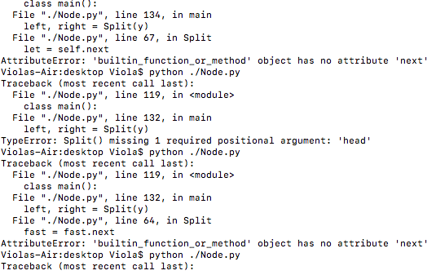

The main thing that I learned from this lab was how to call methods from different classes. Since that was what I had trouble with the most as it would work for some methods but not all of them. This will helped me better understand how to use python. Which seems to be the hardest task for me this semester.

“I certify that this project is entirely my own work. I wrote, debugged, and tested the code being presented, performed the experiments, and wrote the report. I also certify that I did not share my code or report or provided inappropriate assistance to any student in the class.” –Isaiah Hernandez