Isaiah Hernandez

Aguirre

CS 2302

11/6/18

Lab 2:

In this lab we were given a file of words and had to find how many anagrams were in the given file. We also had to see which word in the file had the most anagrams. To do this we had to use a binary tree to store the words.

The first approach that I made to solve this lab was to put all the words in the file in a list then from there I put it into the respective tree depending on what the user picked. Storing the trees with words was actually quite simple since all I really had to do was find everything on Zybooks.

The problem that I had was implementing the count_anagrams method. I had first tried to use a count parameter, and update it whenever there was an anagram of the word but it would always return 0. I had kept running test to figure it out because it would update within the method, but would always return 0. Then what I ended up doing was using a global variable to count the anagrams, and it ended up working out.

After figuring that out it was easy to find the word with the greatest number of anagrams. All I had to do was use the same idea but instead put the total amount of anagrams for every word into a list. Then I just had to traverse through the list and find which word had the most anagrams.

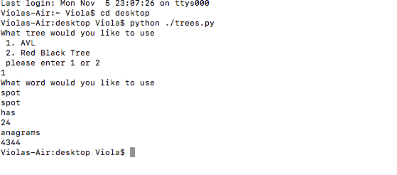

The main thing that I learned from this lab was how to use global variables because I had never really used them before. This lab helped me understand how useful global variables can be. It also helped me get a better understanding of trees, and how they work.

“I certify that this project is entirely my own work. I wrote, debugged, and tested the code being presented, performed the experiments, and wrote the report. I also certify that I did not share my code or report or provided inappropriate assistance to any student in the class.” –Isaiah Hernandez