Isaiah Hernandez

Aguirre

CS 2302

12/6/18

Lab 6:

In this lab we had to implement Kruskal’s algorithm as well as topological sort. So there was never really a problem for us to solve it was just getting those algorithms to implement. Which was pretty easy itself since it did not take long at all.

For this lab I had a hard coded list of vertices and did just as the lab asked. I was relatively easy since we had the code for the topological sort, and all we had to do was do research how to implement Kruskal’s algorithm. So just like the last lab it was very trivial.

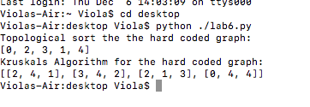

The main thing that I learned from this lab was how to implement topological sort as well learning the code for Kruskal’s algorithm. Which will be very important for future use.

Lastly the run time for topological sort was O(V+E) , and the runtime for Kruskal’s algorithm was O(E log V).

“I certify that this project is entirely my own work. I wrote, debugged, and tested the code being presented, performed the experiments, and wrote the report. I also certify that I did not share my code or report or provided inappropriate assistance to any student in the class.” –Isaiah Hernandez