Isaiah Hernandez

Aguirre

CS 2302

11/6/18

Lab 4:

In this lab we had to get an array of numbers and store them into a min hip. After doing that we had to implement heap sort on the heap array. After doing all that we had to extract the minimum value from the heap array.

For this lab I had a hard coded list of numbers and did just as the lab asked. I was relatively simple especially since a lot of the algorithms were defined on zybooks, so all I had to do was modify it to work for the lab at hand. Extracting the minimum element was as easy as taking the first element from the heap array after implementing heap sort. I didn’t really have any trouble with this lab since it was pretty straight forward, and there wasn’t too much going on. Overall it was a pretty trivial lab.

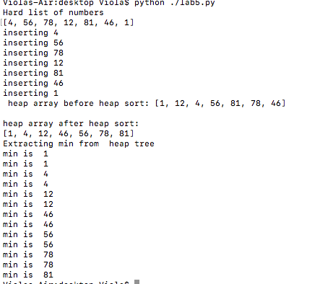

The main thing that I learned with this lab was how to use heap arrays, and how to use heap sort. As well as extracting the minimum value from the heap array. This is very important because it will be useful to know in the future.

Lastly the run time for this lab was O(n log n ) since that is the runtime of heap sort.

“I certify that this project is entirely my own work. I wrote, debugged, and tested the code being presented, performed the experiments, and wrote the report. I also certify that I did not share my code or report or provided inappropriate assistance to any student in the class.” –Isaiah Hernandez