Web 2.0 Vocab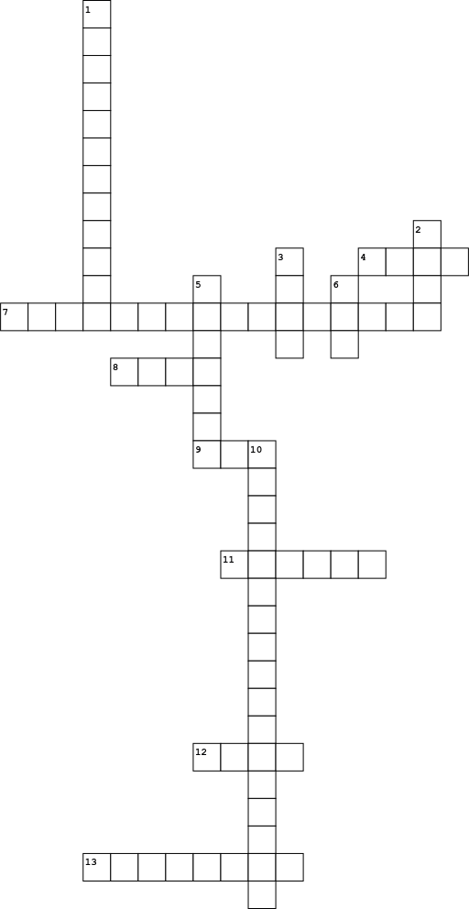

|  |  |
| --- | --- |
| **Down** | |
| **1.** | A generic term used to describe Web-based tools that harness the power of collaboration and group interaction. |
| **2.** | User-generated keywords used to describe online content. |
| **3.** | Originally derived from the word "weblog," a ____ is a simple content website created with inexpensive self-publishing tools. |
| **5.** | a presentation, lecture, workshop or seminar that is transmitted over the Web. |
| **6.** | an abbreviation for "Extensible Markup Language," ___ is a programming code for online data that preserves the structure and formatting of a digital document regardless of whatever application is used to read it. |
| **10.** | help people discover new friends or colleagues by illuminating shared interests, related skills, or a common geographic location. |

|  |  |  |  |  |  |  |  |  |  |  |  |  |  |  |  |  |  |  |
| --- | --- | --- | --- | --- | --- | --- | --- | --- | --- | --- | --- | --- | --- | --- | --- | --- | --- | --- |
| |  |  | | --- | --- | | **Across** | | | **4.** | an important underlying technology used to create interactive Web applications | | **7.** | a way to license your content so that people can share it. | | **8.** | A dynamic Web document that allows users to add, change, or edit the content displayed on the page. | | **9.** | Shorthand for "Real Simple Syndication," ____ is a protocol that makes it easy for computer users to receive content from their favorite providers whenever the content is updated. | | **11.** | Websites or applications that combine content from one or more sources. | | **12.** | A format for the syndication of online content | | **13.** | The act of sending an email that falsely claims to be an established legitimate enterprise in an attempt to scam the user into surrendering private information that will be used for identity theft. | |  |  |

Websites used:

<http://www.socialsignal.com/blog/alexandra-samuel/web-2-0-glossary>

<https://quizlet.com/38953673/web-20-vocabulary-flash-cards/>

<https://compassioninpolitics.wordpress.com/2008/02/01/resource-glossary-of-web-20-terms-and-tools/>

Word Bank

RSS Phishing Social-Media Wiki blog XML Mashup atom

ajax Creative-Commons Social-Networking mashup