INVENTORY MANAGEMENT API

ASSUMPTIONS

1. You have python downloaded in your system else go to <https://www.python.org/>
2. You know how to create an activate a python3 virtual environment

HOW TO USE THE API

1. Create a folder and paste the “inventoryApp” directory in it
2. Create a python virtual environment in the same as the “inventoryApp” folder(<https://docs.python.org/3/library/venv.html>)
3. Activate the python virtual environment.
4. With the virtual environment activated change directory into the “inventoryApp”
5. Run the command “pip install -r requirements.txt” to install the necessary libraries needed
6. Run the command “pip manage.py migrate” to create Django migrations
7. Run the command “pip manage.py makemigrations” to prepare light weight SQLite database
8. Run the command “pip manage.py migrate” to commit all migrations
9. Run the command “python3 manage.py createsuperuser” and follow the prompt to create the administrator of the application
10. Run the command “pip manage.py runserver” to start up your local server
11. On your browser of choice launch [http:localhost:8000](http://localhost:8000/)

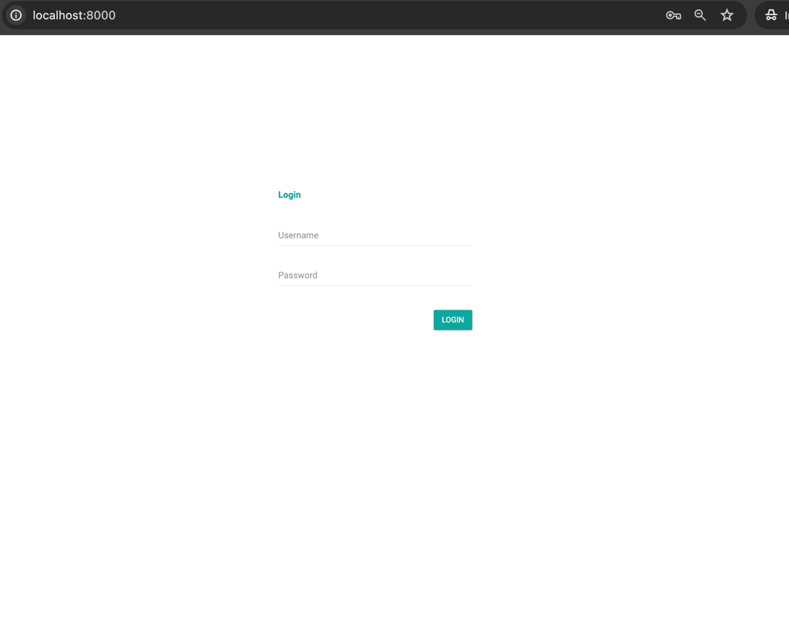

12. Enter the username and password that was created in step 9

13. After successful login. Create and employee. The employee account is the account that can create, update suppliers and create, update, delete items. Make sure to create a password and save somewhere as the password would be needed to access the API endpoints.

14. On your browser of choice launch <http://localhost:8000/admin>.

Enter the superuser username and password to access the admin portal. Here you pick up the apikey for each employee account created under the “employee section”

**Generate API Token**

**Method: POST**

**Endpoint: http://localhost:8000/inventory/generatetoken**

To access the endpoints first generate a Token. The token is valid for 24 hours. To generate the token, pass the following parameters to the token generator endpoint as shown in the figure below. A token is returned after successful validation of the employee account. This endpoint is only accessible to valid employee accounts

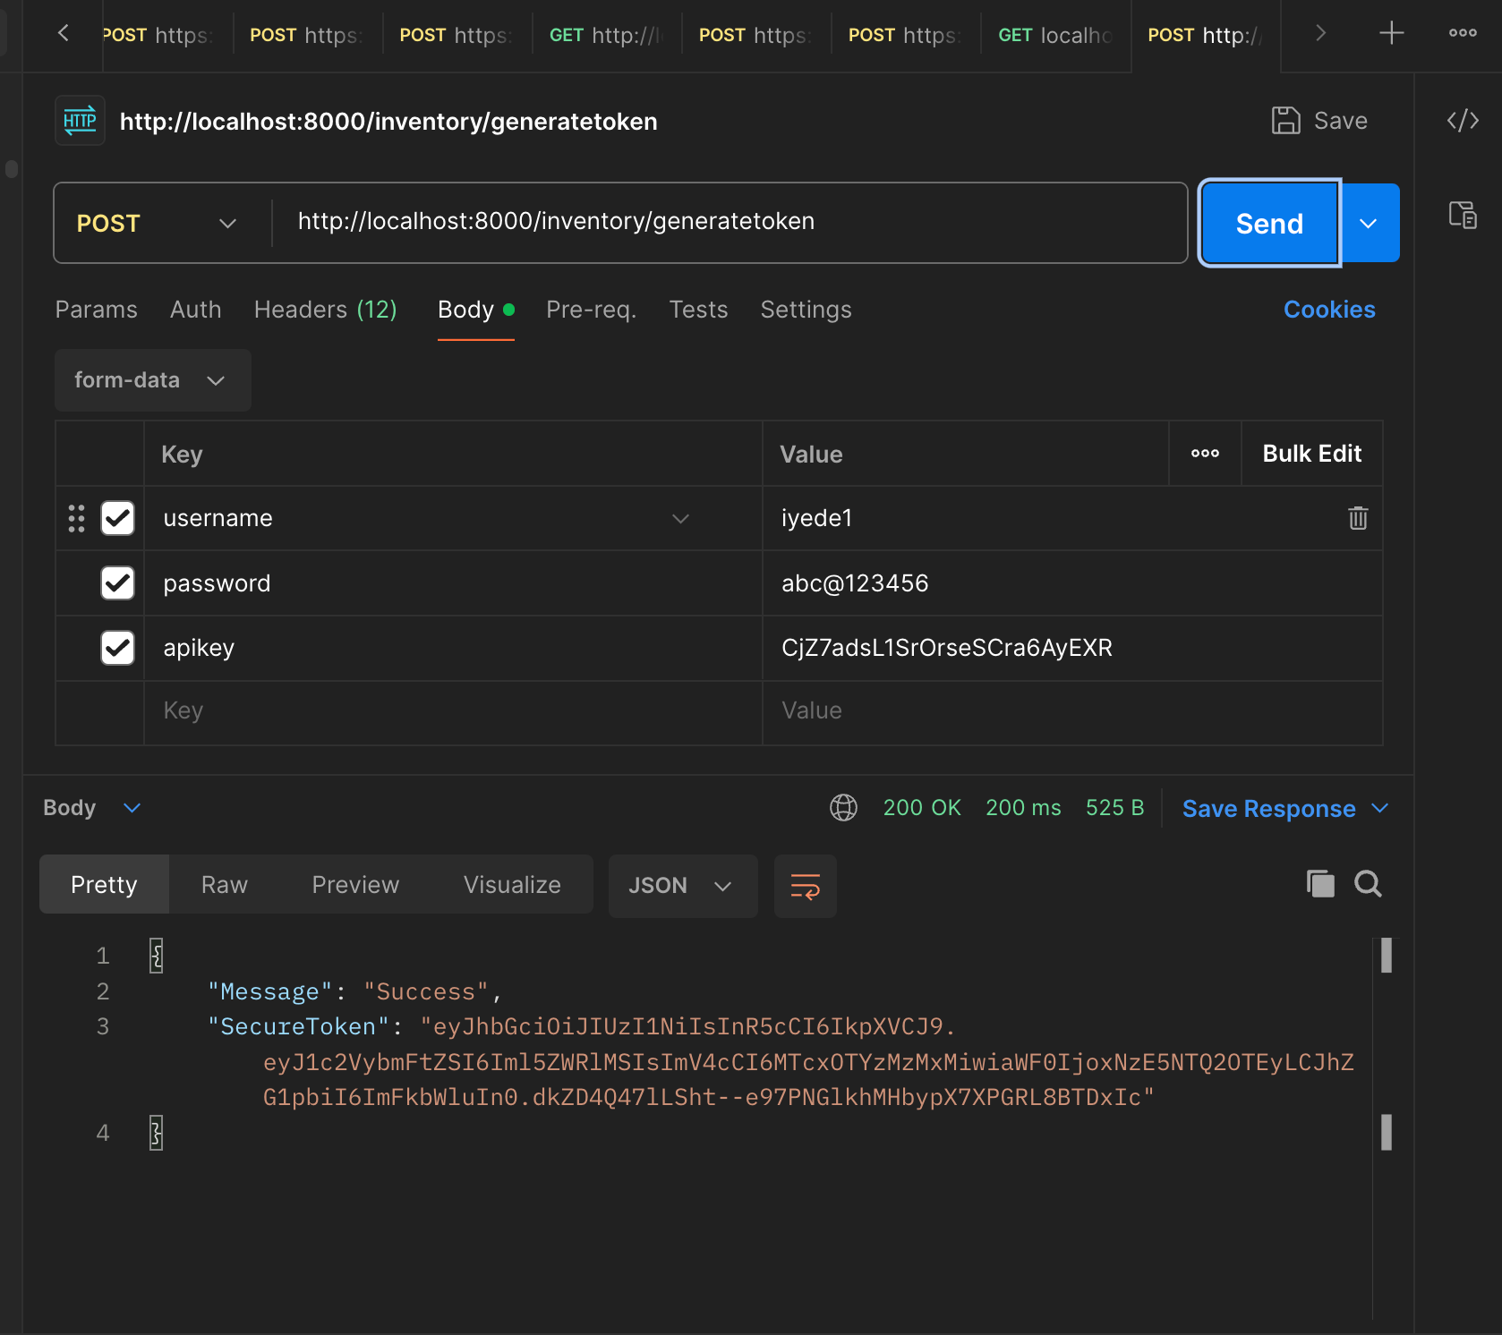

|  |  |  |  |
| --- | --- | --- | --- |
| key | Type/Format | Option | Description |
| username | string | mandatory | Provided by admin |
| password | string | mandatory | Provided by admin |
| apikey | string | mandatory | Provided by admin |

**Create a Supplier**

**Method: POST**

**Endpoint: http://localhost:8000/inventory/suppliers/api**

To create a supplier, see the figure below. This endpoint is only accessible to valid employee accounts. This endpoint also takes a “Bearer Token” header. The value is the token that was generated

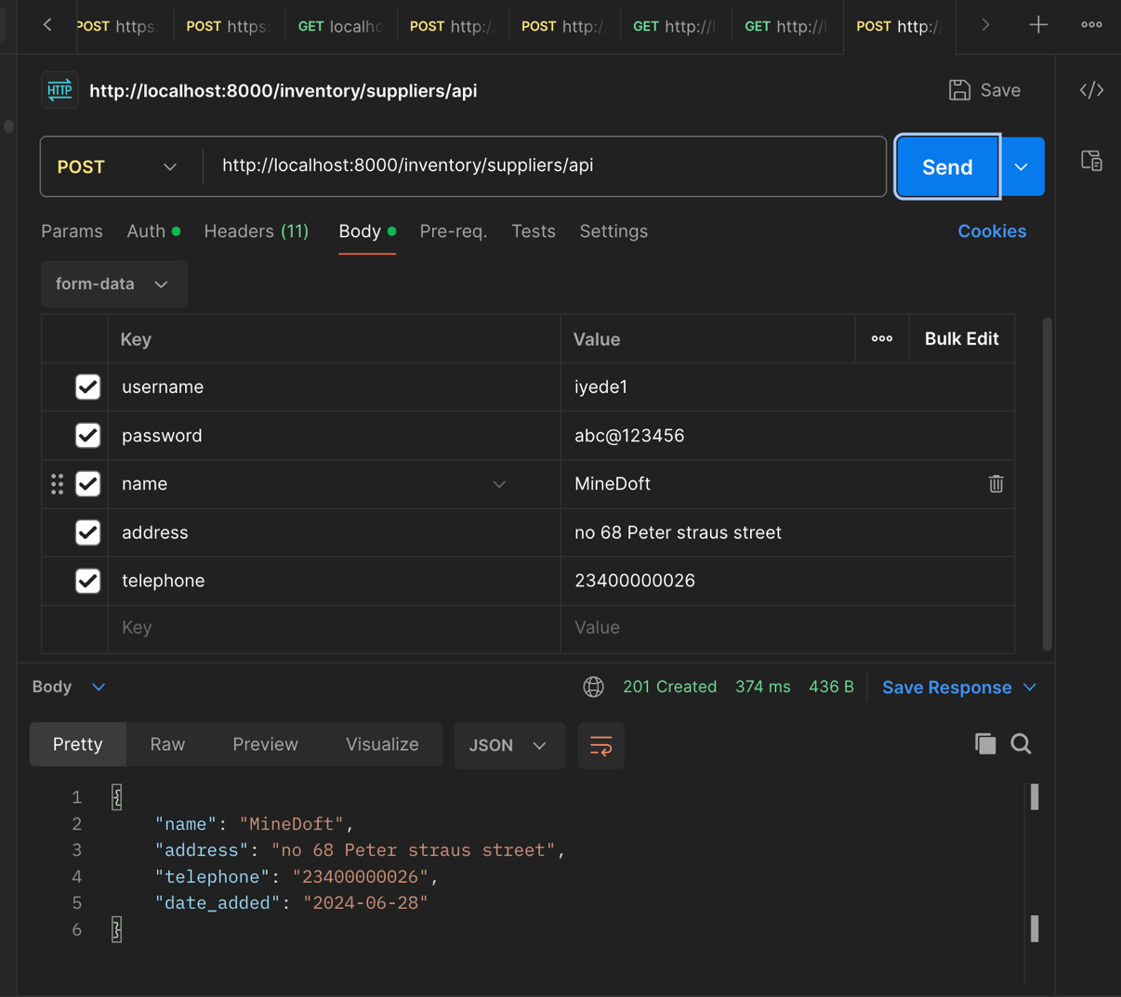

|  |  |  |  |
| --- | --- | --- | --- |
| key | Type/Format | Option | Description |
| username | string | mandatory | Provided by admin |
| password | string | mandatory | Provided by admin |
| name | string | mandatory | Name of supplier |
| address | string | mandatory | Address of supplier |
| telephone | string | mandatory | Telephone of supplier |

**View all suppliers**

**Method: GET**

**Endpoint: http://localhost:8000/inventory/suppliers/api**

To view all supplier, see the figure below. This endpoint is accessible to all users

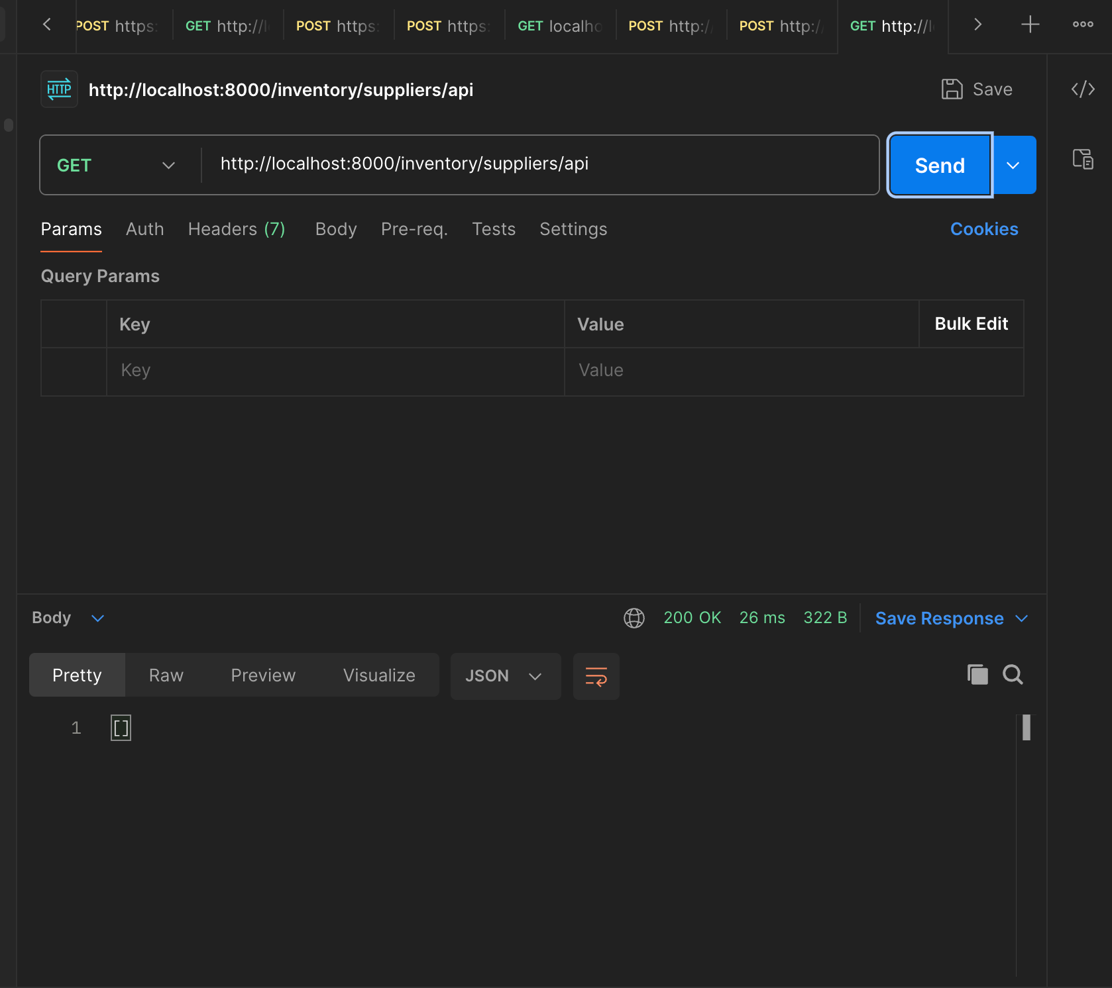

**Update Supplier Details**

**Method: PUT**

**Endpoint: http://localhost:8000/inventory/suppliers/api/<pk>**

To update a supplier details, see the figure below. This endpoint is only accessible to valid employee accounts. The **<pk>** in the endpoint represent the Primary Key for each supplier. The Primary key is seen when a request is made to the endpoint that list all supplies above. This endpoint also takes a “Bearer Token” header. The value is the token that was generated

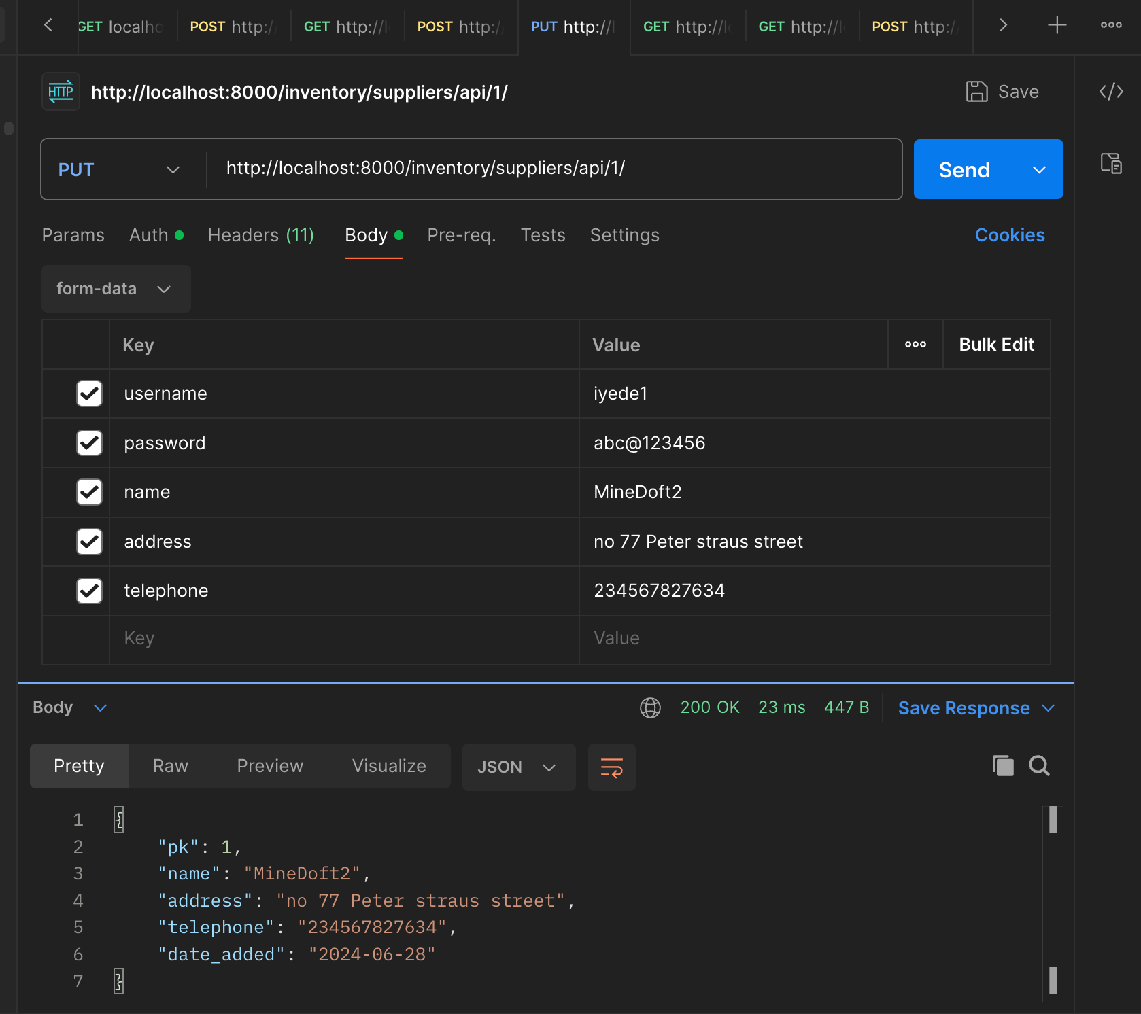

|  |  |  |  |
| --- | --- | --- | --- |
| key | Type/Format | Option | Description |
| username | string | mandatory | Provided by admin |
| password | string | mandatory | Provided by admin |
| name | string | mandatory | Name of supplier |
| address | string | mandatory | Address of supplier |
| telephone | string | mandatory | Telephone of supplier |

**View Supplier Details**

**Method: GET**

**Endpoint: http://localhost:8000/inventory/suppliers/api/<pk>**

To view a supplier details, see the figure below. The **<pk>** in the endpoint represent the Primary Key for each supplier. The Primary key is seen when a request is made to the endpoint that list all supplies above. This is accessible to all users

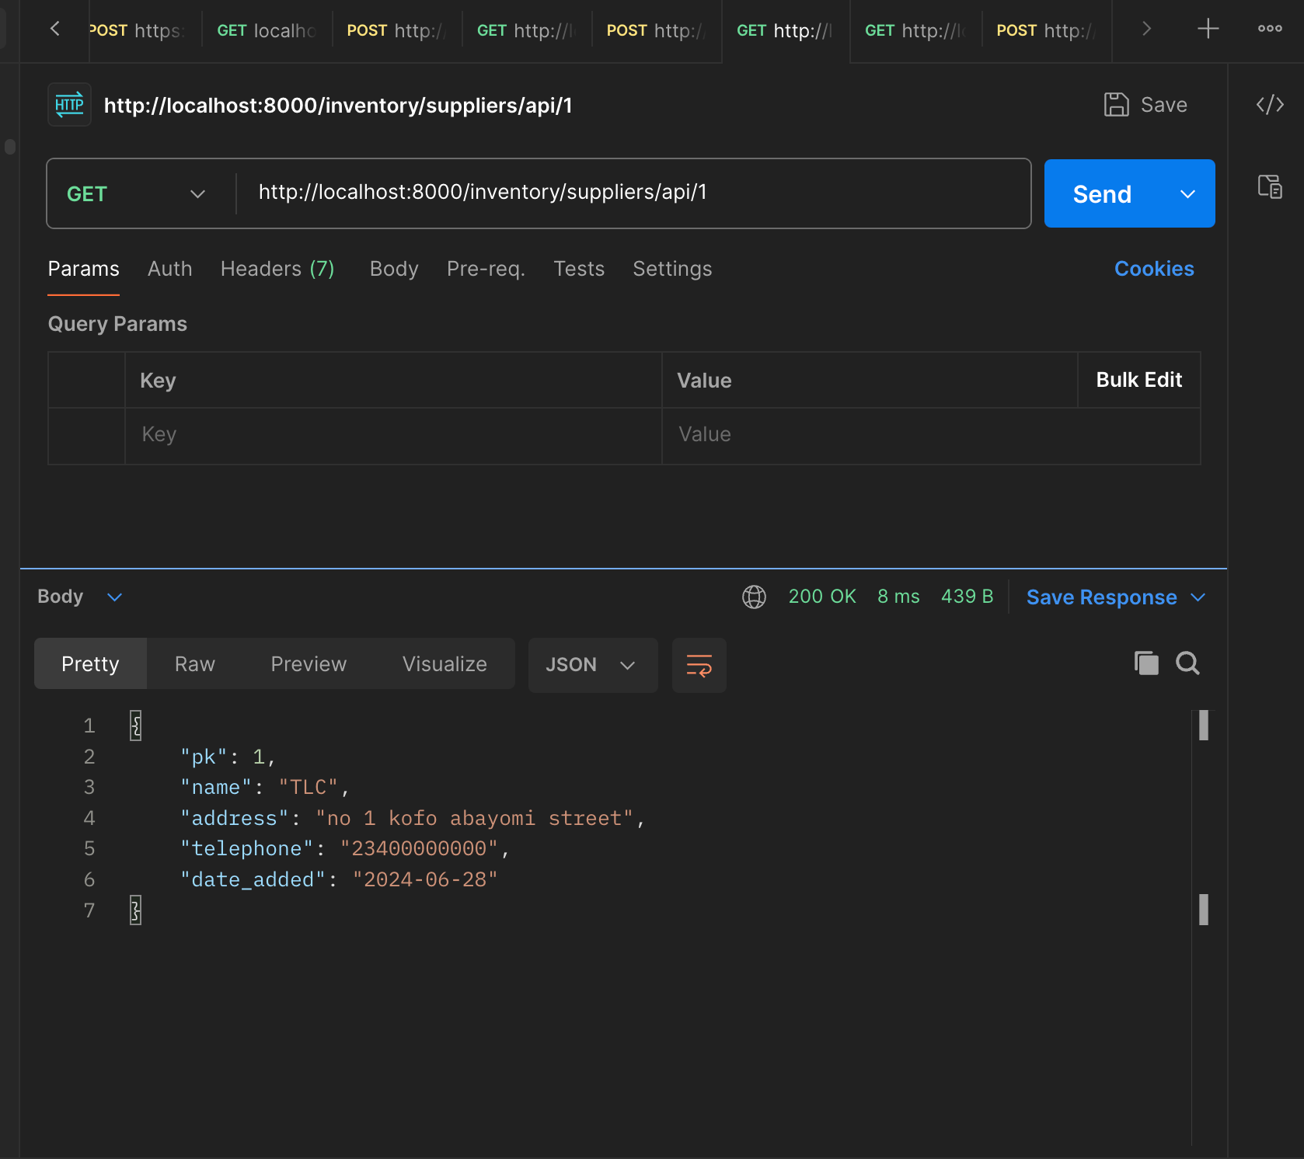

**Create an Item**

**Method: POST**

**Endpoint: http://localhost:8000/inventory/items/api**

To create an item, see the figure below. This endpoint is only accessible to valid employee accounts. This endpoint also takes a “Bearer Token” header. The value is the token that was generated

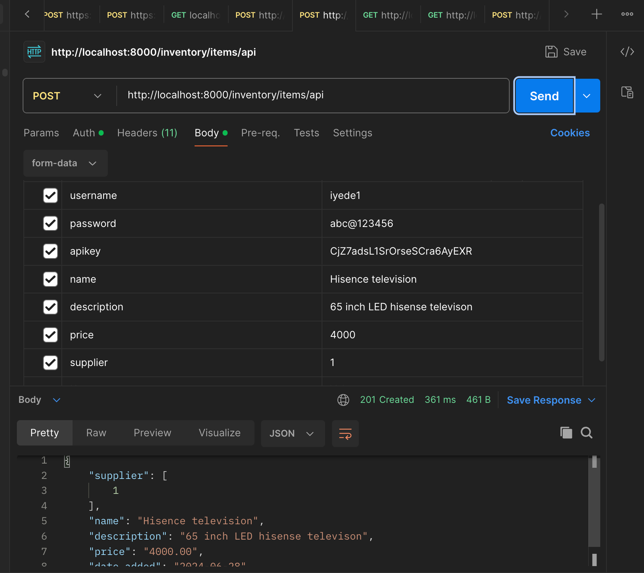

|  |  |  |  |
| --- | --- | --- | --- |
| key | Type/Format | Option | Description |
| username | string | mandatory | Provided by admin |
| password | string | mandatory | Provided by admin |
| apikey | string | mandatory | Provided by admin |
| name | string | mandatory | Name of supplier |
| description | string | mandatory | Description of item |
| price | decimal | mandatory | Price (6 digits) |
| supplier | string | mandatory | The pk of any supplier |

**Update an Item**

**Method: PUT**

**Endpoint: http://localhost:8000/inventory/items/api/<pk>**

To create an item, see the figure below. This endpoint is only accessible to valid employee accounts. The **<pk>** in the endpoint represent the Primary Key for each item. This pk is seen in the endpoint that fetches the list of items. This endpoint also takes a “Bearer Token” header. The value is the token that was generated

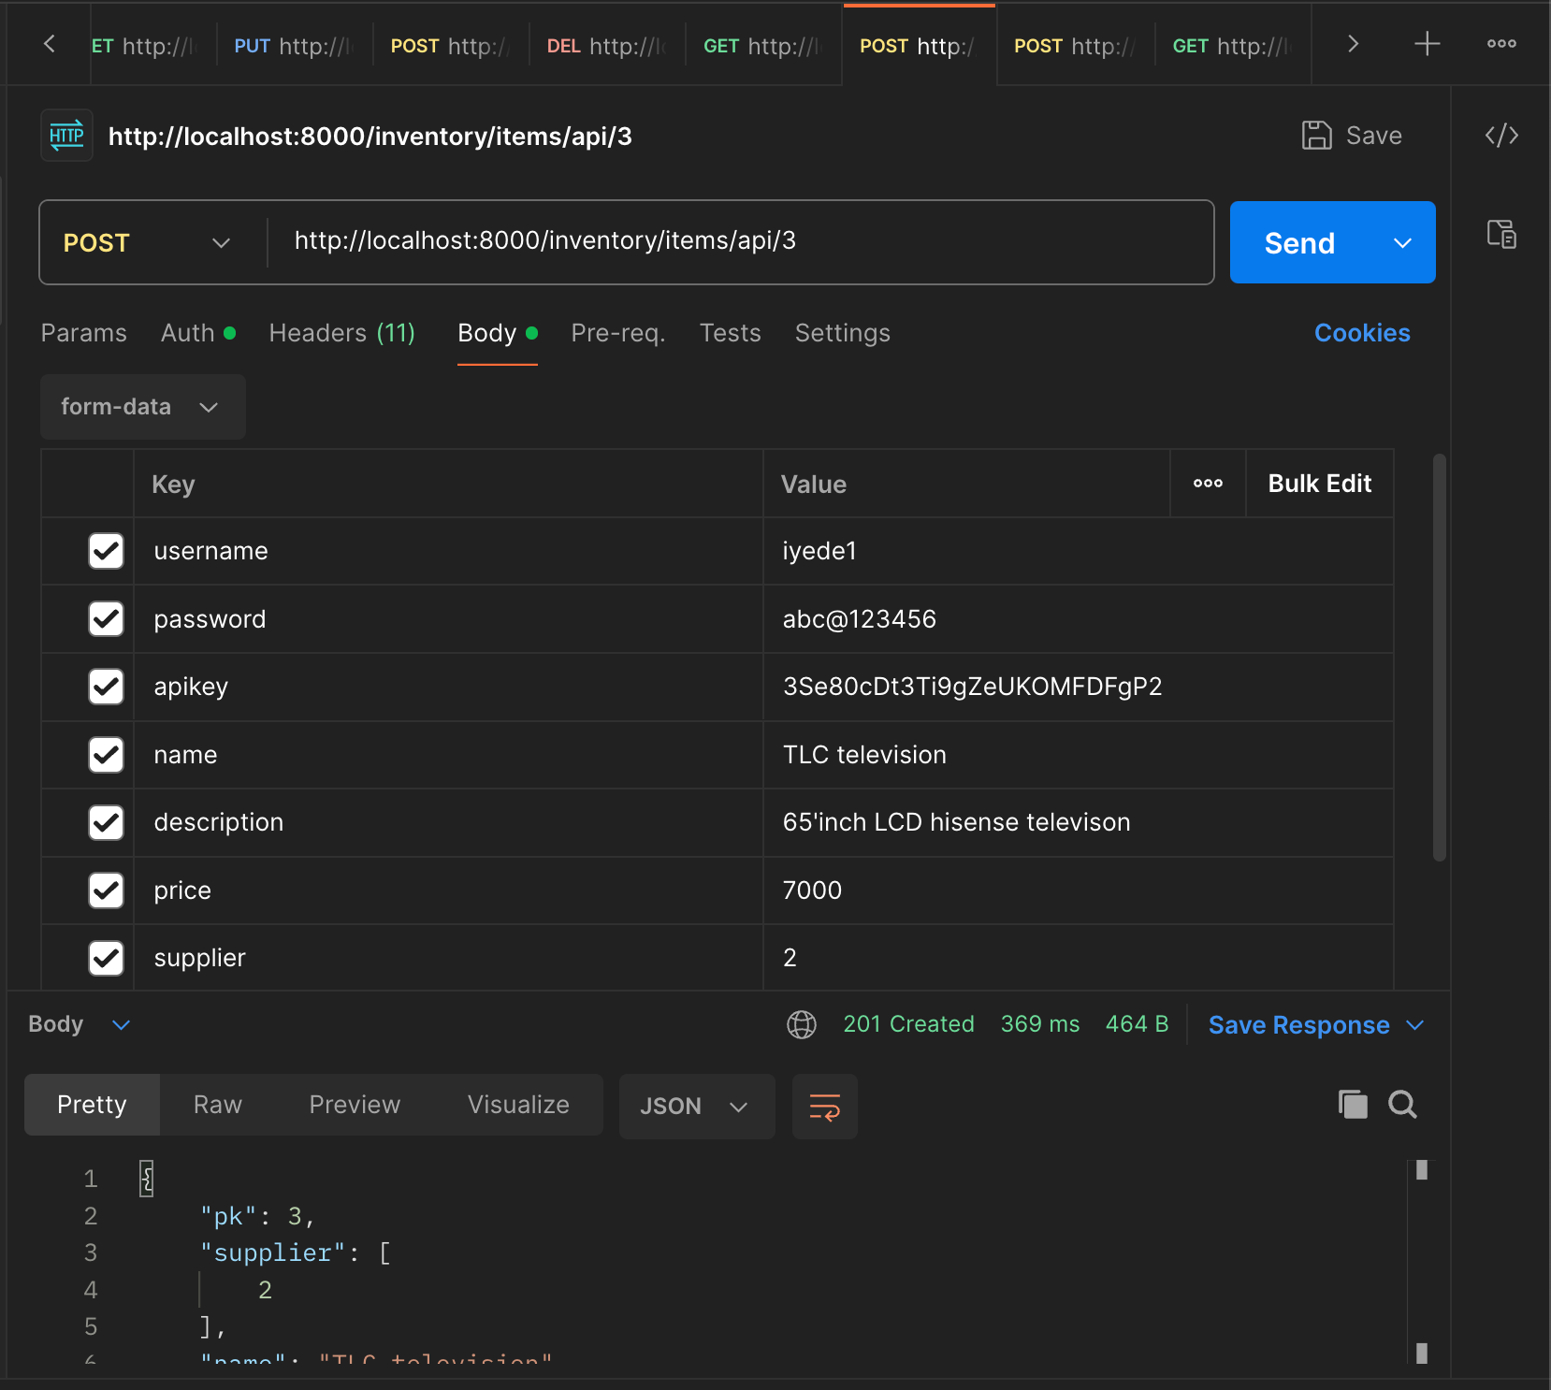

|  |  |  |  |
| --- | --- | --- | --- |
| key | Type/Format | Option | Description |
| username | string | mandatory | Provided by admin |
| password | string | mandatory | Provided by admin |
| apikey | string | mandatory | Provided by admin |
| name | string | mandatory | Name of supplier |
| description | string | mandatory | Description of item |
| price | decimal | mandatory | Price (6 digits) |
| supplier | string | mandatory | The pk of any supplier |

**Delete an Item**

**Method: DELETE**

**Endpoint: http://localhost:8000/inventory/items/api/<pk>**

To create an item, see the figure below. This endpoint is only accessible to valid employee accounts. The **<pk>** in the endpoint represent the Primary Key for each item. This pk is seen in the endpoint that fetches the list of items. This endpoint also takes a “Bearer Token” header. The value is the token that was generated

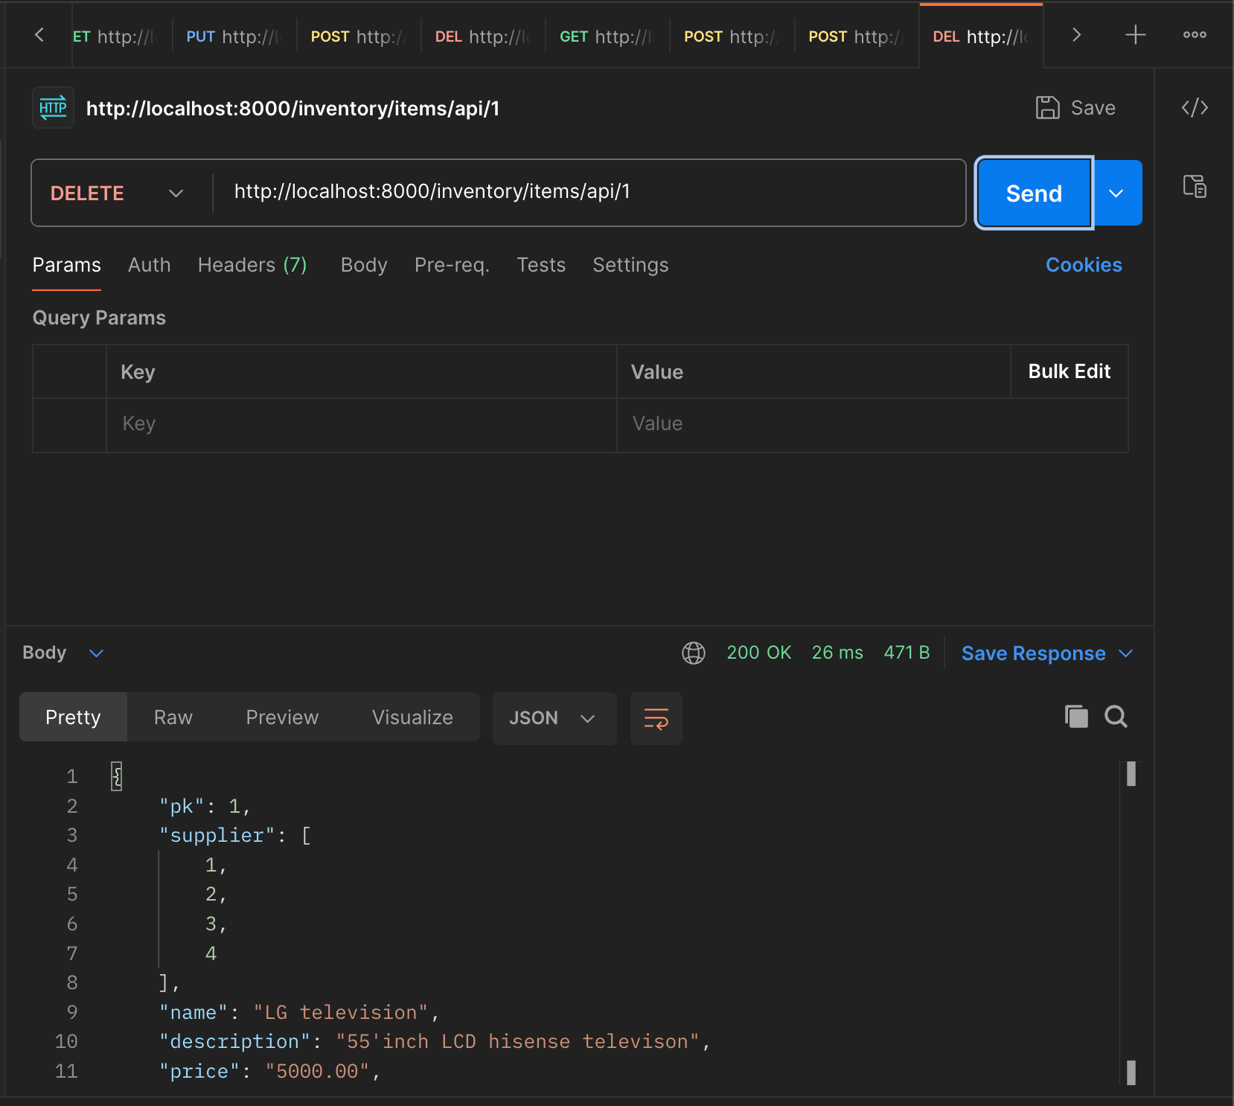

**View all items**

**Method: GET**

**Endpoint: http://localhost:8000/inventory/items/api**

To view all items, see the figure below. This endpoint is accessible to all users

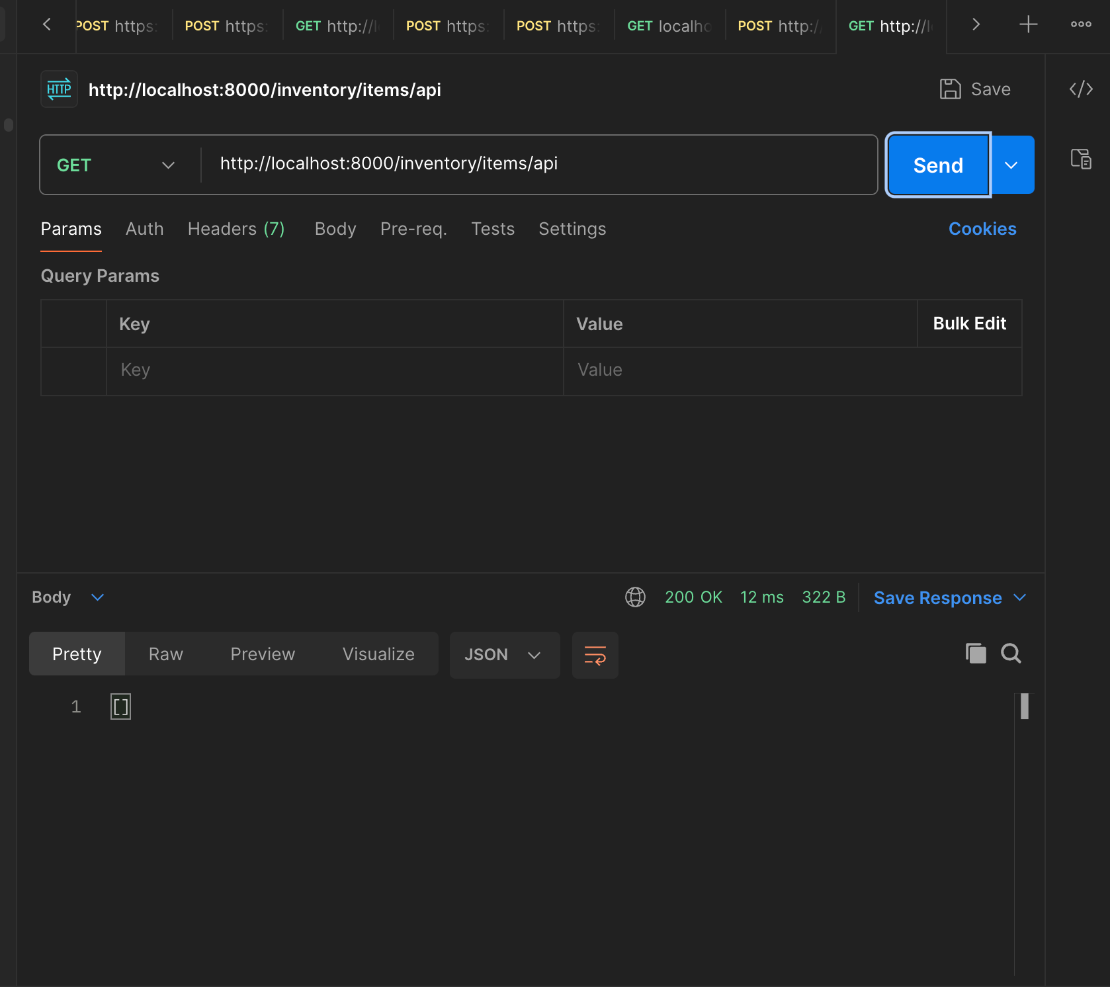

**View item Details**

**Method: GET**

**Endpoint: http://localhost:8000/inventory/item/api/<pk>**

To view an item detail, see the figure below. The **<pk>** in the endpoint represent the Primary Key for each item. The Primary key is seen when a request is made to the endpoint that list all items above. This is accessible to all users

**Add another supplier to an Item**

**Method: POST**

**Endpoint: http://localhost:8000/inventory/items/suppliers/api/<pk>/<supplier_id>**

To another supplier to an item, see the figure below. This endpoint is only accessible to valid employee accounts. This endpoint also takes a “Bearer Token” header. The value is the token that was generated. The <supplier_id> is the Primary key of any supplier as seen when a list of suppliers endpoint is called. The <pk> the Primary Key of the item as seen when a list of items endpoint above is called

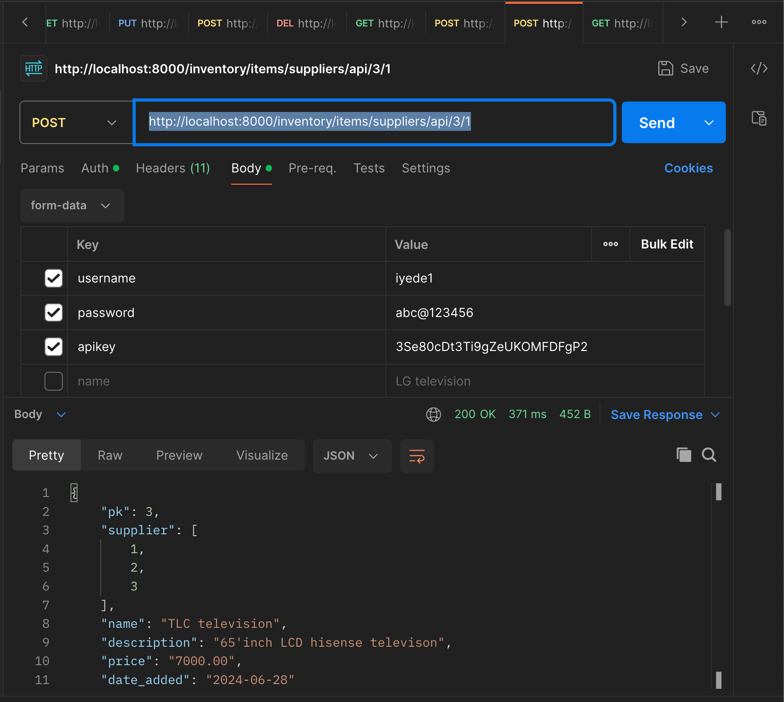

|  |  |  |  |
| --- | --- | --- | --- |
| key | Type/Format | Option | Description |
| username | string | mandatory | Provided by admin |
| password | string | mandatory | Provided by admin |
| apikey | string | mandatory | Provided by admin |

**Get all suppliers of an item**

**Method: GET**

**Endpoint: http://localhost:8000/inventory/item/suppliers/api/<pk>**

To get all suppliers of an item, see the figure below. The **<pk>** in the endpoint represent the Primary Key for each item. The Primary key is seen when a request is made to the endpoint that list all items above. This is accessible to all users

