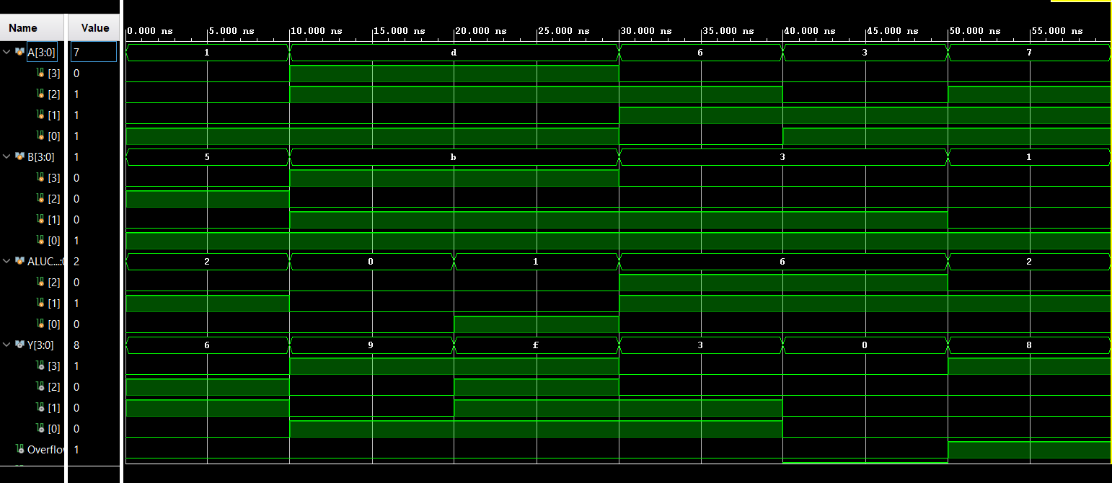I used multiple test cases in my testbench to verify the functionality of the ALU. First, arithmetic operations were tested. A normal addition was performed with A = 1 and B = 5, producing Y = 6 with no overflow. another addition was tested with A = 7 and B = 1, producing Y = 8 with Overflow = 1, confirming correct signed overflow detection.
Logical operations were also verified. For the AND operation, A = 13 and B = 11 produced Y = 9, confirming correct bitwise AND behavior. For the OR operation with the same inputs, the result was Y = 15, as expected.
Subtraction operations were then tested. For A = 6 and B = 3, the ALU produced Y = 3 with no overflow, confirming correct subtraction. A subtraction case of A = 3 and B = 3 produced Y = 0, which correctly set the Zero flag to 1.
The waveform results confirm that the ALU correctly performs arithmetic and logical operations, properly detects overflow conditions, and accurately identifies zero results.

For the demo, I used the numbers 5 and 7.