Children’s Anemia in Nigeria

A look at anemia patterns among children under five, using household survey data

1.0 Research Question
This report looks at one question: which children are most likely to be anemic, and does it come down to money, where they live, or something else?

1.1 Why It Matters
Anemia in young kids matters a lot, it can slow brain development, weaken immunity, and hurt how kids do in school and later in life. So if some groups of kids have much higher anemia rates than others, health programs need to know that, so they can focus help where it's needed most.
This analysis uses survey data on nearly 34,000 children, looking at things like family wealth, rural vs. urban living, mom's education, bed net use, iron supplements, and each child's anemia test results.
Important stipulation: About 6 in 10 kids in the dataset (20,800 of 33,924) simply don't have an anemia test result recorded. So the actual analysis only covers the roughly 13,100 kids who do have results. That's a real limitation, the missing data is large enough that it affects how confidently you can trust the conclusions, and it's worth repeating that caution at the end of any findings.

2. Method
Columns used: Wealth, rural/urban, and mother's education are the main ones, since they're what actually move the anemia numbers. Age, births, and bed net/iron pill use are kept as supporting info. A few columns (smoking, marital status, when the baby was first breastfed, recent fever) aren't part of this question, so they're set aside.
The two hemoglobin/anemia columns: These looked like duplicates but aren't. One version of hemoglobin is adjusted for altitude and smoking, the other only for altitude, and their averages are 15 points apart. The matching anemia columns only agree with each other 38% of the time. So these are two different calculations, not one column typed twice. The more complete one (adjusted for altitude and smoking) is the one used, since it also has less missing data and matches the numbers in the report.
Cleaning:
- 61% of kids have no anemia test at all. Those get dropped from the anemia analysis, not guessed at.
- One column ("when child put to breast") mixes plain answers with leftover number codes, it's messy and would need fixing if anyone uses it later.
- "Don't know" answers are treated as their own category, not lumped in with truly missing data.
- A few extreme hemoglobin readings (like 20 g/dl) look like data entry mistakes and get flagged for a second look.
- Wealth, residence, and education were clean already, no typos or formatting issues.
Tool: Excel or SQL for cleaning and comparing groups, Power BI or Tableau for the charts. Python only got used briefly, to check row by row whether those two hemoglobin/anemia columns really matched. Once that was settled, nothing heavier than a pivot table was needed for the rest.
Techniques
The approach was kept basic on purpose, since the question itself is basic: which groups have higher anemia rates.
Two techniques, that's it:
- Cross-tabs: comparing anemia rates against wealth, rural/urban, education, bed nets, and iron pills, to see how the numbers shift group by group.
- Grouped averages: comparing average hemoglobin (the actual blood number behind the anemia diagnosis) across those same groups, as a double-check that the anemia categories are showing something real.
No correlation: that only works between two number-based variables, and this dataset barely has any (just hemoglobin and mother's age at first birth). Everything else is a category, not a number, so correlation doesn't really apply here.
No regression: regression is for a harder question: figuring out which factor matters most once you strip away the overlap between them (like wealth vs. education vs. location all pointing the same direction). That's not what's being asked here. This is a "who's got it worse" question, not a "what's really causing it" question, so cross-tabs and averages already give a clear answer without overcomplicating things.
One adjustment: anemia was simplified into two buckets, "any anemia" vs. "not anemic," for most comparisons. But severity was also looked at separately in one chart, since blending mild and severe cases together could hide how bad the worst cases really are.

3.0 Findings

3.1 Wealth is the clearest pattern in this data
Children from poorer households are anemic more often, and the gap isn't small.
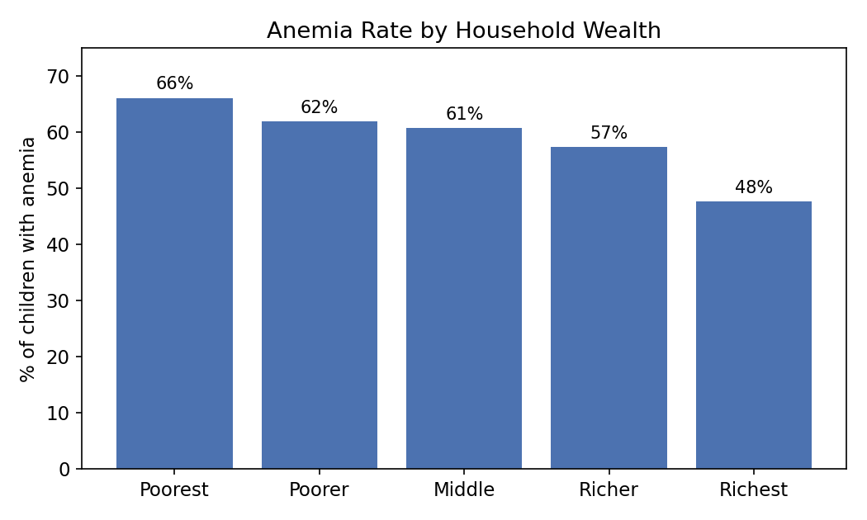
Figure 1: Share of children with any level of anemia, by household wealth group.

Kids in the poorest households have an anemia rate of 66%, compared to 48% in the richest households. That's an 18-point gap between the bottom and top wealth groups, and it moves in a straight line as you go up each wealth tier, which makes it a pretty reliable pattern, not a fluke in one group.

3.2 Severity follows the same pattern, not just whether a child is anemic at all
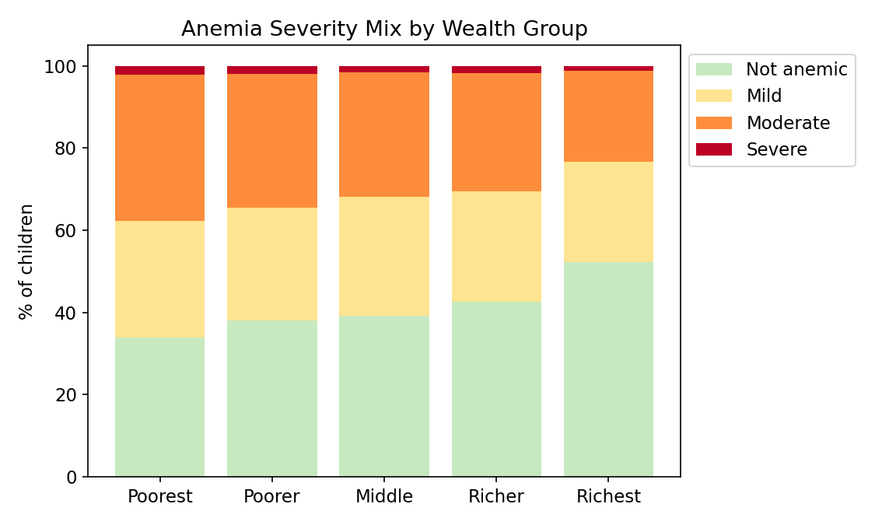
Figure 2: Breakdown of anemia severity (not anemic, mild, moderate, severe) by wealth group.
This is worth sitting with for a second. It's not just that poorer kids are anemic more often, it's that when they are anemic, it tends to be more severe. Moderate anemia sits at 36% among the poorest group versus 22% among the richest. Severe anemia is rare across the board (around 1-2% everywhere), but even that small share skews toward poorer households.

3.3 Rural children are worse off than urban children
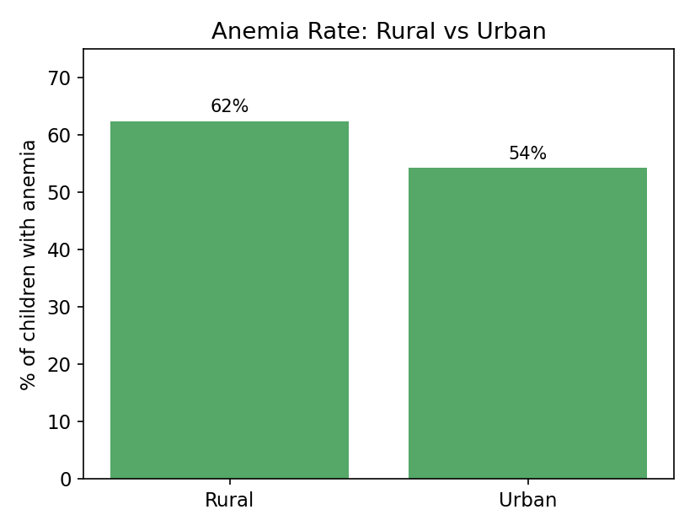
Figure 3: Anemia rate comparing rural and urban children.
62.5% of rural children have some level of anemia, compared to 54.3% in urban areas. An 8-point gap. That lines up with the wealth pattern too, since rural households in this survey skew poorer on average, so this isn't a fully separate story from section 3.1, it's likely part of the same underlying picture.

3.4 Hemoglobin numbers back up the anemia categories
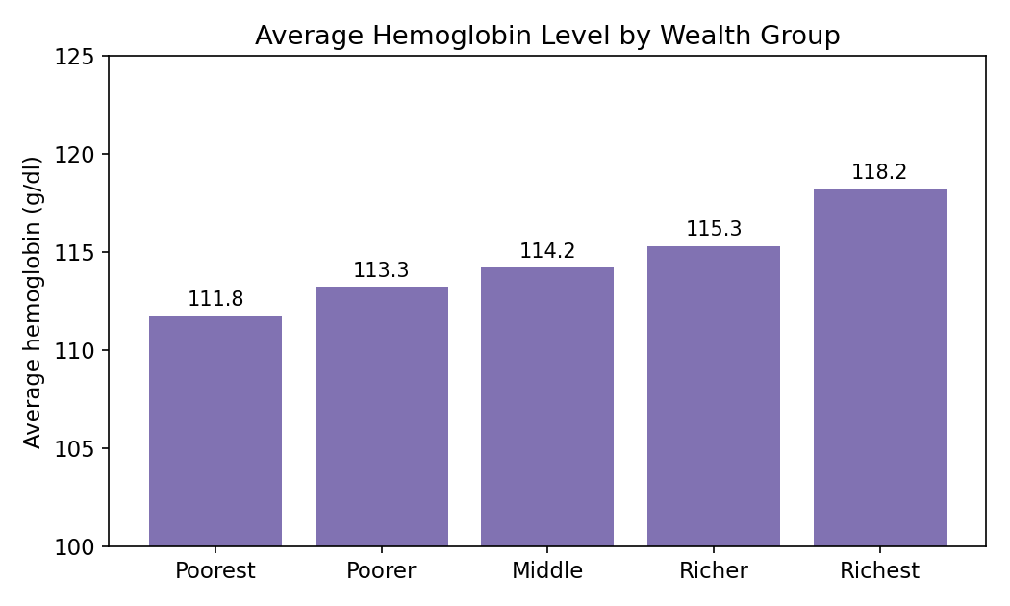
Figure 4: Average hemoglobin level (g/dl) by wealth group. Lower hemoglobin means more anemia.
Average hemoglobin rises step by step from 111.8 g/dl in the poorest group to 118.2 g/dl in the richest. This matches the anemia rate chart almost exactly, which is a good sign. The two measurements (the diagnosed "anemia level" category and the raw hemoglobin number) tell the same story independently, so this isn't an artifact of how anemia was categorized.

3.5 A few things that did NOT make much difference
Two variables I expected to matter turned out to be weak or flat, and I think that's worth reporting honestly rather than leaving out:
- Bed net use: 59.1% anemia rate for children with a bed net vs. 60.1% without one. Basically no difference. This makes sense, since bed nets protect against malaria specifically, and anemia has several other causes (diet, iron deficiency, infections) that a bed net wouldn't touch.
- Iron supplement use: 57.7% anemia rate for children taking iron pills/syrup vs. 59.4% not taking them. Also a small gap, smaller than I'd expect if supplements were working well across the board. This could mean the supplements aren't reaching kids consistently, or that families start giving iron only after a child is already diagnosed anemic, which would flip the direction of cause and effect. I can't tell which from this data alone.
One table that ties the education angle together, since it lines up closely with the wealth pattern:
Mother's Education Level | Anemia Rate
No education | 64.0%
Primary | 59.0%
Secondary | 57.1%
Higher | 48.1%

Table 1: Anemia rate by mother's highest education level.

4. Conclusion
Money is the big factor. Poorer kids get anemia more often, and when they do, it's more severe. This shows up the same way across three different measures (anemia category, severity level, and raw blood hemoglobin), so it's very likely a real pattern, not a fluke.
Location and mom's education point the same way, but that's not a coincidence. Rural areas and less-educated moms tend to also mean less money. So this isn't four separate problems, it's really one problem (poverty) showing up in a few different places.
Bed nets and iron supplements barely made a difference. That's a red flag worth raising. It could mean these tools aren't reaching the kids who need them most, aren't being used consistently, or the iron numbers are mixed up because sick kids are often the ones already given supplements. Any of these would need more digging before pouring more money into scaling those programs up.
Big stipulation: 6 in 10 kids in this dataset have no anemia test result. It's unclear why, whether it's a testing gap or those kids just weren't checked. If sicker-looking kids were more likely to get tested, the numbers here could be skewed higher than reality. So this should be read as a strong, likely direction, not an exact measurement.
Bottom line: Poverty is the real headline here. Any program that only hands out bed nets or iron supplements, without also tackling the underlying poverty and access problem, probably won't move the needle much on its own.

