Isaias Osorio

CPE301 – SPRING 2016

Design Assignment 1

**DO NOT REMOVE THIS PAGE DURING SUBMISSION:**

The student understands that all required components should be submitted in complete for grading of this assignment.

|  |  |  |  |
| --- | --- | --- | --- |
| **NO** | **SUBMISSION ITEM** | **COMPLETED (Y/N)** | **MARKS**  **(/MAX)** |
| 0. | COMPONENTS LIST AND CONNECTION BLOCK DIAGRAM w/ PINS |  |  |
| 1. | INITIAL CODE OF TASK 1/A |  |  |
| 2. | INCREMENTAL / DIFFERENTIAL CODE OF TASK 2/B |  |  |
| 3. | INCREMENTAL / DIFFERENTIAL CODE OF TASK 3/C |  |  |
| 4. | INCREMENTAL / DIFFERENTIAL CODE OF TASK 4/D |  |  |
| 5. | INCREMENTAL / DIFFERENTIAL CODE OF TASK 5/E |  |  |
| 6. | SCHEMATICS |  |  |
| 7. | SCREENSHOTS OF EACH TASK OUTPUT |  |  |
| 8. | SCREENSHOT OF EACH DEMO |  |  |
| 9. | VIDEO LINKS OF EACH DEMO |  |  |
| 10. | GOOGLECODE LINK OF THE DA |  |  |
|  |  |  |  |
|  |  |  |  |

|  |  |  |  |
| --- | --- | --- | --- |
| 0. | COMPONENTS LIST AND CONNECTION BLOCK DIAGRAM w/ PINS |  |  |

Atmel studio

|  |  |  |  |
| --- | --- | --- | --- |
| 1. | INITIAL CODE OF TASK A |  |  |

Store 25 numbers starting from the RAMEND/2 location. Capture the lower 8bits of the variable/memory location RAM_MIDDLE = RAMEND/2 address and use them as your values. You can increment or decrement from RAM_MIDDLE location to get the subsequent 24 numbers. Use the X/Y/Z registers as pointers to fill up 25 numbers starting from location=RAM_MIDDLE.

Screen shot before running code:

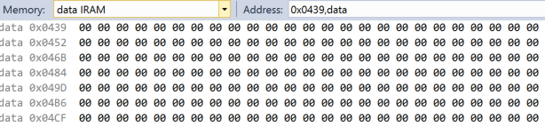

.def count = r22

.def temp = r25

.def zero = r0

; Task a

.cseg

ldi xl, low(ramend / 2) ; Setting X & Y registers to middle of ram

ldi xh, high(ramend / 2)

movw yl, xl ; Y = X

mov r16, xl ; r16 = low(x)

ldi count, 25 ; count = 25

loop25: ; Store 25 integers from middle of ram

st y+, r16 ; *y = r16; y++

inc r16 ; r16++

dec count ; count--

brne loop25 ; loop until count = 0

Screen shot after running code:

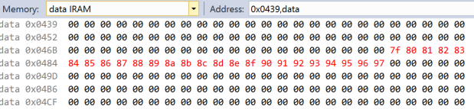

|  |  |  |  |
| --- | --- | --- | --- |
| 2. | INITIAL CODE OF TASK B |  |  |

Use X/Y/Z register to parse through the 25 numbers and add all numbers divisible by 7 and place the result in R20:21.

Screen shot before running code:

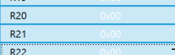

;Task b

movw yl, xl ; y = x

ldi count, 25 ; counter = 25

ldi r17, 7 ; r17 = 7 // divisor

call Add25 ; call Add25 routine

mov r20, r10 ; get return values.

mov r21, r11 ; r21:r20 <- r11:r10

Screenshot after running code:

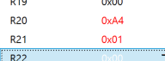

|  |  |  |  |
| --- | --- | --- | --- |
| 4. | INITIAL CODE OF TASK D |  |  |

Check and set register R07.3 if the sum is greater than 8-bits.

Screenshot before running code

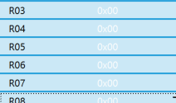

;Task d

; if r21:r20 is larger than 8 bits, set bit 3 in r7

cp r21, zero ; check if high byte is 0

breq lessthan8bits7

mov temp, zero

sbr temp, 4

mov r7, temp ; set bit 3 in r7 is true

lessthan8bits7:

Screenshot before running code

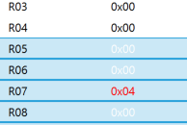

|  |  |  |  |
| --- | --- | --- | --- |
| 3. | INITIAL CODE OF TASK C |  |  |

Use X/Y/Z register to parse through the 25 numbers and add all numbers divisible by 3 and place the result in R23:24. Parsing of the numbers for task b and c has to be done simultaneously.

Screenshot before running code

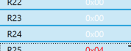

; Task c

; reset y register to x

movw yl, xl ; y <- x

ldi count, 25 ; counter = 25

ldi r17, 3 ; r17 = 3 // divisor

call Add25

mov r23, r10

mov r24, r11 ; r24:r23 <- r11:r10

Screenshot after running code

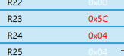

|  |  |  |  |
| --- | --- | --- | --- |
| 4. | Continuation CODE OF TASK D |  |  |

; Task d

; if r24:r23 is larger than 8 bits, set bit 3 in r7

cp r24, zero ; check if high byte is 0

breq lessthan8bits3

mov temp, zero

sbr temp, 4

mov r7, temp ; set bit 3 in r7 is true

lessthan8bits3:

end:

rjmp end

; Add 25 integers previously stored that are divisible by 3.

Add25:

clr r10 ; Clear registers r11:r10

clr r11

add25Loop:

ld r1, y+ ; get next value

mov r16, r1

call div8u ; use divide routine

cp r15, zero ; Check if remainder is 0

brne notDivByR

add r10, r1 ; Add if remainder is 0

adc r11, zero ; add values

notDivByR:

dec count ; loop counter

brne add25Loop

ret ; return to calling routine

;**** A P P L I C A T I O N N O T E A V R 2 0 0 ************************

;*

;* Title: Multiply and Divide Routines

;* Version: 1.1

;* Last updated: 97.07.04

;* Target: AT90Sxxxx (All AVR Devices)

;*

;* Support E-mail: avr@atmel.com

;*

;***************************************************************************

;*

;* "div8u" - 8/8 Bit Unsigned Division

;*

;* This subroutine divides the two register variables "dd8u" (dividend) and

;* "dv8u" (divisor). The result is placed in "dres8u" and the remainder in

;* "drem8u".

;*

;* Number of words :14

;* Number of cycles :97

;* Low registers used :1 (drem8u)

;* High registers used :3 (dres8u/dd8u,dv8u,dcnt8u)

;*

;***************************************************************************

;***** Subroutine Register Variables

.def drem8u =r15 ;remainder

.def dres8u =r16 ;result

.def dd8u =r16 ;dividend

.def dv8u =r17 ;divisor

.def dcnt8u =r18 ;loop counter

div8u:

sub drem8u,drem8u ; clear remainder and carry

ldi dcnt8u,9 ; init loop counter

d8u_1:

rol dd8u ; shift left dividend

dec dcnt8u ; decrement counter

brne d8u_2 ; if done

ret ; return

d8u_2:

rol drem8u ; shift dividend into remainder

sub drem8u,dv8u ; remainder = remainder - divisor

brcc d8u_3 ; if result negative

add drem8u,dv8u ; restore remainder

clc ; clear carry to be shifted into result

rjmp d8u_1 ; else

d8u_3:

sec ; set carry to be shifted into result

rjmp d8u_1

|  |  |  |  |
| --- | --- | --- | --- |
| 5. | TASK E |  |  |

Determine the execution time @ 16MHz/#cycles of your algorithm using the simulation.

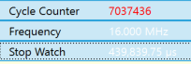

|  |  |  |  |
| --- | --- | --- | --- |
| 6. | SCHEMATICS |  |  |

n/a

|  |  |  |  |
| --- | --- | --- | --- |
| 7. | VIDEO LINKS OF EACH DEMO |  |  |
| n/a | | | |
| 11. | Github Repository |  |  |
| https://github.com/martinjaime/CpE301_Assignments2016S.git | | | |

**Student Academic Misconduct Policy**

<http://studentconduct.unlv.edu/misconduct/policy.html>