Isaias Osorio

CPE301 – SPRING 2016

Design Assignment 4

**DO NOT REMOVE THIS PAGE DURING SUBMISSION:**

The student understands that all required components should be submitted in complete for grading of this assignment.

|  |  |  |  |
| --- | --- | --- | --- |
| **NO** | **SUBMISSION ITEM** | **COMPLETED (Y/N)** | **MARKS**  **(/MAX)** |
| 0. | COMPONENTS LIST |  |  |
| 1. | INITIAL CODE OF TASK 1 |  |  |
| 2. | SCHEMATICS |  |  |
| 3. | SCREENSHOTS OF EACH TASK OUTPUT |  |  |
| 4. | SCREENSHOT OF EACH DEMO |  |  |
| 5. | VIDEO LINKS OF EACH DEMO |  |  |
| 6. | GITHUB LINK OF THE DA |  |  |
|  |  |  |  |
|  |  |  |  |

|  |  |  |  |
| --- | --- | --- | --- |
| 0. | COMPONENTS LIST AND CONNECTION BLOCK DIAGRAM w/ PINS |  |  |

**COMPONENTS:**

ATmega328P Chip x1

RGB LED x1

100 Ω resistor x2

150 Ω resistor x1

|  |  |  |  |
| --- | --- | --- | --- |
| 1. | INITIAL CODE OF TASK 1/A |  |  |

\* DA-4.c

* Created: 4/10/2016 3:11:05 PM

* Author : Isaias Osorio

*/

#define *F_CPU* 8000000UL // frequency for delay functions

#include <util/delay.h> // library for _delay_ms() function

#include <avr/io.h> // library for I/O

void delay (); // function declaration for delay

int main(void)

{

unsigned char i = 230, j=230, k=230;// initialize to 230 for 10% value of 255

unsigned char counter2 = 0, counter3 = 0;

// two variables to update 2nd and 3rd PWMs counters

DDRD = 0x40; // OC0A

DDRB = 0x0A; // OC1A and OC2A

OCR0A = 230; // 230 is 10% value of 255 when decrementing

TCCR0A = 0xC1; // Phase Correct PWM, inverted

TCCR0B = 0x03; // N = 64

OCR1A = 230; // 230 is 10% value of 255 when decrementing

TCCR1A = 0xC1; // Phase Correct PWM, inverted

TCCR1B = 0x03; // N = 64

OCR2A = 230; // 230 is 10% value of 255 when decrementing

TCCR2A = 0xC1; // Phase Correct PWM, inverted

TCCR2B = 0x04; // N = 64

while (1) // loop forever

{

OCR0A = i; // update 3 PWM values at beginning of each loop

OCR1A = j; // from delay of 40ms

OCR2A = k;

counter2++; // increment counter for 2nd PWM every time 1st is updated

i -= 5; // increase duty cycle of PWM1 by 10%

if(i < 30) // if duty cycle is more than 90% (inverted)

i = 230; // reset duty cycle back to 10%

if(counter2 >= 9)

{ // if PWM1 reset duty cycle

counter2 = 0; // clear counter for PWM2

counter3++; // increment counter for PWM3

j -= 5; // increase duty cycle of PWM2 by 10%

if(j < 30) // if duty cycle is more than 90% (inverted)

j = 230; // reset duty cycle back to 10%

}

if(counter3 >= 9)

{ // if PWM2 reset duty cycle

counter3 = 0; // clear counter for PWM3

k-=5; // increase duty cycle of PWM3 by 10%

if(k < 30) // if duty cycle is more than 90% (inverted)

k = 230;// reset duty cycle back to 10%

}

*_delay_ms*(40); // delay for 40ms

}

return 0;

}

|  |  |  |  |
| --- | --- | --- | --- |
| 2. | SCHEMATICS |  |  |

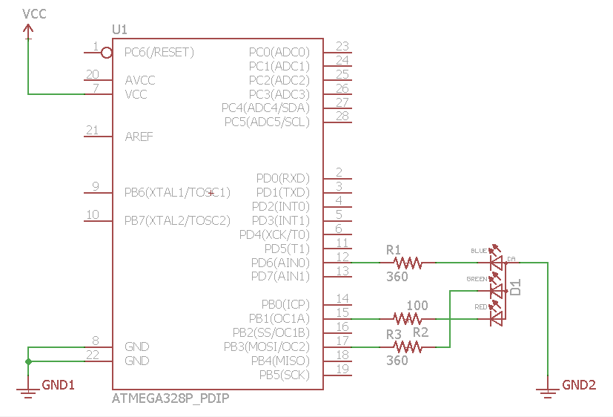

|  |  |  |  |
| --- | --- | --- | --- |
| 3. | SCREENSHOTS OF EACH TASK OUTPUT |  |  |

TASK 1: Showing the value **i** being output to OCR0A as 30 which will be 90% duty cycle using inverted mode.

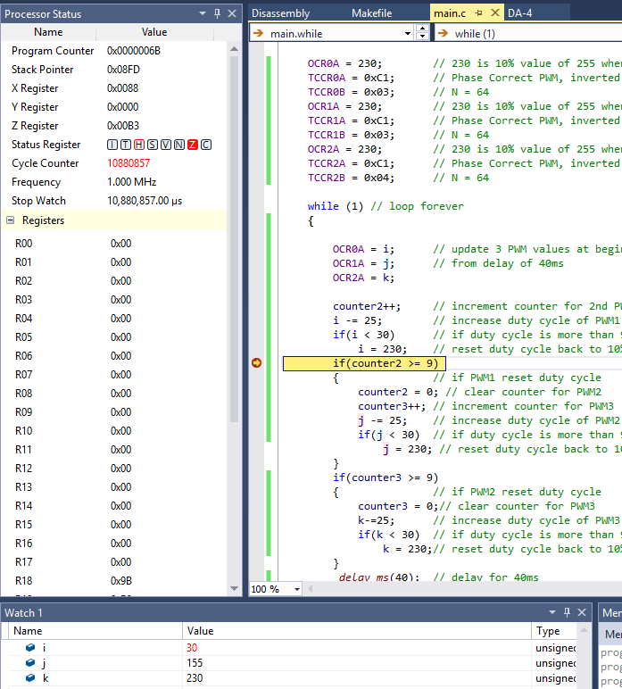

|  |  |  |  |
| --- | --- | --- | --- |
| 4. | SCREENSHOT OF EACH DEMO |  |  |

BREADBOARD: Actual circuit is the ATmega328P connected to RGB with 3 resistors. Image was taken during mid sequence of the RGB.

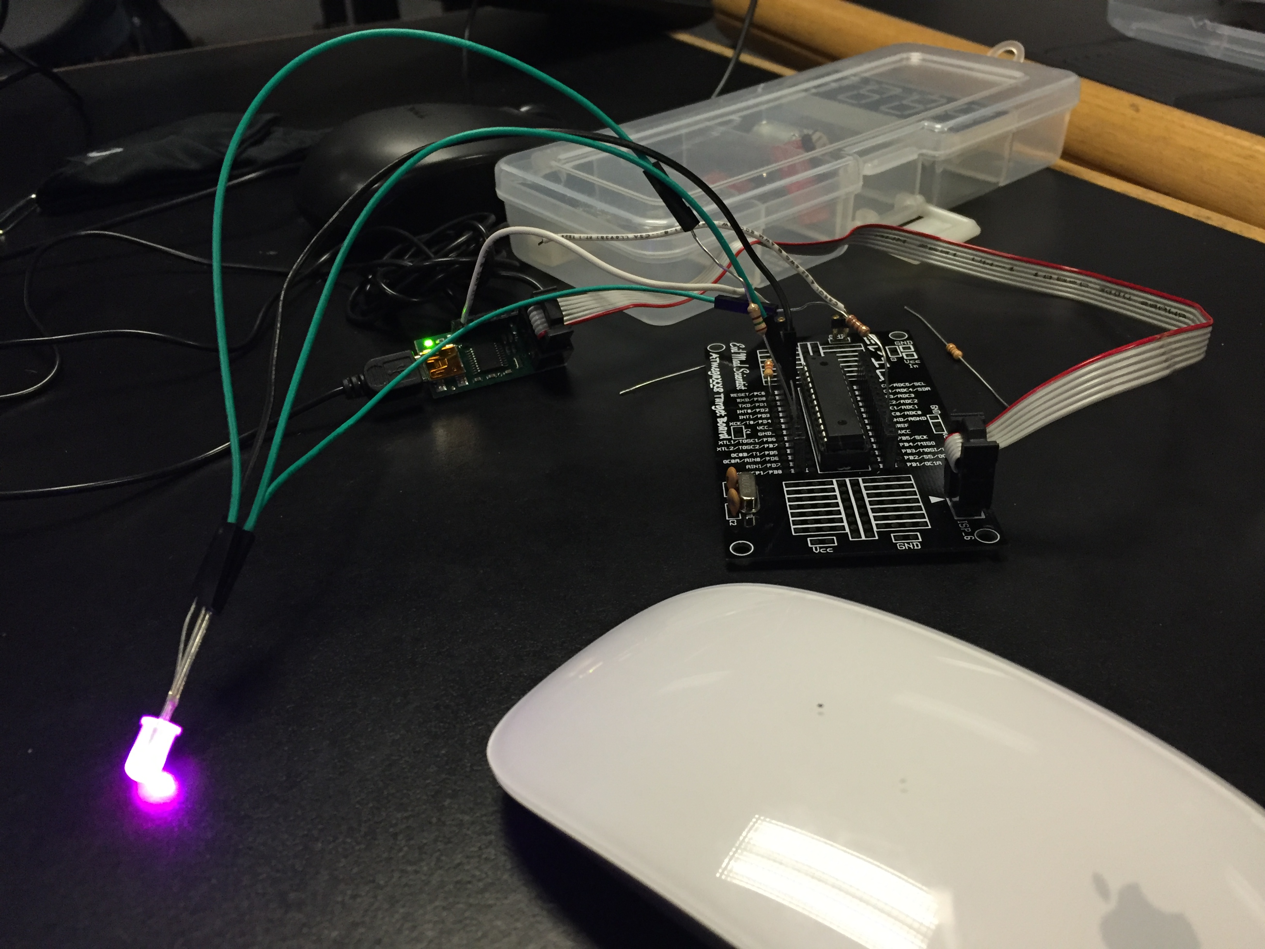

|  |  |  |  |
| --- | --- | --- | --- |
| 5. | VIDEO LINKS OF EACH DEMO |  |  |
| **https://github.com/isaiasmoioso/**[**CPE-301**](https://github.com/isaiasmoioso/CPE-301)/[DA-4](https://github.com/isaiasmoioso/CPE-301/tree/master/DA-4)/**IMG_3748.MOV** | | | |
| 6. | GITHUB LINK OF THE DA |  |  |
| https://github.com/isaiasmoioso/CPE-301.git | | | |

**Student Academic Misconduct Policy**

<http://studentconduct.unlv.edu/misconduct/policy.html>

“This assignment submission is my own, original work”.

Isaias Osorio