Comparing summed probability distributions of shoreline and radiocarbon dates from the Mesolithic Skagerrak coast of Norway

Isak Roalkvam (ORCID: 0000-0001-6974-1374)1,✉ and Steinar Solheim (ORCID: 0000-0001-8293-8147)2

By developing a new methodology for handling and assessing a large number of shoreline dated sites, this paper compares the summed probability distribution of radiocarbon dates and shoreline dates along the Skagerrak coast of south-eastern Norway. Both measures have previously been compared to elucidate demographic developments in Fennoscandia, but these have not been based on probabilistic methods for shoreline dating. The findings indicate a largely diverging development of the two data sets through the Mesolithic. The number of shoreline dated sites undergoes some process of overall decrease through the period, while the radiocarbon data is characterised by a lacking signal in the earliest parts of the period and then undergoes a logistic growth that quickly plateaus and remains stable for the remainder of the period. The precise nature of this discrepancy will necessitate further substantiation and the method of shoreline dating itself still requires further testing and assessment. Having noted this, we still tentatively suggest that while the number of shoreline dated sites is not devoid of influence from a demographic signal, this measure could be more heavily influenced by mobility patterns. Conversely, we also suggest that the lacking radiocarbon data from the earliest part of the Mesolithic is in part the result of mobility patterns, but that the radiocarbon data could be reflecting population dynamics more directly.

1 University of Oslo, Department of Archaeology, Conservation and History  
2 University of Oslo, Museum of Cultural History  
✉ Correspondence: [Isak Roalkvam <isak.roalkvam@iakh.uio.no>](mailto:isak.roalkvam@iakh.uio.no)

Keywords: Mesolithic; Shoreline dates; Radiocarbon dates; Fennoscandia

# 1 Introduction

Population patterns are regarded as important drivers and potential outcomes of cultural variation, and are thus of critical importance to our understanding of past human societies (e.g. French et al., 2021; Shennan, 2000; Shennan & Sear, 2021). During the last decade, the frequency distribution of radiocarbon dates has become the preferred proxy for archaeologists studying prehistoric population dynamics (Crema, 2022; French et al., 2021; Shennan et al., 2013), owing in part to the fact that radiocarbon dates represent the most temporally and spatially widespread archaeological data available for studying past population densities (Bird et al., 2022). This has also been the case for Norwegian Stone Age archaeology (e.g. Bergsvik et al., 2021; Jørgensen, 2020; Lundström, 2023; Nielsen et al., 2019; Nielsen, 2021a; Persson, 2018; Solheim, 2020; Solheim & Persson, 2018; see also Persson, 2009).

The potentially immense value of insights into past population dynamics, combined with the ubiquity of radiocarbon dates and the relative ease with which these can now be processed within what has been termed a dates-as-data methodology (Rick, 1987) has undoubtedly contributed to the popularity of the approach. Several limitations and forms of criticism have, however, been directed at these procedures. Some of the objections are of a methodological nature, while others pertain to the underlying logic and the degree to which there is likely to be a constant and direct connection between the frequency of 14C-dates and population dynamics (e.g. Attenbrow & Hiscock, 2015; Carleton & Groucutt, 2021; Torfing, 2015; Ward & Larcombe, 2021). What appears to be agreed upon by practitioners and critics alike is that radiocarbon dates are best analysed in this manner when compared and contrasted to other proxies for past population dynamics, and other variables that might impact these (Attenbrow & Hiscock, 2015; Bevan et al., 2017; Crombé & Robinson, 2014; French et al., 2021; Palmisano et al., 2017, 2021; Rick, 1987; Williams, 2012). In this paper, we report on and begin to unpack the relationship between two measures that have been linked to relative population size in the context of the Mesolithic Skagerrak coast in south-eastern Norway, namely the summed probability distribution of calibrated radiocarbon dates (RSPD) and the summed probability distribution of shoreline dated sites (SSPD). While fundamental questions concerning the reliability of shoreline dating still persist, our analysis draws on recent developments and ongoing efforts to formalise and better understand the dating method (Roalkvam, 2023a; Rosenvinge et al., 2022, pp. 21–41). We discuss how the data compare with each other as well as how they can potentially be drawn on to understand cultural historical developments in the region through the Mesolithic, c. 9500–4000 BCE.

# 2 Background

Following the retreat of the Fennoscandian Ice Sheet, large parts of the post-glacial landscape of Northern Scandinavia has been characterised by dramatic isostatic uplift that has led to a net sea-level fall throughout the Holocene, despite eustatic sea-level rise (e.g. Mörner, 1979; Steffen & Wu, 2011). The majority of Mesolithic sites along the Norwegian Skagerrak coast are interpreted as having been shore bound or located close to the contemporaneous shoreline at their time of use (see e.g. Darmark et al., 2018; Mjærum, 2022; Roalkvam, 2023a; Solheim, 2020). Consequently, as coastal foragers in this region appear to have predominantly settled on or close to the contemporaneous shoreline during early and mid-Holocene, this can be utilised to assign an approximate date to the occupation of the sites. This is done by coupling the present-day altitude of the sites with reconstructions of past shoreline displacement – a method known as shoreline dating. Shoreline dating has a long tradition of use in Fennoscandian archaeology (Brøgger, 1905; Hollender, 1901), and is especially useful for dating the large number of surveyed archaeological sites where temporal data that often follow with an excavation, such as radiocarbon dates or typological indicators in artefact inventories, are not available. A series of studies have suggested that shoreline dated sites can be used as a proxy to study temporal variation in population density (Jørgensen et al., 2020; Mjærum, 2022; Solheim & Persson, 2018; Tallavaara & Pesonen, 2020).

Previously, the frequency of shoreline dated sites has been evaluated by finding point estimates of shoreline dates that are aggregated in somewhat arbitrary bins of 200 or 500 years (e.g. Fossum, 2020; Mjærum, 2022; Solheim & Persson, 2018; Tallavaara & Pesonen, 2020), or by the use of disjoint time-intervals of variable duration (Berg-Hansen et al., 2022), which could cause issues when comparing the relative counts across these units (Bevan & Crema, 2021). These point-based estimates do not consider the uncertainty in the distance between the sites and the contemporaneous shoreline, nor the impact the variability in the rate of sea-level change has on the precision of the dates that can be achieved with the method. In a recent study, Roalkvam (2023a) has presented a probabilistic method for shoreline dating that takes these parameters into account, thus setting the stage for a more refined investigation of the relationship between the frequency of 14C-dates and shoreline dated sites. The parametrisation of the method was based on simulating the distance between 66 sites with 14C-dates and the prehistoric shoreline along the Skagerrak coast in the region between Horten municipality in the north-east to Arendal municipality in the south-west (see map in Fig. 1). The result of the analysis indicates that the sites tend to have been located close to the shoreline until just after 4000 BCE when a few sites become more withdrawn from the shoreline (see also Nielsen, 2021b), followed by a clear break around 2500 BCE, at which point shoreline dating appears to lose its utility. Consequently, these geographical and temporal limits are also used for this study.

Limiting this study to the same temporal and geographical constraints as was used in Roalkvam (2023a) should mitigate some issues that could follow from undue extrapolation of the technique to areas where the reliability of the method and the parametrisation employed here has not been assessed and therefore might not apply. However, while we view the long history of use and research into shoreline dating as a testament to its general applicability, and these recent developments as an improvement of this framework, it should also be underscored that the method for shoreline dating employed in this study is still hefted with significant questions regarding its reliability (see Roalkvam, 2023a).

The present study is decidedly exploratory. While some thoughts concerning the relationship between the frequency of radiocarbon dates, shoreline dated sites and population dynamics underlie the analysis, these could not be instantiated as concrete hypotheses. Rather, we explore the data by using a set of standard models to begin to unpack patterns and grasp the relationship between these variables. The dates-as-data approach is dependent on there being a link between how prehistoric people generated material that become 14C samples and population dynamics. The sum of shoreline dated sites, on the other hand, is determined by site frequency, and its use as a population proxy is therefore dependent on there being a connection between site count and population density. If a comparison of these proxies indicate that they do not, or only partially correspond, it is thus an open question what factors have impacted either distribution to cause this discrepancy, and which measure, if any, reflects true population dynamics. The issue will therefore initially demand an open and exploratory approach where a multitude of explanatory and confounding effects can be drawn on to suggest explanations of any observed pattern.

## 2.1 Population dynamics and summed probabilities

To what degree the radiocarbon record is determined by past population numbers might vary geographically and chronologically, based on variation in investigatory and taphonomic factors (Bluhm & Surovell, 2019; Surovell et al., 2009), as well as cultural processes within prehistoric populations. One example of the latter is the difference that might exist between farmer and forager populations, where Freeman et al. (2018) have suggested that an increased per capita energy consumption introduced with farming means that 14C-dates should not be weighted equally when making relative population estimates across such populations. Similarly, while site counts have also been invoked for the analysis of past population dynamics, these are likely to be impacted by factors such as land-use and mobility patterns, and settlement nucleation and dispersion, as well as variation in archaeological investigations and what has been taken to constitute a site (Drennan et al., 2015, pp. 16–20; Palmisano et al., 2017). However, these could be considered theoretical issues that have implications for how fluctuations in these proxies should be interpreted, and possibly weighted differently by factors such as those mentioned above. Before any such fluctuations are given any substantive interpretation, however, there is a host of methodological issues that have to be considered (see Crema, 2022 for a recent review).

The most critical of these follows from the fact that the summation of the probabilities associated with the dates for SPDs is not a directly coherent statistical procedure. This is because the summed probabilities can no longer been seen as probabilities, but rather represent the combination of events and chronological uncertainties, making the two indistinguishable, and rendering the interpretation of the resulting sum difficult (Blackwell & Buck, 2003; Crema, 2022). As Timpson et al. (2021, p. 2) put it: ‘the SPD is not *the* single best explanation of the data, nor even *a* single explanation of the data, but rather a conflation of many possible explanations simultaneously, each of which is mired by the artefacts inherited from the calibration wiggles.’ The SPD is not a model. It is the combined representation of a range of possible explanations for the data – the frequency of dated events combined with the variable uncertainty associated with these (Carleton & Groucutt, 2021). This means that a direct visual inspection of SPDs can be misleading, that they cannot be directly analysed to draw inferences on population dynamics, and that they cannot be directly compared to other time-series data (Carleton et al., 2018; Crema, 2022; Timpson et al., 2021). While this problem cannot be entirely resolved, a range of approaches have been developed in an attempt to work around this issue.

The most commonly applied of these is a null-hypothesis significance testing approach by means of Monte Carlo simulation, first introduced by Shennan et al. (2013) and later expanded upon by Timpson et al. (2014) and Crema & Bevan (2021). This works by comparing the observed RSPD with a series of simulated RSPDs, generated from a null model. These null models are typically a uniform, exponential or logistic distribution. These are generally chosen *a priori* with reference to common long-term population dynamics and are typically parametrised by fitting the models by means of least-squares or, given recent methodological developments (Timpson et al., 2021), maximum likelihood estimation (MLE). The result from these simulations is then used to create a 95% critical envelope representing the null model. The proportion of the observed RSPD that falls outside the simulated envelope (i.e. positive or negative divergence of the observed SPD from the fitted null model), is then used to estimate a global p-value indicating whether the null model can be rejected. In the case that it can, the portions of the observed RSPD that falls outside this envelope can subsequently be interpreted as representing potentially meaningful demographic events, relative to the null model. However, care has to be taken in how these are interpreted. First, this follows from the fact that 5% of the deviations from the critical envelope can be expected to be random, and there is no way to know which deviations this pertains to. Secondly, for example, an exponential null model fit to the data is only one of an infinite set of exponential models with different growth rates that could be used. While a model fit by means of MLE will likely have a reasonable growth rate, and by extension exclude many other exponential fits as likely to explain the data, this can be difficult to determine. Finally, the p-value only indicates whether the null model as a whole can be rejected as an explanation of the data, and it does not provide statistical justification for inferring whether local deviations themselves are meaningful demographic signals (Crema, 2022; Timpson et al., 2021).

The procedure outlined above represent the standard approach in efforts to model population dynamics based on RSPDs. This can be helpful for getting an impression of the overall developments of population proxies, and it is an especially useful first step in the treatment of shoreline dated sites, as few assumptions concerning this overall development could be made. However, it is worth underscoring that deviations from these rejected null models do not in themselves give statistical justification for the interpretation of any local deviations, nor a subsequent direct analysis of the SPDs themselves.

# 3 Methods and data

Sites surveyed by means of test-pitting between Horten and Arendal were initially retrieved from the national heritage database Askeladden (Norwegian Directorate for Cultural Heritage, 2018), totalling at 1299 records. The records were then manually reviewed and given a quality score based on the criteria in Table 3.1, indicating the degree to which the spatial location and extent of the sites is believed to be represented by the geometries available in the database (see also Roalkvam, 2020). All sites with a quality score of 4 or worse were excluded from further analysis. Any sites situated at elevations that would result in a shoreline date earlier than 9465 BCE were then excluded. This marks the latest start-date among the employed displacement curves, and no sites in the region have yet been conclusively verified to have an older date than around 9300 BCE (Glørstad, 2016). Data on excavated sites was originally compiled for Roalkvam (2023a) and has been compared with site data as listed in Damlien et al. (2021) and Nielsen et al. (2019). Only excavated sites with available spatial data in Askeladden or local databases at the Museum of Cultural History of the University of Oslo were included in the analysis. The 102 excavated sites in the dataset without relevant 14C-dates that were originally shoreline dated in the excavation reports were included in the SSPD along with the retained surveyed sites. This gave a total of 921 shoreline dated sites in the final SSPD.

The borders of the municipalities within which the shoreline dated sites are located were used to limit the radiocarbon sample. Radiocarbon dates were taken from Roalkvam (2023a) and an unpublished data set collated by Solheim and Kjetil Loftsgarden for the Museum of Cultural History. Dates done on food crusts were then excluded due the issue of marine reservoir effects (Nielsen et al., 2019, p. 83). Following both from the point made by Freeman et al. (2018) concerning the comparison of radiocarbon dates from populations with different economic modes, as noted above, and from the fact that shoreline dating appears less reliable after 4000 BCE and appears to lose its utility c. 2500 BCE, the Mesolithic is the main focus of this analysis. Consequently, probabilities falling later than 2500 BCE were excluded from the analysis, leading to a final sample of 353 14C-dates. Probabilities falling after 4000 BCE, and the first possible small-scale introduction of agriculture in south-eastern Norway, were retained to account for edge-effects but these results should be treated with care for the reasons noted above. Of the final sample, 314 (89%) dates are made on charcoal and burnt nutshell and 39 (11%) on other material such as bone.

All analyses done in this study were performed using the R programming language (R Core Team, 2020). Underlying data and programming code used for the paper is available in an online repository at <https://doi.org/10.5281/zenodo.10449324>. This is structured as a research compendium following Marwick et al. (2018), to allow for reproducibility of the results (see also Marwick, 2017). Analysis of the 14C-dates was mainly done using the R package *ADMUR* v1.0.3 (Timpson, 2020; Timpson et al., 2021) and with some use of *rcarbon* v1.4.4 (Crema & Bevan, 2021). The R package *shoredate* v1.0.2 was used for performing and handling the shoreline dating of sites (Roalkvam, 2023b), with re-purposed code from both *ADMUR* and *rcarbon* used for subsequent model fitting, Monte Carlo simulation and model comparison.

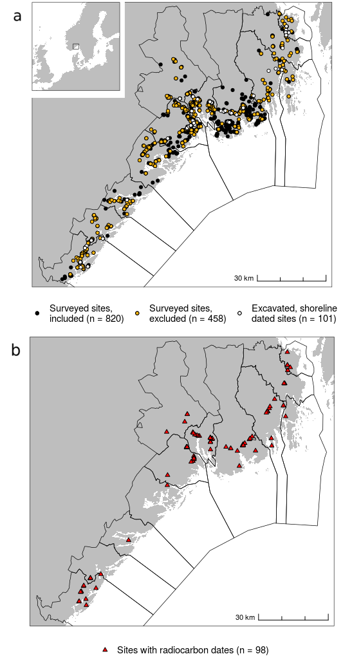  
**Fig. 1**: a) Map displaying the location of the study area and shoreline dated sites. Black lines indicate the6borders between municipalities. The surveyed sites included in the analysis are the ones given a quality score of 3 or higher using the framework in Table 1. b) The distribution of radiocarbon dates employed in the study.

**Table 1:** Quality scoring of site records of surveyed sites retrieved from the national heritage database Askeladden. The scoring system was first used in Roalkvam (2020).

|  |  |  |
| --- | --- | --- |
| Definition | Quality | Count |
| Site delineated by use of a GNSS-device, or a securely georeferenced record. Extensive database entry. | 1 | 353 |
| Secure spatial data. Slight disturbance of the site or somewhat lacking database record. | 2 | 340 |
| Secure spatial data. Damaged site, such as outskirts of a quarry, and/or very limited database entry. | 3 | 148 |
| Surveyed by archaeologists. Database entry is extremely limited/unclear, the site geometry is only given as a point or small automatically generated circle, and/or finds are from the topsoil of a field. | 4 | 165 |
| Likely site but uncertain spatial information. Typical example is recurring stray finds in a field or other larger area. | 5 | 124 |
| Single stray find or unverified claims/suggestions of possible site. | 6 | 169 |

## 3.1 Summed probability of calibrated radiocarbon dates

To account for investigatory bias that can result from variable sampling intensity between sites, the summing of radiocarbon dates with *ADMUR* starts with binning dates from the same sites that fall within 200 uncalibrated 14C years of each other when measured from the mean 14C age. All dates are then calibrated using a resolution of 5 years and normalised to sum to unity. The RSPDs for each site-phase are summed to achieve the final SPD, which is in turn normalised. All calibrations were performed using the IntCal20 calibration curve (Reimer et al., 2020). It can be noted that while several authors have pointed to the fact that normalising the dates can lead to spikes in the RSPD (e.g. Crema & Bevan, 2021, pp. 27–29; Weninger et al., 2015), not normalising the dates did not result in any meaningful difference in the resulting best-fit models for the purposes of this paper (see supplementary figure).

The final RSPD was subjected to the standard null-hypothesis testing approach through Monte Carlo simulation, as introduced above (see Shennan et al., 2013; Timpson et al., 2014), by fitting an exponential, logistic and uniform model to the observed RSPD. Following Timpson et al. (2021), the model parameters were identified by MLE estimation with *ADMUR*, using the differential evolution optimization algorithm *DEoptimR* (Brest et al., 2006). The Monte Carlo simulations were then performed using the *SPDsimulationTest* function from *ADMUR*. For each model, a series of individual calendar years are drawn from the model distribution, with replacement, the number of which equals the number of site phases in the observed RSPD. These are then ‘uncalibrated’ to a single value on the 14C scale and a random error from among the observed errors is added to the date. These are then calibrated back to the calendar scale and finally summed. Here, this procedure was repeated 10,000 times for each null model. The 2.5th and 97.5th percentile of the resulting summed probability for each year across all simulations are then retrieved to create the 95% critical envelope with which to compare the observed RSPD. The degree to which the observed RSPD deviates from the simulations is used to calculate a global p-value, indicating whether the null model under consideration can be rejected.

## 3.2 Summed probability of shoreline dated sites

Summing the probability of the shoreline dated sites and the model-fitting procedures followed the same structure as that for radiocarbon dates and was partly based on re-purposed programming code from *rcarbon* and *ADMUR*. However, idiosyncrasies in the dating method did necessitate some adjustments. To illustrate this, the procedure for shoreline dating a single site, as suggested in Roalkvam (2023a), is provided in Fig. 2 and outlined below.

Four geological reconstructions of shoreline displacement in the region lays the foundation for the method as implemented here (Fig. 2b). These shoreline displacement curves are from Horten (Romundset, 2021), Porsgrunn (Sørensen, Henningsmoen, et al., 2014, in press; Sørensen, Høeg, et al., 2014), Tvedestrand (Romundset et al., 2018; Romundset, 2018) and Arendal (Romundset, 2018), each associated with a shoreline isobase along which the trajectory of relative sea-level (RSL) change has been the same (see Svendsen & Mangerud, 1987, and map in Fig. 2a). The first step in the dating procedure is to interpolate the shoreline displacement to the site to be dated. This is done by inverse distance weighting (e.g. Conolly, 2020), where the RSL change is interpolated to the location of an archaeological site based on its distance from the isobases of the geological displacement curves.

With an estimated trajectory of shoreline displacement at the site to be dated, the elevation of the site can be drawn on to find a likely date for when it was in use, under the assumption that it was in use when located on or close to the shoreline. Fig. 2c indicates where the mean elevation of the polygon representing the example site intersects the interpolated displacement curve. As it can reasonably be assumed that a site was not in use when located under water, this effectively represents a *terminus post quem* (TPQ) date. However, TPQ dates that do not account for the likely distance between site and sea when the site was in use limits the further inferential steps that can be taken. Furthermore, the common practice of adding a constant error or binning point estimates of shoreline dates, as mentioned above, does not consider that the rate of shoreline displacement varies both spatially and temporally, and therefore introduces bias to the result on both the spatial and temporal scale, while also overestimating the precision of the method in most cases.

This last point can be illustrated by finding the range between the upper and the lower limit of the four geological displacement curves for every meter from the marine limit and down to elevations that do not give an earliest date younger than 2500 BCE. This gives a mean TPQ range of 276 years with a standard deviation of 156 years across all four displacement curves, with this range varying significantly over time and between curves.

The analysis in Roalkvam (2023a) found that site phases 14C-dated to before 2500 BCE have a likely elevation above sea-level that can be reasonably approximated by a gamma distribution with shape = 0.286 and scale = 20.833. This is incorporated in the procedure for shoreline dating used for this study (Fig. 2d). When performing this dating procedure, the gamma distribution is sequentially stepped through and transferred to the calendar scale by uniformly distributing the probability across the years in the range between the lower and upper limit of the interpolated displacement curve. This procedure thus gives the shoreline date of a site when accounting for the likely elevation of the site above sea-level when it was in use (see Roalkvam, 2023a for details). Given that the shoreline displacement curves have no inversions and should therefore be commutative (see Weninger et al., 2015, p. 545), each shoreline date is normalised to sum to unity before being summed. To reduce the computational cost of the simulation procedures to follow below, the gamma distribution is here stepped through at increments of 0.1 m and the calendar scale is kept at a resolution of 5 years.

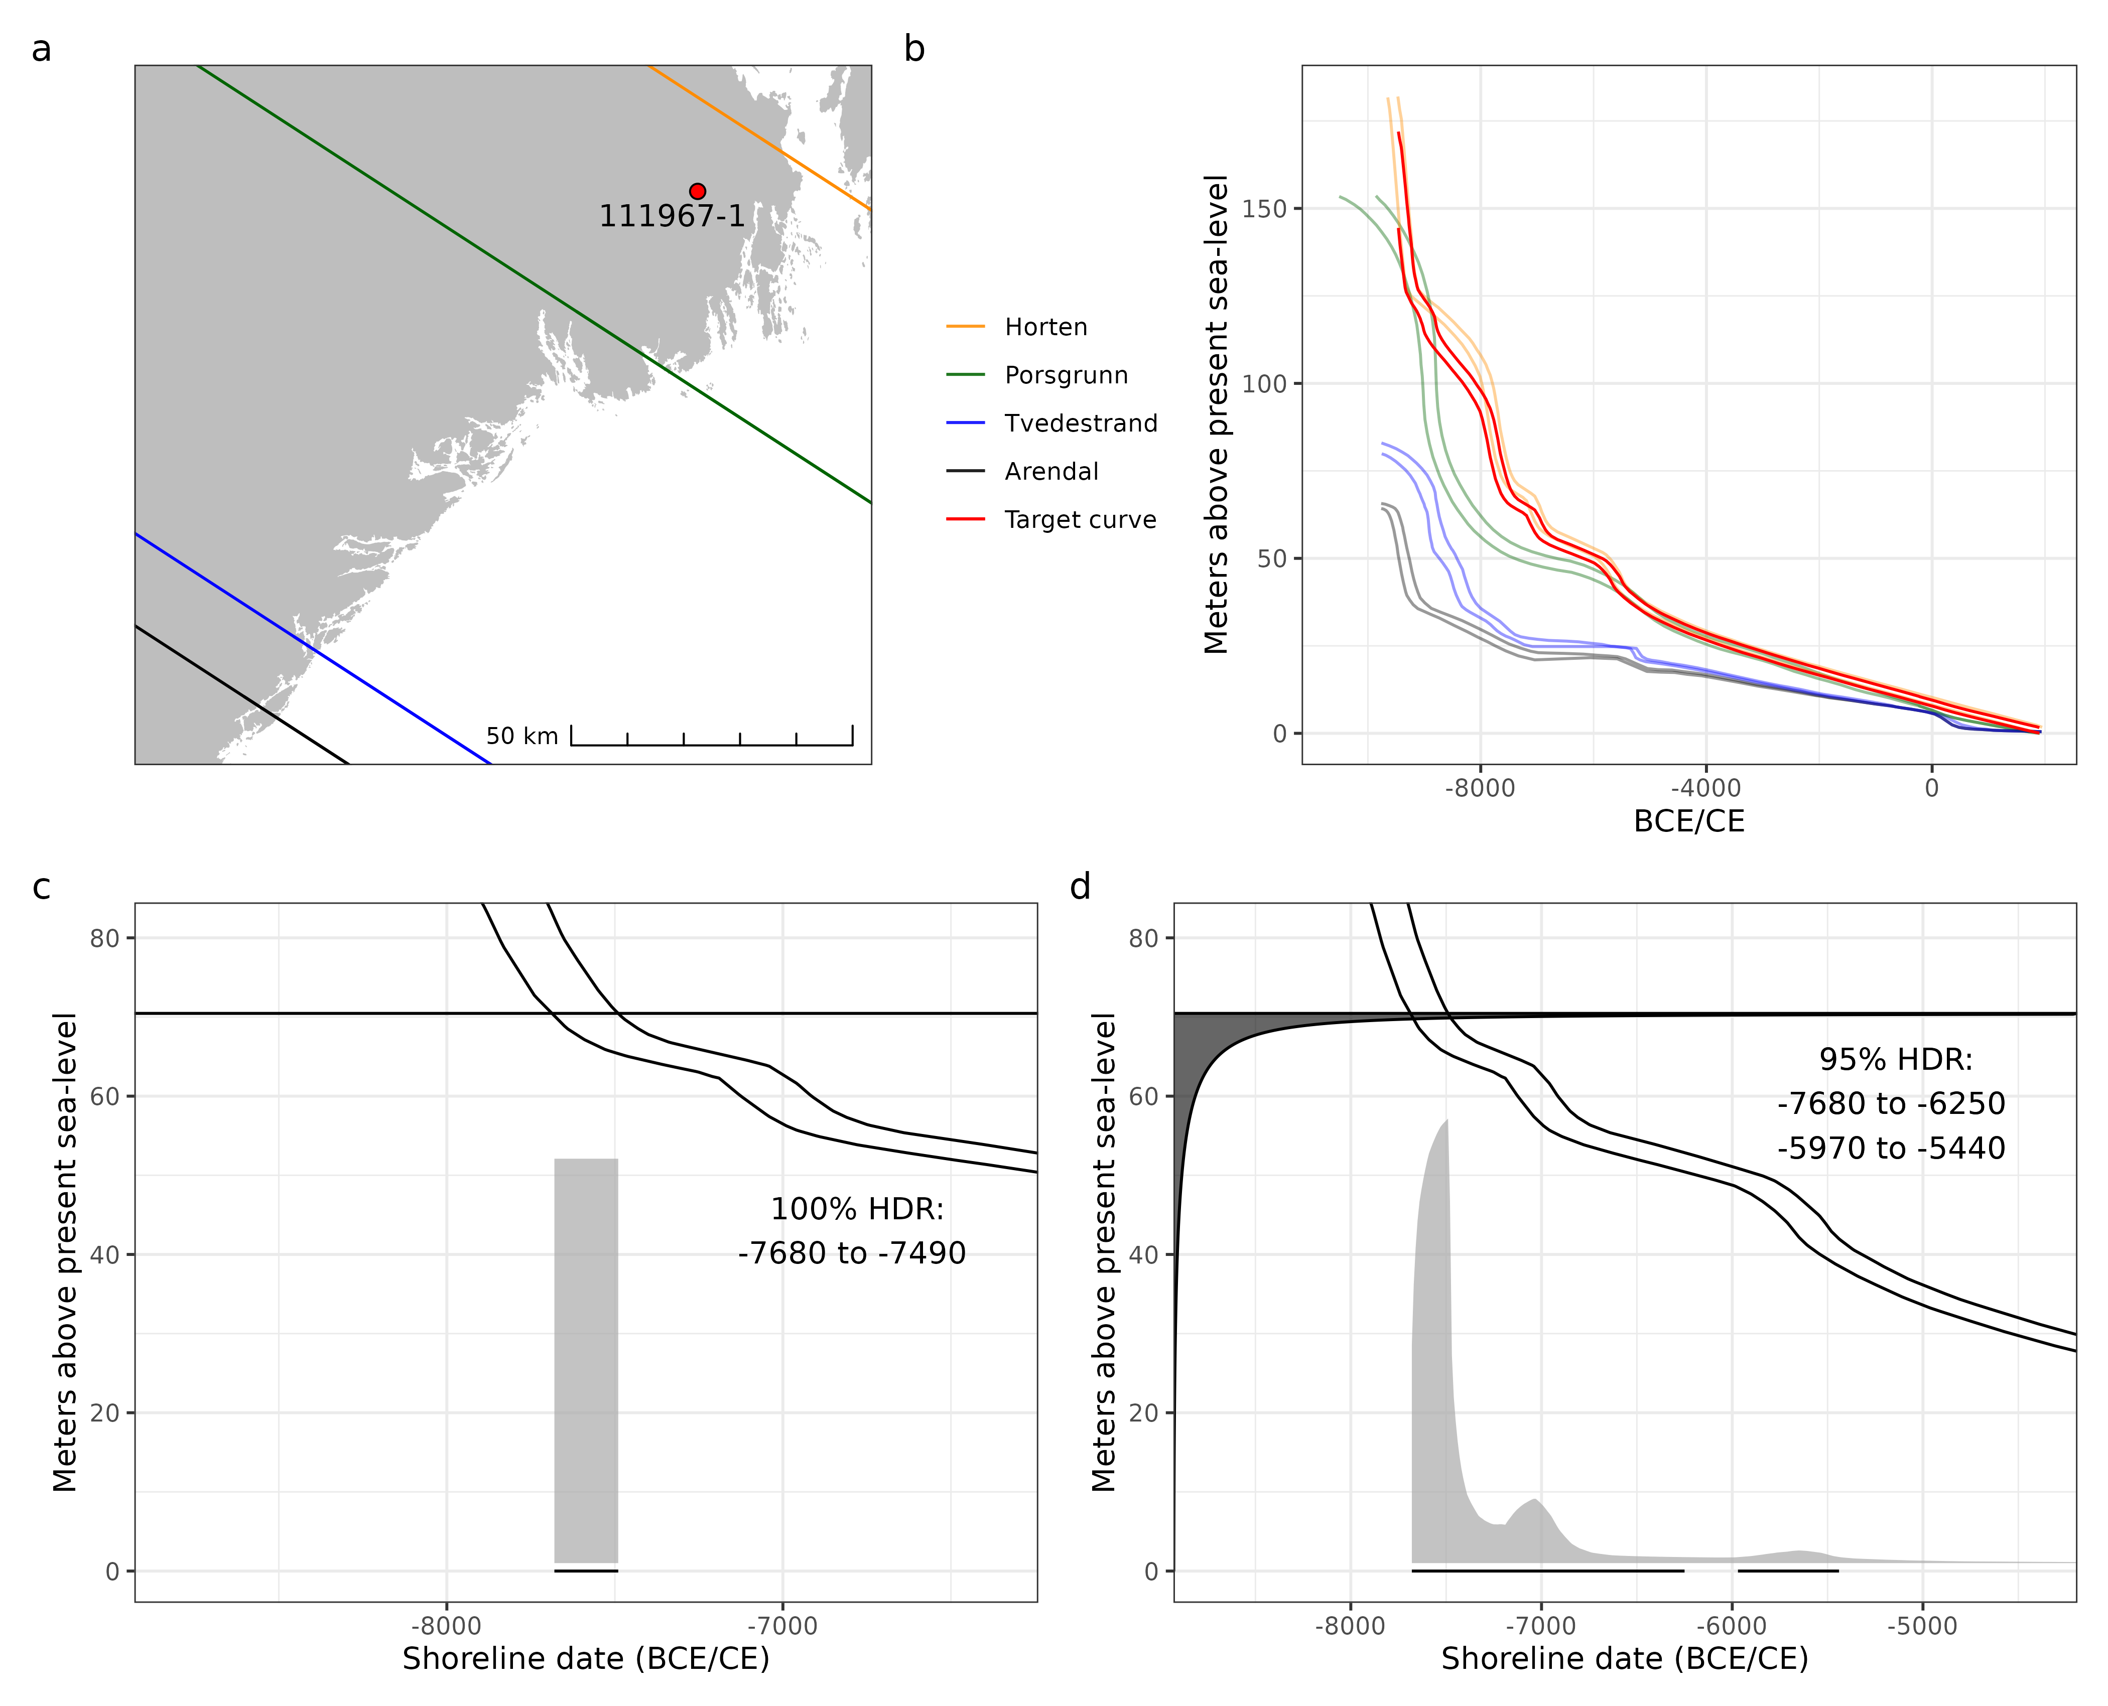  
**Fig. 2**: a) The location of an example site (Askeladden ID 111967-1) relative to the isobases of the displacement curves. b) The geologically derived shoreline displacement curves for the region and the curve interpolated to the example site. c) The black line on the y-axis represents the elevation of the site. This crosses the interpolated displacement curve at 7680 and 7490 BCE, which thus in practice gives an estimate of when the location of the site emerged from the sea and represents a *terminus post quem* date for the site. d) The shoreline dating approach used for this study, where the gamma function on the y-axis describes the likely vertical relationship between the shoreline and the site when it was in use.

The implications of different approaches to shoreline dating and summing the results are illustrated in Fig. 3. In Fig. 3a the sites to be shoreline dated are plotted according to their elevation. Due to the variable rates of shoreline displacement within the study region, the same elevation does not necessarily equate to the same date, and so this does not directly inform us about their temporal distribution. For example, as the trajectory for sea-level regression is more pronounced towards the north-east, the same elevation at a location to the south-west implies a younger date compared to one situated further north-east.

When the frequency distribution of shoreline dates has been investigated in the past, this has typically involved finding point estimates of dates by either using the mean of the displacement curves, or by taking the mean of the TPQ dates for each site (as illustrated in Fig. 3c). As outlined above, these point estimates are then typically aggregated in bins of 200 or 500 years. This approach is illustrated in Fig. 3b. The SSPD resulting from using the probabilistic method of shoreline dating, given in Fig. 3c, demonstrates that accounting for the site-sea relationship gives a substantially different result compared to the more traditional approach, which is indicated by the shifts in the positions of peaks and troughs in the distribution after c. 8000 BCE.

In the same way as with an RSPD, the SSPD cannot merely be assessed visually due to the summation issues introduced above. Furthermore, similar to how characteristics of the calibration curve can introduce bias to the RSPD, the same is true for the SSPD, where the local trajectory of RSL change effectively functions as the calibration curve for each site. As the shoreline displacement curves are interpolated to the sites based on their location along a south-west/north-east gradient, each site is effectively associated with a unique shoreline displacement curve, provided they are not located on exactly the same isobase. With analogy to the radiocarbon methodology, this would be equivalent to each radiocarbon date being associated with a unique calibration curve. As it would be computationally prohibitive to interpolate the shoreline displacement trajectory for each date to be simulated in the Monte Carlo procedure, one shoreline displacement curve was initially interpolated to the centre of each of a series of 2 km wide line segments running perpendicular to the shoreline gradient between the extremes of the distribution of sites. These intervals were assigned a weight based on how the density of observed sites is distributed among them (Fig. 4).

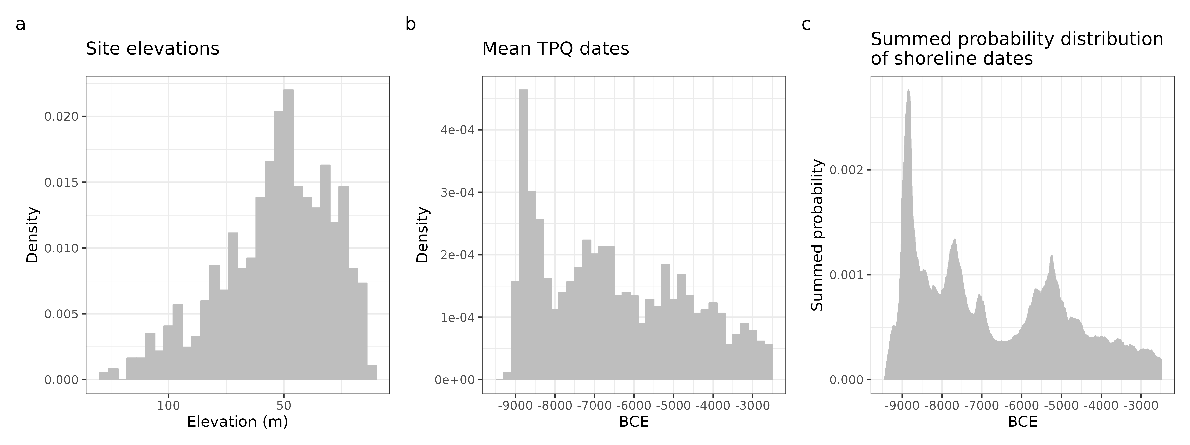  
**Fig. 3**: a) The distribution of the shoreline dated sites (n = 921) by altitude above present sea-level. The binwidth is 4 m. b) The mean of *terminus post quem* dates for the sites, plotted with a binsize of 200 years,reflecting the common approach to summing shoreline dates. c) The result of instead summing the probability of the shoreline dates achieved with the method employed here, which accounts for the likely distance between sites and shoreline. The binwidth is 5 years, following the resolution used with the dating procedure.

The Monte Carlo simulations with the SSPD is based on drawing a sample of calendar dates from the observed date range in the SSPD, equalling the number of shoreline-dated sites, where the probability of drawing any 5-year interval is determined by the null model of choice. This is equivalent to the sampling method *calsample* from *rcarbon* (Crema & Bevan, 2021). Each sampled date is then assigned one of the pre-interpolated displacement curves, the probability of which is weighted by the density of observed sites within each 2 km interval. The calendar date is ‘uncalibrated’ – to follow the RSPD terminology – to an elevation range from which a single elevation value is drawn with uniform probability between the lower and upper limit of the displacement curve at that calendar year, using intervals of 5 cm. As shoreline dating is here done with a gamma distribution with the same parameters across all sites, there is no equivalent of the error term for 14C-dates that determine the shape of the Gaussian distribution associated with the 14C age. Consequently, the elevation value retrieved by ‘uncalibrating’ the shoreline date was shoreline dated using the displacement curve for the relevant 2 km interval with the same gamma distribution for all samples. Having dated the number of samples equalling the number of shoreline-dated sites, these were then summed, and the entire process repeated a total of 10,000 times. The 97.5% highest and 2.5% lowest summed probability at each interval of 5 years across all simulations was then retrieved to create the 95% critical envelope, and the global p-value found in the same manner as for the RSPDs. This was done using re-purposed code from *ADMUR*.

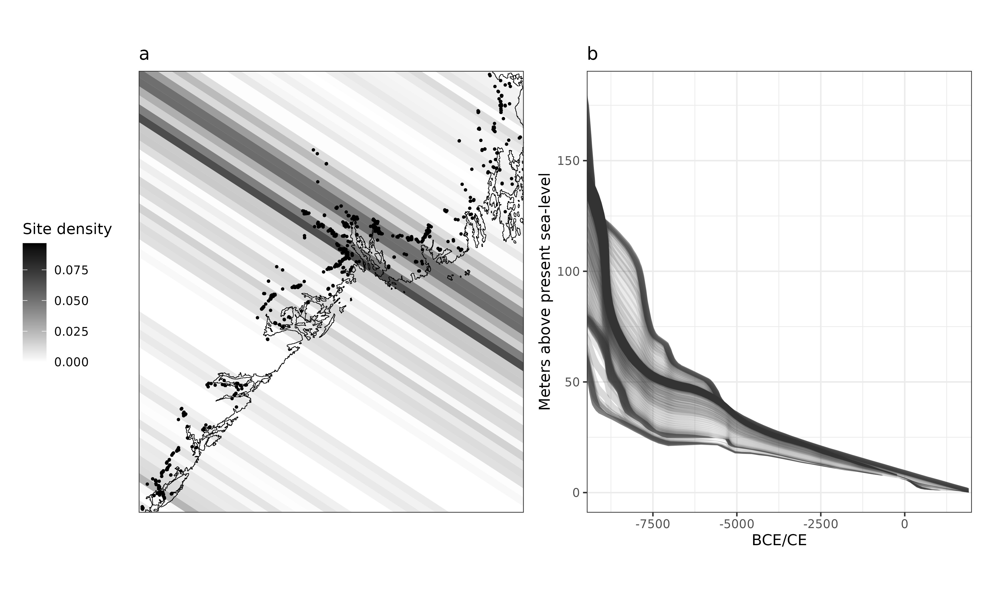  
**Fig. 4**: a) Density of included surveyed sites and excavated sites dated by means of shoreline dating (n =921) as distributed across 2 km wide line segments that run perpendicular to the shoreline gradient. b) The displacement curves interpolated to the centre of each segment for use in the Monte Carlo simulations below.

## 3.3 Comparing model performance

For each dating method, the relative performance of the exponential, logistic and uniform models was compared. This was done by finding the overall relative log-likelihoods of the models using the *loglik* function from *ADMUR*. For any given model, this involves finding the scalar product between the probability of each shoreline date against the probability of the null model, and in the case of the 14C-dates, each site-phase. The overall model likelihood is the product of these individual probabilities and is not, critically, found by using the values of the final SPD (Crema, 2022; Timpson et al., 2021). From these likelihoods, the Bayesian (or Schwarz) information criterion (BIC) was then found for each model. This penalises the models for the number of parameters in use to avoid over-fitting and provides a measure for the relative performance of the models.

# 4 Results

The results of the Monte Carlo simulations are given in Fig. 5, displaying the deviations from the simulation envelopes and the corresponding global p-values. The comparison of the models based on BIC scores is given in Fig. 6.

For the RSPD, the logistic model achieved a p-value of 0.073 and could therefore not be rejected (Fig. 5e). As is also indicated by the BIC values of the compared models, the logistic model represents the best explanation of the data, and the failure to reject the model means that the data could be expected under this logistic development. This is characterised by a rapid growth from the start of the RSPD, around 8500 BCE, which plateaus at around 7500 BCE and then remains stable for the remainder of the period.

All the standard models could be rejected for the SSPD. Of the contrasted models, the BIC values indicate that the exponential model is the best candidate. Its negative direction indicates that some overall process of reduction in the frequency of shoreline-dated sites occurs over time, while the rejection of the model and clear deviations from the exponential pattern indicates that this model does not account for the entire development (Fig. 5a). Some significant deviations occur with the model over-predicting the frequency of sites in the period from c. 9200–9000 BCE, followed by a significant positive peak just after 9000 BCE, lasting until around 8500 BCE. The process of decline is then interrupted by positive deviations at 7900–7400, and with a smaller deviation around 7000 BCE. This is closely followed by a negative deviation between c. 6800 and 5800 BCE. Finally, a positive deviation occurs again around 5300–5000 BCE. While all of the above deviations should also be viewed with caution, questions concerning the reliability of shoreline dating after 4000 BCE (Roalkvam, 2023a) and the small magnitude of the negative deviations that occur around 3000 BCE means that these are disregarded in the discussion to follow.

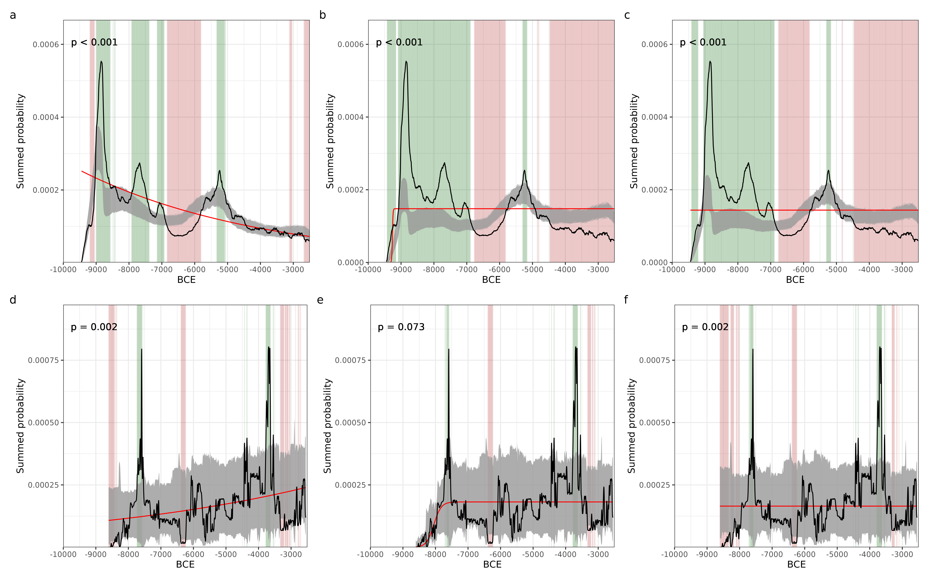  
**Fig. 5**: Monte Carlo simulation for shoreline and radiocarbon dates. a) Summed probability of shoreline-dated sites (n = 921) compared to an exponential null model. b) SSPD compared to a logistic null model. c) SSPD compared to a uniform null model. d) Summed probability of calibrated radiocarbon dates (n = 352, bins = 153) compared to an exponential null model. e) RSPD compared to a logistic null model. f) RSPD compared to a uniform null model.

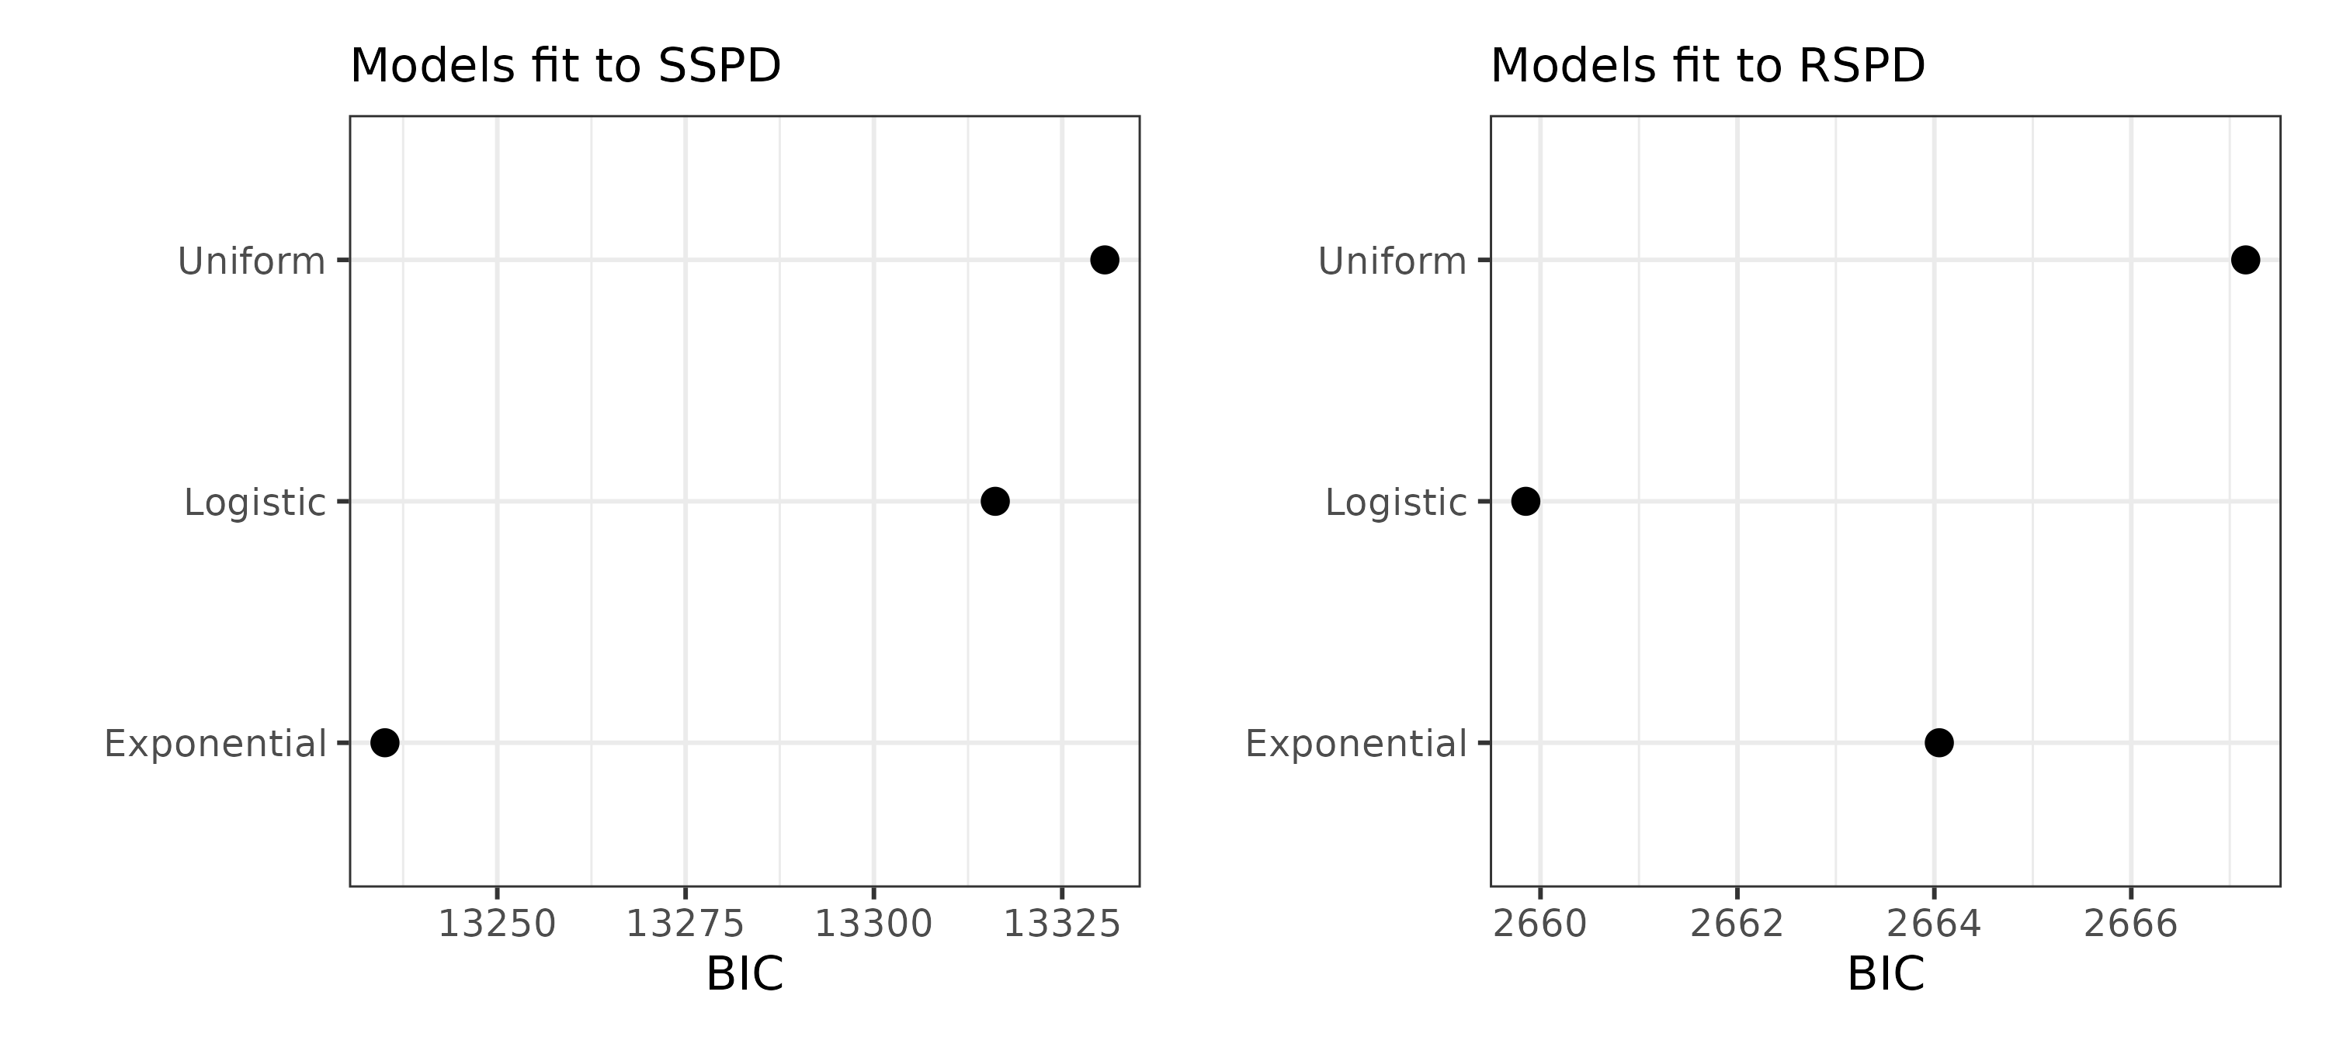  
**Fig. 6**: Bayesian information criterion for the models fit to the SPDs. Lower values indicate a better model.

# 5 Discussion

We start out here by presenting some potentially substantive implications of the results before moving on to consider methodological limitations that could undermine our findings. Although there are generally few 14C-dates from the earliest part of the Mesolithic in Norway (e.g. Åstveit, 2018; Breivik & Bjerck, 2018; Kleppe, 2018; Solheim & Persson, 2018), it is established that Stone Age sites in southern Norway date to the period from before the earliest 14C-dates in the study area for this paper, and at least from as far back as around 9300 BCE (e.g. Damlien & Solheim, 2018; Glørstad, 2016). While the SSPD achieved here starts from c. 9500 BCE, the RSPD shows no evidence of human activity until c. 8500 BCE. What has caused the lack of 14C-dates from this earliest period has been given many possible explanations through the years. These range from taphonomic loss to diverse environmental and/or cultural factors, such as the use of shrubs or rapidly deteriorating seal blubber as fuel for burning, or a preference for consuming raw, dried or fermented food (see Åstveit, 2014; Bjerck, 2017; Damm, 2022). A possible lack of reliable access to firewood has also been seen as a possible contributor to this pattern, although evidence for the early presence of forested landscapes, at least in the southern parts of the country, has now rendered this a less favoured hypothesis (Solheim & Persson, 2018; see also Damm, 2022; Sørensen, Henningsmoen, et al., 2014). The earliest dates in our dataset are made on charcoal, which dominates the dated material overall (see figure in the supplementary material), as other materials such as bone make up a very small portion of the dated material. Furthermore, to assess the potential influence of taphonomy on the logistic model for the RSPD, we fit a version of the model that attempts to account for taphonomy using the workflow from *ADMUR*. Unlike approaches that adjust the SPD directly, using for example the global point estimates for taphonomic correction presented by Surovell et al. (2009) and Bluhm & Surovell (2019), *ADMUR* instead treats this is as additional parameters to be included in the model itself. We used the default constraints for the taphonomy parameters recommended by *ADMUR*, as there is no readily available data that can inform these in our context. As the result of including taphonomy did not alter the MLE parameters of the model, owing also to the fairly small sample of radiocarbon dates with which to narrow the taphonomic parameters, this exercise has been relegated to the supplementary material. In sum therefore, while taphonomic and ecological factors cannot be excluded as part of the picture, we view it as probable that the rapid growth at the start of RSPD and the magnitude of the SSPD in the period preceding this suggest that cultural and demographic factors are central drivers behind the observed pattern.

The considered models also indicate that after the initial jumps of each proxy, some process of decrease in shoreline dated site frequency occurs throughout the Mesolithic, contrasted by a general stationary frequency of 14C-dated material. Following from what is generally held to be a reduction in residential mobility from the earliest to the later parts of the Mesolithic (e.g. Bang-Andersen & Bjerck, 2005; Bjerck, 2008, pp. 103–105; Fuglestvedt, 2018, pp. 16–17; Lindblom, 1984), an immediate explanation of this mismatch could be that the SSPD is more heavily impacted by variation in land-use and mobility patterns, while the RSPD mainly reflects population dynamics.

A common interpretation of the Early Mesolithic in Norway is that the population was small but highly mobile, reflected in large numbers of short-lived sites along the coast (e.g. Bjerck, 2008, 2017; Fuglestvedt, 2012). This is commonly seen in relation to homogeneous lithic technology over large swathes of the Scandinavian Peninsula in this period, and what is believed to have been a rapid colonisation of the Norwegian coastline (e.g. Bang-Andersen, 2012; Bjerck, 2009; Fuglestvedt, 2012). High mobility has been seen as necessary both to maintain demographic viability among colonising groups, and for it to be possible to maintain this technological uniformity over large areas (Rowley-Conwy & Piper, 2017; also discussed by Berg-Hansen, 2018). The initial peak in the SSPD and the trajectory of the exponential model could thus be congruent with a process of rapid colonisation of the Norwegian coast, coupled with a high degree of mobility, leading to the overall high site-count in the earliest period. The lacking signal in the RSPD for the first settlement period could in this view reflect mobility patterns characterised by short occupational duration and corresponding pyrotechnology based on small, short-lived fires (Damm, 2022) and low population numbers.

Following this earliest phase of rapid increase in shoreline dated sites, there is a drop from this initial peak, starting from around 8800 BCE, concluding around 8500 BCE and remaining within the simulation envelope until c. 7900 BCE. It has previously been suggested that a change in mobility patterns starts around 8500–8000 BCE, involving a reduction in residential mobility (e.g. Damlien & Solheim, 2018; Roalkvam, 2022). Furthermore, both genetic data and technological analyses of lithic inventories indicate that the initial phase of human colonisation from the south is followed by an influx, and possible mixing of people from the east around the same time (Günther et al., 2018; Manninen et al., 2021). If this narrative is coupled with the data observed here, these migratory events could appear to result in a relatively sudden drop in site-count as indicated in the SSPD, which in turn could be related to a change in mobility patterns. The end of this drop also roughly corresponds to the first 14C-dates in the RSPD around 8500 BCE, leading to the logistic growth that plateaus in the first centuries after 8000 BCE.

Given that it is well established that people were present in Norway before the earliest 14C-dates in our dataset, the identified logistic model does not capture an initial colonisation. The above-mentioned explanations of low population size and/or mobility patterns that are potentially causing the lacking radiocarbon record in the earliest period of human presence could therefore both be causing the under-prediction of the antiquity of human presence, and, as a consequence, also lead to an exaggeration in the steepens of the growth in the logistic model. If these factors are then counteracted by migratory events around the time of the earliest 14C-dates, the subsequent plateau of the logistic growth curve could nonetheless represent an average carrying capacity, around which the population density has likely fluctuated (e.g. Tallavaara & Jørgensen 2021).

The logistic growth in the RSPD reaches its plateau in the same time-interval as a positive deviation in the SSPD from the exponential model – an increase that was also noted by Berg-Hansen et al. (2022) – which could indicate that a demographic signal is reflected in the frequency of shoreline dated sites as well. Subsequently, the SSPD deviates negatively from the exponential null model from c. 6800 to c. 5800 BCE. This is followed by a positive deviation in the last centuries before 5000 BCE.

These developments should possibly be seen in relation to simultaneous developments in the inland areas of southern Norway that are located beyond the the highest post-glacial elevation of the sea. The negative deviation in the SSPD appears to correspond to an increase in inland activity, which is to take place in the period from c. 6700–5900 BCE and reach its peak around 6200–6000 BCE (Boaz, 1999; Persson, 2018; Selsing, 2010). Boaz (1999) related this to an economic reorganisation, involving a more focused exploitation of the interior and a reduction in the utilisation of coastal areas. This period is followed by a marked reduction in inland activity, lasting until c. 4500–4000 BCE (Persson, 2018, p. 204), the onset of which thus corresponds to the end of the negative deviation in the SSPD at c. 5800 BCE and the positive deviation from c. 5300–5000 BCE. Boaz (1999) associated this period of decrease in inland activity to the onset of the classic Nøstvet phase, which is now believed to commence in the middle of the 6th millennium BCE (Reitan, 2022). The Nøstvet period is argued to be characterised by an increase in specialised coastal adaptation that also coincides with what Fuglestvedt (2018, p. 17) has termed 'the great wave' of rock art in Norway, starting from around 5700 BCE in south-eastern Norway (Fuglestvedt, 2018, pp. 42–46; Glørstad, 2010, pp. 216–233). The onset of the classic Nøstvet thus roughly corresponds with the positive deviation in the SSPD around the later parts of the 6th millennium BCE.

A recent study by Manninen et al. (2023), which considers a larger inland area of northern Scandinavia than the above-referenced studies, found a corresponding increase in inland activity starting from the earliest parts of the Mesolithic that lasted until c. 6000 BCE. However, after this the population dynamics indicated by the radiocarbon record is found to have been characterised by a cessation of growth, rather than the clear decrease suggested by the regional studies in southern Norway. Consequently, properly relating the developments in the coastal region to inland developments and their relevance to each other will benefit from an integrated approach that also explicitly considers the spatial dimension without invoking predefined analytical regions (see Crema et al., 2017).

Following from the divergence between the proxies, assessing the suggested and possibly varying influence of demographic developments and mobility patterns on the measures will remain speculative without drawing on additional variables that can control for such confounding effects. Following from the stationarity of the logistic model of the RSPD after c. 7500 BCE, it is possible that fluctuations in the SSPD reflect variation in mobility patterns that are unrelated to demographic developments. There does appear to be a negative deviation from the logistic null model in the RSPD corresponding to the one in the SSPD just before 6000 BCE. An immediate candidate explanation for this decrease could be the so-called Finse cold event, occurring around 6200 BCE, which has been identified in a range of environmental proxy records from Norway (e.g. Nesje et al., 2005; Nesje, 2009), and which corresponds to the 8.2 ka cal BP cold event evident in North Atlantic climate records more widely (e.g. Alley et al., 1997; Alley & Ágústsdóttir, 2005; Seppä et al., 2009). The possible societal relevance of the Finse event for the Norwegian Mesolithic has been discussed extensively (e.g. Breivik et al., 2018; Fossum, 2020; Persson, 2018). However, as the logistic model could not be rejected for the RSPD it is inappropriate to interpret any deviations from the Monte Carlo envelope and place any analytical weight on the deviations in the RSPD, at least given the present data. While it is possible that the limited sample of 14C-dates has led to an underestimation of this deviation, there is, additionally, no indications in the RSPD of an increased demographic signal in the period just before 5000 BCE that would correspond to the positive deviation in SSPD (see also Solheim & Persson, 2018). A related point that is also worth making here is that the overall demographic trends that the modelling efforts can hope to identify are likely to have been subject to smaller scale demographic fluctuations that simply cannot be ascertained given the available data and its resolution (Tallavaara & Jørgensen, 2021), and which impacts the comparison of the two proxies following both from the different resolutions of the dating methods and the sample sizes underlying the SPDs.

Given the presence of people and corresponding signal in the SSPD before the start of the RSPD, and the suggested relevance of mobility patterns for the lacking signal in the RSPD in this earliest period, neither proxy is presumably devoid of influence from population density or mobility patterns. This is also given support by the correspondence between the logistic growth in the RSPD and the positive deviation in the SSPD in the first centuries of the 8th millennium BCE. However, properly assessing this relationship and the degree to which it has held constant throughout the period will depend on independent data that track the developments of the other factors that have been suggested to be of relevance to the behaviour of the two proxies.

It is important to underscore that underpinning the potential relevance of demographic and cultural factors that have been highlighted here is the fact that the implemented method for shoreline dating is hefted with considerable unresolved questions concerning its applicability and reliability, and the degree to which the site-sea relationship has been stationary through the Mesolithic and within the study area. For example, it was in Roalkvam (2023a) found that the vertical distances between site and sea were associated with a higher uncertainty in the earliest part of the Holocene, due to the rapid shoreline displacement in this period. This uncertainty is not properly accounted for in the implemented method, as the MLE parameters of the gamma distribution in use was found when treating all sites older than 2500 BCE in aggregate. Additionally, the MLE parameters for the gamma distribution are point estimates that do not account for the underlying sample size used for deriving them. Furthermore, the rapid shoreline displacement in the early Holocene is also a challenge for the geological reconstructions themselves, and there is reason to question whether this is properly accounted for in the compiled time-series for RSL-change in the region (see e.g. Romundset et al., 2018; Sørensen, Henningsmoen, et al., 2014; cf. Ashe et al., 2019). Although these factors will hamper the traditionally employed TPQ approach even more, there is therefore a danger that the severe right skew of the gamma distribution, combined with the rapid shoreline displacement in the earliest period, leads to an overestimation of the antiquity of the sites and the precision of the earliest dates.

While the apparent applicability of shoreline dating is a testament to the importance the sea has played for movement, communication and resource exploitation through the Mesolithic in the region, the immediate inland has also seen some use through the Mesolithic in south-eastern Norway (e.g. Brøgger, 1905; Gundersen, 2013). However, with one notable exception (Mjærum, 2018), radiocarbon dates reflecting the use of coastal hinterland sites are associated with a few site features that are otherwise unrelated to typo-chronological indicators in the lithic inventories on the same sites, which are instead associated with an earlier date than the radiocarbon dates. Consequently, these later radiocarbon dates are typically interpreted as either being of a non-anthropogenic nature, or the result of visits of a more ephemeral nature that have succeeded the settlement on the sites (e.g. Breivik et al., 2018; Schülke, 2020, 2023; see also Roalkvam, 2023a) – potentially reflecting an increase in logistic utilisation of the immediate inland areas in the later stages of the Mesolithic. While this conclusion has been reached by several researchers independently of each other, thus increasing the confidence that shoreline dating captures the date of settlement on the sites, there is still reason to question whether the available radiocarbon record reflects the true use of the hinterland in later periods. If the coastal hinterland has been utilised more actively than what is currently evidenced by the radiocarbon record, the SSPD would be biased towards overestimating the intensity of site frequency in earlier periods.

Furthermore, as was suggested by two reviewers of this paper, it could be possible to evaluate the method of shoreline dating by performing the dating procedure on the radiocarbon dates that underlie the RSPD. By comparing the RSPD with the resulting SSPD, this could make it possible to assess how well shoreline dating captures anthropogenic activity represented by 14C-dates. However, the RSPD is the sum of all radiocarbon dates with an anthropogenic origin from within the study area, irrespective of their context beyond this. Any mismatch between the RSPD and a SSPD that would result from shoreline dating the radiocarbon dates would therefore have had to be followed by a *post hoc* evaluation of the potential causes for this deviation – whether related to the unreliability of shoreline dating, issues or non-relevance of individual radiocarbon dates, or issues to do with topographic disturbances or uncertain elevation data that might influence the shoreline date in each case. Consequently, as any observed deviations in such a comparison would have to be explored in a *post hoc* manner, we have instead opted to save this data for a more comprehensive and rigorous test of shoreline dating that is currently in process of being preregistered (see e.g. Ross & Ballsun-Stanton, 2022), where the reliability and relevance of available radiocarbon data will be evaluated before being subjected to the test (following e.g. Pettitt et al., 2003).

Another relevant point to mention here is that the RSL change is effectively built into the Monte Carlo simulations, much in the same way as the Monte Carlo simulation method used with radiocarbon dates account for fluctuations in the calibration curve (e.g. Crema, 2022). The simulation envelopes therefore pertain to the frequency of shoreline dated sites that could be expected under the null models, given the distribution of sites in the study area (Fig. ??a), the corresponding local trajectories of RSL change (Fig. ??b), and a constant relationship between sites and shoreline described by the gamma function employed for the dating procedure (Fig. ??d). Beyond uncertainties to do with the dating method itself, and by extension also the generation of the Monte Carlo envelope, it is also conceivable that variation in rates of sea-level change has impacted settlement patterns beyond that which could be directly expected under these null models. An increased movement instantiated by increased rates of RSL change could result in the transition to a settlement pattern involving more frequent moves than that which could be expected under a constant adjustment to the shoreline. If this is the case, the proxy would still reflect the degree of occupational duration, but this could be a response to the rate of RSL change rather than other cultural and societal dimensions such as migratory events or adjustments to other environmental developments. Directly accounting for variation in the rate of sea-level change could thus prove important for properly assessing the substantive implications of the fluctuations in this proxy.

Finally, analogous to investigatory biases that might impact the frequency of radiocarbon dates from certain time-intervals, for example resulting from targeted sampling directed towards certain periods of interest, the distribution of sites over different elevations in the landscape might be influenced by survey practices. In evaluating two larger survey projects within the present study region, Persson (2014) and Solheim (2017) found that the test-pitting was generally conducted in a comparable degree across elevations, but that altitudes equating to shoreline dates towards the end of the Stone Age might be under-represented (also Solheim & Persson, 2018, p. 337). Moving forward, similar investigations conducted in a more comprehensive manner will be important for properly evaluating the impact investigatory factors might have on the distribution of shoreline dated sites over time. This will also benefit from directly accounting for the elevation at which residential and commercial infrastructure development has been undertaken, as this generally dictates where surveys are conducted, while also relating this to the topographic characteristics of the landscape.

# 6 Conclusion

This paper has presented a new methodology for assembling and assessing the sum of a larger number of shoreline dates. This was done by employing the probabilistic method for shoreline dating presented in Roalkvam (2023a), and by drawing on analogous procedures in the treatment of the temporal frequency distribution of radiocarbon dates (Crema, 2022; Crema & Bevan, 2021; Timpson et al., 2014). The result of employing this methodology was then compared to radiocarbon dates from within the same area, to begin to assess the relationship between the two data types.

The main results were that the RSPD is consistent with the logistic model fit to the data. This is characterised by a rapid logistic growth from the start of the RSPD around 8500 BCE, which plateaus and remains stationary from the first centuries after 8000 BCE. This is contrasted to the shoreline dates, the development of which were better described by a function of exponential decay. While this indicates that some process of decline in the number of shoreline dated sites has occurred over time, the model was rejected as an adequate description of the SSPD. Some of the deviations from the model were then narratively explored to suggest some possible reasons for these deviations. However, given the lack of a model that adequately describe the data, and consequently the informal treatment of these deviations, these should be viewed as suggestions that represent potential lines for further interrogation.

While it appears that the SSPD and RSPD are differentially impacted by population density, and, we cautiously suggest, the SSPD is more heavily influenced by land-use and mobility patterns, this suggestion and the nature of the discrepancy between the proxies clearly requires further investigation. This is also relevant for the treatment of RSPDs in Scandinavia more broadly, as we suggested that mobility patterns have relevance for the kind of pyrotechnologies that were utilised in the first period of human occupation in the region, and that the technologies utilised largely explain the absence of radiocarbon dates from this earliest period. The degree and stability with which mobility patterns might have impacted the radiocarbon record from later periods, possibly as mediated by pyrotechnology, remains unclear, and could prove important for properly isolating a demographic signal in the radiocarbon data – a point that has also been made in other contexts (Crombé & Robinson, 2014; Hiscock & Attenbrow, 2016, p. 219).

Some further lines of inquiry could be to draw on lithic technology and tool-kit diversity as a function of population size and density (e.g. Berg-Hansen, 2018; Collard et al., 2013; Riede, 2014; Solheim et al., 2020), and mobility patterns that can potentially be inferred from the composition of lithic assemblages (e.g. Barton & Riel-Salvatore, 2014; Clark & Barton, 2017; Preston & Kador, 2018; Roalkvam, 2022), which is potentially also influenced by variable rates of RSL change. In terms of mobility patterns, focus was directed here towards residential movement and occupational duration; but other dimensions relating for example to seasonal and territorial mobility, as reflected in the discussion of inland activity, could also prove to be important. In the same vein, environmental conditions, constraints and developments beyond RSL change also represent a range of factors that can have implications for these dimensions, and will consequently be of future importance to unpack the relationship between the proxies (e.g. Hoebe et al., 2023; Jørgensen et al., 2020; Lundström, 2023; Manninen et al., 2018; Ordonez & Riede, 2022). To account for the confounding effects these might have, a more principled and comprehensive evaluation of how investigatory practices might impact the SPDs would also be beneficial. While certainly also pertinent for the RSPD, this has generally been considered more extensively for radiocarbon data than for shoreline dated sites. Furthermore, aligning the complex web of causes and effects that these different lines of evidence potentially represent will also benefit from a more direct modelling of the development in the SSPD, rather than simply basing the analysis on deviations from a rejected null model (see Timpson et al., 2021). Finally, mapping and contrasting these developments across a larger region will not only offer a larger sample size, which is especially limited for the 14C-data employed here, but could also provide important contextualisation for the observed developments (see e.g. Lundström et al., 2021; Manninen et al., 2023; Solheim & Persson, 2018) and potentially reduce the impact of idiosyncratic investigations that might impact the present SPDs inordinately (see e.g. Crema, 2022; Hoebe et al., 2023; Rick, 1987).

Seeing as the implemented method for shoreline dating was recently developed and has been subjected to limited evaluation and testing, there are still considerable uncertainties and limitations associated with its application. While we believe the approach represents an improvement over previous implementations, the results should therefore be considered a cautions first exploration of the implications of employing a probabilistic method for shoreline dating when evaluating large scale trends in the temporal frequency distribution of coastal sites in the region.

# Competing interests

The authors have no competing interests to declare.

# Funding

This research received no external funding.

# 7 References

Alley, R. B., & Ágústsdóttir, A. M. (2005). The 8k event: cause and consequences of a major Holocene abrupt climate change. *Quaternary Science Reviews*, *24*(10), 1123–1149. <https://doi.org/10.1016/j.quascirev.2004.12.004>

Alley, R. B., Mayewski, P. A., Sowers, T., Stuiver, M., Taylor, K. C., & Clark, P. U. (1997). Holocene climatic instability: A prominent, widespread event 8200 yr ago. *Geology*, *25*(6), 483–486. <https://doi.org/10.1130/0091-7613(1997)025<0483:HCIAPW>2.3.CO;2>

Ashe, E. L., Cahill, N., Hay, C., Khan, N. S., Kemp, A., Engelhart, S. E., Horton, B. P., Parnell, A. C., & Kopp, R. E. (2019). Statistical modeling of rates and trends in Holocene relative sea level. *Quaternary Science Reviews*, *204*, 58–77. <https://doi.org/10.1016/j.quascirev.2018.10.032>

Åstveit, L. I. (2014). Noen synspunkt på den tidligmesolittiske bosetningen i Sør-Norge. *Primitive Tider*, *16*, 87–104. <https://doi.org/10.5617/pt.7233>

Åstveit, L. I. (2018). The Early Mesolithic of Western Norway. In H. P. Blankholm (Ed.), *Early Economy and Settlement in Northern Europe. Pioneering, Resource Use, Coping with Change* (pp. 231–274). Equinox.

Attenbrow, V., & Hiscock, P. (2015). Dates and demography: are radiometric dates a robust proxy for long-term prehistoric demographic change? *Archaeology in Oceania*, *50*(51), 30–36. <https://doi.org/10.1002/arco.5052>

Bang-Andersen, S. (2012). Colonizing Contrasting Landscapes. The Pioneer Coast Settlement and Inland Utilization in Southern Norway 10,000-9500 Years Before Present. *Oxford Journal of Archaeology*, *31*(2), 103–120. <https://doi.org/10.1111/j.1468-0092.2012.00381.x>

Bang-Andersen, S., & Bjerck, H. B. (2005). Mesolitikum. In E. Østmo & L. Hedeager (Eds.), *Norsk Arkeologisk Leksikon* (pp. 244–250). Pax.

Barton, C. M., & Riel-Salvatore, J. (2014). The Formation of Lithic Assemblages. *Journal of Archaeological Science*, *46*, 334–352. <https://doi.org/10.1016/j.jas.2014.03.031>

Berg-Hansen, I. M. (2018). Continuity and Change in Late- and Post-glacial Social Networks: Knowledge Transmission and Blade Production Methods in Ahrensburgian and Early Mesolithic North West Europe. In K. Knutsson, H. Knutsson, J. Apel, & H. Glørstad (Eds.), *The Early Settlement of Northern Europe. Transmission of Knowledge and Culture* (pp. 63–98). Equinox.

Berg-Hansen, I. M., Hårstad, S., Granados, T. J., Reitan, G., Romundset, A., Johannessen, L. S., & Solheim, S. (2022). Enculturating Coastal Environments in the Middle Mesolithic (8300–6300 cal BCE) – Site Variability, Human–Environment Relations, and Mobility Patterns in Northern Vestfold, SE-Norway. *Open Archaeology*, *8*(1), 634–639. <https://doi.org/10.1515/opar-2022-0251>

Bergsvik, K. A., Darmark, K., Hjelle, K. L., Aksdal, J., & Åstveit, L. I. (2021). Demographic developments in Stone Age coastal western Norway by proxy of radiocarbon dates, stray finds and palynological data. *Quaternary Science Reviews*, *259*, 106898. <https://doi.org/10.1016/j.quascirev.2021.106898>

Bevan, A., Colledge, S., Fuller, D., Fyfe, R., Shennan, S., & Stevens, C. (2017). Holocene fluctuations in human population demonstrate repeated links to food production and climate. *Proceedings of the National Academy of Sciences*, *114*(49), E10524–E10531. <https://doi.org/10.1073/pnas.1709190114>

Bevan, A., & Crema, E. R. (2021). Modifiable reporting unit problems and time series of long-term human activity. *Philosophical Transactions of the Royal Society B*, *376*, 20190726. <https://doi.org/10.1098/rstb.2019.0726>

Bird, D., Miranda, L., Vander Linden, M., Robinson, E., Bocinsky, R. K., Nicholson, C., Capriles, J. M., Finley, J. B., Gayo, E. M., Gil, A., Guedes, J. d’Alpoim, Hoggarth, J. A., Kay, A., Loftus, E., Lombardo, U., Mackie, M., Palmisano, A., Solheim, S., Kelly, R. L., & Freeman, J. (2022). p3k14c, a synthetic global database of archaeological radiocarbon dates. *Scientific Data*, *9*(1), 27. <https://doi.org/10.1038/s41597-022-01118-7>

Bjerck, H. B. (2008). Norwegian Mesolithic Trends: A Review. In G. Bailey & P. Spikins (Eds.), *Mesolithic Europe* (pp. 60–106). Cambridge University Press.

Bjerck, H. B. (2009). Colonizing seascapes: Comparative perspectives on the development of maritime relations in Scandinavia and Patagonia. *Arctic Anthropology*, *46*(1–2), 118–132. <https://doi.org/10.1353/arc.0.0019>

Bjerck, H. B. (2017). Settlements and Seafaring: Reflections on the Integration of Boats and Settlements Among Marine Foragers in Early Mesolithic Norway and the Yámana of Tierra del Fuego. *The Journal of Island and Coastal Archaeology*, *12*(2), 276–299. <https://doi.org/10.1080/15564894.2016.1190425>

Blackwell, P. G., & Buck, C. E. (2003). The Late Glacial human reoccupation of north-western Europe: new approaches to space-time modelling. *Antiquity*, *77*(296), 232–240. <https://doi.org/10.1017/S0003598X00092231>

Bluhm, L. E., & Surovell, T. A. (2019). Validation of a global model of taphonomic bias using geologic radiocarbon ages. *Quaternary Research*, *91*(1), 325–328. <https://doi.org/10.1017/qua.2018.78>

Boaz, J. (1999). Pioneers in the Mesolithic: The Initial Occupation of the Interior of Eastern Norway. In J. Boaz (Ed.), *The Mesolithic of Central Scandinavia* (pp. 125–152). University of Oslo.

Breivik, H. M., & Bjerck, H. B. (2018). Early Mesolithic Central Norway: A Review of Research History, Settlements, and Tool Tradition. In H. P. Blankholm (Ed.), *Early Economy and Settlement in Northern Europe. Pioneering, Resource Use, Coping with Change* (pp. 169–206). Equinox.

Breivik, H. M., Fossum, G., & Solheim, S. (2018). Exploring human responses to climatic fluctuations and environmental diversity: Two stories from Mesolithic Norway. *Quaternary International*, *465*, 258–275. <https://doi.org/10.1016/j.quaint.2016.12.019>

Brest, J., Greiner, S., Boskovic, B., Mernik, M., & Zumer, V. (2006). Self-Adapting Control Parameters in Differential Evolution: A Comparative Study on Numerical Benchmark Problems. *IEEE Transactions on Evolutionary Computation*, *10*(6), 646–657. <https://doi.org/10.1109/TEVC.2006.872133>

Brøgger, W. C. (1905). *Strandliniens Beliggenhed under Stenalderen i Det Sydøstlige Norge*. Norges geologiske undersøkelse.

Carleton, W. C., Campbell, D., & Collard, M. (2018). Radiocarbon dating uncertainty and the reliability of the PEWMA method of time-series analysis for research on long-term human-environment interaction. *PloS One*, *13*(1), e0191055. <https://doi.org/10.1371/journal.pone.0191055>

Carleton, W. C., & Groucutt, H. S. (2021). Sum things are not what they seem: Problems with point-wise interpretations and quantitative analyses of proxies based on aggregated radiocarbon dates. *The Holocene*, *31*(4), 630–643. <https://doi.org/10.1177/0959683620981700>

Clark, G. A., & Barton, C. M. (2017). Lithics, landscapes & la Longue-durée – Curation & expediency as expressions of forager mobility. *Quaternary International*, *450*, 137–149. <https://doi.org/10.1016/j.quaint.2016.08.002>

Collard, M., Ruttle, A., Buchanan, B., & O’Brien, M. J. (2013). Population Size and Cultural Evolution in Nonindustrial Food-Producing Societies. *PLOS ONE*, *8*(9), e72628. <https://doi.org/10.1371/journal.pone.0072628>

Conolly, J. (2020). Spatial interpolation. In M. Gillings, P. Hacıgüzeller, & G. Lock (Eds.), *Archaeological Spatial Analysis: A Methodological Guide* (pp. 118–134). Routledge.

Crema, E. R. (2022). Statistical inference of prehistoric demography from frequency distributions of radiocarbon dates: a review and a guide for the perplexed. *Journal of Archaeological Method and Theory*. <https://doi.org/10.1007/s10816-022-09559-5>

Crema, E. R., & Bevan, A. (2021). Inference from large sets of radiocarbon dates: Software and methods. *Radiocarbon*, *63*, 23–39. <https://doi.org/10.1017/RDC.2020.95>

Crema, E. R., Bevan, A., & Shennan, S. (2017). Spatio-temporal approaches to archaeological radiocarbon dates. *Journal of Archaeological Science*, *87*, 1–9. <https://doi.org/10.1016/j.jas.2017.09.007>

Crombé, P., & Robinson, E. (2014). C dates as demographic proxies in Neolithisation models of northwestern Europe: a critical assessment using Belgium and northeast France as a case-study. *Journal of Archaeological Science*, *52*, 558–566. <https://doi.org/10.1016/j.jas.2014.02.001>

Damlien, H., Berg-Hansen, I. M., Melheim, L., Mjærum, A., Persson, P., Schülke, A., & Solheim, S. (2021). *Steinalderen i Sørøst-Norge: Faglig program for steinalderundersøkelser ved Kulturhistorisk museum*. Cappelen Damm Akademisk.

Damlien, H., & Solheim, S. (2018). The Pioneer Settlement of Eastern Norway. In H. P. Blankholm (Ed.), *Early Economy and Settlement in Northern Europe. Pioneering, Resource Use, Coping with Change* (pp. 335–367). Equinox.

Damm, C. B. (2022). Mesolithic Pyrotechnology: Practices and Perceptions in Early Holocene Coastal Norway. *European Journal of Archaeology*, *25*(1), 4–21. <https://doi.org/10.1017/eaa.2021.31>

Darmark, K., Viken, S., & Johannessen, L. S. (2018). A Good Place. Stone Age Locations in Southern Norway: A Diachronic GIS Approach. In G. Reitan & L. Sundström (Eds.), *The Stone Age Coastal Settlement in Aust-Agder, Southeast Norway* (pp. 489–502). Cappelen Damm Akademisk.

Drennan, R. D., Berrey, C. A., & Peterson, C. E. (2015). *Regional Settlement Demography in Archaeology*. Eliot Werner Publications.

Fossum, G. (2020). Specialists facing climate change. The 8200 cal BP event and its impact on the coastal settlement in the inner Oslo fjord, southeast Norway. In A. Schülke (Ed.), *Coastal Landscapes of the Mesolithic: Human Engagement with the Coast from the Atlantic to the Baltic Sea* (pp. 179–201). Routledge.

Freeman, J., Byers, D. A., Robinson, E., & Kelly, R. L. (2018). Culture Process and the Interpretation of Radiocarbon Data. *Radiocarbon*, *60*(2), 453–467. <https://doi.org/10.1017/RDC.2017.124>

French, J. C., Riris, P., Fernandéz-López de Pablo, J., Lozano, S., & Silva, F. (2021). A manifesto for palaeodemography in the twenty-first century. *Philosophical Transactions of the Royal Society B: Biological Sciences*, *376*(1816), 20190707. <https://doi.org/10.1098/rstb.2019.0707>

Fuglestvedt, I. (2012). The Pioneer Condition on the Scandinavian Peninsula: the Last Frontier of a ‘Palaeolithic Way’ in Europe. *Norwegian Archaeological Review*, *45*(1), 1–29. <https://doi.org/10.1080/00293652.2012.669998>

Fuglestvedt, I. (2018). *Rock Art and the Wild Mind: Visual Imagery in Mesolithic Northern Europe*. Routledge.

Glørstad, H. (2010). *The Structure and History of the Late Mesolithic Societies in the Oslo Fjord Area 6300-3800 BC*. Bricoleur Press.

Glørstad, H. (2016). Deglaciation, sea-level change and the Holocene colonization of Norway. *Geological Society, London, Special Publications*, *411*(1), 9–25. <https://doi.org/10.1144/SP411.7>

Gundersen, J. (2013). Verken fjord eller fjell – steinalderen i det kystnære innlandet. Gamle og nye funn fra Notodden i Telemark. *Viking*, *76*, 35–62.

Günther, T., Malmström, H., Svensson, E. M., Omrak, A., Sánchez-Quinto, F., Kılınç, G. M., Krzewińska, M., Eriksson, G., Fraser, M., Edlund, H., Munters, A. R., Coutinho, A., Simões, L. G., Vicente, M., Sjölander, A., Sellevold, B. J., Jørgensen, R., Claes, P., Shriver, M. D., … Jakobsson, M. (2018). Population genomics of Mesolithic Scandinavia: Investigating early postglacial migration routes and high-latitude adaptation. *PLOS Biology*, *16*(1), e2003703. <https://doi.org/10.1371/journal.pbio.2003703>

Hiscock, P., & Attenbrow, V. (2016). Dates and demography? The need for caution in using radiometric dates as a robust proxy for prehistoric population change. *Archaeology in Oceania*, *51*(3), 218–219. <https://doi.org/10.1002/arco.5096>

Hoebe, P. W., Peeters, J. M. H. H., & Arnoldussen, S. (2023). Parsing prehistoric patterns: Prospects and limitations of a big radiocarbon dataset for understanding the impact of climate on Late Palaeolithic and Mesolithic populations in northwest Europe (16–7.5 ka calBP). *Journal of Archaeological Science: Reports*, *49*, 103944. <https://doi.org/10.1016/j.jasrep.2023.103944>

Hollender, A. (1901). Om sveriges nivåförändringar efter menniskans invandring. *Geolgiska Föreningen i Stockholm Förhandlingar*, *23*(4), 1118–1130. <https://doi.org/10.1080/00293652.1975.9965220>

Jørgensen, E. K. (2020). The palaeodemographic and environmental dynamics of prehistoric Arctic Norway: An overview of human-climate covariation. *Quaternary International*, *549*, 36–51. <https://doi.org/10.1016/j.quaint.2018.05.014>

Jørgensen, E. K., Pesonen, P., & Tallavaara, M. (2020). Climatic changes cause synchronous population dynamics and adaptive strategies among coastal hunter-gatherers in Holocene northern Europe. *Quaternary Research*, 1–16. <https://doi.org/10.1017/qua.2019.86>

Kleppe, J. I. (2018). The Pioneer Colonization of Northern Norway. In H. P. Blankholm (Ed.), *Early Economy and Settlement in Northern Europe. Pioneering, Resource Use, Coping with Change* (pp. 13–57). Equinox.

Lindblom, I. (1984). Former for økologisk tilpasning i Mesolitikum, Østfold. *Universitetets Oldsaksamling Årbok*, *1982/1983*, 43–86.

Lundström, V. (2023). Living through changing climates: Temperature and seasonality correlate with population fluctuations among Holocene hunter-fisher-gatherers on the west coast of Norway. *The Holocene*, 09596836231185839. <https://doi.org/10.1177/09596836231185839>

Lundström, V., Robins, P., & Riede, F. (2021). Demographic estimates from the Palaeolithic–Mesolithic boundary in Scandinavia: comparative benchmarks and novel insights. *Philosophical Transactions of the Royal Society B: Biological Sciences*, *376*(816), 20200037. <https://doi.org/10.1098/rstb.2020.0037>

Manninen, M. A., Damlien, H., Kleppe, J. I., Knutsson, K., Murashkin, A., Niemi, A. R., Rosenvinge, C. S., & Persson, P. (2021). First encounters in the north: cultural diversity and gene flow in Early Mesolithic Scandinavia. *Antiquity*, *95*(380), 310–328. <https://doi.org/10.15184/aqy.2020.252>

Manninen, M. A., Fossum, G., Ekholm, T., & Persson, P. (2023). Early postglacial hunter-gatherers show environmentally driven “false logistic” growth in a low productivity environment. *Journal of Anthropological Archaeology*, *70*, 101497. <https://doi.org/10.1016/j.jaa.2023.101497>

Manninen, M. A., Tallavaara, M., & Seppä, H. (2018). Human responses to early Holocene climate variability in eastern Fennoscandia. *Quaternary International*, *465*, 287–297. <https://doi.org/10.1016/j.quaint.2017.08.043>

Marwick, B. (2017). Computational Reproducibility in Archaeological Research: Basic Principles and a Case Study of Their Implementation. *Journal of Archaeological Method and Theory*, *24*(2), 424–450. <https://doi.org/10.1007/s10816-015-9272-9>

Marwick, B., Boettiger, C., & Mullen, L. (2018). Packaging Data Analytical Work Reproducibly Using R (and Friends). *The American Statistician*, *72*(1), 80–88. <https://doi.org/10.1007/s10816-015-9272-9>

Mjærum, A. (2018). Hinterland Discoveries: Middle Mesolithic Woodland Utilization and the Case of the Site Eidsberg, Eastern Norway. *Current Swedish Archaeology*, *26*(1), 159–188. <https://doi.org/10.37718/CSA.2018.11>

Mjærum, A. (2022). A Matter of Scale: Responses to Landscape Changes in the Oslo Fjord, Norway, in the Mesolithic. *Open Archaeology*, *8*(1), 62–84. <https://doi.org/10.1515/opar-2022-0225>

Mörner, N.-A. (1979). The Fennoscandian Uplift and Late Cenozoic Geodynamics: Geological Evidence. *GeoJournal*, *3*(3), 287–318. <https://doi.org/10.1007/BF00177634>

Nesje, A. (2009). Latest Pleistocene and Holocene alpine glacier fluctuations in Scandinavia. *Quaternary Science Reviews*, *28*(21), 2119–2136. <https://doi.org/10.1016/j.quascirev.2008.12.016>

Nesje, A., Jansen, E., Birks, H. J. B., Bjune, A. E., Bakke, J., Andersson, C., Dahl, S. O., Kristensen, D. K., Lauritzen, S.-E., Lie, Ø., Risebrobakken, B., & Svendsen, J.-I. (2005). Holocene climate variability in the northern North Atlantic region: A review of terrestrial and marine evidence. In H. Drange, T. Dokken, T. Furevik, R. Gerdes, & W. Berger (Eds.), *The Nordic Seas: An lntegrated Perspective* (pp. 289–322). American Geophysical Union.

Nielsen, S. V. (2021a). A Late Mesolithic Forager Dispersal Caused Pre-Agricultural Demographic Transition in Norway. *Oxford Journal of Archaeology*, *40*(2), 153–175. https://doi.org/<https://doi.org/10.1111/ojoa.12218>

Nielsen, S. V. (2021b). Early farming in Southeastern Norway: New evidence and interpretations. *Journal of Neolithic Archaeology*, *23*, 83–113. <https://doi.org/10.12766/jna.2021.4>

Nielsen, S. V., Persson, P., & Solheim, S. (2019). De-Neolithisation in southern Norway inferred from statistical modelling of radiocarbon dates. *Journal of Anthropological Archaeology*, *53*, 82–91. <https://doi.org/10.1016/j.jaa.2018.11.004>

Norwegian Directorate for Cultural Heritage. (2018). *Askeladden versjon 3.0 brukerveiledning.*

Ordonez, A., & Riede, F. (2022). Changes in limiting factors for forager population dynamics in Europe across the last glacial-interglacial transition. *Nature Communications*, *13*(1), 5140. <https://doi.org/10.1038/s41467-022-32750-x>

Palmisano, A., Bevan, A., & Shennan, S. (2017). Comparing archaeological proxies for long-term population patterns: An example from central Italy. *Journal of Archaeological Science*, *87*, 59–72. <https://doi.org/10.1016/j.jas.2017.10.001>

Palmisano, A., Lawrence, D., de Gruchy, M. W., Bevan, A., & Shennan, S. (2021). Holocene regional population dynamics and climatic trends in the Near East: A first comparison using archaeo-demographic proxies. *Quaternary Science Reviews*, *252*, 106739. <https://doi.org/10.1016/j.quascirev.2020.106739>

Persson, P. (2009). Mesolithic inland settlement in southern Norway. In S. B. McCartan, R. Schulting, G. Warren, & P. Woodman (Eds.), *Mesolithic Horizons: Papers presented at the Seventh International Conference on the Mesolithic in Europe, Belfast 2005. Volume 1* (pp. 243–247). Oxbow Books.

Persson, P. (2014). Registrering av stenålderslokaler inför Vestfoldbaneprosjektet. In S. Melvold & P. Persson (Eds.), *Vestfoldbaneprosjektet. Arkeologiske undersøkelser i forbindelse med ny jernbane mellom Larvik og Porsgrunn. Bind 1. Tidlig- Og mellommesolittiske lokaliteter i Vestfold og Telemark* (pp. 55–59). Portal.

Persson, P. (2018). The Earliest Settlement in the Middle Scandinavian Inland: A Discussion about Joel Boaz’s Pioneers in the Mesolithic. In P. Persson, F. Riede, B. Skar, H. M. Breivik, & L. Jonsson (Eds.), *Ecology of Early Settlement in Northern Europe: Conditions for Subsistence and Survival* (pp. 197–217). Equinox.

Pettitt, P. B., Davies, D., Gamble, C. S., & Richards, M. B. (2003). Palaeolithic radiocarbon chronology: quantifying our confidence beyond two half-lives. *Journal of Archaeological Science*, *30*(12), 1685–1693. <https://doi.org/10.1016/S0305-4403(03)00070-0>

Preston, P. R., & Kador, T. (2018). Approaches to Interpreting Mesolithic Mobility and Settlement in Britain and Ireland. *Journal of World Prehistory*, *31*(3), 321–345. <https://doi.org/10.1007/s10963-018-9118-y>

R Core Team. (2020). *R: A Language and Environment for Statistical Computing*. R Foundation for Statistical Computing.

Reimer, P. J., Austin, W. E. N., Bard, E., Bayliss, A., Blackwell, P. G., Ramsey, C. B., Butzin, M., Cheng, H., Edwards, R. L., Friedrich, M., Grootes, P. M., Guilderson, T. P., Hajdas, I., Heaton, T. J., Hogg, A. G., Hughen, K. A., Kromer, B., Manning, S. W., Muscheler, R., … Talamo, S. (2020). The IntCal20 Northern Hemisphere Radiocarbon Age Calibration Curve (055 cal kBP). *Radiocarbon*, *62*(4), 725–757. <https://doi.org/10.1017/RDC.2020.41>

Reitan, G. (2022). A Revised Chronology of the Mesolithic in Southeast Norway. In D. E. F. Olsen (Ed.), *The Stone Age Conference in Bergen 2017* (pp. 183–227). University Museum of Bergen & Department of Archaeology, History, Cultural Studies,; Religion.

Rick, J. W. (1987). Dates as Data: An Examination of the Peruvian Preceramic Radiocarbon Record. *American Antiquity*, *52*(1), 55–73. <https://doi.org/10.2307/281060>

Riede, F. (2014). Success and failure during the Lateglacial pioneer human re-colonisation of southern Scandinavia. In F. Riede & M. Tallavaara (Eds.), *Lateglacial and Postglacial Pioneers in Northern Europe* (pp. 33–52). Archaeopress.

Roalkvam, I. (2020). Algorithmic classification and statistical modelling of coastal settlement patterns in Mesolithic south-eastern Norway. *Journal of Computer Applications in Archaeology*, *3*(1), 288–307. <https://doi.org/10.5334/jcaa.60>

Roalkvam, I. (2022). Exploring the composition of lithic assemblages in Mesolithic south-eastern Norway. *Journal of Archaeological Science: Reports*, *42*, 103371. <https://doi.org/10.1016/j.jasrep.2022.103371>

Roalkvam, I. (2023a). A simulation-based assessment of the relation between Stone Age sites and relative sea-level change along the Norwegian Skagerrak coast. *Quaternary Science Reviews*, *299*, 107880. <https://doi.org/10.1016/j.quascirev.2022.107880>

Roalkvam, I. (2023b). shoredate: An R package for shoreline dating coastal Stone Age sites. *Journal of Open Source Software*, *8*(85), 5337. <https://doi.org/10.21105/joss.05337>

Romundset, A. (2018). Postglacial shoreline displacement in the Tvedestrand-Arendal area. In G. Reitan & L. Sundström (Eds.), *The Stone Age Coastal Settlement in Aust-Agder, Southeast Norway* (pp. 463–478). Cappelen Damm Akademisk.

Romundset, A. (2021). *Resultater fra NGUs undersøkelse av etteristidas strandforskyvning nord i Vestfold*. Geological Survey of Norway.

Romundset, A., Lakeman, T. R., & Høgaas, F. (2018). Quantifying variable rates of postglacial relative sea level fall from a cluster of 24 isolation basins in southern Norway. *Quaternary Science Reviews*, *197*, 175–192. <https://doi.org/10.1016/j.quascirev.2018.07.041>

Rosenvinge, C. S., Persson, P., Damlien, H., Lyby, S. S., Havstein, J. A. M., Stubberud, S. M., Lindboe, K., Viken, S., Koxvold, L. U., Søbakken, A., & Johannessen, L. S. (2022). *Oslofjordforbindelsen, trinn 2. Delrapport 1. Sammenfattende rapport. Froen 38/1, Rommerud (39/1), Stubberud (40/1), Kongsdelene (356/1), Verpen (353/13, 358/1), Frogn og Asker kommuner, Viken*. University of Oslo, Museum of Cultural History.

Ross, S. A., & Ballsun-Stanton, B. (2022). Introducing preregistration of research design to archaeology. In E. Watrall & L. Goldstein (Eds.), *Digital Heritage and Archaeology in Practice: Data, Ethics, and Professionalism* (pp. 15–35). University of Florida Press.

Rowley-Conwy, P., & Piper, S. (2017). Hunter-Gatherer Variability: Developing Models for the Northern Coasts. *Arctic*, *69*(5), 1–14. <https://doi.org/10.14430/arctic4623>

Schülke, A. (2020). First visit or revisit? Motivations of mobility and the use and reuse of sites in the changing coastal areas of Mesolithic southeastern Norway. In A. Schülke (Ed.), *Coastal Landscapes of the Mesolithic: Human Engagement with the Coast from the Atlantic to the Baltic Sea* (pp. 359–393). Routledge.

Schülke, A. (2023). From Coastal Sites to Elevated Hinterland Locations in the Mesolithic – Discussing Human–Woodland Interaction in the Oslo Fjord Region, Southeast Norway. *Open Archaeology*, *9*(1), 20220290. <https://doi.org/10.1515/opar-2022-0290>

Selsing, L. (2010). *Mennesker og natur i fjellet i Sør-Norge etter siste istid med hovedvekt på Mesolitikum*. University of Stavanger, Museum of Archaeology.

Seppä, H., Bjune, A. E., Telford, R. J., Birks, H. J. B., & Veski, S. (2009). Last nine-thousand years of temperature variability in Northern Europe. *Climate of the Past*, *5*(3), 523–535. <https://doi.org/10.5194/cp-5-523-2009>

Shennan, S. (2000). Population, Culture History, and the Dynamics of Culture Change. *Current Anthropology*, *41*(5), 811–835. <https://doi.org/10.1086/317403>

Shennan, S., Downey, S. S., Timpson, A., Edinborough, K., Colledge, S., Kerig, T., Manning, K., & Thomas, M. G. (2013). Regional population collapse followed initial agriculture booms in mid-Holocene Europe. *Nature Communications*, *4*(1), 2486. <https://doi.org/10.1038/ncomms3486>

Shennan, S., & Sear, R. (2021). Archaeology, demography and life history theory together can help us explain past and present population patterns. *Philosophical Transactions of the Royal Society B: Biological Sciences*, *376*(1816), 20190711. <https://doi.org/10.1098/rstb.2019.0711>

Solheim, S. (2017). Kunnskapsstatus og faglig bakgrunn for undersøkelsene. In S. Solheim (Ed.), *E18 Rugtvedt-Dørdal. Arkeologiske undersøkelser av lokaliteter fra steinalder og jernalder i Bamble kommune, Telemark fylke* (pp. 29–42). University of Oslo, Museum of Cultural History.

Solheim, S. (2020). Mesolithic coastal landscapes. Demography, settlement patterns and subsistence economy in southeastern Norway. In A. Schülke (Ed.), *Coastal Landscapes of the Mesolithic: Human Engagement with the Coast from the Atlantic to the Baltic Sea* (pp. 44–72). Routledge.

Solheim, S., Damlien, H., & Fossum, G. (2020). Technological transitions and human-environment interactions in Mesolithic southeastern Norway, 11 500–6000 cal. BP. *Quaternary Science Reviews*, *246*, 106–501. <https://doi.org/10.1016/j.quascirev.2020.106501>

Solheim, S., & Persson, P. (2018). Early and mid-holocene coastal settlement and demography in southeastern norway: Comparing distribution of radiocarbon dates and shoreline-dated sites, 8500–2000 cal. BCE. *Journal of Archaeological Science: Reports*, *19*, 334–343. <https://doi.org/10.1016/j.jasrep.2018.03.007>

Sørensen, R., Henningsmoen, K. E., Høeg, H. I., & Gälman, V. (2014). *Holocene landhevningsstudier i søndre vestfold og sørøstre telemark – revidert kurve* (S. Melvold & P. Persson, Eds.; pp. 36–47). Portal.

Sørensen, R., Henningsmoen, K. E., Høeg, H. I., & Gälman, V. (in press). Holocen vegetasjonshistorie og landhevning i søndre Vestfold og sørøstre Telemark. In P. Persson & S. Solheim (Eds.), *The Stone Age in Telemark. Archaeological results and scientific analysis from Vestfoldbaneprosjektet and E18 Rugtvedt-Dørdal*.

Sørensen, R., Høeg, H. I., Henningsmoen, K. E., Skog, G., Labowsky, S. F., & Stabell, B. (2014). Utviklingen av det senglasiale og tidlig preboreale landskapet og vegetasjonen omkring steinalderboplassene ved Pauler. In L. Jaksland & P. Persson (Eds.), *E18 Brunlanesprosjektet. Bind I. Forutsetninger og kulturhistorisk sammenstilling* (pp. 171–213). University of Oslo, Museum of Cultural History.

Steffen, H., & Wu, P. (2011). Glacial isostatic adjustment in Fennoscandia–A review of data and modeling. *Journal of Geodynamics*, *52*(3), 169–204. <https://doi.org/10.1016/j.jog.2011.03.002>

Surovell, T. A., Byrd Finley, J., Smith, G. M., Brantingham, P. J., & Kelly, R. L. (2009). Correcting temporal frequency distributions for taphonomic bias. *Journal of Archaeological Science*, *36*(8), 1715–1724. <https://doi.org/10.1016/j.jas.2009.03.029>

Svendsen, J. I., & Mangerud, J. (1987). Late Weichselian and Holocene sea-level history for a cross-section of western Norway. *Journal of Quaternary Science*, *2*(2), 113–132. <https://doi.org/10.1002/jqs.3390020205>

Tallavaara, M., & Jørgensen, E. K. (2021). Why are population growth rate estimates of past and present hunter–gatherers so different? *Philosophical Transactions of the Royal Society B: Biological Sciences*, *376*(1816), 310–328. <https://doi.org/10.1098/rstb.2019.0708>

Tallavaara, M., & Pesonen, P. (2020). Human ecodynamics in the north-west coast of Finland 10,000–2000 years ago. *Quaternary International*, *549*, 26–35. <https://doi.org/10.1016/j.quaint.2018.06.032>

Timpson, A. (2020). *ADMUR: Ancient demographic modelling using radiocarbon*. University College London (UCL). <https://github.com/UCL/ADMUR>

Timpson, A., Barberena, R., Thomas, M. G., Méndez, C., & Manning, K. (2021). Directly modelling population dynamics in the South American Arid Diagonal using C dates. *Philosophical Transactions of the Royal Society B: Biological Sciences*, *376*(1816), 20190723. <https://doi.org/10.1098/rstb.2019.0723>

Timpson, A., Colledge, S. and, Crema, E., Edinborough, K., Kerig, T., Manning, K., & Thomas, S., Mark G. Shennan. (2014). Reconstructing regional population fluctuations in the European Neolithic using radiocarbon dates: a new case-study using an improved method. *Journal of Archaeological Science*, *52*, 549–557. <https://doi.org/10.1016/j.jas.2014.08.011>

Torfing, T. (2015). Neolithic population and summed probability distribution of C-dates. *Journal of Archaeological Science*, *63*, 193–198. <https://doi.org/10.1016/j.jas.2015.06.004>

Ward, I., & Larcombe, P. (2021). Sedimentary unknowns constrain the current use of frequency analysis of radiocarbon data sets in forming regional models of demographic change. *Geoarchaeology*, *36*(3), 546–570. <https://doi.org/10.1002/gea.21837>

Weninger, B., Clare, L., Jöris, O., Jung, R., & Edinborough, K. (2015). Quantum theory of radiocarbon calibration. *World Archaeology*, *47*(4), 543–566. <https://doi.org/10.1080/00438243.2015.1064022>

Williams, A. N. (2012). The use of summed radiocarbon probability distributions in archaeology: a review of methods. *Journal of Archaeological Science*, *39*(3), 578–589. <https://doi.org/10.1016/j.jas.2011.07.014>