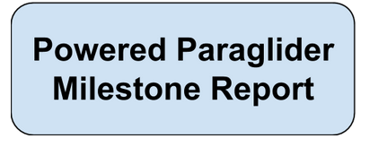

Elioth S. Fraijo

Jerry Wang

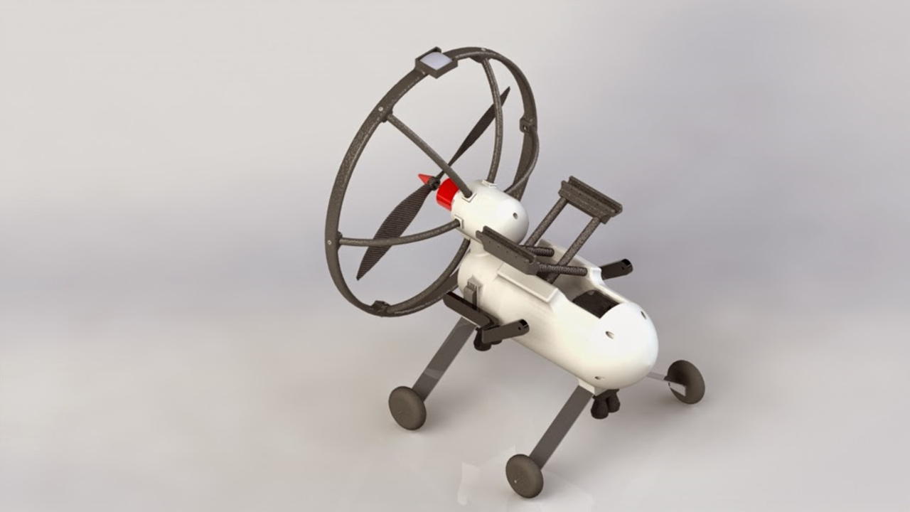

Milestones

Below, you will find the initial level milestones which were set for the powered paraglider development.

|  |  |  |  |  |
| --- | --- | --- | --- | --- |
| **#** | **Priority 1 (low) - 5 (high)** | **Milestone Description** | **Due Date** | **Responsible People** |
| 1 | 5 | Assembly and manufacturing of Powered paraglider to  maiden the First Flight. | 4/4/2015 | Elioth Fraijo |
| 2 | 4 | Calibration and tuning of control  surfaces prior to first flight. | 4/9/2015 | Elioth Fraijo Dominique Meyer  Jerry Wang  Miguel De la Villa |
| 3 | 2 | Compile documentation for the familiarization of BBB  Architecture | 4/9/2015 | Jerry Wang Elioth Fraijo |
| 4 | 3 | Log of IMU and Sensor Data for  initial sensor parameterization | 4/16/2015 | Elioth Fraijo  Jerry Wang |
| 5 | 3 | Purchase of Hardware sensor kit (Barometer, GPS, Speed Sensor) | 4/16/2015 | Elioth Fraijo |
| 6 | 4 | Test and log transmitter and control inputs  through BBB to control surfaces | 4/23/2015 | Elioth Fraijo  Jerry Wang |
| 7 | 2 | Hardware Data Sheet  Documentation | 4/23/2015 | Elioth Fraijo |
| 8 | 5 | Characterization of system model  behavior (Model Transfer Function) | 4/30/2015 | Elioth Fraijo Miguel de la Villa |
| 9 | 4 | Analytical and Experimental  Model Comparison | 4/30/2015 | Elioth Fraijo |
| 10 | 3 | Test and log barometric sensor data for the use or altitude readings | 4/30/2015 | Elioth Fraijo Jerry Wang |
| 11 | 3 | GPS, magnetometer, and speed sensor integration | 4/30/2015 | JerryWang |
| 12 | 5 | Steady state control development | 5/9/2014 | EliothFraijo  Jerry Wang |

Progress Update

Milestome #1 – Complete (due 4/4/15)

**Task:** Assembly and manufacturing of the powered paraglider in preparations for the maiden flight.

**Work Completed:** This milestone was necessary to get the paraglider ready for stability testing and data acquisition. The airframe of the paraglider was manufactured using the 3DP 1x1x.5 meter 3D printer. The hardware and electronic assembly was done by Elioth Fraijo and Miguel de la Villa.

Milestone #2 – Complete (due 4/4/15)

**Task**: Calibration and tuning of control surfaces prior to first flight.

**Work Completed**: This task was completed prior to the maddening and testing of the paraglider. The tension lines and control surfaces were trimmed allowing the canopy to expand and maintain in air stability. We found that the optimal length for the control lines was # meters. ( Include pictures of the tunning control surfaces, tension line points)

Milestone #3 – Complete (due 4/9/15)

**Task**: Compile documentation for the familiarization of Beagle Bone Black architecture

**Work Completed**: The beagle bone black board is the computing machine that is in charge of collecting the data from our sensors and integrating a flight control to aid with the guidance of the paraglider. This was a necessary step for our team to start developing the sensor integration code. The necessary documentation of the beagle bone architecture has been compiled and posted on the GitHub.

Milestone #4 – Incomplete (due 4/16/15)

**Task**: Log of IMU and Sensor Data for initial sensor parameterization

**Work Completed:**  As of now, the majority of the sensor integration has been completed and the beagle bone is ready for logging. The main obstacle in obtaining the data for the sensor parameterization has been a servo problem with the hardware. We have found that the canopy produces a great amount of tension, which causes the plastic servo arm to strip from the servo metal gears.This causes the control lines to be unresponsive, making flight unattainable. This milestone due date has been changed to 5/16/15.

Milestone #5 – Complete (due 4/16/15)

**Task**: Purchase of Hardware sensor kit (Barometer, GPS, Speed Sensor)

**Work Completed:** The hardware kit was not purchased, instead the team was able to obtain spare sensors from UCSD’s E4E aerial team. All sensors required have now been obtained and are ready for integration.

Milestone #6 – Complete (due 4/23/15)

**Task**: Test and log transmitter and control inputs through BBB to control surfaces.

**Work Completed:** The testing and logging of control inputs through the BBB is completed and will be integrated in the logging code. We are now able to input a signal through the BBB to move the control lines on our system. The main goal of this milestone was to integrate all our avionics through the main flight computer. Also, the pilot’s inputs will be logged to do real time and post-processing of flight analysis.

Milestone #7 – Complete (due 4/23/15)

**Task**: Hardware Data Sheet Documentation

**Work Completed:** All the data sheet for the sensors is now compiled and updated in the GitHub.

Milestone #8 – Incomplete (due 4/30/15)

**Task**: Characterization of system model behavior (Model Transfer Function).

**Work Completed:** As of now, the characterization of the system model behavior has not been completed. The main obstacle is obtaining the sensor data since the team has not been able to fly the system due to the servo problem. We have found that the canopy produces a great amount of tension, which causes the plastic servo arm to strip from the servo metal gears. This causes the control lines to be unresponsive, making flight unattainable. This milestone due date has been changed to 5/30/15

Milestone #9 – Not Complete (due 4/30/15)

**Task**: Analytical and experimental model comparison

**Work Completed:**  The analytical model is ready to be validated with experimental data. Due to the lack of data from our system logs, we are unable to perform this milestone.

Milestone #10 – Complete (due 4/30/15)

**Task**: Test and log barometric sensor data for the use or altitude readings

**Work Completed:**  The barometer sensor is now fully integrated in our logging code. We are able to obtain temperature and pressure readings from the barometers. More testing needs to be done in order to obtain true altitude and sensor placement optimization.

Milestone #11 – Not Complete (due 4/30/15)

**Task**: GPS, magnetometer, and speed sensor integration

**Work Completed:** The GPS code is under development and should be done by 5/16/15. The team found that the GPS drivers were not compatible with our system and Jerry Wang had to write his own. As of now, the GPS is of high priority in order to obtain the performance sheets of our platform. The magnetometer and speed sensors are under development.

Milestone #12 – Not Complete (due 5/09/15)

**Task**: Steady state control development

**Work Completed:** Data for the steady state controller has not been received. The documentation of the system is being compiled and studied for the expedition of the controller development. The team expects this milestone to be done by 6/10/15.