B100101

I have been working in the production and warehousing sector for the last three years.

In one of my recent assignments, I worked on the calibration of Turbochargers. I was able to gain exposure to a range of different turbo-chargers. However, I will focus on the B100101 for this article.

When you are calibrating the B100101 turbocharger you must first align the water pipes. We used a device called a Jig. In simple terms, a jig is a piece of equipment that provides accuracy and consistency.

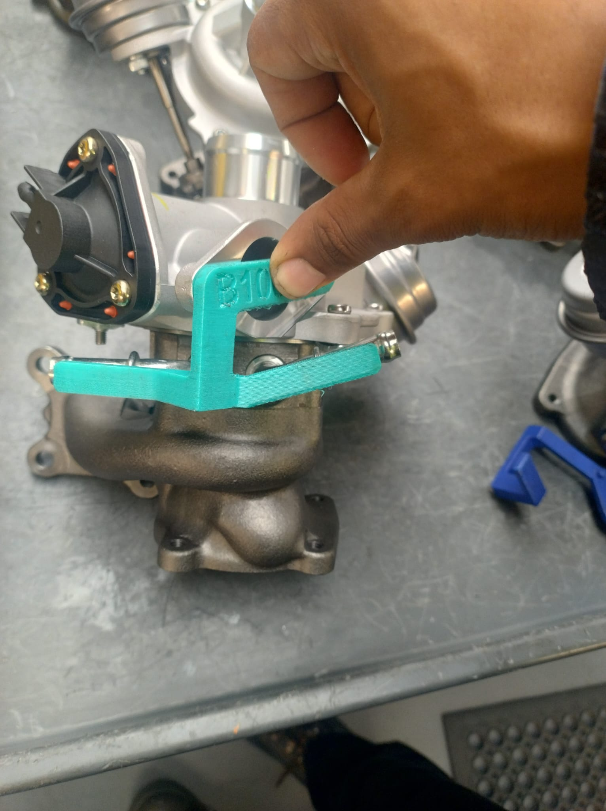

The first jig checks that the water pipes are inline. If they are not then a heat-torch is used to melt the glue which holds the water pipes so that it can be knocked into place by a soft hammer.

The second alignment is for the oil value. The Oil value is checked that it is aligned. If the oil valve is out of alignment then the compression housing should be unfastened and manually adjusted so that it fits with the Dark blue jig.

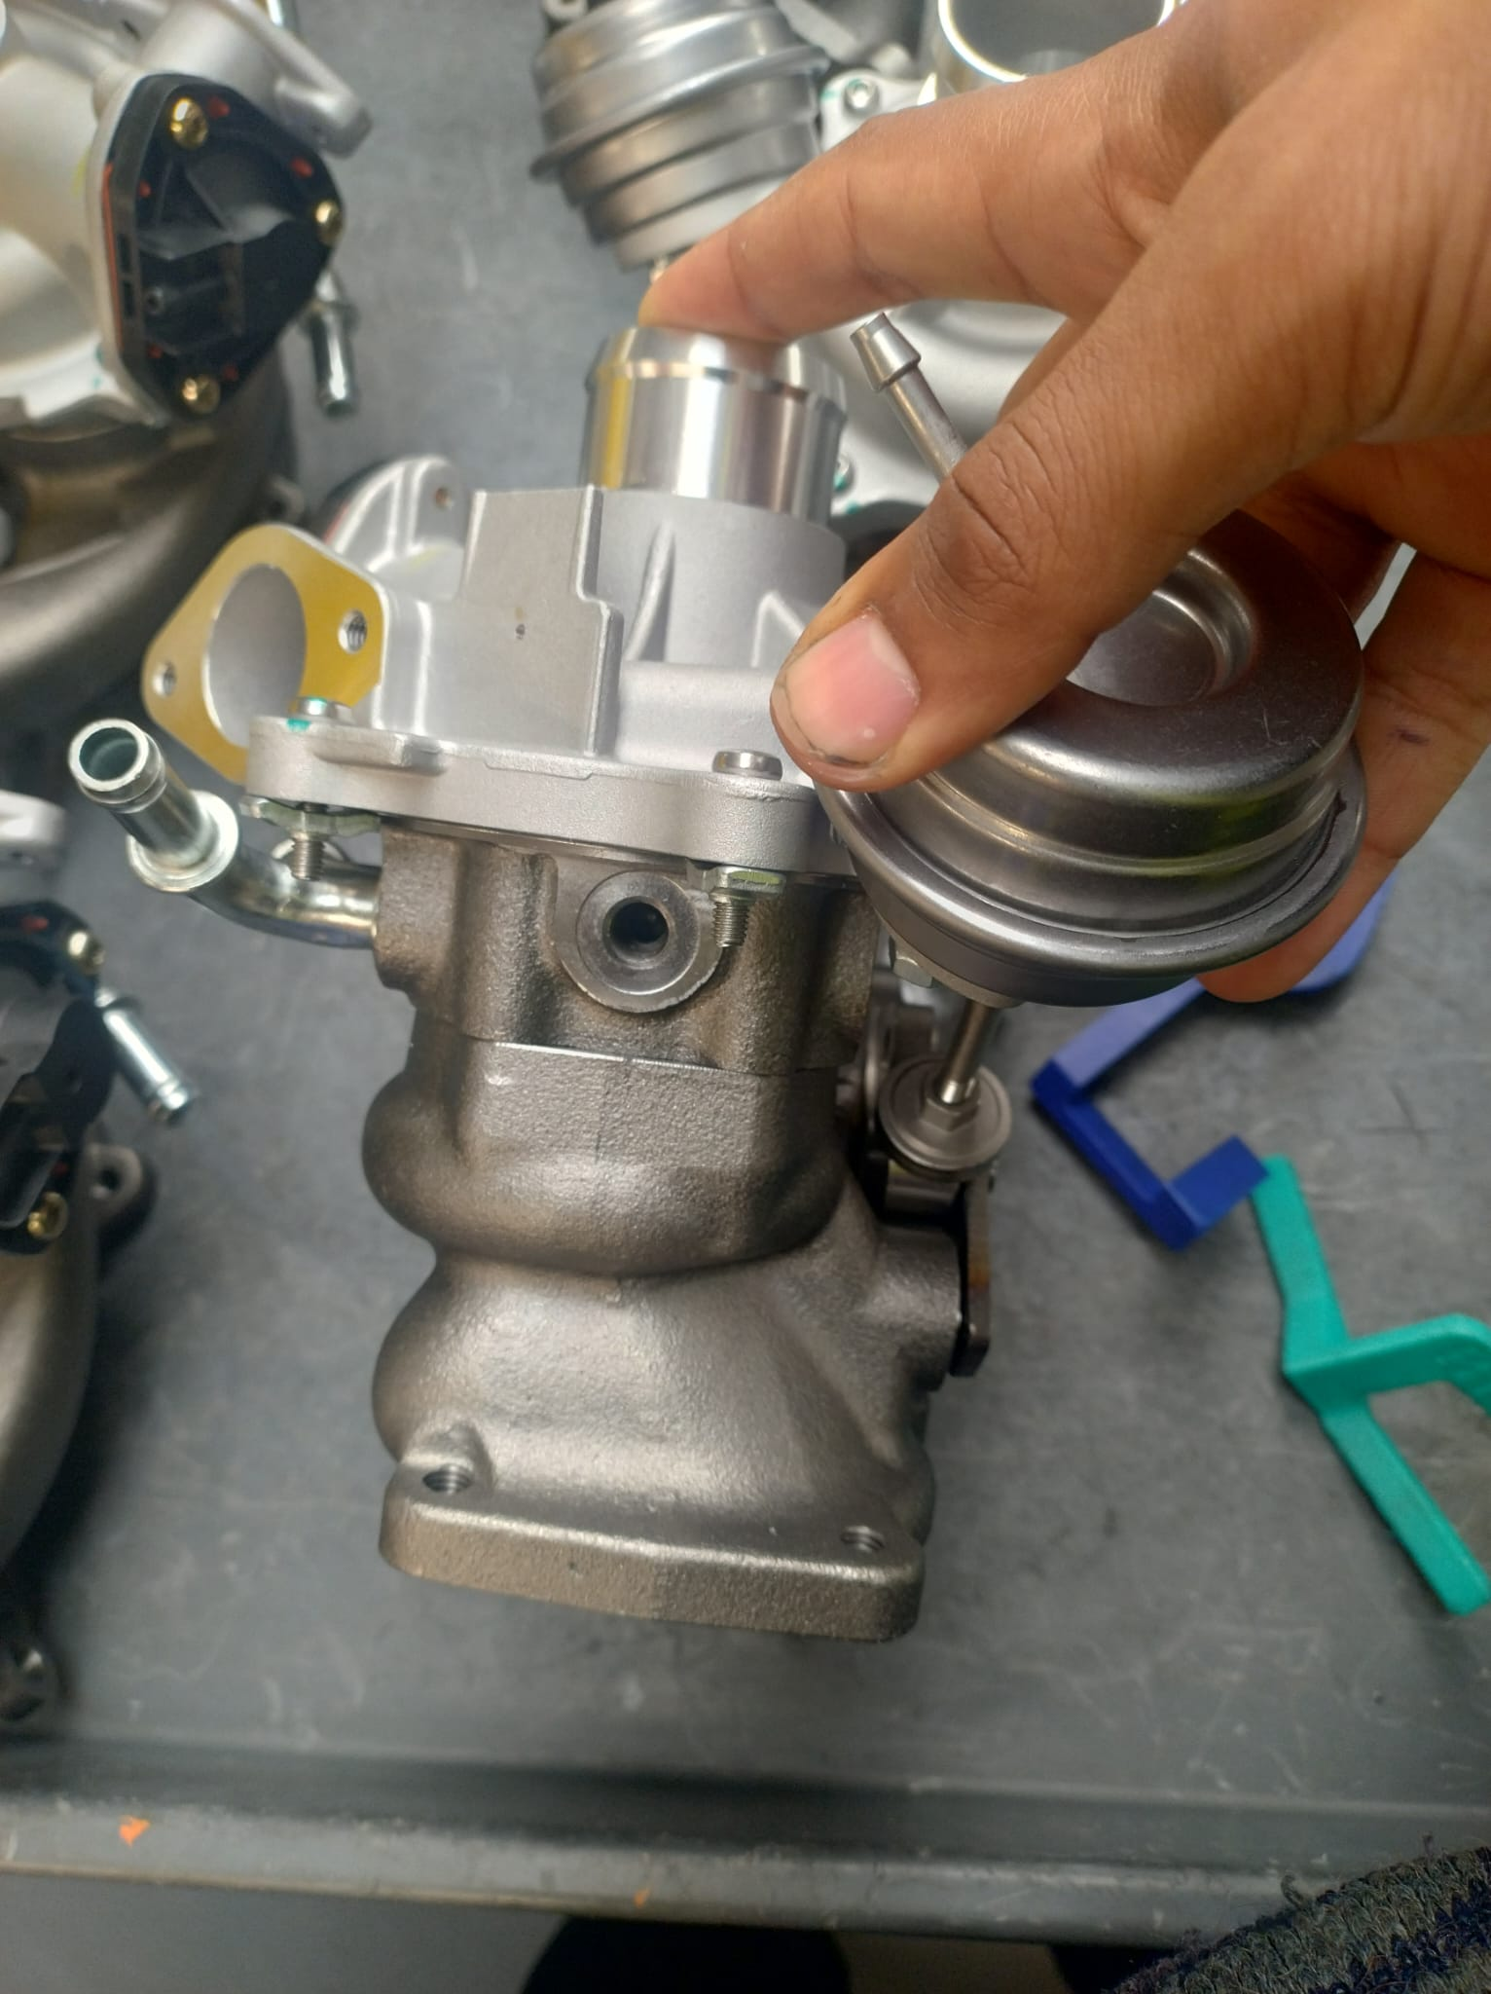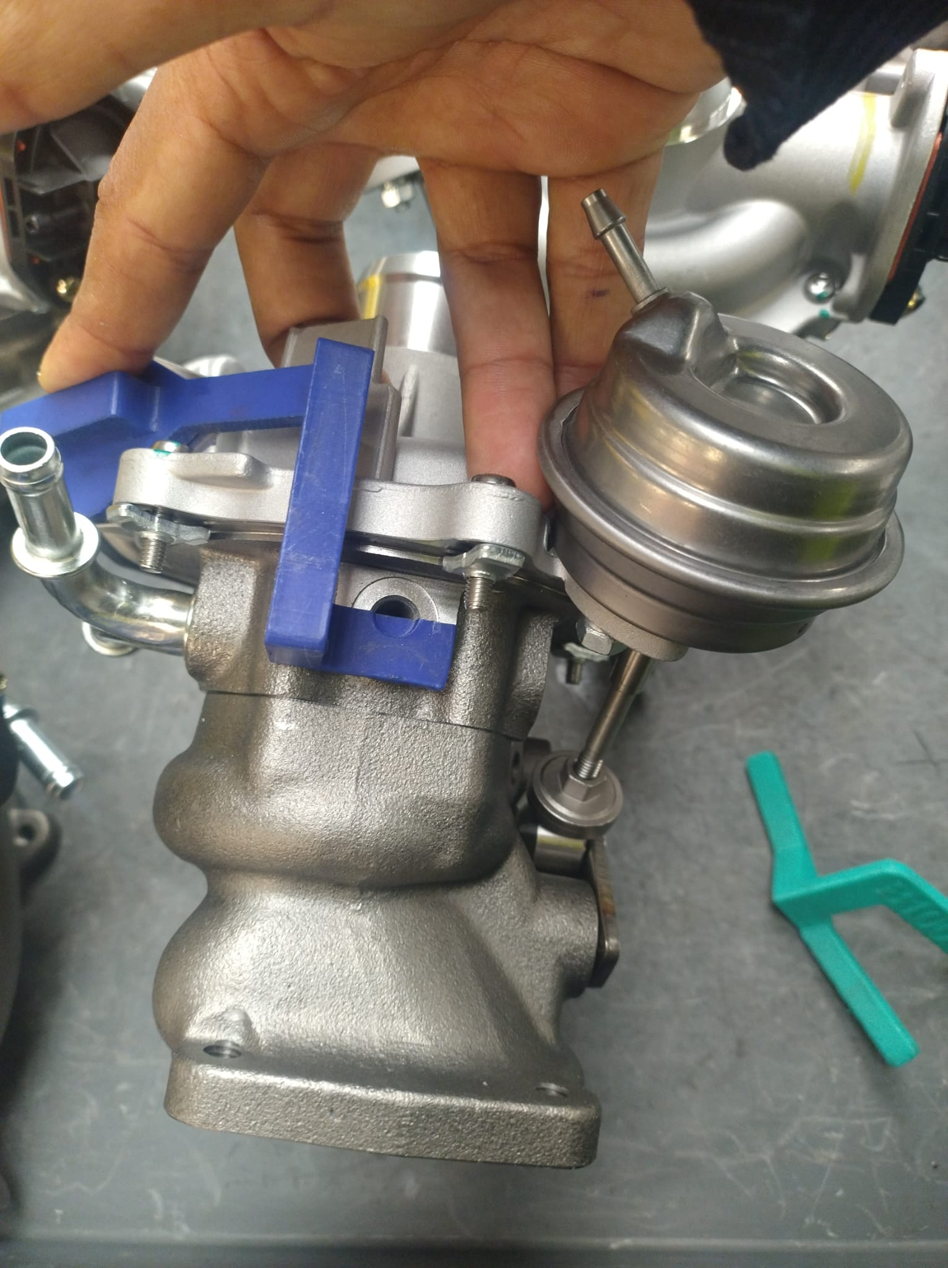

A mityvac is used to then check that the Turbo-charger holds air. Insert the mityvac’s tube into the black feed area highlighted below. After a few pumps of the mityvac you should hear a distinctive pop sound. Pump to **-50 inHg.** The dial’s arm should hold at the latter value. If the arm falls below that value within a twenty second counter period. Then you need to remove the black air dump valve and apply red grease. Re-test again. The grease will improve air retention.

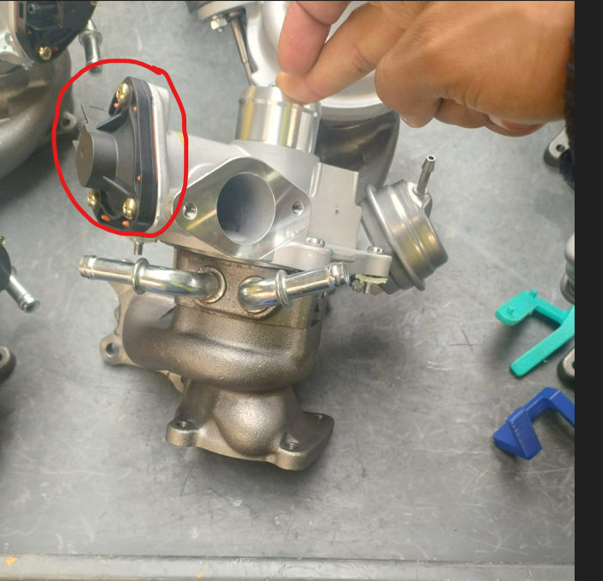

The last step is that the turbine housing outlet should have a waste gate. We want the waste gate to close at the value of -50inhg. The wastegate is controlled by the actuator. The actuator needs to be calibrated so that it closes on exactly at -50inhg.

Using the mityvac again, this time insert into the valve circled below. This is called the actuator valve. Use generous pumps of the mityvac lever and keep pumping until the waste gate is closed. Then check the dial value. It should be spot on -50 inHg. If the value is - 55 inhg for example. Then you need to decrease the size of the arm. In the value is -45 inhg for example, then you need to increase the size of the actuator arm.

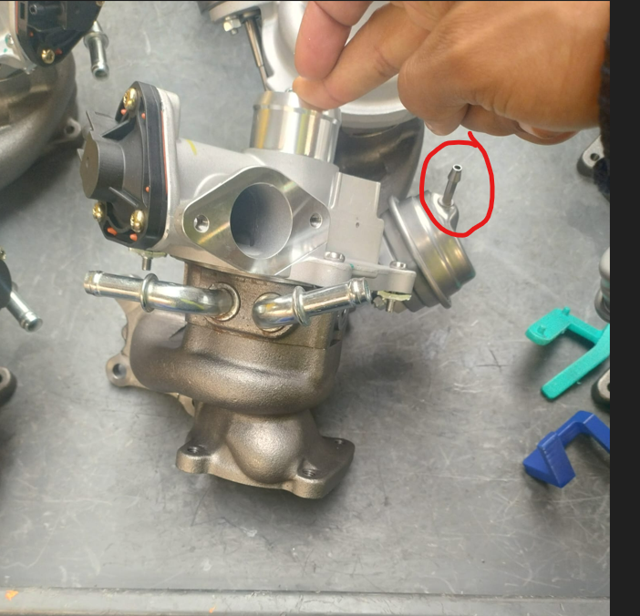

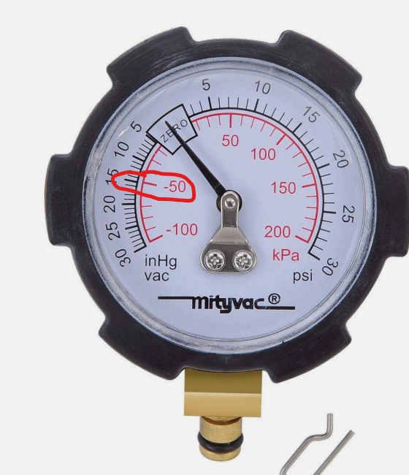

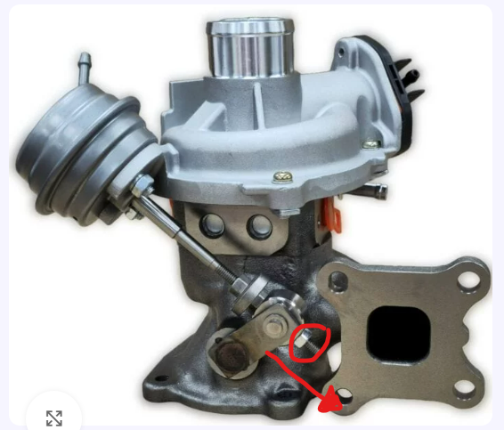

To increase the length, unscrew and move the arm downwards are indicated.

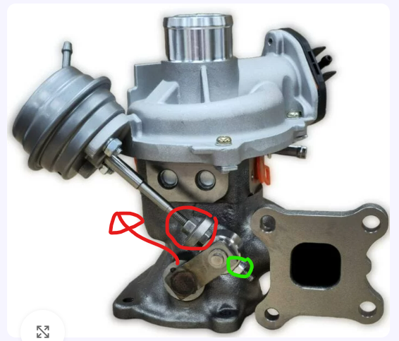

To shorten the length of the arm, unscrew the red screw and move upwards then retighten both the red and green circled screw.

Apply glue underneath and nuts once you have calibrated. This ensures that the nuts remain solitude once inside the consumer’s car engine.

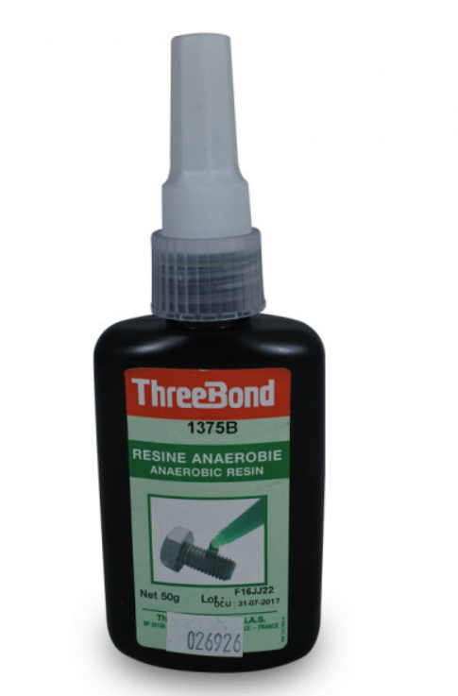

A water test can be performed on the water pipes as well. This is a step that involves placing two tubes on the water valves to ensure that water leakage does not occur.