**Prerequisites**

* Ensure that the auto sleep and auto lock features are disabled on your Windows system.
* Connect the computer to a continuous power source to prevent interruptions.
* Ensure you login as admin user

**Media File Setup**  
Place your desired .mp4 video file into the program’s (windows-auto-video-play-main) directory. This program contains a sample file. After you add your media file **delete the sample file**.

*In case multiple mp4 files are present, the program will select and play only one of them.*

**Time Configuration**

Set your computer's time to desired timezone

*If you need guide time zone change:  
https://www.pcworld.com/article/1513815/how-to-make-your-laptop-change-time-zones-automatically-in-windows-11.html*

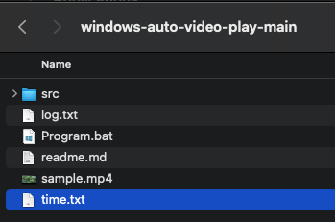

**Set start and stop time**

The program will determine the video's start and end times based on your desired input to **time.txt (time)** file.

example of the time.txt file

10:00

17:00

*10:00 is start time and 17:00 is stop time*

Open the "time.txt" file.

Specify the start time and stop time in 24 hour format for the video playback.

**Running the Program**

Locate and double-click on the **"Program.bat" (Program)** file in the downloaded folder to initiate the process.

If you encounter a popup notification from Windows Defender or any antivirus software, please allow the program to run.

**Logs**

Any activity or errors encountered by the program will be logged. You can review these logs in the "**logs.txt"** file.