Creating sub interfaces on routers

**Router 1**

Router>en

Router#conf t

Enter configuration commands, one per line. End with CNTL/Z.

Router(config)#

Router(config)#int g0/2

Router(config-if)#no shut

Router(config-if)#

%LINK-5-CHANGED: Interface GigabitEthernet0/2, changed state to up

%LINEPROTO-5-UPDOWN: Line protocol on Interface GigabitEthernet0/2, changed state to up

Router(config-if)#

Router(config-if)#

Router(config-if)#

Router(config-if)#ex

Router(config)#

Router(config)#

Router(config)#int g0/2.10

Router(config-subif)#

%LINK-5-CHANGED: Interface GigabitEthernet0/2.10, changed state to up

%LINEPROTO-5-UPDOWN: Line protocol on Interface GigabitEthernet0/2.10, changed state to up

Router(config-subif)#en

Router(config-subif)#encapsulation do

Router(config-subif)#encapsulation dot1Q 10

Router(config-subif)#ip add 192.168.5.1 255.255.255.248

Router(config-subif)#no shut

Router(config-subif)#ex

Router(config)#

Router(config)#

Router(config)#int g0/2.20

Router(config-subif)#

%LINK-5-CHANGED: Interface GigabitEthernet0/2.20, changed state to up

%LINEPROTO-5-UPDOWN: Line protocol on Interface GigabitEthernet0/2.20, changed state to up

Router(config-subif)#enca

Router(config-subif)#encapsulation dot

Router(config-subif)#encapsulation dot1Q 20

Router(config-subif)#ip add 192.168.5.9 255.255.255.248

Router(config-subif)#no shut

Router(config-subif)#ex

Router(config)#

Router(config)#

Router(config)#

Router(config)#int g0/2.30

Router(config-subif)#

%LINK-5-CHANGED: Interface GigabitEthernet0/2.30, changed state to up

%LINEPROTO-5-UPDOWN: Line protocol on Interface GigabitEthernet0/2.30, changed state to up

Router(config-subif)#en

Router(config-subif)#encapsulation do

Router(config-subif)#encapsulation dot1Q 30

Router(config-subif)#ip add 192.168.5.17 255.255.255.248

Router(config-subif)#no shut

Router(config-subif)#ex

**Router 02**

Router>

Router>

Router>en

Router#conf t

Enter configuration commands, one per line. End with CNTL/Z.

Router(config)#

Router(config)#

Router(config)#

Router(config)#int g0/2

Router(config-if)#no shut

Router(config-if)#

%LINK-5-CHANGED: Interface GigabitEthernet0/2, changed state to up

%LINEPROTO-5-UPDOWN: Line protocol on Interface GigabitEthernet0/2, changed state to up

Router(config-if)#

Router(config-if)#

Router(config-if)#

Router(config-if)#

Router(config-if)#ex

Router(config)#

Router(config)#

Router(config)#

Router(config)#

Router(config)#int g0/2.10

Router(config-subif)#

%LINK-5-CHANGED: Interface GigabitEthernet0/2.10, changed state to up

%LINEPROTO-5-UPDOWN: Line protocol on Interface GigabitEthernet0/2.10, changed state to up

Router(config-subif)#en

% Ambiguous command: "en"

Router(config)#en

Router(config)#endo

Router(config)#en

Router(config)#int g0/2.10

Router(config-subif)#en

Router(config-subif)#encapsulation do

Router(config-subif)#encapsulation dot1Q 10

Router(config-subif)#ip add 192.168.10.1 255.255.255.0

Router(config-subif)#no shut

Router(config-subif)#ex

Router(config)#

Router(config)#int g0/2.20

Router(config-subif)#

%LINK-5-CHANGED: Interface GigabitEthernet0/2.20, changed state to up

%LINEPROTO-5-UPDOWN: Line protocol on Interface GigabitEthernet0/2.20, changed state to up

Router(config-subif)#en

Router(config-subif)#encapsulation do

Router(config-subif)#encapsulation dot1Q 20

Router(config-subif)#ip add 192.168.20.1 255.255.255.0

Router(config-subif)#no shut

Router(config-subif)#ex

Router(config)#

Router(config)#

Router(config)#

Router(config)#int g0/2.30

Router(config-subif)#

%LINK-5-CHANGED: Interface GigabitEthernet0/2.30, changed state to up

%LINEPROTO-5-UPDOWN: Line protocol on Interface GigabitEthernet0/2.30, changed state to up

Router(config-subif)#ip add 192.168.30.1 255.255.255.0

% Configuring IP routing on a LAN subinterface is only allowed if that

subinterface is already configured as part of an IEEE 802.10, IEEE 802.1Q,

or ISL vLAN.

Router(config-subif)#

Router(config-subif)#no shut

Router(config-subif)#ex

Router(config)#

**Router 03**

Router>en

Router#conf t

Enter configuration commands, one per line. End with CNTL/Z.

Router(config)#

Router(config)#

Router(config)#int g0/2

Router(config-if)#no shut

Router(config-if)#

%LINK-5-CHANGED: Interface GigabitEthernet0/2, changed state to up

%LINEPROTO-5-UPDOWN: Line protocol on Interface GigabitEthernet0/2, changed state to up

Router(config-if)#

Router(config-if)#

Router(config-if)#

Router(config-if)#

Router(config-if)#ex

Router(config)#

Router(config)#

Router(config)#int g0/2.10

Router(config-subif)#

%LINK-5-CHANGED: Interface GigabitEthernet0/2.10, changed state to up

%LINEPROTO-5-UPDOWN: Line protocol on Interface GigabitEthernet0/2.10, changed state to up

Router(config-subif)#en

Router(config-subif)#encapsulation do

Router(config-subif)#encapsulation dot1Q 10

Router(config-subif)#ip add 192.168.40.1 255.255.255.240

Router(config-subif)#no shut

Router(config-subif)#ex

Router(config)#

Router(config)#

Router(config)#int g0/2.20

Router(config-subif)#

%LINK-5-CHANGED: Interface GigabitEthernet0/2.20, changed state to up

%LINEPROTO-5-UPDOWN: Line protocol on Interface GigabitEthernet0/2.20, changed state to up

Router(config-subif)#en

Router(config-subif)#encapsulation do

Router(config-subif)#encapsulation dot1Q 20

Router(config-subif)#ip add 192.168.40.33 255.255.255.240

Router(config-subif)#no shut

Router(config-subif)#ex

Router(config)#

Router(config)#

Router(config)#

Router(config)#int g0/2.30

Router(config-subif)#

%LINK-5-CHANGED: Interface GigabitEthernet0/2.30, changed state to up

%LINEPROTO-5-UPDOWN: Line protocol on Interface GigabitEthernet0/2.30, changed state to up

Router(config-subif)#en

Router(config-subif)#encapsulation do

Router(config-subif)#encapsulation dot1Q 30

Router(config-subif)#ip add 192.168.40.65 255.255.255.240

Router(config-subif)#no shut

Router(config-subif)#ex

**Router 04**

Router>en

Router#conf t

Enter configuration commands, one per line. End with CNTL/Z.

Router(config)#

Router(config)#

Router(config)#

Router(config)#int g0/2

Router(config-if)#no shut

Router(config-if)#

%LINK-5-CHANGED: Interface GigabitEthernet0/2, changed state to up

%LINEPROTO-5-UPDOWN: Line protocol on Interface GigabitEthernet0/2, changed state to up

Router(config-if)#

Router(config-if)#

Router(config-if)#ex

Router(config)#

Router(config)#int g0/2.10

Router(config-subif)#

%LINK-5-CHANGED: Interface GigabitEthernet0/2.10, changed state to up

%LINEPROTO-5-UPDOWN: Line protocol on Interface GigabitEthernet0/2.10, changed state to up

Router(config-subif)#en

Router(config-subif)#encapsulation do

Router(config-subif)#encapsulation dot1Q 10

Router(config-subif)#ip add 192.168.50.1 255.255.255.240

Router(config-subif)#no shut

Router(config-subif)#

Router(config-subif)#ex

Router(config)#

Router(config)#

Router(config)#int g0/2.20

Router(config-subif)#

%LINK-5-CHANGED: Interface GigabitEthernet0/2.20, changed state to up

%LINEPROTO-5-UPDOWN: Line protocol on Interface GigabitEthernet0/2.20, changed state to up

Router(config-subif)#en

Router(config-subif)#encapsulation do

Router(config-subif)#encapsulation dot1Q 20

Router(config-subif)#ip add 192.168.50.33 255.255.255.240

Router(config-subif)#no shut

Router(config-subif)#ex

Router(config)#

Router(config)#

Router(config)#int g0/2.30

Router(config-subif)#

%LINK-5-CHANGED: Interface GigabitEthernet0/2.30, changed state to up

%LINEPROTO-5-UPDOWN: Line protocol on Interface GigabitEthernet0/2.30, changed state to up

Router(config-subif)#en

Router(config-subif)#encapsulation do

Router(config-subif)#encapsulation dot1Q 30

Router(config-subif)#ip add 192.168.50.65 255.255.255.240

Router(config-subif)#no shut

Router(config-subif)#ex

Creating vlans on switches and setting access on routers to each sub interface with router trunking

**Switch 01**

Switch>

Switch>

Switch>

Switch>en

Switch#conf t

Enter configuration commands, one per line. End with CNTL/Z.

Switch(config)#

Switch(config)#

Switch(config)#

Switch(config)#vlan 10

Switch(config-vlan)#ex

Switch(config)#vlan 20

Switch(config-vlan)#ex

Switch(config)#vlan 30

Switch(config-vlan)#ex

Switch(config)#

Switch(config)#

Switch(config)#swi

Switch(config)#int f0/2

Switch(config-if)#swi

Switch(config-if)#switchport mo

Switch(config-if)#switchport mode acc

Switch(config-if)#switchport mode access

Switch(config-if)#swi

Switch(config-if)#switchport ac

Switch(config-if)#switchport access vl

Switch(config-if)#switchport access vlan 10

Switch(config-if)#no shut

Switch(config-if)#ex

Switch(config)#

Switch(config)#

Switch(config)#int f0/4

Switch(config-if)#swi

Switch(config-if)#switchport mo

Switch(config-if)#switchport mode ac

Switch(config-if)#switchport mode access

Switch(config-if)#sw

Switch(config-if)#switchport ac

Switch(config-if)#switchport access vl

Switch(config-if)#switchport access vlan 20

Switch(config-if)#no shut

Switch(config-if)#ex

Switch(config)#

Switch(config)#

Switch(config)#int f0/3

Switch(config-if)#sw

Switch(config-if)#switchport mo

Switch(config-if)#switchport mode ac

Switch(config-if)#switchport mode access

Switch(config-if)#sw

Switch(config-if)#switchport ac

Switch(config-if)#switchport access vl

Switch(config-if)#switchport access vlan 30

Switch(config-if)#no shut

Switch(config-if)#

Switch(config-if)#ex

Switch(config)#

Switch(config)#

Switch(config)#

Switch(config)#int f0/1

Switch(config-if)#sw

Switch(config-if)#switchport mo

Switch(config-if)#switchport mode ac

Switch(config-if)#switchport mode access

Switch(config-if)#sw

Switch(config-if)#switchport mo

Switch(config-if)#switchport mode tr

Switch(config-if)#switchport mode trunk

Switch(config-if)#

%LINEPROTO-5-UPDOWN: Line protocol on Interface FastEthernet0/1, changed state to down

%LINEPROTO-5-UPDOWN: Line protocol on Interface FastEthernet0/1, changed state to up

Switch(config-if)#sw

Switch(config-if)#switchport tru

Switch(config-if)#switchport trunk al

Switch(config-if)#switchport trunk allowed vl

Switch(config-if)#switchport trunk allowed vlan 1,10,20,30

Switch(config-if)#no shut

Switch(config-if)#

Switch(config-if)#ex

Switch(config)#

Switch(config)#

Switch(config)#

Switch(config)#ex

Switch#

%SYS-5-CONFIG_I: Configured from console by console

Switch#

Switch#sh vl

Switch#sh vlan in

Switch#sh in

Switch#sh interfaces tr

Switch#sh interfaces trunk br

Switch#sh interfaces trunk

Port Mode Encapsulation Status Native vlan

Fa0/1 on 802.1q trunking 1

Port Vlans allowed on trunk

Fa0/1 1,10,20,30

Port Vlans allowed and active in management domain

Fa0/1 1,10,20,30

Port Vlans in spanning tree forwarding state and not pruned

Fa0/1 30

**Switch 02**

Switch>

Switch>

Switch>

Switch>en

Switch#conf t

Enter configuration commands, one per line. End with CNTL/Z.

Switch(config)#

Switch(config)#

Switch(config)#vlan 10

Switch(config-vlan)#ex

Switch(config)#vlan 20

Switch(config-vlan)#ex

Switch(config)#vlan 30

Switch(config-vlan)#ex

Switch(config)#

Switch(config)#

Switch(config)#

Switch(config)#int ra

Switch(config)#int range f0/1-2

Switch(config-if-range)#sw

Switch(config-if-range)#switchport ac

Switch(config-if-range)#switchport mo

Switch(config-if-range)#switchport mode ac

Switch(config-if-range)#switchport mode access

Switch(config-if-range)#swi

Switch(config-if-range)#switchport ac

Switch(config-if-range)#switchport access vlan 10

Switch(config-if-range)#no shut

Switch(config-if-range)#ex

Switch(config)#

Switch(config)#

Switch(config)#

Switch(config)#int ra

Switch(config)#int range f0/3-4

Switch(config-if-range)#sw

Switch(config-if-range)#switchport mo

Switch(config-if-range)#switchport mode ac

Switch(config-if-range)#switchport mode access

Switch(config-if-range)#sw

Switch(config-if-range)#switchport ac

Switch(config-if-range)#switchport access vlan 20

Switch(config-if-range)#no shut

Switch(config-if-range)#

Switch(config-if-range)#

Switch(config-if-range)#ex

Switch(config)#

Switch(config)#

Switch(config)#int r

Switch(config)#int range f0/5-6

Switch(config-if-range)#sw

Switch(config-if-range)#switchport mo

Switch(config-if-range)#switchport mode ac

Switch(config-if-range)#switchport mode access

Switch(config-if-range)#sw

Switch(config-if-range)#switchport ac

Switch(config-if-range)#switchport access vl

Switch(config-if-range)#switchport access vlan 30

Switch(config-if-range)#no shut

Switch(config-if-range)#ex

Switch(config)#

Switch(config)#

Switch(config)#

Switch(config)#int f0/7

Switch(config-if)#swi

Switch(config-if)#switchport mo

Switch(config-if)#switchport mode tr

Switch(config-if)#switchport mode trunk

Switch(config-if)#

%LINEPROTO-5-UPDOWN: Line protocol on Interface FastEthernet0/7, changed state to down

%LINEPROTO-5-UPDOWN: Line protocol on Interface FastEthernet0/7, changed state to up

Switch(config-if)#sw

Switch(config-if)#switchport tr

Switch(config-if)#switchport trunk al

Switch(config-if)#switchport trunk allowed vl

Switch(config-if)#switchport trunk allowed vlan 1,10,20,30

Switch(config-if)#no shut

Switch(config-if)#

Switch(config-if)#ex

Switch(config)#

Switch(config)#

Switch(config)#ex

Switch#

%SYS-5-CONFIG_I: Configured from console by console

Switch#

Switch#sh

Switch#show i

Switch#show tr

Switch#show inter

Switch#show interfaces tr

Switch#show interfaces trunk

Port Mode Encapsulation Status Native vlan

Fa0/7 on 802.1q trunking 1

Port Vlans allowed on trunk

Fa0/7 1,10,20,30

Port Vlans allowed and active in management domain

Fa0/7 1,10,20,30

Port Vlans in spanning tree forwarding state and not pruned

Fa0/7 30

**Switch 03**

Switch>

Switch>

Switch>

Switch>en

Switch#conf t

Enter configuration commands, one per line. End with CNTL/Z.

Switch(config)#

Switch(config)#

Switch(config)#vlan 10

Switch(config-vlan)#ex

Switch(config)#vlan 30

Switch(config-vlan)#ex

Switch(config)#vlan 20

Switch(config-vlan)#ex

Switch(config)#

Switch(config)#

Switch(config)#

Switch(config)#

Switch(config)#int ra

Switch(config)#int range f0/1-2

Switch(config-if-range)#sw

Switch(config-if-range)#switchport mo

Switch(config-if-range)#switchport mode ac

Switch(config-if-range)#switchport mode access

Switch(config-if-range)#sw

Switch(config-if-range)#switchport ac

Switch(config-if-range)#switchport access vl

Switch(config-if-range)#switchport access vlan 10

Switch(config-if-range)#no shut

Switch(config-if-range)#ex

Switch(config)#

Switch(config)#

Switch(config)#

Switch(config)#int ran

Switch(config)#int range f0/3-4

Switch(config-if-range)#sw

Switch(config-if-range)#switchport mo

Switch(config-if-range)#switchport mode ac

Switch(config-if-range)#switchport mode access

Switch(config-if-range)#sw

Switch(config-if-range)#switchport ac

Switch(config-if-range)#switchport access vl

Switch(config-if-range)#switchport access vlan 20

Switch(config-if-range)#no shut

Switch(config-if-range)#ex

Switch(config)#

Switch(config)#

Switch(config)#

Switch(config)#int r

Switch(config)#int range f0/5-6

Switch(config-if-range)#swi

Switch(config-if-range)#switchport mo

Switch(config-if-range)#switchport mode ac

Switch(config-if-range)#switchport mode access

Switch(config-if-range)#sw

Switch(config-if-range)#switchport ac

Switch(config-if-range)#switchport access vl

Switch(config-if-range)#switchport access vlan 30

Switch(config-if-range)#no shut

Switch(config-if-range)#ex

Switch(config)#

Switch(config)#

Switch(config)#

Switch(config)#int f0/7

Switch(config-if)#sw

Switch(config-if)#switchport mo

Switch(config-if)#switchport mode tr

Switch(config-if)#switchport mode trunk

Switch(config-if)#

%LINEPROTO-5-UPDOWN: Line protocol on Interface FastEthernet0/7, changed state to down

%LINEPROTO-5-UPDOWN: Line protocol on Interface FastEthernet0/7, changed state to up

sw

Switch(config-if)#switchport tr

Switch(config-if)#switchport trunk al

Switch(config-if)#switchport trunk allowed vl

Switch(config-if)#switchport trunk allowed vlan 1,10,20,30

Switch(config-if)#no shu

Switch(config-if)#no shutdown

Switch(config-if)#ex

Switch(config)#

Switch(config)#ex

Switch#

%SYS-5-CONFIG_I: Configured from console by console

Switch#sh inte

Switch#sh interfaces tr

Switch#sh interfaces trunk

Port Mode Encapsulation Status Native vlan

Fa0/7 on 802.1q trunking 1

Port Vlans allowed on trunk

Fa0/7 1,10,20,30

Port Vlans allowed and active in management domain

Fa0/7 1,10,20,30

Port Vlans in spanning tree forwarding state and not pruned

Fa0/7 none

Loopback interface and

NTP server configuration

Router>

Router>

Router>

Router>en

Router#clo

Router#clock set

% Incomplete command.

Router#clo

Router#clock set?

set

Router#clock set 10:10:00 2 aug 2025

Router#conf t

Enter configuration commands, one per line. End with CNTL/Z.

Router(config)#ntp?

ntp

Router(config)#ntp ?

authenticate Authenticate time sources

authentication-key Authentication key for trusted time sources

master Act as NTP master clock

server Configure NTP server

trusted-key Key numbers for trusted time sources

update-calendar Configure NTP to update the calendar.

Router(config)#ntp ser

Router(config)#ntp server ?

A.B.C.D IP address of peer

Router(config)#ntp server 192.168.5.10

Router(config)#do sh clock

*10:10:50.580 UTC Sat Aug 2 2025

Router(config)#do sh ntp ?

LINE <cr>

Router(config)#do sh ntp asso

Router(config)#do sh ntp association

address ref clock st when poll reach delay offset disp

~192.168.5.10 127.127.1.1 1 11 16 1 0.00 55560.00 0.00

* sys.peer, # selected, + candidate, - outlyer, x falseticker, ~ configured

Router(config)#

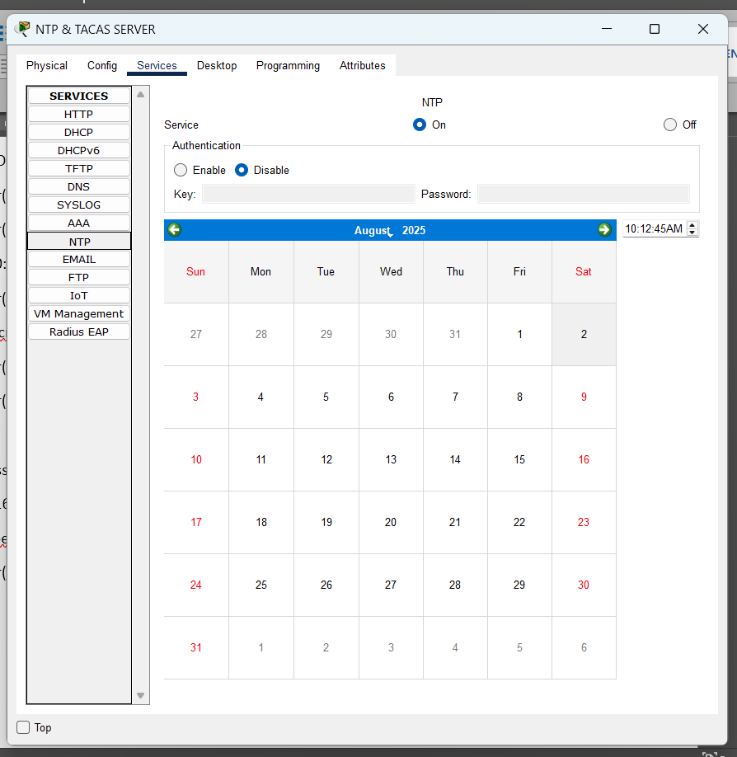

Enable port security on Switch 1,2 and 3.

a. Two dynamically learned MAC addresses can be used in Switch 2 and 3 ports. If a port violation occurs, restrict port access.

b. Statically assign the MAC addresses of the Servers and Admin PC to Switch 1 ports. If a port violation occurs, disable port access.

**Dynamic mac addressing**

Switch(config)#

Switch(config)#int ra

Switch(config)#int range f0/1-2

Switch(config-if-range)#sw

Switch(config-if-range)#switchport mo

Switch(config-if-range)#switchport mode ac

Switch(config-if-range)#switchport mode access

Switch(config-if-range)#sw

Switch(config-if-range)#switchport po

Switch(config-if-range)#switchport port-security ?

aging Port-security aging commands

mac-address Secure mac address

maximum Max secure addresses

violation Security violation mode

<cr>

Switch(config-if-range)#switchport port-security ma

Switch(config-if-range)#switchport port-security max

Switch(config-if-range)#switchport port-security maximum 2

Switch(config-if-range)#sw

Switch(config-if-range)#switchport po

Switch(config-if-range)#switchport port-security mac

Switch(config-if-range)#switchport port-security mac-address sti

Switch(config-if-range)#switchport port-security mac-address sticky

Switch(config-if-range)#swi

Switch(config-if-range)#switchport po

Switch(config-if-range)#switchport port-security vio

Switch(config-if-range)#switchport port-security violation ?

protect Security violation protect mode

restrict Security violation restrict mode

shutdown Security violation shutdown mode

Switch(config-if-range)#switchport port-security violation re

Switch(config-if-range)#switchport port-security violation restrict

Switch(config-if-range)#ex

**Static mac address assigning**

Switch>

Switch>

Switch>

Switch>en

Switch#conf t

Enter configuration commands, one per line. End with CNTL/Z.

Switch(config)#

Switch(config)#

Switch(config)#

Switch(config)#

Switch(config)#swi

Switch(config)#int f0/4

Switch(config-if)#swi

Switch(config-if)#switchport mo

Switch(config-if)#switchport mode ac

Switch(config-if)#switchport mode access

Switch(config-if)#sw

Switch(config-if)#switchport po

Switch(config-if)#switchport port-security mac

Switch(config-if)#switchport port-security mac-address 00E0.8F01.ED93

Port-security not enabled on interface FastEthernet0/4.

Switch(config-if)#swi

Switch(config-if)#switchport po

Switch(config-if)#switchport port-security vio

Switch(config-if)#switchport port-security violation ?

protect Security violation protect mode

restrict Security violation restrict mode

shutdown Security violation shutdown mode

Switch(config-if)#switchport port-security violation shu

Switch(config-if)#switchport port-security violation shutdown

Switch(config-if)#do wr

Building configuration...

[OK]

Switch(config-if)#

Switch(config-if)#ex

Switch(config)#

Switch(config)#

Switch(config)#

Switch(config)#

Switch(config)#int f0/3

Switch(config-if)#swi

Switch(config-if)#switchport mo

Switch(config-if)#switchport mode ac

Switch(config-if)#switchport mode access

Switch(config-if)#swi

Switch(config-if)#switchport po

Switch(config-if)#switchport port-security mac

Switch(config-if)#switchport port-security mac-address 000C.8576.A932

Port-security not enabled on interface FastEthernet0/3.

Switch(config-if)#swi

Switch(config-if)#switchport po

Switch(config-if)#switchport port-security

Switch(config-if)#swi

Switch(config-if)#switchport por

Switch(config-if)#switchport port-security mac

Switch(config-if)#switchport port-security mac-address 000C.8576.A932

Switch(config-if)#swi

Switch(config-if)#switchport po

Switch(config-if)#switchport port-security vio

Switch(config-if)#switchport port-security violation ?

protect Security violation protect mode

restrict Security violation restrict mode

shutdown Security violation shutdown mode

Switch(config-if)#switchport port-security violation shu

Switch(config-if)#switchport port-security violation shutdown

Switch(config-if)#ex

Switch(config)#

Switch(config)#

Switch(config)#int f0/2

Switch(config-if)#swi

Switch(config-if)#switchport mo

Switch(config-if)#switchport mode ac

Switch(config-if)#switchport mode access

Switch(config-if)#sw

Switch(config-if)#switchport po

Switch(config-if)#switchport port-security

Switch(config-if)#sw

Switch(config-if)#switchport po

Switch(config-if)#switchport port-security mac

Switch(config-if)#switchport port-security mac-address 0001.43CD.23A8

Switch(config-if)#swi

Switch(config-if)#switchport po

Switch(config-if)#switchport port-security vio

Switch(config-if)#switchport port-security violation shu

Switch(config-if)#switchport port-security violation shutdown

Switch(config-if)#ex

Switch(config)#

Switch(config)#ex

Switch#

Networks A, B, D, and E can only access the website on the web server

Router>en

Router#conf t

Enter configuration commands, one per line. End with CNTL/Z.

Router(config)#

Router(config)#

Router(config)#

Router(config)#ip acc

Router(config)#ip access-list st

Router(config)#ip access-list standard webserver

Router(config-std-nacl)#permit 192.168.10.0 0.0.0.255

Router(config-std-nacl)#permit 192.168.20.0 0.0.0.255

Router(config-std-nacl)#permit 192.168.40.0 0.0.0.31

Router(config-std-nacl)#permit 192.168.40.32 0.0.0.31

Router(config-std-nacl)#deny any

Router(config-std-nacl)#ex

Router(config)#

Router(config)#

Router(config)#int g0/2.10

Router(config-subif)#ip ac

Router(config-subif)#ip access-group webserver out

Router(config-subif)#do wr

Building configuration...

[OK]

Router(config-subif)#

Router(config-subif)#ex

Router(config)#

Router(config)#do sh ip ac

Router(config)#do sh ip acce

Router(config)#ex

Router#

%SYS-5-CONFIG_I: Configured from console by console

Router#sh ip ac

Router#sh ip access-lists

Standard IP access list webserver

10 permit 192.168.10.0 0.0.0.255

20 permit 192.168.20.0 0.0.0.255

30 permit 192.168.40.0 0.0.0.31

40 permit 192.168.40.32 0.0.0.31

50 deny any

Networks C and F can communicate only with each other and cannot interact with any other networks

Router>

Router>

Router>

Router>en

Router#conf t

Enter configuration commands, one per line. End with CNTL/Z.

Router(config)#

Router(config)#

Router(config)#

Router(config)#ip ac

Router(config)#ip access-list ex

Router(config)#ip access-list extended pclisttwo

Router(config-ext-nacl)#permit ?

ahp Authentication Header Protocol

eigrp Cisco's EIGRP routing protocol

esp Encapsulation Security Payload

gre Cisco's GRE tunneling

icmp Internet Control Message Protocol

ip Any Internet Protocol

ospf OSPF routing protocol

tcp Transmission Control Protocol

udp User Datagram Protocol

Router(config-ext-nacl)#permit ip 192.168.40.0 0.0.0.31 192.168.50.0 0.0.0.31

Router(config-ext-nacl)#deny ip any any

Router(config-ext-nacl)#do wr

Building configuration...

[OK]

Router(config-ext-nacl)#

Router(config-ext-nacl)#ex

Router(config)#

Router(config)#

Router(config)#

Router(config)#int g0/2.10

Router(config-subif)#ip ac

Router(config-subif)#ip access-group pclisttwo out

Router(config-subif)#do wr

Building configuration...

Tacacs server configuration

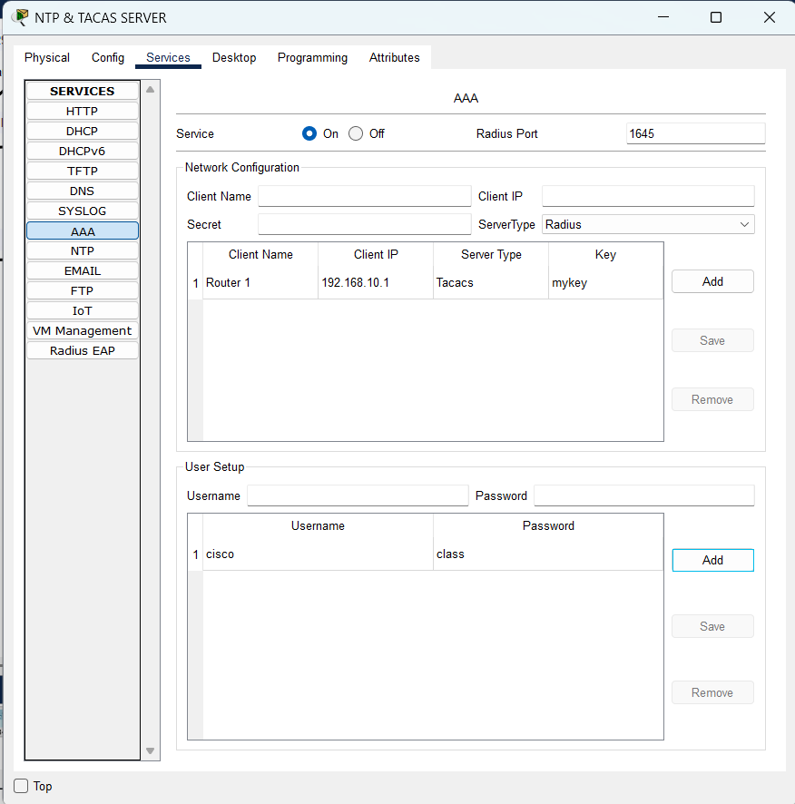

Router>

Router>

Router>

Router>

Router>en

Router#conf t

Enter configuration commands, one per line. End with CNTL/Z.

Router(config)#

Router(config)#

Router(config)#

Router(config)#aaa?

aaa

Router(config)#aaa ?

accounting Accounting configurations parameters.

authentication Authentication configurations parameters.

authorization Authorization configurations parameters.

new-model Enable NEW access control commands and functions.(Disables

OLD commands.)

Router(config)#aaa new

Router(config)#aaa new-model

Router(config)#aaa ?

accounting Accounting configurations parameters.

authentication Authentication configurations parameters.

authorization Authorization configurations parameters.

new-model Enable NEW access control commands and functions.(Disables

OLD commands.)

Router(config)#aaa authe

Router(config)#aaa authentication ?

enable Set authentication lists for enable.

login Set authentication lists for logins.

ppp Set authentication lists for ppp.

Router(config)#aaa authentication login ?

WORD Named authentication list.

default The default authentication list.

Router(config)#aaa authentication login myauth ?

enable Use enable password for authentication.

group Use Server-group.

local Use local username authentication.

local-case Use case-sensitive local username authentication.

none NO authentication.

Router(config)#aaa authentication login myauth group ?

radius Use list of all Radius hosts.

tacacs+ Use list of all Tacacs+ hosts.

Router(config)#aaa authentication login myauth group tac

Router(config)#aaa authentication login myauth group tacacs+ ?

enable Use enable password for authentication.

group Use Server-group.

local Use local username authentication.

local-case Use case-sensitive local username authentication.

none NO authentication.

<cr>

Router(config)#aaa authentication login myauth group tacacs+ local

Router(config)#taca

Router(config)#tacacs-server ?

host Specify a TACACS server

key Set TACACS+ encryption key.

Router(config)#tacacs-server host 192.168.5.10 ?

key per-server encryption key (overrides default)

single-connection Multiplex all packets over a single tcp connection to

server (for CiscoSecure)

<cr>

Router(config)#tacacs-server host 192.168.5.10 key mykey

Router(config)#en

Router(config)#ena

Router(config)#enable pas

Router(config)#enable password class

Router(config)#li

Router(config)#lin

Router(config)#line vt

Router(config)#line vty 0 4

Router(config-line)#lo

Router(config-line)#logi

Router(config-line)#login ?

authentication authenticate using aaa method list

local Local password checking

<cr>

Router(config-line)#login auth

Router(config-line)#login authentication ?

WORD authenticate using aaa method list

default authenticate using aaa default list

Router(config-line)#login authentication myauth

Router(config-line)#do wr

Building configuration...

[OK]

Router(config-line)#

Router(config-line)#

Router(config-line)#

Router(config-line)#exit

Router(config)#do sh aaa ?

LINE <cr>

Router(config)#do sh aaa sessions

Total sessions since last reload: 0

Router(config)#