Examination Rules and Examples

Certified Professional for Software Architecture

Foundation Level

International Software Architecture Qualification Board e.V.

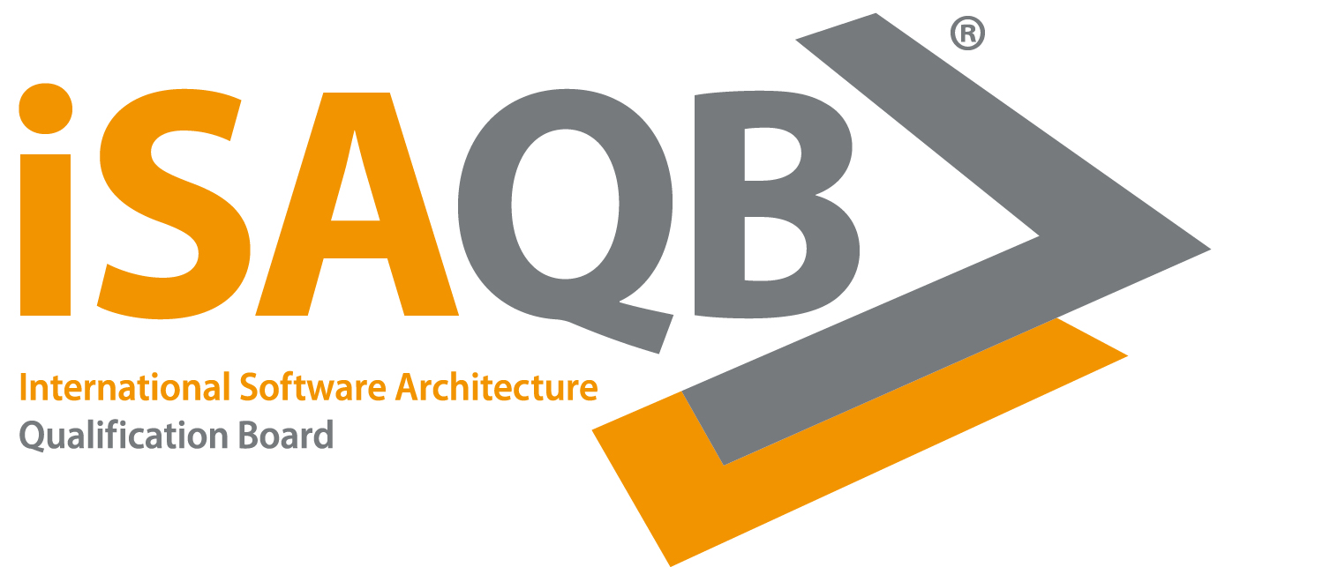

Version: 2020.2-EN
Date: 2021-11-29
Distribution: public
Status: released

© (Copyright), International Software Architecture Qualification Board e.V. (iSAQB® e.V.) 2021

We stress that, as a matter of principle, this examination rules are protected by copyright. The International Software Architecture Qualification Board e.V. (iSAQB® e.V.) has exclusive entitlement to these copyrights.

The abbreviation "e.V." is part of the iSAQB’s official name and stands for "eingetragener Verein" (registered association), which describes its status as a legal entity according to German law. For the purpose of simplicity, iSAQB e.V. shall hereafter be referred to as iSAQB without the use of said abbreviation.

Examination Rules:

The examination consists of about 40 multiple choice questions. There is a maximum of 75 minutes for native speakers and 90 minutes for non-native speakers to answer them (earlier submission possible).

Their value ranges from 1-2 points, depending on the level of difficulty; the total points possible for each question are shown in the question header. The general principle is: correct answers result in additional points, incorrect answers in subtracted points, but only related to the respective question. There are no negative points to other questions or the overall result. The assessment is detailed below under "Types of Questions".

To successfully pass the exam, the participant must achieve a minimum of 60% of the total score.

No aids, tools or resources (like training material, books, telephones etc.) are allowed during the exam. In case the participant uses notepads or additional sheets of paper besides the official exam paper, he/she must leave them in the room at the end of the examination.

The participant is not allowed to leave the room during the examination.

Notification of Examination Outcome and Re-examination:

The participants will be notified of the outcome of the examination by the certifying body in written form. The certificate will be shipped by the certifying body to the participants' home address.

The examination fee must be paid in full for the certificate to be sent.

The exam can be repeated several times without any waiting period.

Types of Questions:

- Single-Choice Questions (A – „Single Correct Answer“-Fragen):

Select one answer from a list of possible answers. Only one answer is correct, which must be ticked. Depending on the formulation of the question this can be the only right or the only wrong answer. There is only one correct choice per question.

The participant receives the corresponding points for selecting the correct answer. No selection, more than one selected answer or incorrect answers result in 0 points for that question. The point value of the answers range between 1-2, depending on the difficulty level.

Example of an A Question:
Which American president was assassinated in 1963? |  |  |  | 2 points
A Question: Choose one answer.
 |  | a) | Abraham Lincoln
 |  | b) | Harry S. Truman
 |  | c) | John F. Kennedy
The participant selected the correct answer. He/She receives 2 points.

 |  | a) | Abraham Lincoln
 |  | b) | Harry S. Truman
 |  | c) | John F. Kennedy
The participant did not choose any answer and therefore does not receive any points.

 |  | a) | Abraham Lincoln
 |  | b) | Harry S. Truman
 |  | c) | John F. Kennedy
The participant selected an incorrect answer. The score is 0 for this question.

 |  | a) | Abraham Lincoln
 |  | b) | Harry S. Truman
 |  | c) | John F. Kennedy
The participant receives 0 points. He/she marked too many answers for an s-type question.

- Pick Multiple Questions (P – „Pick-from-many“-Questions):

Select the requested number of correct answers from a list of possible answers. P questions are partly about estimations. As an experienced architect, however, you should be able to find the answers with the highest probability. Tick the maximum number of answers required in the introductory text, e. g., four, if it says: "Select the four most important topics, which ...". For each correct answer, you will receive 1/n of the total points, e. g., ¾ of the points in case of three correctly placed crosses.

For each incorrect cross, 1/n of the points is subtracted. If this results in a negative overall score for this question, it is scored with 0 points. The question is also evaluated with 0 points if you have ticked more than the required number. The score is 1-2 points depending on the difficulty level.

Example of a P Question:
Who are the two most important presidents? |  |  |  | 2 points
P Question: Choose from the four following answers the two that are most appropriate.
 |  | a) | George Washington
 |  | b) | Martin van Buren
 |  | c) | Abraham Lincoln
 |  | d) | Calvin Coolidge
The participant receives 2 points for answering the question correctly.

 |  | a) | George Washington
 |  | b) | Martin van Buren
 |  | c) | Abraham Lincoln
 |  | d) | Calvin Coolidge
The participant did not choose any answer and therefore does not receive any points.

 |  | a) | George Washington
 |  | b) | Martin van Buren
 |  | c) | Abraham Lincoln
 |  | d) | Calvin Coolidge
The participant receives 0 points since the chosen answer is incorrect.

 |  | a) | George Washington
 |  | b) | Martin van Buren
 |  | c) | Abraham Lincoln
 |  | d) | Calvin Coolidge
The participant does not receive any points, since one answer is correct and one answer is incorrect.

 |  | a) | George Washington
 |  | b) | Martin van Buren
 |  | c) | Abraham Lincoln
 |  | d) | Calvin Coolidge
The participant receives 0 points, since more than the required answers were chosen.

- Allocation Questions (K – „Choose Category“-Questions):

Allocate for each answer the correct choice from two alternatives, e. g., "right" or "wrong", “applicable” or ”not applicable”.

Points are awarded for each correct allocation, e. g., 1/3 of the points for each correct answer with three possible answers. An incorrect allocation results in a subtraction of the according points. If the total for a question results in a negative figure the question will be evaluated with 0 points. Depending on the difficulty level, the score is 1-2 points.

Example for a K Question:
Which American presidents were assassinated? |  |  |  | 1 point
K Question: Allocate all answers.
assassinated | not assassinated
 |  | a) | Abraham Lincoln
 |  | b) | George Washington
 |  | c) | John F. Kennedy
The participant receives 1 point for answering all 3 questions correctly.

 |  | a) | Abraham Lincoln
 |  | b) | George Washington
 |  | c) | John F. Kennedy
The participant did not choose any answer and therefore does not receive any points.

 |  | a) | Abraham Lincoln
 |  | b) | George Washington
 |  | c) | John F. Kennedy
The participant receives 1/3 points. He/She chose two answers correctly (2/3 points) and one incorrectly (1/3 points are
subtracted).

 |  | a) | Abraham Lincoln
 |  | b) | George Washington
 |  | c) | John F. Kennedy
The participant receives 0 points. He/She chose two answers incorrectly (2/3 points) and one correctly (1/3 point).

 |  | a) | Abraham Lincoln
 |  | b) | George Washington
 |  | c) | John F. Kennedy
The participant receives 2/3 points. He/She chose two answers correctly but did not choose any answer for the second
alternative.

Confidentiality Agreement

The present examination material provided to me must be treated as strictly confidential. I hereby assure iSAQB e. V. that I undertake to treat any information on the content of the material made available to me for the examination as confidential and to use it only in the actual context of the examination. I shall not pass on this information to any third parties not authorised by iSAQB e. V., nor shall I make it available to such third parties in any other shape or form, but take all appropriate steps in order to prevent such third parties from accessing the information. This non-disclosure undertaking shall remain in force for as long as this examination material is valid. This non-disclosure undertaking shall not apply if the information in question becomes public knowledge without any fault of my own or in any other unlawful manner.

I am aware that iSAQB e. V. may hold me liable for damages in the event of my non-compliance. iSAQB e. V. estimates any potential damages to amount to a minimum of EUR 10,000.

First name and last name
Street
Post code & city/town
E-mail (please print clearly – the certifier will inform you of your examination results via e-mail)

Place, date Signature
________________________ ______________________________________________

