**Our Services detail**

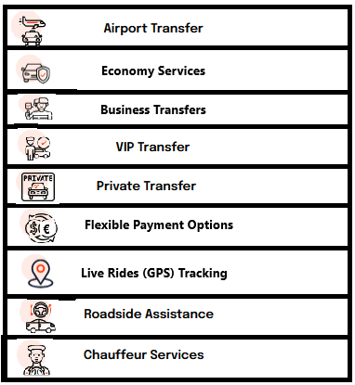

* Airport Transfer

**Quick & Seamless Airport Transfer**

Alpen Getaway have a proper Airport Transfer system, we have our own representatives in airports to welcome and receive our honorable customers on their arrivals.

As a traveler your priority after arrival on airport is that you have to reach your destination seamlessly, so keeping this understanding in mind, we have created a smart and quick transfer system, where we track the Flights of customers through their given flight number. As a result, we completely control their arrival so that our customers avoid delays in their picking at the airport by the drivers and vice versa upon departure.

We have a unique way of receiving our normal customers, Business customers & VIP Customers (Stars, Influencers, Vloggers, Players), with the proper cooperation with the airport’s authorities, we can arrange to pick the VIP´s from their private Jet/chartered Jets elevators.

* Economy services

**Quality transfers at affordable prices**

Alpen Getaway not only offer quality services to our valued customers but also deeply considers your holidays budget and offer market competitive prices, so that you do not stress about transfer budget.

With minimum budget and affordable holidays to our customers is our mission. We think everyone deserves the best holidays trips and they should not miss out or cancel their trips due to high transportations costs.

* Business Services

**Comfortable and reliable transfers to the Business Enterprises**

If you are looking for Business Class Services, then you are on the right Platform. We offer Business Class Vehicles with professional Chauffeurs. We offer light refreshment during your ride, so you can arrive with peace of mind to your destination. On time pick & drop from airports so you don’t miss out any of your important Business meetings .

* VIP´s Transfer

**Aplen Getaway values your standards**

Getting you to your destinations with protocol, Luxury and ultimate comfort is our utmost priority.

Enjoyable, refreshing and entertaining ride across the way until you reach your destination, with our high-tech, Luxurious vehicles, we offer priority pick & drop services.

* Private Transfer & Events Transportation

**Let us take you to your meetings and seminars at the time.**

Alpen Getaway not restricting its services to airport transportation but also offering its services for your special events, such as going to the Business meetings, wedding occasions, family tours & corporate tours.

Avail our services now and let our professional team handle the rest of your special events transportation. Your trust in us in this regard will give you feelings of achieving your event’s goal.

* Flexible Payment Options

**Pay the way you want**

Keeping our international clients in view, we are introducing multiple payment options through very secure ways. It includes payments online on our website booking section with different currencies.

Besides this we offer on-board payment options, that are through Credit/Debit cards and Cash. If you pay us by any means, at the end you will receive the invoice both in digital and physical form.

We believe in providing ease to our valued customers in every possible way.

* Ride monitoring

**Keep you safe and reach your destination seamlessly**

We track your journey so that you reach your destination safely and secure as smoothly as possible. We monitor live vehicles speed and alternative ways in case of busy roads.

If you are a company or organization and you are booking ride for your customers through our platform, then upon request & allowance, we can share the live tracking details of your customer´s journey

* Crisis Management system

**In-Travel assistance to save your time**

In case of unexpected incidents occurring during your journey then we have the backup plan with us to accommodate your ride.

Before every ride starts, we let our vehicles go through a ready2ride check protocol & after that systems allow that vehicle to go for a ride.

So, reaching your destinations safely & with comfort is our priority!

* Chauffeur Services

**Luxury with Professionalism**

Alpen Getaway believes in offering a professional chauffeur service to their valued customers.

We have created a smart & easy pick & drop system for our chauffeurs, so that customers do not wait at their arrival points. Our chauffeurs are well trained, well versed, well mannered & bilingual for smooth communication.