**Sub menues definations**

* Service Details. (we have created an alone file for this)
* Booking Management.

Alpen Getaway is the only company in the booking market that can let their customers edit their already booked ride online on our website without contacting our customer service. Upon completion of booking with us, a customer receives an auto generated booking/Reference number. After you edit the form (manage my booking), all the changes take place automatically and you don’t need to inform us.

In this section you can manage (edit or cancel) your booking through your received booking/reference number. Here you can edit the booking that you have already booked with us.

Customers can change the following options in (manage my booking) form.

* **Pick & Drop Locations:** you can change only the exact pick & Drop place but if you want to change your main pick & drop location then you have to click (on request) button, one of our team members will fulfill your request.
* **Date, time & Flight number:** you can change all three in booking form directly.
* **Vehicles Change:** here you can add/remove passengers up to your selected car capacity for free, you can change in extras (child seats, ski equipment, luggage) free of costs, but if you want to change the vehicle then you have to click (on request) button.
* **In route changes:** If you want to add multiple stops in your ride then you have to click (on request) button.
* **Payment Options:** you can change the payment option from on board payment to online payment option (pay now) button.
* Destinations



* Pricing

Info for Omar ( upon clicking Pricing) a simple page with a specific image with theme page!

**Where Luxury meet comfort & affordability**

Alpen Getaway have a transparent pricing system in the market. Our prices have been mentioned in our booking section of website, all our prices are inclusive taxes, tolls and refreshments. there is no hidden or extra charges. Such as delay upon arrival charges is totally free of cost with us. We don’t charge for extra travel equipment (Child seats, Ski equipment, luggage), these are totally free of cost on our platform.

Alpen Getaway offer affordable prices for their Luxurious services, by keeping in mind the requirements of a traveler.

Cancellation Policy: We have a free cancellation Policy for all rides.

If you want to cancel your ride 24 Hours before your ride began, then it is free of cost, but If you want to cancel your ride within 24 hours of your ride began then it will cost you 25% of your ride.

24 hours’ time span mean, that we manage, assign & change in this time span!

Cancellation of the booking you can find in manage my booking section of our website under (Manage my booking) button….

* Our Fleet

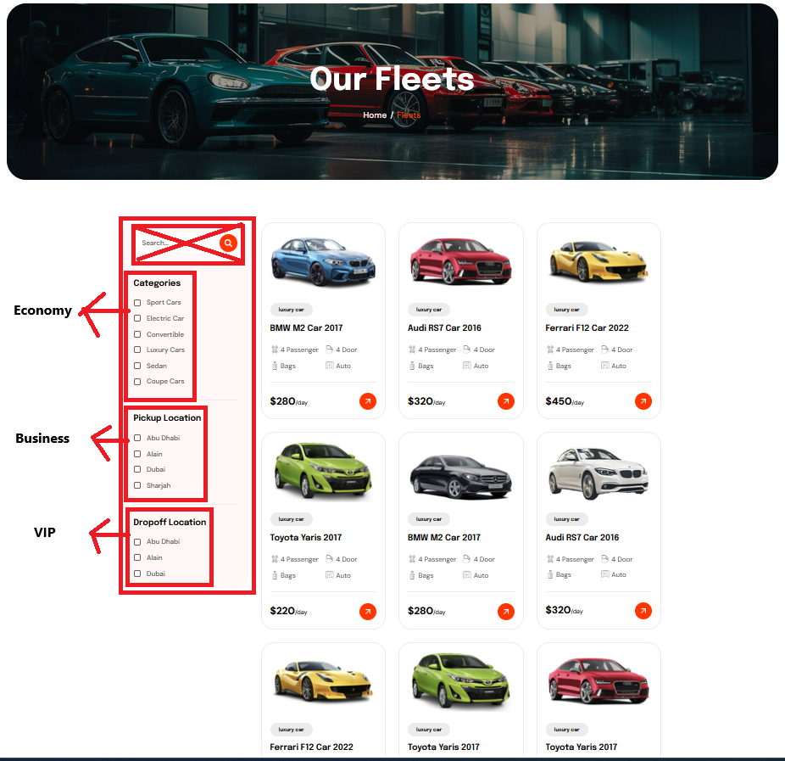

* Affiliate Booking

Info for Omar(a simple theme page with Pic and heading and the following text)

Here businesses & travel agencies from all over the world, that would like to book a ride for their customers on behalf of their company. They can get a special discount on their first booking. If they want further discounts on more rides, then they can contact us for further cooperation.

We will offer a special discount to all the Businesses and travel agencies, that want to book a transfer with us for the special events, fests, seminars and other occasions across Europe. if you are interested then **(click here)** (upon clicking here will take you to affiliate booking form)

* B2B Partnership

Info for Omar(a simple theme page with Pic and heading and the following text)

Every transport company that would like to use our platform, needs to register with us to gain access to our website CRM. This registration process needs some steps to be completed according to our agreement requirements eligibility criteria such as Cars, Drivers and Company History. If you are interested then **(click here)** (upon clicking here will take you to B2B registeration form)

* Customer Services

Info for Omar(a simple theme page with Pic and heading and the following text)

**Customer Support at a Call/Message Distance**

Alpen Getaway has a smart and quick responsive customer service system, we have a multilingual customer service team with skills.

We offer 24/7 Customer Support services. Customer can place a direct call, WhatsApp Message and Email, will get a response as soon as our customer support team receives it.

* Contact Us

