NexTime
Project & Timesheet System
User & System Guide
URL: https://vibeproject.online
Date: June 23, 2026 | Version 1.0

Table of Contents

1. System Overview
NexTime is a web-based Project & Timesheet System that enables teams to track projects, manage tasks using Agile methodologies, log working hours, and generate HR & Cost reports — all in one place.

1.1 System Access Information
System Name | NexTime — Project & Timesheet System
URL | https://vibeproject.online
Developer | Antigravity (ATGV)
Type | Web Application (compatible with all browsers)

1.2 Key Features
Module | Description | Primary Users
Dashboard | KPI overview and project status summary | All roles
Projects | Create and manage projects | Admin / PM
Project Plan | Gantt Chart and Milestone Timeline | Admin / PM
Tasks & Agile Planner | Backlog, Kanban Board, Timeline | All roles
Timesheet | Log daily working hours | All roles
Team & Approvals | Manage team members and approve timesheets | Admin / PM
HR & Cost Reports | Time usage and cost reports | Admin / PM
System Settings | Configure templates, permissions, and labor rates | Admin

Chapter 2: Dashboard

2. Dashboard
The Dashboard provides a real-time overview of project status and user tasks immediately after login.

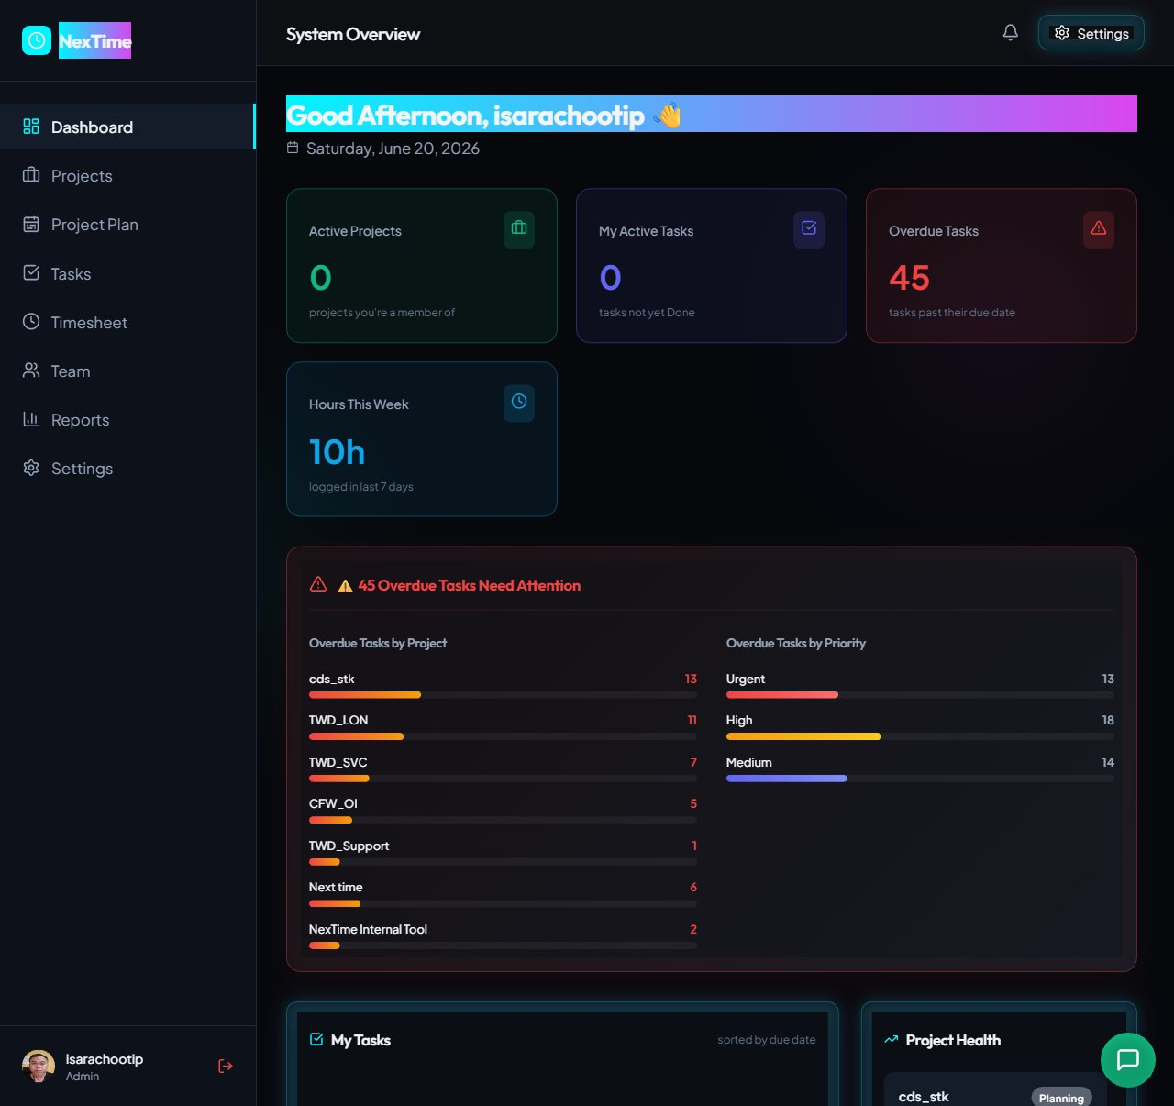
Figure 2.1 — Dashboard showing Summary Cards and Overdue Tasks

2.1 Summary Cards
Card | Description
Active Projects | Number of active projects the user is a member of
My Active Tasks | Number of incomplete tasks (not in Done status)
Overdue Tasks | Number of tasks past their due date — displayed in red
Hours This Week | Hours logged in Timesheet over the last 7 days

2.2 Overdue Tasks Section
Displays overdue task details grouped by Project and Priority (Urgent / High / Medium).

2.3 My Tasks & Project Health
User tasks sorted by Due Date, and Project Health cards showing Progress %, team members, and overdue dates.

Chapter 3: Projects

3. Projects
The Projects page displays all projects in a Card View layout.

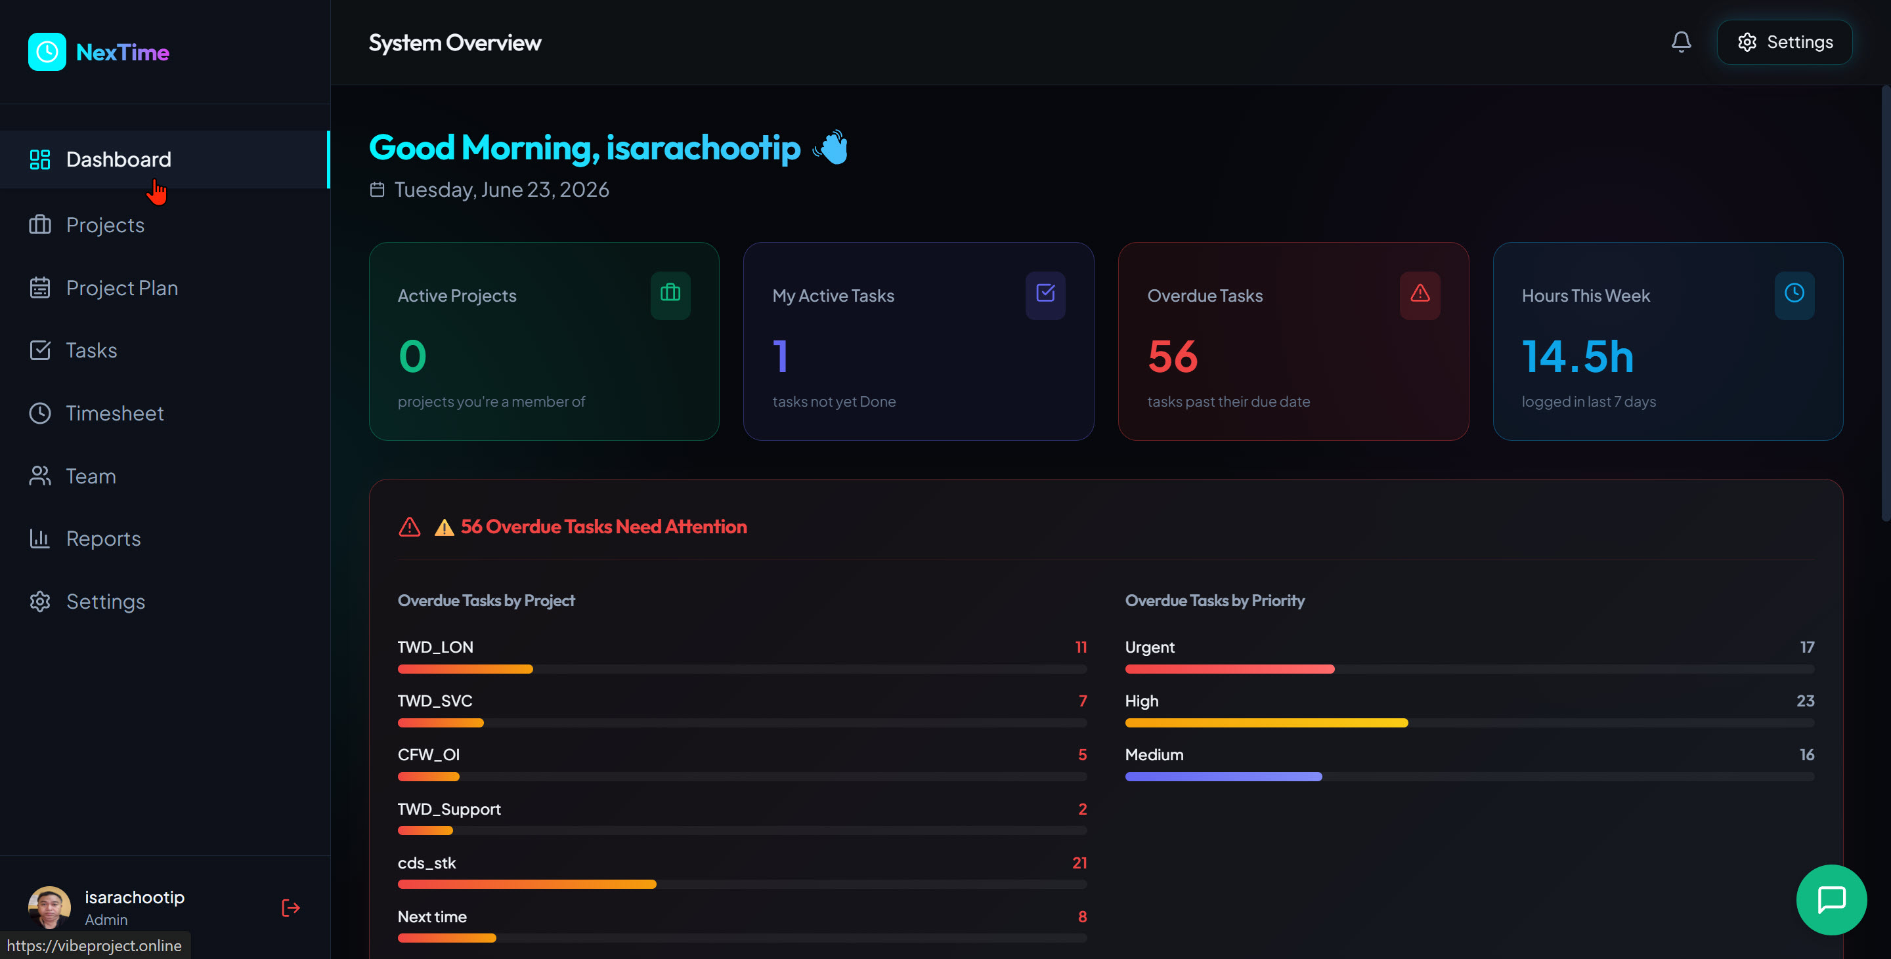
Figure 3.1 — Projects page showing all project cards

3.1 Project Card Information
Component | Details
Project Name | e.g. TWD_LON, NexTime Internal Tool
Status Badge | Active (green) or Planning (yellow)
Dates | Project start date – end date
Budget | Project budget, e.g. $250,000
Team | Number and avatars of team members
Plan | Link to the Auto-Generated Plan (Milestones)

3.2 Current Projects in System
Project | Status | Budget | Timeline
TWD_LON | Active | $250,000 | 10/06 – 29/05/2026
TWD_SVC | Planning | – | 01/01 – 01/08/2026
CFW_OI | Planning | – | 01/05/2025 – 31/08/2026
TWD_Support | Planning | – | 11/06 – 11/12/2026
cds_stk | Planning | – | 01/06 – 15/11/2026
E-Commerce Platform Redesign | Planning | – | 15/07/2026 – Ongoing
Next time | Planning | $5,000,000 | 05/06 – 10/07/2026
NexTime Internal Tool | Active | $50,000 | 01/06 – 30/08/2026

3.3 Creating a New Project
Click '+ New Project' in the top-right corner. The system will automatically generate an Auto-Generated Plan with 11 standard milestones.

Chapter 4: Project Plan & Timeline

4. Project Plan & Timeline
Used to track milestones and compare the Base Plan against the Current Live Plan via a Gantt Chart.

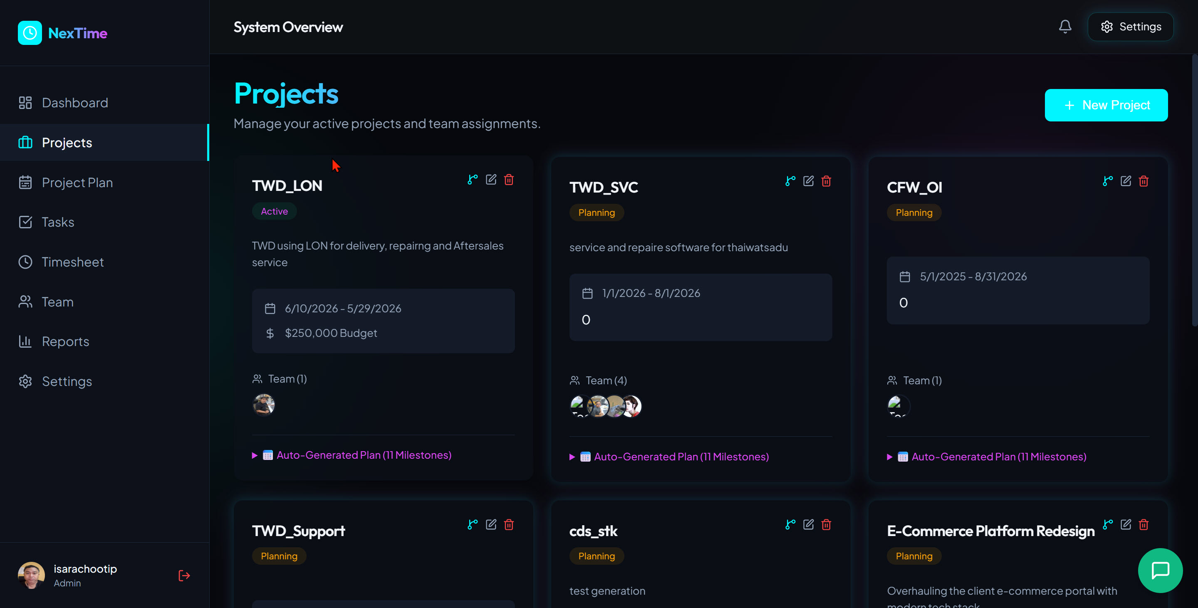
Figure 4.1 — Project Plan & Timeline showing Gantt Chart and Drift Metrics

4.1 Drift Metrics
Metric | Description
Schedule Slippage (Drift) | Number of days delayed from original plan — green = On Track
Estimate Drift | Hours added or reduced from original estimate
Story Points Drift | Story Points changed from original plan
Approved Actual Hours | Actual hours logged and approved from Timesheet

4.2 Standard 11-Step Milestones
# | Milestone | Phase (%) | Default Est.
1 | Kick off Meeting | 0–2% | 4h
2 | SOW & Contract Sign off | 2–6% | 8h
3 | Get Requirements & User Stories | 6–20% | 16h
4 | UX/UI Design & Prototyping | 20–35% | 24h
5 | Setup Cloud Infrastructure & Environments | 25–32% | 12h
6 | API Contract & Backend Architecture Setup | 32–40% | 16h
7 | Core Backend & Frontend Development | 40–75% | 40h
8 | Data Migration & Seeding | 70–75% | 16h
9 | SIT (System Integration Testing) | 75–85% | 16h
10 | UAT (User Acceptance Testing) | 85–95% | 24h
11 | Production Release & Handover | 95–100% | 8h

Chapter 5: Tasks & Agile Planner

5. Tasks & Agile Planner
The primary module for task management, supporting Sprints, Backlog, Kanban Board, and Timeline views.

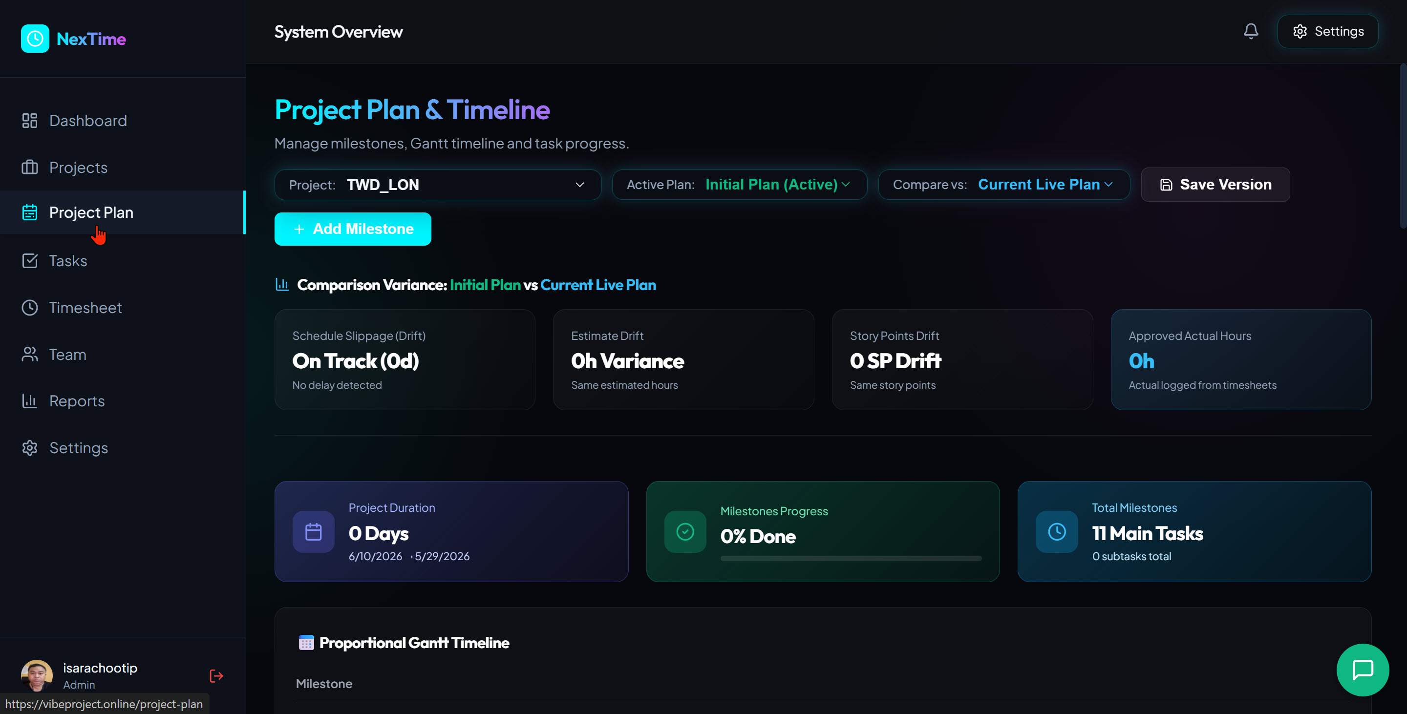
Figure 5.1 — Tasks & Agile Planner showing Summary and Team Workload

5.1 Tabs and Views
Tab | Details
Summary | KPI overview: TO DO / IN PROGRESS / REVIEW / DONE + Team Workload + Upcoming Tasks
Backlog | All tasks awaiting a Sprint — Sprints can be started from this tab
Board | Kanban Board with 4 columns; drag and drop tasks between columns
Timeline | Gantt-style view for visualizing tasks over time

5.2 Current Task Statistics (All Projects)
Status | Count
TO DO | 81
IN PROGRESS | 54
REVIEW | 13
DONE | 11
Total | 159 Tasks

5.3 Adding a New Task
Click '+ Add Task' → Fill in: Task name, Project, Priority (Urgent/High/Medium/Low), Assignee, Due Date, Story Points.

Chapter 6: Timesheet

6. Timesheet
Log daily working hours and track approval status from the PM.

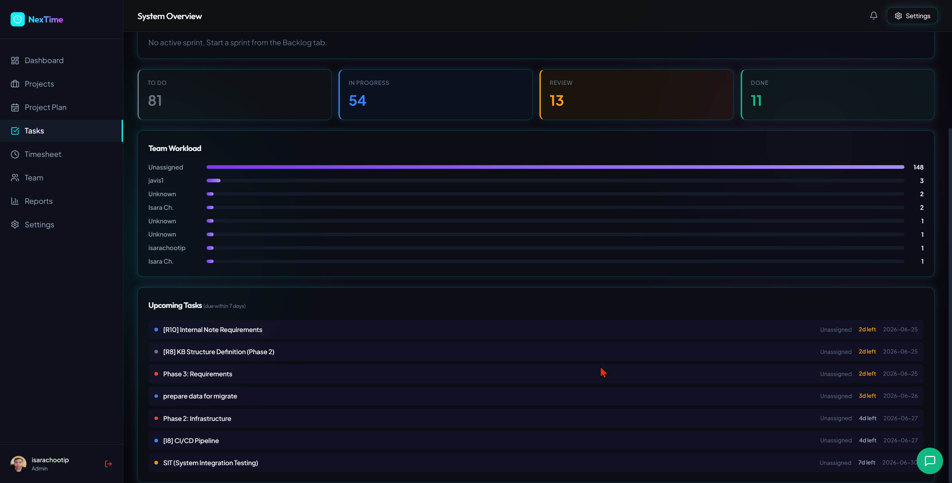
Figure 6.1 — Timesheet showing Calendar View, Monthly Summary and Approval Status

6.1 Logging Time
Select a date on the calendar → Click '+ Log Time' → Fill in: Date, Project, Hours, Description.

6.2 Monthly Summary
Field | Description
Total Logged | Total hours logged for the month
Target | Monthly hour target (default 160h)

6.3 Approval Status
Status | Description
Approved (green) | Hours that have been approved by PM/Admin
Pending (orange) | Awaiting PM approval

Chapter 7: Team & Approvals

7. Team & Approvals
Manage team member information and approve timesheets submitted by employees.

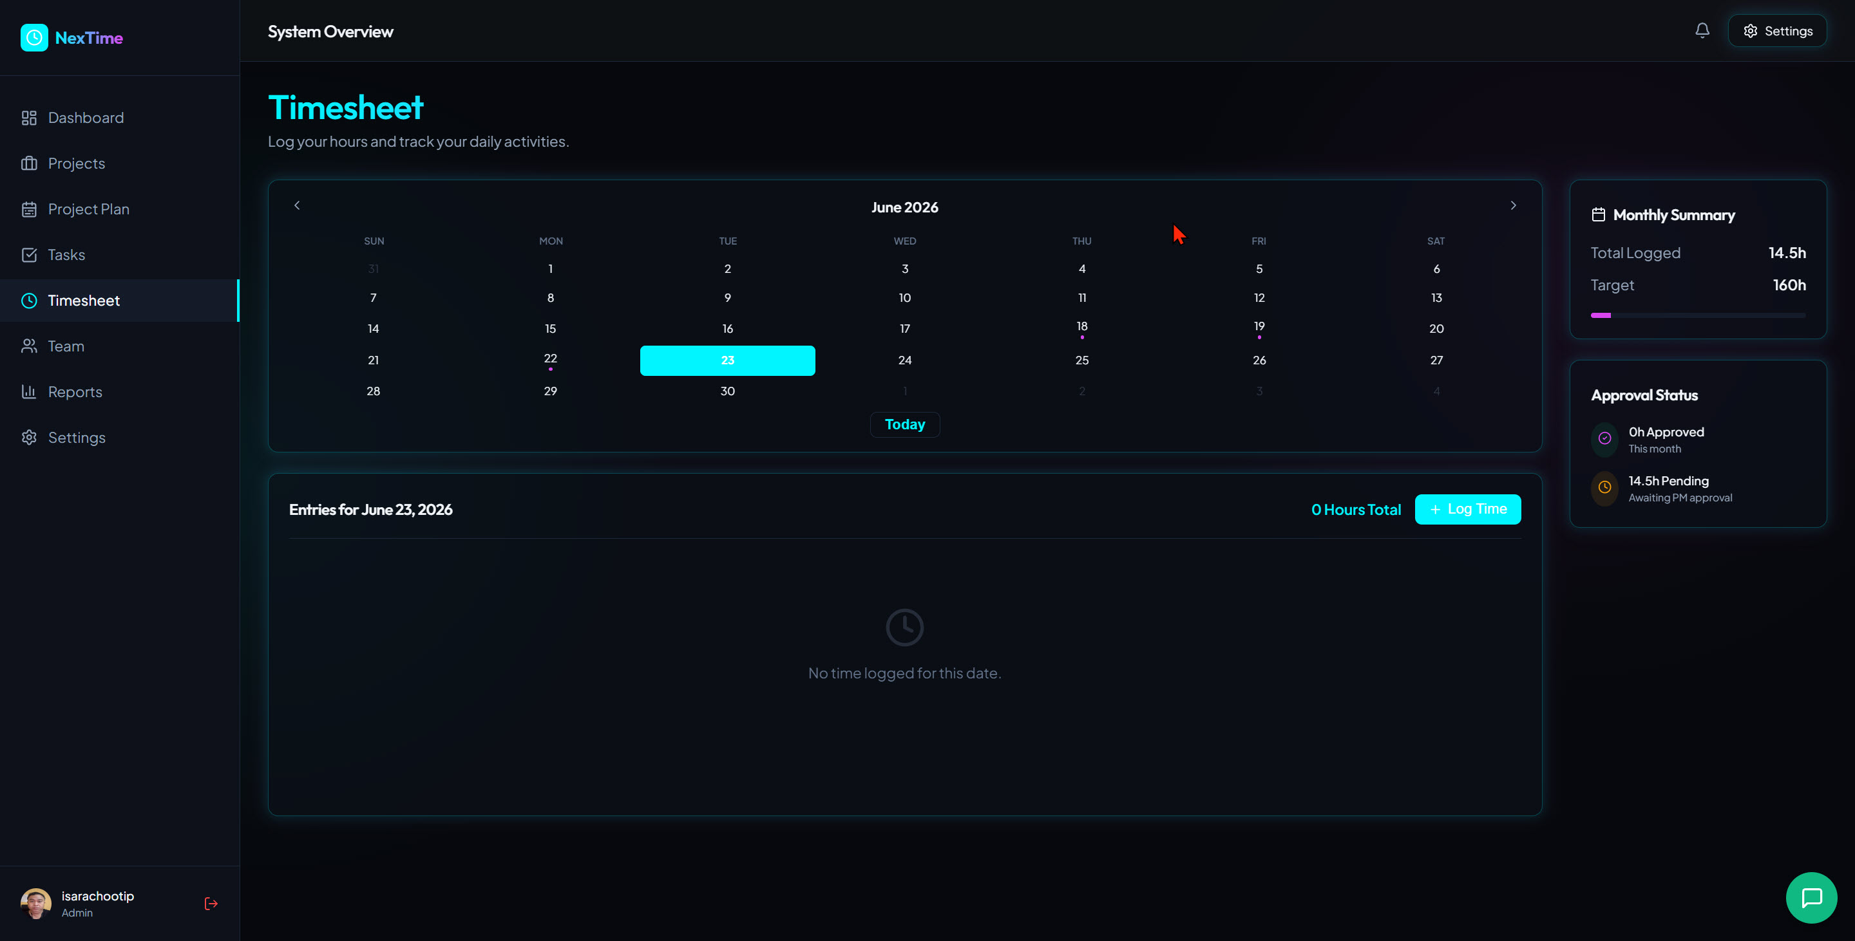
Figure 7.1 — Team & Approvals showing Team Directory and all members

7.1 Team Directory
Each card displays: Name, Role, Email, Skills, and assigned Project Roles.

7.2 Pending Approvals
PM/Admin can approve or reject timesheets from the 'Pending Approvals' tab (red badge shows the number of pending items).

7.3 Current Team Members (11 people)
Name | Role | Primary Project
isarachootip | Admin • Management | –
Polakrit | Employee • outsource | NexTime Internal Tool (PM)
Naruedom Mukkhan | Employee • Special Project | TWD_Support, cds_stk (Lead)
Kridsada Somwong | Employee • special project | cds_stk (Frontend dev)
Pailin Chompun | Employee • special project | TWD_SVC, TWD_Support
Jitpanu Thepsuya | Employee | TWD_LON, TWD_Support
Sakda Ruengthong | Employee • special project | TWD_SVC (PM), TWD_Support
Natchaphon Jumnakros | Employee • special project | TWD_SVC (Lead), TWD_Support
Isara Ch. | Employee • Engineering | NexTime Internal Tool, cds_stk

Chapter 8: HR & Cost Reports

8. HR & Cost Reports
Analyze team time utilization, project costs, and individual performance.

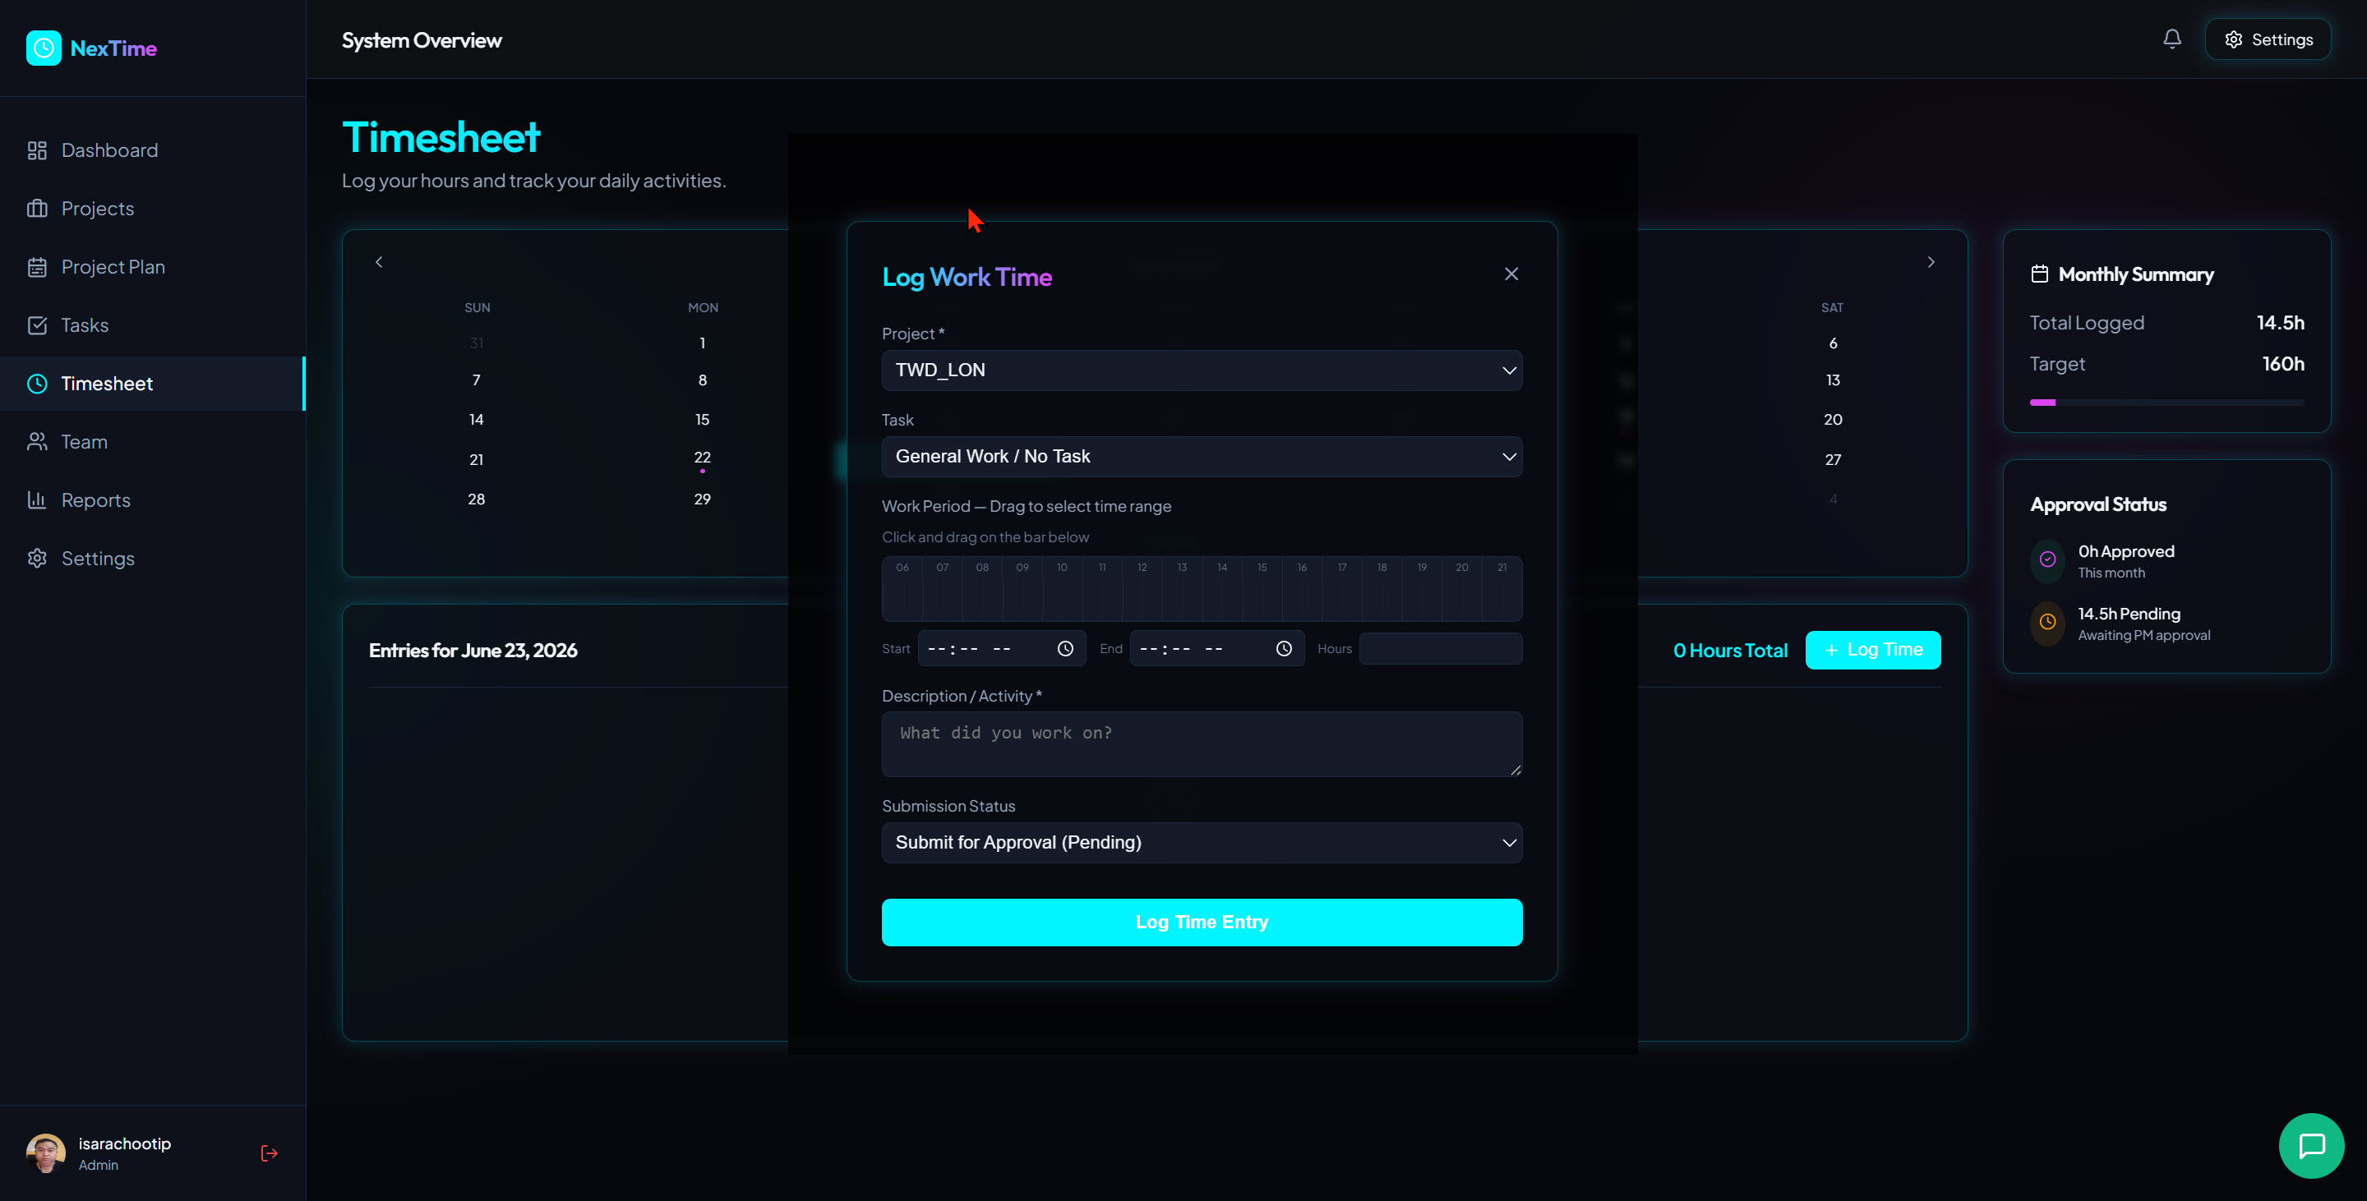
Figure 8.1 — HR & Cost Reports showing Overview: Time Allocation and Resource Hours

8.1 Key Metrics
Metric | Description
Total Logged Hours | Total hours logged in the selected period
Approved Hours | Approved hours / total hours
Approval Rate | Percentage of hours approved
Time Allocation by Project | Time distribution broken down by project
Resource Hours Summary | Total hours per individual team member

8.2 Report Tabs
Tab | Details
Overview | Summary: Time Allocation, Resource Hours, Timesheet Calendar
Personal Performance | Individual performance metrics per team member
Project Cost | Project cost calculated from Hours × Labor Rate

8.3 Export
Export as CSV (for Excel analysis) or PDF (formal report) using the button in the top-right corner.

8.4 Current Data (June 2026)
Data | Value
Total Logged | 70.5h (13 entries)
Approved | 14h (20%)
Top Project by Hours | NexTime Internal Tool — 45h (64%)

Chapter 9: System Settings

9. System Settings
Used by Admin to configure system-wide settings, including project plan generation, access permissions, and labor rates.

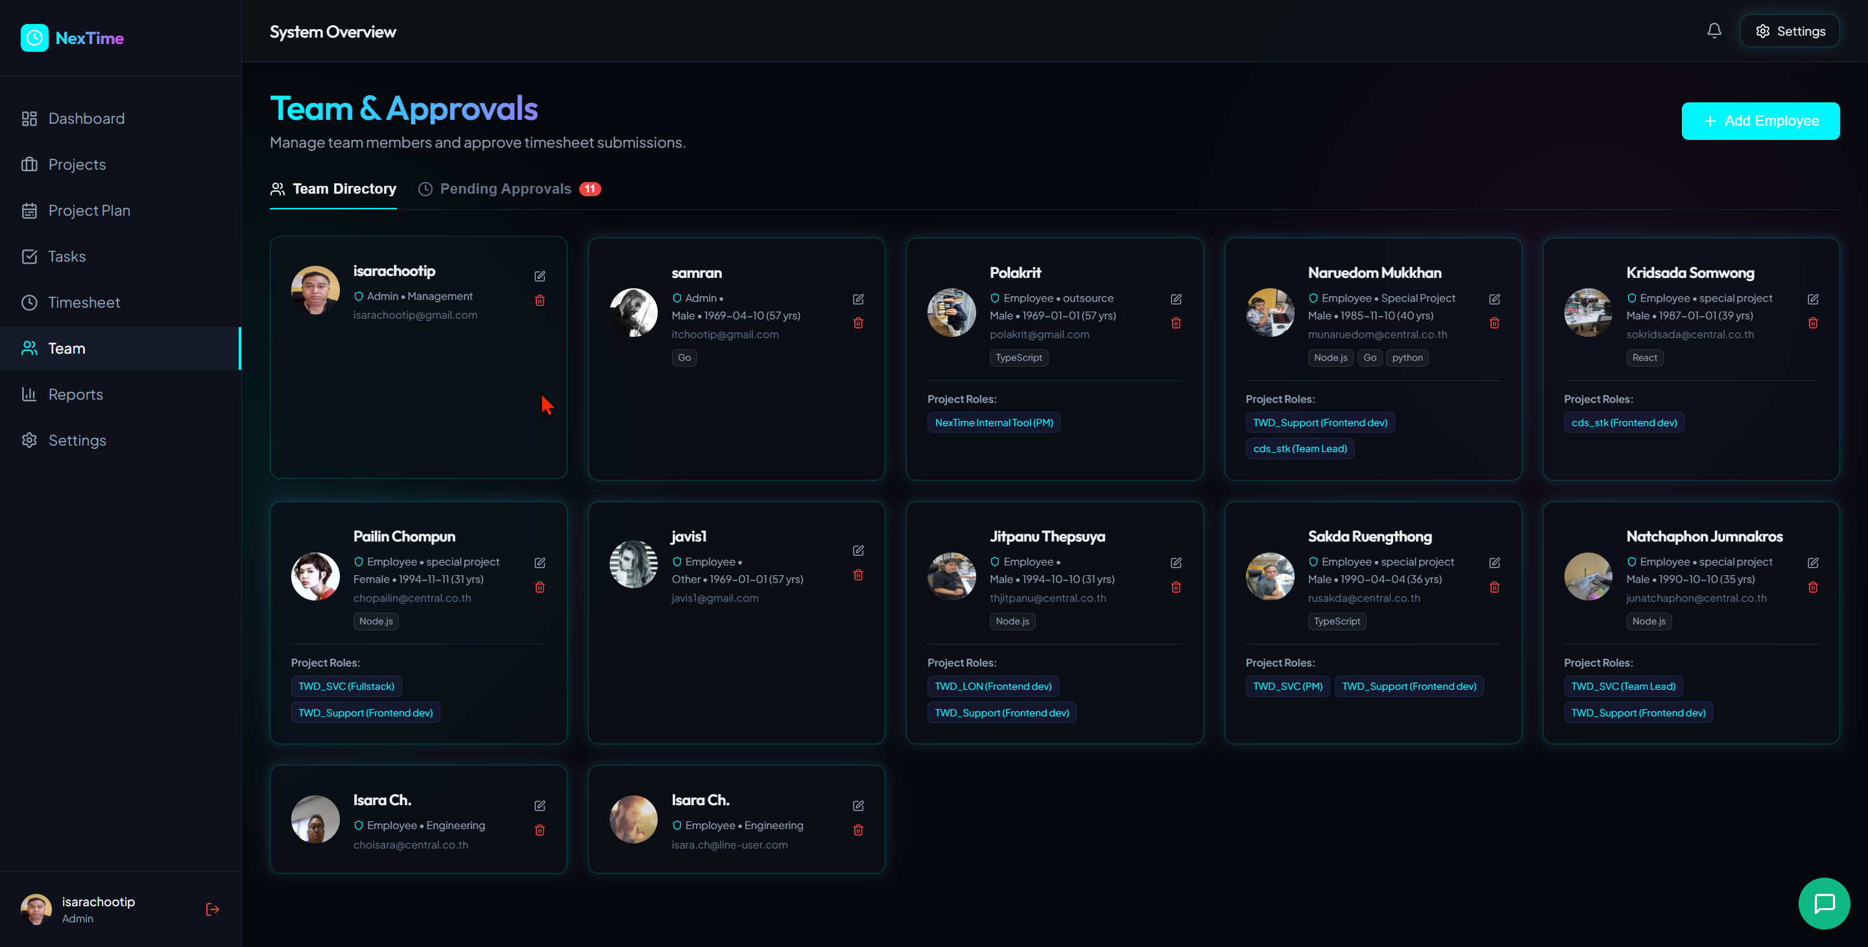
Figure 9.1 — System Settings showing Milestone Templates and Visual Timeline Preview

9.1 Milestone Templates
Define standard milestones that are auto-generated when a new project is created. Click '+ Add Milestone Template' to add new ones.

9.2 Git Webhook Integrations
Connect GitHub/GitLab repositories to projects for automatic commit and deployment tracking.

9.3 Permission Schemes
Define access rights for each module per role.

9.4 Labor Rates
Set hourly labor rates by employee type — used to calculate Project Cost in reports.

Chapter 10: FAQ & Appendix

10. Frequently Asked Questions (FAQ)
Question | Answer
Can I log timesheet entries for past dates? | Yes — select the date on the calendar and click Log Time.
Why is my Timesheet stuck in Pending? | It is awaiting approval from PM/Admin via the Team & Approvals page.
What should I do when a task shows as Overdue? | Update the task status to Done, or request a Due Date extension from the PM.
What is an Auto-Generated Plan? | A plan automatically created by the system from the Milestone Template defined in Settings.
What is a Sprint? | A development cycle of 1–4 weeks. Sprints can be started from the Backlog tab.
What export formats are available for reports? | CSV (Excel) and PDF — use the button in the top-right corner of the Reports page.

Appendix: Main Page URLs
Page | URL
Dashboard | https://vibeproject.online/
Projects | https://vibeproject.online/projects
Project Plan | https://vibeproject.online/project-plan
Tasks | https://vibeproject.online/tasks
Timesheet | https://vibeproject.online/timesheet
Team | https://vibeproject.online/team
Reports | https://vibeproject.online/reports
Settings | https://vibeproject.online/settings

— End of NexTime User & System Guide —
NexTime v1.0 | Antigravity (ATGV) | June 2026

