

ZODIAC Anonymization Guideline

Version 0.4 (Draft – Not Approved)
Prepared by: IAEA NMDI / ZODIAC Team
Classification: Internal Use
Table of Contents
ZODIAC Anonymization Guideline 1
1. Purpose and Scope 3
2. Privacy-by-Design and Data Minimization 3
3. Roles and Responsibilities 4
4. Workflow Overview 4
Step 1 — Anonymize DICOM and Clinical Data (client-side) 4
Step 2 — Upload Anonymized Studies 5
Step 3 — Review and Visualize Uploaded Data 8
5. Anonymizer & Upload Interface 9
6. Configuration and Profiles 11
7. Clinical Data (Excel) 14
8. Validation and Audit 15
9. Compliance Mapping 16
10. Retention and Deletion 17
11. Change Log 17

Purpose and Scope
This document describes the anonymization and upload process for medical imaging (DICOM) and associated clinical data in the ZODIAC Pillar-4 platform.
The system ensures that no identifiable patient data is transferred to or stored on the central platform. All anonymization is performed client-side in the uploader’s web browser before any data leaves the institute’s control.
This guideline is intended for:
- Participating institutes uploading data
- IAEA platform administrators
- Data privacy and security reviewers
It demonstrates compliance with IAEA information security requirements (AM.IV/3), DICOM PS3.15 Basic Application Level Confidentiality Profile principles, and GDPR Recital 26 (anonymized data is not personal data).

Privacy-by-Design and Data Minimization
The ZODIAC platform is designed according to privacy-by-design and data minimization principles:
- All anonymization of patient identifiers occurs exclusively at the participating institute, using a fully client-side tool running in the uploader’s web browser.
- No original, partially anonymized, or identifiable patient data is ever transmitted to or processed by IAEA systems.
- Any local identity mapping or traceability files remain under sole control of the institute and are never uploaded.
- Clinical data (.xlsx or .json) is anonymized using the same deterministic rules as DICOM metadata.
- To further reduce re-identification risk while preserving analytical validity, exact dates of birth are removed, age values are generalized into 5-year ranges, and all other date fields are shifted by a small random offset applied consistently per patient.
As a result, the IAEA platform receives, stores, and processes only anonymized datasets. In accordance with GDPR Recital 26, such data is no longer considered personal data when re-identification is not reasonably possible by IAEA or any platform user, as the required mapping information is never transmitted and remains exclusively under the institute’s control.

Roles and Responsibilities
Role | Responsibility
Participating Institute | Acts as controller for data collection and anonymization at institute level; collects data under national law; performs client-side anonymization; reviews results and resolves conflicts; uploads only anonymized data; retains any local mapping files.
IAEA (ZODIAC Team) | Acts as controller for processing of anonymized data at platform level; receives, stores, and analyses only anonymized datasets; configures anonymization profiles and archives; monitors upload logs.
UNICC (Infrastructure) | Provides secure hosting, encryption, access controls, audit logging, and DevSecOps governance.

While patient data processed by the platform is fully anonymized prior to upload and is therefore not considered personal data under GDPR Recital 26, the platform also processes limited personal data related to user accounts (username and email address) for authentication and access control purposes.
This personal data is limited to basic identification information and does not include special categories of personal data.
Based on this scope and the implemented technical and organizational safeguards, the overall privacy risk is assessed as low.

Workflow Overview
The anonymization and upload steps are:

Step 1 — Anonymize DICOM and Clinical Data (client-side)
- User selects Anonymization Profile
- User selects Source DICOM Folder (full PACS export)
- User optionally selects Clinical Data File (.xlsx or .json)
- User selects Destination Folder (local folder on their computer)
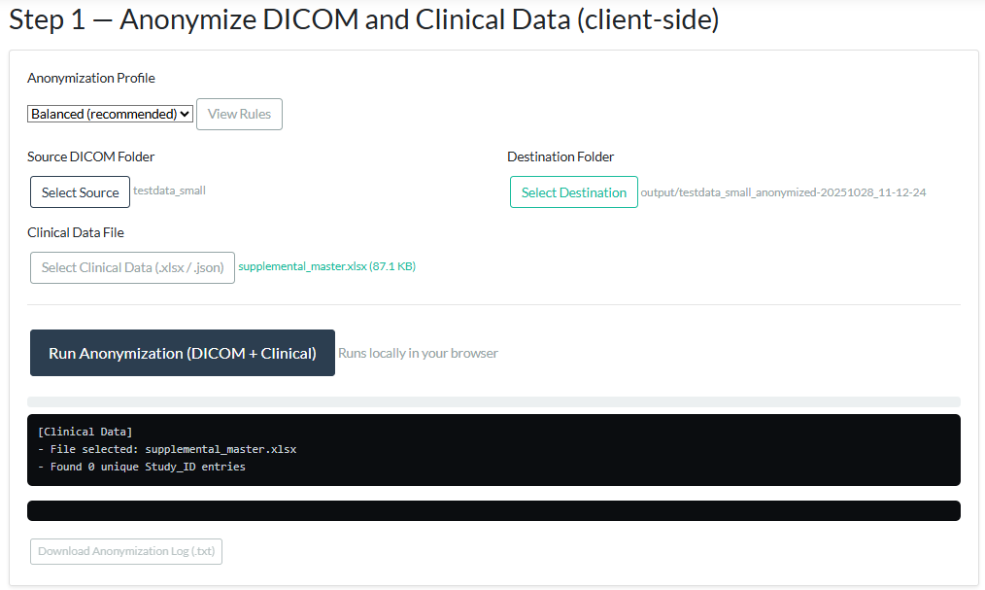
- Click "Run Anonymization (DICOM + Clinical)" → fully client-side
- Progress bar + logs shown
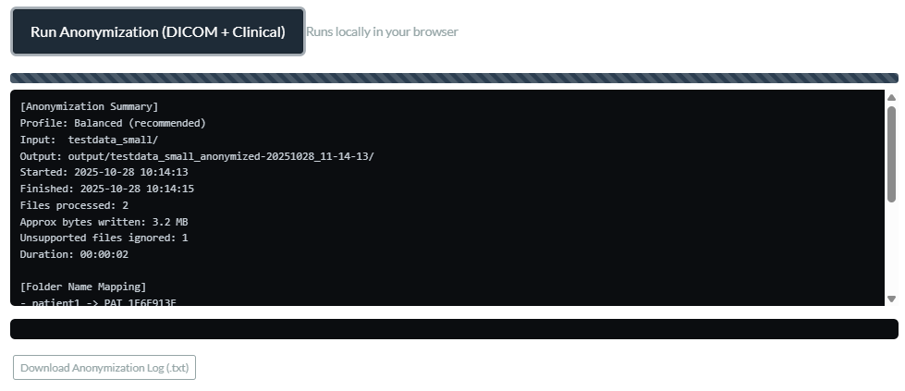
- Result: a new local folder is created/populated with fully anonymized DICOM files and (if provided) an anonymized clinical file

Step 2 — Upload Anonymized Studies
- User selects Target Archive on the platform
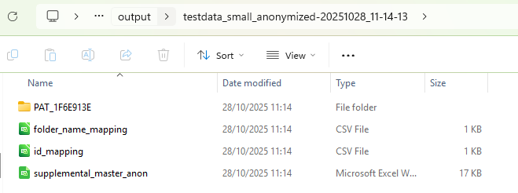
- User points to the Anonymized Root folder (by default, the destination folder from Step 1 is auto-selected).
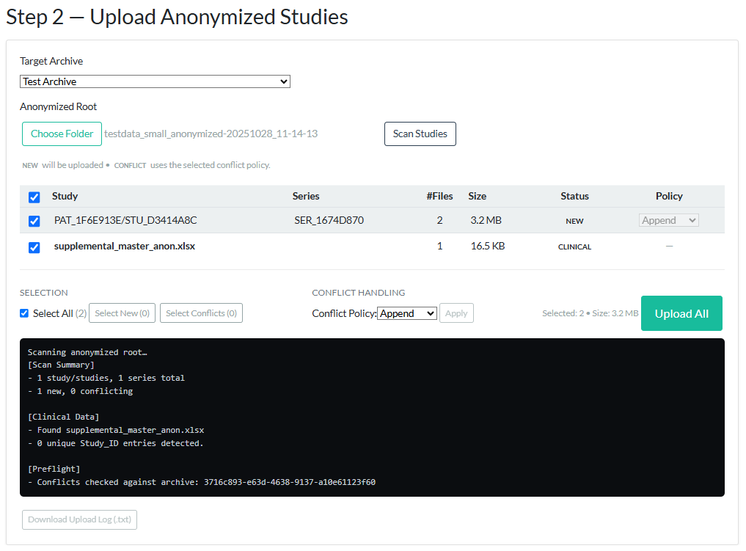
- Click "Scan Studies" — the tool analyses the local anonymized folder structure.
- A table appears showing each detected study and series with:
  - Status (NEW or CONFLICT)
  - Number of files and total size
  - Selection checkbox
  - Conflict policy option (Append / Overwrite / Skip)

- User reviews, resolves any conflicts, and selects items for upload.
- Click "Upload All" — only the selected anonymized series and clinical file (if applicable) are transmitted.
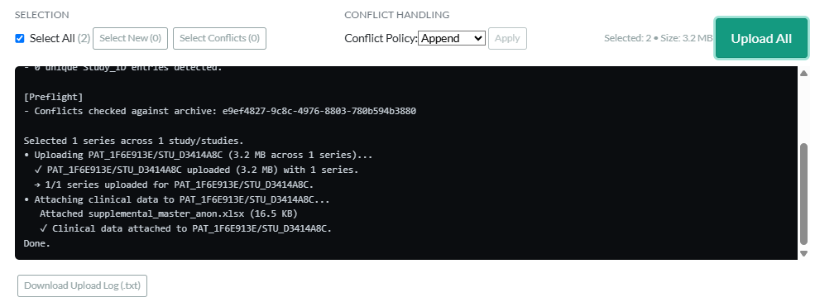
- Upload progress and results are logged; the log is downloadable.

Step 3 — Review and Visualize Uploaded Data
- After successful upload (data encrypted in AWS S3 bucket), the user navigates to the selected Archive in the platform.
- Uploaded items appear in the Archive Items list.
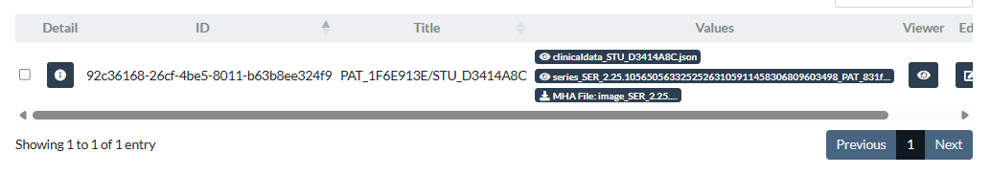
- Clicking the eye icon (preview) on any item opens the integrated CuraMate DICOM Viewer.
- Inside the viewer, users can:
  - Browse series and individual slices
  - Adjust window/level, zoom, pan
  - Use measurement tools
  - View anonymized DICOM header metadata (for verification)
  - Access linked clinical data (if uploaded)
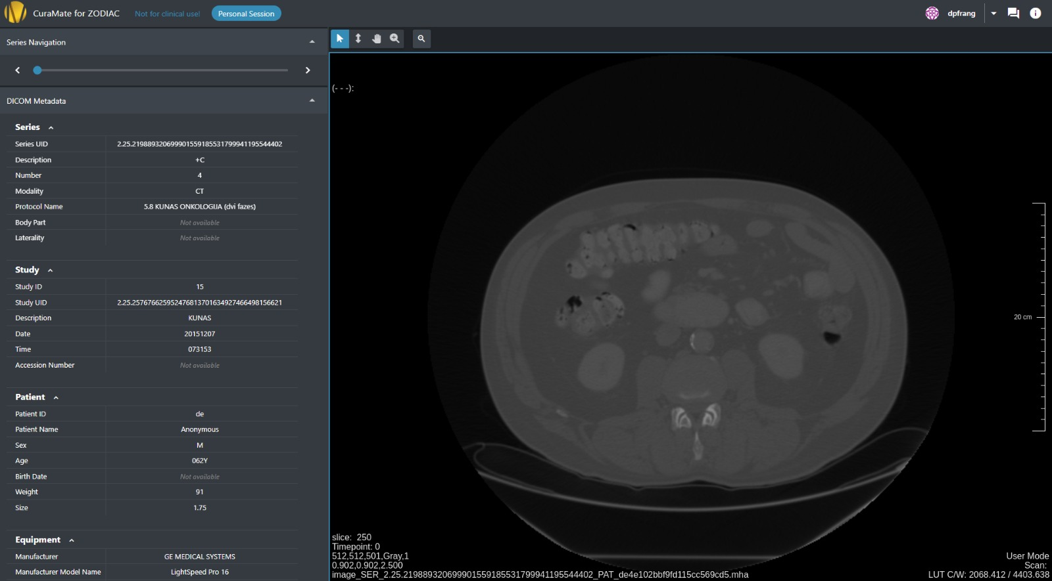
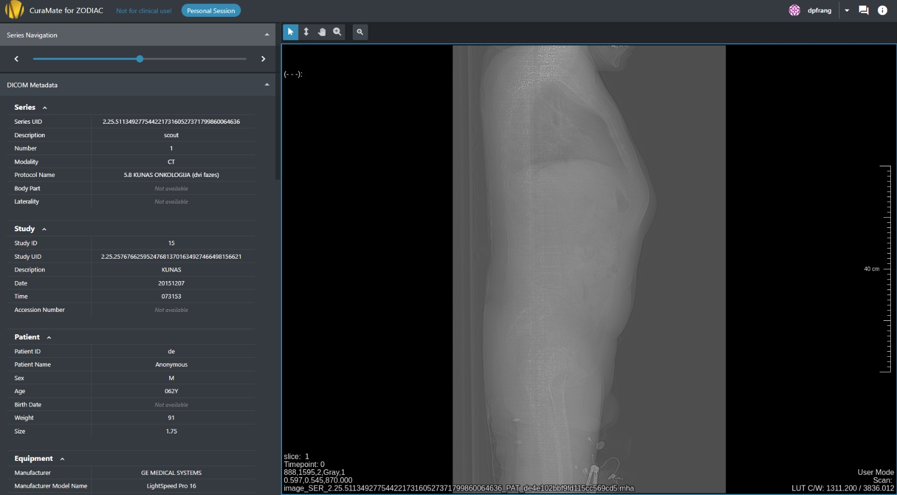
This step allows institutes and authorized reviewers to verify data quality, completeness, and correct anonymization before further analysis or AI processing.
Critical Privacy Guarantee: Identifiable patient data never leaves the institute until it is fully anonymized and explicitly selected for upload. All subsequent viewing occurs on anonymized data only.

Anonymizer & Upload Interface
The anonymizer runs entirely in the web browser using JavaScript libraries (dcmjs, JSZip, SheetJS) to anonymize DICOM files inside the browser. The user selects a folder, and the tool reads the files and removes or replaces patient information. Anonymized files are saved to a new folder with '_anonymized' added to the name. No data is sent to the server during the anonymization phase, and no patient information leaves the user’s computer until explicitly uploaded in Step 2. The browser-based anonymizer does not persist temporary files, caches, or intermediate datasets beyond the user-selected destination folder.
The interface is divided into two distinct panels that correspond to the two phases of the workflow.
Step 1 Panel – Local Anonymization
- Anonymization profile selector (Light-touch, Balanced (recommended), Max-safe) with a link to view the current rules in JSON format. The selected profile decides how many fields are removed or hashed in both the DICOM headers and the related clinical data.
- Source DICOM folder picker (full PACS export).
- Optional clinical data file picker (.xlsx or .json).
- Destination folder selector (local folder on the user’s computer).
- “Run Anonymization (DICOM + Clinical)” button.
- Live progress bar and detailed status logs.
- Downloadable anonymization log (.txt).
When the user clicks “Run Anonymization”, the tool reads the selected DICOM files and clinical data, applies the chosen profile’s rules (removing or hashing identifiers in DICOM headers and matching Excel columns/JSON fields), and writes the fully anonymized files to the chosen destination folder.
Step 2 Panel – Upload of Anonymized Studies
- Target archive dropdown.
- Anonymized root folder selector (points to the destination folder created in Step 1).
- “Scan Studies” button.
- Interactive table showing detected studies and series with:
  - Status (NEW or CONFLICT)
  - Number of files and total size
  - Selection checkbox
  - Conflict policy (Append / Overwrite / Skip)
- Bulk tools for selection and conflict policy application.
- “Upload All” button.
- Upload progress log (downloadable).
Only after the user explicitly selects items and clicks “Upload All” in Step 2 is any data transmitted to the platform.
This clear separation ensures complete user control and eliminates any risk of identifiable data being sent inadvertently.

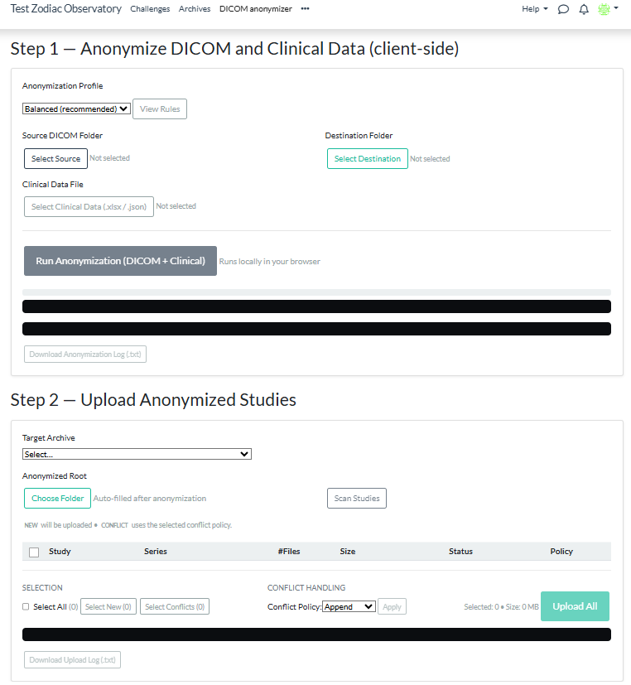

Configuration and Profiles
Anonymization rules are defined in three JSON-based profiles: Light-touch, Balanced (recommended), and Max-safe. These profiles are loaded dynamically from the platform and apply consistent one-way cryptographic hashing (SHA-256-based) to generate non-reversible pseudonymous identifiers, with no capability for reverse lookup or re-identification on the platform.
Profile | Label | Description
light.json | Light-touch | Keeps most non-identifying fields; applies hashing and rounding only to key personal fields. Suitable for trusted data sources. Minimal intervention: hashes key identifiers and UIDs, removes birth date, retains institution/centre information where appropriate. Suitable for lower-risk scenarios.
default.json | Balanced (recommended) | Recommended default: sets patient name and referring physician to “Anonymous”, hashes patient/study/accession IDs, generates stable pseudonymized UIDs, removes birth date, and retains clinically valuable fields.
strict.json | Max-safe | Removes or clears almost all optional fields that could contain identifiers. Used when maximum anonymization is required. Most aggressive: clears additional potential identifiers (e.g., institution name, device details, operator name) in addition to the Balanced profile actions. Use when maximum privacy protection is required.

The following table summarizes the “must have” anonymization and pseudonymization rules applied by the platform across DICOM metadata, derived series JSON, and clinical data for all profiles listed above.
Field / Attribute | Handling | Notes
Patient Name | Set to “Anonymous” | Removed at source
Referring / Performing / Physician Names | Set to “Anonymous” | Covers all physician name tags
Patient ID | Hash | Stable pseudonym
Study ID / Accession No. | Hash | Stable pseudonym
DICOM UIDs (Study, Series, SOP) | Hash UID | Preserves DICOM consistency
Gender | Keep | No anonymization: Required for analysis
Age | Rounded | 5-year range. e.g. 32→30, 33→35
Date of Birth | Null | Avoids direct re-identification
Diagnosis | Keep | No anonymization: Clinically essential
Any date field (study, admission, ICU, etc.) | Shift ±3 days | Random offset per patient: Same offset applied to all dates for that patient

Certain clinically essential variables (such as gender and diagnosis) are intentionally retained without anonymization to preserve scientific and analytical value. Any potential re-identification risk arising from rare diagnoses is mitigated through strong pseudonymization of identifiers, removal of direct and quasi-identifiers such as dates of birth, age generalization, and consistent per-patient temporal date shifting.
All profiles are based on the principles of DICOM PS3.15 Annex E (Basic Application Level Confidentiality Profile) with configurable retention or cleaning of attributes.
The selected profile is displayed in the interface with a direct link to view the full JSON rules. The following example illustrates a simplified view of the anonymization configuration used by the platform.
Example from default.json (Balanced profile)
{
"slug": "default",
"label": "Balanced (recommended)",
"dicom_rules": [
{ "op": "set", "tag": "00100010", "value": "Anonymous" },
{ "op": "hash", "tag": "00100020" },
{ "op": "hash", "tag": "00080050" },
{ "op": "hash", "tag": "00200010" },
{ "op": "hash_uid", "tag": "0020000D" },
{ "op": "hash_uid", "tag": "0020000E" },
...
],
"clinical_rules": {
"columns": [
{ "name": "Patient_ID", "op": "hash" },
{ "name": "Study_ID", "op": "hash" },
{ "name": "Sex", "op": "keep" },
{ "name": "Age", "op": "keep" },
{ "name": "Diagnosis", "op": "keep" },
...
]
}
}

DICOM section → defines which tags are changed, removed, or hashed.
Clinical section → applies the same logic to Excel columns.
The system automatically loads the selected profile before anonymization.
Each institute can use the Balanced profile unless stricter rules are required.
During anonymization, the tool also generates internal mapping and summary files in the output folder. These include id_mapping.csv and folder_name_mapping.csv, which record how identifiers and folder names were transformed during the anonymization process.
They are used only for internal traceability by the institute (for example, if reverse lookup is required by ethics approval) and are not uploaded to the ZODIAC platform.
These files act as lightweight anonymization logs, showing how each dataset was processed.

Clinical Data (Excel)
The anonymization profiles use the same logic for Excel columns as for DICOM tags.
Patient identifiers are hashed using stable pseudonymization. Dates of birth are removed entirely, age values are generalized into 5-year ranges, and all other date fields are shifted by a controlled random offset applied consistently per patient. Clinical variables such as gender and diagnosis are retained to preserve analytical value.
A supplemental Excel template (supplemental_template_sample.xlsx) is provided to standardize data submission.
Institutes should fill this template using anonymized values only.
Each column name in the template corresponds to a predefined anonymization rule in the selected profile (e.g., Patient_ID → hash, Study_Date → date_round_jan1).
AnonID | Age | Gender | Diagnosis
ANON-001 | 56 | M | Pneumonia

Clinical data is limited to structured fields defined in the provided template, and free-text clinical notes are not supported.
A residual risk remains that users could theoretically enter identifiable information into structured fields. This risk is mitigated through:
- Restriction of editable fields to predefined clinical variables
- Role-based access control for metadata editing
- Validation rules aligned with the anonymization profiles
- Clear guidance to participating institutes on appropriate data entry
These measures reduce the likelihood of accidental inclusion of personal data while preserving analytical utility.
Editing of anonymized metadata after upload is restricted to authenticated users assigned to uploader or editor roles within their own clinical center archive. Metadata fields are structured (JSON-based); free-text clinical notes are not supported.

Validation and Audit
Automated validation checks are applied before and during upload to ensure that mandatory anonymization rules have been correctly applied. These checks verify, for example, that Patient Name fields are set to “Anonymous”, that pseudonymized Patient and Study identifiers are present and correctly formatted, and that no direct personal identifiers remain in DICOM headers. If any validation check fails, the upload is blocked, and the user is informed via the interface logs. The user must correct the anonymization locally and rerun the process before upload can proceed.
Upon successful upload, the platform performs a final server-side validation of DICOM metadata and associated clinical files. Any dataset found to contain personal data or invalid structure is rejected. Audit logs are maintained within UNICC-managed infrastructure (AWS CloudTrail) and reviewed as part of information security controls by InfoSec. In addition, infrastructure-level threat detection is provided through AWS-native monitoring services. Enablement of Amazon GuardDuty for enhanced runtime threat detection is pending final approval.
Additionally, the browser interface provides downloadable Info Panels after anonymization and upload.
The Anonymization Info Panel summarizes processed files, selected profile, and detected issues.
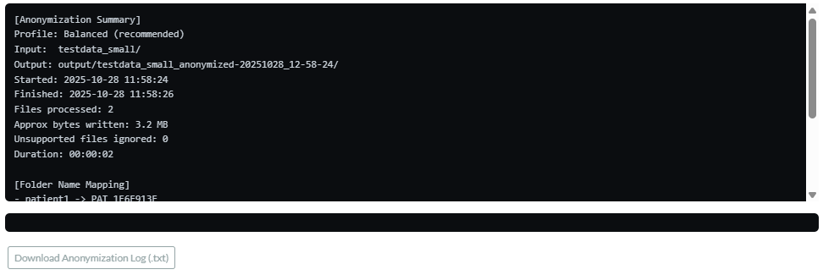
The Upload Info Panel confirms successful upload and validation.
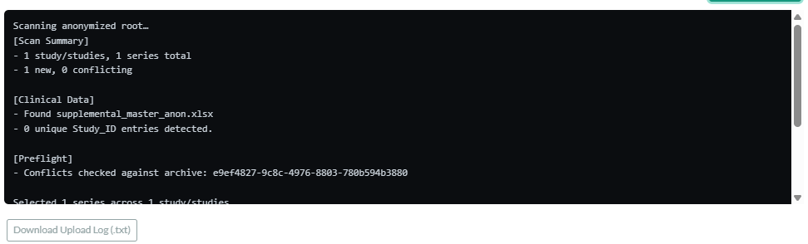
Both can be saved locally as evidence for audit or internal record keeping.

Compliance Mapping
Standard | How it is followed
IAEA ISMS AM.IV/3 | Data anonymized before upload, encrypted storage and audit logs.
GDPR Article 32 | Data protected by design and by encryption.
DICOM PS3.15 Annex E | Used as reference for confidentiality tags.
UNICC Security Policy | System under DevSecOps control with CloudWatch and audit.

Retention and Deletion
Data is retained in accordance with the approved project duration (currently 3 years), unless extended by formal project decision.
S3 storage changes class automatically: 0–30 days Standard, 31–180 days Infrequent Access, after that Glacier. After 3 years, data is deleted unless the project is extended.

Change Log
Version | Date | Description | Author / Reviewed by
0.1 | 22.10.2025 | Initial draft. Added anonymization workflow, clinical data handling, and compliance mapping. | Ibrahim Saracoglu / ZODIAC Team
0.2 | 18.12.2025 | Updated to reflect current two-phase local anonymization workflow, corrected technical implementation details (pure JavaScript, user-defined destination folder), added Step 3 (viewer), improved interface description. | Ibrahim Saracoglu / ZODIAC Team
0.3 | 20.01.2026 | Updated anonymization strategy: age generalization, removal of date of birth, controlled date shifting, clarified handling of gender and diagnosis, and added consolidated anonymization rules table. | Ibrahim Saracoglu / ZODIAC Team
0.4 | 13.02.2026 | Security Risk Assessment comments are applied. | Ibrahim Saracoglu / ZODIAC Team

