Proposed project: Enterprise Invoice IDP Automation
For this demo IDP use case, I've designed a reference implementation using Amazon S3, Textract, Bedrock Data Automation, Lambda, and Step Functions.
I have leveraged, Google, Chat gpt, and AWS Documentations for research and develop the project.
I'll walk through the end-to-end processing architecture, explain the service selection, show sample Python/boto3 functions and BDA blueprint configurations, and discuss how I would provision, secure, monitor, and troubleshoot the solution in production.
Technology stack used:
Amazon S3,
Textract,
Bedrock Data Automation,
Lambda, Step Functions,
EventBridge,
SQS,
SNS,
DynamoDB,
IAM,
CloudWatch
Terraform.

Project: aws-idp-demo-lab

Important architecture decision
Demonstrate both Extraction paths:
- Primary path — Amazon BDA: Extract invoice fields using a custom BDA blueprint and produce structured JSON.
- Alternative path — Textract: Use AnalyzeExpense or asynchronous StartExpenseAnalysis to extract invoice fields, tables, and confidence information.
Order of build the demonstration:
- Architecture diagram and component-by-component explanation — including why each service is needed and alternatives.
- Sample invoice, BDA blueprint, and output JSON — the core IDP functionality.
- Python Lambda scripts and Step Functions workflow — enough code to demonstrate implementation.
- Terraform and production troubleshooting — leveraging your existing strengths.
Initially we verify the Python code locally, inspect the Terraform configuration, and discuss how it would be deployed.
Architecture Diagram
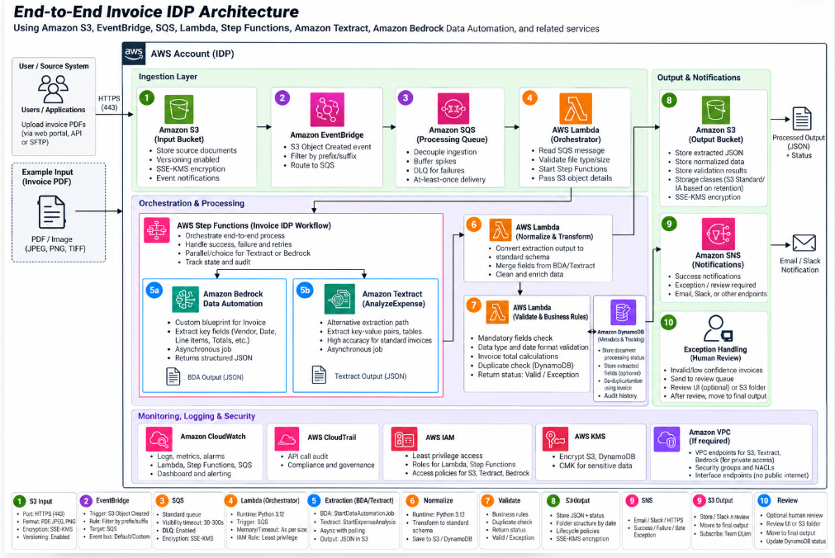
Project implementation plan
Local-first:
Phase 1 — Project foundation: Folder structure, sample invoice, sample extracted JSON, Python validation, local tests.
Phase 2:
2.1. Extraction: BDA blueprint design,
2.2. BDA boto3 invocation,
2.3. BDA status handling
2.4. Textract alternative
2.5. Output normalization
2.6. Local integration test
Phase 3 - Orchestration: Step Functions JSON, asynchronous status handling, retries, failures, SQS and SNS.
- Phase 4 — Infrastructure: Terraform modules, IAM policies, S3, Lambda, EventBridge, SQS, Step Functions.
- Phase 5 — Interview demonstration: Architecture walkthrough, local demo, troubleshooting, and advanced Q&A.

Phase 1 — Create reusable, locally testable foundation for IDP-invoice-processing application

Planned activity | Purpose | Current result
Project structure | Separate business logic, tests, sample data, and infrastructure | Foundation established
Sample invoices | Represent valid and invalid extraction scenarios | Two JSON fixtures created
Common invoice schema | Define expected fields for downstream processing | Basic field contract established
Python validation | Check extracted invoice fields | Implemented
Local demonstration | Execute business logic without AWS | Passed
Unit tests | Verify normal and failure scenarios | 5/5 passed
Sample PDF | Represent the original source document | Still to be added or verified

Project Structure:
aws-idp-demo-lab/
│
├── README.md
├── run_demo.py
│
├── lambda/
│ ├── validate_invoice.py
│ └── ... Phase 2 functions
│
├── sample-documents/
│ └── ... source PDFs
│
├── sample-output/
│ └── ... extracted JSON
│
├── tests/
│ └── test_validate_invoice.py
│
├── bda/
│ └── ... Phase 2 blueprint
│
├── step-functions/
│ └── ... Phase 3 workflow
│
├── terraform/
│ └── ... Phase 4 infrastructure
│
└── architecture/
└── ... architecture diagrams

Folder / file | Architectural responsibility
lambda/ | Independent Python business functions deployable to AWS Lambda
sample-documents/ | Original invoice PDFs/images used as test inputs
sample-output/ | Simulated extraction results and expected outputs
tests/ | Automated verification and regression tests
bda/ | BDA extraction blueprint definitions and configuration
step-functions/ | State-machine orchestration definitions
terraform/ | Infrastructure provisioning and IAM configuration
architecture/ | Design diagrams and technical documentation
run_demo.py | Local entry point for demonstrating processing
README.md | Project purpose, prerequisites, setup, and execution

I organized the project by responsibility so that the extraction engine, validation logic, orchestration, infrastructure, and automated tests remain independent. This makes the solution easier to maintain, test, deploy, and extend. For example, we can switch from BDA to Textract without rewriting our invoice validation logic.

Process Flow:

Extract invoice JSON (invoice-valid.json / invoice-review.json) - Loads JSON and invokes validation (run_demo.py) Mandatory fields, dates, numeric amounts (lambda/validate_invoice.py) Validate / Reeview_reqired

A. src/validate_invoice.py
This file contains two functions:
- validate_invoice(invoice) — pure Python business validation.
- lambda_handler(event, context) — AWS Lambda-compatible entry point that calls the same validation logic.
- The current validation checks:
Validation | Business reason
Mandatory fields | Prevent incomplete invoices from proceeding
ISO invoice date | Reject invalid calendar dates
Positive finite amount | Prevent negative, zero, or invalid totals
Supported currency | Restrict processing to USD, EUR, and GBP
Status generation | Separate valid documents from review cases

Phase 2 — Document Extraction
Step | Deliverable | Purpose
2.1 | BDA Blueprint Design | Define invoice fields and extraction requirements
2.2 | BDA boto3 integration | Start asynchronous BDA processing
2.3 | BDA status handling | Check completion and retrieve output
2.4 | Textract alternative | Extract invoice fields using AnalyzeExpense
2.5 | Output normalization | Convert BDA/Textract results to our Phase 1 JSON schema
2.6 | Local tests | Verify extraction mapping without live AWS resources

Step 2.1 — Amazon BDA Blueprint Design

Amazon Bedrock Data Automation, a blueprint defines the structured information we want to extract from a document.
Fields to be extracted for invoice-processing application:
Field Type Extraction requirement
invoice_number String Unique invoice reference printed on the document
vendor_name String Name of the supplier issuing the invoice
invoice_date String Invoice date, normalized to YYYY-MM-DD
due_date String Payment due date
currency String ISO currency code, e.g. USD
subtotal Number Amount before tax
tax_amount Number Total tax
total_amount Number Final invoice amount
line_items Array Description, quantity, unit price, amount

BDA Process Flow:
Invoice PDF in Amazon S3 -
Extraction schema and field definition (BDA Project + Invoice Blueprints)
Process Invoice document (BDA Async Invocation)
Structured BDA Output in S3
Normalize (Phase 1 Validation)

Why custom blueprints – to define invoice-specific files and their descriptions.
blueprint provides a consistent extraction contract, while our Python validation layer independently checks the extracted values.

Step 2.1 Design Invoice Blueprint (JSON) & Validate
File name & Path: /awss-idp-demo-lab/bda/invoice-blueprint.json
The blueprint contains eight initial invoice fileds
Validate the blueprint:
python3 -m json.tool bda/invoice-blueprint.json > /dev/null

Step 2.2 BDA boto3 invocation

Step 2.3. BDA status handling

Step 2.4. Textract alternative

Step 2.5. Output normalization

Step 2.6. Local integration tests

==
Dt: 11/03/2026
# 1. View existing blueprint
cat bda/invoice-blueprint.json

# 2. Validate JSON syntax
python -m json.tool bda/invoice-blueprint.json > /dev/null \
&& echo "Blueprint JSON valid"

# 3. Check BDA CLI support
aws bedrock-data-automation help

