Mobile Management System

The fast rhythm of live demands to take information and control some situations in any time from any place, still we are in moved. So needed devices and completed information systems that can be gives solution in that wants. Below gives an example in those situations.
There is an information system which controls a situation. This system could be a control alarm system or a stock management system, or an economical management system, or any information system. This system must be extended to send information’s remote to some users or allow remote control from some users for special procedures.
How can be builted this communication remotely? What kind of devices could be used for remote accessibility? How these devices could be programmed? The answer in these questions is “Mobile phones”. Mobile phones can send and receives data over GPRS, they are cheap and anyone have a Mobile phone. The latest generations of Mobile phones supports programming in odd programming languages. The standard programming platform which supported from the most manufacturers is JAVA and for exactly the J2ME a small edition of Java especial for micro device. Consequently mobile phones are good choice such mobile devices in a remote system.
As extend in current information system a remote communication system has been developed with specifics procedures, in a specific part of our information system. The new system is allowed connection between the Server of information center and mobile phones. After a while other parts of our information system or other departments of our organization or other information system are needed to extend and support a remote management system. This means that must be designed and written again new applications for this communication because the first remote communication system is not compatible with new necessities.

Basic idea for MMS
The basic idea of Mobile Management System is to extend an back office system with mobile communications abilities. These extensions must be done in an easy way without being necessary to develop a new mobile system for any kind of back office system.
First of all the MMS sets an environment in which it accomplishes communication between mobile devices and the existing information system. Secondly the MMS gives the ability to design the signals which are exchanged between mobile devices and the existing information system. At the end the MMS give an API interface and some rules for designing and developing small applications which are connected with the existing information system with the MMS platform.
Communication schema
The MMS is composed by two applications MMSClient application (Client applications) and MMSCentral application (Server application).
MMSClient Application
The first application is the MMSClient application .This is a Java application written in J2ME platform. MMSClient runs on mobile phones and gives the clients the ability to communicate with the Server.
MMSCentral
The Second application is the MMSCentral Application. This application is a middleware platform between mobile clients and the back office system. This is a Java application written in JSDK2 platform. MMSCentral runs on a PC. Firstly, it controls the communication between the clients, secondly it gives the main control to the administrator and thirdly it communicates with the back office system via extended applications.
Extended Applications
Extended Applications are a group of small applications which undertake the role to work like a bridge between MMSCentral and back office system. These applications are necessary because the MMSCentral doesn’t know the back office system and the back office system doesn’t know how to communicate with MMSCentral. There is no restriction in the programming language for the usage of these applications. These applications must be developed/configured from the MMSCentral administrator.
Basic architect
In this section simple example paradigm will be described for the basic architect of MMS. The MMSClient applications are connected to MMSCentral application. MMSCentral application controls the communication between MMSClient applications. An MMSClient application sends a requirement for the current information system. The MMSCentral receives this requirement and runs the specific extended application. The extended application undertakes the responsibility to interact with the back office system and if necessary to give a response back to MMSCentral. The MMSCentral sends back to the MMSClient application the response. When the current information system wants to communicate with MMSClient application it runs an extended application. The extended application gives a requirement to MMSCentral. MMSCentral communicates with MMSClient applications and sends the requirement.
Any MMSCentral can be managed from a lot of clients. In this way a lot of users can communicate with the existing information system via MMSCentral to ask for something or give a command. The MMS also supports some internal signals that give the clients the ability to communicate through MMSCentral.

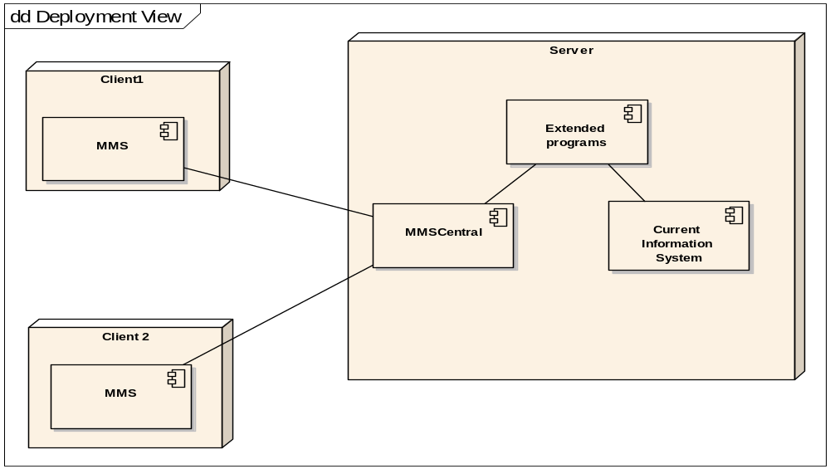

Each signal on Mobile Management System is in fact a command. Every command activates an external program or an internal class of MMSCentral. As will be described, in chapter 4 there are two protocols, the internal and the external protocol. The signals in the internal protocol are fixed and activate build in functions. The signals in external protocol are built from the administrator and are activated by extended programs or activate extended programs.
Extended application can be activated from MMSCentral application. MMSCentral application gives as argument to extended programs some information such as client ID, scenario number, command number, signal number and a number of files with other information (images, sound, text, binary, etc). So these programs can take these information and perform some tasks to the back office system such as: write to a file or database, make a call to exist system and others.
Extended application can be activated from back office system and sends a signal to a client. Extended application can take information form back office system and write them as signal to ExtSignalFile.mms file. MMSCentral application reads this file and sends to the client the signal that has been saved in the file. Of course there is a specific format for records in this file and the signal which will be written in this file must be generated before by the administrator on the MMSCentral application so as to be in the set of signals.
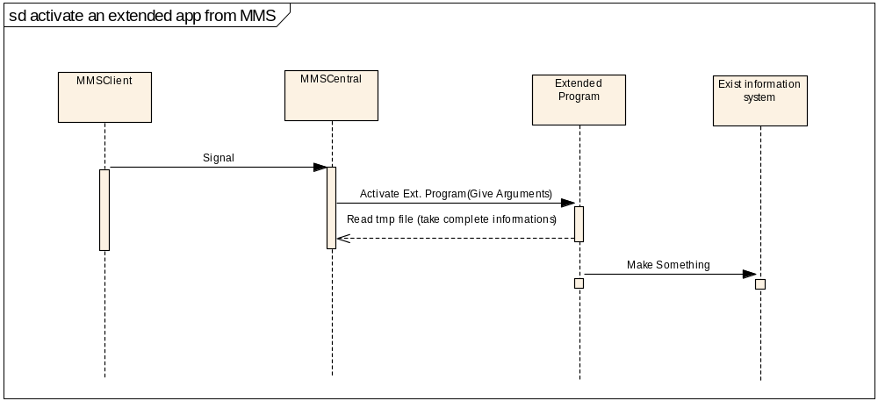

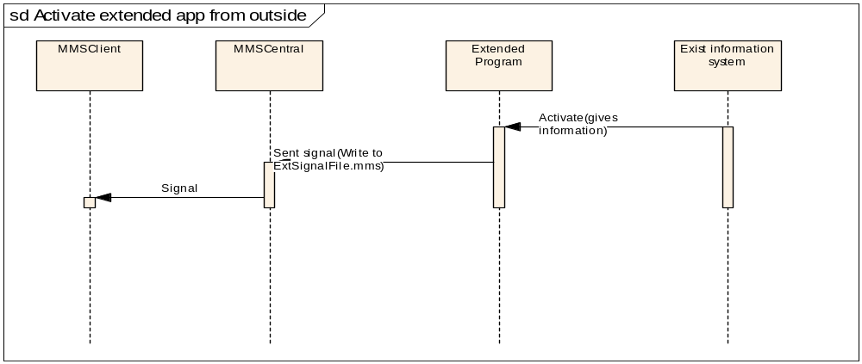
Σταματήσαμε εδώ
Scenarios
In order to manage an back office system, a set of external signals and a set of external programs must be created. In case more than one back office system or different signals from different categories of clients needs to be supported, the Mobile Management System implements scenarios. Scenario is a packet with different external signals and different clients. Each client belongs to a scenario, and each signal belongs to a scenario. So with scenarios Mobile Management System can support more than one back office systems because it has different clients for any back office system and different set of signal for any information system. In the case different set of signals are needed for a back office system a scenario for any user category , build clients for any scenario and signals for any scenario so we can have different signals for different categories of clients. So one user can be connected from the same cell phone at the same time with two or more scenarios as a different user for each scenario and have two or more different packets of signals to send and receive from the server.
Multi connections
The Mobile Management System supports a multi connection environment, and this system can be supported by a lot of and different kinds of connection.
- An MMSClient application can connect to an MMSCentral application with a scenario.
- An MMSClient application can connect to an MMSCentral application, with more than one scenario.
- An MMSClient application can connect to more than one MMSCentral application with a scenario for each MMSCentral.
- An MMSClient application can connect to more than one MMSCentral application, with more than one scenario for each MMSCentral.
- An MMSClient application can communicate with other MMSClient applications via throw MMSCentral application. The MMSClient applications can communicate only if connected with the same MMSClient application and the same scenario.
The number of connections that can be supported by MMSClient applications depends on the cell phone capabilities and the maximum number of connection that can be supported by MMSCentral application is one thousand. An example of this connection appears in the diagram below.

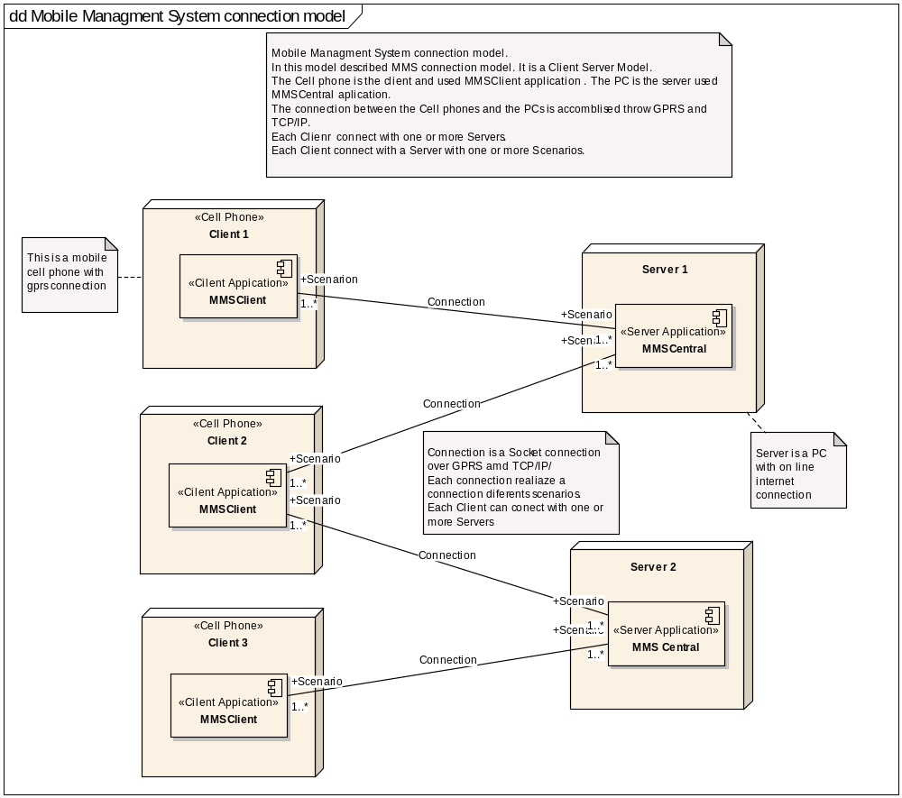

Connection Details
The connection between MMSCentral application and MMSClient application is a TCP/IP connection throw (through?) Internet network. The MMSClient application must be run on a pc with permanent connection on Internet network, pc connection must have static IP or a standard domain name in a dynamic DNS server. The mobile in which runs MMSCentral application must have activated GPRS connection and Internet connection from telecommunication mobile company provider. The MMSCentral application opens the TCP port 5001 and listens for a connection request in its’ own IP. If receive a connection request it generates a TCP connection with the client but in a different TCP port, not with the TCP port 5001 because none could be connected again in this port until this connection is closed. MMSClient application must know the IP or domain name for the pc on which the MMSCentral application runs. When MMSClient application tries to connect with MMSCentral application it sends a TCP connection request to pc in which the MMSCentral application runs in TCP port 5001. Both of applications behave as they have a TCP connection but the reality is more complex. When MMSClient application tries to connect, the mobile phone makes a GPRS connection with telecommunication mobile company provider and via him the data travel to the Internet network. Of course there is the problem with quality of GPRS connection. Although the connection speed of GPRS is 171, 2 Kbits/sec in reality is lower depending on the quality of wireless network and the abilities of the cell phone.
Design of protocol
The connection between client and server is over GPRS and internet, so communication must be over TCP/IP protocol. Our signals must be encapsulated in TPC/IP packets and they travel through internet and GPRS network. For this reason the first step in our communication is to establish a connection on TCP level. This can be accomplished on Java with a Socket connection.
The most important part in this project is to build our communication protocol to take place over the TCP connection. First of all our protocol must be described by the packet of data for our signals that can be transferred between the server and the client. The second part of this protocol is to control signals that have been send and received. The MMS is a platform not a stand alone application. This platform is used as a base and over this base any project can be built. So the protocol must be more flexible than common protocols.
The basic idea for this protocol is that an abstract protocol is required. The protocol does not describe the functions for every signal from the beginning, but the functions for every signal can be described in any case by the user. The user must be able to generate a signal and then the functions for this signal to be described. So if signal is made, the properties for this signal must be specified. Properties are a team of adjustments that prescribe the functions in a signal. Most of the signals are used like commands that can be used by the client or by the server. With the tearm commands it is meant a list of available acts that the user can choose by the client or by the server to do something. So when a signal is generated by the user for the protocol, at the same time a list is created with the available commands for the client user and the server user. The protocol is separated in two parts, the first part is the control protocol with the control signals and the second part is the general protocol with the external signals.
Control Protocol
The control protocol is a total of standard signals with embedded specifications in application code. These signals control the basic operations of communication between server and client. This part of protocol has the basic signal format and basic signal properties format but the specification for properties is into the application code
General Protocol
The general protocol is created by the user and it is a total of abstract signals. This protocol (Signal and specification of signals properties) is created by the user. Server application helps the user to specify signal properties. Client application receives these specifications in first connection. This part of protocol has the basic format for signal. The specifications of signals properties are created by the user and there are in an external file.

Type of Signals
The protocol is based on five types of signals
Signals Type 1 (Control Signal of Request)
These signals belong to control protocol and are sent by the server or by the client to require something or as command which waits for verification.
Signals Type 2 (Control Signal of Response)
These signals belong to control protocol and are sent by the server or by the client as response or verification of signal type 1 or as a command without verification.
Signals Type 3 (General Signal of Request)
These signals belong to general protocol and are sent by the server or by the client to require something or as command which waits for verification.
Signals Type 4 (General Signal of Response)
These signals belong to general protocol and are sent by the server or by the client as response or verification of signal type 3.
Signals Type 5 (General Signal of Request without response)
These signals belong to general protocol and are sent by the server or by the client as a command without verification.
Signal Command
Signal is a command or a response command, after a command. Every signal must be unique as a command. For every response the command request is required to known. So for every signal the command must be specified. There is an integer number in every signal. This number makes the signal unique as a command or request command. This property is unrelated between signals with signal type 1,3 and 5 , but it is close related between signals with signal type 1 and 2 or signal with signal type 3 and 4
If a signal type 1 or a signal type 3 is sent with signal command 1 then the signal that is received is signal type 2 or signal type 4 which must be signal command 1 as a receiving in signal command 1.

Signal Packet Structure
Packet of signal
The basic part of protocol is the packet of signal. The packet is the format of data for every signal which is sent or received by the client or the server. In the table below the data format for a packet can be seen.

Structure of Signal Packet
Name of field | Values | Type of Data
Sender | >0 Server ID – User ID | Byte
Receiver | >0 User ID – Serer ID | Byte
Scenario | >0 Scenario ID | Integer (4 Byte)
Signal Type | 1.Control Signal of Request  2.Control Signal of Response  3.General Signal of Request  4.General Signal of Response  5.General Signal of Request without response | Byte
Signal Command | >0 Command ID | Integer (4 Byte)
Priority | 0 High  1 Normal  2 Low | Byte
Date_Time |  | Long (8 Byte)
Data_Size1 | Size of Data 1 | Integer (4 Byte)
Data 1 | Data | Byte Array
Data_Size2 | Size of Data 2 | Integer (4 Byte)
Data 2 | Data | Byte Array

The size for the smallest signal is 22 Byte (if fields Data 1 and Data2 were empty) and there is almost no limit for the biggest signal.
Signals Properties
Signals properties are properties that describe a signal. Signal properties specify what a signal means, if and how the signal can be seen by the user, which procedure or which program will run to serve the signal and others. If a signal has not signal properties, it will be refused by the receiver. In control protocol signal properties are pre-specified in application code. In general protocol signal properties are specified in a file (externalsignal.mms) and specified by the user. User specifies signal properties from the server application. It is possible that there are a lot of externalsignal.mms files one for every scenario. Client application receives this file when it is connected with the server for the first time.
The available properties can be seen as well as information at the next rows.
Signal Type
Signal type property specifies the type of signal. Available types are Signals Type 1 (Control Signal of Request), Signals Type 2 (Control Signal of Response), Signals Type 3 (General Signal of Request), Signals Type 4 (General Signal of Response) and Signals Type 5 (General Signal of Response without response)
Signal type property has the size of a Byte and the limit of value is a number between 1 and 5 .
Signal Command
Signal command property specifies the number of commands. As it was listed previously every signal is a command and this property specifies the number of command.
Signal command property has the size of 4 Bytes and the limit of value is a number greater than 0.
Priority
This property adjusts the priority of service for each signal. This property does not work in this version.
Signal type property has the size of 1 Byte and the limit of value is a number between 0 and 2 (0 High priority, 1 Normal priority, 2 Low priority)
Visible
Visible property specifies if this signal will be visible to user as a command. If value of this property is true this signal will be appeared in available command list. If the value of this property is true this signal can be seen when it is received. This property specifies if a signal will be available to send it or to seen when received. Some times a special signal with type 2 or 4.is not wanted to be seen
Visible property has the size of 1 Byte and the limit of value is 1 (true) and 0 (false).
Description
Description property specifies the description name for a signal. When a command is sent the description name must be seen in the available commands in the command list. When a signal is received a description for received signal can be seen. This property specifies what can be seen in those cases.
Description property has the size 20 bytes and 20 characters can be typed without space.
Used Command
Some times a signal must be visible as a command in command list by the client or by the server or by both of them.
Used command property specifies if this signal will be visible as a command.
Description property has size 6 bytes and the follow three words can be typed Client, Server and Both.
If Client is typed this signal will be available as a command only from clients’ applications.
If Server is typed this signal will be available as a command only from server application.
If Both is typed this signal will be available as a command from clients’ application and from server application.
Class Name
The Biggest problem especially for general protocol was how a function could be specified for a signal by the user?
The solution to this problem is the class name property. This property specifies the name of program; it must be called by the application when this signal is received
In case of control protocol the property “Class Name” has the name of class which needs to run when this signal is received. In case of general protocol the property “Class Name” has the name of a class which needs to run when this signal is received. In case of external protocol the property “Class Name” has the name of a external program which needs to run when this signal is received. With this solution functions for every signal can be specified.
There is a limit on client application because with J2ME platform an external program can not be called. So, if the source code is not available, new classes can not be added in client application code, so only available classes can be used.
This limit bypass to server application because an external program can be called, so for every new function required, a new program can be run.
Of course there is a standard procedure to pass parameters of each signal.Class name property has the size 50 bytes and 50 characters without space can be typed.
Standard class name and description
Class Name | Description of class operations
Server Classes
ChkPasswdSendFile  (works only in control protocol) |  | This class checks a logon signal and if it is valid it permits the connection and sends to client the externalsignal.mms file for specified scenario.  This class gets the user name from signal packet field Data1 and Password from signal packet field Data2 and if logons are correct sends in Data1 “OK” , create a logon session and in Data2 put the file with External signals specification or else sends in Data1“NO”.
CheckPasswd  (works only in control protocol) |  | This class checks a logon signal and if it is valid it permits the connection  This class gets the user name form signal packet field Data1 and Password from signal packet field Data2 and if logons are correct sends in Data1 “OK” and creates a logon session or else sends in Data1“NO”.
SendUsersFile  (works only in control protocol) |  | This class sends a file with names of active users (All users that are connected with server at that moment in this scenario) or a file with all users (All users which are written in password file in this scenario)  Then the number of signal command is checked in received signal .if signal command is 105 it sends in signal packet field Data1 the name of file (ServerID”_”ScenarionID”_AllUsers.txt”) and in signal packet field Data2 the names of all users.  If signal command is 104 it sends in signal packet field Data1 the name of file (ServerID”_”ScenarionID”_ ActUsers.txt”) and in signal packet field Data2 the names of active users.
ForwardMsg |  | It receives a message from a client and forwards this message to another client.  This class takes the user name from signal packet field Data 1 and the message from signal packet field Data2 and forwards a new signal to the user with the user name
ForwardFile |  | It receives a message and a file from a client and forwards this message and the file to another client.  This class takes the user name from signal packet field Data 1 and the message and the file from signal packet field Data2 and forwards a new signal to the user with the user name
SendAvaliableFiles |  | Send a file with names of all available files to the server.  This class sends in signal packet field Data1 the name of file (ServerID”_AvaliableFiles.txt”) and in signal packet field Data2 the names of available files in server.
Client Classes

AnsPasswdSendFile  (works only in control protocol) |  | This class establishes or disconnects a connection and saves the externalsignal.mms file.  This class gets the “OK” or “NO” form signal packet field Data1 and externalsignal.mms file from signal packet field Data2.  If Data1 is “OK” establishes a connection and saves externalsignal.mms file, or else close the connection is disconnected.
AnsCheckPasswd  (works only in control protocol) |  | This class establishes or disconnects a connection.  This class gets the “OK” or “NO” form signal packet field Data1.  If Data1 is “OK” establishes a connection or else disconnects the connection.
ShowMsg |  | Show in special form a message from another client.  This class gets the sender user name form signal packet field Data1 and the message from signal packet field Data2.
ShowFileMsg |  | Shows in special form a message and a file from another client.  This class gets the sender’s user name form signal packet field Data1 and the message and the file from signal packet field Data2 .
Server and Client Classes
CheckCloseConnection  (works only in control protocol) |  | This class runs when a logoff signal is received and disconnects the sender client.
IAmAlive  (works only in control protocol) |  | When a signal AreYouAlive is received, this class sends a signal IAmAlive.
ResetIAmAlive  (works only in control protocol) |  | When client or server has sent a signal AreYouAlive and receives a signal IAmAlive run this class to stop waiting for response.
GetFile |  | This class takes a file and saves it.  It takes in signal packet field Data1 the name of file and in signal packet field Data2 the data of file and saves it.
SendFile |  | When receive a signal SendMefile search for this file and sends it.  Send in signal packet field Data1 the name of file and in signal packet field Data2 the data of file.
ShowSendImage |  | Show an image from a send image signal.  Takes in signal packet field Data1 the name of image and in signal packet field Data2 the data of image and shows it
PlayMedia |  | Plays a media file from a already send media signal.  Takes in signal packet field Data1 the name of media file and in signal packet field Data2 the data of media file and plays it
Returnback |  | When receive a signal type 1 or 3 makes it signal type 2 or 4 with the same signal command and sends back to sender as an answer.
None |  | It is not a class but this string is used when there is no requirement for the signal to do something.

Parameters
Parameters are data (see table Structure of Signal Packet) Data1 and Data 2 which are contained in a signal.
In case a signal is received, it is not always desired all data to be seen by the user so this property specifies the number of parameters that can be seen by the user. This must definitely be used in some cases (eg if a file is sent, it is required the user to see only the file name, no the data of file. So put the file name to Data1, put file data to Data2 and specify the property parameters as value 1).
In case a signal is sent , it must be specified bythe number of parameters that can be specified by the user.
Parameters property has the size of 1 Bytes and limit of value is 0,1,2
Value 0 User can not see any data.
Value 1 User can see only Data 1.
Value 2 User can see Data 1 and Data 2.

Parameter Name
This property specifies a name for parameter which visible to user. We want to see a title when we put value in a parameter that we send or when we receive a signal with parameter. In this property we type the title name for parameter.
Parameter Name property has the size of 10 bytes and we can type 10 characters without space

Parameter Type
This property specifies the type of data for parameter which is visible to user. (eg If it is required that a user is to send a signal in which type as Data1 is a text and as Data 2 a long integer number, then must be specified as ParameterType1 the value 0 and as ParameterType1 the value 1 .
Parameter type property has size 1 Bytes and limited value is 0,1,2
Parameter type 0 parameter type is txt put text.
Parameter type 1 parameter type is int put integer number.
Parameter type 2 parameter type is float put float number.

Parameter Class
Some times a special interface is necessary to help the user to set data of parameters, so this property specifies the name of code class which run and gives us the special interface.
Like property Class Name unless source code is known only available classes can be used.
Parameter Class property has the size of 50 bytes and 50 characters without space can be typed

Standard Parameter class name and description
Class Name | Description of class operations
Client
SendFiletoUser | Opens a form for the name of user which is wanted to sent file to be chosen, text box to write the message and a list box to chose the file.  This class puts in signal packet field Data1 the name of user name and in signal packet field Data2 the message and the data of file.
SendMsgtoUser | Opens a form for the name of user which wants to send message to be chosen and text box to write the message.  This class put in signal packet field Data1 the name of user name and in signal packet field Data2 the message.
SendMeFile | Opens a form to choose the file name, which is needed to be received from server.  This class put in signal packet field Data1 the name of file.
Server and Client
FileManager | Open a file manager window to choose a file or an image that is required to be sent.  This class put in signal packet field Data1 the name of file and in signal packet field Data2 the data of file .
None | It is not a class but this string is used when the signal is not required to do something

Structure of Signal Properties
Signal Properties | Values | Description
Signal Type | 0-5 | The type of signal
Signal Command | >0 | The signal command
Visible | 0-1  (1 is Default value ) | 0- this signal is not visible as incoming signal or as signal command  1- this signal is visible as incoming signal or as command
Used Command | Both  Client  Server  (“Both” is Default Value) | Both- this signal can be used from server and from client  Client- this signal can be used only from client  Server- this signal can be used only from server
Description | 20 characters without spaces | This is the description name of the signal. This is the name you can see the signal when it is an incoming signal or as a command in the command list
Class Name | 50 characters  without spaces  (If signal Type is 3 Default value is “returnback”, If signal Type is 4 or 5 Default value is “None” ) | This property has two cases  First case  If the signal type is 1 or 2  The name of class can be put in this property. This is emended class in the code and it is called when the signal is received.  Second case  If the signal type is 3 or 4 or 5  The name of program can be put in this property. This program is an external program and it is called when the signal is received
Parameters | 0-1-2  (0 is default Value) | Number of parameter which is visible to user
Parameter 1Name | 10 characters without spaces  (“None” is default Value) | The name for first parameter
Parameter 1 Type | 0-1-2  (0 is Default Value) | Type of data for first parameter  0- txt- Text  1- int- Integer  2- float- Float
Parameter 2Name | 10 characters without spaces  (“None” is default Value) | Then name for second parameter
Parameter 2 Type | 0-1-2  (0 is Default Value) | Type of data for second parameter  0- txt- Text  1- int- Integer  2- float- Float
Parameter Class | 50 characters without spaces  (“None” is default Value) | The name of embedded in code class is put in this property. This class will be called when the signal is chosen as a command to specify parameters

Control Protocol flow control signals
In this section below can be seen which signals are transferred between the client and the server and the contents of signals packets (in the example the client has clientID 1 , username test and password 1234. The server has ServerID 2. the scenario has Scenario 1)

When a client is connected to the server for the first time, client sends a signal (Logon Signal File) and receives a signal (Answer Logon Signal File) from the server
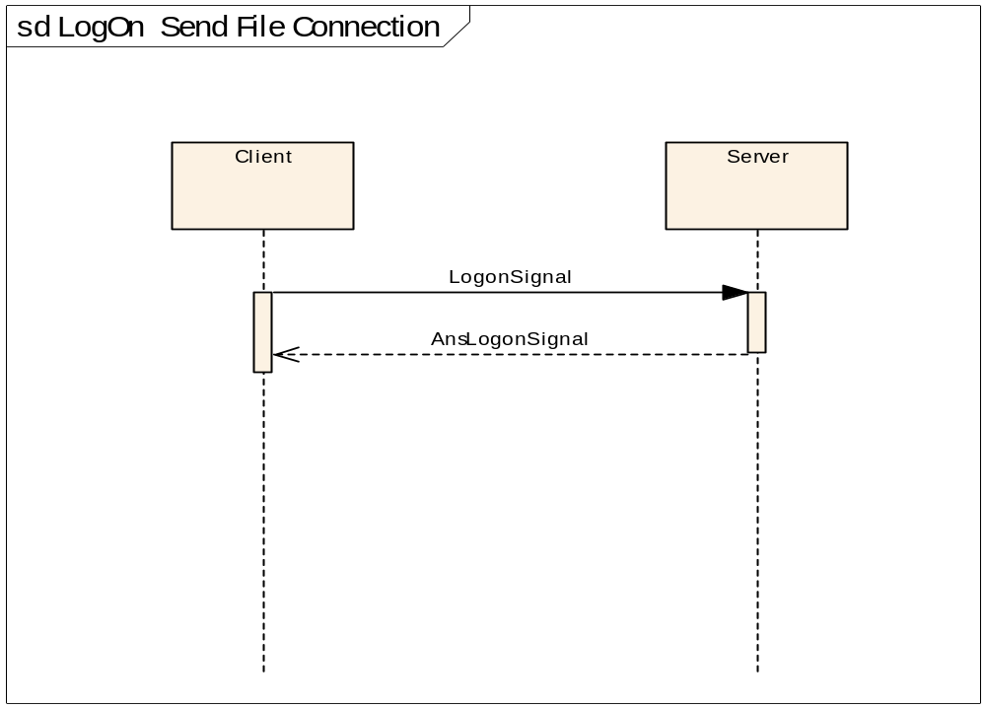
Logon procedure and send externalsignal.mms
Signal packet fields | Request from client | Possible Responses from server
Sender | 1 | 2 | 2
Receiver | 2 | 1 | 1
Scenario | 1 | 1 | 1
Signal Type | 1 | 2 | 2
Signal Command | 0 | 0 | 0
Priority | 1 | 1 | 1
Date_Time | System time and date | System time and date | System time and date
Data_Size1 | 4 | 2 | 2
Data 1 | Test | OK | NO
Data_Size2 | 4 | Number of bytes of externalsignal.mms file
Data 2 | 1234 | Data of externalsignal.mms file

When a client is connected to the server and client has connected to server at least one time. Client sends a signal (Logon Signal) and receives a signal (Answer Logon Signal) from the server
Logon procedure
Signal packet fields | Request from client | Possible Responses from server
Sender | 1 | 2 | 2
Receiver | 2 | 1 | 1
Scenario | 1 | 1 | 1
Signal Type | 1 | 2 | 2
Signal Command | 1 | 1 | 1
Priority | 1 | 1 | 1
Date_Time | System time and date | System time and date | System time and date
Data_Size1 | 4 | 2 | 2
Data 1 | Test | OK | NO
Data_Size2 | 4 | 0 | 0
Data 2 | 1234

When server or client has not sent a signal for a long time, server or client sends a signal (Are You Alive) and receives a signal (I Am Alive) from the client/server.
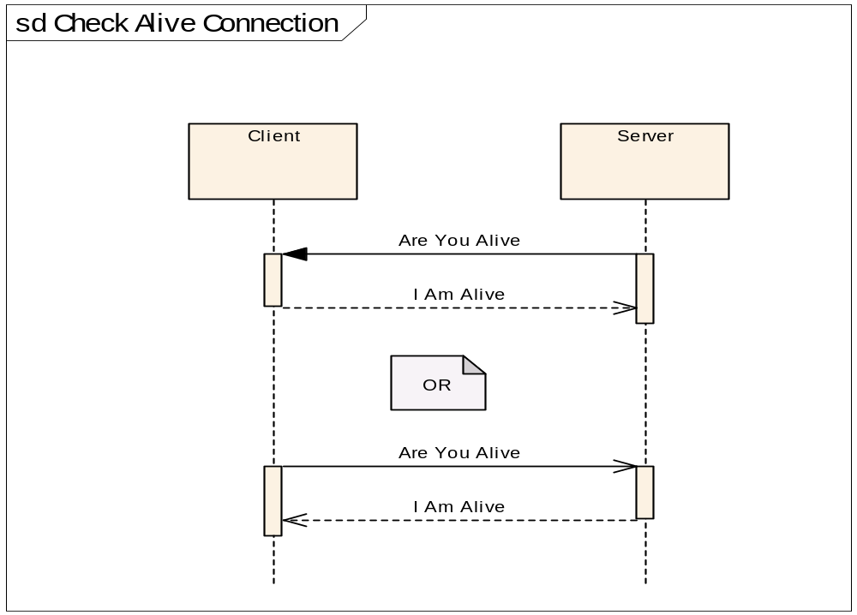
Check Alive
Signal packet fields | Request from client | Possible Responses from server
Sender | 1 | 2
Receiver | 2 | 1
Scenario | 1 | 1
Signal Type | 1 | 2
Signal Command | 3 | 3
Priority | 1 | 1
Date_Time | System time and date | System time and date
Data_Size1 | 0 | 0
Data 1
Data_Size2 | 0 | 0
Data 2

When the server or a client wants to be disconnected, server or client sends a signal (Logoff)
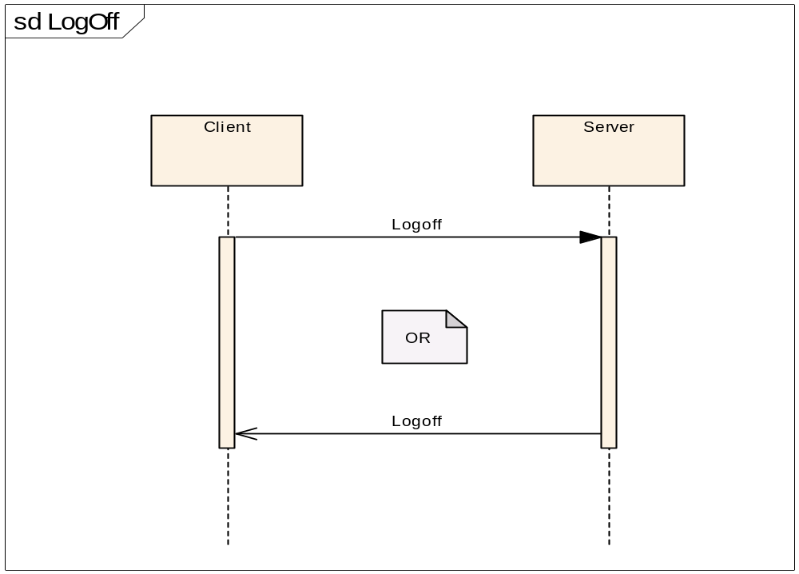
Logoff procedure
Signal packet fields | Command from client
Sender | 1
Receiver | 2
Scenario | 1
Signal Type | 2
Signal Command | 3
Priority | 1
Date_Time | System time and date
Data_Size1 | 0
Data 1
Data_Size2 | 0
Data 2

When server/client sends a file to the server/client, sends a signal (Send a File) and receives a signal (Received a file) from the client/server.
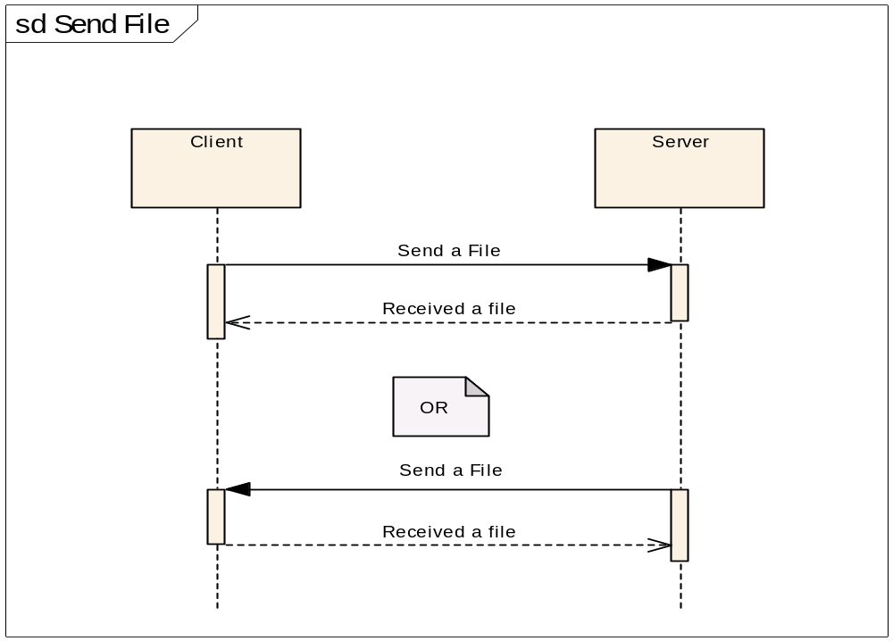
Send a file
Signal packet fields | Request from client | Possible Responses from server
Sender | 1 | 2
Receiver | 2 | 1
Scenario | 1 | 1
Signal Type | 1 | 2
Signal Command | 100 | 100
Priority | 1 | 1
Date_Time | System time and date | System time and date
Data_Size1 | Size of bytes of filename | Size of bytes of filename
Data 1 | Filename | Filename
Data_Size2 | Size of bytes of file data | 0
Data 2 | File data

When server/client sends an image to the server/client sends a signal (Send an Image) and receives a signal (Received an Image) from the client/server.
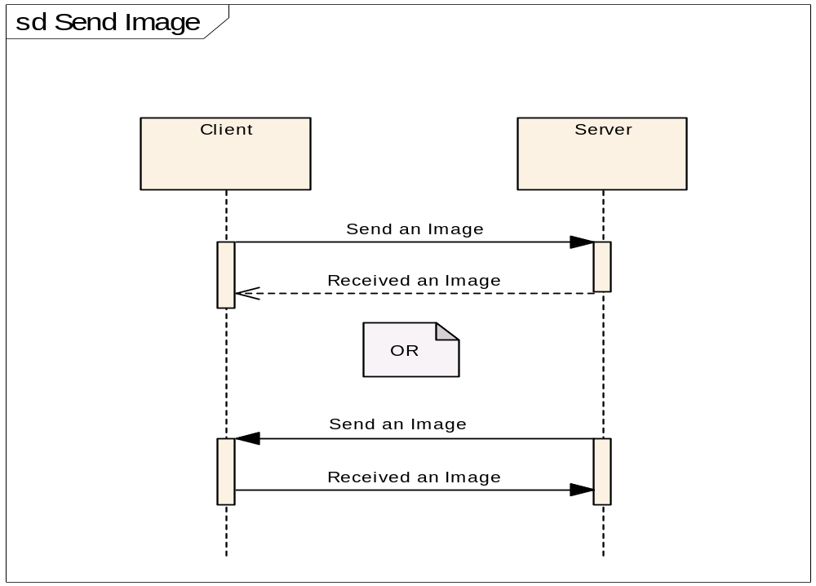
Send an image
Signal packet fields | Request from client | Possible Responses from server
Sender | 1 | 2
Receiver | 2 | 1
Scenario | 1 | 1
Signal Type | 1 | 2
Signal Command | 102 | 102
Priority | 1 | 1
Date_Time | System time and date | System time and date
Data_Size1 | Size of bytes of image name | Size of bytes of image name
Data 1 | Image name | Image name
Data_Size2 | Size of bytes of image data | 0
Data 2 | Image data

When server/client sends a media file to the server/client sends a signal (Send a Media File) and receives a signal (Received a Media File) from the client/server.
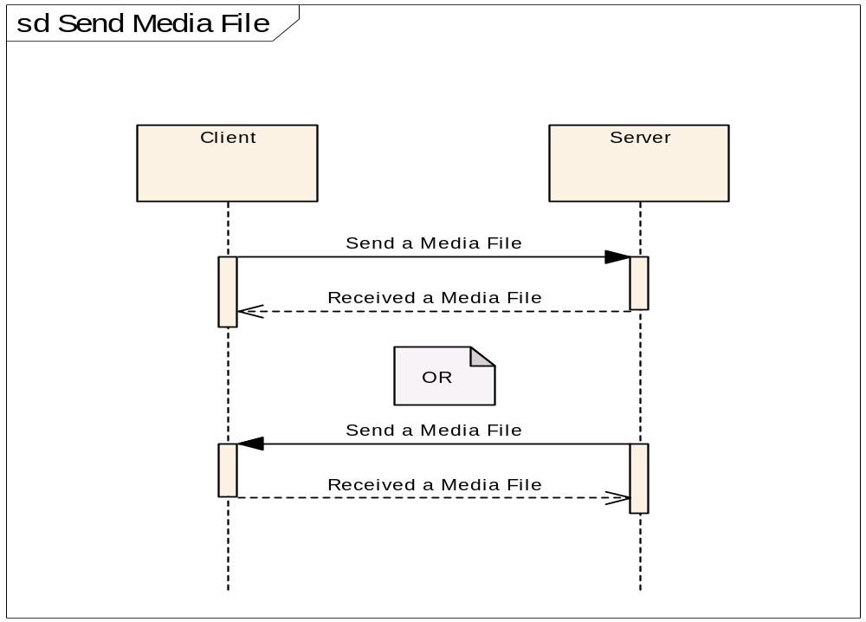
Send a media file
Signal packet fields | Request from client | Possible Responses from server
Sender | 1 | 2
Receiver | 2 | 1
Scenario | 1 | 1
Signal Type | 1 | 2
Signal Command | 103 | 103
Priority | 1 | 1
Date_Time | System time and date | System time and date
Data_Size1 | Size of bytes of media file name | Size of bytes of media file name
Data 1 | Media file name | Media file name
Data_Size2 | Size of bytes of media file data | 0
Data 2 | Media file data

When a client wants to receive a list with active users from a scenario, sends a signal (Get Actives User) and receives a signal (Received Actives Users) from the server.
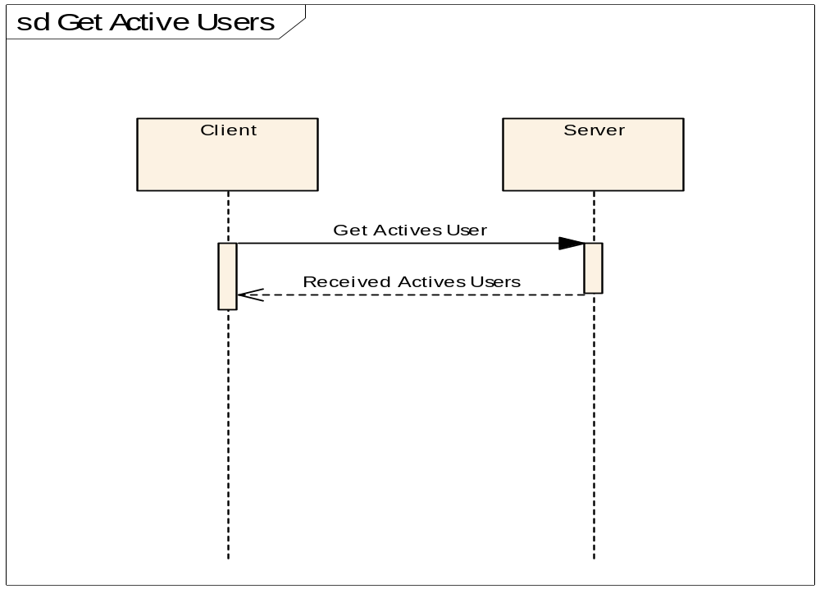
Get Actives Users
Signal packet fields | Request from client | Possible Responses from server
Sender | 1 | 2
Receiver | 2 | 1
Scenario | 1 | 1
Signal Type | 1 | 2
Signal Command | 104 | 104
Priority | 1 | 1
Date_Time | System time and date | System time and date
Data_Size1 | 0 | Size of bytes of file name with actives users list
Data 1 |  | File name with actives users list
Data_Size2 | 0 | Size of bytes of file with actives users list
Data 2 |  | Data of file with actives users list

When a client wants to receive a list with all available users from a scenario, sends a signal (Get All User) and receives a signal (Received All Users) from the server.
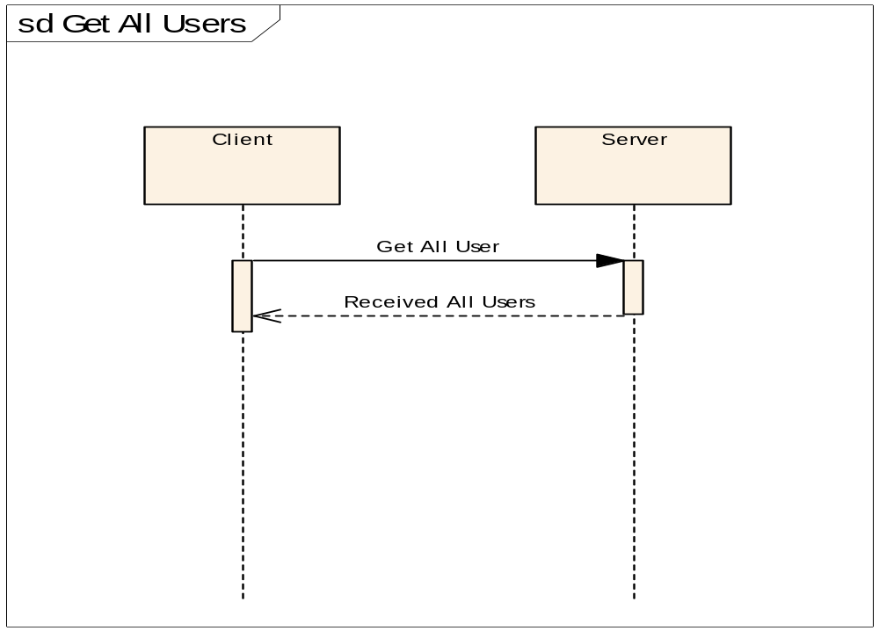
Get All Users
Signal packet fields | Request from client | Possible Responses from server
Sender | 1 | 2
Receiver | 2 | 1
Scenario | 1 | 1
Signal Type | 1 | 2
Signal Command | 105 | 105
Priority | 1 | 1
Date_Time | System time and date | System time and date
Data_Size1 | 0 | Size of bytes of file name with all users list
Data 1 |  | File name with all users list
Data_Size2 | 0 | Size of bytes of file with all users list
Data 2 |  | Data of file with all users list

When a client wants to send a message to another client, sends the message through the server. First sends a signal (Send Message to a User) and receives a signal (Sending Message) from the server. After a while the Server sends the message to the other client. The server sends a signal (Received a Message) and receives a signal (Message Received from User) from the other client.
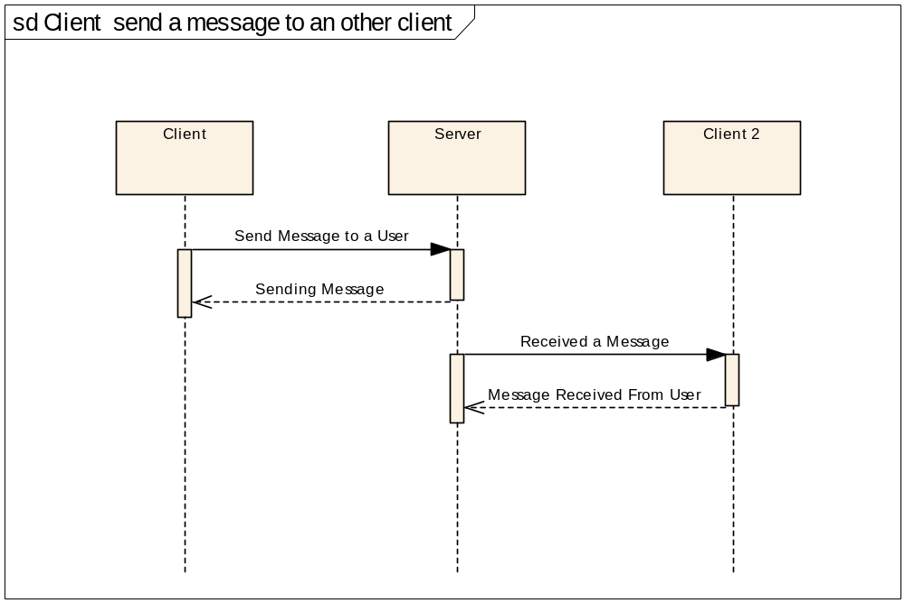
Send Message to a User (Signals between client and server)
Signal packet fields | Request from client | Possible Responses from server
Sender | 1 | 2
Receiver | 2 | 1
Scenario | 1 | 1
Signal Type | 1 | 2
Signal Command | 106 | 106
Priority | 1 | 1
Date_Time | System time and date | System time and date
Data_Size1 | Size of bytes of receiver user name | Size of bytes of user name
Data 1 | Receiver User name | Receiver User name
Data_Size2 | Size of bytes of message | 0
Data 2 | Message

Received a message (Signals between server and client)
Signal packet fields | Request from server | Possible Responses from client
Sender | 2 | 1
Receiver | 1 | 2
Scenario | 1 | 1
Signal Type | 1 | 2
Signal Command | 107 | 107
Priority | 1 | 1
Date_Time | System time and date | System time and date
Data_Size1 | Size of bytes of sender user name | 0
Data 1 | Sender User name
Data_Size2 | Size of bytes of message | 0
Data 2 | Message

When a client wants to send a message and a file to another client, sends the message and the file through the server. First sends a signal (Send a File to a User) and receives a signal (Sending a File Message) from the server. After a while the Server sends the message and the file to the other client. The server sends a signal (Received a File Message) and receives a signal (File Message Received From User) from the other client.
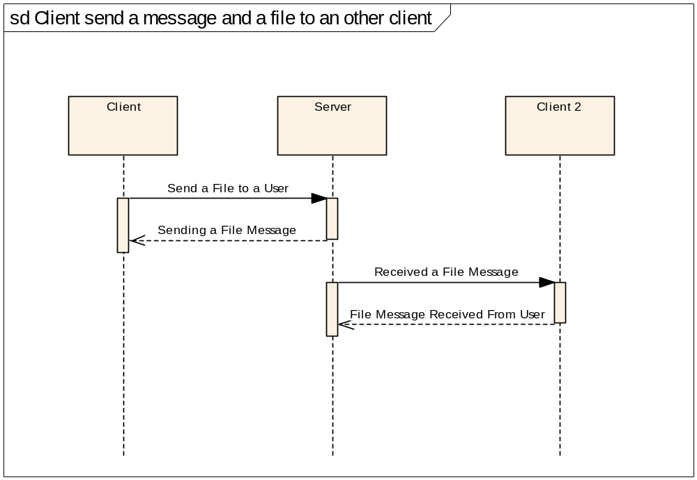
Send File to a User (Signals between client and server)
Signal packet fields | Request from client | Possible Responses from server
Sender | 1 | 2
Receiver | 2 | 1
Scenario | 1 | 1
Signal Type | 1 | 2
Signal Command | 108 | 108
Priority | 1 | 1
Date_Time | System time and date | System time and date
Data_Size1 | Size of bytes of receiver user name | Size of bytes of user name
Data 1 | Receiver User name | Receiver User name
Data_Size2 | Size of bytes of message and the file | 0
Data 2 | Data of message and data of file

Received a File message (Signals between server and client)
Signal packet fields | Request from server | Possible Responses from client
Sender | 2 | 1
Receiver | 1 | 2
Scenario | 1 | 1
Signal Type | 1 | 2
Signal Command | 107 | 107
Priority | 1 | 1
Date_Time | System time and date | System time and date
Data_Size1 | Size of bytes of sender user name | 0
Data 1 | Sender User name
Data_Size2 | Size of bytes of message and the file | 0
Data 2 | Data of message and data of file

When a client wants to receive a list with available files from the server , sends a signal (Get Available Files) and receives a signal (Received Available Files) from server.
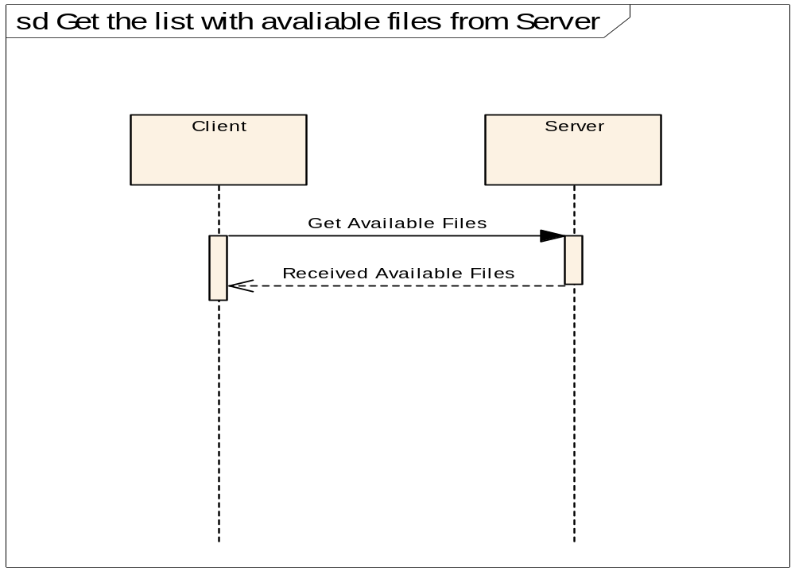
Get All Users
Signal packet fields | Request from client | Possible Responses from server
Sender | 1 | 2
Receiver | 2 | 1
Scenario | 1 | 1
Signal Type | 1 | 2
Signal Command | 110 | 110
Priority | 1 | 1
Date_Time | System time and date | System time and date
Data_Size1 | 0 | Size of bytes of file name with available files list
Data 1 |  | File name with available files list
Data_Size2 | 0 | Size of bytes of file with available files list
Data 2 |  | Data of file with available files list

When client wants to receive a file from the server, sends a signal (Send Me a File) and receives a signal(Send a File) from the server. After that the client receives a signal (Receive a file) with the encapsulated file.
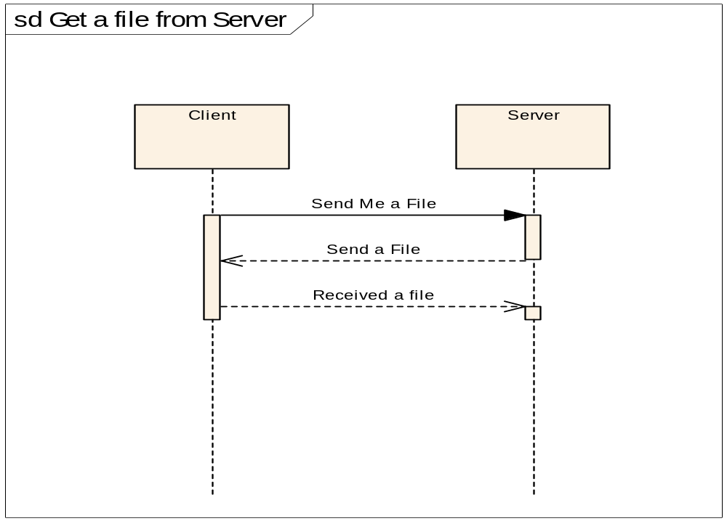
Send Me a file
Signal packet fields | Request from Server
Sender | 1
Receiver | 2
Scenario | 1
Signal Type | 1
Signal Command | 101
Priority | 1
Date_Time | System time and date
Data_Size1 | Size of bytes of filename
Data 1 | Filename
Data_Size2
Data 2

Send a file
Signal packet fields | Request from Server | Possible Responses from Client
Sender | 2 | 1
Receiver | 1 | 2
Scenario | 1 | 1
Signal Type | 1 | 2
Signal Command | 100 | 100
Priority | 1 | 1
Date_Time | System time and date | System time and date
Data_Size1 | Size of bytes of filename | Size of bytes of filename
Data 1 | Filename | Filename
Data_Size2 | Size of bytes of file data | 0
Data 2 | File data

Security
One of the most important things, when data is transferred in public network as Internet is the security of data. The data is likely to be stolen and read. So the only solution is to encrypt data before send that. It is not necessary to encrypt all data, us it is not our concern if someone reads from a signal the type of signal or the command signal field. Only the data (field Data1 and field Data2) in signal is encrypted in a packet. An encrypt method with a private key must be used. The user on server application gives a key number for each client user when he makes an account for the client user; the key number is a number between 1 and 2.147.483.647. The Key is the key number. Every client takes the key number from the server user with all other settings. So each client and the server for each client has a known key.
For encryption Bouncy Castle Crypto package is used. Bouncy Castle Crypto package is a Java implementation of cryptographic algorithms; it was developed by the Legion of the Bouncy Castle. RC4 crypt algorithm is used. RC4 is a symmetric encryption algorithm, which means that the same key is used to encrypt and decrypt data. RC4 is a stream cipher designed by Rivest for RSA Data Security (now RSA Security). It is a variable key-size stream cipher with byte-oriented operations. The algorithm is based on the use of a random permutation. Analysis shows that the period of the cipher is overwhelmingly likely to be greater than 10100. Eight to sixteen machine operations are required per output byte, and the cipher can be expected to run very quickly in software. Independent analysts have scrutinized the algorithm and it is considered secure.
What is the server application (MMSCentral)
MMSCentral is the name for the server application. The server application is an application which takes care to serve all the clients. The server application runs on a Personal Computer. PC must be connected to internet all time and pc must be had a static IP address or a standard DNS name because all client must be knew the address of server. All clients connect to server application, clients can take or send information to the server and can communicate between them via the server application. So the server application is the center of all this system, everything pass from he.
The server application is not designed to serve thousands clients at the same time. The system response time is depended by the telecommunications networks like GPRS networks and internet network. So by definition the system response time is long. Also it is very accommodating this application can be running on any Operating System. With these thinks we decide to code the server application in Java programming language. Java running over java virtual machine, this make the java to be slow but gives the ability to run on every operating system. We used Java 2 Standard Development Kit (j2sdk-1_4_2_05).
Precondition for server application
As we have see above first we need a pc. PC can be run any operating system. PC must be connected to internet all the time and must be had a static IP address or standard domain name. Clients must be had a standard address for connect with the server.
Java programs can be run on any operating system but java programs need Java 2 runtime environment j2re 1_4_2_05 or newer. We can download the j2re-1_4_2_05 or newer from Sun’s site (http://www.sun.com), there are different versions for different operating systems.
The server application is used TCP port 5000 by default and opens one more TCP port for every connection. So if our server protected by a firewall we must open this port in the firewall.
If we use a secure operating system, we must give the right security permitions to the server application and to the folder in which is saved the data. Server application creates folders, creates files deletes files, reads and writes in files.
How the server application works
Below we can see a case model diagram and descriptions for the basic function of server application.
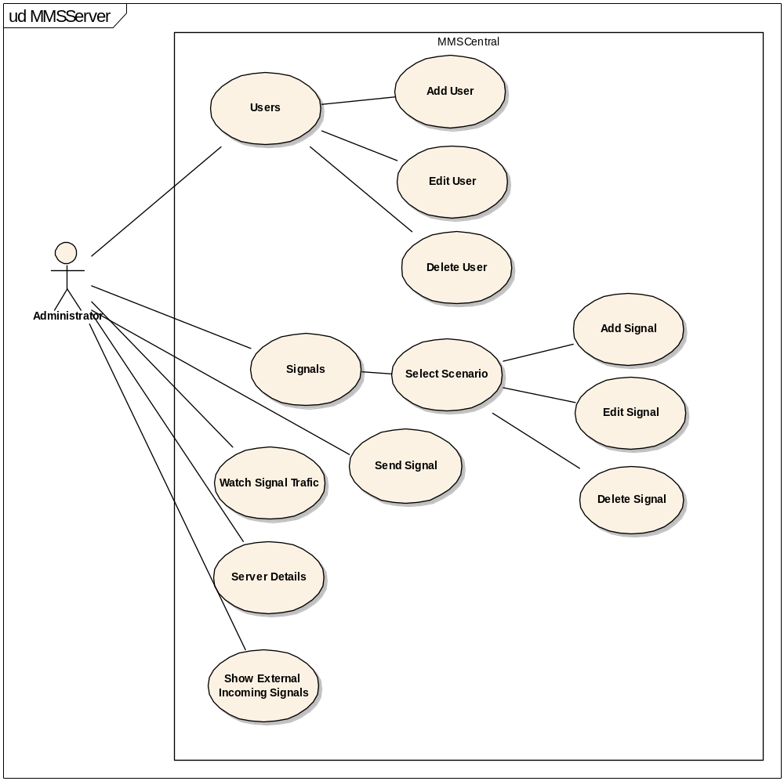

Start application
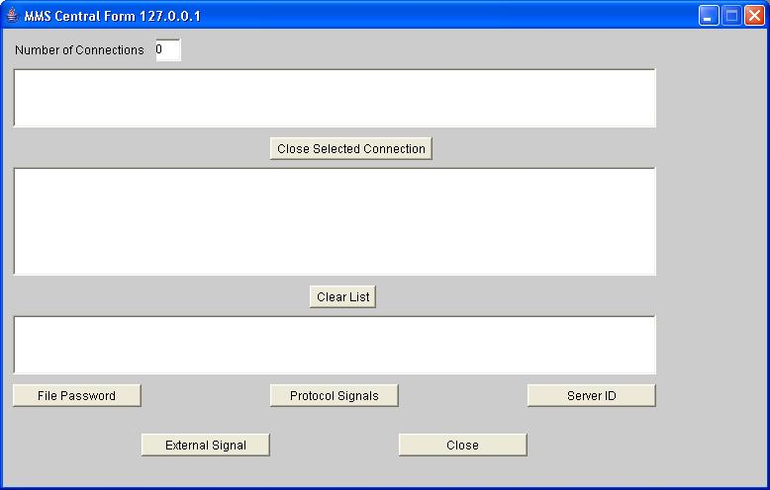

When the server application open check if there are the basics folders. If these folders there are not, the server application creates them. The basic folders are ExternalProcess, Media, Pictures, System and TransferFiles. ExternalProcess folder must be contained all extended executable files that are saved by the user of server application. Media folder must be contained all media files (sound, video) that are saved by the user of server application. Pictures folder must be contained all image files that are saved by the user of server application. System folder contains all file that create and control the server application. TransferFiles contains all files that are sent by the clients.
After check or generate basic folders open a server socket and listen the TCP port 5000.
Initialize MMSCentral
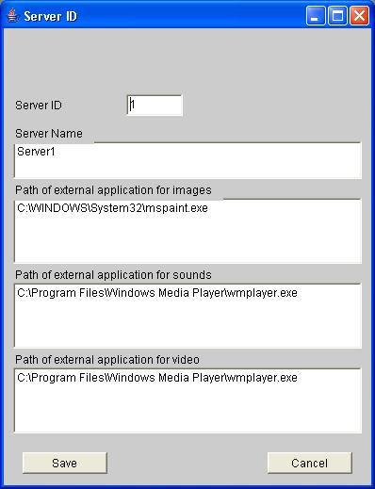
User’s management
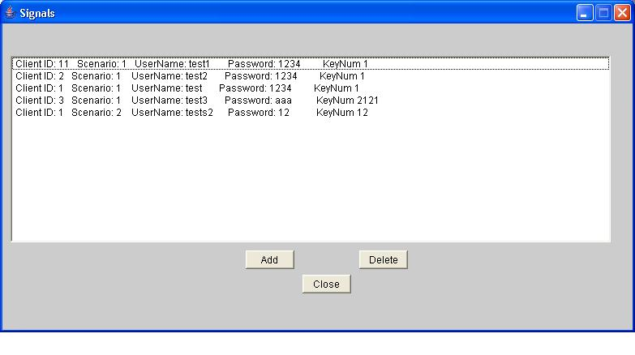

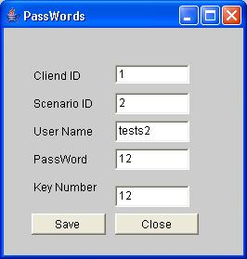

Signal’s Management

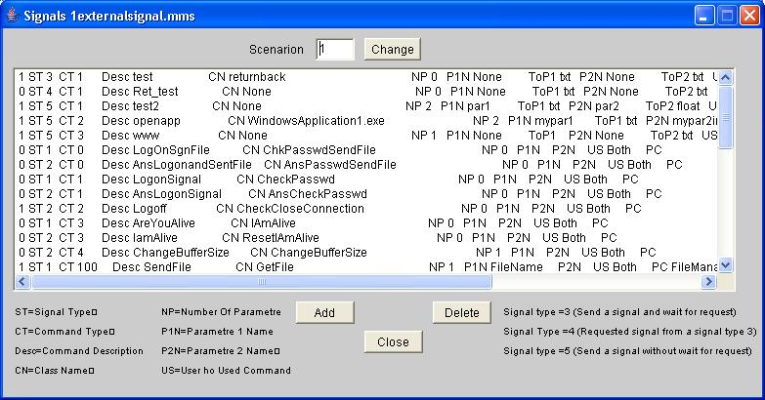

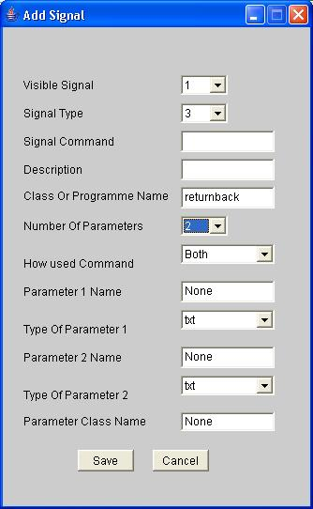

When a client try to connect

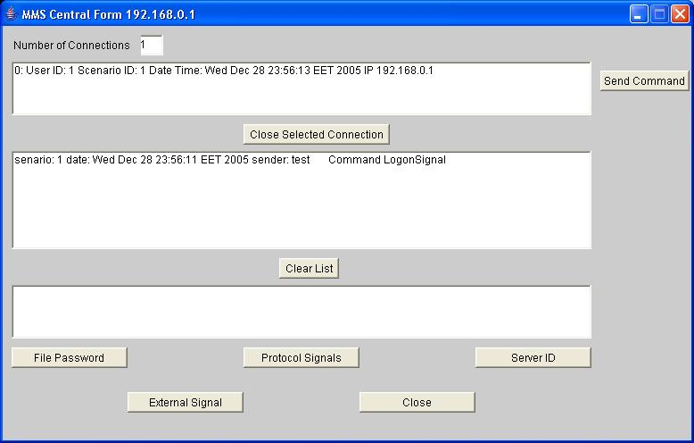

Server application listens on port 5000. If server application listens a client to try creates a socket connection then creates a socket client in an other TCP port and establishes a socket connection. Server application receives the first signal. First signal must be a “logon signal” or a “logon signal file”.
The type of signal is recognized form signal type field and signal command filed from signal. Check these signal fields with signal properties in “controlprotocol” class. Server application decrypts the data in signal packet field Data1 and Data2. Take from signal the client ID, from Data 1 the user name and from Data2 the password .Check the client ID, user name and password from signal with the data from “paswdf.mms” file. If finds a record in “paswdf.mms” file with the same properties with signal then creates a connection session with the client and sends back a “Answer Logon Signal” signal or a “Answer Logon Signal File” signal with the value “OK” in the signal packet field Data1. If sends a signal “Answer Logon Signal File” in the signal packet field Data2 sends the data of “externalsignal.mms” file. If do not find a record in “paswdf.mms” file with the same properties with signal then sends back a “Answer Logon Signal” signal or a “Answer Logon Signal File” signal with the value “NO” in the signal packet field Data1.
Check connected client
Server application runs a loop and checks all connected clients from connection session. Checks if the client is alive and if there is a external signal for this client.
When a client send a signal
Now there is a socket connection between client and server. Serve knows the connected clients from the connection session that server has created. A signal is arrived by the client application. Server application decrypts the data in signal packet field Data1 and Data2. Show signal in arrived signal list. Check if server application expects an other signal. If does not expects an other signal or if this signal is the expected signal then check these signal fields with signal properties in “control protocol” class (For signal Type 1 and 2) or in “externalsignal.mms” file(For signal Type 3 ,4 and 5) else ignores this signal. Call the class or run the program that is described in class name signal property. Writes the description of signal to “PreviewsIncSignal.txt” file. Writes to the session the date and time that is arrived the last signal by the specific client.
Server sends a signal
When the server application sends a signal first of all encrypts the data in signal packet field Data1 and Data2. Tries to sends signal if client connection is ok then sends signal and checks the signal type field in sent signal. If signal type field in sent signal is type 2 of 3 then puts a record in answer signal list , with this list server application is able to know if is waited for a response by a client.

Server sends an external signal
Server user administrate the accounts
Server user administrate signals
Server user administrate the settings for server application
Server check if connection is Alive
User manual for the server application
Extented applications

Client
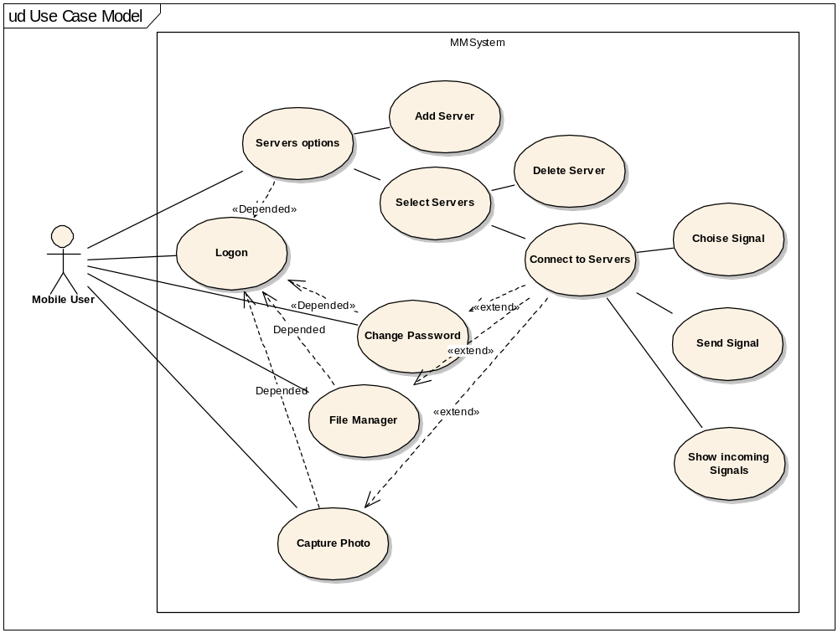

Control Protocol Signals and Signal Properties
In this section below we can see the list of signals in control protocol and the signal properties specification for these. These specifications are in ControlProtocol.class file.

Signal Name | Logon Signal File
Signal Description | This signal is sent by the client to require the server to logon and if the logon is accepted the server sends the externalsignal.mms file.
Signal Properties
Signal Type | 1
Signal Command | 0
Visible | 0
Used Command | Both
Description | LogOnSgnFile
Class Name | ChkPasswdSendFile
Parameters | 0
Parameter 1Name | None
Parameter 1 Type | 0
Parameter 2Name | None
Parameter 2 Type | 0
Parameter Class | None

Signal Name | Answer Logon Signal File
Signal Description | This signal is sent by the server as response to Logon Signal File
Signal Properties
Signal Type | 2
Signal Command | 0
Visible | 0
Used Command | Both
Description | AnsLogonandSentFile
Class Name | AnsPasswdSendFile
Parameters | 0
Parameter 1Name | None
Parameter 1 Type | 0
Parameter 2Name | None
Parameter 2 Type | 0
Parameter Class | None

Signal Name | Logon Signal
Signal Description | This signal is sent by client to require the server to logon.
Signal Properties
Signal Type | 1
Signal Command | 1
Visible | 0
Used Command | Both
Description | LogonSignal
Class Name | CheckPasswd
Parameters | 0
Parameter 1Name | None
Parameter 1 Type | 0
Parameter 2Name | None
Parameter 2 Type | 0
Parameter Class | None

Signal Name | Answer Logon Signal
Signal Description | This signal is sent by the server response to Logon Signal.
Signal Properties
Signal Type | 2
Signal Command | 1
Visible | 0
Used Command | 0
Description | AnsLogonSignal
Class Name | AnsCheckPasswd
Parameters | 0
Parameter 1Name | None
Parameter 1 Type | 0
Parameter 2Name | None
Parameter 2 Type | 0
Parameter Class | None

Signal Name | Logoff
Signal Description | This signal is sent by the server or client for close a connection.
Signal Properties
Signal Type | 2
Signal Command | 2
Visible | 1
Used Command | Both
Description | Logoff
Class Name | CheckCloseConnection
Parameters | 0
Parameter 1Name | None
Parameter 1 Type | 0
Parameter 2Name | None
Parameter 2 Type | 0
Parameter Class | None

Signal Name | Are You Alive
Signal Description | This signal is sent by the server or client for check if connection is alive.
Signal Properties
Signal Type | 1
Signal Command | 3
Visible | 0
Used Command | Both
Description | AreYouAlive
Class Name | IAmAlive
Parameters | 0
Parameter 1Name | None
Parameter 1 Type | 0
Parameter 2Name | None
Parameter 2 Type | 0
Parameter Class | None

Signal Name | I Am Alive
Signal Description | This signal is sent by the server or client as response r to Are You Alive signal.
Signal Properties
Signal Type | 2
Signal Command | 3
Visible | 0
Used Command | Both
Description | IamAlive
Class Name | ResetIAmAlive
Parameters | 0
Parameter 1Name | None
Parameter 1 Type | 0
Parameter 2Name | None
Parameter 2 Type | 0
Parameter Class | None

Signal Name | Send a File
Signal Description | This signal is sent by the server or client when they want to sent a file.
Signal Properties
Signal Type | 1
Signal Command | 100
Visible | 1
Used Command | Both
Description | SendFile
Class Name | GetFile
Parameters | 1
Parameter 1Name | FileName
Parameter 1 Type | 0
Parameter 2Name | None
Parameter 2 Type | 0
Parameter Class | FileManager

Signal Name | Received Sent File
Signal Description | This signal is sent by the server or client as response to Send a File signal
Signal Properties
Signal Type | 2
Signal Command | 100
Visible | 0
Used Command | Both
Description | RecievedSendedFile
Class Name | None
Parameters | 1
Parameter 1Name | FileName
Parameter 1 Type | 0
Parameter 2Name | None
Parameter 2 Type | 0
Parameter Class | FileManager

Signal Name | Send Me a File
Signal Description | This signal is sent by the server or client to require to receive a file .
Signal Properties
Signal Type | 1
Signal Command | 101
Visible | 1
Used Command | Both
Description | SendMeFile
Class Name | SendFile
Parameters | 1
Parameter 1Name | FileName
Parameter 1 Type | 0
Parameter 2Name | None
Parameter 2 Type | 0
Parameter Class | SendMeFile

Signal Name | Received a File
Signal Description | This signal is sent by the server or client as response to Send Me a File signal
Signal Properties
Signal Type | 2
Signal Command | 101
Visible | 0
Used Command | Both
Description | RecieveFile
Class Name | GetFile
Parameters | 1
Parameter 1Name | FileName
Parameter 1 Type | 0
Parameter 2Name | None
Parameter 2 Type | 0
Parameter Class | None

Signal Name | Send an Image
Signal Description | This signal is sent by the server or client when they want to sent an image.  Image showing immediately .
Signal Properties
Signal Type | 1
Signal Command | 102
Visible | 1
Used Command | Both
Description | SendImage
Class Name | ShowSendImage
Parameters | 1
Parameter 1Name | ImageName
Parameter 1 Type | 0
Parameter 2Name | None
Parameter 2 Type | 0
Parameter Class | FileManager

Signal Name | Received an Image File
Signal Description | This signal is sent by the server or client as response to Send an Image signal
Signal Properties
Signal Type | 2
Signal Command | 102
Visible | 0
Used Command | Both
Description | RecievedImageFile
Class Name | None
Parameters | 1
Parameter 1Name | ImageName
Parameter 1 Type | 0
Parameter 2Name | None
Parameter 2 Type | 0
Parameter Class | FileManager

Signal Name | Send a Media File
Signal Description | This signal is sent by the server or client when they want to sent a media file.  Media file play immediately .
Signal Properties
Signal Type | 1
Signal Command | 103
Visible | 1
Used Command | Both
Description | SendMedia
Class Name | PlayMedia
Parameters | 1
Parameter 1Name | MediaName
Parameter 1 Type | 0
Parameter 2Name | None
Parameter 2 Type | 0
Parameter Class | FileManager

Signal Name | Received a Media File
Signal Description | This signal is sent by the server or client as response to Send a Media File signal
Signal Properties
Signal Type | 2
Signal Command | 103
Visible | 0
Used Command | Both
Description | RecievedMediadFile
Class Name | None
Parameters | 1
Parameter 1Name | ImageName
Parameter 1 Type | 0
Parameter 2Name | None
Parameter 2 Type | 0
Parameter Class | FileManager

Signal Name | Get Actives Users
Signal Description | This signal asks to receive a file with all actives users in this scenario.
Signal Properties
Signal Type | 1
Signal Command | 104
Visible | 1
Used Command | Client
Description | GetActiveUsers
Class Name | SendUsersFile
Parameters | 0
Parameter 1Name | None
Parameter 1 Type | 0
Parameter 2Name | None
Parameter 2 Type | 0
Parameter Class | None

Signal Name | Received Actives Users
Signal Description | This signal is sent by the server or client as response to Get Actives Users signal with the active users file.
Signal Properties
Signal Type | 2
Signal Command | 104
Visible | 0
Used Command | Server
Description | RecievedActiveUsersList
Class Name | GetFile
Parameters | 1
Parameter 1Name | AcitveUsersFile
Parameter 1 Type | 0
Parameter 2Name | None
Parameter 2 Type | 0
Parameter Class | None

Signal Name | Get All Users List
Signal Description | This signal asks to receive a file with all users in this scenario.
Signal Properties
Signal Type | 1
Signal Command | 105
Visible | 1
Used Command | Client
Description | GetAllUsers
Class Name | SendUsersFile
Parameters | 0
Parameter 1Name | None
Parameter 1 Type | 0
Parameter 2Name | None
Parameter 2 Type | 0
Parameter Class | None

Signal Name | Received All Users List
Signal Description | This signal is sent by the server or client as response to Get All Users List signal with the all users file.
Signal Properties
Signal Type | 2
Signal Command | 105
Visible | 0
Used Command | Server
Description | RecievedAllUsersList
Class Name | GetFile
Parameters | 1
Parameter 1Name | AllUsersFile
Parameter 1 Type | 0
Parameter 2Name | None
Parameter 2 Type | 0
Parameter Class | None

Signal Name | Send Message to a User
Signal Description | This signal is sent by the client a message to an other client (through the server)
Signal Properties
Signal Type | 1
Signal Command | 106
Visible | 1
Used Command | Client
Description | SendMsgToUser
Class Name | ForwardMsg
Parameters | 2
Parameter 1Name | UserName
Parameter 1 Type | 0
Parameter 2Name | Message
Parameter 2 Type | 0
Parameter Class | SendMsgtoUser

Signal Name | Sending Message
Signal Description | This signal is sent by the server as response to Send Message to a User for say to client that has take the message and forward this.
Signal Properties
Signal Type | 2
Signal Command | 106
Visible | 0
Used Command | Both
Description | SendingMsg
Class Name | None
Parameters | 1
Parameter 1Name | UserName
Parameter 1 Type | 0
Parameter 2Name | None
Parameter 2 Type | 0
Parameter Class | None

Signal Name | Received a Message
Signal Description | This signal is sent by the server as forward message.
Signal Properties
Signal Type | 1
Signal Command | 107
Visible | 0
Used Command | Server
Description | RecieveAMsg
Class Name | ShowMsg
Parameters | 2
Parameter 1Name | UserName
Parameter 1 Type | 0
Parameter 2Name | Message
Parameter 2 Type | 0
Parameter Class | None

Signal Name | Message Received From User
Signal Description | This signal is sent by the client as response to Received a Message signal.
Signal Properties
Signal Type | 2
Signal Command | 107
Visible | 0
Used Command | Both
Description | MsgRecievedFromUser
Class Name | None
Parameters | 1
Parameter 1Name | UserName
Parameter 1 Type | 0
Parameter 2Name
Parameter 2 Type | 0
Parameter Class | None

Signal Name | Send a File to a User
Signal Description | This signal is sent by the client a message and a file to an other client (through the server)
Signal Properties
Signal Type | 1
Signal Command | 108
Visible | 1
Used Command | Client
Description | SendFiletoUser
Class Name | ForwardFile
Parameters | 1
Parameter 1Name | par1
Parameter 1 Type | 0
Parameter 2Name
Parameter 2 Type | 0
Parameter Class | SendFiletoUser

Signal Name | Sending a File Message
Signal Description | This signal is sent by the server as response to Send a File to a User for say to client that has take the message and the file and forward these.
Signal Properties
Signal Type | 2
Signal Command | 108
Visible | 0
Used Command | Both
Description | SendingFileMsg
Class Name | None
Parameters | 2
Parameter 1Name | UserName
Parameter 1 Type | 0
Parameter 2Name | FileName
Parameter 2 Type | 0
Parameter Class | None

Signal Name | Received a File Message
Signal Description | This signal is sent by the server as forward message and file
Signal Properties
Signal Type | 1
Signal Command | 109
Visible | 0
Used Command | Server
Description | RecieveAFileMsg
Class Name | ShowFileMsg
Parameters | 1
Parameter 1Name | UserName
Parameter 1 Type | 0
Parameter 2Name
Parameter 2 Type | 0
Parameter Class | None

Signal Name | File Message Received From User
Signal Description | This signal is sent by the client as response to Received a File Message signal.
Signal Properties
Signal Type | 2
Signal Command | 109
Visible | 0
Used Command | Both
Description | FileMsgRecievedFromUser
Class Name | None
Parameters | 2
Parameter 1Name | UserName
Parameter 1 Type | 0
Parameter 2Name | FileName
Parameter 2 Type | 0
Parameter Class | None

Signal Name | Get Available Files
Signal Description | This signal is sent by the client to require from server to send a list with all available file for transfer.
Signal Properties
Signal Type | 1
Signal Command | 110
Visible | 1
Used Command | Client
Description | GetAvaliableFiles
Class Name | SendAvaliableFiles
Parameters | 0
Parameter 1Name | None
Parameter 1 Type | 0
Parameter 2Name | None
Parameter 2 Type | 0
Parameter Class | None

Signal Name | Received Available Files
Signal Description | This signal is sent by the server as response to Get Available Files signal
Signal Properties
Signal Type | 2
Signal Command | 110
Visible | 0
Used Command | Server
Description | RecievedAvaliableFileList
Class Name | GetFile
Parameters | 1
Parameter 1Name | AvaliableFiles
Parameter 1 Type | 0
Parameter 2Name | None
Parameter 2 Type | 0
Parameter Class | None

