ASSIGNMENT 3

Use the both Big M method and Two-stage simplex method to solve the following problems:
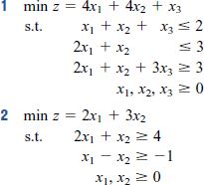

Question 1
Big M method
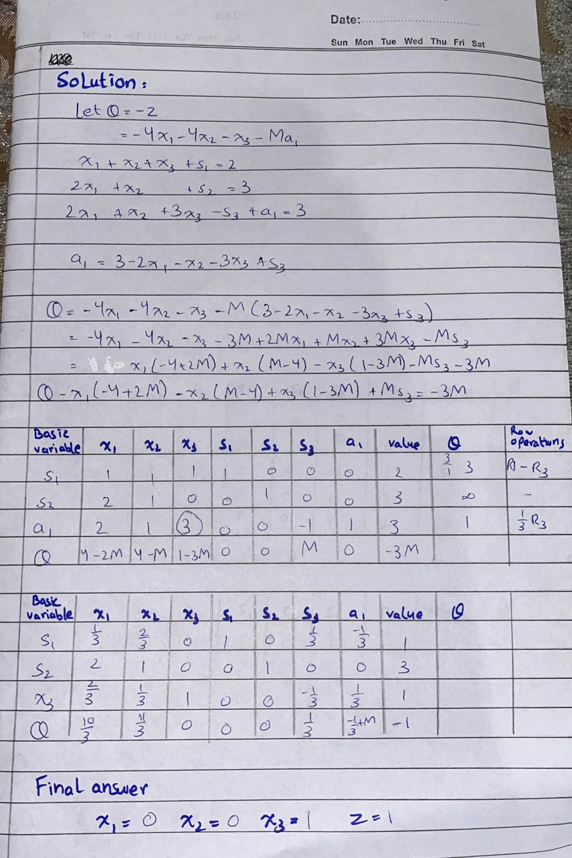

TWO STAGE
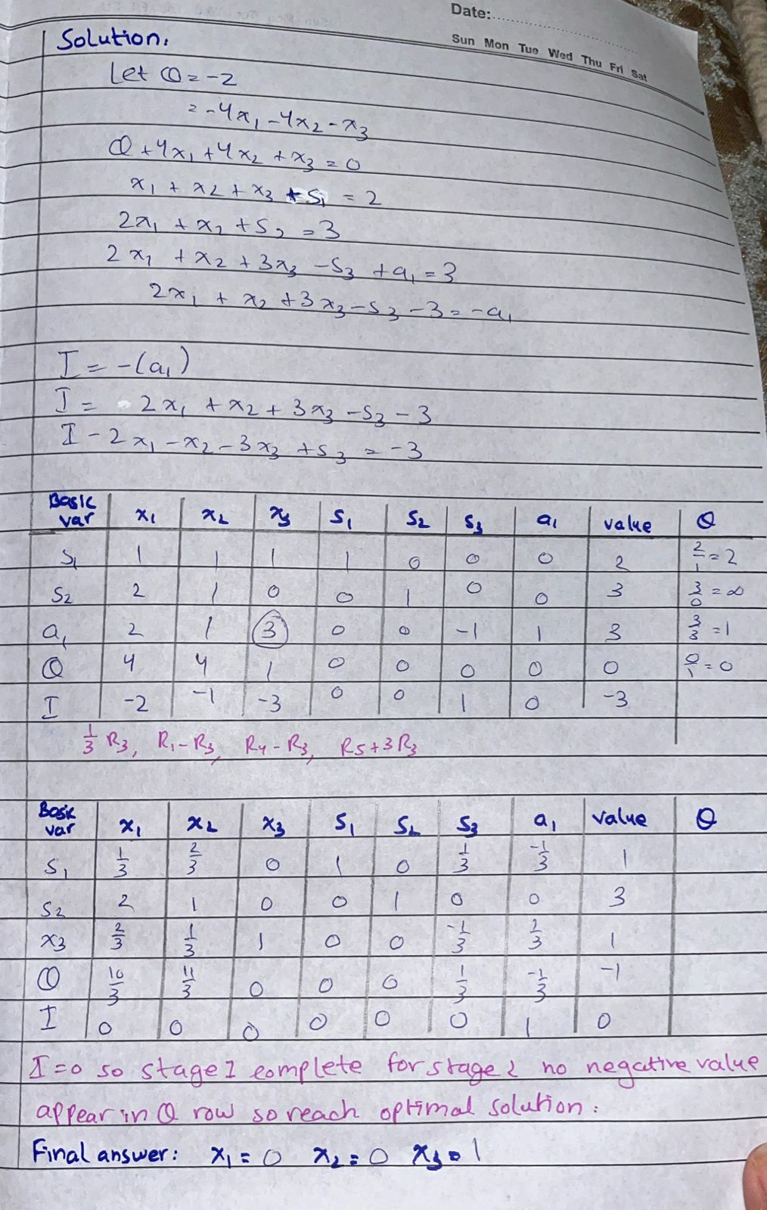

Question 2
BIG M
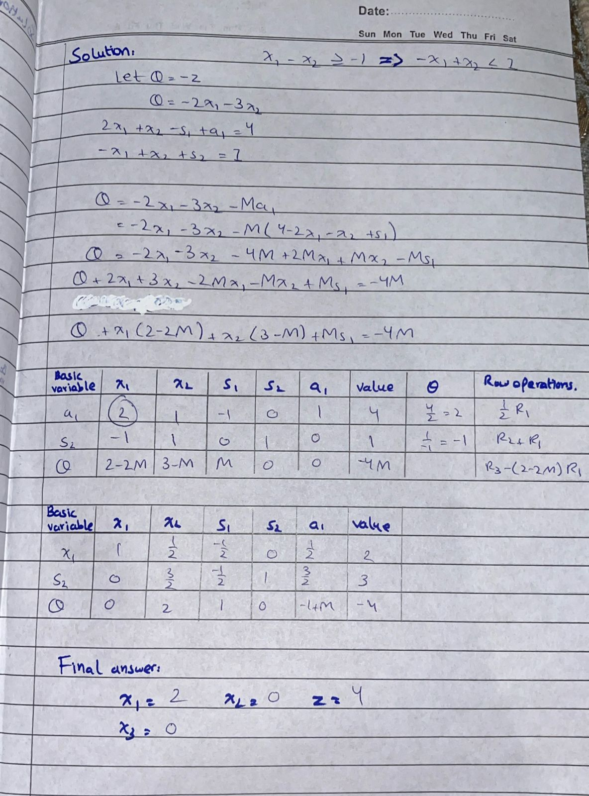

TWO STAGE
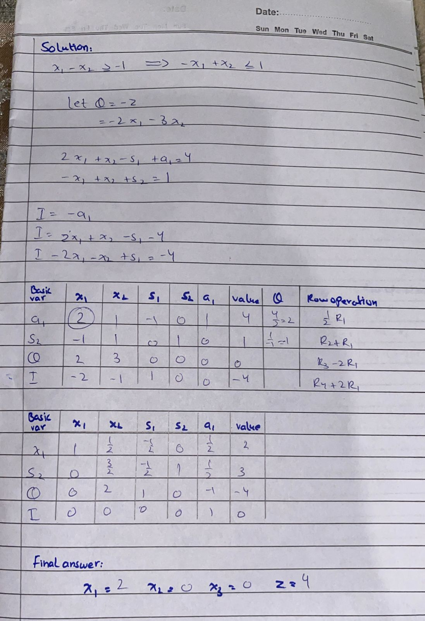

INSTRUCTIONS:
- Submission deadline:4th June, 2025 (Wednesday)
- Submit on Google Classroom
- Submit PDF only (Not multiple PDFs in one file, only 1 complete PDF document)
- Individual Assignment
- Copied assignment from any source (from internet or class fellows) marked as Zero.
- Late assignment will not be accepted.

