 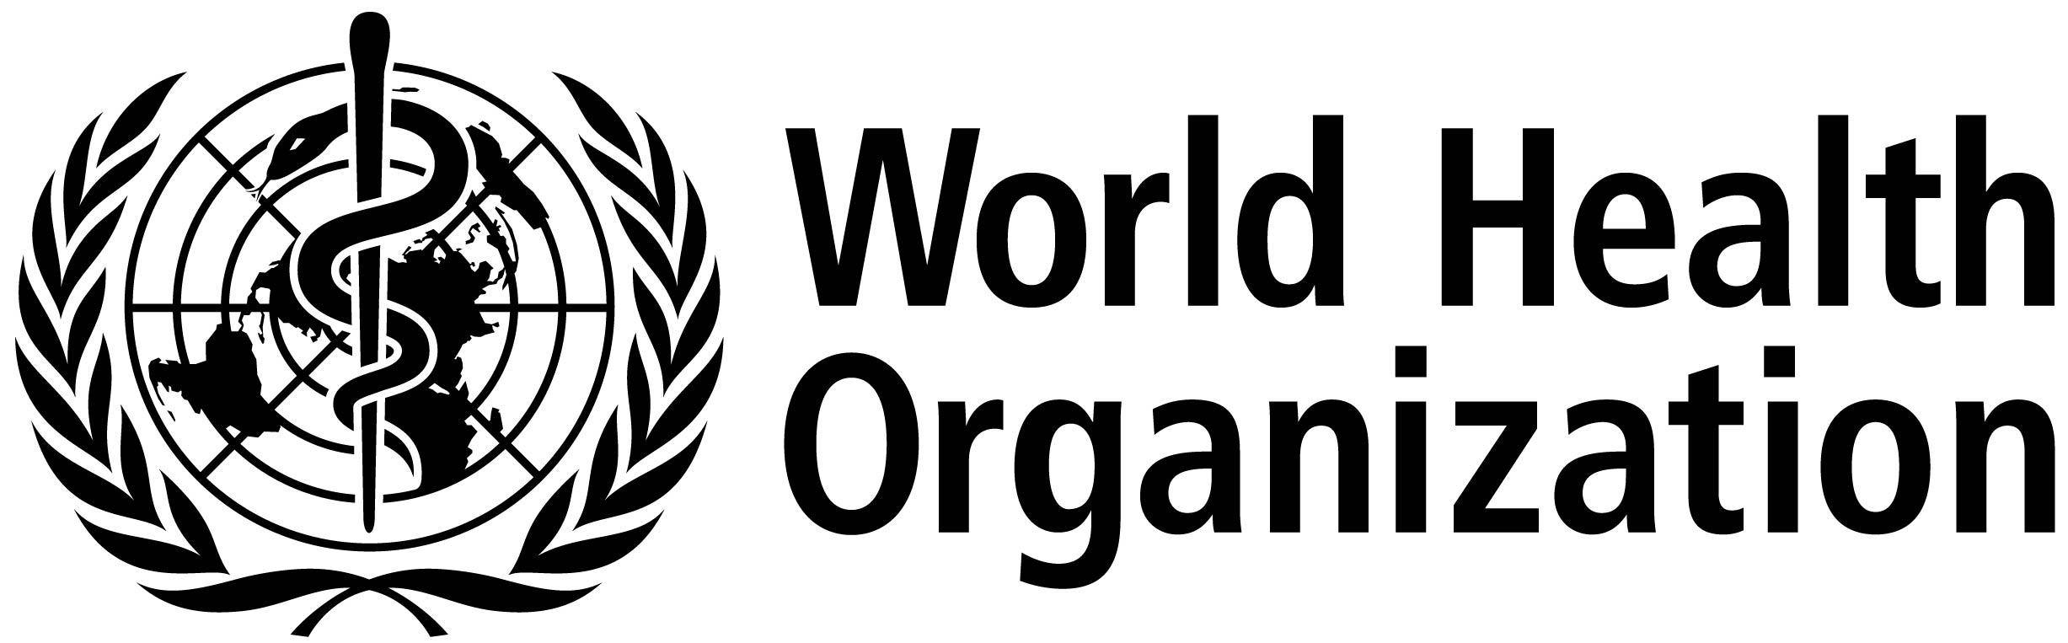

**ISARIC/WHO Severe Acute Respiratory Infection Biological Sampling Study**

**Cartoon information sheet for discussing study with young children**

**13th May 2013. Version 2.5.0**

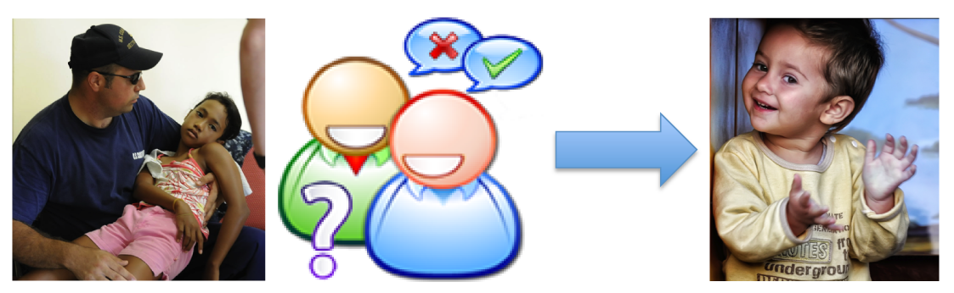

We want to find out why a problem with your chest is making you unwell so that we can help other children like you. To help us find out more about what is making you and other children unwell we will take some extra samples of blood and other samples while you are in hospital.

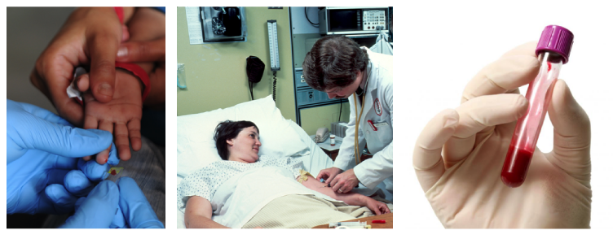

Blood samples will be taken by finger prick or existing lines. The sample will be small. Numbing cream can be used.

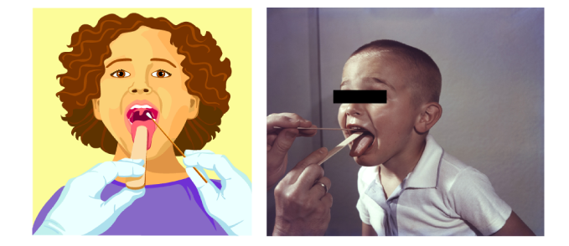

Throats will be wiped (swabbed) using cotton buds This does not hurt, but can tickle a bit. Samples of poo (stool), wee (urine), snot (nasal aspirate) and cough spit (phlegm) will also be collected when you make them.