 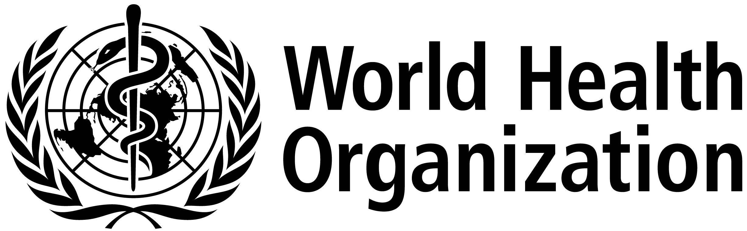

**ISARIC/WHO Severe Acute Respiratory Infection Biological Sampling Study**

**INFORMATION SHEET FOR CHILDREN YOUNGER THAN 12 YEARS OLD**

**13th May 2013. Version 2.5.0**

Parents and carers are asked to go through this information with their child.

Please consider using the cartoon sheet to help explain the study to young children.

Please ask study staff if you or your child has any questions.

We want to find out why a problem with your chest is making you unwell so that we can help other children like you.

**What does this mean for me?**

To help us find out more about what is making you and other children unwell we will take some extra samples of blood and other samples while you are in hospital.

These are extra to what would normally be collected for your care:

* a small blood sample
* one throat swab (a wipe with a cotton bud) from your throat
* a swab from any sore skin
* a bit of sputum (chest spit / phlegm) sample
* a small urine sample (wee)
* a small stool sample (poo) or rectal (bottom) swab.

The amount of blood will depend on how big you are. We will weigh you so that we only take a safe amount. We will explain how much blood will be taken at each visit. We will also keep any leftover samples from your normal care. We will make sure the amount of blood is as small as possible.

We will take the same samples again over the next two weeks , every other day, . When you are better will ask you to return to the hospital or clinic in 3 and 6 months time to give us one more blood sample.

**Do I have to take part?**

It is up to you and your parents to decide if you should be involved in helping us.

If you don't want to be involved, then you don't have to.

Either way, your decision will not affect your care and treatments in any way.

**What will happen to the samples and information?**

We will use the samples to see how your body fights the infection and how the treatment works.

All information about you will be kept private.

**Are there any benefits to taking part in this study?**

No. By helping us find out more about why you are ill, we will be able to help look after children better in the future.

Being a part of this study means that more samples will be taken than are needed for normal care.

 

**YOUNG CHILD (<12 YEARS OLD) ASSENT FORM**

**Emerging Severe Acute Respiratory Infection Observational Study**

Please tick (✔) the boxes if you agree. If you don't agree, leave the boxes empty or put an x in the box.

* I have been told about the study and given the information sheet about it and have had the chance to ask questions ❑
* I know I don't have to take part. If I do, I can change my mind - the doctors and nurses will still look after me ❑
* I do not mind if someone doing the research looks at my medical records - I know the people doing the research will keep personal things about me private ❑
* I agree to take part ❑

Patient name:___________________________________ Signature:______________________ Date:__________

Person taking consent:___________________________________ Signature:______________________ Date:__________