 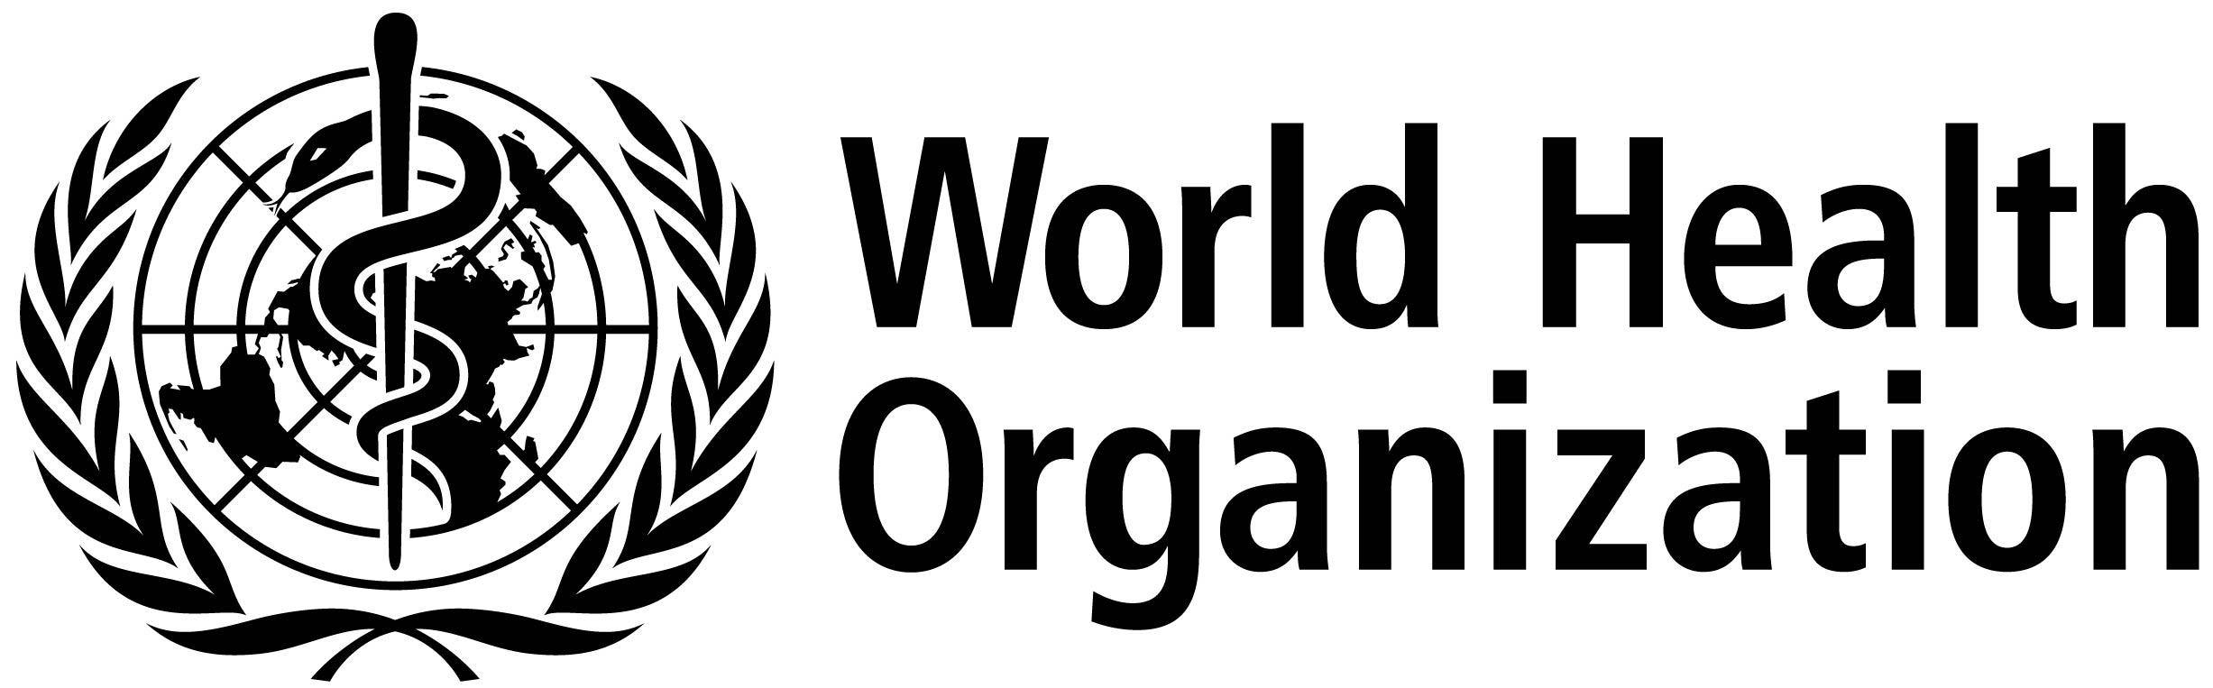

**ISARIC/WHO Severe Acute Respiratory Infection Biological Sampling Study**

**INFORMATION SHEET FOR CONSULTEE**

**13th May 2013. Version 2.5.0**

We are undertaking a research study involving people with severe acute respiratory infections. We are asking you about the participation of an individual who is not able to consent for themselves, because he/she lacks the legal capacity to do so. To help decide if he/she should join the study, we would like to ask your opinion whether or not he/she would want to be involved.

Before you decide it is important for you to understand why the research is being done and what it would involve for the participant. Please take time to read this information carefully. One of our team will go through the information with you. Please ask us if there is anything that is not clear or if you would like more information and time to decide. Your decision is completely voluntary. The decision you make will not affect the participant's care or treatment in any way.

**What is the study about?**

Infectious diseases affect millions of people around the world every year. Most cases are mild, but some people become very unwell. There is a great deal that we do not understand about existing infections, and new infectious diseases continue to appear. This research study will gain important information about respiratory infections so we can try to find better ways to manage and treat them in the future.

**What will happen if I take part in this study?**

We will collect information and samples which are in addition to what would normally be collected for the participant's medical care.

A blood sample will be taken now, together with a swab from the participant's throat, a swab from any infected sites/sores, a sputum sample, urine sample and a stool sample or rectal swab.

We will take the same samples again over the next two weeks, every second day and then every week for as long as the pariticipant is unwell up to a maximum of 100 days. We will also invite the participant to return to the hospital or clinic in 3 months and 6 months to have a blood sample taken. Each sample will take less than 15mls (3 teaspoons) of blood.

If any other samples are taken from the participant for regular care, and if there is leftover sample after the tests requested by the participant's doctors are done, we will store the leftover to be tested.

**What will happen to the samples and information?**

We will use the blood samples to look at how the body fights the infection and how the treatments work in the body. We will also use the blood sample to analyse the participant's DNA. We will examine the participant's DNA together with DNA from many other people to try to find out what makes some people more susceptible to infection. Some of the tests may be done in different countries.

All information about the participant will be handled in confidence and only the people responsible for the participant's care and for this study will know that the participant were a part of the study. We will review the participant's medical records and keep limited information about the participant on a secure file. All information and samples will be labelled only with a number so that they cannot be directly linked to the participant personally. With your permission, we would also like to store the participant's samples and use them for future ethically approved medical research. The data and samples collected during this study may be looked at by public health agencies.

**Are there any benefits to taking part in this study?**

There is no benefit to you or the participant personally. The information gained from this study may not be available in time to affect the participant's care. Any results available while the pariticipant is in hospital will be given to your treating doctor. The information we learn may help in caring for other patients in the future.

**What are the risks of being in the study?**

Being a part of this study means that more samples will be taken than are needed for normal care. Whenever possible these samples will be taken at the same time as regular samples to reduce the extra procedures. There is a risk of pain or irritation when samples are taken.

When DNA testing is done, there is a small chance that the results will show a genetic condition that could affect the participant's future health. Since the tests will be conducted anonymously, no-one on the study team will know that such a result applies to the participant, and in any case there is usually considerable uncertainty about the implications of any research DNA test result for individual health. For these reasons we would not attempt to identify the participant or inform the participant of any results from DNA testing.

**Who is responsible and what if something goes wrong?**

[***insert sponsor and contact details***]

**Can I request that I be withdrawn from the study at any point?**

Yes, you or the participant can withdraw at anytime without giving a reason and without affecting the participant's care. Any samples that have not already been analysed can be destroyed anytime you or the participant request it.

**What if I have any problems or would like further information about the study?**

[***insert details***]