Subnetting

Using the given network address **192.168.40.0**, all interfaces should be configured with appropriate IP addresses, subnet mask and gateways

So, according to our topology diagram,  
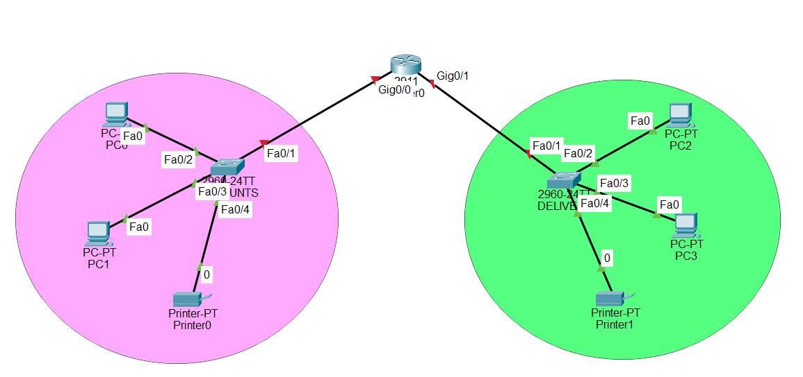  
So we have 2 department means we have N = 1 Bit network  
now lets perform subnetting

The IP address 192.168.40.0 belongs to class C  
so we have Network Bits is 24 and Host Bits is 8

2^n = 2^1 = 2

N = 1,

11111111.11111111.11111111.10000000

8+8+8+1 =25

255.255.255.128

So,

N = 4, $S_{n}=1$, H = 7

Now,

|  |
| --- |
| N $S_{n}$ H |
| 192.168.40. 0 0000000 |
| 192.168.40. 1 0000000 |

* 192.1.1.0
* 192.1.1.128

|  |
| --- |
| So the subnet mask is 255.255.255.128 |
| Network ID 192.168.40.0 |
| Range of Valid Host 192.168.40.1 – 192.168.40.126 |
| Broadcast Id 192.168.40.127 |

1st Subnet:

Subnet mask = 255.255.255.128

Network ID = 192.168.40.0

Range of Valid Host = 192.168.40.1 – 192.168.40.126

Broadcast ID = 192.168.40.127

2nd Subnet

Subnet mask = 255.255.255.128

Network ID = 192.168.40.128

Range of Valid Host = 192.168.40.129 – 192.168.40.254

Broadcast ID = 192.168.40.255

• S**ubnet 1:**

* Start (Network ID): 192.168.40.0
* End = 192.168.40.0 + 128 - 1 = 192.168.40.127 → ✅ **Broadcast address**
* Usable Hosts: 192.168.40.1 to 192.168.40.126

• **Subnet 2:**

* Start (Network ID): 192.168.40.128
* End = 192.168.40.128 + 128 - 1 = 192.168.40.255 → ✅ **Broadcast address**
* Usable Hosts: 192.168.40.129 to 192.168.40.254