Subnetting

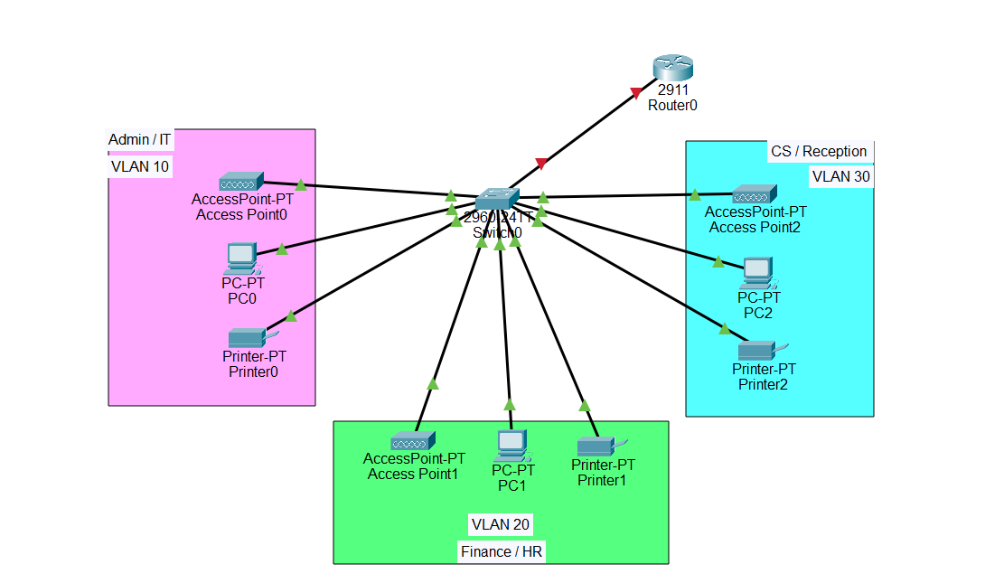

**Base Network**

**192.168.1.0**

**No of subnets** = 3

**No of Subnets** = 2^n

**n** = number of borrowed network bits

so we have no of subnets 3 so we take number of bits(n) greater then No of subnets or equivalent to No of subnets

so in this case we take

n = 2

Class C subnet mask is 255.255.255.0

11111111. 11111111.11111111. 00000000

So we borrow to bits which is n = 2 to satisfied the condition

11111111. 11111111.11111111.11000000 / 26

So covert it to Decimal it becomes

255.255.255.192

So new subnet mask is : 255.255.255.192

**Block Size Calculation:**

Block Size formula:  
256 - Subnet Mask’s last octet  
256 - 192 = 64

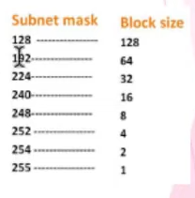

192 represent bock size of 64

* **1st Subnet**

Network ID : 192.168.1.0/26

Broadcast ID : 192.168.1.63

Host Range: 192.168.1.1 – 192.168.1.62

**So for second Subnet mask the 1st Network ID + Blocksize**

* **2nd Subnet**

Network ID : 192.168.1.0 +64 = 192.168.1.64/26

Broadcast ID : 192.168.1.127

Host Range: 192.168.1.65 – 192.168.1.126

**So for second Subnet mask the 2nd Network ID + Blocksize**

* **3rd Subnet**

Network ID : 192.168.1.64 + 64 = 192.168.1.128

Broadcast ID : 192.168.1.191/26

Host Range: 192.168.1.129 – 192.168.1.190

|  |  |  |  |
| --- | --- | --- | --- |
| **Subnet** | **Network ID** | **Broadcast ID** | **Host Range** |
| 1 | 192.168.1.0/26 | 192.168.1.63 | 192.168.1.1 – 192.168.1.62 |
| 2 | 192.168.1.64/26 | 192.168.1.127 | 192.168.1.65 – 192.168.1.126 |
| 3 | 192.168.1.128/26 | 192.168.1.191 | 192.168.1.129 – 192.168.1.190 |