CENTRAL DATA HUB
BI / Analytics Architecture — Technical Solution Write-Up
InfoMatrix | Daz Tech | Premier


Table of Contents
6.1 Overview and Design Approach 3
6.2 BI / Semantic-Layer Architecture 4
6.3 Proposed BI Tools 7
6.4 Tool-Selection Justification 8
6.5 Integration with the MPP Platform 11
6.6 Integration with the Lakehouse 12
6.7 Integration with Data Governance and Catalog 12
6.8 Self-Service Analytics Architecture 13
6.9 Reporting and Dashboard Architecture 14
6.10 Compute-Cluster Architecture 15
6.11 AI/ML Platform Design 17
6.12 Compliance with Tender Requirements 19
6.13 Conclusion 20

6.1 Overview and Design Approach
This document presents the BI / Analytics architecture proposed for Central Data Hub (CDH), delivered through Pakistan Revenue Automation (Pvt.) Limited (PRAL). It addresses Section 6 of the tender and also provides the two artefacts the evaluation specifically requires: the compute-cluster architecture diagram (Section 6.10) and the AI/ML platform design (Section 6.11).
The CDH is a single, fully on-premises lakehouse that consolidates FBR's transactional systems (including IRIS, eFBR, RegSys and TAMS) into governed Bronze, Silver and Gold layers, held on Oracle AI Database 26ai on Exadata (MPP) and HPE Alletra Storage MP X10000 (object storage), with a Redis Enterprise serving cache. The BI / Analytics tier sits on top of the Gold layer. It turns those governed data products into statutory reports, executive dashboards, officer-facing case lists and self-service analysis, without creating a second copy of the data or a second version of any metric.
Both products are deployed on-premises inside FBR's network perimeter, authenticate through the same SSO / AD identity fabric, read the same certified Gold-layer data products, and are governed through the same catalog. The reference architecture below shows where this tier sits in the overall platform: Zone 11 (Data Consumers) and Zone 4 (Data Science & Analytics), fed by Zone 3 (Central Data Hub) and exposed to applications and partners through Zone 10 (API Framework).
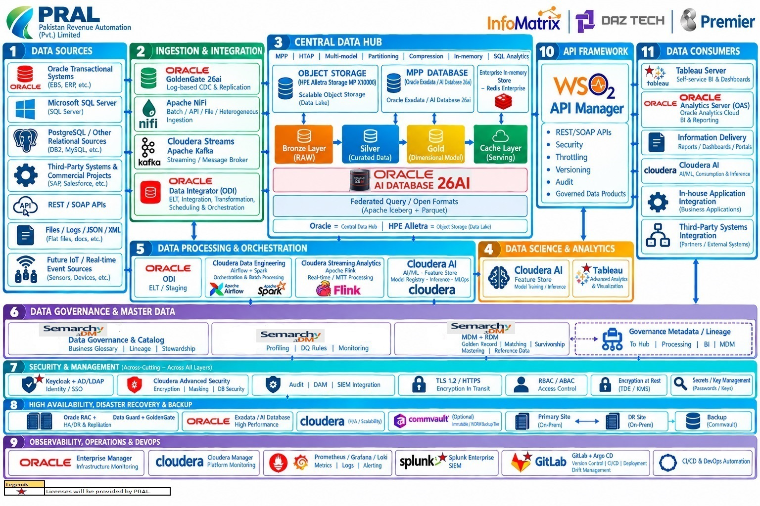
Figure 1 — CDH Reference Architecture Diagram (BI / Analytics components in Zones 4 and 11)

6.1.1 BI / Analytics Design Principles
- One version of the truth: every KPI is defined once in the Gold layer and the semantic layer. Both BI tools consume those definitions; neither redefines them locally.
- Query in place: BI tools query the MPP database and the open-format Lakehouse directly through certified connectors. Data is not bulk-extracted into a separate BI silo.
- Governed self-service: business users build their own analysis on certified, quality-scored data, within guardrails for security, performance and publication.
- Security by design: identity, row- and column-level security, masking and audit are enforced consistently from the database through the semantic layer to the dashboard.
- Fit-for-purpose tooling: statutory pixel-perfect reporting and exploratory visual analytics have different requirements. Each is served by the tool best suited to it, with defined boundaries between them.
- Fully on-premises and air-gapped: no BI, semantic or AI/ML component depends on public cloud services or external connectivity.
6.2 BI / Semantic-Layer Architecture
The BI architecture is organized into five logical layers, shown in Figure 2, with security and governance applied as vertical, cross-cutting planes. Each layer has a single responsibility, so a change in one layer (for example, a new dashboard or a new Gold table) does not require rework in the others.
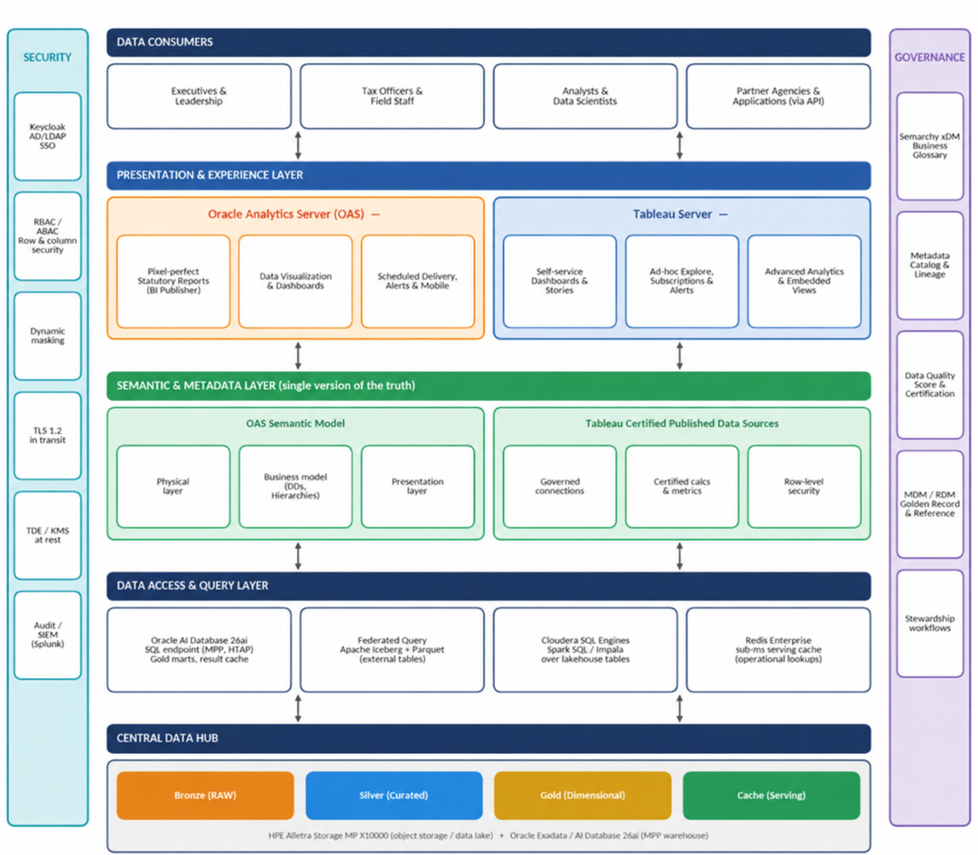

Figure 2 — BI and Semantic-Layer Architecture
Layer | Components | Function
Central Data Hub | Bronze / Silver / Gold / Cache layers on HPE Alletra X10000 and Oracle Exadata / AI Database 26ai | Authoritative, governed data. The Gold layer holds dimensional data products (Taxpayer 360, Compliance Behavior, Revenue Performance, Audit & Enforcement, Refund Management).
Data Access & Query | Oracle AI Database 26ai SQL endpoint; federated query over Apache Iceberg + Parquet; Cloudera SQL engines (Spark SQL / Impala); Redis Enterprise cache | Provides SQL access to warehouse and lake data with workload isolation. The Redis tier serves applications and APIs; BI tools use the SQL endpoints.
Semantic & Metadata | OAS Semantic Model; Tableau Certified Published Data Sources | Translates technical tables into business entities, KPIs, hierarchies and security rules, shared by every report and dashboard built on top.
Presentation & Experience | OAS (BI Publisher, Data Visualization, scheduled delivery); Tableau Server (dashboards, exploration, embedding) | Delivers statutory reports, dashboards and self-service analysis to officers, executives, analysts and (through APIs) partners.
Data Consumers | Executives, tax officers and field staff, analysts and data scientists, partner agencies and applications | Consume certified content through browser, mobile and embedded channels.

6.2.1 Semantic Layer Design
The semantic layer is where raw data structures become business meaning. It is implemented natively in each BI tool, with both models bound to the same Gold-layer tables and the same business definitions held in the governance catalog.
- OAS Semantic Model: a three-layer model comprising a Physical layer (connections and Gold-layer tables), a Business Model and Mapping layer (logical dimensions, facts, hierarchies, calculated measures, time-series functions and aggregation rules), and a Presentation layer (subject areas exposed to report authors in business terminology). Application roles and data filters in the model enforce row- and column-level security, and aggregate persistence can pre-compute high-volume summaries for common drill paths.
- Tableau Certified Published Data Sources: curated data sources published to Tableau Server by designated data stewards, carrying certified joins, calculated fields and metrics, descriptions and row-level security through user filters. Authors connect to the certified source rather than to raw tables, so every workbook inherits the same logic.
- Shared conformed dimensions: Taxpayer, Legal Entity, Tax Product, Filing Period and Geographic Unit dimensions are sourced from the golden-record MDM and reference-data registry, so a taxpayer counted in an OAS statutory report and in a Tableau dashboard is the same taxpayer.
- Metric registry: each enterprise KPI (for example, Net Revenue Collected, Filing Compliance Rate, Refund Turnaround Time) has a business definition, owner and calculation recorded in the Business Glossary, and is implemented once in the Gold layer or the semantic model.

6.2.2 Cross-Cutting Planes
Security (SSO with AD/LDAP single sign-on, RBAC/ABAC, dynamic masking, TLS 1.2, TDE/KMS, audit and SIEM integration) is applied at every layer, so a user sees the same data regardless of which tool or channel they use. Governance (business glossary, catalog and lineage, Data Quality scoring and certification, MDM/RDM and stewardship workflows) supplies the definitions, certification status and lineage that the semantic and presentation layers display and enforce.

6.2.3 BI Platform Integration Architecture
Figure 2A shows how the BI tier is wired to the three platform components named in the tender: the MPP Enterprise Data Warehouse (Oracle AI Database 26ai on Exadata), the Lakehouse (Apache Iceberg and Parquet on HPE Alletra Storage MP X10000) and Data Governance and Catalog (Zone 6). Each integration is numbered in the figure and specified in the interface table that follows, so that the connection mechanism, the data direction and the security treatment of every link are explicit.
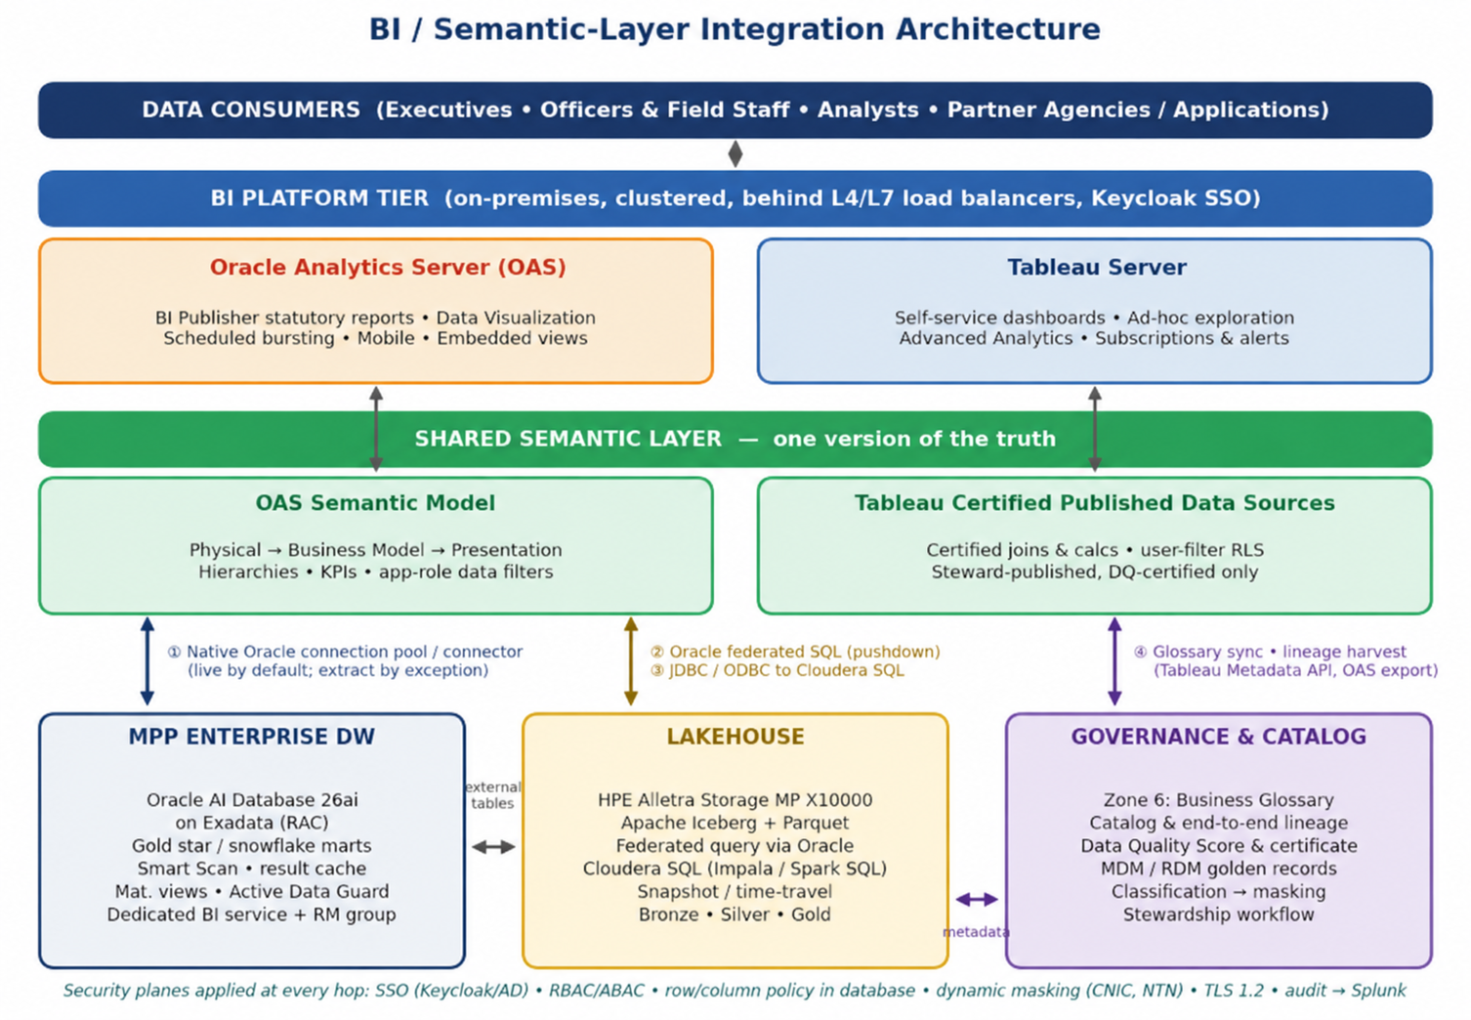

Figure 2A — BI / Semantic-Layer Integration Architecture (MPP, Lakehouse, Governance and Catalog)
# | Integration | Interface and mechanism | Mode and behaviour | Security and control
1 | OAS to MPP Enterprise DW | Native Oracle Database connection pool to a dedicated Exadata database service; the Physical layer maps to Gold-layer tables and views. | Live query with aggregation, filter and join pushdown to Exadata; aggregate persistence for high-volume drill paths. | Read-only service account on certified Gold objects; end-user identity passed through so database row/column policies apply.
1 | Tableau to MPP Enterprise DW | Native Oracle connector to the same Gold-layer schemas. | Live connection by default; scheduled extracts only for very high-concurrency dashboards, refreshed after Gold publication. | Same least-privilege account model; user filters on published data sources; database remains the final control point.
2 | OAS to Lakehouse | Oracle AI Database federated (external-table) query over Iceberg / Parquet on HPE Alletra; JDBC to Cloudera SQL engines where scale-out scans are needed. | In-place access with no bulk copy; lake tables can be joined to warehouse dimensions in one SQL statement; Iceberg snapshots support as-of reporting. | Access governed by the same roles and sensitivity labels; object-store credentials held by the database / engine, never by end users.
3 | Tableau to Lakehouse | Certified Cloudera connectors (Impala / Hive, Spark SQL) over TLS; Oracle connector for lake tables exposed through federation. | Analyst and exploratory workloads on Silver / Gold lake data; Gold remains the default source for broad audiences. | Engine-level authorization and masking; quota-controlled analyst sandbox with catalog registration and audit.
4 | Semantic layer to Governance / Catalog (glossary) | Business Glossary terms and KPI definitions mapped to OAS presentation objects and Tableau data-source fields; descriptions synchronized. | Catalog is the system of record for definitions; BI tools display, and do not redefine, approved terms. | Changes to a KPI definition follow steward approval and GitLab-based change control.
4 | BI metadata to Catalog (lineage) | Tableau Metadata API (GraphQL) and OAS metadata export / REST APIs harvested by the catalog on a schedule. | Lineage extended from Gold tables through the semantic model to report and dashboard. | Read-only harvesting account; lineage visible to stewards and auditors by role.
4 | Catalog to BI (certification and classification) | Data Quality Score and certificate from Zone 6 gate which Gold datasets can be published; sensitivity labels drive masking policies. | Only DQ-certified data appears in subject areas and published data sources; certification status can be shown on dashboards. | PII (for example CNIC, NTN) masked by default and revealed only to approved roles.
5 | BI to Identity and Audit | Keycloak with AD/LDAP single sign-on (SAML / OIDC) for both tools; BI, database and gateway logs forwarded to Splunk. | One identity for OAS, Tableau, database and APIs; every query and content change is attributable to a person. | RBAC / ABAC, TLS 1.2 in transit, TDE / KMS at rest.
6 | AI/ML outputs to BI | Cloudera AI risk scores, anomaly flags and forecasts written back as governed Gold tables. | Surfaced in Tableau and OAS exactly like any other measure; no separate path. | Same certification, lineage and access controls as every Gold data product.

6.3 Proposed BI Tools
The proposed BI estate consists of two products. Each serves a distinct, well-defined role, and together they cover the full range of reporting and analytical needs of a revenue authority.
Product | Role in the platform | Key capabilities
Oracle Analytics Server (OAS) | Enterprise BI and statutory reporting platform | Semantic modelling; pixel-perfect, paginated reporting (BI Publisher) with scheduling and bursting; governed dashboards and data visualization; Excel / PDF export; mobile access; application-role security; native Oracle Database connectivity.
Tableau Server | Governed self-service BI and visual analytics | Drag-and-drop dashboards and exploration; certified published data sources; row-level security; subscriptions and alerts; drill-through to transaction-level detail; embedded views in business applications; web and mobile access.
Tableau Advanced Analytics & Visualization | Advanced analysis for analysts and data scientists (Zone 4) | Statistical functions, forecasting and clustering; visual exploration of model outputs and risk scores published from Cloudera AI.
Tableau licences are provided by PRAL, as indicated by the licence legend in the Reference Architecture Diagram. Both products are deployed as multi-node, on-premises clusters (Section 6.10) behind the platform load balancers, and use SSO / AD/LDAP for single sign-on.

6.3.1 Tool Postioning
To avoid duplication and to give users a clear choice, the two tools are positioned by workload:
Workload | Primary tool | Rationale
Statutory and regulatory reports, pixel-perfect output, scheduled bursting | OAS (BI Publisher) | Paginated, template-driven output with precise layout, scheduled distribution and Excel/PDF export.
Enterprise MIS and certified executive dashboards on the governed semantic model | OAS | Metrics defined once in the semantic model and tightly integrated with Oracle AI Database 26ai.
Self-service exploration, ad-hoc analysis and analyst-built dashboards | Tableau Server | Intuitive visual authoring on certified data sources, supporting rapid exploration without IT involvement.
Officer-facing operational dashboards (risk-prioritized case lists, taxpayer drill-through) | Tableau Server | Interactive filtering and drill-through from summary to transaction level.
Embedded analytics in business applications (for example, Faceless Assessment Center) | Tableau Server / OAS | Both support secured embedding; the choice follows the application's design and the data product it displays.
Advanced statistical analysis and model-output exploration | Tableau Advanced Analytics | Forecasting and statistical functions over Gold data and Cloudera AI outputs.

6.4 Tool-Selection Justification
The proposed tools were selected against the tender's mandatory requirement that the BI tool have native connectivity to the Object Store and MPP platform and support self-service reporting and dashboarding, and against the practical needs of a national tax administration. The assessment below is organized by criterion.
Criterion | OAS | Tableau Server | Assessment
Native connectivity to the MPP platform | Native Oracle Database connectivity to Oracle AI Database 26ai on Exadata; supports query pushdown and Oracle-specific SQL. | Native Oracle connector with live-connection and extract options. | Both meet the requirement for the MPP tier.
Native connectivity to the Object Store / Lakehouse | Reaches Iceberg / Parquet data on HPE Alletra through the Oracle federated-query endpoint and through JDBC connections to Cloudera SQL engines. | Certified connectors for Cloudera Hadoop (Impala / Hive) and Spark SQL, and the Oracle connector for lake tables exposed through federation. | Both reach the object store through engines that read it natively. No bulk copy is required (Section 6.6).
Self-service reporting and dashboarding | Data Visualization for governed self-service on the semantic model. | Industry-leading visual self-service with certified data sources. | Tableau leads for exploratory self-service; OAS covers governed self-service on the enterprise model.
Pixel-perfect statutory reporting | BI Publisher provides paginated, template-driven output with bursting and multi-format export. | Not designed for pixel-perfect paginated output. | OAS is the right tool for statutory reports.
Enterprise semantic layer | Full three-layer semantic model with hierarchies, aggregation and time intelligence. | Published data sources with certified calculations. | OAS holds the enterprise model; Tableau consumes certified definitions aligned to it.
Row- and column-level security | Application roles and model-level data filters; honors database-enforced policies. | User filters and row-level security on data sources; honors database-enforced policies. | Both enforce FBR's access rules. The database remains the final control point.
On-premises / air-gapped deployment | Fully on-premises, with no cloud dependency. | Tableau Server is fully on-premises, with no cloud dependency. | Both satisfy the air-gapped requirement.
Scale and concurrency | Horizontally scalable clustered deployment; aggregate persistence and caching. | Multi-node cluster with dedicated roles for backgrounder, VizQL and data server processes. | Both scale out to meet FBR's officer and executive user base.
Governance and catalog integration | Metadata export and REST APIs for glossary and lineage exchange. | Metadata API (GraphQL) exposes lineage, fields and certification for harvesting. | Both integrate with the governance catalog (Section 6.7).

6.4.1 Why Two Products
A single tool would force a compromise. A tool optimized for paginated statutory output is not the best choice for exploratory visual analysis, and the reverse is also true. Combining OAS and Tableau gives FBR the strongest option for each workload, while the shared Gold layer, shared semantic definitions, common identity and a single governance catalog keep the experience coherent. Users can move between tools without encountering different numbers, different security rules or different definitions.

6.4.2 Why These Products for FBR
- Oracle alignment: OAS integrates natively with Oracle AI Database 26ai on Exadata, the CDH's MPP core, so statutory reporting benefits from Exadata performance features and from database-enforced security.
- Proven self-service adoption: Tableau's visual authoring supports broad business-user adoption, which reduces dependence on central IT report development and shortens time to insight.
- Open, engine-agnostic data access: the platform stores data in open Iceberg and Parquet formats, and both tools reach it through standards-based SQL endpoints. The BI choice therefore does not lock FBR into a single data engine.
- Operational maturity: both products offer enterprise-grade clustering, SSO, auditing and administration suited to a mission-critical, regulated environment.

6.4.3 Weighted Tool-Selection Scorecard
To make the selection reproducible, the criteria in the table above were weighted by their importance to FBR and each option was scored from 1 (does not meet) to 5 (fully meets). Three options were assessed: OAS alone, Tableau Server alone, and the proposed combination in which each tool is used for the workload it serves best. The weights favour the tender's mandatory requirements (native MPP and object-store connectivity and self-service reporting) and the statutory reporting duty of a revenue authority.
Criterion | Weight (%) | OAS only | Tableau only | Proposed (OAS + Tableau)
Native connectivity to the MPP platform | 15 | 5 | 4 | 5
Access to the Object Store / lakehouse | 15 | 3 | 4 | 4
Self-service reporting and dashboarding | 15 | 3 | 5 | 5
Pixel-perfect statutory reporting | 10 | 5 | 1 | 5
Enterprise semantic layer | 10 | 5 | 3 | 5
Row / column security and masking | 10 | 5 | 4 | 5
Governance and catalog integration | 10 | 4 | 4 | 4
On-premises / air-gapped deployment | 5 | 5 | 5 | 5
Scale and concurrency | 5 | 4 | 4 | 4
Operational simplicity | 5 | 5 | 4 | 4
Weighted score (out of 5) | 100 | 4.25 | 3.80 | 4.65

Neither product alone satisfies the full requirement set: OAS alone scores 4.25 because exploratory self-service and lakehouse-scale analysis are secondary strengths, and Tableau alone scores 3.80 because it is not designed for paginated statutory output. The combination scores 4.65 while keeping a single semantic foundation, identity fabric and governance catalog.

6.4.4 Cross-Tool Integration Robustness
Running two BI products is only sound if the seams between them are controlled. The risks below are the ones most likely to affect a multi-tool BI estate, together with the design measure that addresses each.
Risk | Where it arises | Design measure
Divergent KPI values between tools | The same measure defined separately in OAS and Tableau. | KPIs are defined once in the Gold layer or the semantic model and recorded in the Business Glossary; Tableau published data sources point to the same Gold objects. Steward certification is required before publication; reconciliation checks compare headline KPIs across both tools.
Security rules drifting apart | Row-level rules re-implemented differently in each tool. | The database is the final control point for row/column policies and masking. BI-level rules are additive only, and end-user identity is passed through so a user sees the same rows in either tool.
Conflicting taxpayer and reference labels | Dimensions maintained locally per tool. | Conformed Taxpayer, Legal Entity, Tax Product, Filing Period and Geographic Unit dimensions are sourced from MDM / RDM golden records.
Loss of lineage across tools | Metadata held inside each product. | Tableau Metadata API and OAS metadata export are harvested into the catalog, giving one end-to-end lineage from source system to dashboard.
Lake query performance | Interactive dashboards pointed at large lake tables. | Gold on Exadata is the default BI source; federated and Cloudera SQL paths are used for historical and exploratory workloads, with workload isolation, query timeouts and extract schedules as guardrails.
Single-product outage or upgrade | One BI platform unavailable. | Both platforms run as clusters behind active-active load balancers with a warm-standby tier at the DR site; because both read the same Gold layer, users can fall back to the other tool for critical views.
Connector or version incompatibility | Driver changes between database, Cloudera and BI releases. | Certified connector versions are held in the GitLab-controlled configuration baseline and tested in the development and test environments before promotion.
Skills and administration overhead | Two platforms to operate and train for. | A single BI Centre of Excellence and BI platform team own both tools, with shared standards, templates, role-based training and common monitoring through Prometheus / Grafana.

6.5 Integration with the MPP Platform
The MPP platform, Oracle AI Database 26ai on Exadata, is the primary query engine for BI. The Gold layer is modelled as star and snowflake schemas, so dashboards and reports run against purpose-built dimensional structures rather than raw operational tables.

6.5.1 Connectivity Pattern
- OAS: connects through its native Oracle Database connection pool to dedicated database services on the Exadata RAC cluster. The semantic model's Physical layer maps directly to Gold-layer tables and views, and the BI server pushes aggregation, filtering and joins down to the database so that Exadata does the heavy computation.
- Tableau Server: connects through the native Oracle connector to the same Gold-layer schemas. Live connections are the default for operational and executive dashboards, so users always see current certified data. Extracts are used selectively for very high-concurrency dashboards, refreshed on a schedule aligned with Gold-layer publication.
- Read-only, least-privilege accounts: each BI tool connects with a dedicated service account that holds read access on certified Gold-layer objects only. End-user identity and security context are passed through so that database-enforced policies apply to the individual user.

6.5.2 Performance and Workload Isolation
Mechanism | How it benefits BI workloads
Exadata Smart Scan and storage offload | Filtering and column projection execute in the storage servers, so large scans on fact tables return only the required data.
In-memory columnar execution and hybrid columnar compression | Accelerates analytical aggregation across large fact tables and reduces I/O.
Partitioning and partition pruning | Gold-layer facts are partitioned by period and domain, so queries read only relevant partitions.
Result cache and materialized views | Repeated dashboard queries are served from cache; common roll-ups are pre-computed.
OAS aggregate persistence and caching | Frequently used summaries are persisted and the optimiser re-routes queries to them transparently.
Dedicated database services and resource management | BI queries run in their own service and resource consumer group, so ELT jobs and interactive dashboards do not compete for resources.
Read offload to Active Data Guard standby (optional) | Heavy statutory reporting runs can be directed at the synchronized standby to protect the primary.

6.5.3 Consistent Security
Security is enforced at three levels so that no single control is a point of failure: SSO / AD single sign-on authenticates the user; the BI tool applies its application-role and row-level rules; and the database enforces its own row- and column-level policies, including dynamic masking of sensitive fields such as CNIC and NTN. All access is written to the audit trail and forwarded to Splunk.

6.6 Integration with the Lakehouse
The Lakehouse tier is HPE Alletra Storage MP X10000, an on-premises S3-compatible object store holding data in open Apache Iceberg and Parquet formats. BI tools reach this data through engines that read the object store natively, which gives native, in-place access without ETL copies or format conversion.
Access pattern | Path | When used
A. Warehouse (default) | BI tool → Oracle AI Database 26ai → Gold-layer tables on Exadata | Interactive dashboards, executive reporting and statutory reports needing consistent sub-second to seconds-level response.
B. Federated Lake query | BI tool → Oracle AI Database 26ai federated query → Iceberg / Parquet tables on HPE Alletra | Historical, detailed or less frequently used data; joins between lake tables and warehouse dimensions in one SQL statement; as-of (time-travel) reporting.
C. Direct Lakehouse SQL | BI tool → Cloudera SQL engine (Spark SQL / Impala) → Iceberg / Parquet on HPE Alletra | Large-scale exploratory analysis and analyst workloads that benefit from distributed scan engines.

- Single copy of data: Spark, Flink and Oracle's SQL engine read and write the same Iceberg tables through a shared versioned catalog, so BI queries always reflect the certified state of the data.
- Snapshot consistency and time travel: Iceberg snapshots allow a report to be re-run as of a past date, which supports legal defensibility of historical tax assessments and reproducible audit evidence.
- Placement guidance: the Gold layer is the primary BI source. Silver and Bronze data is available for governed exploration by authorized analysts, but is not exposed to broad business audiences.
- Redis Enterprise: the in-memory cache layer serves APIs and applications at sub-millisecond latency. BI tools do not query it directly, which keeps the interactive BI path and the operational serving path independent.
- Format openness: because the tables are open-format, FBR may adopt additional engines or tools in the future without migrating data.

6.7 Integration with Data Governance and Catalog
Governance and the data catalog are provided by the Data Governance & Master Data zone (Zone 6), which delivers the business glossary, catalog, lineage, data quality and MDM/RDM. The BI tier is integrated with it at six points.
Integration point | Mechanism | Outcome for BI users
Business glossary alignment | Glossary terms and KPI definitions are mapped to semantic-model objects and published-data-source fields. Descriptions are synchronized to OAS presentation-layer descriptions and Tableau data-source metadata. | Report authors and consumers see the same approved definition in the BI tool as in the catalog.
Certified data only | Only Gold-layer datasets holding a passing Data Quality Score and Data Quality Certificate are made available in published data sources and subject areas. | Dashboards are built exclusively on quality-certified data.
End-to-end lineage | Lineage from source system through Bronze, Silver and Gold into the semantic model, report and dashboard is captured. BI metadata is harvested through the Tableau Metadata API and OAS metadata export into the catalog. | Officers and auditors can trace any figure on a dashboard back to its source record.
Master and reference data | Conformed dimensions use golden-record entities and governed code sets from MDM / RDM. | Consistent taxpayer and reference-data labelling across all reports.
Classification and masking | Sensitivity labels assigned in the catalog (for example, PII) drive masking and access policies applied in the database and the BI tools. | PII is protected by default and revealed only to approved roles.
Stewardship and certification | BI content is registered in the catalog and promoted to "certified" status through a steward-approved workflow. The Data Quality Score and certification date can be displayed on dashboards. | Users can distinguish certified enterprise content from personal or departmental content.

The "Governance Metadata / Lineage" flow in the Reference Architecture Diagram (to Hub, Processing, BI and MDM) is the mechanism that carries this metadata in both directions. Lineage and classification therefore propagate automatically to every downstream consumer rather than being maintained by hand.

6.8 Self-Service Analytics Architecture
Self-service analytics lets business users answer their own questions quickly without compromising security, accuracy or performance. The architecture combines a curated foundation, tiered content spaces, tiered user roles and automated guardrails.

6.8.1 User Tiers
Tier | Typical users | Capabilities | Tooling
Viewer | Executives, officers, partners (via API) | Consume certified dashboards and reports; filter, drill and subscribe. | OAS and Tableau Server
Explorer | Business analysts, supervisors | Explore certified data sources; save personal views; build simple dashboards. | Tableau Server; OAS Data Visualization
Creator | Power users, domain analysts | Author new workbooks and dashboards on certified data; blend approved departmental data. | Tableau Server; OAS Data Visualization
Publisher / Steward | Designated data stewards and BI developers | Publish and certify data sources and enterprise content; maintain the semantic layer. | OAS semantic model; Tableau published data sources
Administrator | BI platform team | Manage capacity, security, content promotion and monitoring. | Both platforms

6.8.2 Content Spaces and Lifecycle
- Personal sandbox: private workspace for experimentation, not visible to others.
- Departmental space: shared by a team, reviewed by the team lead, using certified data sources.
- Enterprise (certified) space: stewarded content with a defined owner, a passing Data Quality Score and a published refresh schedule. This is the only space promoted to executive and cross-department audiences.
Content moves from sandbox to departmental to enterprise through a promotion workflow with steward approval. Production content is managed through the same GitLab-based change control used elsewhere on the platform, with separate development, test and production environments.

6.8.3 Guardrails
- Curated foundation: self-service happens on certified semantic models and published data sources, never directly on raw operational tables.
- Security inheritance: row- and column-level policies apply automatically to everything a user builds, so self-service cannot bypass access rules.
- Resource governance: query timeouts, row limits for exports, extract-refresh schedules and workload isolation on the MPP tier prevent a single heavy workbook from degrading shared service.
- Analyst sandbox on the Lakehouse: authorized analysts may use quota-controlled sandbox schemas to combine approved datasets with their own uploads, under catalog registration and audit.
- Usage analytics: consumption and performance metrics identify popular, stale and slow content so that the BI team can retire, optimize or promote it.

6.8.4 Enablement
A BI Centre of Excellence, with role-based training, design standards, template workbooks and a published catalog of certified data products, supports adoption and keeps self-service content consistent in quality and appearance.

6.9 Reporting and Dashboard Architecture
The reporting architecture supports the full range of FBR output, from statutory paginated reports to interactive operational dashboards, through one governed delivery path.

6.9.1 Report and Dashboard Families
Family | Gold data product | Primary tool | Typical audience
Revenue Performance | Revenue Performance | OAS dashboards; Tableau | Executives, policy and planning
Compliance Behavior and filing monitoring | Compliance Behavior | Tableau; OAS | Compliance wings, regional offices
Taxpayer 360 | Taxpayer 360 Profile | Tableau; embedded in applications | Officers, assessment teams
Audit and Enforcement | Audit & Enforcement | Tableau; OAS | Audit and enforcement units
Refund Management | Refund Management | OAS; Tableau | Refund processing, oversight
Statutory and regulatory reports | Multiple Gold domains | OAS (BI Publisher) | FBR leadership, Parliament, regulators, external bodies
Risk-prioritised case lists | Risk scores from Cloudera AI | Tableau | Field officers and case managers

6.9.2 Delivery Path
Every request follows the same governed path: user → LDAP /SSO → load balancer → BI web tier (OAS or Tableau) → semantic layer → query tier (Oracle AI Database 26ai, federated lake query or Cloudera SQL) → Gold-layer data. Results are returned along the same path, with caching at the BI tier, in the Exadata result cache and in the semantic layer's aggregates. Each request is audited.

6.9.3 Dashboard Design Standards
- Summary to detail: every dashboard follows a consistent pattern, from headline KPIs to trend and breakdown views, with drill-through to transaction-level detail for authorised users.
- Consistent KPI cards and filters: standard layouts, colour conventions, date and organisational filters across all families.
- Performance objective: design standards target second-level response for executive and officer-facing dashboards, backed by the Gold-layer modelling, partition pruning and caching described above.
- Certification visible on the page: each enterprise dashboard shows its data source, refresh time and Data Quality certification status.
- Multi-channel access: browser and mobile layouts. Unicode support for English and Urdu data values and labels.

6.9.4 Scheduling, Distribution and Embedding
- Scheduled and burst delivery: BI Publisher schedules, bursts and distributes statutory reports to named recipients, portals or secure shares in PDF, Excel and other formats.
- Subscriptions and alerts: Tableau and OAS support scheduled snapshots and threshold-based alerts for officers and managers.
- Information Delivery: curated, certified reports and dashboards are published to designated business portals (Zone 11).
- Embedding: secured views are embedded in in-house applications such as the Faceless Assessment Center. Data products that applications consume directly are exposed through the WSO2 API Manager.

6.10 Compute-Cluster
The platform is built from purpose-specific clusters, each sized, scaled and made highly available according to its workload. Compute and storage are deliberately disaggregated: HPE Alletra scales capacity and throughput independently of the Cloudera and BI compute tiers, and Exadata scales database servers and storage servers independently.
Cluster | Components | Scale-out and HA design | Indicative minimum footprint
Ingestion & streaming | Oracle GoldenGate hub; Apache NiFi; Cloudera Streams (Apache Kafka) | GoldenGate in active/standby configuration; NiFi as a clustered flow engine with automatic failover; Kafka brokers with replicated partitions and a quorum controller; brokers added to scale throughput. | GoldenGate: 2 nodes. NiFi: 3 nodes. Kafka: 3 brokers plus 3-member quorum.
Cloudera processing & AI | Apache Flink; Cloudera Data Engineering (Spark + Airflow); Cloudera AI workbenches and inference | Containerised workloads on Kubernetes with elastic worker pools; Flink JobManager high availability with checkpointing; failed Spark and Flink tasks are rescheduled automatically; optional GPU pool for deep-learning workloads. | Control plane: 3 nodes. Worker pools sized to workload; optional GPU nodes.
MPP database | Oracle Exadata with Oracle AI Database 26ai (RAC) | Real Application Clusters across multiple database servers, with Smart Scan storage servers and an internal RDMA (RoCE) fabric; Active Data Guard standby at the DR site; scales by adding database or storage servers. | Database servers: 2+. Storage servers: 3+ (Exadata minimum HA configuration).
Object storage | HPE Alletra Storage MP X10000 | Scale-out, disaggregated all-flash NVMe nodes with erasure coding, inline data reduction and object-lock immutability; capacity and performance scale independently. | Minimum supported cluster for HA, expanded with data volume.
In-memory serving | Redis Enterprise | Clustered, sharded and replicated, with automatic failover and AOF / snapshot persistence; shards rebalanced online as the data set grows. | 3 nodes.
BI, API & governance | Oracle Analytics Server; Tableau Server; WSO2 API Manager; Data Governance & Master Data platform | OAS in a clustered configuration; Tableau Server multi-node with dedicated process roles; WSO2 gateways active-active behind load balancers; governance application and repository highly available. | OAS: 2+ nodes. Tableau: 3 nodes. WSO2 gateway: 2 nodes. Governance: 2 application nodes.
Security, operations & DevOps | Keycloak; secrets / key management; Splunk; Prometheus / Grafana / Loki; Oracle Enterprise Manager; Cloudera Manager; GitLab + Argo CD | Clustered identity and key services; log indexers scaled by volume; GitOps deployment via Argo CD with configuration drift management. | Clustered, minimum 2–3 nodes per service.

6.10.1 Workload Isolation
- BI and ELT isolation: BI queries run in dedicated Exadata services and resource consumer groups, while ELT and streaming jobs run in the Cloudera clusters and in separate database services.
- Batch and real-time isolation: Flink stream processing and Spark batch jobs run in separate worker pools, so a heavy batch job cannot starve a real-time pipeline.
- Training and serving isolation: AI/ML model training runs in separate compute pools from model-serving endpoints, so retraining never degrades live scoring.

6.10.2 Network and Site Design
- Data fabric: dual 25 GbE leaf-spine network for inter-cluster traffic; RoCE internal fabric within Exadata; separate out-of-band management and backup networks.
- Load balancing: an active-active pair of L4 / L7 load balancers distributes traffic to the API gateways and BI web tier.
- DR site: the DR site is on-premises and holds an Active Data Guard standby for Exadata, GoldenGate replication, replicated object storage, Redis and Kafka replication, and warm-standby BI and API tiers. Commvault provides the immutable backup tier.

6.10.3 Scaling Approach
Each cluster scales horizontally by adding nodes, without re-platforming: database and storage servers for Exadata, object nodes for HPE Alletra, brokers and workers for the Cloudera estate, shards for Redis, and web or gateway nodes for the BI and API tiers. Capacity is monitored through Oracle Enterprise Manager, Cloudera Manager and Prometheus / Grafana, with alerts against defined thresholds so that expansion is planned ahead of demand.

6.11 AI/ML Platform Design
The AI/ML platform is built on Cloudera AI, running on the Cloudera on-premises processing estate, and consumes governed data from the Central Data Hub. It supports the full lifecycle from feature engineering through training, registration, deployment and monitoring, and publishes model outputs back into the platform as governed data products. Figure 4 shows the end-to-end design.
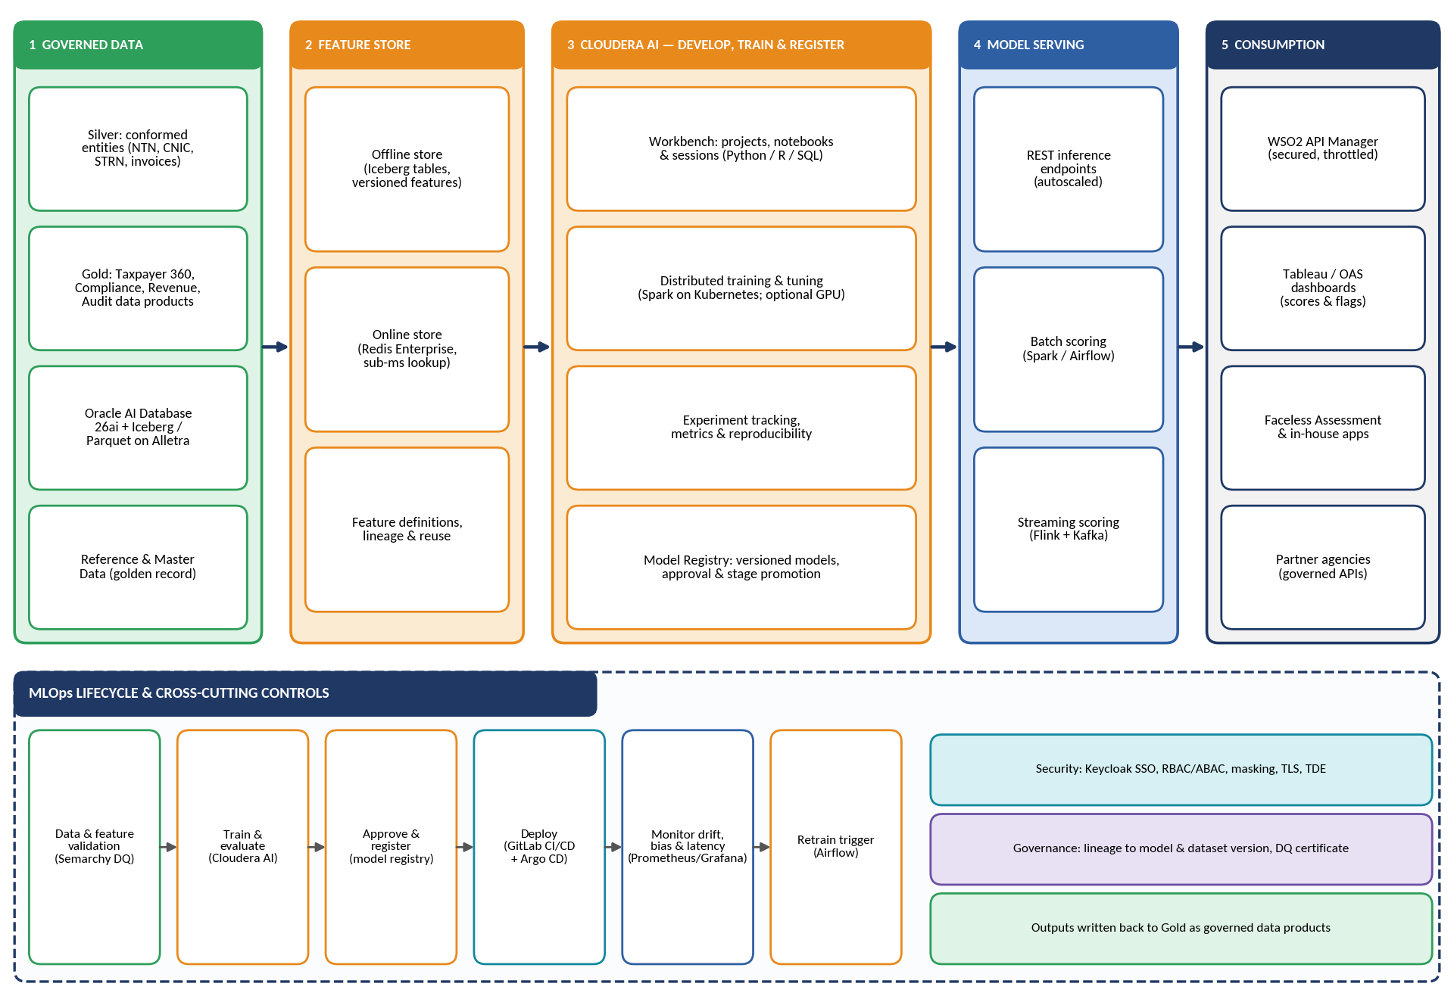
Figure 4 — AI/ML Platform Design

6.11.1 Platform Components
Component | Technology | Function
Governed data foundation | Silver and Gold layers on Oracle AI Database 26ai and Iceberg / Parquet on HPE Alletra; MDM/RDM golden records | Quality-certified, lineage-tracked training and scoring data. No model is trained on ungoverned extracts.
Feature Store | Cloudera AI Feature Store with offline store (Iceberg tables) and online store (Redis Enterprise) | Curates reusable, versioned, model-ready features; delivers the same feature values for training and scoring, and serves online features with sub-millisecond lookup.
Development workbench | Cloudera AI projects, notebooks and sessions (Python, R, SQL) | Collaborative, containerized environments for data scientists with controlled access to governed data.
Training and tuning | Spark on Kubernetes; optional GPU pool in the future | Distributed training and hyper-parameter tuning; scales within the on-premises cluster.
Experiment tracking and Model Registry | Cloudera AI experiments and Model Registry | Records parameters, metrics and the exact dataset version used for every run; versioned models with approval and stage promotion.
Model serving | Cloudera AI inference (REST endpoints), batch scoring (Spark / Airflow), streaming scoring (Flink + Kafka) | Real-time, batch and event-driven scoring, with autoscaled endpoints.
Exposure and consumption | WSO2 API Manager; Tableau and OAS; in-house applications | Scores and flags reach officers through dashboards, applications and governed APIs.
MLOps automation | Apache Airflow, GitLab CI/CD, Argo CD, Prometheus / Grafana | Scheduled retraining, controlled deployment, and monitoring of drift, performance and latency.

6.11.2 Priority Use Cases
Use case | Description | Scoring mode
Taxpayer risk scoring | Scores taxpayers on non-compliance likelihood using filing, payment, invoice and third-party data. | Batch, with online features cached for lookup
Anomaly and fraud detection | Detects unusual invoice, refund and transaction patterns, including in streaming sales-tax data. | Streaming and batch
Compliance-behaviour forecasting | Forecasts filing and payment behaviour and revenue shortfalls by segment and region. | Batch
Case prioritisation | Ranks audit and enforcement cases by expected recovery and risk, feeding officer worklists. | Batch and on demand
Taxpayer segmentation and entity linkage | Clusters taxpayers by behaviour and supports identity resolution across IRIS, eFBR, RegSys and TAMS. | Batch

6.11.3 MLOps Lifecycle
The lifecycle shown at the bottom of Figure 4 operates as a controlled loop: data and feature validation (Data Quality scores gate training data), train and evaluate, approve and register (human approval before promotion), deploy (GitLab CI/CD with Argo CD, so every model release is version-controlled and auditable), monitor (drift, performance, bias and latency in Prometheus / Grafana) and retrain (triggered by schedule or by drift thresholds through Airflow).

6.11.4 Responsible AI and Governance
- Lineage to the model: every model version records the dataset version, features and code that produced it, and this lineage is registered in the governance catalog.
- Explainability: risk scores are accompanied by the main contributing factors, so officers can understand and justify decisions that affect taxpayers.
- Human oversight: models inform officers' decisions and prioritise their work. They do not issue assessments automatically.
- Access control and privacy: features and models inherit the platform's RBAC / ABAC, masking and audit controls. PII is restricted by default.
- Air-gapped operation: model training, artefacts and inference run entirely on-premises, with no calls to external AI services.

6.11.5 Integration with BI
Model outputs (risk scores, anomaly flags, forecasts) are written back as governed tables in the Gold layer, following the same certification path as any other data. Dashboards in Tableau and OAS therefore display AI-derived insight with the same security, lineage and quality controls as every other measure, and applications retrieve scores through the WSO2 API Manager.

6.12 Compliance with Tender Requirements
Tender requirement | How the proposal meets it | Section
BI / semantic-layer architecture | Five-layer BI architecture with OAS Semantic Model and Tableau Certified Published Data Sources over the Gold layer. | 6.2
Proposed BI tool | Oracle Analytics Server (DT) and Tableau Server (IM), with Tableau Advanced Analytics. | 6.3
Tool-selection justification | Criterion-by-criterion assessment and rationale for two complementary products. | 6.4
Integration with MPP | Native Oracle connectivity to Oracle AI Database 26ai on Exadata; Exadata performance features; workload isolation; consistent security. | 6.5
Integration with Lakehouse | In-place access to Iceberg / Parquet on HPE Alletra via federated query and Cloudera SQL engines; time-travel reporting. | 6.6
Integration with Data Governance / Catalog | Glossary alignment, certified-data-only publishing, lineage harvesting, MDM-conformed dimensions, classification-driven masking, stewardship workflow. | 6.7
Self-service analytics architecture | User tiers, tiered content spaces, promotion workflow, guardrails and enablement. | 6.8
Reporting / dashboard architecture | Report families aligned to Gold data products; governed delivery path; design standards; scheduling and embedding. | 6.9
Native connectivity to Object Store and MPP; self-service reporting and dashboarding | Native connectors to the MPP platform and to the engines that natively read the object store; self-service in both tools. | 6.4, 6.5, 6.6, 6.8
Compute-cluster architecture diagram | Figure 3 and cluster-by-cluster description for the primary and DR sites. | 6.10
AI/ML platform design | Figure 4, platform components, use cases, MLOps lifecycle and responsible-AI controls. | 6.11
BI / semantic-layer architecture diagram and tool-selection justification | Figure 2 and Figure 2A (BI and integration architecture); weighted tool-selection scorecard; cross-tool integration risk controls; interface specification for MPP, Lakehouse and Governance / Catalog links. | 6.2, 6.2.3, 6.4.3, 6.4.4
Integration of BI / semantic layer with MPP EDW, Lakehouse, Data Governance and Catalog | Numbered integration paths with mechanism, mode and security for each link (native Oracle connectivity, federated and Cloudera SQL access, glossary / lineage / certification exchange). | 6.2.3, 6.5, 6.6, 6.7

6.13 Conclusion
The proposed BI / Analytics tier turns the governed Gold layer of the Central Data Hub into a coherent set of reporting, dashboard and self-service capabilities. Oracle Analytics Server provides governed enterprise and statutory reporting with native integration to Oracle AI Database 26ai on Exadata. Tableau Server provides governed self-service visual analytics. Both operate on one semantic foundation, one identity and security fabric and one governance catalog, so every user sees the same certified numbers regardless of channel.
Both tools reach the MPP platform and the open-format Lakehouse in place, without copies or lock-in. The cluster architecture scales horizontally and is highly available across the primary and DR sites. The Cloudera AI platform extends the same governed data foundation into predictive and prescriptive analytics, delivering risk scores and anomaly detection to officers through the same dashboards and APIs. The result is a BI and analytics environment that is secure, auditable, legally defensible and built to grow with FBR's data volumes and use cases.

