AI/ML Platform and Compute Cluster Architecture

1. Purpose and Scope
This section describes the compute and AI/ML foundation of the proposed Central Data Hub: the compute cluster architecture, the AI/ML platform design, node sizing, the separation of compute from storage, workload isolation, the micro-batch and streaming processing architectures, and the approach to scalability. It supports FBR's move from descriptive reporting to predictive and prescriptive analytics, including risk scoring, anomaly detection, compliance-behaviour forecasting and case prioritisation, on governed and quality-certified data.
The design is fully on-premises. The open processing and AI/ML stack is delivered through the Cloudera platform (Cloudera Data Engineering with Apache Spark and Airflow, Cloudera Streaming Analytics with Apache Flink, Cloudera Streams with Apache Kafka, and Cloudera AI), alongside Apache NiFi for ingestion and Redis Enterprise for online serving. Data resides in the HPE Alletra Storage MP X10000 object store and in Oracle AI Database 26ai on Exadata, so compute can be scaled and isolated independently of storage.
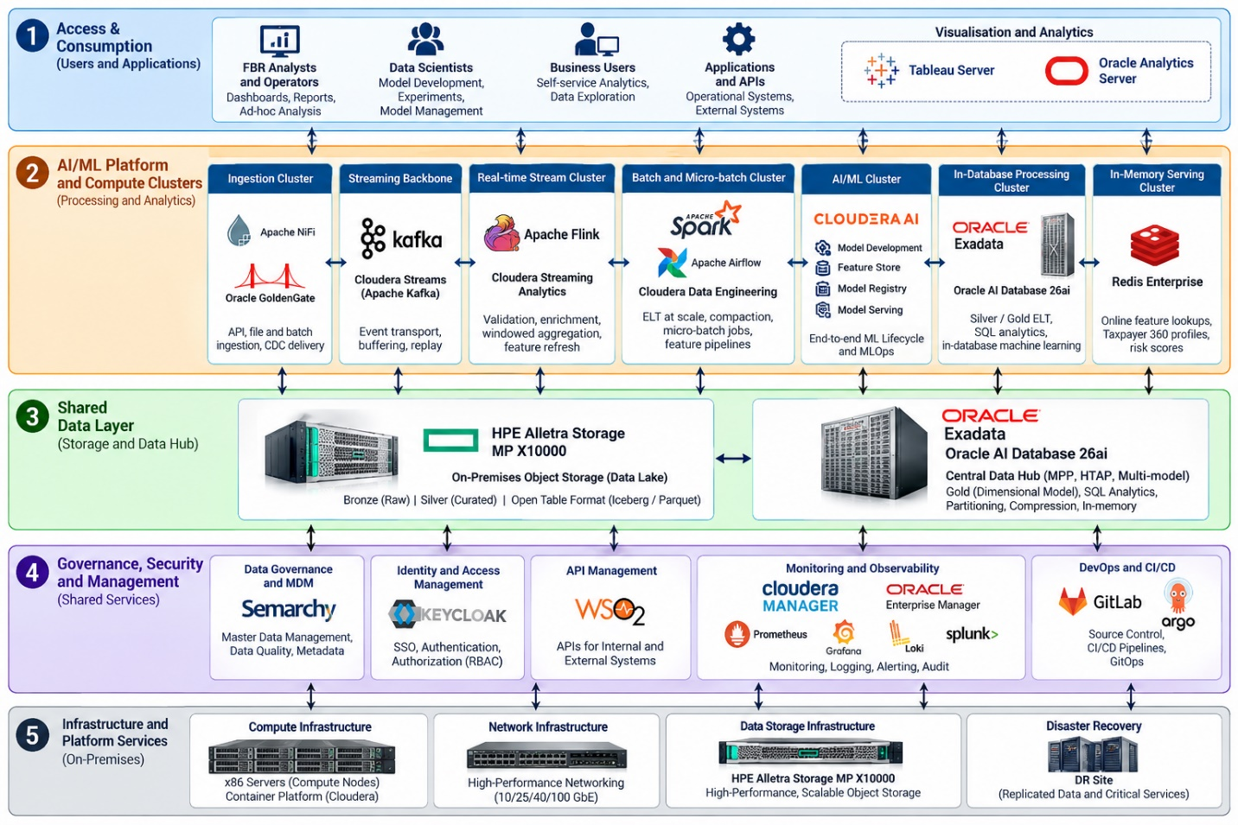

2. Overview of Compute and AI/ML Components
Component | Technology | Role
Batch and ELT compute | Cloudera Data Engineering (Apache Spark, Apache Airflow) | Distributed batch transformation, feature engineering, compaction, orchestration
Micro-batch compute | Spark Structured Streaming on Cloudera Data Engineering | Near-real-time processing at seconds-to-minutes latency
Stream compute | Cloudera Streaming Analytics (Apache Flink) | True real-time, stateful stream processing
Event backbone | Cloudera Streams (Apache Kafka) | Durable, replayable, partitioned event streams
Ingestion compute | Apache NiFi cluster | API, file and heterogeneous ingestion
AI/ML platform | Cloudera AI (workbench, feature store, model registry, experiment tracking, model serving) | End-to-end ML lifecycle and MLOps
In-database processing | Oracle Exadata, Oracle AI Database 26ai | Set-based ELT (ODI), SQL analytics, optional in-database machine learning
Online serving | Redis Enterprise | Online feature lookups and pre-computed scores at sub-millisecond latency
Object storage | HPE Alletra Storage MP X10000 | Shared data lake for all engines (Iceberg / Parquet)
Monitoring and operations | Cloudera Manager, Oracle Enterprise Manager, Prometheus / Grafana / Loki, Splunk | Observability and security monitoring
Delivery pipeline | GitLab, Argo CD | CI/CD and GitOps for code, pipelines and models

3. Compute Cluster Architecture
The compute estate is organized as a set of purpose-built clusters that share the same data layer and the same security, governance and observability fabric. Each cluster scales independently, and none stores the system of record: durable data lives in the Alletra object store and on Exadata, while compute nodes are replaceable.

3.1 Cluster roles
Cluster / Pool | Main Technology | Workloads | Scaling Dimension
Ingestion cluster | Apache NiFi (clustered), GoldenGate | API, file and batch ingestion; CDC delivery | Flow throughput; node count
Streaming backbone | Kafka brokers | Event transport, buffering, replay | Partitions and brokers
Real-time stream cluster | Flink (JobManagers in HA, TaskManager pool) | Validation, enrichment, windowed aggregation, feature refresh, Gold-to-cache reshaping | Task slots; parallelism
Batch and micro-batch cluster | Spark on Cloudera Data Engineering, Airflow | Bronze-to-Silver ELT at scale, compaction, micro-batch jobs, feature pipelines | Executors; worker nodes
AI/ML cluster | Cloudera AI workbench (CPU pool, optional GPU pool) | Interactive development, distributed training, batch scoring, model serving | Sessions, jobs, replicas, GPU count
MPP database cluster | Exadata (compute and storage servers) | Silver / Gold ELT, dashboards, statutory reporting, federated queries | Database servers; storage servers
In-memory serving cluster | Redis Enterprise (sharded, replicated) | Online features, Taxpayer 360 profiles, risk scores | Shards; memory
Control and management plane | Cloudera Manager and platform control nodes, Airflow scheduler, catalog, monitoring stack | Administration, scheduling, metadata, observability | Redundant, fixed footprint

3.2 Compute cluster architecture diagram
The diagram below shows the compute clusters, the shared storage layer, and the data and control flows between them. Components marked as shared (object storage, Exadata, governance, security, observability) are common to all clusters.
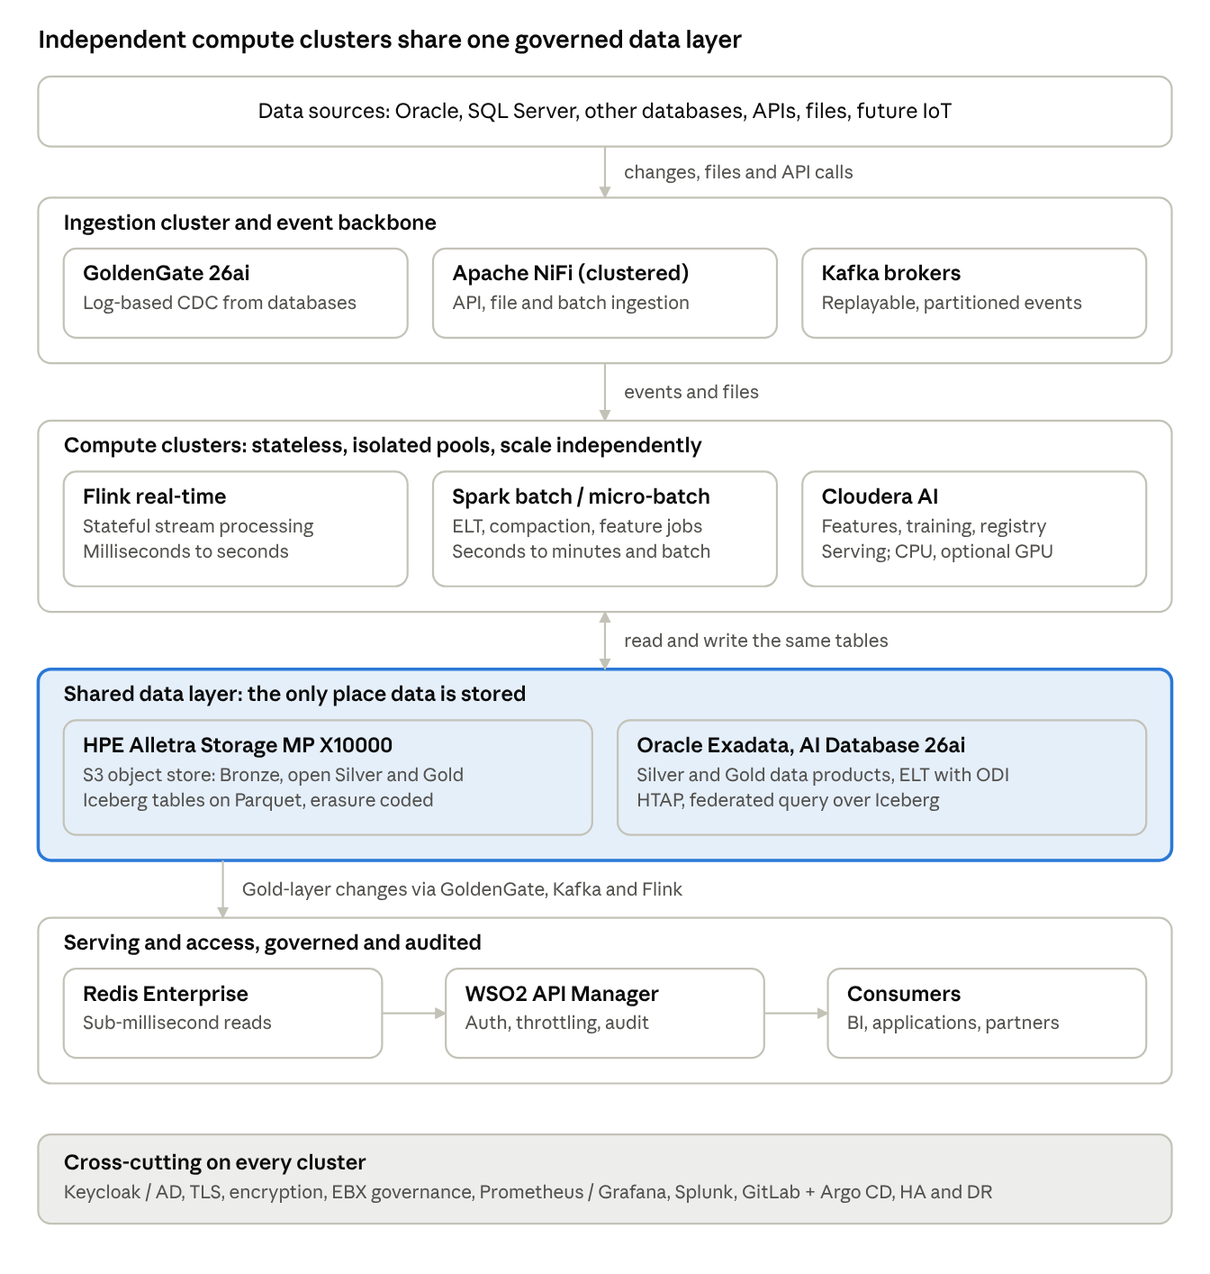
compute cluster architecture · 5 tiers, shared data layer
The compute clusters scale and are isolated independently, while all durable data stays in the shared Alletra and Exadata layer.

3.3 Design characteristics
- Container-based, scheduler-driven compute: processing and AI workloads run as scheduled, containerised workloads on a Cloudera-supported on-premises container platform, with resource quotas and priorities per workload class.
- Shared-data, independent-compute model: every engine reads the same Iceberg / Parquet tables through the shared catalog, so adding or retiring compute never requires moving data.
- Redundant control plane: control and scheduling services run in highly available configuration, so loss of one management node does not interrupt running workloads.
- Three environments: production, pre-production / test, and development, with separate resource pools and promotion through GitLab and Argo CD.
- Disaster recovery: the DR site hosts the platform's critical services and a scaled-down compute footprint that can be expanded on activation; data is protected by database replication, object-store replication and immutable backup.

4. AI/ML Platform Design

4.1 Design goals
- Governed, reproducible and auditable machine learning on tax data, with full lineage from source record to model prediction.
- A single platform for data scientists, ML engineers and operations teams, from experimentation to production.
- Low-latency online inference for officer-facing and API-driven use cases, and scalable batch scoring for portfolio-wide risk assessment.
- Fully air-gapped operation, with no dependency on external model hubs or public package repositories.

4.2 ML lifecycle and platform components
Stage | Capability | Technology | Notes
1. Data access | Governed access to certified Gold and Silver data products | Iceberg / Parquet on Alletra; Exadata; EBX catalog | Only quality-certified, classified datasets are offered; PII masked by default
2. Feature engineering | Batch and streaming feature pipelines | Spark (batch), Flink (streaming), Airflow orchestration | Features computed once and reused across models
3. Feature store | Offline and online feature serving | Cloudera AI Feature Store; offline store on Gold / Iceberg; online store on Redis Enterprise | Same feature definitions for training and scoring, avoiding training-serving skew
4. Experimentation | Interactive notebooks and IDEs in isolated project workspaces | Cloudera AI workbench (Python, R, SQL), scalable CPU and optional GPU sessions | Per-project resource quotas and access control
5. Model training | Distributed and single-node training | Spark MLlib, scikit-learn, XGBoost / LightGBM, TensorFlow / PyTorch (GPU where justified) | Training jobs scheduled and tracked as reproducible runs
6. Experiment tracking and registry | Parameters, metrics, artefacts, model versions and approvals | Cloudera AI experiment tracking and model registry | Each model version linked to the exact training-dataset version and code commit
7. Validation and approval | Performance, bias, stability and explainability checks; business and risk sign-off | Cloudera AI, approval workflow with stewards and model owners | A model reaches production only after recorded approval
8. Deployment | Online model endpoints and batch scoring jobs | Cloudera AI model serving; Spark batch scoring | Endpoints exposed to applications only through WSO2 API Manager
9. Online inference | Low-latency scoring using features from Redis | Cloudera AI endpoints plus Redis online features | Sub-second scoring suitable for case-prioritisation and inline checks
10. Monitoring and retraining | Data drift, prediction drift, accuracy and latency monitoring; scheduled or triggered retraining | Cloudera AI monitoring, Prometheus / Grafana, Airflow | Alerts to model owners; retraining pipelines run under the same controls
11. Write-back | Scores and flags written back as governed data products | Silver-to-Gold certification path; EBX registration | Model outputs follow the same quality and lineage rules as other data

4.3 Target use cases
Use Case | Typical Approach | Processing Mode
Taxpayer risk scoring | Supervised classification and gradient-boosted models on Taxpayer 360 features | Batch scoring plus online lookup of latest score
Anomaly and fraud detection (for example invoice anomalies, refund irregularities) | Unsupervised and semi-supervised detection; rule-augmented models | Streaming (Flink) and micro-batch
Compliance-behaviour forecasting | Time-series and survival models | Batch
Case prioritisation for audit and enforcement | Ranking models combining risk, revenue-at-stake and workload | Batch with online refresh
Taxpayer segmentation | Clustering and behavioural profiling | Batch
Network and relationship analysis (linked taxpayers, invoice chains) | Graph features computed in Spark and Exadata | Batch
Document and text analytics (notices, correspondence) | NLP models, GPU-accelerated where justified | Batch and on-demand
The use-case list is indicative. Final model selection is confirmed with FBR's business owners during the implementation phase.

4.4 Offline and online feature architecture
- Offline store: curated feature tables on Iceberg (object store) and Gold-layer tables, used for training and batch scoring, with point-in-time correctness so that training uses only information available at the time of each historical event.
- Online store: the latest feature values held in Redis Enterprise for millisecond lookups at inference time, refreshed continuously by Flink jobs and by Gold-layer change propagation.
- Consistency: a single feature definition drives both stores, and reconciliation jobs compare online and offline values to detect divergence.

4.5 In-database machine learning option
Where data volumes are large and models are well suited to SQL-resident execution, Oracle AI Database 26ai on Exadata can run machine-learning workloads next to the data, avoiding extraction. This complements Cloudera AI and is selected per use case; models trained in-database are registered and governed alongside others.

4.6 Air-gapped operation
- Internal, curated mirrors of Python / R packages and container images, scanned and approved before use.
- Pre-approved base images and libraries for notebooks and jobs; no direct internet access from workbench sessions.
- Pre-trained models and artefacts, where used, are imported through a controlled, scanned, audited process and registered in the model registry.

4.7 Responsible AI and model governance
Control | Approach
Explainability | Feature-importance and per-prediction explanations stored with each score, so officers and reviewers can see why a case was flagged
Human in the loop | Model outputs support officer decisions; enforcement and assessment actions remain subject to FBR's procedures and human review
Fairness and bias review | Pre-deployment testing across relevant taxpayer segments, repeated on a schedule
Reproducibility and audit | Every model version tied to dataset version, code commit, parameters and approver; retained to the audit retention period
Change control | Model code and pipelines in GitLab; promotion by Argo CD across environments
Data protection | PII restricted by default, masked or tokenised features where policy requires, access through Keycloak / AD with RBAC / ABAC, audit to Splunk

5. Node Sizing

5.1 Sizing method
The reference configuration below includes a five-node on-premises compute cluster, with each master/compute node sized at 32 cores, 384 GB RAM and 12 × 2 TB NVMe disks. Other dedicated infrastructure tiers (including Kafka, NiFi, Redis Enterprise, Exadata, object storage and DR) are sized separately. Final placement, high-availability design and workload capacity will be validated against FBR's confirmed data volumes, event rates, concurrency and model portfolio during the sizing workshop and proof of concept.
Cluster | Sizing Driver
Kafka | Peak events per second, average message size, retention days, replication factor (disk and network throughput)
Flink | Peak event rate, state size per job, window lengths, required end-to-end latency (memory and task slots)
Spark / batch | Daily and peak data volume, batch windows, concurrency of jobs (cores and memory; scratch NVMe for shuffle)
Cloudera AI | Number of concurrent data scientists and projects, training dataset sizes, scoring volume, GPU need
NiFi | Number and rate of flows, payload sizes, API concurrency
Redis Enterprise | Dataset size in memory, replication (double memory), headroom for growth and persistence overhead, peak operations per second
Exadata | Gold / Silver data volume, concurrency of dashboard users, ELT windows
Object store | Raw plus curated volume, retention years, growth rate, compression ratio

5.2 Indicative reference configuration (production)
Cluster | Node Role | Indicative Nodes | Indicative Node Profile | Notes
Compute cluster | Master and compute nodes | 5 | 32 cores, 384 GB RAM, 12 × 2 TB NVMe disks per node | Five-node on-premises cluster comprising master and compute nodes; supports Cloudera Data Engineering / Spark, Cloudera AI CPU workloads and general platform compute. Confirm master-to-worker allocation and workload placement during detailed design.
Ingestion | Apache NiFi | 3 | 16 to 32 cores, 128 GB RAM, local SSD for repositories | Clustered with automatic failover
Streaming backbone | Kafka brokers | 5 | 32 cores, 256 GB RAM, local NVMe for logs | Replication factor 3; rack-aware placement
In-memory serving | Redis Enterprise nodes | 3 minimum (more as dataset grows) | 24 to 32 cores, 512 GB RAM, NVMe for persistence | Sharded, replicated, automatic failover
MPP database | Exadata (database and storage servers) | Per Exadata sizing, minimum quarter-rack-class entry configuration with RAC | Engineered system | Elastic expansion by adding database or storage servers
Object storage | HPE Alletra Storage MP X10000 | Per capacity and throughput sizing | All-flash NVMe, erasure coded | Capacity and performance scale independently
DR site | Scaled-down replica of critical services | Per DR design | Sized to run critical workloads, expandable on activation | Database and object-store replication; Cohesity NetBackup backup
The node profiles above are reference values for planning. The commercial bill of materials will state the final hardware specification and counts once FBR confirms the sizing inputs.

5.3 Headroom policy
- N+1 capacity at every clustered tier, so one node can fail without breaching service levels.
- Planned utilization targets that leave headroom for peak periods such as filing deadlines.
- Capacity reviews each quarter using observed utilization, trend and forecast from the monitoring stack.

6. Compute / Storage Separation
The platform deliberately separates where data lives from where it is processed.
Principle | Implementation
Durable data lives in shared storage | HPE Alletra object store (Iceberg / Parquet) and Oracle Exadata hold the system of record and all certified data products
Compute is stateless and replaceable | Spark executors, Flink workers, AI sessions and NiFi workers can be added, removed or rebuilt without data loss; state is checkpointed to durable storage
Independent scaling | Compute scales for processing demand; storage scales for capacity; Alletra's disaggregated architecture scales performance and capacity independently
One copy, many engines | Spark, Flink, Oracle and Cloudera AI read and write the same open-format tables through a shared catalog, with no engine-specific copies
Local disks are for scratch only | Local NVMe is used for shuffle, spill, Kafka logs and Flink state, never as the sole copy of business data
Elastic workloads | Batch and AI workloads can use temporary extra compute during peaks and release it afterwards
Benefits to FBR: compute can be expanded or reallocated without data migration; storage grows without buying unneeded processors; failed compute nodes are replaced without recovery from backup; and different teams can run different engines on the same governed data.
Deliberate exceptions: Kafka brokers and Redis Enterprise keep data on local NVMe or memory for latency. Their durability comes from replication, persistence, and the fact that both are derived from, or replayable into, the object store and Exadata, which remain the sources of truth.

7. Workload Isolation Approach
Workloads with different priorities and risk profiles must not be able to starve or disturb one another. Isolation is applied at four levels.

7.1 Isolation mechanisms
Level | Mechanism
Compute capacity | Dedicated node pools and resource quotas per workload class (real-time streaming, scheduled ELT, interactive analytics, data science, GPU); priority classes so critical workloads pre-empt lower-priority ones
Namespace and project | Separate namespaces or virtual clusters for production, pre-production and development, and per team or domain; per-project quotas, limits and access control in Cloudera AI
Network | Network policies between namespaces and tiers; segregated data, management and user networks; only approved paths to storage endpoints
Data and identity | Separate service accounts per workload with least-privilege access to buckets, topics and schemas; RBAC / ABAC and column masking enforced by the engines

7.2 Workload classes
Class | Examples | Priority | Isolation Treatment
Real-time and online serving | Flink streaming jobs, online model endpoints, Redis, API-backing services | Highest | Reserved capacity; dedicated task slots and replicas; not shared with experimentation
Scheduled production ELT | Bronze-to-Silver, Silver-to-Gold, Gold-to-cache bulk jobs | High | Production pool; scheduled windows; resource guarantees
Interactive BI and reporting | Dashboards, statutory reports on Exadata | High | Exadata resource management plans prioritizing interactive consumer groups
Data science and experimentation | Notebooks, training experiments | Medium | Per-project quotas; separate pool; GPU access by approval
Ad hoc and exploratory | Analyst queries, sandboxes | Lower | Capped resources; query limits; cannot pre-empt production

7.3 Technology-specific controls
- Kafka: per-client quotas for produce and consume throughput; topic-level ACLs; separate topics per domain.
- Flink: application-mode deployment so that critical jobs run in dedicated clusters, isolated from one another.
- Spark: per-job executor limits, dynamic allocation within quotas, and queue-based scheduling.
- Exadata: database resource management and consumer groups to protect dashboard performance from ELT and ad hoc queries; separate services for ELT, reporting and ad hoc use.
- Redis Enterprise: separate databases per data product or tenant, ACLs per key pattern, memory limits and eviction policy per database.
- Environments: production data is not available to development environments except through approved, masked extracts.

8. Micro-Batch Processing Architecture
Micro-batch processing serves workloads that need data within seconds to minutes rather than milliseconds, and benefits from the efficiency and simplicity of processing small, bounded batches.

8.1 Architecture
- Source: Kafka topics populated by GoldenGate CDC, NiFi and other producers.
- Engine: Spark Structured Streaming jobs on Cloudera Data Engineering read Kafka offsets in small trigger intervals, typically from several seconds to a few minutes, configurable per pipeline.
- Processing: each micro-batch is validated against schema, deduplicated, enriched, and applied to Iceberg tables by incremental MERGE or append.
- Sink: Bronze and Silver Iceberg tables on the Alletra object store; selected outputs to Exadata staging for ODI-driven promotion to Gold.
- Orchestration and recovery: Airflow DAGs manage dependencies and recovery; Kafka offsets and Spark checkpoints are stored durably, so a failed job resumes from its last committed batch with no loss or duplication.

8.2 Characteristics
Aspect | Design
Latency | Seconds to minutes, set by the trigger interval
Delivery semantics | Exactly-once effect through idempotent writes and transactional Iceberg commits
Back-pressure | Rate limits per trigger; Kafka retains events during downstream slowdowns
Small-file control | Batch size tuning plus scheduled compaction jobs on Iceberg tables
Late and out-of-order data | Event-time handling with watermarks; merge logic that respects source commit order
Data quality | EBX rules applied per batch; failing records routed to quarantine without stopping the batch
Typical uses | Continuous landing into Bronze, near-real-time Silver refresh, frequently updated reporting tables, feature refresh for non-urgent models

9. Streaming Processing Architecture
True real-time processing, from milliseconds to seconds, is delivered by Apache Flink on Cloudera Streaming Analytics, consuming from and publishing to Kafka.

9.1 Architecture
- Event backbone: Kafka topics, partitioned by business key (for example NTN or invoice identifier) to preserve per-entity ordering, with governed schemas in the schema registry.
- Stream processing: Flink jobs perform validation, enrichment against reference data, deduplication, stateful pattern detection, windowed aggregation and continuous feature computation, using event-time semantics and watermarks.
- State and fault tolerance: keyed state held in local state backends and checkpointed periodically to durable storage; JobManagers in high-availability mode; automatic restart from the latest checkpoint after failure.
- Sinks: Kafka topics for downstream consumers, Redis Enterprise for online features and cache refresh, Iceberg tables on the object store for history, and alert topics for operational events.
- Quarantine path: records failing critical validation are routed to dead-letter topics without halting the pipeline.

9.2 Characteristics
Aspect | Design
Latency | Milliseconds to seconds for time-critical use cases
Delivery semantics | Exactly-once processing within Flink using checkpointing and transactional or idempotent sinks
Scalability | Parallelism raised by adding task slots and TaskManagers; Kafka partitions sized to match
Upgrades | Savepoints allow stateful jobs to be upgraded or rescaled without losing state
Observability | Job, checkpoint, lag and back-pressure metrics in Cloudera Manager and Grafana
Typical uses | Inline anomaly detection, real-time feature refresh, Gold-to-Redis cache updates, Track and Trace and POS event handling in future phases

9.3 Choosing between micro-batch and streaming
Requirement | Recommended Engine
Sub-second to seconds, stateful, event-driven decisions | Flink streaming
Seconds to minutes, table-oriented transformation into Iceberg | Spark micro-batch
Large periodic recomputation, hourly to daily | Spark batch and ODI ELT
Set-based transformation of data already inside Exadata | ODI with SQL push-down

10. Scalability Approach

10.1 Principles
- Scale out, not only up: every compute tier adds nodes horizontally, with no redesign.
- Scale each tier independently: ingestion, streaming, batch, AI, serving, database and storage grow separately according to their own demand.
- Partition for parallelism: Kafka partitions, Flink parallelism, Spark partitions and Iceberg partitioning are designed together, so added nodes immediately add throughput.
- Design for planned growth: the initial deployment includes headroom for expected growth, with expansion paths defined in advance.

10.2 Scaling by tier
Tier | How It Scales
Object storage (Alletra) | Add capacity or performance nodes independently; erasure coding rebalances; no application change
Exadata | Elastic expansion by adding database servers for compute and storage servers for capacity and scan throughput; RAC spreads load
Kafka | Add brokers and rebalance partitions; increase partitions for hotter topics
Flink | Add TaskManagers and raise parallelism; rescale stateful jobs with savepoints
Spark / batch | Add worker nodes; dynamic executor allocation within quotas
Cloudera AI | Add CPU or GPU workers; scale model-serving replicas by request load
NiFi | Add nodes to the cluster; flows redistribute automatically
Redis Enterprise | Add shards and nodes; online resharding without downtime
API tier | WSO2 gateway nodes added behind load balancers; throttling protects backends at peak

10.3 Operational scaling practices
- Autoscaling within limits: elastic pools for batch and AI workloads expand and contract within quotas to handle peaks such as filing deadlines, then release capacity.
- Capacity planning: quarterly review using utilisation and growth trends, with expansion triggers defined per tier.
- Performance regression control: load and soak tests in the pre-production environment before major changes.
- Data growth management: compaction, lifecycle policies, and tiering of cold data to cost-efficient object storage.

11. Resilience, Security and Operations
Area | Approach
High availability | Clustered control plane, Kafka replication, Flink HA, Redis replication with automatic failover, Exadata RAC with Active Data Guard, erasure-coded object storage
Failure recovery | Checkpointed Flink and Spark jobs resume without full reprocessing; Kafka replay; failed workloads are rescheduled onto healthy nodes
Disaster recovery | Primary and DR sites with replication and Cohesity NetBackup immutable backup
Security | Keycloak / AD identity, TLS 1.2 or higher, encryption at rest, RBAC / ABAC, masking, secrets vault, audit to Splunk
Observability | Cloudera Manager, Oracle Enterprise Manager, Prometheus / Grafana / Loki; sub-30-second operational dashboards and alerting on lag, job failures, resource saturation and model drift
Change management | GitLab version control and Argo CD GitOps for pipeline code, infrastructure definitions and model artefacts

12. Summary of Compliance with Compute and AI/ML Requirements
Requirement | How It Is Met
Compute cluster architecture diagram | Section 3 presents the cluster roles and the architecture diagram
AI/ML platform design | Section 4: Cloudera AI platform with feature store, registry, serving, monitoring, governance and air-gapped operation
Node sizing | Section 5: sizing method and indicative reference configuration with N+1 headroom, to be finalised against FBR volumes
Compute / storage separation | Section 6: shared Alletra and Exadata data layer with stateless, independently scalable compute
Workload isolation | Section 7: node pools, quotas, namespaces, network policy and engine-level controls
Micro-batch architecture | Section 8: Spark Structured Streaming on Cloudera Data Engineering into Iceberg, with checkpointed recovery
Streaming architecture | Section 9: Kafka and Flink with exactly-once processing, state checkpointing and HA
Scalability approach | Section 10: independent horizontal scaling of every tier with defined expansion paths

Supplementary Detail: Five-Node Converged Compute Configuration
This supplementary section incorporates the additional design basis, hardware capacity, NVMe allocation, node-role assignment, resource budgeting, and MPP-isolation details for the proposed five-node production compute cluster.

A. Design Basis and Assumptions
Item | Reference configuration
Node count | 5 identical nodes; master and compute roles are converged
CPU per node | 32 cores; 160 physical cores across the cluster
Memory per node | 384 GB RAM; 1,920 GB across the cluster
Local storage per node | 12 × 2 TB NVMe disks (24 TB raw); 120 TB raw across the cluster
Master roles | Hosted on N1–N3 to provide a three-node quorum; these nodes also run compute workloads
GPU | No GPU in the baseline; optional GPU-capable nodes may be added for justified deep-learning/NLP workloads
Separate platforms | Oracle Exadata, HPE Alletra Storage MP X10000, Redis Enterprise and WSO2 API tier are external to these five nodes
Environments | Pre-production and development are separate, smaller footprints
Network assumption | Bonded 25 GbE or faster data interfaces per node, plus a separate management interface; confirm during infrastructure design
Sizing validation | Validate CPU, memory, disk, event rates, data volumes, concurrency and model portfolio during sizing workshop and proof of concept

B. Capacity and System Reserve
Resource | Per node | Cluster total | Indicative allocatable total
CPU cores | 32 | 160 | 150 (reserve 2 cores/node for OS, runtime and agents)
Memory | 384 GB | 1,920 GB | 1,800 GB (reserve 24 GB/node for OS, runtime and agents)
NVMe raw capacity | 24 TB | 120 TB | Allocated by disk purpose; usable capacity depends on layout and filesystem/replication overhead

C. Indicative NVMe Disk Layout per Node
The proposed layout separates the heaviest I/O consumers across dedicated devices. Final filesystem, RAID, replication and usable-capacity decisions must be validated against the selected server platform and Cloudera support requirements.
Disks | Configuration | Raw / usable capacity | Purpose
D1–D2 | RAID-1 mirror | 4 TB raw / 2 TB usable | Operating system, container runtime and images, control-plane metadata
D3–D6 | JBOD; one log directory per disk | 8 TB raw | Kafka partition logs
D7–D9 | Striped scratch volumes | 6 TB raw | Spark shuffle, spill and executor scratch
D10 | Dedicated volume | 2 TB raw | Flink keyed state (RocksDB) and checkpoint staging
D11 | Dedicated volume | 2 TB raw | Cloudera AI ephemeral project workspaces and dataset cache
D12 | Dedicated volume | 2 TB raw | NiFi repositories on NiFi nodes and observability buffers (Prometheus/Loki)
Across five nodes, the layout allocates 40 TB raw to Kafka, 30 TB raw to Spark scratch, and 10 TB raw each to Flink state, AI workspaces, and NiFi/observability. Local NVMe is for logs, scratch and state—not the sole copy of business data.

D. Kafka Event-Retention Capacity
With replication factor 3, 40 TB raw allocated to Kafka represents approximately 13.3 TB of unique event data before operating headroom. At a maximum 70% fill target, the indicative retained replayable event capacity is approximately 9 TB. Actual retention in days depends on FBR’s confirmed peak event rate and average message size and must be fixed during detailed sizing.

F. Indicative Resource Budget by Pool
Pool | Cores | Memory | Planning note
Control plane | 12 | 144 GB | Three-node quorum
Kafka (5 brokers) | 20 | 160 GB | Pinned cores and dedicated NVMe logs
NiFi (3 nodes) | 12 | 72 GB | Flow back-pressure and concurrency limits
Flink (5 TaskManagers; 20 slots) | 20 | 160 GB | Reserved, non-pre-emptible capacity for critical streaming
Spark batch and micro-batch | 32 | 400 GB | About 8 cores / 96 GB for continuous micro-batch; remainder for scheduled ELT
Cloudera AI CPU pool | 24 | 400 GB | Interactive sessions, training, batch scoring and model serving
N+1 reserve | 30 | 360 GB | Capacity equivalent to one node; protect during node failure
Unallocated memory buffer | — | 104 GB | Additional memory headroom

