Section 7: Real-Time / Streaming Architecture

7.1 Overview and Design Intent
The CDH real-time layer delivers continuous, low-latency movement and processing events and is designed to accommodate future event sources also. It is a first-class capability of the platform, independent of the batch ELT path, and operates entirely within FBR's on-premises perimeter with no dependency on public cloud services.
The layer is built on four principles:
- Durable, replayable backbone. Every change event is persisted in Cloudera Streams (Apache Kafka) before any consumer processes it, so downstream failures never cause data loss and any consumer can be rewound and replayed.
- Zero source impact. Oracle GoldenGate 26ai mines transaction logs rather than querying source tables, so IRIS, eFBR, RegSys and TAMS performance is not degraded.
- Exactly-once outcomes. Apache Flink, with checkpointed state and transactional sinks, provides exactly-once processing from Kafka through to the Bronze, Silver and Cache layers.
- Governed streaming. SEMARCHY DATA PLATFORM data quality and reference-data rules are applied inline; records failing critical rules are quarantined for stewardship without halting the pipeline.

7.2 Streaming Architecture Diagram
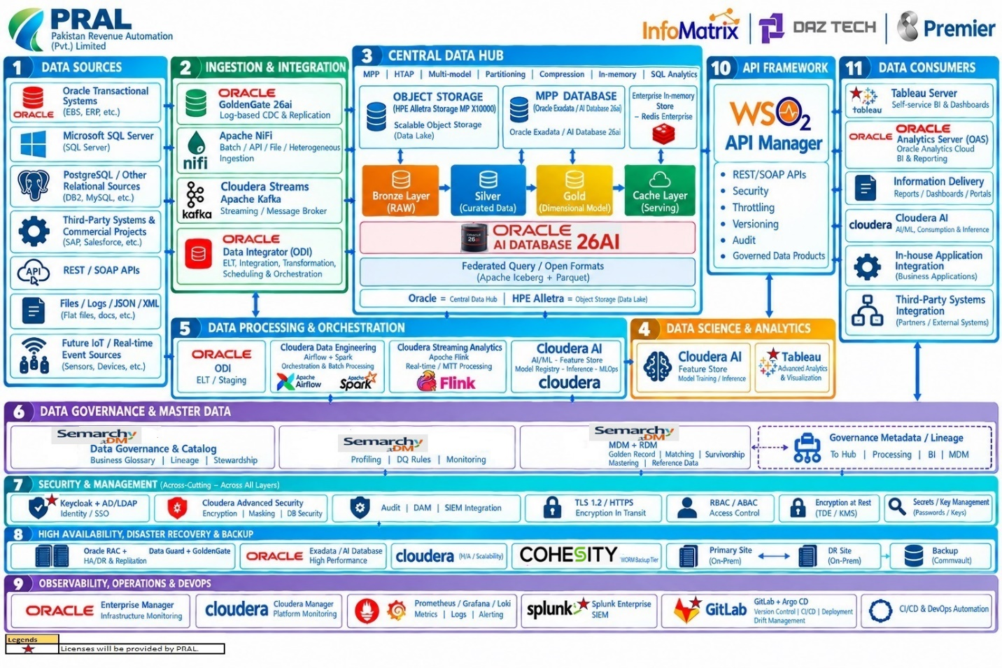
The streaming path is shown below and corresponds to zones 1, 2, 3, 5, 10 and 11 of the Reference Architecture Diagram above
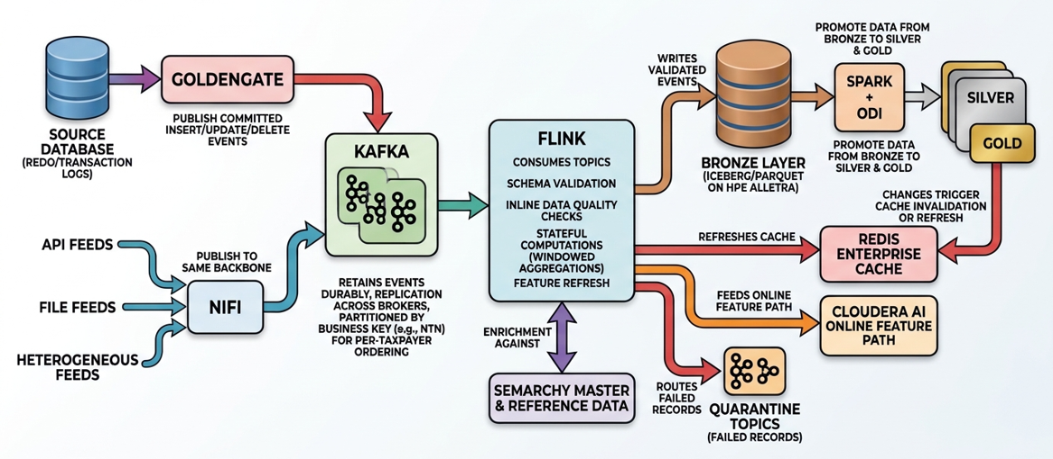

Flow summary
- GoldenGate captures committed INSERT/UPDATE/DELETE events from source redo/transaction logs and publishes them to Kafka topics. NiFi publishes API, file and other heterogeneous feeds to the same backbone.
- Kafka retains events durably with replication across brokers, partitioned by business key (for example NTN) to preserve per-taxpayer ordering.
- Flink consumes topics, performs schema validation, inline data quality checks, enrichment against Semarchy master and reference data, and stateful computations such as windowed aggregations and feature refresh.
- Flink writes validated events to the Bronze layer on HPE Alletra in Iceberg/Parquet, refreshes the Redis Enterprise cache, feeds the Cloudera AI online feature path, and routes failed records to quarantine topics.
- Spark and ODI promote data from Bronze to Silver and Gold; Gold changes trigger cache invalidation or refresh so that APIs and AI inference read current values.

7.3 Streaming Compute Cluster Design
The streaming compute estate is organised into dedicated, independently scalable clusters, so that messaging, stream processing, ingestion and serving each scale and fail independently.
Cluster | Technology | Design characteristics
CDC capture tier | Oracle GoldenGate 26ai | Extract and Distribution paths per source system; trail files on resilient storage; active-active capable for HA; GoldenGate also feeds the DR replication path.
Messaging cluster | Cloudera Streams (Apache Kafka) | Multi-broker cluster with a replication factor of 3 and min in-sync replicas of 2; rack-aware replica placement across the primary site; dedicated controller quorum of 3 nodes; tiered retention with long-term history held in the Bronze layer; Schema Registry for contract enforcement.
Stream processing cluster | Cloudera Streaming Analytics (Apache Flink) | Highly available JobManagers (active plus standby); horizontally scalable TaskManagers; RocksDB state backend with incremental checkpoints to HPE Alletra S3 storage; exactly-once semantics with transactional Kafka sinks; savepoints for controlled upgrades.
Heterogeneous ingestion cluster | Apache NiFi | Clustered NiFi with zero-master coordination; back-pressure and prioritised queues; publishes to Kafka and writes directly to object storage where appropriate.
Serving cluster | Redis Enterprise | Sharded, replicated, persistent in-memory cluster with automatic failover; the primary low-latency read path for APIs and the online feature interface.
Micro-batch / batch engine | Cloudera Data Engineering (Spark and Airflow) | Consumes the same Kafka topics for micro-batch workloads, and runs Bronze-to-Silver-to-Gold promotion as DAGs.
Object storage tier | HPE Alletra Storage MP X10000 | Landing zone for Bronze data and Flink checkpoints; erasure-coded, S3-compatible, with object-lock immutability.
Resilience behaviour
- A broker failure triggers automatic leader re-election with no data loss for acknowledged writes.
- A TaskManager failure causes Flink to restart affected tasks from the last checkpoint with no duplicate outputs.
- A JobManager failure causes failover to the standby JobManager.
- NiFi and Cloudera Manager provide node-level health monitoring and automatic workload redistribution.
- Kafka topics and GoldenGate replication to the DR site keep the DR environment current; Cohesity NetBackup immutable backup provides the final line of defence.

7.4 Node and Cluster Sizing (Proposed Infrastructure)
The following node pools are the proposed infrastructure baseline. Aggregate capacity is calculated from the supplied node counts and per-node specifications. Usable capacity and achievable throughput depend on storage overhead, replication, Cloudera role placement, workload profiles, network configuration and performance testing.
Planning assumptions
Parameter | Planning value
Sustained event rate (all sources combined) | 2000-3000 events/second
Peak event rate (filing-deadline surge) | 15000 events/second
Average event size (after serialization) | 1 KB
Kafka replication factor | 3
Kafka hot retention | 7 days (long-term history in Bronze layer)
Concurrent Flink jobs | 10 to 20 (CDC apply, DQ, enrichment, feature refresh, cache refresh)

Proposed node-pool sizing (primary site)
Node pool | Nodes | Per-node specification | Aggregate capacity | Primary role / placement
Cloudera Master | 3 | 16 cores; 256 GB RAM; 8 × 1 TB NVMe | 48 cores; 768 GB RAM; 24 TB raw NVMe | Dedicated management/control-plane roles; keep general-purpose jobs off these nodes.
Cloudera Worker | 21 | 32 cores; 384 GB RAM; 6 × 4 TB NVMe | 672 cores; 8,064 GB RAM; 504 TB raw NVMe | Primary distributed processing tier; allocate Flink TaskManagers and approved compute services using resource pools/queues.
Cloudera Kafka | 3 | 32 cores; 384 GB RAM; 4 × 4 TB NVMe | 96 cores; 1,152 GB RAM; 48 TB raw NVMe | Dedicated Kafka brokers and messaging services; broker logs on dedicated NVMe.
Cloudera Utility | 3 | 32 cores; 384 GB RAM; 4 × 1 TB NVMe | 96 cores; 1,152 GB RAM; 12 TB raw NVMe | Approved utility and support services based on final low-level role assignment.
Derived capacity check – The capacity calculation assumes an average event size of 1 KB, a sustained ingestion rate of 2,000–3,000 events/second, a peak rate of 15,000 events/second, and seven-day Kafka retention. The storage calculation uses the sustained rate; the peak rate is used for throughput sizing because the peak is assumed to be temporary.
Assumed Throughput and storage calculations
Metric | Sustained — Lower | Sustained — Upper | Peak
Event rate | 2,000/sec | 3,000/sec | 15,000/sec
Average event size | 1 KB | 1 KB | 1 KB
Incoming payload throughput | 2 MB/s | 3 MB/s | 15 MB/s
Approx. network throughput | 16 Mbps | 24 Mbps | 120 Mbps
Broker write traffic (3 replicas) | 6 MB/s | 9 MB/s | 45 MB/s
Events per day | 172.8 million | 259.2 million | 1.296 billion
Logical storage per day | 172.8 GB | 259.2 GB | 1.296 TB
Storage per day with 3 replicas | 518.4 GB | 777.6 GB | 3.888 TB
Logical storage for 7 days | 1.21 TB | 1.81 TB | 9.07 TB
Storage for 7 days with 3 replicas | 3.63 TB | 5.44 TB | 27.22 TB

Scaling model. Every tier scales horizontally without re-architecture: add Kafka brokers and rebalance partitions, add Flink TaskManagers and raise parallelism from a savepoint, add NiFi nodes to the cluster, and add Redis shards and nodes online. Compute and storage scale independently because state, checkpoints and history reside on HPE Alletra object storage.

7.5 Workload Isolation Approach
Isolation is applied at several levels so that a surge or fault in one workload cannot degrade another.
- Dedicated clusters per function. Messaging, stream processing, ingestion, serving and batch engines run on separate node pools, so heavy analytics or batch jobs do not compete with real-time processing for CPU, memory or disk.
- Priority tiers within streaming. Flink jobs are separated into tiers: Tier 1 (cache refresh, risk-score feature refresh, operational alerts), Tier 2 (CDC apply to Bronze, inline data quality) and Tier 3 (exploratory or backfill jobs). Each tier has dedicated task slots and resource quotas, and backfills run on separate job clusters.
- Topic-level controls. Kafka client quotas (produce, consume and request rate) are set per application and principal; critical topics have dedicated partitions and replication placement; consumer groups are separated by use case.
- API-tier protection. WSO2 API Manager applies throttling and rate limits per application, subscription tier and API, and Redis Enterprise serves reads so that high API traffic does not reach the MPP database or the streaming layer.
- Database workload management. Oracle Exadata resource management isolates streaming apply and API-driven queries from analytical and reporting workloads.
- Security isolation. Keycloak/AD-backed RBAC and ABAC, topic-level ACLs, namespace isolation in Redis and TLS between all components ensure each workload sees only the data it is authorised to see.
- Failure isolation. Records failing quality rules are diverted to quarantine topics, so a poison message or bad source feed never blocks the main pipeline.

7.6 Latency Benchmarks
Latency is specified per stage so that each can be measured and monitored independently.
Stage | Design target
Source commit to GoldenGate capture | Sub-second
Kafka publish to consume | Milliseconds to low single-digit seconds
Flink processing (stateless and light stateful) | Milliseconds to seconds
Source commit to Bronze availability | Seconds (event-driven path)
Gold change to Redis cache refresh | Seconds
Cache read via API | Sub-millisecond at Redis, with end-to-end API response in tens of milliseconds under normal load
Micro-batch consumers | Seconds to minutes, configurable
Failure detection and alerting | Sub-minute, with dashboards refreshing in under 30 seconds

7.7 Comparable Deployment Evidence
Organization/Sector | Technology in scope | Published scale / results | Reference
mBank — Banking, Poland | Cloudera, Apache Kafka, Apache NiFi, Spark Streaming | Continuous ingestion and real-time financial-liquidity monitoring. Exact events/sec and data volume not published. | Cloudera customer case study
Deutsche Börse Group — Financial markets, Germany | Redis Enterprise and real-time data-serving technologies | Real-time quote and trade data processing for regulatory reporting. Exact operations/sec not published. | Redis customer case study
Bank Syariah Indonesia (BSI) — Banking, Indonesia | Oracle GoldenGate, Oracle Data Integrator, Oracle Exadata Cloud@Customer | Reported 50% improvement in data processing and financial-report production performance. Exact CDC throughput not published. | Oracle customer case study
Royal Bank of Canada (RBC) — Banking, Canada | Confluent Platform / Apache Kafka | More than 50 applications deployed on an event-driven architecture. Exact throughput not published. | Confluent customer case study

7.8 Summary of Compliance
Requirement | How it is met
Streaming architecture diagram | Section 7.2
Streaming compute cluster design | Section 7.3: dedicated Kafka, Flink, NiFi, GoldenGate and Redis clusters, highly available and horizontally scalable
Node and cluster sizing | Section 7.4: baseline sizing, derived capacity check and scaling model
Workload isolation | Section 7.5: cluster, priority-tier, topic, API, database and security isolation
Throughput benchmarks | Section 7.6: targets and validation method
Latency benchmarks | Section 7.7: per-stage targets and validation method
Comparable deployment evidence | Section 7.8: reference template for verified deployments

Compute Layer Supplement
This supplement updates Section 7 sizing with the specified Cloudera node inventory and expands the node architecture, workload isolation and benchmark evidence. Aggregate figures are raw installed capacity, not usable capacity or a guaranteed performance result.

A. Proposed cluster sizing summary
Pool | Nodes and per-node specification | Aggregate CPU / RAM | Aggregate raw NVMe
Master | 3 × (16 cores, 256 GB RAM, 8 × 1 TB NVMe) | 48 cores / 768 GB | 24 TB
Worker | 21 × (32 cores, 384 GB RAM, 6 × 4 TB NVMe) | 672 cores / 8,064 GB | 504 TB
Kafka | 3 × (32 cores, 384 GB RAM, 4 × 4 TB NVMe) | 96 cores / 1,152 GB | 48 TB
Utility | 3 × (32 cores, 384 GB RAM, 4 × 1 TB NVMe) | 96 cores / 1,152 GB | 12 TB
TOTAL | 30 physical nodes | 912 cores / 11,136 GB RAM | 588 TB raw NVMe

B. Node architecture and service placement
Pool | Placement intent | Availability / operating controls
Master (3) | Reserve for Cloudera management and control-plane roles selected in low-level design. No general-purpose streaming/batch jobs. | Distribute across failure domains where possible; monitor management services and document recovery procedures.
Worker (21) | Primary distributed compute tier for Flink TaskManagers and other approved Cloudera compute roles. Use distinct resource pools/queues for real-time, micro-batch and backfill. | Set resource guarantees/quotas and maintain headroom for recovery, rebalancing and growth.
Kafka (3) | Dedicated Kafka brokers, with broker logs on local NVMe. Use replication factor 3 and min.insync.replicas=2 for critical topics where appropriate. | Use rack-aware placement where supported; alert on under-replicated partitions, disk pressure, request latency and consumer lag.
Utility (3) | Approved utility/support roles, monitoring agents or auxiliary services only as assigned by the detailed service-role map. | Do not place latency-critical broker or TaskManager data paths here without capacity and interference testing.

C. Logical streaming compute architecture
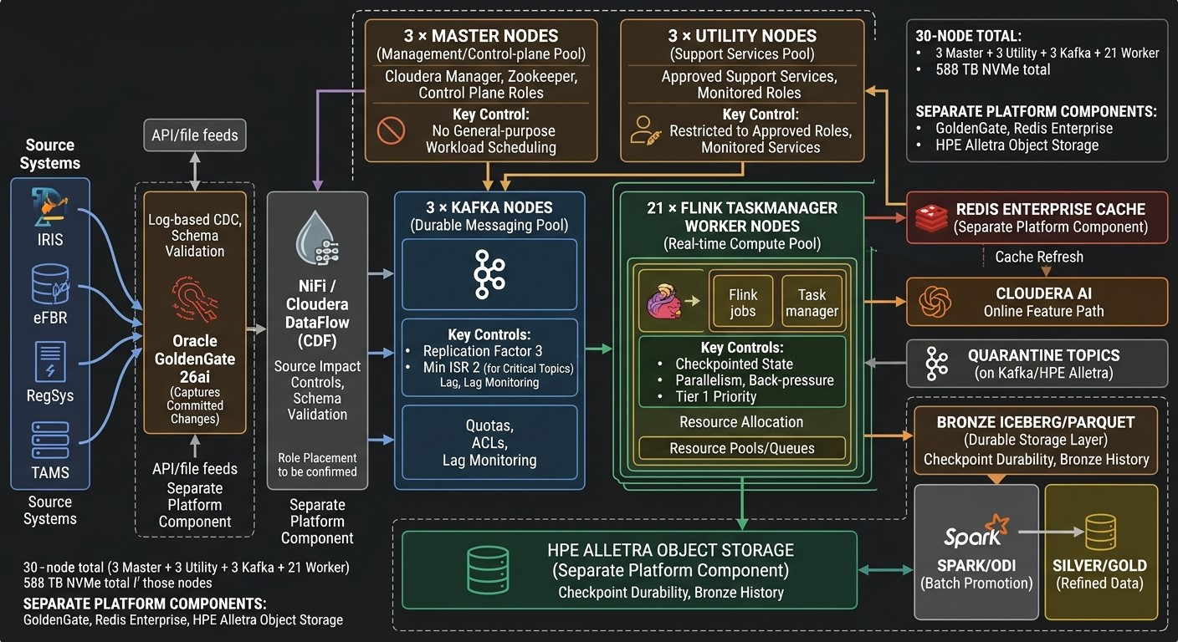

- Source Systems & Ingestion: Data originates from source systems (IRIS, eFBR, RegSys, and TAMS) and flows into Oracle via log-based Change Data Capture (CDC) using Oracle GoldenGate 26ai, alongside API and file feeds.
- Data Flow & Messaging: Ingested data moves through NiFi / Cloudera DataFlow into a dedicated 3-node Kafka messaging pool configured with replication factor 3, minimum ISR 2 for critical topics, quotas, and ACLs.
- Real-Time Processing & Compute: A 21-node worker pool running Apache Flink TaskManagers handles real-time compute, utilizing checkpointed state, parallelism controls, back-pressure handling, and resource pooling.
- Cluster Management & Utility: The infrastructure includes a 3-node master pool dedicated to control-plane services and Cloudera Manager (with no general-purpose workload scheduling), plus a 3-node utility pool restricted to approved and monitored support services.
- Storage, Caching & Serving Layers: Processed data lands in Bronze Iceberg/Parquet storage on HPE Alletra Object Storage, feeds quarantine topics, updates the Redis Enterprise cache, and powers the Cloudera AI online feature path, with Spark/ODI subsequently promoting data to Silver and Gold layers.
- Infrastructure Summary: The core compute and messaging infrastructure totals 30 nodes and 588 TB of NVMe storage, while external/separate platform components (GoldenGate, Redis Enterprise, and HPE Alletra Object Storage) are sized independently.
Flow stage | Assigned node pool / platform | Key controls
Ingestion | GoldenGate and NiFi / Cloudera DataFlow (role placement to be confirmed) | Log-based CDC, source impact controls, schema validation
Durable messaging | 3 × Kafka nodes | Replication factor 3; min ISR 2 for critical topics; quotas, ACLs, lag monitoring
Real-time compute | 21 × worker nodes hosting Flink TaskManagers through resource pools/queues | Checkpointed state, parallelism, back-pressure, Tier 1 priority
Management | 3 × master nodes | Control-plane services; no general-purpose workload scheduling
Utility/support | 3 × utility nodes | Restricted to approved utility roles and monitored services
Storage and serving | HPE Alletra object storage, Redis Enterprise, Oracle platform | Checkpoint durability, Bronze history, cache refresh; separately sized

D. Workload isolation
Physical isolation: Kafka brokers use a dedicated three-node pool; master nodes are reserved for control-plane services; worker nodes provide distributed compute; utility nodes are restricted to approved support roles.
Priority tiers: Tier 1 includes operational alerts, cache refresh and online-feature refresh; Tier 2 includes CDC apply and inline data quality; Tier 3 includes replay, backfill and exploratory jobs. Apply separate resource pools/queues, concurrency limits and resource guarantees.
Messaging controls: set Kafka producer/consumer/request quotas by application and principal, enforce topic ACLs, separate consumer groups by use case and reserve partitions/capacity for critical topics where justified.
Back-pressure and failure isolation: throttle lower-priority backfills before they affect critical streams; route invalid records to quarantine topics; use Flink checkpoints/savepoints and Kafka replication/replay for recovery.
Security isolation: Keycloak/AD-backed identity, least-privilege RBAC, TLS in transit, service-specific credentials and audited administration.
Acceptance under contention: test peak ingest while replay/backfill and node-failure scenarios are active; verify Tier 1 latency and consumer lag remain within agreed SLOs.

E. Alignment with RFP Section 6 sizing requirements
The proposed inventory specifies 30 nodes, 912 physical cores, 11,136 GB RAM and 588 TB raw NVMe. Section 6 compliance should be cross-checked against the actual Section 6 requirements for network speed/redundancy, usable storage, rack/failure-domain placement, power, OS/platform versions, HA/DR and growth headroom; these cannot be confirmed from CPU/RAM/disk counts alone.
Dimension | Sizing interpretation / required verification
Compute | Aggregate values are arithmetic totals of the specified node inventory; reserve resources for operating system, management agents and failover.
Storage | 588 TB is raw NVMe. Calculate usable capacity after formatting, RAID/filesystem overhead, reserved space and any data replication. Kafka retention must be validated against payload rate and replication factor.
Network | Confirm redundant high-bandwidth links for Kafka replication, Flink shuffles and storage. Link speed is not specified in the supplied node inventory.
Availability | Three Kafka nodes enable a three-replica design but do not alone prove rack-level or site-level resilience; verify physical failure domains and DR replication.
Capacity acceptance | Run representative sustained, peak, replay and node-failure tests. Capture CPU/RAM, NVMe throughput/latency, network use, consumer lag, checkpoint duration and p50/p95/p99 end-to-end latency.

F. Public benchmark and comparable-deployment evidence
Public documentation supports the technology choice and provides benchmark methods, but does not establish measured end-to-end performance for this exact FBR configuration. The 50,000 events/sec sustained and 150,000 events/sec peak values in the original Section 7.6 should be treated as proposed acceptance targets until measured on the proposed hardware.
Reference | Published evidence / relevance | Limitations | Public URL
Cloudera Runtime Kafka Performance Tuning | Official Kafka sizing guidance derives capacity from network/disk throughput, replication factor and consumer load; recommends simulating expected workloads with Kafka producer/consumer performance tools. | Methodology, not a guarantee for this hardware. Use to structure broker sizing and tests. | https://docs.cloudera.com/cdp-private-cloud-base/latest/kafka-performance-tuning/kafka-performance-tuning.pdf
Cloudera Streaming overview | Describes Cloudera streaming based on Kafka and Flink for high-volume, low-latency workloads. | General vendor capability statement; no FBR-specific workload measurements. | https://www.cloudera.com/products/stream-processing.html
Apache Flink official site | Documents stateful stream processing, exactly-once state consistency, low latency/high throughput, incremental checkpoints and scale-out. | Capability evidence only; job logic, state, parallelism and checkpoint storage affect results. | https://flink.apache.org/
Apache Flink benchmark repository | Provides micro-benchmarks for Flink internals and state backend. | Not an end-to-end pipeline benchmark; use for component-level regression tests. | https://github.com/apache/flink-benchmarks
Cloudera on-premises customer case study | A customer case study describes migration of 900+ nodes to CDP Private Cloud Base and use of Cloudera Streams Messaging for buffering and cross-data-centre replication. | Comparable operating-scale evidence, but no comparable events/sec or p95/p99 results are published. | https://www.cloudera.com/customers/global-information-technology-company.html

G. PRAL infrastructure throughput / latency test plan
Test | Profile | Measurements / acceptance evidence
Kafka broker throughput | Use Kafka producer/consumer performance tools; test at 1×, 3× and 5× approved sustained target, with representative payloads and replication factor 3. | Events/sec, MB/sec, disk IOPS/latency, network throughput, under-replicated partitions, errors and consumer lag; demonstrate no sustained backlog growth at approved peak.
End-to-end stream | GoldenGate/NiFi → Kafka → Flink validation/enrichment → Bronze and cache with production-like schemas and data-quality rules. | Events/sec, duplicate/loss checks, checkpoint duration, back-pressure, consumer lag and source-to-Bronze p50/p95/p99 latency.
Failure and recovery | Terminate one Kafka broker and one Flink TaskManager in separate test runs; checkpointing enabled; validate replay/restart. | Recovery time, restore time, lag recovery, data correctness and impact on Tier 1 latency.
Soak / contention | At least 4-hour sustained test plus agreed longer soak; run lower-priority replay/backfill concurrently. | Stable resource use, no unbounded lag growth, and no critical SLO breach.
Test report | Record exact hardware/firmware, Cloudera/Kafka/Flink versions, partitions, replication, payload mix, parallelism and test tools. | Attach test scripts, raw logs, Prometheus/Grafana exports, p50/p95/p99 tables, bottlenecks and remediation actions.

