OpenShift Virtualization vs VMware: Key Differences, Technologies & Use Cases

Table of Contents
1. Understanding Virtualization Technology 3
Core Concepts of Virtualization 3
The Role of Hypervisors 3
Type 1 Hypervisors 4
Type 2 Hypervisors 4
Resource Management in Virtual Environments 4
Real-World Example: 4
1. CPU Scheduling 5
2. Memory Management 5
3. Storage Virtualization 5
4. Network Resource Sharing and Isolation 6
Simple Real-Life Analogy 6
Exam-Friendly Definition 6
VMware's Enterprise Virtualization Platform 6
ESXi: The Foundation of VMware Infrastructure 6
2. OpenShift Virtualization with KubeVirt 7
Merging Container and VM Workloads 7
KubeVirt Technology 7
KVM Integration 7
3. Hardware & Storage 7
HPE iLO and Dell iDRAC 7
What is HPE iLO? 8
What is Dell iDRAC? 9
The most important concept: Out-of-Band Management 10
In-Band Management 10
Out-of-Band Management 11
Real-World Example 1: — The Server Is Hung 12
Real-World Example 2 — Windows Server Crash 12
Hardware Health Monitoring 13
Real-World Example — Fan Failure 13
Temperature monitoring 13
RAM/DIMM monitoring 14
Storage aur RAID monitoring 14
HPE Storage Architecture 14
Dell Storage Architecture 15
RAID monitoring 15
Real-World RAID Example 15
Power Supply Monitoring 16
Virtual Media — very important 16
Firmware Updates 17
Logs — A Critical Part of Troubleshooting 17
Dedicated IP Addresses for iLO and iDRAC 18
Management Network 18
VMware with iLO / iDRAC 19
Out-of-Band Remediation via iLO: 19
Activity 1: Data Centre Components 20
Rack Manifold 20
CDU 20
How to Connect a CDU, Rack Manifold, and GPU Servers 21
Step-by-step connection process 23
Step 1: Connect the CDU to the cooling infrastructure 23
Step 2: Connect the CDU to the rack manifold 23
Step 3: Connect the rack manifold to the GPU servers 23
CDU (Racks) 23
24
Figure. CoolIT CHx™200 is a rack-based CDU 24
CoolIT CHx™200 is a rack-based CDU, built for the needs of today’s most demanding HPC and enterprise server requirements. Capable of managing 200 kW of heat load in a remarkably small 4U of space, this system provides cooling for up to 200 servers. 24
Liquid cooling hoses 24
Liquid cooling hoses transport heat-transfer fluids like water, glycol mixes, or deionized water through PC setups, AI servers, and data center thermal management systems. 24

Understanding Virtualization Technology

Core Concepts of Virtualization
Virtualization technology enables multiple operating systems to operate independently on a single physical server. This technology creates isolated software environments that share underlying hardware resources efficiently. At its core, virtualization transforms physical computing components into software-defined resources, allowing for better resource utilization and increased operational flexibility.

The Role of Hypervisors
The hypervisor serves as the foundation of virtualization technology, acting as the control center that manages and distributes hardware resources among virtual machines. This essential software layer creates and maintains separation between physical hardware and virtual environments, ensuring secure and efficient operation of multiple virtual instances.

Type 1 Hypervisors
Bare-metal hypervisors, known as Type 1, represent the most efficient virtualization approach. These hypervisors install directly on server hardware, eliminating the need for a host operating system. This direct hardware access results in superior performance and reduced resource overhead. Notable examples include VMware ESXi, KVM, and Citrix Hypervisor. Organizations typically choose Type 1 hypervisors for production environments where performance and security are paramount.

Type 2 Hypervisors
In contrast, Type 2 hypervisors operate as applications within a conventional operating system. While these hosted hypervisors offer easier installation and management, they introduce additional overhead due to the underlying operating system layer. Solutions like VMware Workstation and Oracle VirtualBox fall into this category. These hypervisors excel in development, testing, and desktop virtualization scenarios where maximum performance isn't critical.

Resource Management in Virtual Environments
Successful virtualization depends on efficient resource allocation and management. Modern hypervisors employ sophisticated techniques to distribute computing resources, including:
- CPU scheduling and allocation
- Memory management and distribution
- Storage virtualization and allocation
- Network resource sharing and isolation
These resource management capabilities enable organizations to maximize hardware utilization while maintaining performance and isolation between virtual instances. The hypervisor continuously monitors and adjusts resource allocation to ensure optimal performance across all virtual machines.

Real-World Example:
Imagine a company has a powerful physical server. Instead of using this server for only one application, a hypervisor divides it into multiple Virtual Machines (VMs).
For example, the physical server has:
- 16 CPU cores
- 64 GB RAM
- 2 TB storage
- 10 Gbps network
The hypervisor distributes these resources among different VMs:
Virtual Machine | CPU | RAM | Storage | Use
VM 1 | 4 cores | 16 GB | 500 GB | Web Server
VM 2 | 4 cores | 16 GB | 500 GB | Database
VM 3 | 2 cores | 8 GB | 300 GB | Application
VM 4 | 2 cores | 8 GB | 300 GB | Testing

1. CPU Scheduling
Suppose VM 1 is running a website and suddenly many users visit the website. It needs more CPU power.
The hypervisor manages the CPU and gives more processing time to VM 1 when needed.
In simple words:
The hypervisor makes sure that CPU resources are not wasted and are given to the VMs that need them.

2. Memory Management
Suppose VM 3 has 8 GB RAM allocated to it, but it is currently using only 4 GB. Another VM may need more memory.
The hypervisor can manage the available memory efficiently according to its configuration and memory-management techniques.
In simple words:
The hypervisor helps make better use of the available RAM.

3. Storage Virtualization
The physical server has 2 TB of storage, but each VM appears to have its own virtual disk.
For example:
- VM 1 → 500 GB
- VM 2 → 500 GB
- VM 3 → 300 GB
The physical storage is divided and managed logically for different VMs.
In simple words:
Each VM gets its own virtual storage while the physical storage is managed by the underlying system.

4. Network Resource Sharing and Isolation
All VMs can share the same physical network hardware, but the hypervisor and network virtualization mechanisms manage their network traffic.
For example:
- VM 1 → Web traffic
- VM 2 → Database traffic
- VM 3 → Internal application traffic
The network resources can be controlled so that heavy traffic from one VM does not unnecessarily affect other VMs.

Simple Real-Life Analogy
Think of a physical server as an apartment building.
- Physical Server = Apartment Building
- Hypervisor = Building Manager
- VMs = Different Apartments
- CPU = Electricity
- Memory = Water supply
- Storage = Storage space
- Network = Internet connection
The building manager distributes resources among different apartments and keeps the apartments separate.

Exam-Friendly Definition
A hypervisor acts like a building manager. It efficiently distributes the physical server's CPU, memory, storage, and network resources among different virtual machines while maintaining isolation between them.

VMware's Enterprise Virtualization Platform

ESXi: The Foundation of VMware Infrastructure
VMware's ESXi represents the cornerstone of enterprise virtualization, operating as a bare-metal hypervisor that directly manages hardware resources. Unlike traditional operating systems, ESXi's streamlined architecture minimizes system overhead while maximizing performance. This efficient design enables organizations to run numerous virtual machines on a single physical server with optimal resource utilization.
- Virtual Machines virtualize the hardware, giving you an entirely separate, heavy virtual computer with its own complete operating system.

- Containers virtualize the operating system, sharing the host machine's existing kernel to run applications as lightweight, isolated processes.

OpenShift Virtualization with KubeVirt

Merging Container and VM Workloads
OpenShift Virtualization is a technology that allows organizations to run and manage virtual machines (VMs) and containers on the same Kubernetes-based OpenShift platform. It helps companies run old and new applications together.

KubeVirt Technology
KubeVirt is an open-source technology that extends Kubernetes to run and manage virtual machines alongside containers.

KVM Integration
KVM is the hypervisor used by OpenShift Virtualization to run virtual machines efficiently, while KubeVirt allows Kubernetes to manage those VMs.

We can use OpenShift Virtualization because it provides a unified Kubernetes-based platform where we can manage existing VMs while also running containerized cloud-native applications, which can simplify gradual application modernization.

Hardware & Storage

HPE iLO and Dell iDRAC
HPE-iLO or Dell iDARC both are remote management controller of a server
For example:
If server is a car then HPE-iLO or Dell iDARC are the remote control + dashboard + diagnostic system
You can check a server's power status, hardware health, temperatures, fans, RAM, CPU, storage, RAID controller, power supply, BIOS/UEFI, and hardware logs without having to visit it in person.
You can also perform several operations remotely, such as powering the server on or off, restarting it, launching a remote console, accessing the BIOS, installing the operating system, applying firmware updates, and mounting virtual ISOs.

What is HPE iLO?
iLO stands for Integrated Lights-Out. It is a dedicated remote management controller embedded directly onto the motherboard of HPE ProLiant servers (such as the HPE ProLiant DL380).
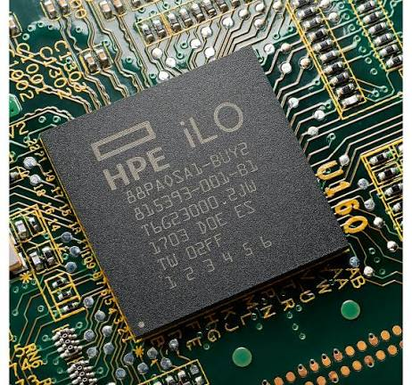
Figure. HPE iLO

HPE ProLiant DL380
|
└── HPE iLO (Dedicated Hardware Chip)

HPE ProLiant DL380 is an industry-standard 2U, dual-socket rack server originally introduced by Compaq in January 2000 and currently produced by Hewlett Packard Enterprise (HPE). Known as the flagship of the "Density Line" (DL) family, it is widely regarded as a data center workhorse for enterprise virtualization, database management, cloud computing, and AI workloads.
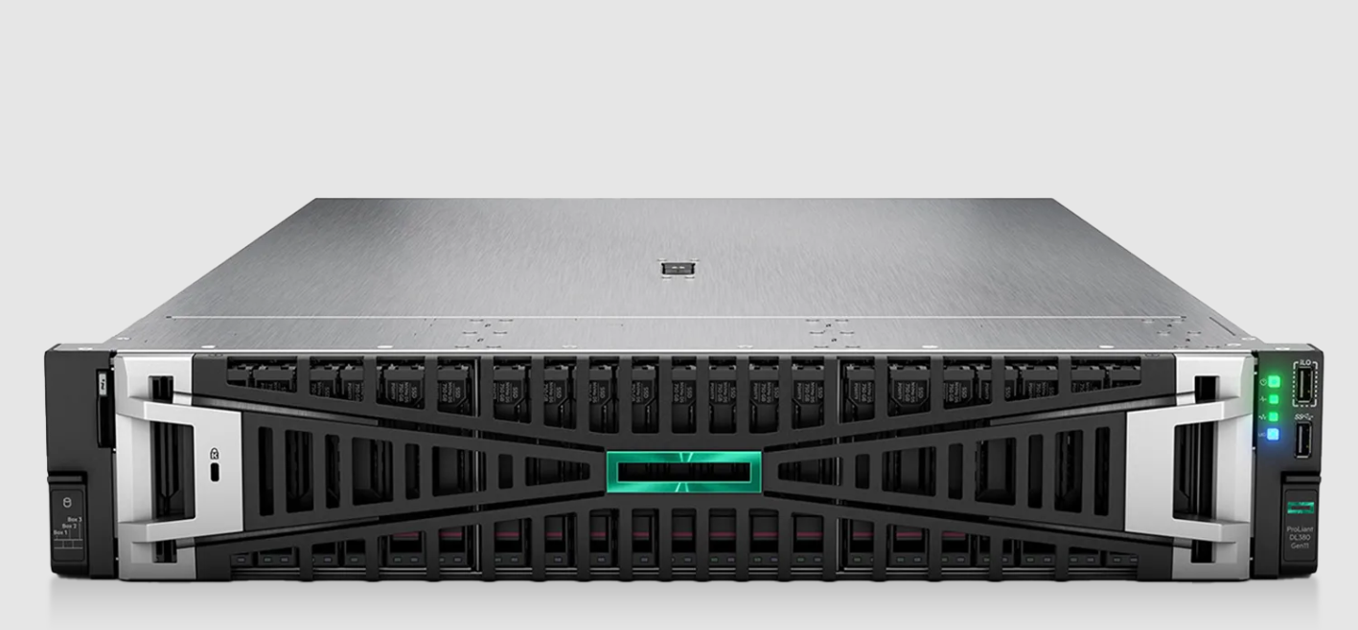
Figure. HPE ProLiant DL380

iLO is a dedicated management controller on the server's motherboard.
Its most important feature is that:
iLO is independent of the operating system.
This means that even if Windows or Linux crashes on the server, iLO can normally still be accessed.

What is Dell iDRAC?
iDRAC stands for Integrated Dell Remote Access Controller. It is embedded in Dell PowerEdge servers (such as the Dell PowerEdge R760).

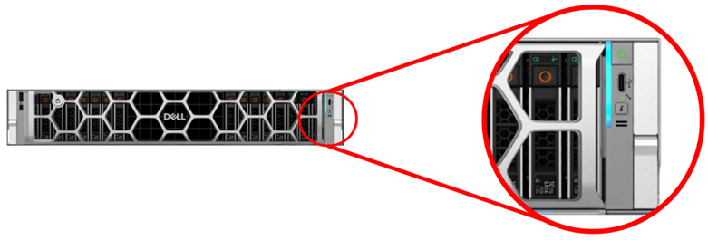
Figure . PowerEdge 17th generation server iDRAC Direct port location

Dell PowerEdge R760
|
└── Dell iDRAC
The Dell PowerEdge R760 is a powerful 2U dual-socket rack server designed for enterprise workloads like virtualization, databases, and AI.
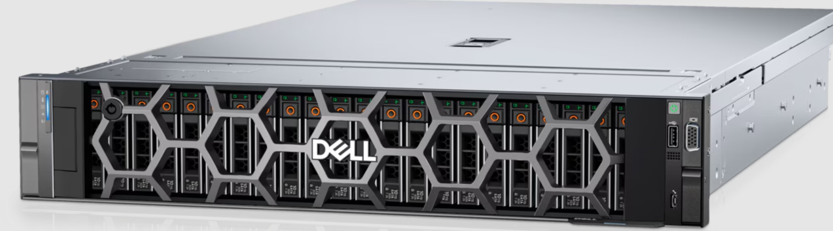
Figure. PowerEdge R760 Server
The purpose of iDRAC is identical to that of iLO, enabling comprehensive remote monitoring, remote power management, and remote console access. It also handles hardware monitoring, BIOS and firmware management, system logs, storage and RAID monitoring, and virtual media redirection.
HPE | Dell
iLO | iDRAC
ProLiant | PowerEdge
Smart Array | PERC
HPE One View | Dell Open Manage

The most important concept: Out-of-Band Management
This is a highly critical concept for every System Engineer.
To understand it, you need to understand the two common types of management:

In-Band Management
In this method, we manage the server through its operating system.

Administrator
↓
Network
↓
Windows/Linux
↓
Server
Examples:
- SSH
- RDP
- PowerShell
- Linux commands

The problem is, if the OS itself goes down:
Linux
↓
CRASH ❌
↓
SSH ❌
Then you don’t access server with the help of SSH.

Out-of-Band Management
This is where the concept of iLO and iDRAC comes into play.

Administrator
↓
Management Network
↓
iLO / iDRAC
↓
Physical Server

It manages the server from outside the operating system.
Therefore:
iLO and iDRAC are classified as Out-of-Band Management technologies.

Real-World Example 1: — The Server Is Hung
Imagine you are a System Engineer in a data center. You have an HPE ProLiant DL380 server with VMware ESXi installed.
One day, the VMware host stops responding. You try the following troubleshooting steps:
- SSH → ❌ (Fails)
- vCenter → ❌ (Shows "Host Not Responding")
- Ping → ❌ (No response)
You are not physically near the server. What do you do next?
You use iLO (Integrated Lights-Out). You log into iLO via this connection path:
Laptop → Management Network → HPE iLO → DL380 Server
Once logged in, you check the hardware status:
- Power Status: ON
- Temperature: Normal
- Fans: Normal
- Memory: Normal
- CPU: Normal
- PSU (Power Supply Unit): Normal
Since the hardware looks fine, you open the Remote Console to view the server's actual screen. On the screen, you might see a VMware ESXi Kernel Panic (Purple Screen of Death) or notice that the server is stuck on boot.
Using iLO, you perform a remote reboot. The server restarts through the following sequence:
POST → BIOS → ESXi → VMware Host → vCenter
The server successfully recovers, and you did not have to physically visit the data center.

Real-World Example 2 — Windows Server Crash
Suppose you have a Dell PowerEdge server running Windows Server, which hosts an application.
Dell PowerEdge → Windows Server → Application
Suddenly, the application crashes, and Windows goes into a blue screen. You attempt to connect remotely:
- RDP → ❌ (Fails)
- SSH → (Obviously not available)
However, your remote management access is working:
- iDRAC → ✅ (Available)
You log into iDRAC and open the Remote Console. On the server's screen, you see the Windows Blue Screen (BSOD).
Using the iDRAC interface, you remotely restart the server to bring it back online.

Hardware Health Monitoring
You can think of iLO / iDRAC as the server's health dashboard.
Suppose the server displays the following status:
- CPU
  - CPU 1 → OK
  - CPU 2 → OK
- Memory
  - DIMM 1 → OK
  - DIMM 2 → OK
  - DIMM 3 → Failed ❌
- Fans
  - Fan 1 → OK
  - Fan 2 → OK
  - Fan 3 → Failed ❌
- PSU
  - PSU 1 → OK
  - PSU 2 → Failed ❌
- Temperature
  - CPU Temperature → Normal
  - System Temperature → Normal
This critical information is incredibly useful for a System Engineer during the troubleshooting process.

Real-World Example — Fan Failure
Imagine a fan fails inside a Dell PowerEdge server.
Without proper monitoring, the following chain reaction occurs:
Fan Failure → Temperature increases → CPU throttling → Performance decreases → Server shutdown
However, with iDRAC monitoring, the engineer is alerted immediately:
iDRAC → Fan 3 → FAILED ⚠️
Because of this, the System Engineer catches the issue early before any downtime happens. The hardware team can then schedule a quick visit to replace the faulty fan.

Temperature monitoring
Server room mein cooling bohat important hoti hai.
iLO/iDRAC sensors ke through temperatures monitor kiye ja sakte hain.
Example:
CPU 1: 55°C
CPU 2: 57°C
Memory: Normal
System Board: Normal
Agar temperature unusually increase kare:
Temperature
↓
High
↓
Warning
↓
System Engineer
Potential reasons:
- Fan failure
- Blocked airflow
- Data-center cooling issue
- Dust
- High workload

RAM/DIMM monitoring
Suppose HPE server mein 16 DIMMs installed hain.
iLO show kar sakta hai:
DIMM 1 → OK
DIMM 2 → OK
DIMM 3 → OK
DIMM 4 → Error
...
Aapko pata chal sakta hai ke particular memory module problem create kar raha hai.
Dell mein ye information iDRAC se mil sakti hai.

Storage aur RAID monitoring

HPE Storage Architecture
HPE servers commonly use HPE Smart Array controllers to manage storage.
HPE Server → Smart Array Controller → RAID Configuration → Physical Disks
Through the iLO interface, you can directly monitor both the overall storage health and detailed controller information.

Dell Storage Architecture
Dell PowerEdge servers commonly use PERC (PowerEdge RAID Controller) controllers to manage storage.
Dell Server → PERC Controller → RAID Configuration → Physical Disks
Through the iDRAC interface, you can easily monitor both the storage array and the controller status.

RAID monitoring
Is the process of regularly checking the health, performance, and status of your RAID (Redundant Array of Independent Disks) storage system so you know immediately if a hard drive is failing or has already failed?

Here is the English translation of your real-world RAID example:

Real-World RAID Example
Suppose a Dell server has:
- 8 × SSDs installed.
RAID Controller:
- PERC configured as RAID 5
A disk failure occurs:
- Disk 1 → OK
- Disk 2 → OK
- Disk 3 → FAILED ❌
- Disk 4 → OK
- Disk 5 → OK
- ...
Monitoring and Notification:
- iDRAC displays a warning alert.
- The Systems Engineer is notified: "Disk 3 needs replacement."
Resolution:
- The faulty disk can then be hot-swapped/replaced, and the RAID array can automatically rebuild.

Power Supply Monitoring
Enterprise servers often feature redundant Power Supply Units (PSUs).
Normal State:
- PSU 1 → AC → OK
- PSU 2 → AC → OK
If PSU 2 fails:
- PSU 1 → OK
- PSU 2 → FAILED ❌
System Impact and Alerts:
- The server typically remains running without interruption because PSU 1 continues to provide power.
- However, iLO/iDRAC triggers a critical warning alert.
- The Systems Engineer is notified that the PSU requires immediate replacement.

Virtual Media — very important
Suppose aapko remote server par RHEL install karna hai.
Server Karachi mein hai.
Aap Islamabad mein hain.
Aap physical USB lekar Karachi nahi jana chahte.
Aapke laptop par:
RHEL ISO
available hai.
iLO/iDRAC ke Virtual Media feature se ISO ko remotely server ke virtual CD/DVD ke taur par attach kiya ja sakta hai.
Concept:
Your Laptop
|
RHEL ISO
↓
iLO / iDRAC
↓
Virtual CD/DVD
↓
Server
↓
RHEL Installation
Ye remote data-center operations mein extremely useful feature hai.

Firmware Updates
Firmware is critical in enterprise server environments. Firmware is low-level software that is written directly to a hardware device's non-volatile memory to provide the permanent instructions that control how that hardware communicates and operates. Yes, exactly! Firmware is the low-level software embedded directly into a hardware device's non-volatile memory (like ROM, EEPROM, or Flash) that provides the essential instructions for how the hardware operates and communicates with other software.
Common Examples:
- BIOS / UEFI firmware
- RAID controller (PERC / Smart Array) firmware
- Network Interface Card (NIC) firmware
- Storage drive (HDD / SSD) firmware
- Baseboard Management Controller (BMC) firmware (iLO / iDRAC)

Management Capabilities:
- Through out-of-band management tools like iLO and iDRAC, administrators can inspect installed versions and apply firmware updates, depending on platform support and licensing tiers.

Workflow Example:
- Current BIOS: Version 2.10
- Available BIOS: Version 2.20
- The Systems Engineer can evaluate release notes, schedule a maintenance window, and execute the upgrade remotely.

Logs — A Critical Part of Troubleshooting
Out-of-band management controllers like iLO and iDRAC continuously record hardware events into dedicated system event logs.
Timeline Example:
- 10:05 AM → PSU Warning ⚠️
- 10:15 AM → Fan Speed Warning ⚠️
- 10:20 AM → High Temperature Alert 🔥
- 10:25 AM → Sudden Server Reboot 🔄
Significance:
- If a server is crashing repeatedly, analyzing these sequential logs provides vital clues to identify the root cause (e.g., in this case, a failing fan caused overheating, which triggered an automatic thermal shutdown).

Dedicated IP Addresses for iLO and iDRAC
By default, an out-of-band management controller maintains its own distinct IP address on the network, completely separate from the host operating system.
HPE Example:
- HPE Server (Host OS): 10.10.10.50
- iLO (Management Interface): 10.10.20.50
Dell Example:
- Dell Server (Host OS): 10.10.10.60
- iDRAC (Management Interface): 10.10.20.60
Network Architecture:
- In standard enterprise data center designs, the production network (used by customer-facing workloads) and the management network (used by administrators) are kept strictly isolated on separate subnets or VLANs for enhanced security and traffic segmentation.

Management Network
In large-scale data centers, isolating management traffic from normal operations is an industry standard best practice.

Architecture Diagram:

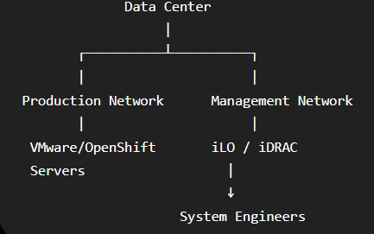

VMware with iLO / iDRAC
This scenario is critical for your upcoming Systems Engineer role.
Architecture Overview:
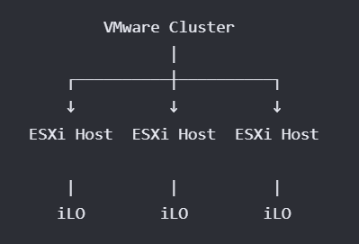
Failure Scenario:
- An ESXi host crashes or encounters a kernel panic (PSOD — Purple Screen of Death).
- vCenter Status: Displays as "Not Responding" or "Disconnected".
- Troubleshooting capabilities directly through vCenter become severely limited or entirely inaccessible.

Out-of-Band Remediation via iLO:
- Launch the Remote Console (HTML5/IRC) to view the live physical display output.
- Inspect the host screen for a PSOD (Purple Screen of Death) and record the crash dump / backtrace error codes.
- Check the BIOS / POST diagnostics and verify real-time Hardware Health (e.g., failed memory DIMMs, storage controller errors, or thermal faults).
- Perform a graceful or hard Power Cycle / Reboot directly through the console if the host is completely hung.
(In a Dell-based VMware deployment, iDRAC performs the exact same operational role as HPE's iLO).

Activity 1: Data Centre Components

Rack Manifold
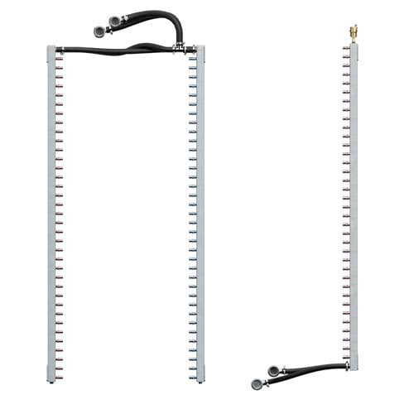
Figure. Rack Manifold

A Rack Manifold is a piping assembly installed in or near a server rack that distributes cooling liquid to multiple servers or cooling components and collects the heated liquid for return to the cooling system. It is commonly used in liquid-cooled data centers to ensure efficient and controlled heat removal from IT equipment.

CDU
A Coolant Distribution Unit (CDU) is a cooling system component used in liquid-cooled data centers to circulate and regulate coolant flow between the cooling infrastructure and IT equipment, such as GPU servers. It typically uses pumps, heat exchangers, and monitoring controls to manage coolant circulation and transfer heat from the server cooling loop to a facility cooling system, helping maintain safe operating temperatures for the equipment.
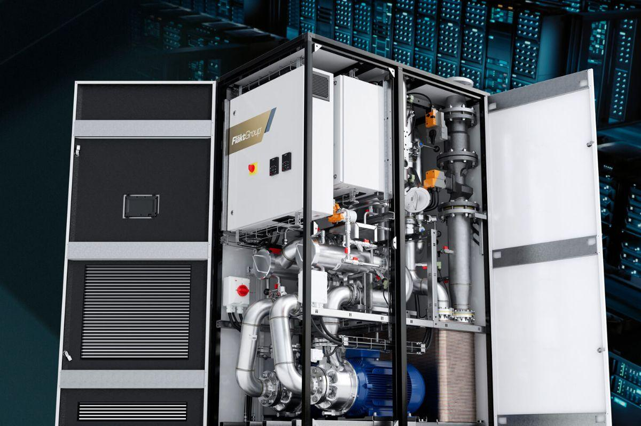
Figure. Coolant Distribution Unit

A Coolant Distribution Unit (CDU) is a cooling system component used in liquid-cooled data centers to circulate and regulate coolant flow between the cooling infrastructure and IT equipment, such as GPU servers. It typically uses pumps, heat exchangers, and monitoring controls to manage coolant circulation and transfer heat from the server cooling loop to a facility cooling system, helping maintain safe operating temperatures for the equipment.

How to Connect a CDU, Rack Manifold, and GPU Servers

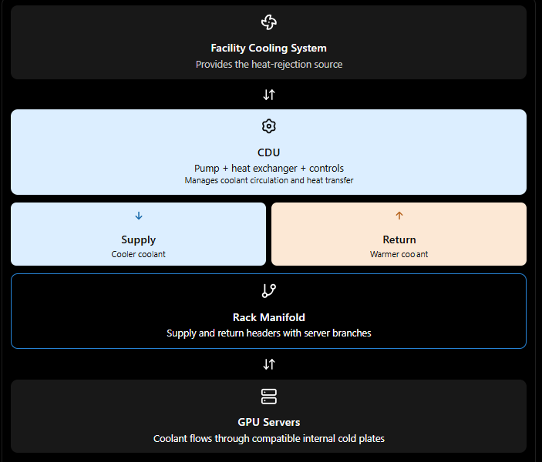
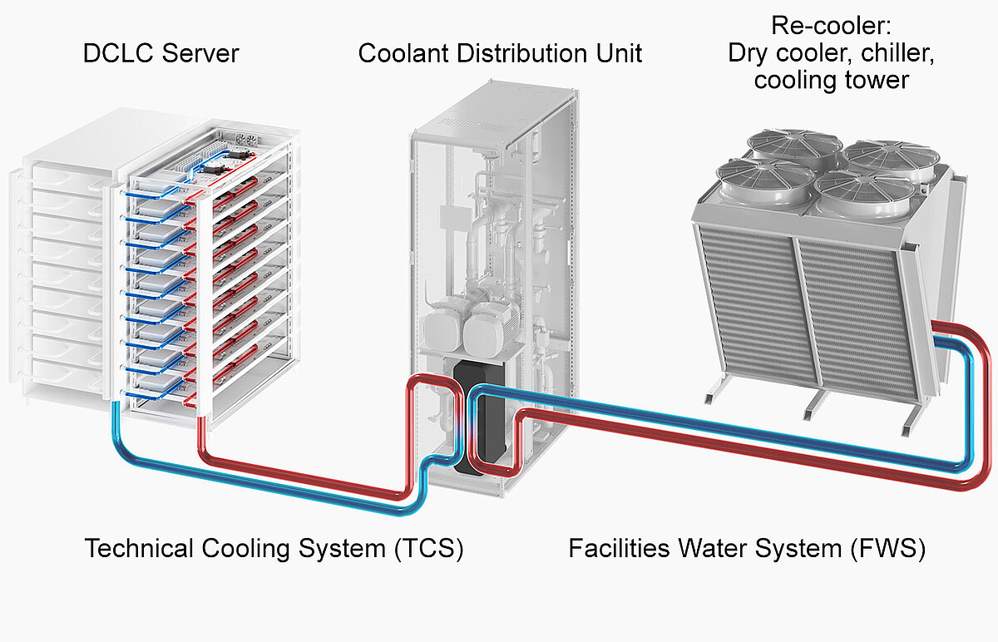

Step-by-step connection process

Step 1: Connect the CDU to the cooling infrastructure
The CDU typically has two separate circuits:
- Facility water circuit: Connects the CDU to the building's approved cooling-water infrastructure.
- Technology cooling circuit (TCS): Circulates coolant between the CDU and the GPU servers.
In a typical liquid-to-liquid CDU, the heat exchanger transfers heat between these circuits without mixing their liquids.

Step 2: Connect the CDU to the rack manifold
The CDU's technology cooling circuit has two main connections:
- Coolant Supply Outlet: Connect this to the rack manifold's supply inlet.
- Coolant Return Inlet: Connect this to the rack manifold's return outlet.
Use compatible pipes or hoses, fittings, valves, and quick-disconnect couplings specified by the equipment manufacturer.

Step 3: Connect the rack manifold to the GPU servers
The rack manifold normally has a supply header and a return header, with branches for individual servers.
- Connect each server's designated coolant inlet to a supply branch.
- Connect each server's designated coolant outlet to a return branch.
- Verify that connector types, pressure ratings, coolant specifications, and flow requirements match.
Some GPU systems use blind-mate manifold connections, where the server connects directly to the manifold when inserted into the rack.

CDU (Racks)
Figure. CoolIT CHx™200 is a rack-based CDU
CoolIT CHx™200 is a rack-based CDU, built for the needs of today’s most demanding HPC and enterprise server requirements. Capable of managing 200 kW of heat load in a remarkably small 4U of space, this system provides cooling for up to 200 servers.

Liquid cooling hoses
Liquid cooling hoses transport heat-transfer fluids like water, glycol mixes, or deionized water through PC setups, AI servers, and data center thermal management systems.

