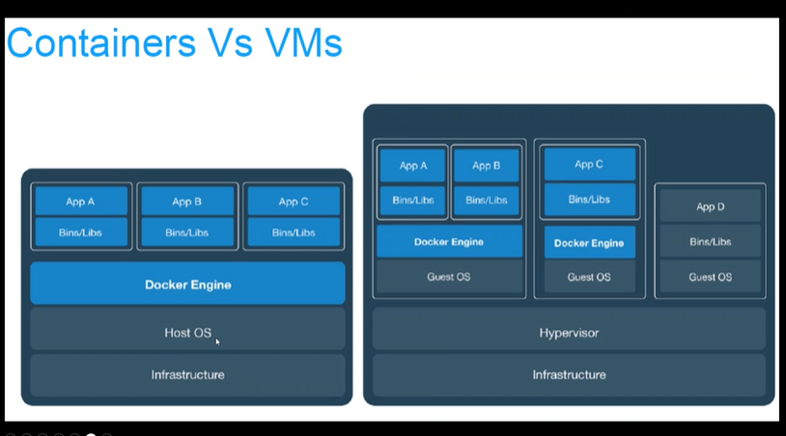

Instalar doker

<https://docs.docker.com/engine/install/ubuntu/>

<https://docs.docker.com/desktop/install/windows-install/>

virtual machine

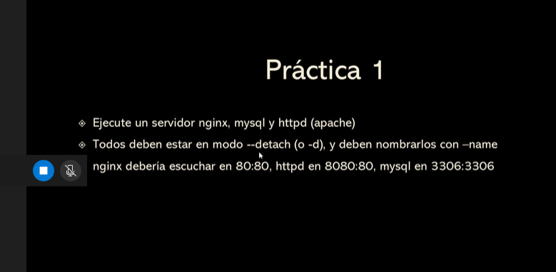

Docket contoner ls –a

Para ver todo

<https://docs.docker.com/desktop/install/windows-install/>