Name: Navelgas, Quenzzy J.

Section: UCOS 3-2

**EXPERIMENT NO. 5 – CASE STUDY**

# Objective(s):

* Enhance network performance, security, and management for campus visits using VLAN trunking and IP configuration

**Apparatus:** Packet Tracer 5.1 or higher

# Background:

XYZ University regularly hosts campus visits for prospective students and their families. The university wanted to provide reliable, secure Wi-Fi access for visitors while ensuring that their internal systems and staff networks remained isolated. Additionally, the IT department needed to manage this growing demand without creating complex, difficult-to-maintain networks across different campus buildings.

To achieve this, XYZ University decided to simulate and test a VLAN trunking solution with appropriate IP configurations using Cisco Packet Tracer before deploying it across the actual campus network. The objective was to segment visitor traffic from internal staff traffic, using VLANs to maintain security and network efficiency, while testing the solution's effectiveness in handling multiple subnets and trunking.

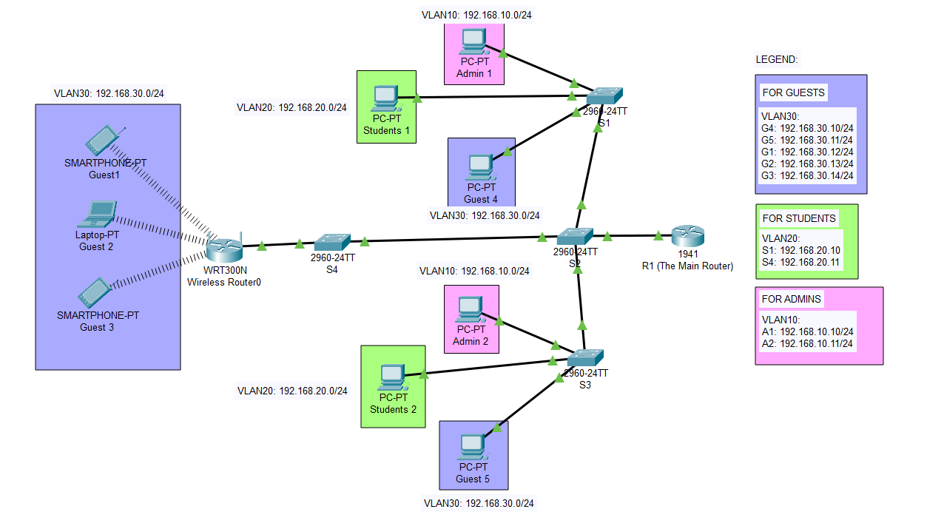**The Topology**

**Configuring the CLI**

**ROUTER**

**SWITCH 1**

**Switch 3**

**SWITCH 2**

**Simulation**

**Guests**

**Students**

**Admins**

