1. **Winfield Public Transit Authority**

Winfield is a small city with a population of 22,000. Until now, Winfield was served by a bus route from a nearby city. The Winfield City Council has held a bond sale to fund the purchase of several buses to serve three routes in Winfield and neighboring areas. As the city’s IT director, you have been asked to set up an information system for the new Transportation Authority. Assume that multiple buses will run on each route.

**Tasks**

1. Draw an ERD for the Winfield Public Transit Authority system.

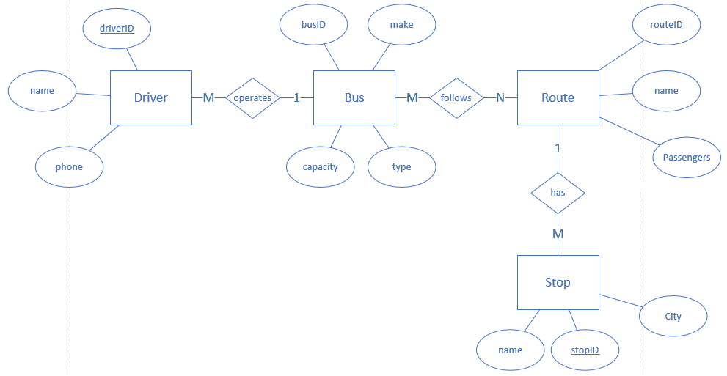

1. Indicate cardinality - by indicating the crow-foot notation.

Each driver operates one bus and each bus is driven by many drivers (M to 1)

Each bus has multiple routes and each route is served by multiple buses (M to N)

Each route has multiple bus stops and each bus stop follows one route. (1 to M)

1. Identify all fields you plan to include in the tables.

driver ID, driver name, driver phone

bus ID, bus make, bus capacity, bus type

route ID, route name, route passengers

stop ID, stop name, stop city

1. Create 3NF table design (Design the tables with no repeating groups.)

DRIVER (driverID, name, phone, address, busID*)

BUS (busID, make, type, capacity)

BUS_ROUTE (busID*, routeID*)

ROUTE (routeID, name)

STOP (stopID, name, routeID*)

Note:

* underlined attributes indicate primary key
* astrisk* indicate foreign key

The tables are in 3rd normal form because they do not contain any transitive nor derived dependencies.

1. **Working Shoes**

Working Shoes is a multistate shoe store that offers an extensive selection of casual and dress shoes designed for men and women who work on their feet. Working Shoes plans to launch a new Web site, and the company wants to develop a new set of product codes. Currently, 250 different products exist, with the possibility of adding more in the future. Shoes and many accessories come in various sizes, styles, and colors. The marketing manager asked you to develop an individualized product code that can identify a specific item and its characteristics.

**Tasks**

1. Design a code scheme that will meet the marketing manager’s stated requirements for at least 10 examples.

*Product coding scheme: (sex-type-brand-style-color-size)*

|  |  |
| --- | --- |
| ***Item*** | ***Product Code*** |
| *Mens, casual, nike jordans 1, red, size 11* | *01-01-21-01-05-11* |
| *Unisex, work, sketchers tough, black, size 8* | *03-03-25-02-03-08* |
| *Unisex, casual, converse all star, white, size 8* | *03-01-21-04-01-09* |
| *Nike shoe brush, black* | *00-00-21-00-03-00* |
| *Mens, classic, ralph lauren classic, blue, size 7* | *01-01-02-02-04-07* |
| *Womans, dress, zahara sandels, tan, size 6* | *02-02-43-08-06-06* |
| *Unisex, casual, gucci flipflops, green, size 9* | *03-01-15-03-02-09* |
| *Mens, dress, hans knee socks, black, size 8* | *01-03-06-05-03-08* |
| *Womans, dress, hans ankle socks, tan, size 5* | *02-02-06-04-06-05* |
| *Womans, work, puma safety, pink, size 7* | *02-03-05-03-09-07* |

1. Write a brief memo/email is fine to the marketing manager suggesting code proposed, and state your reasons.

Hello Marketing Manager,

I have designed a simple product coding scheme that can easily identify specific products and its characteristics for the company Working Shoes.

My proposed product coding scheme is as shown below:

*(sex-type-brand-style-color-size)*

Each attribute follows a two digit-number sytem that uniquely refines a characteristics of a product. What is great about this coding scheme is that it is easy to follow and allows for expandability in the future. One would simple increase the number of digits an attributes uses. If one of the attributes does not apply to a product, the attribute can be set to 00.

Here is a quick example of the two digit number system working with various attributes:

|  |  |  |  |  |  |
| --- | --- | --- | --- | --- | --- |
| **Sex** | **Type** | **Brand** | **Style** | **Color** | **Size** |
| Male = 01 | Casual = 01 | Nike = 21 | Jordans = 04 | Red = 05 | sz 9 = 09 |
| Female = 02 | Dress = 02 | Adidas = 18 | Yeezy = 43 | Black = 03 | sz 5 - 05 |
| Unisex = 03 | Work = 03 | Sketchers = 04 | Dlite = 12 | White = 01 | sz 12 = 12 |
| ect.. | ect.. | ect.. | ect.. | ect.. | ect.. |

|  |  |
| --- | --- |
| ***Product*** | ***Code*** |
| *Male, casual, adidas yeezy , white, size 9* | *02-03-05-03-09-07* |

If you have any questions, please feel free to contact me.

Thank you,

* Chris Banci.

1. Suggest a code scheme that will identify each specific order. Consider using the date or type of transaction such as web or in store purchases.

Order code scheme:

(DD-MM-YYYY-T-####)

Format:

**DD** = Day

**MM** = Month

**YYYY** = Year

**T** = Type (W for web and S for store purchase)

**#####** = Number of orders for a particular type in a given day. Resets everday.

Example:

Transaction 0023, Web purchase, Date: 4/26/2016

* (04262016-W-0023)

Transaction 0154, Store purchase, Date: 4/23/2017

* (04232017-S-0154)

1. **Data Design Terms**

**Briefly define the following terms (use 2-3 sentences)**

|  |  |
| --- | --- |
| ***Term*** | ***Definition*** |
| *Attribute* | *An attribute is a property value that describes an entity. It is similiar to the idea of member variables of a class in programming languages.*  *Ex: attributes of a person are its color, make, wheel style, transmission type, ect..* |
| *Crow’s feet notation* | *Crow’s feet notation is a type of notation used in entity relationship diagrams to show the relationships (cardinality) between entities.*  *Ex: 1 to 1, 1 to many, and many to many.* |
| *Entity* | *An entity is a collection object that can be physical or conceptual. It is similar to the idea of classes in programming languages.*  *Ex: Car, person, course, job, ect...* |
| *JDBC* | *JDBC stands for Java Database Connectivity and it is an API used in the java language, which is used to connect clients to a database.*  *It allows one to embed sql statements using java code and send it off to a database.* |
| *Primary Key* | *A column or combination of two or more colums that uniquely identifies each row of a table. A primary key hat contains more than two or more columns is called a composite primary ke.*  *Ex: SSN uniquely identifies a person as each SSN is uniquely different.* |
| *Referential integrity* | *Referential integrity is used to enforce the business rules that govern the relationship between columns of different tables. It allows one to develop a parent-child relationship between tables.*  *Ex: Deleting a primary key in a parent table should effect the child table. This is known as cascading delete.* |